ED919 - 2 Mercury Gate Enhanced Layer Model UAT Process

## Introduction

The MercuryGate Transportation Management System (TMS) is a comprehensive platform designed to streamline logistics operations. It provides robust functionalities for managing transportation processes, including planning, execution, and reporting. The integration of MercuryGate TMS with Snowflake, a leading cloud-based data warehousing solution, enables HD Supply to leverage advanced analytics on large datasets, enhancing decision-making capabilities.

Upon migrating data from MercuryGate TMS to Snowflake tables, a rigorous testing process is vital to ensure the integrity, accuracy, and consistency of the transferred data. This process serves multiple purposes:

* **Validation of Data Integrity**: Ensures that data is not altered or corrupted during transfer.
* **Confirmation of Data Completeness**: Verifies that all records are correctly migrated.
* **Assessment of Consistency**: Checks for uniformity across various datasets to identify discrepancies.

## Data Ingestion Process

The data ingestion process from the MercuryGate TMS to Snowflake is a critical phase that involves several technical steps to ensure seamless data migration. This process can be divided into three main components: data extraction, transformation, and loading.

### Data Extraction

Data is extracted from the MercuryGate TMS using **API calls** or **database queries** that pull the needed datasets in real-time or in scheduled intervals. The data formats used during this extraction phase is:

* **XML (eXtensible Markup Language)**: Often used for more complex data structures with significant metadata.

### Data Transformation

Once data is extracted, it may undergo various transformations to prepare it for loading into Snowflake. Transformations can include:

* **Data Cleansing**: The MercuryGate data is landed as is.
* **Data Aggregation**: No data summarizing is made.
* **Data Enrichment**: No enhancements have been added.

### Data Loading

After the transformation process, data is loaded into Snowflake using **bulk loading techniques**, which allows efficient insertion of large volumes of data. This is often accomplished through: **Data Stream ingestion**: For real-time data ingestion

## Testing Methodology

After the successful migration of data from MercuryGate TMS to Snowflake, a comprehensive testing methodology is crucial to validate data integrity, accuracy, and completeness. This section outlines the specific testing techniques employed in this process.

### **Testing Techniques**

1. **Unit Testing**
   * **Objective**: Validate individual components for their correctness.
   * **Process**: Each table's schema and data types are checked to ensure that they match the specifications outlined prior to migration. Tests are run on sample rows to ensure that transformations were executed correctly during the data loading phase.
2. **Integration Testing**
   * **Objective**: Ensure that combined components function appropriately together.
   * **Process**: Focuses on relationships between datasets, verifying that foreign key constraints, joins, and aggregations yield the expected results. This method assesses the interaction between the migrated data and existing Snowflake functionalities.
3. **Data Quality Checks**
   * **Objective**: Confirm the integrity and consistency of the data.
   * **Process**:
     + **Row Count Validation**: Compares the row count from the source system with that of the target tables to check for completeness.
     + **Data Profiling**: Analyzes various data attributes to identify anomalies or trends that might indicate data integrity issues.
     + **Freight Payable Validation**: Audit the data landed in Snowflake with the invoicing data in FPA_data table in SQL Server.

By implementing these methodologies systematically, HD Supply can ensure the accuracy and reliability of the analytics processes in Snowflake, thereby reinforcing confidence in data-driven decision-making.

## Findings and Issues

Throughout the testing phase following the migration from MercuryGate TMS to Snowflake, several key findings related to data accuracy and consistency surfaced. The testing identified expected **discrepancies** and data quality issues that required no further, processing or intervention.

### Data Quality Issues

Some of the primary issues encountered during testing included:

* **Inconsistent Location Naming**: Certain fields showed discrepancies in the same location naming for the same location. For example, Name field “. HOME DEPOT PRO “ was used which is a generic name and requires additional fields to properly identify the Location, in this instance “ATLANTA” the City Field.
* **Duplicate Records**: Instances of duplicative entries were found in Invoice data, which could require a “cleansing”, to ensure accurate analytics.
* **Loss of Data During Transformation**: Zero Loss.

### Discrepancies and Solutions

To address these findings, several actions were taken and noted:

* **Inconsistent Location Naming**: There is a project in place to Standardize the location naming and codes to promote better data governance for Carriers, Vendors and internal users.
* **Deduplication Processes**: Carriers re-submit the invoices using the same invoice number for outstanding balances on a previously invoiced amount. Although the Freights Payable Auditors rename the Invoice with a “BD” at the end of the invoice number. Prior to auditors processing these shipments, the invoice will show as a duplication. (NOTE)

|  |  |  |  |  |  |  |  |  |  |  |  |  |  |  |  |  |  |  |  |  |  |  |  |  |  |  |  |  |
| --- | --- | --- | --- | --- | --- | --- | --- | --- | --- | --- | --- | --- | --- | --- | --- | --- | --- | --- | --- | --- | --- | --- | --- | --- | --- | --- | --- | --- |
| **ED919 - 2 Mercury Gate Enhanced Layer Model** | | | | | | | |  | | | |  | |  | |  | |  | |  | |  | |  | | | |  |
| **UAT ED-1065** | **UAT - Mercury Gate Enhanced Layer Transportation Model** | | | | | |  | |  |  | **Overall Progress & Details for each UAT Stage** | | | | | | | | | | | | | | | |
| **Source** | SnowFlake | | | | | | | **STATUS** | | | | **Complete** | | 100% | | | | | | | | | | |
| **Database reference** | EDP_QA.ENH_MERCURY_GATE.TRANSPORTATION_XXX | | | | | | |  | | | |  | |  | |  | |  | |  | |  | |  | | | |  |
| **Table Count** | 15 | | | | | | |  | | | |  | |  | |  | |  | |  | |  | |  | | | |  |
|  |  |  |  |  |  |  |  | |  |  |  | |  | |  | |  | |  | |  | |  | | |  | | | |  |
| **ID** | **Test Case Descriptions & requirements** | | | | | | | **Due** | | | | **Date Complete** | |  | |  | |  | |  | |  | |  | | | |  |
| **919.2.1.0** | **Check tables structure:** | | | | | | | **3/13/2025** | | | | **3/12/2025** | |  | |  | |  | |  | |  | |  | | | |  |
| 919.2.1.1 | - Check that tables have joins to retrieve data from each table - Visualize the table structure - List the needed keys  **Expected Result:** - There is a main and sub join keys - SQL query joins work if applied - Some fields will be null based on the limited data. | | | | | | | - 03/10/2025 ■ - 03/11/2025 ■ - 03/12/2025 ■  **Notes on Results:** - 2 Master Keys - Master_BOL_ID, RAW_ID - SQL MG_UAT1 - Some fields are null as expected, additional Invoices files were requested | | | | | | | | | | | | | | | | |
| **919.2.2.0** | **Retrieve data:** | | | | | | | **3/19/2025** | | | | **3/18/2025** | |  | |  | |  | |  | |  | |  | | | |  |
| 919.2.2.1 | - Test each field is relevant (against required) - Build a Normalized table with the applicable fields - Match Normalized table records with individual tables records  **Expected Result:** - The normalized table is a replication of every table - Some fields will be null based on the limited data - Check that the nulls are valid | | | | | | | - 03/14/2025 ■ - 03/14/2025 ■ - 03/18/2025 ■  **Notes on Results:** - Bonnie added invoice files (total = 94) 35 have extract dates which should correlate to FPA (SQL Server)RAW_ID - SF Table MG_UAT1 Created - Some are null as expected, additional Invoices files were requested | | | | | | | | | | | | | | | | |
| **919.2.3.0** | **Check all data in MercuryGate®:** | | | | | | | **3/25/2025** | | | | **3/25/2025** | |  | |  | |  | |  | |  | |  | | | |  |
| 919.2.3.1 | - Extract all shipments found in tables, from MercuryGate® - Validate the fields in with MercuryGate® (where applicable) - List Shipments & fields tested   **Expected Result:** - 100% match for the instance at that point in time - MGate will show the latest update. Will need to refer to Audit logs | | | | | | | - 03/19/2025 ■ - 03/24/2025 ■ - 03/25/2025 ■  **Notes on Results:** - 2 Master Keys - Master_BOL_ID, RAW_ID - SQL MG_UAT1 - Some are null as expected, additional Invoices files were requested | | | | | | | | | | | | | | | | |
| **919.2.4.0** | **Validate the invoice relevant data with FPA:** | | | | | | | **3/28/2025** | | | | **3/28/2025** | |  | |  | |  | |  | |  | |  | | | |  |
| 919.2.4.1 | - Review all invoiced Shipments  - Validate the fields in FPA SQL Server - Summarize and review with Rachel   **Expected Result:** - 100% match for the instance at that point in time - FPA will have additional reference data not available in MercuryGate® | | | | | | | - 03/26/2025 ■ - 03/27/2025 ■ - 03/28/2025 ■  **Notes on Results:** - 100 % match to the invoices in FPA_DATA in SQL Server  - 0% variance on invoice value for (status Complete) - Some are null as expected  - Meeting held with Rachel Fields to confirm 100% match and $0 variance on values | | | | | | | | | | | | | | | | |
| **919.2.5.0** | **Calculate the level of confidence in the UAT Sample:** | | | | | | | **4/1/2025** | | | | **4/1/2025** | |  | |  | |  | |  | |  | |  | | | |  |
| 919.2.5.1 | - Calculate the confidence level - Signoff on the level with FPA - Signoff on the level with project team   **Expected Result:** - Might need to add more shipments to a level that is acceptable and redo - Repeat steps 919.2.4 & 919.2.5 for the added shipments | | | | | | | - 03/28/2025 ■ - 03/29/2025 ■ - 03/31/2025 ■  **Notes on Results:** - Margin of error - 0.44% - Confidence Level 99.995% - Due to the time lapse since the samples, 1 Invoice was resubmitted for payments (balance due) have been added | | | | | | | | | | | | | | | | |
|  |  |  |  |  |  |  |  | |  |  |  | | | |  | |  | |  | |  | |  | | |  | | | |  |

Below is a list of appendix references using the UAT stage ID as a header

### APPENDIX 919.2.1.0.a



### APPENDIX 919.2.1.0.b



### APPENDIX 919.2.1.0.c

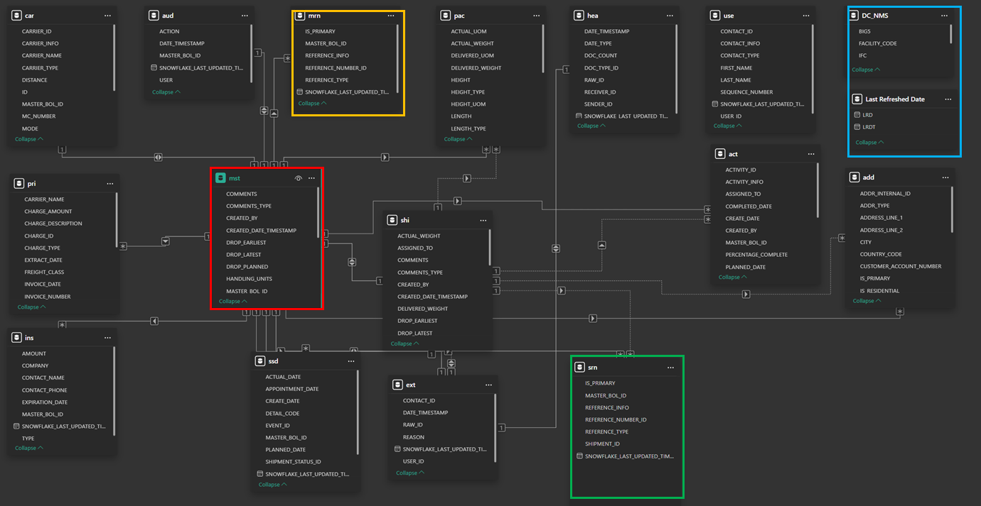

Al list of the invoice files for each of the additional audited lines above will be added the document pack

APPENDIX 919.2.4.0.a 