Supplementary Material

Table S1. Identity and traits (average biomass in g, food relocation behavior, and type of diet) for 24 species of dung beetles (Coleoptera: Scarabaeinae) sampled in the introduced Brazilian pastures. NA: missing data.
Species | Biomass (g) | Food relocation behavior | Diet
Ateuchus ovalis | 0.0263 | Tunneler | Necrophagous
Ateuchus pauperatus | 0.0937 | Tunneler | Coprophagous
Ateuchus vividus | 0.0439 | Tunneler | Generalist
Canthidium aff. viride | 0.8323 | Tunneler | Necrophagous
Canthidium prasinum | 0.1954 | Tunneler | Necrophagous
Canthon curvodilatatus | 0.0735 | Roller | Necrophagous
Canthon histrio | 0.0303 | Roller | NA
Canthon lituratus | 0.0149 | Roller | NA
Canthon maldonadoi | 0.0022 | Roller | NA
Coprophanaeus spitzi | 10.3553 | Tunneler | Necrophagous
Dichotomius bos | 13.9033 | Tunneler | Generalist
Dichotomius glaucus | 1.4773 | Tunneler | Generalist
Dichotomius nisus | 1.8338 | Tunneler | Generalist
Dichotomius opacipennis | 3.9323 | Tunneler | Generalist
Dichotomius semianeus | 0.2521 | Tunneler | NA
Dichotomius sexdentatus | 7.9759 | Tunneler | Necrophagous
Digitonthophagus gazella | 0.3070 | Tunneler | Coprophagous
Genieridium bidens | 0.2222 | Dweller | Generalist
Ontherus appendiculatus | 14.4487 | Tunneler | Coprophagous
Onthophagus hircus | 0.0559 | Tunneler | Generalist
Oxysternom palaemon | 1.3077 | Tunneler | Necrophagous
Phanaeus palaeno | 0.4389 | Tunneler | NA
Trichillum externepunctatum | 0.2098 | Dweller | Coprophagous
Uroxys aff. corporaali | 0.0138 | NA | Coprophagous

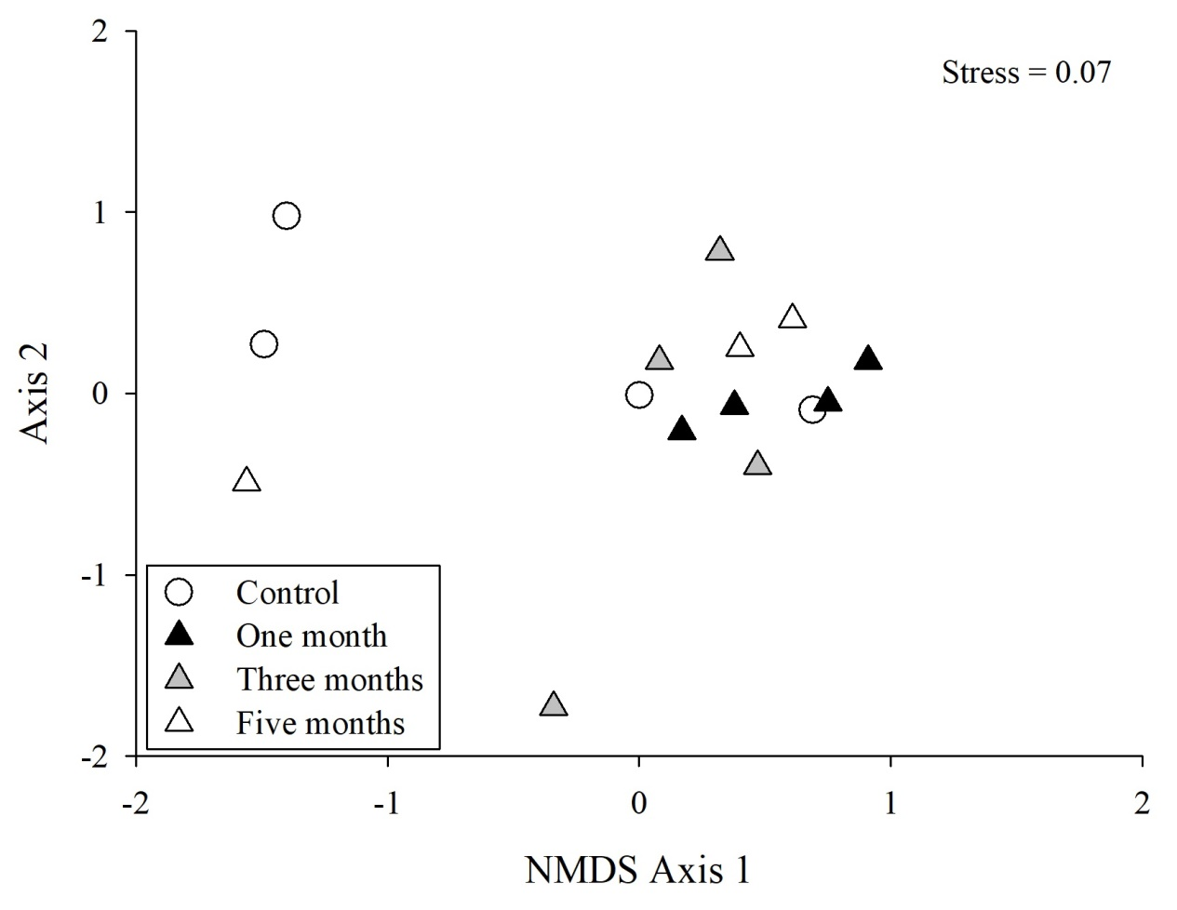
Fig. S1. Non-metric multidimensional scaling results (NMDS), constructed from Bray-Curtis matrices, for dung beetle assemblages in introduced pastures with different times of cattle grazing removal in Aquidauana, Mato Grosso do Sul, Brazil.
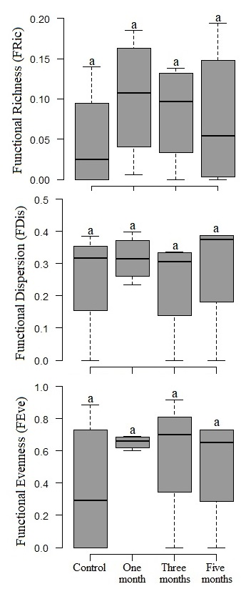
Fig. S2 Average Functional Richness, Functional Dispersion, and Functional Evenness of dung beetle assemblages sampled in introduced pastures with different times of cattle grazing removal in Aquidauana, Mato Grosso do Sul, Brazil. Error bars represent ± standard errors. NS = no significance (p > 0.05), according to F-test.

