Supporting Information

Fig. S1. Distribution histogram of carabid body size.

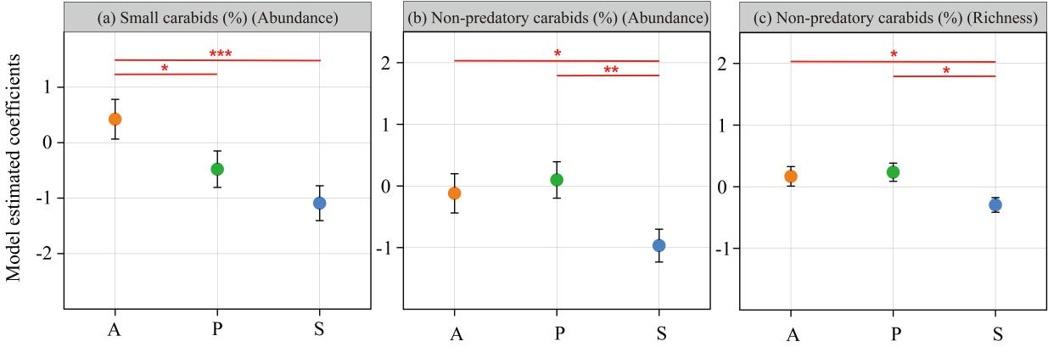
Fig. S2. Estimated coefficients from generalized linear mixed models showing the differences between assemblages in different land use types (A: annual crops; P: perennial crops; S: semi-natural habitats): (a) proportion of small carabids abundance (b) proportion of non-predatory carabids abundance (c) proportion of non-predatory carabids species richness; error bars refer to the SE of estimates, and asterisks indicate a significant difference based on the models (*≤0.05; **≤0.01; ***<0.001).

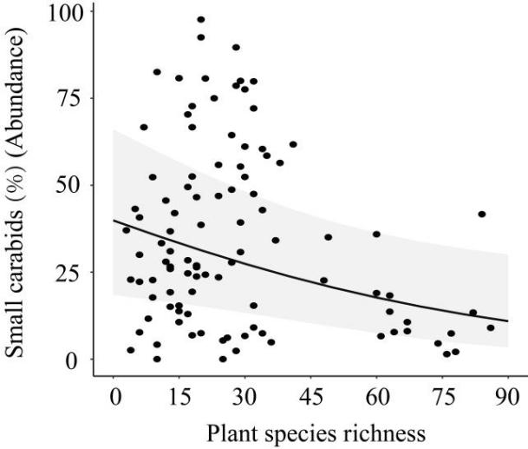
Fig. S3. Effects of the plant species richness on the proportion of small carabid abundance.

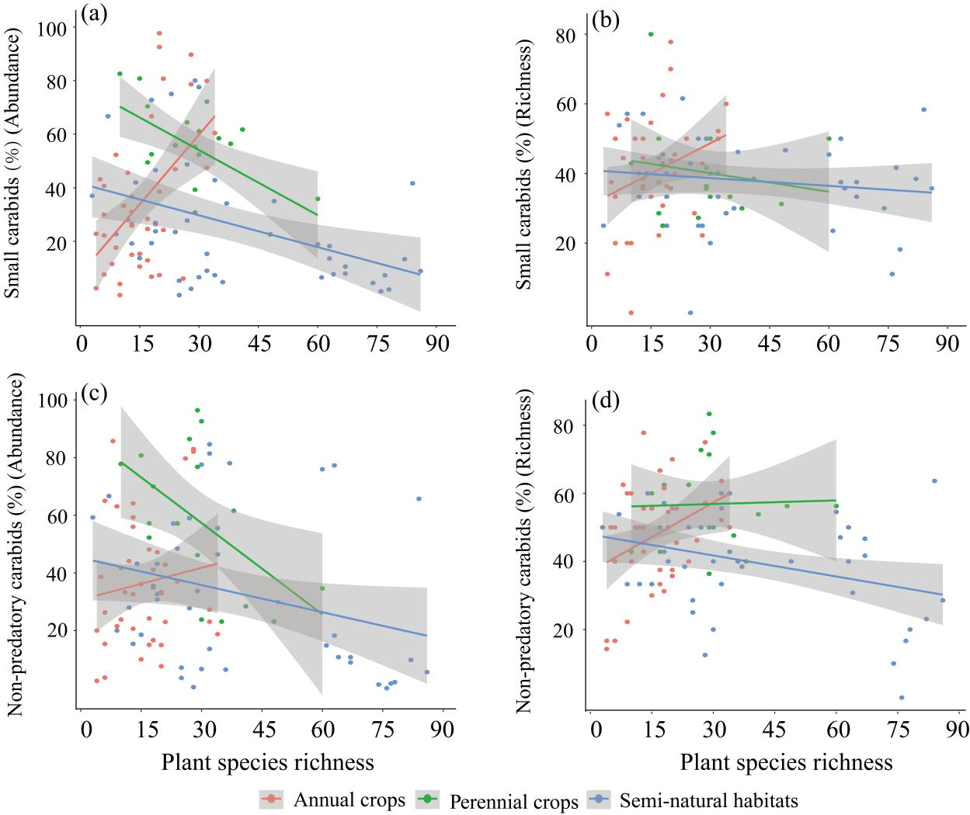
Fig. S4. Effects of land use types and plant species richness on the proportion of small-sized carabids with regards to abundance (a) and species richness (b), and on the proportion of non-predatory carabids based on abundance (c) and species richness (d).
Table S1. Land use types and sampling time in different areas, and brackets refer to the number of plots and sampling days of every month, respectively.
Study area | Land use type and number of plots |  |  | Sampling period
Study area | Annual crop (plots) | Perennial crop (plots) | Semi-natural land (plots) | Month /days. Month-1 | Year
Baiqi | Potato field (2)  Maize field (1)  Oat field (1) | / | Plantation forest (4)  Grassland (4) | May~October /6 | 2006~2007
Fangshan | / | Walnut planting (4) | Plantation forest (4)  Alpine meadow (4) | May~October /6 | 2011~2012
Gaojiaying | Maize field (4) | Orchard (4) | Grassland (4) | May~October /6 | 2006~2007
Haidian | Maize field (4) | Orchard(4) | Woodland (4) | May~October /6 | 2006
Miyun | Wheat field (4)  Peanut field (4) | Orchard (4) | Field margin (4)  Windbreak (4)  Woodland (4) | May~October/ 6 | 2010
Qianjiang | Rainfed field (4)  Paddy field (8)  Vegetable field (8) | / | Dyke grassland (5)  Field margin (5)  Windbreak (6)  Woodland (4) | May-October /4 | 2013
Quzhou | Wheat/Maize field (4)  Cotton field (4) | Orchard (4) | Woodland (3)  Grassland (3) | May-October /10 | 2005~2006
Shizigou | Cabbage field (2)  Potato field (2) | / | Plantation forest (4)  Grassland (4) | May~October /6 | 2006~2007
Yanqing | Maize field (4) | Orchard (4) | Woodland(4) | May-October /6 | 2006~2007
Total number of plots | 56 | 24 | 74 | / | /

Table S2. Plant species richness in different land use types.
Habitat type | Community structure | Dominant species | Mean±SE | Min | Max
Annual cops | Herb layer | Zea mays, Arachis hypogaea, Digitaria sanguinalis, Glycine max, Brassica pekinensis, Echinochloa crusgalli, Acalypha australis, Triticum aestivum, Gossypium hirsutum, Solanum tuberosum | 14.73±1.26 | 3 | 43
Perennial crops | Herb layer | Amaranthus retroflexus, Humulus scandens, Digitaria sanguinalis, Pennisetum alopecuroides, Artemisia scoparia, Kochia scoparia, Chenopodium glaucum, Salsola collina, Artemisia argyi, Hibiscus trionum | 22.54±1.93 | 7 | 56
 | Tree layer | Armeniaca vulgaris, Juglans regia, Malus asiatica, Amygdalus persica, Malus domestica, Prunus salicina, Pyrus sorotina | 2.42±0.26 | 4 | 1
Semi-natural habitats | Herb layer | Artemisia capillaris, Carex humilis, Cynodon dactylon, Chenopodium glaucum, Humulus scandens, Carex duriuscula, Digitaria sanguinalis, Artemisia annua, Eremochloa ophiuroides, Cyperus rotundus | 32.77±2.87 | 3 | 87
 | Shrub layer | Vitex negundo, Wikstroemia chamaedaphne, Spiraea trilobata, Cayratia japonica, Lespedeza inschanica, Clerodendrum bungei | 2.06±0.31 | 0 | 13
 | Tree layer | Larix principis-rupprechtii, Populus × beijingensis, Populus cathayana, Robinia pseudoacacia, Ulmus pumila, Populus tomentosa, Ulmus davidiana，Juglans mandshurica，Metasequoia glyptostroboides | 2.48±0.23 | 0 | 8

Table S3. Parameters of plant species richness in different land use types.
Land use types |  | Mean±SE
Annual crops | Cabbage field | 33.00±10.00
Annual crops | Potato field | 26.80±2.87
Annual crops | Vegetable field | 20.00±1.15
Annual crops | Maize field | 17.31±1.71
Annual crops | Cotton field | 14.75±1.31
Annual crops | Wheat field | 11.50±2.15
Annual crops | Rainfed field | 9.60±1.81
Annual crops | Paddy field (wheat field and soybean field) | 5.33±0.67
Annual crops | Peanut field | 5.25±1.31
Perennial crops | Walnut planting | 28.75±0.63
Perennial crops | Orchard | 26.55±2.90
Semi-natural habitats | Grassland | 62.27±6.87
Semi-natural habitats | Plantation forest | 41.25±6.04
Semi-natural habitats | Woodland | 30.36±1.79
Semi-natural habitats | Alpine meadow | 26.75±3.09
Semi-natural habitats | Windbreak | 22.71±3.08
Semi-natural habitats | Field margin | 15.29±1.39
Semi-natural habitats | Dyke grassland | 6.00±1.73

Table S4. Species list of carabid beetles with number of individuals and trophic levels (Small<12 mm and large ≥12 mm).
 | Specise | Body size (mm) | Annual crops | Perennial crops | Semi-natural habitats | trophic level
small | Acupalpus dubius Schilsky, 1888 | 3.62 | 1 | 0 | 1 | Predatory
 | Agonum sp1. | 8.64 | 1 | 0 | 0 | /
 | Agonum sp2. | 10.02 | 7 | 1 | 40 | Predatory
 | Amara alacris Tschitscherine, 1899 | 5.75 | 0 | 1 | 0 | Non-predatory
 | Amara aurichalcea Germar, 1824 | 8.75 | 8 | 0 | 0 | Non-predatory
 | Amara chalcites Dejean, 1828 | 9.31 | 12 | 0 | 2 | Non-predatory
 | Amara communis Panzer, 1796 | 7.33 | 10 | 0 | 15 | Non-predatory
 | Amara harpaloides Dejean, 1828 | 11.41 | 1 | 0 | 6 | Non-predatory
 | Amara majuscula Chaudoir, 1850 | 7.20 | 1 | 0 | 4 | Non-predatory
 | Amara sp1. | 8.32 | 2 | 0 | 0 | Non-predatory
 | Amara sp2. | 7.35 | 3 | 0 | 12 | Non-predatory
 | Amara sp3. | 9.14 | 4 | 0 | 2 | Non-predatory
 | Amara tumida Morawitz, 1862 | 6.53 | 0 | 0 | 3 | Non-predatory
 | Anisodactylus punctatipennis Morawitz, 1862 | 11.30 | 19 | 0 | 5 | Non-predatory
 | Asaphidion semilucidum Motschulsky, 1862 | 4.69 | 12 | 19 | 7 | Non-predatory
 | Bembidion difforme Motschulsky, 1844 | 4.00 | 4 | 0 | 1 | Predatory
 | Bembidion incidiosum | 4.91 | 48 | 1 | 0 | Predatory
 | Bembidion pogonoides Bate, 1883 | 6.54 | 3 | 0 | 0 | Predatory
 | Bradycellus sp. | 6.06 | 2 | 0 | 0 | Non-predatory
 | Callistomimus modestus Schaum, 1863 | 4.96 | 1 | 0 | 0 | Predatory
 | Chlaenius inops Chaudoir, 1856 | 11.01 | 3 | 0 | 0 | Predatory
 | Chlaenius pericallus Redtenbacher, 1867 | 11.68 | 2 | 0 | 0 | Predatory
 | Cymindis daimio Bates, 1873 | 9.00 | 0 | 0 | 2 | Predatory
 | Cymindis sp. | 9.54 | 1 | 0 | 1 | Predatory
 | Dyschirius sp. | 3.30 | 0 | 0 | 2 | Predatory
 | Harpalus aequicollis Motschulsky, 1844 | 11.55 | 3 | 0 | 2 | Non-predatory
 | Harpalus bungii Chaudoir, 1844 | 8.57 | 18 | 37 | 29 | Non-predatory
 | Harpalus davidi Tschitscherine, 1897 | 10.80 | 0 | 1 | 1 | Non-predatory
 | Harpalus davidianus Tschitscherine, 1903 | 9.85 | 1 | 0 | 14 | Non-predatory
 | Harpalus griseus Panzer, 1796 | 11.33 | 68 | 169 | 30 | Non-predatory
 | Harpalus melaneus Bates, 1878 | 11.97 | 1 | 0 | 2 | Non-predatory
 | Harpalus pallidipennis Morawitz, 1862 | 10.12 | 521 | 108 | 289 | Predatory
 | Harpalus pastor Motschulsky, 1844 | 11.88 | 317 | 266 | 244 | Non-predatory
 | Harpalus sp. | 7.39 | 4 | 0 | 49 | Non-predatory
 | Harpalus suensoni Kataev, 1997 | 11.50 | 3 | 0 | 2 | Non-predatory
 | Harpalus tinctulus Bates, 1873 | 7.40 | 0 | 1 | 0 | Non-predatory
 | Harpalus tridens Morawitz, 1862 | 11.85 | 2 | 0 | 326 | Non-predatory
 | Lebia sp. | 4.64 | 0 | 0 | 1 | Predatory
 | Lesticus magnus Motschulsky, 1860 | 7.79 | 17 | 2 | 17 | Predatory
 | Loricera pilicornis Fabricius, 1775 | 7.79 | 0 | 0 | 2 | Predatory
 | Loxoncus circumcinctus Motschulsky, 1857 | 9.16 | 4 | 0 | 0 | Predatory
 | Licinus setosus Sahlberg, 1880 | 8.00 | 4 | 0 | 5 | /
 | Mastax poecila Schaum, 1863 | 3.90 | 1 | 0 | 1 | Non-predatory
 | Oxycentrus jelineki Ito, 2006 | 8.32 | 15 | 1 | 3 | Predatory
 | Oxycentrus sp. | 6.94 | 5 | 0 | 5 | Predatory
 | Panagaeus davidi Fairmaire, 1887 | 10.8 | 1 | 0 | 0 | Predatory
 | Peronomerus auripilis Bates, 1883 | 9.50 | 0 | 1 | 0 | Predatory
 | Pheropsophus occipitalis Macleay, 1825 | 8.85 | 3 | 1 | 0 | Predatory
 | Pterostichus haptoderoides Tschitschérine, 1889 | 7.46 | 2 | 0 | 2 | Predatory
 | Pterostichus kiangsu Jedlicka, 1965 | 11.82 | 0 | 0 | 4 | Predatory
 | Pterostichus microcephalus Motschulsky, 1860 | 9.50 | 111 | 217 | 14 | Predatory
 | Pterostichus sulcitarsis Morawitz, 1862 | 8.93 | 5 | 0 | 11 | Predatory
 | Stenaspis castaneipennis Dupont, 1838 | 10.00 | 0 | 0 | 9 | /
 | Stenolophus difficilis Hope, 1845 | 5.38 | 17 | 0 | 4 | Predatory
 | Syntomus pallipes Dejean 1825 | 3.30 | 25 | 2 | 1 | Predatory
 | Synuchus major Lindroth, 1956 | 8.21 | 0 | 0 | 1 | Predatory
 | Synuchus nordmani Morawitz, 1862 | 9.25 | 32 | 3 | 24 | Predatory
 | Synuchus sp. | 8.21 | 3 | 1 | 8 | Predatory
 | Tachus gradatus | 3.04 | 83 | 14 | 2 | Non-predatory
 | Tachys sp1. | 2.62 | 32 | 0 | 3 | Non-predatory
 | Tachys sp2. | 2.10 | 2 | 0 | 0 | Non-predatory
large | Anisodactylus signatus Panzer, 1797 | 12.25 | 7 | 6 | 3 | Non-predatory
 | Amara gigantea Motschulsky, 1844 | 18.31 | 0 | 2 | 7 | Non-predatory
 | Amara macronota Solsky, 1875 | 13.23 | 7 | 23 | 15 | Non-predatory
 | Brachinus scotomedes Redtenbacher, 1867 | 14.00 | 7 | 0 | 3 | Predatory
 | Calosoma denticolle Gebler,1833 | 22.50 | 0 | 0 | 1 | Predatory
 | Calosoma lugens Chaudoir, 1869 | 23.00 | 1 | 3 | 0 | Predatory
 | Carabus brandti Faldermann,1835 | 27.28 | 16 | 15 | 11 | Predatory
 | Carabus canaliculatus Adams, 1812 | 24.67 | 0 | 0 | 7 | Predatory
 | Carabus conciliator Fischer von Waldheim, 1822 | 30.26 | 1 | 0 | 0 | Predatory
 | Carabus crassesculptus Kraatz, 1881 | 23.03 | 3 | 0 | 20 | Predatory
 | Carabus kruberi Fischer von Waldheim, 1822 | 21.00 | 6 | 0 | 76 | Predatory
 | Carabus latreillei Fischer von Waldheim, 1820 | 22.30 | 0 | 3 | 10 | Predatory
 | Carabus manifestus Kraatz, 1881 | 21.03 | 0 | 0 | 31 | Predatory
 | Carabus smaragdinus Fischer von Waldheim, 1823 | 33.63 | 26 | 14 | 19 | Predatory
 | Carabus vladimirskyii Dejean, 1830 | 22.87 | 0 | 1 | 142 | Predatory
 | Carabus elysii Thomson, 1856 | 39.00 | 3 | 0 | 10 | Predatory
 | Chlaenius aspericollis Bates, 1873 | 13.76 | 36 | 0 | 10 | Predatory
 | Chlaenius bengalensis Chaudoir, 1856 | 15.86 | 4 | 0 | 4 | Predatory
 | Chlaenius bimaculatus Dejean 1826 | 13.60 | 2 | 0 | 7 | Predatory
 | Chlaenius costiger Chaudoir, 1856 | 22.23 | 1 | 0 | 5 | Predatory
 | Chlaenius leueops | 13.24 | 1 | 0 | 23 | Predatory
 | Chlaenius micans Fabricius, 1792 | 15.96 | 513 | 11 | 64 | Predatory
 | Chlaenius pallipes Gebler, 1823 | 14.17 | 31 | 2 | 2 | Predatory
 | Chlaenius posticalis Motschulsky, 1854 | 14.50 | 229 | 47 | 181 | Predatory
 | Chlaenius touzalini Andrewes, 1920 | 14.75 | 6 | 0 | 0 | Predatory
 | Chlaenius virgulifer Chaudoir, 1876 | 13.50 | 2 | 2 | 1 | Predatory
 | Curtonotus giganteus Motschulsky, 1844 | 21.30 | 1 | 10 | 13 | Non-predatory
 | Dolichus halensis Schaller, 1783 | 17.59 | 125 | 283 | 223 | Predatory
 | Harpalus brevicornis Germar, 1824 | 15.47 | 6 | 2 | 1 | Non-predatory
 | Harpalus crates Bates, 1883 | 12.57 | 3 | 3 | 0 | Non-predatory
 | Harpalus chalcentus Bates, 1873 | 12.74 | 72 | 24 | 71 | Non-predatory
 | Harpalus coreanus Tschitscherine, 1895 | 14.35 | 0 | 1 | 0 | Non-predatory
 | Harpalus corporosus Motschulsky, 1861 | 15.03 | 76 | 69 | 11 | Non-predatory
 | Harpalus eous Tschitscherine, 1901 | 15.29 | 2 | 0 | 0 | Non-predatory
 | Harpalus lumbaris Mannerheim, 1825 | 13.04 | 34 | 1 | 5 | Non-predatory
 | Harpalus roninus Bates, 1873 | 17.60 | 8 | 0 | 0 | Predatory
 | Harpalus rubripes Duftschmid, 1812 | 13.35 | 0 | 0 | 1 | Non-predatory
 | Harpalus simplicidens Schauberger, 1929 | 12.67 | 119 | 66 | 16 | Non-predatory
 | Harpalus sinicus Hope, 1845 | 13.73 | 54 | 6 | 147 | Non-predatory
 | Harpalus ussuriensis Chaudoir, 1863 | 13.73 | 5 | 0 | 3 | Non-predatory
 | Harpalus vicaius Harold, 1878 | 17.60 | 5 | 1 | 0 | Predatory
 | Nebria livida angulata Bänninger,1949 | 16.65 | 2 | 0 | 0 | Predatory
 | Pheropsophus jessoensis Morawitz, 1862 | 17.37 | 300 | 0 | 353 | Predatory
 | Planetes puncticeps Andrewes, 1919 | 13.63 | 0 | 0 | 1 | Predatory
 | Pristosia sp. | 13.76 | 1 | 0 | 4 | Predatory
 | Pseudotaphoxenus mongolicus Jedlička, 1953 | 15.00 | 7 | 2 | 306 | Predatory
 | Pseudotaphoxenus rugipennis Faldermann, 1835 | 22.07 | 3 | 0 | 16 | Predatory
 | Pterostichus acutidens Fairmaires,1888 | 17.46 | 15 | 0 | 24 | Predatory
 | Pterostichus adstrictus Eschscholtz, 1823 | 15.79 | 0 | 0 | 63 | Predatory
 | Pterostichus fortipes Chaudoir, 1850 | 14.44 | 40 | 94 | 640 | Predatory
 | Pterostichus gebleri Dejean, 1828 | 16.44 | 64 | 52 | 217 | Non-predatory
 | Pterostichus interruptus Dejean, 1828 | 18.02 | 0 | 0 | 1 | Predatory
 | Scarites acutidens Chaudoir, 1855 | 32.09 | 4 | 0 | 2 | Non-predatory
 | Scarites sulcatus Olivier, 1795 | 27.62 | 7 | 0 | 2 | Predatory
 | Scarites terricola Bonelli, 1813 | 17.61 | 127 | 18 | 92 | Non-predatory
 | Tachys sp3. | 18.31 | 1 | 0 | 0 | /
 | Tachys sp4. | 22.50 | 1 | 0 | 0 | /
 | Trigonognatha jeachi Sciaky 1995 | 22.22 | 0 | 2 | 5 | Non-predatory

