Functional Traits Linked to Pathogen Prevalence in Wild Bee Communities
Supplementary Material

Authors: Laura L. Figueroa^{1,2}* llf44@cornell.edu
Sally Compton¹ sallymcompton@gmail.com
Heather Grab¹ hlc66@cornell.edu
Scott H. McArt¹ shm33@cornell.edu

¹Department of Entomology, Cornell University, Ithaca, NY 14853, USA
²Department of Environmental Conservation, University of Massachusetts, MA, 01003, USA

*Corresponding author: Laura L. Figueroa
Figure S1. Histogram showing distribution of bee size in B. impatiens workers. One clear outlier was removed from the B. impatiens intraspecific statistical analyses (furthest to the left).
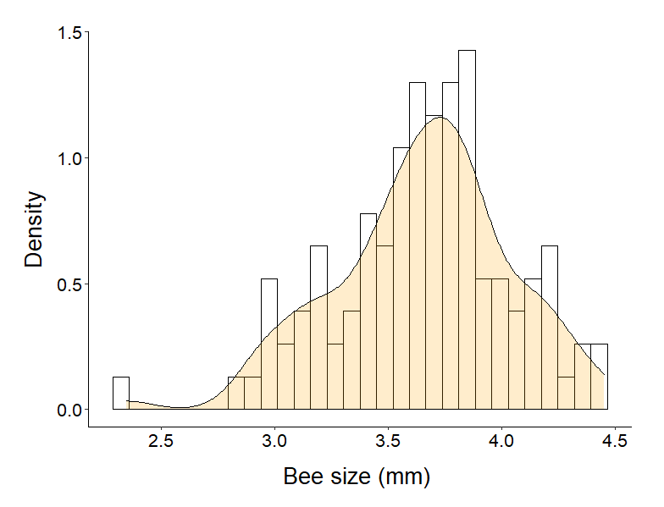

Figure S2. Relationship between individual Bombus impatiens worker size and likelihood of Nosema ceranae presence A) for all bees sampled and B) excluding theoutlier (Figure S1). 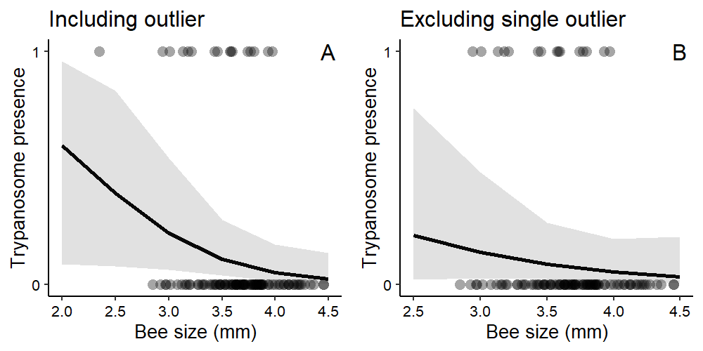

Figure S3. Relationship between bee size and trypanosome prevalence (mean ±SE) in the overall community (A) when A. aurata included and (B) when A. aurata excluded. Relationship between peak seasonal activity (in Julian days) and trypanosome prevalence (mean ±SE) in the overall community (A) when A. aurata included and (B) when A. aurata excluded. Data analyzed as continuous and plotted as such in Figure 4, presented here as proportion for ease of visualization.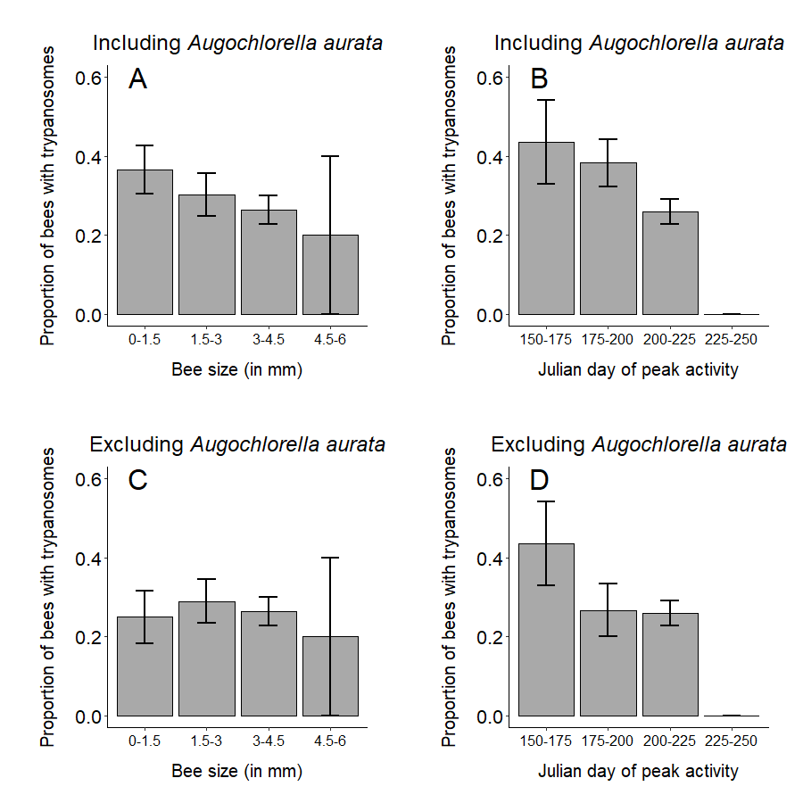
Figure S4. Histogram showing distribution of peak seasonal activity (based on Julian day) for the samples included in the functional trait analyses (A) and for the species in the NE of the US (overlapping region with the present study)¹.

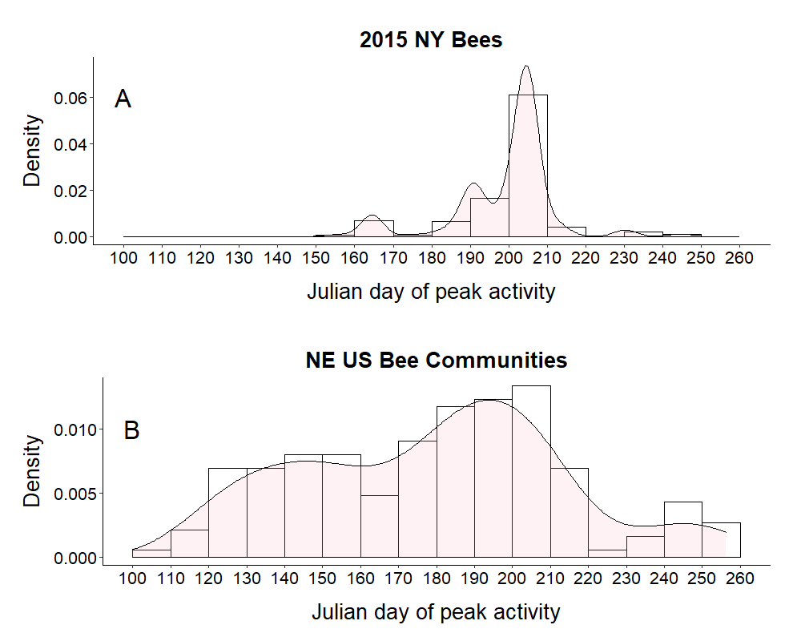
Table S1: Flower species present in wildflower planting and adjacent area where bees were collected.

In planting | Adjacent
Agastache nepetoides | Convolvulus arvensis
Cirsium arvense | Daucus carota
Coreopsis lanceolata | Hypericum perforatum
Daucus carota | Leucanthemum vulgare
Erigeron annuus | Lotus corniculatus
Lobelia siphilitica | Malva moschata
Medicago sativa | Potentilla fruticosa
Penstemon digitalis | Plantago lanceolata
Silphium perfoliatum | Rubus fruticosus
Solidago juncea | Symphyotrichum novi-belgii
Trifolium pratens
Trifolium repens
Veronicastrum virginicum

Table S2: Plant families visited by each bee species across the 11 sampled sites.

Bee species | Plant Family | n
Agapostemon virescens | Asteraceae | 4
Agapostemon virescens | Plantaginaceae | 7
Andrena simplex | Asteraceae | 1
Andrena spp. | Asteraceae | 1
Andrena wilkella | Fabaceae | 2
Anthophora terminalis | Plantaginaceae | 22
Anthophora terminalis | NA | 1
Apis mellifera | Asteraceae | 33
Augochlora pura | Plantaginaceae | 2
Augochlorella aurata | Asteraceae | 9
Augochlorella aurata | Convolvulaceae | 6
Augochlorella aurata | Fabaceae | 2
Augochlorella aurata | Plantaginaceae | 8
Bombus bimaculatus | Asteraceae | 3
Bombus bimaculatus | Fabaceae | 4
Bombus bimaculatus | Plantaginaceae | 16
Bombus fervidus | Asteraceae | 1
Bombus fervidus | Fabaceae | 1
Bombus fervidus | Plantaginaceae | 1
Bombus griseocollis | Asteraceae | 4
Bombus griseocollis | Plantaginaceae | 5
Bombus impatiens | Apiaceae | 2
Bombus impatiens | Asteraceae | 99
Bombus impatiens | Campanulaceae | 3
Bombus impatiens | Fabaceae | 1
Bombus impatiens | Lamiaceae | 5
Bombus impatiens | Plantaginaceae | 12
Bombus perplexus | Asteraceae | 1
Bombus ternarius | Asteraceae | 3
Bombus ternarius | Plantaginaceae | 2
Bombus vagans | Asteraceae | 3
Bombus vagans | Fabaceae | 1
Bombus vagans | Plantaginaceae | 6
Calliopsis andreniformis | Asteraceae | 1
Calliopsis nebraskensis | Asteraceae | 1
Ceratina calcarata | Asteraceae | 5
Ceratina calcarata | Campanulaceae | 3
Ceratina calcarata | Malvaceae | 1
Ceratina calcarata | Plantaginaceae | 3
Ceratina calcarata | Rosaceae | 1
Ceratina calcarata | NA | 2
Ceratina dupla | Plantaginaceae | 1
Ceratina dupla | Rosaceae | 1
Ceratina mikmaqi | Asteraceae | 8
Ceratina mikmaqi | Fabaceae | 1
Ceratina mikmaqi | Hypericaceae | 1
Ceratina mikmaqi | Plantaginaceae | 8
Ceratina spp. | Asteraceae | 2
Ceratina spp. | Campanulaceae | 1
Ceratina spp. | Plantaginaceae | 3
Coelioxys rufitarsis | Asteraceae | 1
Colletes kincaidii | Asteraceae | 1
Halictus confusus | Asteraceae | 13
Halictus confusus | Convolvulaceae | 1
Halictus confusus | Plantaginaceae | 2
Halictus confusus | Rosaceae | 1
Halictus ligatus | Asteraceae | 32
Halictus ligatus | Convolvulaceae | 8
Halictus rubicundis | Fabaceae | 1
Heriades carinata | Asteraceae | 1
Hoplitis producta | Plantaginaceae | 1
Hoplitis spp. | Asteraceae | 1
Hylaeus affinis | Asteraceae | 6
Hylaeus affinis | Convolvulaceae | 2
Hylaeus affinis | Plantaginaceae | 3
Hylaeus annulatus | Asteraceae | 1
Hylaeus annulatus | Malvaceae | 1
Hylaeus annulatus | Plantaginaceae | 1
Hylaeus modestus | Asteraceae | 1
Hylaeus modestus | Campanulaceae | 9
Hylaeus modestus | Plantaginaceae | 4
Hylaeus spp. | Asteraceae | 3
Lasioglossum coriaceum | Plantaginaceae | 3
Lasioglossum hitchensi | Plantaginaceae | 1
Lasioglossum imitatum | Asteraceae | 2
Lasioglossum inconditum | NA | 1
Lasioglossum lineatulum | Asteraceae | 1
Lasioglossum lineatulum | Plantaginaceae | 2
Lasioglossum perpunctatum | Asteraceae | 1
Lasioglossum pilosum | Asteraceae | 4
Lasioglossum pilosum | Plantaginaceae | 7
Lasioglossum spp. | Asteraceae | 10
Lasioglossum spp. | Convolvulaceae | 1
Lasioglossum spp. | Hypericaceae | 4
Lasioglossum spp. | Plantaginaceae | 10
Lasioglossum versatum | Plantaginaceae | 3
Lasioglossum viridatum | Asteraceae | 7
Lasioglossum viridatum | Convolvulaceae | 4
Lasioglossum viridatum | Fabaceae | 1
Lasioglossum viridatum | Plantaginaceae | 31
Lasioglossum viridatum | Rosaceae | 2
Lasioglossum viridatum | NA | 1
Lasioglossum weemsi | Campanulaceae | 1
Lasioglossum zephyrum | Asteraceae | 3
Lasioglossum zephyrum | Hypericaceae | 3
Lasioglossum zephyrum | Plantaginaceae | 1
Megachile spp. | Asteraceae | 1
Megachile spp. | Plantaginaceae | 4
Melissodes agilis | Asteraceae | 5
Melissodes bimaculata | Asteraceae | 4
Melissodes desponsa | Asteraceae | 6
Melissodes druriella | Asteraceae | 3
Melissodes spp. | Asteraceae | 37
Melissodes spp. | NA | 1
Melissodes subillata | Asteraceae | 3
Melissodes trinodis | Asteraceae | 29
Osmia atriventris | Plantaginaceae | 1
Osmia bucephala | Plantaginaceae | 4
Peponapis pruinosa | Asteraceae | 1
Xylocopa virginica | Asteraceae | 2

Table S3. Molecular conditions used for pathogen screening (PCR).
Primers and source | Thermal Cycling |  |  | Amplicon size (bp)
Primers and source | Denaturing Min | Temp | Replication Sec | Temp | Elongation Min | Temp | Amplicon size (bp)
Apidae^{A} (host) and Trypanosomes^{T} ² | 2 | 94 | 35x  30 | 94  30 | 61  45 | 68 | 5 | 68 | 130^{A}  420^{T}
ApidaeF(5-3): AGATGGGGGCATTCGTATTG
ApidaeR(5-3): ATCTGATCGCCTTCGAACCT
SEF(5-3): CTTTTGGTCGGTGGAGTGAT
SER(5-3): GGACGTAATCGGCACAGTTT
Neogregarines ² | 2 | 94 | 35x  30 | 94  30 | 60.7  45 | 68 | 3 | 68 | 260
NeoF (5-3): CCAGCATGGAATAACATGTAAGG
NeoR(5-3): GACAGCTTCCAATCTCTAGTCG
Nosema apis^{A}, N ceranae^{Nc 3} | 4 | 95 | 35x  60 | 95  60 | 60  60 | 68 | 5 | 68 | 297^{Na} 662^{Nc}
NosaRNAPol-F2 (5-3): AGCAAGAGACGTTTCTGGTACCTCA
NosaRNAPol-R2 (5-3): CCTTCACGACCACCCATGGCA
NoscRNAPol-F2 (5-3): TGGGTTCCCTAAACCTGGTGGTTT
NoscRNAPol-R2 (5-3): TCACATGACCTGGTGCTCCTTCT
Nosema bombi ⁴ | 4 | 95 | 35x  60 | 95  60 | 50  60 | 68 | 4 | 68 | 323
Nbombi-SSU-Jf1 (5-3): CCA TGC ATG TTT TTG AAG ATT ATT AT
Nbombi-SSU-Jr1 (5-3): CAT ATA TTT TTA AAA TAT GAA ACA ATA A

Table S4: Summary of bee species and functional traits. Sample size refers to bees for which we had complete functional trait information, including sex (n = 289). Peak activity and Activity range in Julian days.
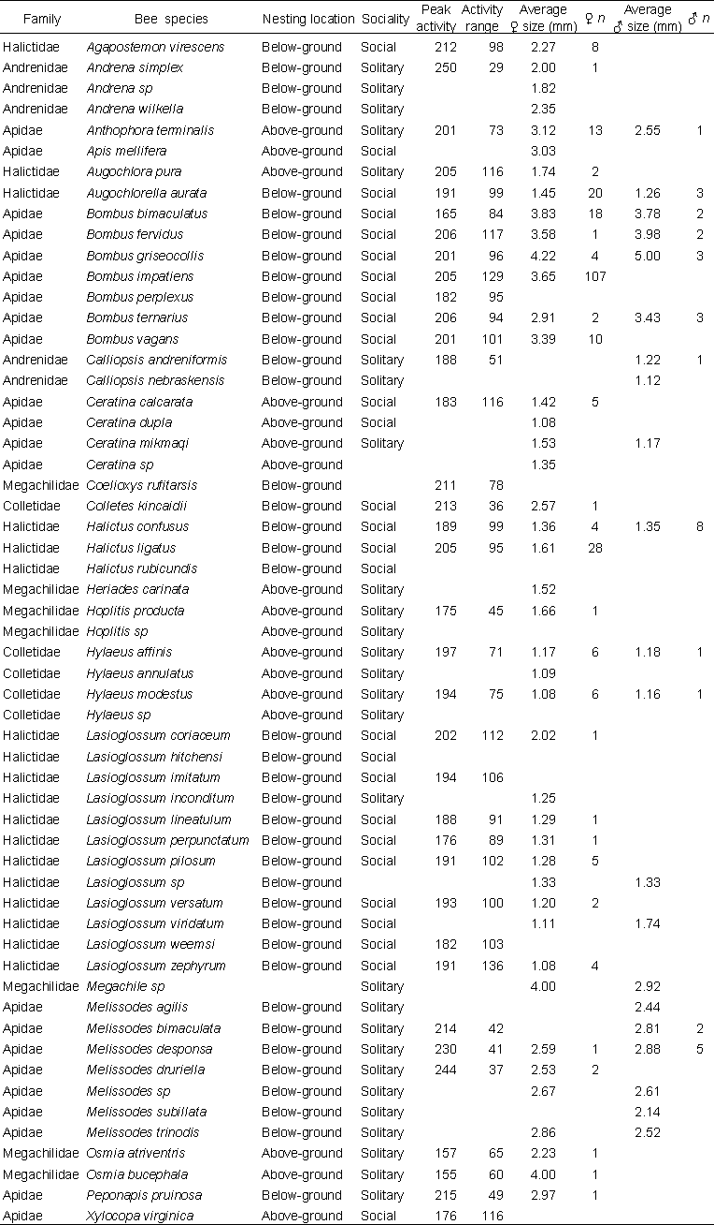
Table S5: Post-hoc comparison of differences between genera. Comparisons that resulted in P values ≥ 0.9 are not shown. The estimate correspond to the Estimated Marginal Means.
Pathogen | Contrast | Estimate | SE | z ratio | P value
Trypanosomes | Augochlorella - Lasioglossum | 2.52 | 0.60 | 4.16 | 0.005
Trypanosomes | Augochlorella - Bombus | 1.91 | 0.50 | 3.85 | 0.017
Trypanosomes | Augochlorella - Apis | 3.17 | 0.88 | 3.61 | 0.040
Trypanosomes | Halictus - Lasioglossum | 1.69 | 0.54 | 3.15 | 0.158
Trypanosomes | Agapostemon - Apis | 3.34 | 1.07 | 3.12 | 0.174
Trypanosomes | Agapostemon - Lasioglossum | 2.68 | 0.86 | 3.10 | 0.180
Trypanosomes | Lasioglossum - Melissodes | -1.61 | 0.52 | -3.07 | 0.195
Trypanosomes | Apis - Halictus | -2.35 | 0.83 | -2.84 | 0.328
Trypanosomes | Apis - Melissodes | -2.27 | 0.82 | -2.76 | 0.386
Trypanosomes | Bombus - Halictus | -1.09 | 0.41 | -2.68 | 0.443
Trypanosomes | Bombus - Melissodes | -1.01 | 0.38 | -2.66 | 0.459
Trypanosomes | Agapostemon - Bombus | 2.08 | 0.79 | 2.63 | 0.479
Trypanosomes | Augochlorella - Ceratina | 1.68 | 0.67 | 2.50 | 0.585
Trypanosomes | Augochlorella - Hylaeus | 1.66 | 0.73 | 2.27 | 0.754
Trypanosomes | Agapostemon - Ceratina | 1.84 | 0.89 | 2.07 | 0.873
N. ceranae | Anthophora - Bombus | 2.22 | 0.64 | 3.47 | 0.063
N. ceranae | Bombus - Melissodes | -1.49 | 0.47 | -3.15 | 0.161
N. ceranae | Bombus - Megachile | -3.84 | 1.26 | -3.06 | 0.200
N. ceranae | Augochlorella - Megachile | -3.97 | 1.43 | -2.78 | 0.371
N. ceranae | Anthophora - Lasioglossum | 1.91 | 0.70 | 2.75 | 0.394
N. ceranae | Lasioglossum - Megachile | -3.53 | 1.29 | -2.74 | 0.397
N. ceranae | Bombus - Halictus | -1.37 | 0.51 | -2.67 | 0.452
N. ceranae | Anthophora - Augochlorella | 2.35 | 0.94 | 2.50 | 0.582
N. ceranae | Apis - Bombus | 1.30 | 0.57 | 2.28 | 0.748
N. ceranae | Ceratina - Megachile | -2.93 | 1.35 | -2.17 | 0.822
N. ceranae | Lasioglossum - Melissodes | -1.18 | 0.57 | -2.08 | 0.866

Table S6: Summary table of functional traits and pathogen prevalence models. P values < 0.05 are in bold.
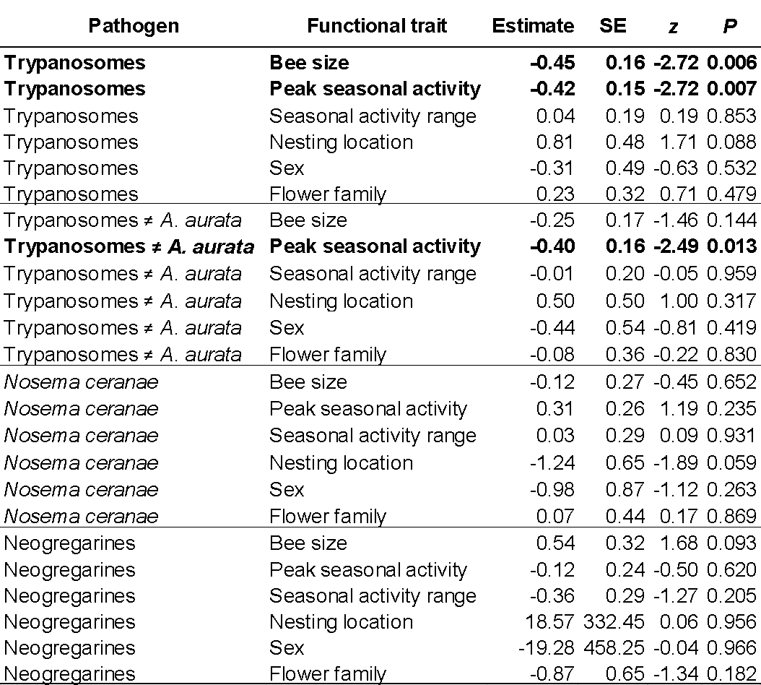

1 Bartomeus, I. et al. Historical changes in northeastern US bee pollinators related to shared ecological traits. Proc. Natl. Acad. Sci. USA 110, 4656-4660, doi:10.1073/pnas.1218503110 (2013).
2 Meeus, I., De Graaf, D., Jans, K. & Smagghe, G. Multiplex PCR detection of slowly‐evolving trypanosomatids and neogregarines in bumblebees using broad‐range primers. J. Appl. Microbiol. 109, 107-115 (2010).
3 Gisder, S. & Genersch, E. Molecular differentiation of Nosema apis and Nosema ceranae based on species–specific sequence differences in a protein coding gene. J. Invertebr. Pathol. 113, 1-6 (2013).
4 Klee, J., Tay, W. T. & Paxton, R. J. Specific and sensitive detection of Nosema bombi (Microsporidia: Nosematidae) in bumble bees (Bombus spp.; Hymenoptera: Apidae) by PCR of partial rRNA gene sequences. J. Invertebr. Pathol. 91, 98-104 (2006).

