Supplementary Material to the manuscript entitled ’Pace of life and mobility as key factors to survive in farmland – relationships between functional traits of diurnal Lepidoptera and landscape structure’.

Table S1. Traits of butterflies and burnet moths used in the analysis with species names abbreviations, the number of sites with occurrences (Occ.) and total abundance (Ab.) of all 104 species.
Species | Mobility | Larval diet | Overw.  stage | Voltinism | HAT | HAST | Abbreviation | Occ. | Ab.
Adscita geryon | 2 | M | Larva | 1 | 1 | 2 | Ads.ger | 1 | 1
Adscita statices | 2 | O | Larva | 1 | 2 | 3 | Ads.sta | 6 | 13
Aglais io | 3 | M | Adult | 1.5 | 3 | 3 | Agl.io | 66 | 344
Aglais urticae | 3 | M | Adult | 2 | 2 | 2 | Agl.urt | 91 | 586
Anthocharis cardamines | 2 | O | Pupa | 1 | 3 | 5 | Ant.car | 18 | 37
Apatura ilia | 2.5 | O | Larva | 1.5 | 1 | 2 | Apa.ili | 4 | 4
Apatura iris | 2.5 | O | Larva | 1 | 1 | 1 | Apa.iri | 4 | 6
Aphantopus hyperantus | 2 | O | Larva | 1 | 4 | 8 | Aph.hyp | 70 | 1368
Aporia crataegi | 2.5 | O | Larva | 1 | 3 | 5 | Apo.cra | 8 | 59
Araschnia levana | 2.5 | M | Pupa | 2.5 | 2 | 3 | Ara.lev | 33 | 132
Argynnis adippe | 2.5 | NO | Egg | 1 | 2 | 4 | Arg.adi | 13 | 61
Argynnis aglaja | 2.5 | P | Larva | 1 | 1 | 2 | Arg.agl | 12 | 65
Argynnis niobe | 2.5 | NO | Egg | 1 | 1 | 2 | Arg.nio | 1 | 5
Argynnis paphia | 2.5 | P | Larva | 1 | 1 | 1 | Arg.pap | 43 | 406
Aricia agestis | 1.5 | P | Larva | 2.5 | 2 | 3 | Ari.age | 18 | 34
Aricia artaxerxes | 1.5 | P | Larva | 1 | 1 | 2 | Ari.art | 2 | 6
Aricia eumedon | 1 | NO | Larva | 1 | 3 | 6 | Ari.eum | 4 | 37
Boloria dia | 2 | NO | Larva | 2.5 | 2 | 2 | Bol.dia | 17 | 198
Boloria eunomia | 1 | M | Larva | 1 | 1 | 2 | Bol.eun | 4 | 49
Boloria euphrosyne | 2 | NO | Larva | 1 | 2 | 3 | Bol.eup | 8 | 28
Boloria selene | 1.5 | NO | Larva | 1.5 | 3 | 5 | Bol.sel | 9 | 19
Boloria titania | 2 | P | Larva | 1 | 2 | 3 | Bol.tit | 2 | 12
Brenthis ino | 1 | O | Egg | 1 | 1 | 3 | Bre.ino | 16 | 141
Callophrys rubi | 2 | P | Pupa | 1 | 3 | 5 | Cal.rub | 4 | 9
Carcharodus alceae | 3 | O | Larva | 2 | 2 | 4 | Car.alc | 3 | 7
Carterocephalus palaemon | 1 | O | Larva | 1 | 3 | 6 | Car.pal | 10 | 19
Celastrina argiolus | 2.5 | P | Pupa | 2.5 | 1 | 2 | Cel.arg | 8 | 10
Coenonympha arcania | 2 | O | Larva | 1.5 | 2 | 4 | Coe.arc | 13 | 169
Coenonympha glycerion | 1.5 | O | Larva | 1 | 2 | 2 | Coe.gly | 5 | 34
Coenonympha pamphilus | 2 | O | Larva | 3 | 3 | 5 | Coe.pam | 87 | 1548
Coenonympha tullia | 1 | P | Larva | 1 | 1 | 1 | Coe.tul | 2 | 10
Colias alfacariensis | 3 | O | Larva | 3 | 2 | 3 | Col.alf | 7 | 15
Colias croceus | 4 | O | Larva | 2 | 2 | 5 | Col.cro | 3 | 4
Colias hyale | 3 | O | Larva | 2.5 | 2 | 5 | Col.hya | 30 | 88
Cupido argiades | 2.5 | O | Larva | 3 | 4 | 6 | Cup.arg | 36 | 126
Cupido minimus | 1 | O | Larva | 2 | 2 | 3 | Cup.min | 4 | 25
Erebia aethiops | 2 | O | Larva | 1 | 1 | 2 | Ere.aet | 1 | 13
Erebia ligea | 2 | O | Egg | 1 | 1 | 1 | Ere.lig | 3 | 13
Erebia medusa | 2 | O | Larva | 1 | 3 | 6 | Ere.med | 14 | 69
Erebia meolans | 2 | NO | Larva | 1 | 2 | 2 | Ere.meo | 3 | 56
Erynnis tages | 2 | O | Larva | 1.5 | 2 | 4 | Ery.tag | 15 | 42
Glaucopsyche alexis | 1 | O | Pupa | 1 | 2 | 3 | Gla.ale | 1 | 1
Gonepteryx rhamni | 2 | O | Adult | 1 | 1 | 2 | Gon.rha | 50 | 235
Hamearis lucina | 1 | NO | Pupa | 1 | 3 | 4 | Ham.luc | 2 | 2
Issoria lathonia | 3 | NO | Pupa | 3 | 3 | 5 | Iss.lat | 23 | 71
Jordanita globulariae | 2 | O | Larva | 1 | 3 | 5 | Jor.glo | 1 | 1
Lasiommata maera | 2 | O | Larva | 1.5 | 2 | 4 | Las.mae | 4 | 19
Lasiommata megera | 2 | O | Larva | 2.5 | 2 | 4 | Las.meg | 15 | 44
Leptidea sp. | 1 | O | Pupa | 2.5 | 3 | 5 | Lep.sp | 48 | 298
Limenitis camilla | 2 | NO | Larva | 1.5 | 1 | 1 | Lim.cam | 16 | 41
Limenitis populi | 2 | NO | Larva | 1 | 1 | 1 | Lim.pop | 1 | 1
Lycaena dispar | 2 | NO | Larva | 2 | 3 | 4 | Lyc.dis | 1 | 4
Lycaena hippothoe | 2 | NO | Larva | 1 | 2 | 3 | Lyc.hip | 2 | 2
Lycaena phlaeas | 3 | NO | Larva | 2.5 | 2 | 5 | Lyc.phl | 32 | 55
Lycaena tityrus | 2 | NO | Larva | 2 | 3 | 6 | Lyc.tit | 24 | 67
Maculinea alcon XER | 1 | M | Larva | 1 | 1 | 2 | Mac.alc | 1 | 7
Maculinea nausithous | 1 | M | Larva | 1 | 1 | 1 | Mac.nau | 4 | 8
Maculinea teleius | 1 | M | Larva | 1 | 1 | 1 | Mac.tel | 1 | 2
Maniola jurtina | 2 | O | Larva | 1 | 4 | 6 | Man.jur | 87 | 5739
Melanargia galathea | 2 | O | Larva | 1 | 2 | 4 | Mel.gal | 70 | 3248
Melitaea athalia | 2 | P | Larva | 1 | 3 | 4 | Mel.ath | 12 | 79
Melitaea aurelia | 1 | NO | Larva | 1 | 1 | 2 | Mel.aur | 2 | 7
Melitaea britomartis | 1 | P | Larva | 1 | 2 | 2 | Mel.bri | 5 | 95
Melitaea cinxia | 2 | P | Larva | 1.5 | 1 | 2 | Mel.cin | 5 | 27
Melitaea diamina | 2 | P | Larva | 1 | 3 | 4 | Mel.dia | 10 | 34
Melitaea didyma | 2 | P | Larva | 1.5 | 2 | 3 | Mel.did | 3 | 70
Nymphalis antiopa | 2.5 | P | Adult | 1 | 1 | 2 | Nym.ant | 3 | 3
Nymphalis polychloros | 2.5 | P | Adult | 1 | 1 | 2 | Nym.pol | 4 | 4
Ochlodes sylvanus | 2 | O | Larva | 1 | 4 | 7 | Och.syl | 57 | 212
Papilio machaon | 3 | P | Pupa | 2 | 3 | 7 | Pap.mac | 26 | 50
Pararge aegeria | 2 | O | Pupa | 2.5 | 1 | 2 | Par.aeg | 21 | 63
Pieris brassicae | 3 | O | Pupa | 3 | 2 | 5 | Pie.bra | 54 | 346
Pieris napi | 3 | O | Pupa | 3.5 | 4 | 8 | Pie.nap | 78 | 688
Pieris rapae | 3 | O | Pupa | 4 | 2 | 5 | Pie.rap | 94 | 2457
Plebeius argus | 1.5 | O | Egg | 1.5 | 2 | 3 | Ple.arg | 5 | 49
Plebeius argyrognomon | 1.5 | O | Egg | 2.5 | 2 | 3 | Pl.argy | 5 | 68
Polygonia c-album | 3 | P | Adult | 2 | 1 | 2 | Pol.c-a | 26 | 47
Polyommatus bellargus | 2 | O | Larva | 2.5 | 2 | 3 | Pol.bel | 12 | 142
Polyommatus coridon | 1.5 | O | Egg | 1 | 2 | 4 | Pol.cor | 8 | 179
Polyommatus daphnis | 1.5 | O | Egg | 1 | 1 | 1 | Pol.dap | 1 | 1
Polyommatus icarus | 2 | O | Larva | 2.5 | 3 | 7 | Pol.ica | 91 | 1181
Polyommatus semiargus | 1.5 | O | Larva | 2.5 | 3 | 5 | Pol.sem | 58 | 513
Polyommatus thersites | 2 | NO | Larva | 2 | 1 | 2 | Pol.the | 4 | 122
Pyrgus armoricanus | 2 | NO | Larva | 2.5 | 3 | 4 | Pyr.arm | 1 | 1
Pyrgus malvae | 2 | O | Pupa | 1.5 | 4 | 6 | Pyr.mal | 9 | 19
Pyronia tithonus | 1.5 | O | Larva | 1 | 3 | 5 | Pyr.tit | 5 | 95
Satyrium acaciae | 1 | M | Egg | 1 | 2 | 3 | Sat.aca | 1 | 1
Satyrium pruni | 2.5 | NO | Egg | 1 | 1 | 2 | Sat.pru | 11 | 35
Satyrium spini | 2 | NO | Egg | 1 | 2 | 4 | Sat.spi | 2 | 3
Satyrium w-album | 1.5 | NO | Egg | 1 | 1 | 2 | Sat.w-a | 3 | 4
Spialia sertorius | 2 | M | Larva | 2 | 2 | 3 | Spi.ser | 4 | 13
Thecla betulae | 2 | NO | Egg | 1 | 1 | 2 | The.bet | 1 | 1
Thymelicus lineola | 2 | O | Egg | 1 | 4 | 7 | Thy.lin | 70 | 1073
Thymelicus sylvestris | 2 | O | Larva | 1 | 3 | 5 | Thy.syl | 39 | 245
Vanessa atalanta | 4 | M | Adult | 3.5 | 4 | 4 | Van.ata | 45 | 72
Zygaena carniolica | 2 | O | Larva | 1 | 1 | 2 | Zyg.car | 1 | 15
Zygaena ephialtes | 2 | O | Larva | 1 | 3 | 5 | Zyg.eph | 2 | 8
Zygaena filipendulae | 2 | O | Larva | 1 | 4 | 7 | Zyg.fil | 17 | 86
Zygaena lonicerae | 2 | O | Larva | 1 | 2 | 4 | Zyg.lon | 1 | 3
Zygaena loti | 2 | O | Larva | 1 | 2 | 3 | Zyg.lot | 11 | 113
Zygaena purpuralis | 2 | NO | Larva | 1 | 2 | 4 | Zyg.pur | 4 | 99
Zygaena transalpina | 2 | O | Larva | 1 | 2 | 4 | Zyg.tra | 4 | 28
Zygaena trifolii | 2 | O | Larva | 1 | 1 | 3 | Zyg.tri | 2 | 25
Zygaena viciae | 2 | O | Larva | 1 | 4 | 6 | Zyg.vic | 4 | 21

Table S2. Correlation tests between mobility scores used in our study and in previous ones.
Reference dataset | Geographic region | No. overlapping species | Correlation coefficient | p-value
Bink (1992) | NW Europe | 89 | Pearson's r = 0.75 | << 0.001
Cowley et al. (2001) | UK | 43 | Spearman's ρ = 0.82 | << 0.001
Komonen et al. (2004) | Finland | 53 | Pearson's r = 0.52 | << 0.001

Figure S1. Map of an exemplary arable site at Oberkessach, Germany. 340 m a.s.l. A: the red line is the 1500 m long transect, a black line represents the 100 m buffer around the transect, the square is 1 km × 1 km large. B: landscape structure within the 100 m buffer. Yellow – arable fields, light green – grasslands, purple – edge vegetation, dark green – forest, grey – impervious surface (roads and built-in area).
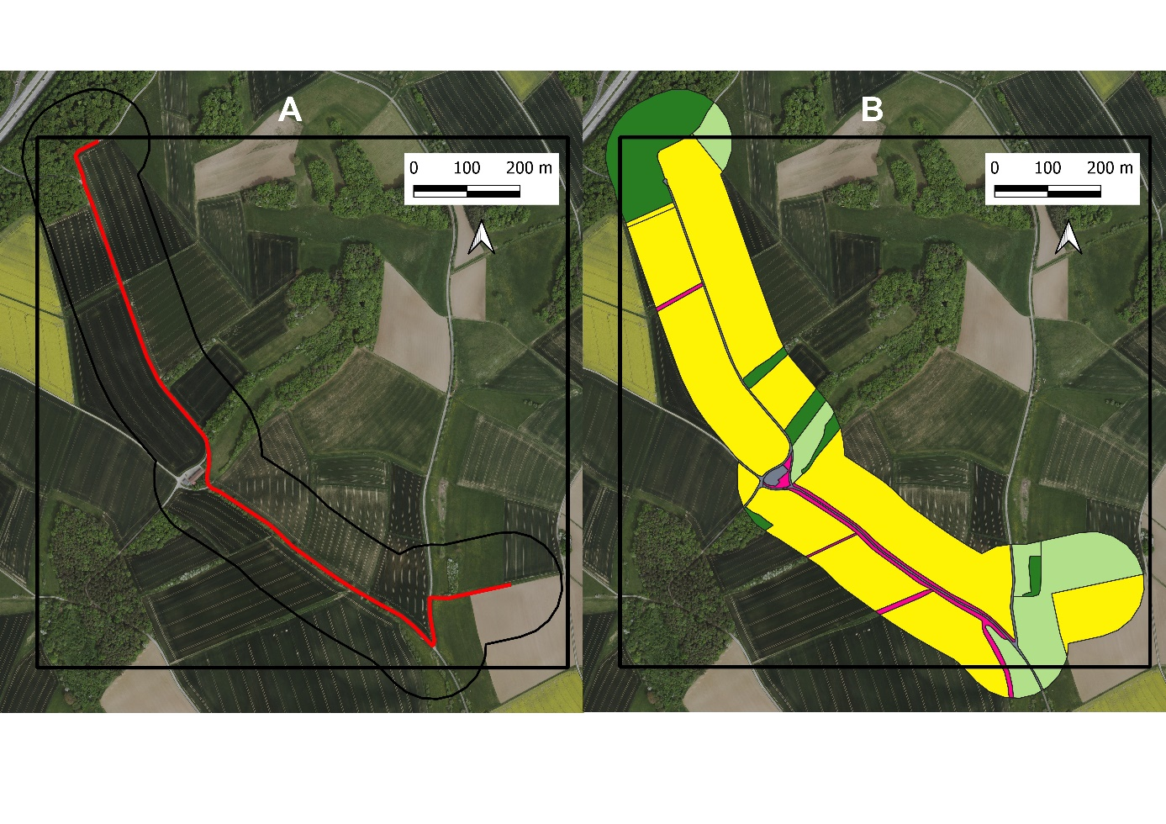

Figure S2. Map of an exemplary grassland site at Wolfbühl, Germany, 750 m a.s.l. A: the red line is the 1500 m long transect, a black line represents the 100 m buffer around the transect, the square is 1 km × 1 km large. B: landscape structure within the 100 m buffer. Light green – grasslands, blue – intensive grasslands, purple – edge vegetation, dark green – forest, grey – impervious surface (roads and built-in area).
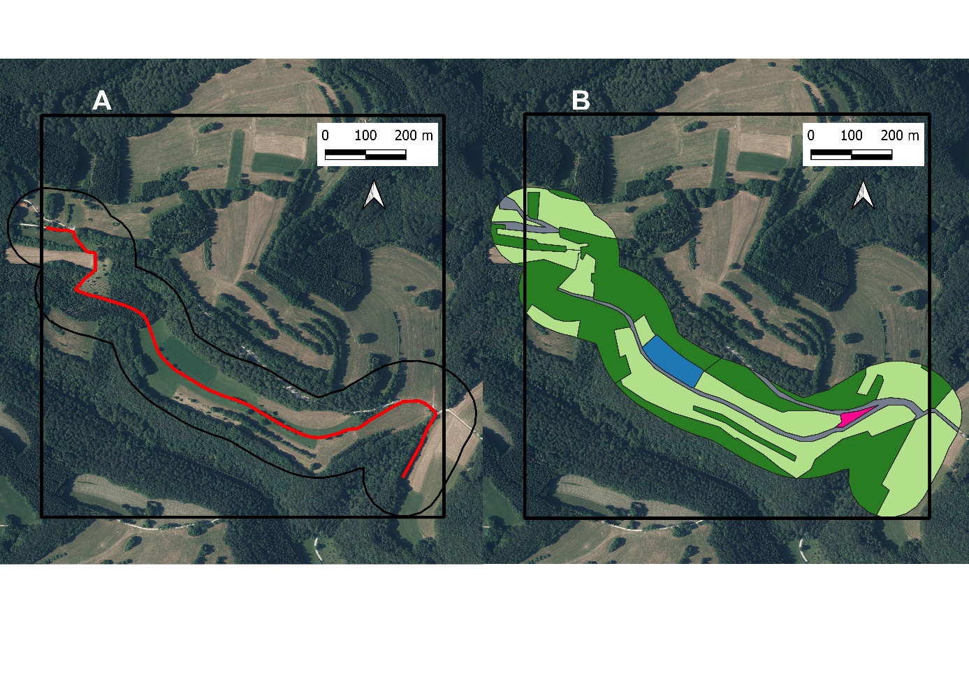

Figure S3. Map of an exemplary nature reserve „Steinriegellandschaft” at Weikersheim, Germany, 305 m a.s.l. A: the red line is the 1500 m long transect, a black line represents the 100 m buffer around the transect, the purple line denotes the nature reserve. B: landscape structure within the 100 m buffer. Yellow – arable fields, light green – grasslands, purple – edge vegetation, dark green – forest, grey – impervious surface (roads and built-in area), white – other.
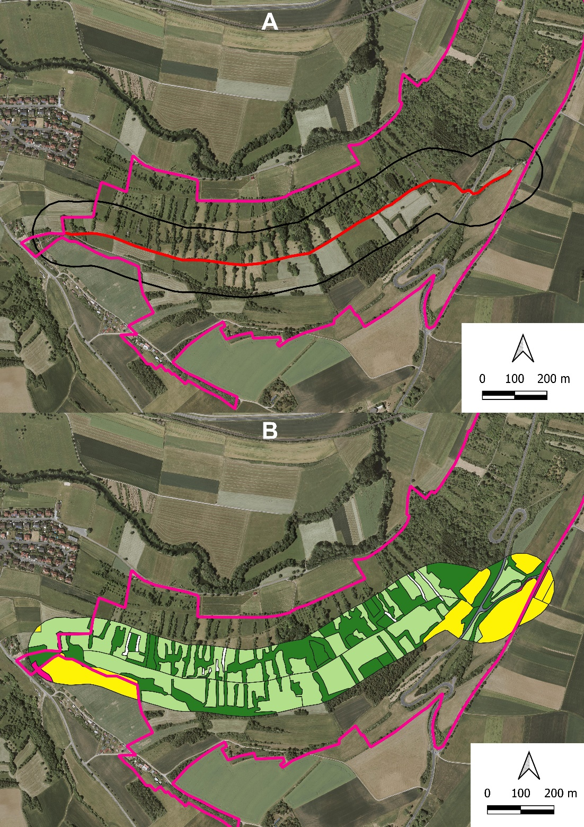

Figure S4. Environmental variables in the three site types. Letters indicate significant differences after multiple comparisons (ANOVA and Tukey post-hoc tests). * Proportion of semi-natural biotopes was square-root transformed. NR: nature reserves.
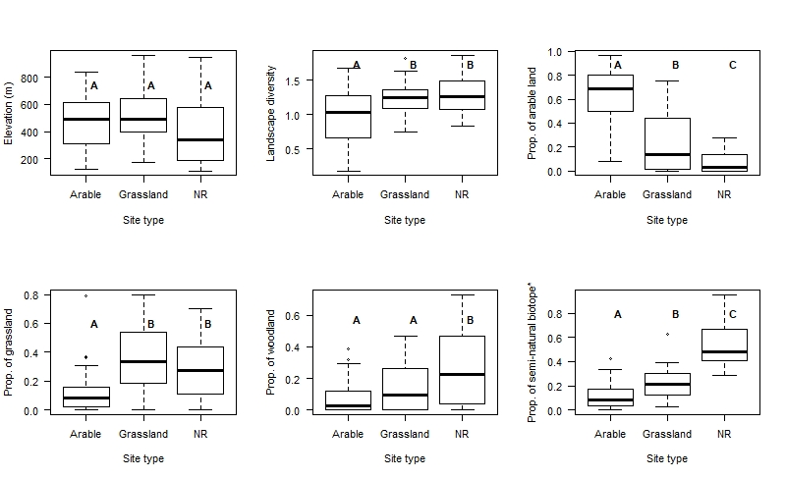

Figure S5. Species scores along the two RLQ axes. Label positions are slightly jittered for better visibility. For abbreviations of species names see SM Table S1.
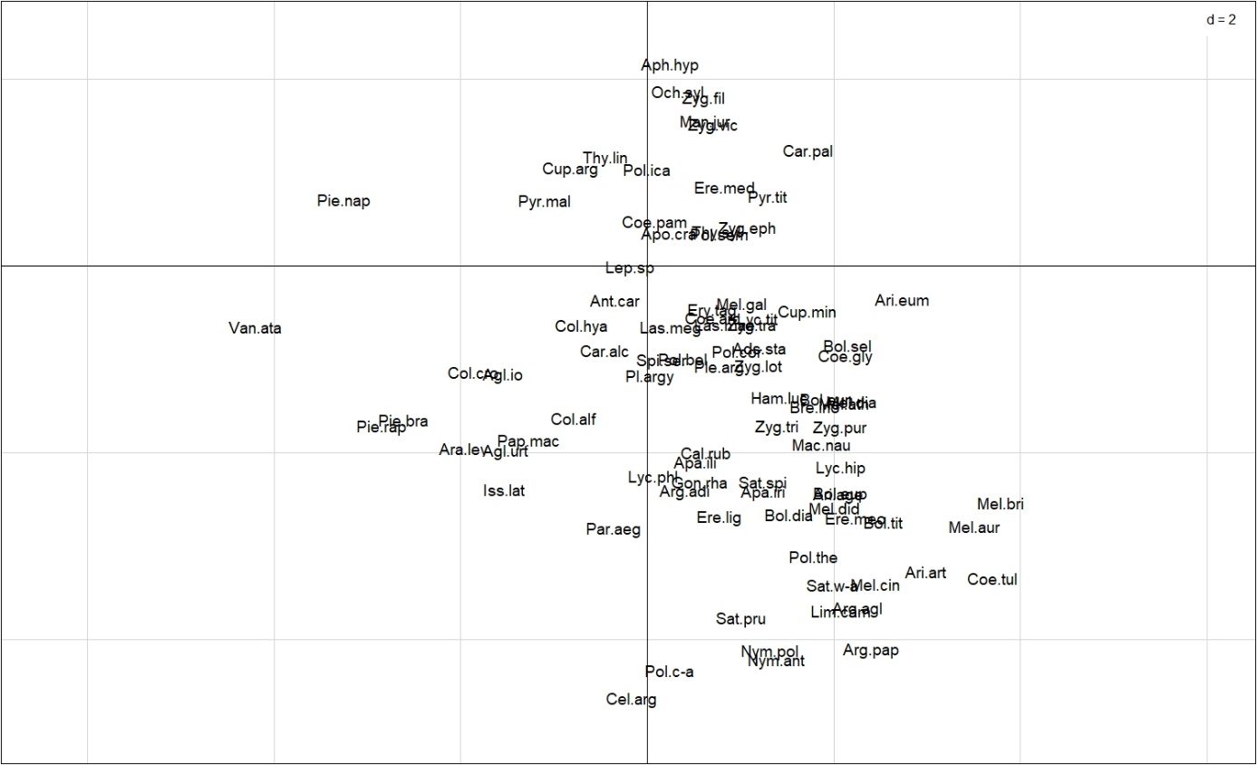

References
Bink, F.A.. 1992. Ecologische Atlas van de Dagvlinders van Noordwest-Europa. Schuyt & Co., Haarlem, The Netherlands.
Cowley, M.J.R., Thomas, C.D., Roy, D.B., Wilson, R.J., León-Cortés, J.L., Gutiérrez, D., Bulman, C.R., Quinn, R.M., Moss, D., Gaston, K., 2001. Density–distribution relationships in British butterflies. I. The effect of mobility and spatial scale. J. Anim. Ecol., 70, 410–425.
Komonen, A., Grapputo, A., Kaitala, V., Kotiaho, J.S., Päivinen, J., 2004. The role of niche breadth. resource availability and range position on the life history of butterflies. Oikos, 105, 41–54.

