Step-by-step tutorial on how to run the region-template’s tuning examples for both Yi and Nscale.

**Step 0)** Download region-templates, but don’t install it yet.

**Step 1)** Install Opencv version 2.4.9 (compile w/ CUDA support if GPU will be used)

<http://sourceforge.net/projects/opencvlibrary/files/opencv-unix/2.4.9/opencv-2.4.9.zip/download>

(It must be version 2.4.9). Newer versions of opencv have not been tested yet. There might be compatibility issues.

**Step 2)** Install ITK library (<http://www.itk.org/ITK/resources/software.html)>. Do not forget to enable the flag ‘Bridge to OpenCV’. We tested with the version 4.9.1 of the library.

How to install: Assuming that the directory where the source code was extracted is named SRC_DIR, and BUILD_DIR is the directory where the code will be built:

1. cd BUILD_DIR

2. ccmake SRC_DIR

2.1 Press 'c' to configure. Then press ‘t’ to toggle advanced mode, and turn on the flags ‘BUILD_SHARED_LIBS’ and ‘Module_ITKVideoBridgeOpenCV’. After that, press ‘c’ again to configure. Insert the opencv build path. Press ‘c’ again and again. And then ‘g’ to generate.

3. make

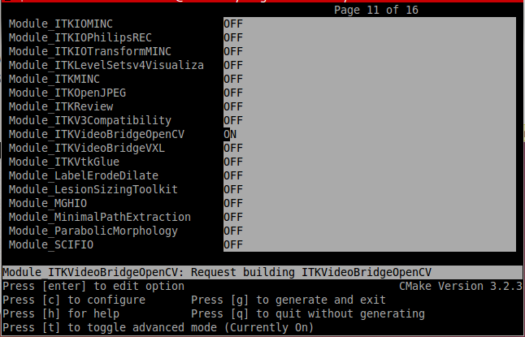

**Step 3)** Install Nscale lib. <https://github.com/SBU-BMI/nscale>

How to install: Clone the repository. Assuming that the directory where the source code was extracted is named ROOT_DIR, and BUILD_DIR is the directory where the code will be built:

1. cd BUILD_DIR

2. ccmake ROOT_DIR

2.1 Press 'c' to configure. Enable the flags NS_SEGMENT, NS_NORMALIZATION, NS_FEATURE. Press ‘c’ to configure. Insert the opencv src path(cmake_dir) and build path. Press ‘c’to configure twice. Press ‘g’to generate.

3. make

**Step 4)** Install Yi’s library. You can find a compatible version of his code at **region-templates/runtime/regiontemplates/external-src/yi-src.tar.gz**

How to install: Extract the files. Assuming that the directory where the source code was extracted is named SRC_DIR, and BUILD_DIR is the directory where the code will be built:

1. cd BUILD_DIR

2. ccmake SRC_DIR

2.1 Press 'c' to configure. Insert opencv and itk build paths. Press ‘c’to configure. If an error msg appears, ignore it. Make sure that you GLIB installed in your machine. It should be installed by default. Turn off ‘build_mainTileAndSegmentWSINuclei’. Press 'c' to configure. Turn on ‘build_mainSegmentSmallImage’. Press 'c' to configure. And then ‘g’ to generate.

3. make

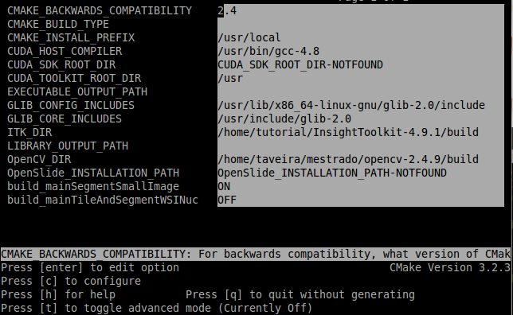

**Step 5)** Install Active Harmony. Active harmony is a lib that provides the NM and PRO tuning algorithms. You can find a compatible version of the library at **region-templates/runtime/regiontemplates/external-src/activeharmony-4.5**

How to install: Take a quick look at the README file inside this folder. Assuming that the directory where the source code was extracted is named SRC_DIR and BUILD_DIR is the directory where the code will be built:

1. cd SRC_DIR
2. make install
3. export HARMONY_HOME=SRC_DIR
4. check if you have installed it correctly by going to the SRC_DIR/example/client_api folder and running the ./example.c

**Step 6)** Install Hadoop-GIS. You can find the compatible version of the code at **region-templates/runtime/regiontemplates/external-src/hadoopgis**

How to install: Take a quick look at the README file inside this folder. Assuming that the directory where the source code was extracted is named SRC_DIR and BUILD_DIR is the directory where the code will be built:

1. cd SRC_DIR
2. cd SRC_DIR/install
3. sudo bash installhadoopgis.sh

**Step 7)** Install Region Templates.

Requirements:

1. Cmake 2.6 or later
2. make – GNU make utility to maintain and compile groups of programs
3. OpenCV 2.4.9 (compile w/ CUDA support if GPU will be used)
4. gcc/g++compiler
5. libeigen2-dev, libpng-dev, libpng++-dev, libtiff 3.9.4-5ubuntu6 (through

ubuntu), OpenMP

1. OpenMPI 1.5
2. CUDA 5.0 (need drivers, toolkit, and SDK from NVIDIA) (Optional – for examples

with CUDA support)

How to install: Assuming that the directory where the source code was extracted is named SRC_DIR and BUILD_DIR is the directory where the code will be built:

1. cd BUILD_DIR

2. ccmake SRC_DIR

2.1 Press 'c' to configure. Insert opencv build path. Press 'c' to configure. Turn on ‘BUILD_SAMPLE_APLICATIONS’ AND ‘RTEMPLATES_EXAMPLES’ AND ‘USE_REGION_TEMPLATES’. Press 'c' to configure. Make sure to insert NSCALE_SRC_DIR (notice that nscale source folder is not the root folder of the nscale project. The source folder is called ‘src’ inside de root folder of the project ) and NSCALE_BUILD_DIR. Turn on the flags: ‘RT_TUNING_NSCALE_EXAMPLE’ and ‘RT_TUNING_YI_EXAMPLE’ and ‘USE_HADOOPGIS’ and ‘USE_ACTIVEHARMONY’. Press 'c' to configure. Insert ITK_DIR, YI_BUILD_DIR and YI_SRC_DIR. Press 'c' to configure. Press ‘g’ to generate.

3. make

How to run the examples

1. Cd region-template’s build folder (BUILD_FOLDER)
2. Cd BUILD_FOLDER/regiontemplates/examples/
3. This folder contains the example aplications.
4. The folder PipelineRTFS-NS-Diff-AH-PRO-Yi-GIS for example, is the tuning example of Yi application using active harmony (PRO or NM algorithm) using HadoopGIS metrics.

To run the example you must execute it under MPI. Ex.: mpirun -n <number_of_procs> PipelineRTFS-NS-Diff-AH-PRO-Yi-GIS -i <input_folder_with_images>