Pedro Avila
Module 1.2 Assignment

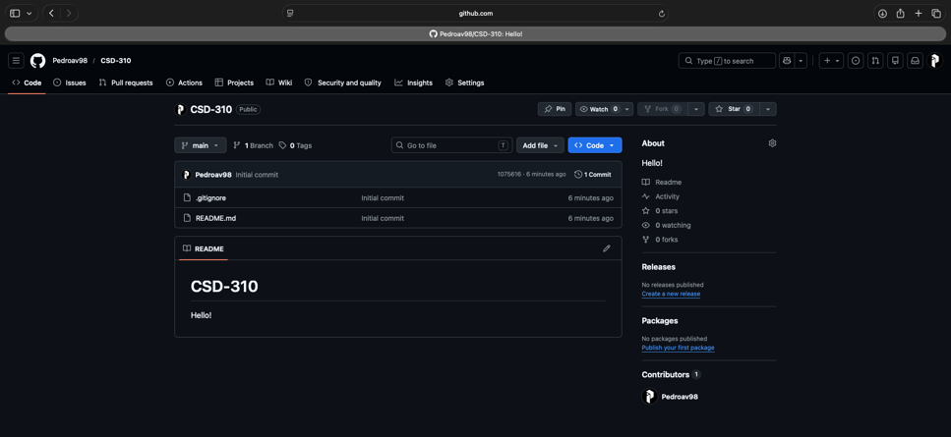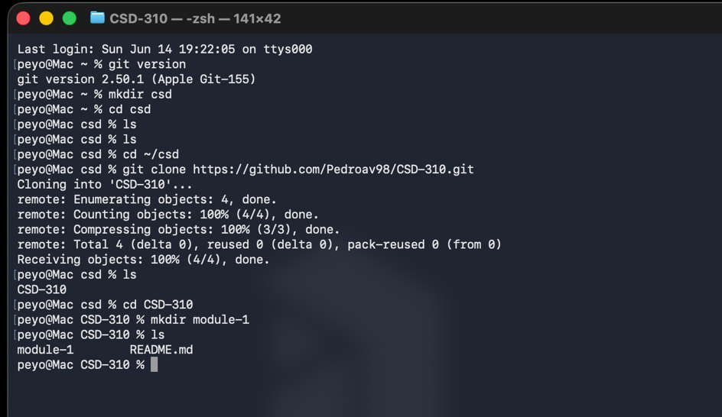
https://github.com/Pedroav98/CSD-310.git

