Pedro Avila
CSD-325
Module 2
Documented Debugging

Figure 1. Breakpoint Created:
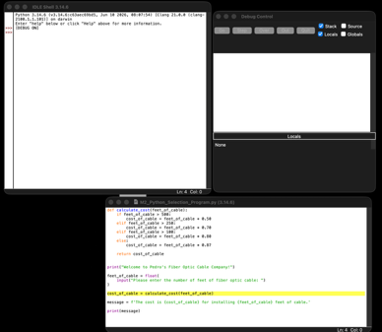
I created a breakpoint on the line that calls the calculate_cost() function. This will pause the program before the function executes, allowing me to follow its execution and inspect its variables.

Figure 2. Stepping Into the Function:
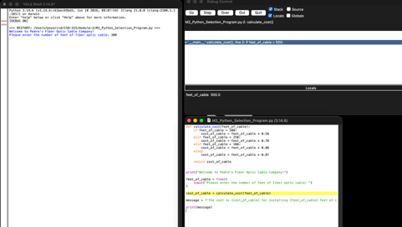
I used the debugger to step into the calculate_cost() function. The Debug Control window shows that the feet_of_cable variable has a value of 300.0, allowing me to follow the function as it evaluates the different cable pricing conditions.

Figure 3. Stepping Through the Cost Calculation:
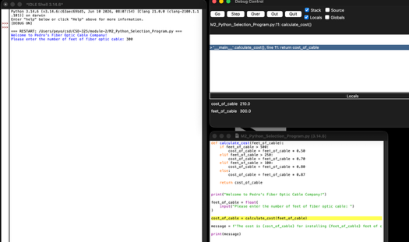
I used the Over command to move through the conditional statements in the function. Since 300 feet is greater than 250 but less than 500, the program selected the $ 0.70-per-foot rate. The debugger shows that cost_of_cable was calculated as 210.0.

