Pedro Avila

CSD-340

Module 5.2 Assignment

Jazmin Fonseca – bioSite Interview
1. How would you describe yourself in three words?
Emotional, bossy, and strong.
2. Where did you grow up, and what was your childhood like?
I grew up in San Luis, Arizona. My childhood was filled with love, especially when I was spending time with my grandparents. I also grew up around my uncles, who taught us to be tough, enjoy sports, and never be afraid of a little competition. One of my favorite parts of growing up was spending summers in Ensenada, Mexico, where my grandparents would take us to a beach house. Those trips gave me some of my favorite childhood memories.
3. What is one of your favorite childhood memories?
One of my favorite childhood memories is when my grandpa would come home from work and surprise us with little scratch-off prize toys. Another memory I'll never forget is watching him count his money at the kitchen table. My siblings and I would hide underneath the table, and he would purposely drop money for us to find. We genuinely thought he was dropping it by accident, but he knew exactly what he was doing. He would just laugh and enjoy watching how excited we got. Looking back, those little moments meant so much to me.
4. Who has influenced you the most in life, and why?
My aunt Blanca has been one of the biggest influences in my life. She is strong, loving, generous, and independent. Growing up, I always admired the way she carried herself and how much she cared for the people around her. She has always been someone I look up to, and I've always wanted to become a strong and independent woman like her.
5. What hobbies or activities do you enjoy most?
Some of my favorite things to do are sleeping, relaxing while watching crime documentaries, and playing board games with my family. I love spending quality time with the people closest to me, especially when there's a little friendly competition involved.
6. How did you become interested in those hobbies?
My boyfriend introduced me to a lot of different board games, and I quickly realized how much I enjoyed playing them. I'm naturally very competitive, so once I started playing, I always wanted to keep going until I could beat him. What started as something fun to do together became one of my favorite activities.
7. What is an accomplishment you are especially proud of?
One of my proudest accomplishments was being nominated at work to represent the She is PepsiCo initiative. As part of the recognition, a PepsiCo trailer was dedicated to promoting women in manufacturing and featured my picture. It was an incredible feeling to be recognized and to know that I could help inspire other women to pursue careers in an industry that has traditionally been male-dominated. It's an accomplishment I'll always be proud of.
8. What has been one of the biggest challenges you've overcome?
One of my biggest personal challenges has been learning to be more patient with others. I've had to understand that everyone is different and that people learn, communicate, and approach situations in their own ways. Learning to recognize those differences has helped me become more understanding and grow as a person.
9. What motivates you to keep working toward your goals?
My younger self is one of my biggest motivations. I grew up with very little, and I know what it's like to not have everything you want or need. Now that I've been given opportunities to create a better future, I don't want to take any of them for granted. I keep pushing myself because I want to build a life that I can truly enjoy and be proud of. I also want to make the younger version of myself proud of how far I've come.
10. What personal or professional goals do you have for the future?
Some of my biggest goals are to marry my boyfriend, start a family, and buy a home together. I want us to continue building a happy and stable future where we can create memories, accomplish our goals, and enjoy everything we've worked hard for.
11. What is something about you that most people don't know?
Something most people don't know about me is that I've always dreamed of becoming a mom. Growing up, I would always tell people that I didn't want kids, but deep down, becoming a mother was something I truly wanted. I guess I just wasn't ready to admit it back then.
12. What advice would you give someone who wants to pursue their dreams?
Keep going, even when things get difficult. Don't give up on yourself or the things you want in life. Sometimes you have to put yourself first, and there's nothing wrong with that. It's okay to say no, set boundaries, and make decisions that are best for your future. At the end of the day, you're the one responsible for creating the life you want, so don't be afraid to go after it.
Jazmin Fonseca: A Story of Strength, Family, and Ambition
Jazmin Fonseca is a strong, determined, and caring individual who values family, personal growth, and the creation of a better future. Growing up in San Luis, Arizona, she was surrounded by love and support from her grandparents, uncles, and other family members. Some of her favorite childhood memories include spending summers in Ensenada, Mexico, at her grandparents' beach house. She also remembers the small but meaningful moments with her grandfather, who would surprise her and her siblings with little toys and purposely drop money under the kitchen table for them to find. These experiences helped shape her appreciation for family and the importance of creating lasting memories.
One of Jazmin's biggest influences has been her aunt Blanca, whom she admires for her strength, independence, generosity, and love for others. Growing up, Jazmin looked up to her aunt and hoped to develop those same qualities. Over time, she has also learned the importance of patience and understanding that everyone communicates and approaches situations differently.
Outside of work, Jazmin enjoys relaxing, watching crime documentaries, and playing board games with her family. Her competitive personality makes game nights especially entertaining, and she enjoys spending quality time with loved ones while enjoying a little friendly competition.
One of Jazmin's proudest professional accomplishments was being selected to represent PepsiCo's She is PepsiCo initiative. As part of this recognition, her picture was featured on a PepsiCo trailer celebrating women in manufacturing. This experience was especially meaningful because it gave her an opportunity to represent and inspire other women working in a traditionally male-dominated industry.
Looking toward the future, Jazmin is motivated by her younger self and the challenges she experienced growing up. She hopes to continue building a happy and stable life, own a home, and raise a family. Her journey reflects determination, resilience, and a desire to keep growing. Above all, Jazmin believes in never giving up on your dreams, knowing your worth, and making decisions that help create the future you want.

Jazmin Fonseca – Proposed Color Palette
I selected these colors because they create a welcoming atmosphere while maintaining an elegant appearance. The dusty rose represents strength and warmth, while the lighter pink and ivory make the website feel inviting. Charcoal provides a strong contrast for readability, and muted gold adds a subtle decorative element.
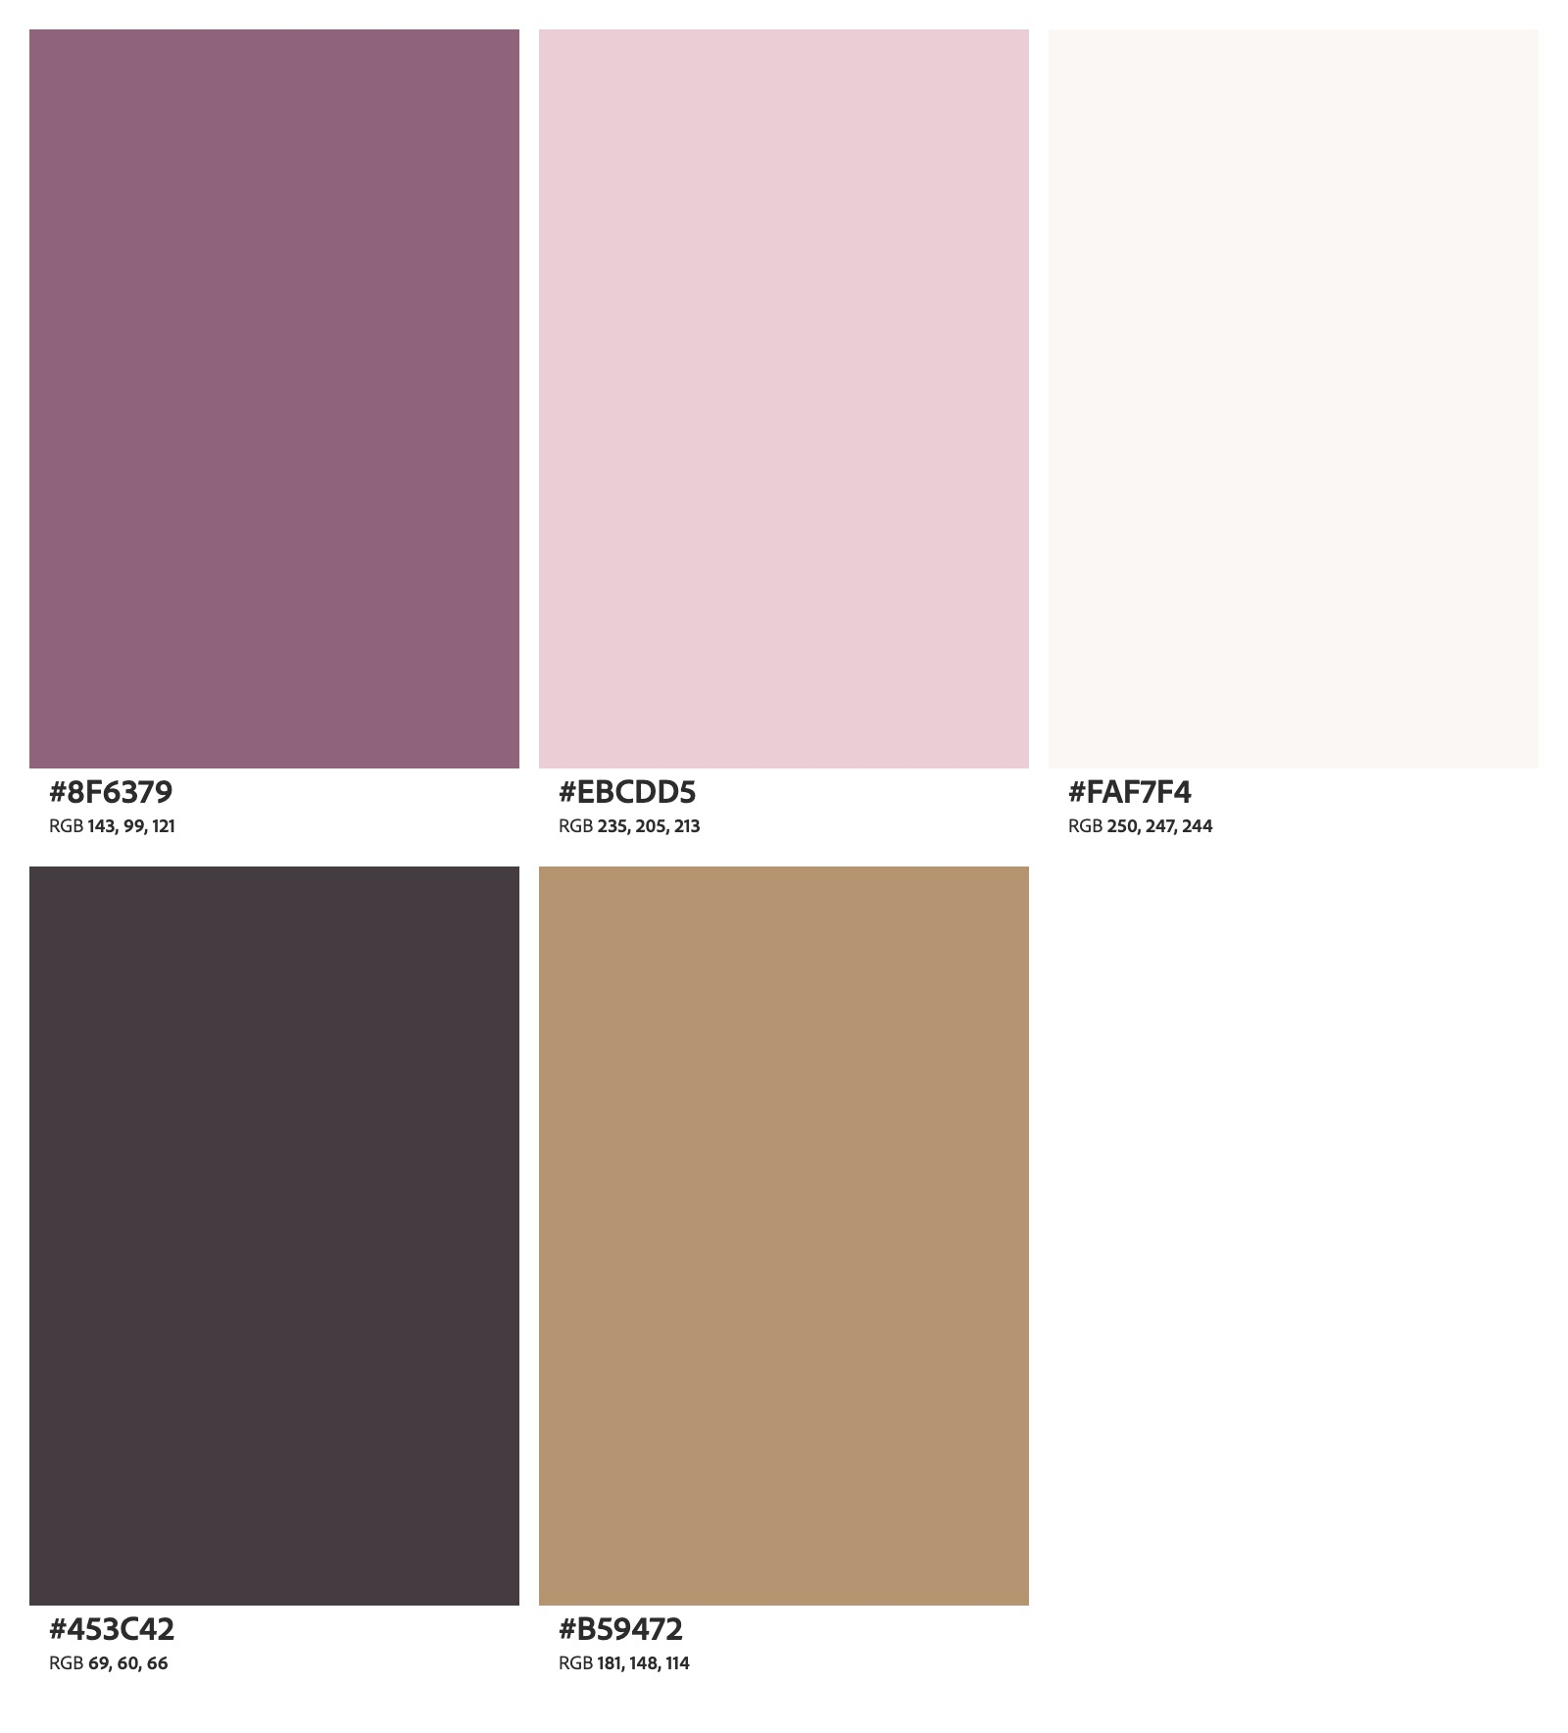

Typography
- Primary Headings (H1): Playfair Display, 40px, bold
- Secondary Headings (H2): Georgia, 28px, bold
- Subheadings (H3): Georgia, 22px
- Body Text: Arial, 16px
- Navigation Text: Arial, 16px, bold
- Line Spacing: 1.6
The serif headings will create a more elegant appearance, while the Arial body text will help visitors read Jazmin's story comfortably.

Navigation
The website will include a navigation menu displayed consistently across all three pages:
Home | About | Hobbies
The navigation will allow visitors to move easily between the main sections. The active page will be highlighted using Dusty Rose.

Buttons and Links
Primary buttons will use a Dusty Rose background with white text and slightly rounded corners. Secondary buttons will have an outlined style. Interactive links will provide a visual response when a visitor hovers over them.
The site will also include an external link to a website related to Jazmin's hobbies.

Images
Images will be displayed with consistent spacing, rounded corners, and descriptive captions. The About page will feature Jazmin's portrait, the landing page will highlight her accomplishments and goals, and the Hobbies page will feature activities she enjoys.

Layout and Spacing
The website will use a simple, centered layout with a maximum content width of 1100px. Sections will have enough white space to avoid appearing crowded. The design will use approximately 24px between smaller elements and 48px between major sections.
The layout will also adjust for smaller screens by stacking images and text vertically.

Atomic Design
The website will follow Atomic Design principles by creating reusable elements that maintain a consistent appearance.
- Atoms: Colors, headings, fonts, buttons, and images.
- Molecules: Image cards containing a photograph, heading, and description.
- Organisms: Navigation menus, hero sections, photo galleries, and footers.
- Templates: The overall structure of the Home, About, and Hobbies pages.
- Pages: The three completed website pages using Jazmin's actual biography, photographs, and personal stories.
Using these reusable elements will help keep the website organized and make future updates easier.

Wireframe 1: Landing Page Design Explanation
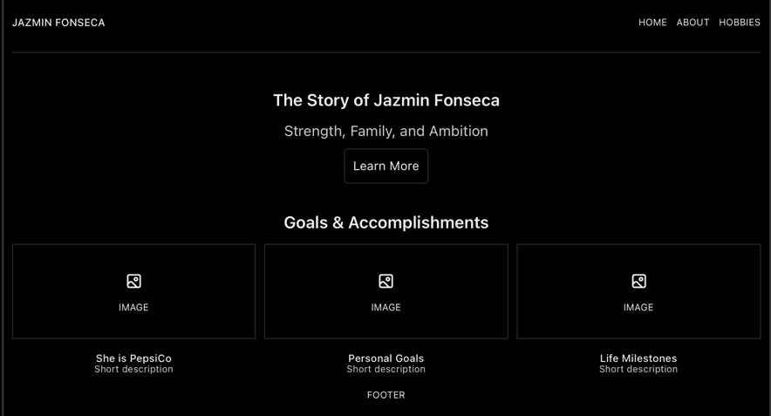
The landing page will introduce visitors to Jazmin Fonseca and provide an overview of her story. A welcoming headline will appear at the top, followed by three images highlighting important moments, accomplishments, and future goals. One of the featured accomplishments will be her recognition through the She is PepsiCo initiative. The page will use soft background colors and organized image cards to create a balanced layout that encourages visitors to explore the rest of the website.

Wireframe 2: About Page Design Explanation
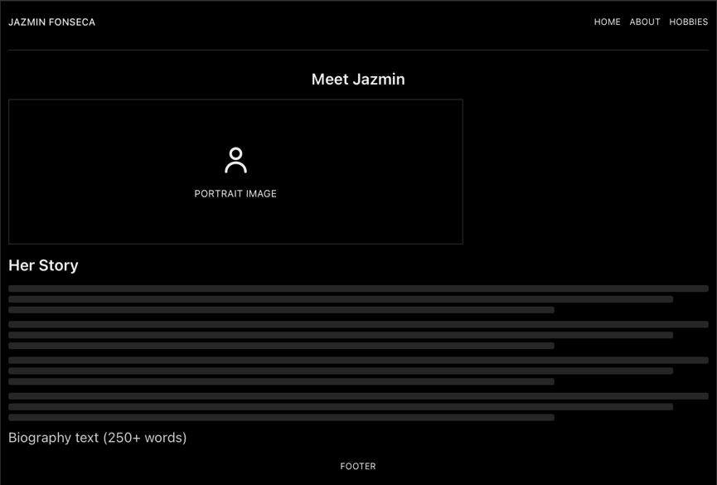
The About page will focus on Jazmin's background and the experiences that shaped her personality. A portrait photograph will appear near the top of the page, followed by her formal biography. The biography will discuss her childhood in San Luis, Arizona, her relationship with her grandparents, the influence of her aunt Blanca, and her personal and professional growth. The page will use readable typography and comfortable spacing to keep the focus on her story.

Wireframe 3: Hobbies Page Design Explanation
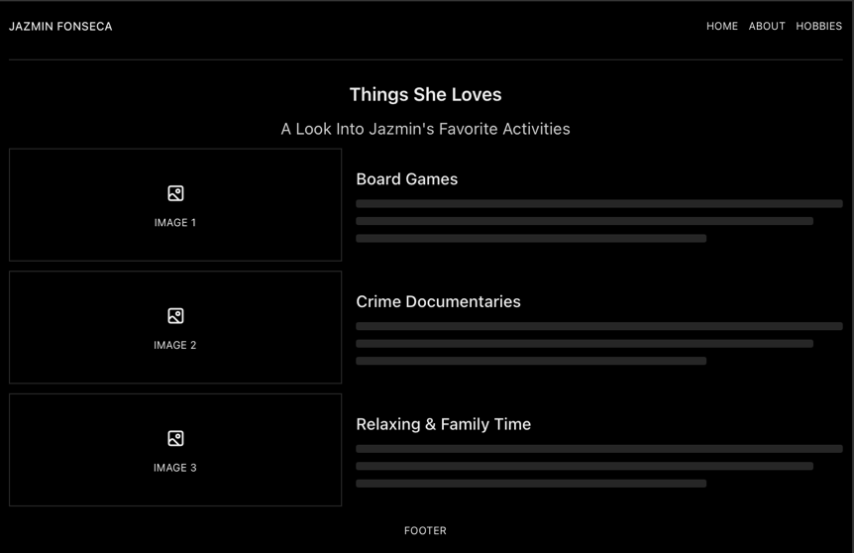
The Hobbies page will highlight three activities Jazmin enjoys: playing board games, watching crime documentaries, and spending time relaxing with family. Each hobby will have its own image and short description. This layout will allow visitors to learn more about Jazmin's interests and how she enjoys spending her free time. Using separate sections for each hobby will make the content easy to follow while keeping the page visually organized.

Photograph Collection and Descriptions

Landing Page – Goals and Accomplishments
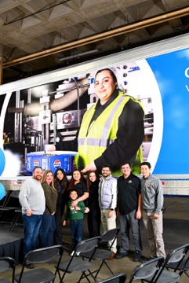
- She is PepsiCo Recognition

One of Jazmin's proudest professional accomplishments was being nominated to represent the She is PepsiCo initiative. Her photograph was featured on a PepsiCo trailer celebrating women in manufacturing. This recognition reflects her hard work, determination, and ability to inspire other women in the industry.

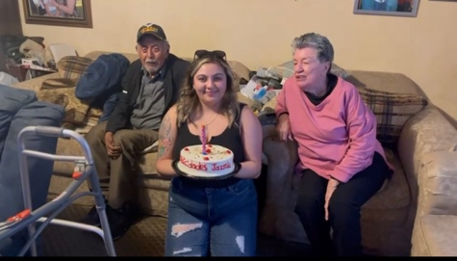
- Building a Better Future

Jazmin is motivated by her childhood experiences and the opportunities she has worked hard to create for herself. Her goal is to build a stable and happy future while continuing to grow personally and professionally. This image represents one of the important goals she is working toward.
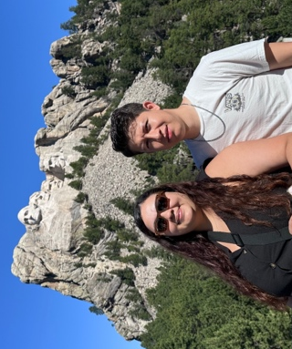
- Important Life Milestones

Family and meaningful experiences have always been important parts of Jazmin's life. She values the memories she creates with loved ones and looks forward to reaching new milestones. This image highlights an important experience or accomplishment that reflects her journey.

About Page – Portrait


- Portrait of Jazmin Fonseca

This portrait introduces Jazmin to visitors and gives a face to the story shared throughout the website. It represents the strong, caring, and determined individual described in her biography.

Hobbies Page – Personal Interests
- Board Games and Friendly Competition
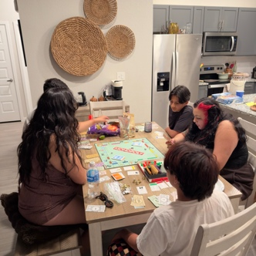

Jazmin enjoys playing board games with her family and loved ones. After being introduced to different games by her partner, she quickly developed an interest in them. Her competitive personality makes game nights entertaining, especially when she's determined to win.

- Crime Documentaries
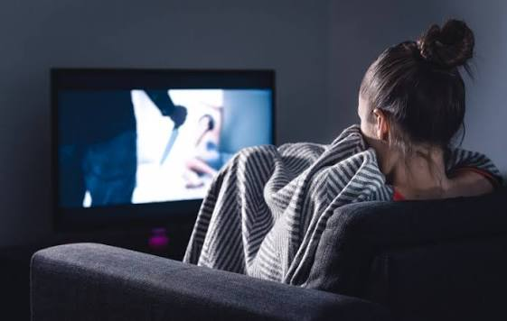
One of Jazmin’s favorite ways to relax is by watching crime documentaries. She enjoys spending her free time watching different stories and unwinding after a busy day. This hobby is part of how she enjoys quiet moments at home.

- Relaxation and Family Time
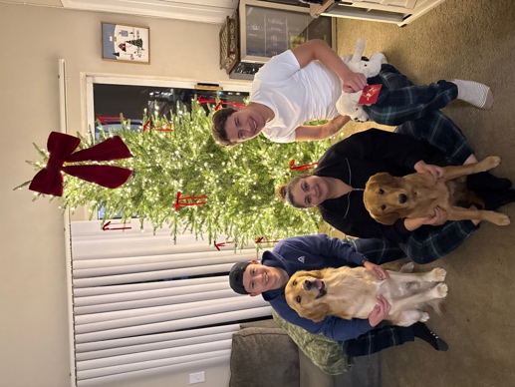
Jazmin values having time to relax and spend meaningful moments with the people closest to her. Whether enjoying a quiet afternoon or spending time with family, these moments give her an opportunity to recharge and appreciate the relationships that matter most to her.

Design Inspiration
When planning Jazmin's bioSite, I wanted to create a website that felt personal, welcoming, and easy to navigate. Since the website focuses on her childhood, family, accomplishments, and hobbies, I wanted the overall design to feel warm without being overly complicated.
I selected a color palette consisting of Dusty Rose, Blush Pink, Warm Ivory, Charcoal, and Muted Gold. These colors create a soft, modern appearance while keeping the content easy to read. I also chose a combination of serif headings and simple body text to give the website a clean but slightly elegant style.
My layout inspiration came from minimalist personal portfolio websites that use large photographs, clear headings, and plenty of white space. I wanted the images to help tell Jazmin's story rather than simply act as decoration. Each of the three pages will focus on a different part of her life while maintaining the same colors, navigation, and overall design.
I also used front-end style guide examples to understand how consistent typography, navigation, buttons, and spacing can improve the visitor's experience. By following these ideas, my goal is to create a bioSite that feels organized and visually appealing while highlighting Jazmin's personality and achievements.

