Pedro Avila
CSD340
Module 3.2 Assignment

Screenshot 1: HTML Validation
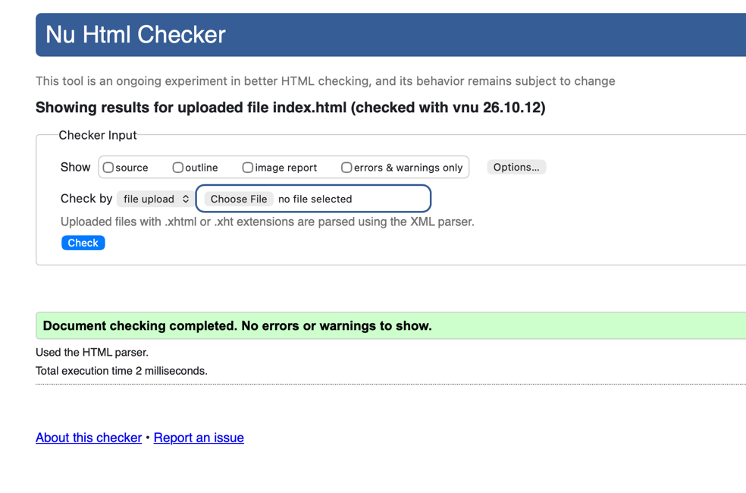
Screenshot 2: CSS Validation
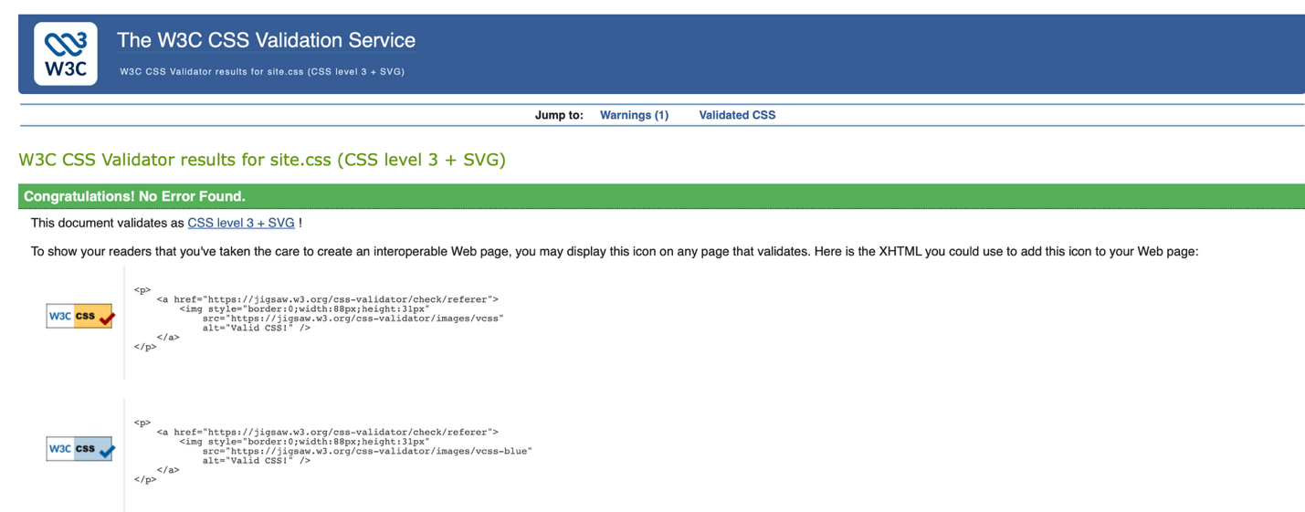

Screenshot 3: Landing Page Browser Output
