0-23 months Features (INPUTS):

**bw_grams**

**wdrinking**

**psoc_hh**

**age_child**

**age_hh**

**educ_mom**

**parity**

**feeding**

**educ1_hh**

Link:

**https://apingfnriowryts-mp5lnbev7a-as.a.run.app/prediction**

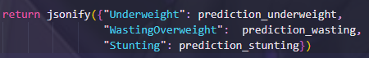OUTPUT JSON:

24-53 months

Features (INPUTS):

**bw_grams**

**psoc_hh**

**age_hh**

**hhsize**

**psccat_mom**

**wcooking**

**educ_hh**

**agemos**

**whands**

Link:

**https://apingfnriowryts-mp5lnbev7a-as.a.run.app/predictions**

OUTPUT JSON: