**US419**

**Problem statement**: In this use case, the proposed problem is to know the best way to distribute the load on the ship so that it has a stable equilibrium.

Before we understand how the merchandise is placed, we will have to know how the physics of a ship of this kind works. There are two very important points we should know about ship physics, which are:

1. We have to understand that the density of the ship has to be less than the density of sea water, and this is achieved due to the hollow structure of the ship.

**d(ship) < d(sea water)**

1. We must realize that the normal force exerted on the ship cancels out so that the balance of the ship is possible, as the expression below demonstrates.

**P = E**

In order for a ship to have a stable balance it is necessary that the center of center of mass, calculated in the US418 use case, does not move from the position that allows it to maintain balance and that the normal force exerted on the ship is null, so that when it suffers the lateral forces of the waves of the sea, it is always able to return to the starting position, as the following figure exemplifies:

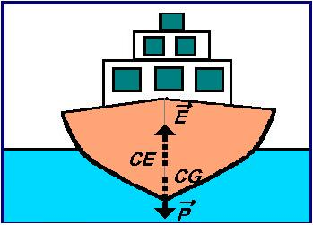

Another detail that we must take into account before starting to accommodate the load is to know its dimensions and for this reason the following calculations were carried out:

**Dimensions of a dry box container 20' and 20' Reefer (RF) Refrigerator**

Lenght = 6,06 m; Width = 2,44 m; Height 2,59 m

Area (total) = 2(ab + bc + ac) => 2(6,06 x 2,44 + 2,44 x 2,59 + 6,06 x 2,59) = 73,60 m2

Volume(v) = a x b x c => 6,06 x 2,44 x 2,59 = 38,30 m3

Center of mass (CM) = (x = 3,03m - y = 1,22m - z = 1,295m)

**Problem resolution:** Taking into account all that was mentioned above regarding the physics that keep the ship in balance and having calculated the center of mass of the ship, we move to the center of the proposed problem, where to position a certain amount of containers on the ship?

Bearing in mind that our ship's center of mass is a little on the right side, due to the bodies that are part of the ship, such as the tower, among others, the containers start to be positioned according to two criteria:

1. So that they have a minimum displacement when they need to be unloaded at the ports, for greater efficiency.
2. So that the center of mass does not shift in xx and yy, ie the containers must be positioned symmetrically in relation to the vertical longitudinal plane of the ship, or over it, if possible.

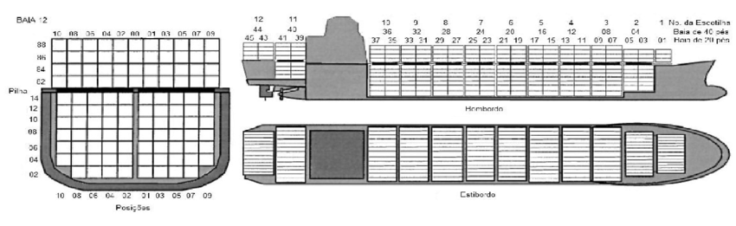

Ship cell exemple

Finally, by positioning the containers on our ship in this way, we can draw the conclusion that the center of mass will never deviate enough to create an imbalance in the ship.