>docker ps

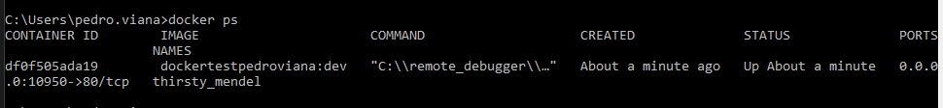

>cd C:\Users\pedro.viana\source\repos\DockerTest_PedroViana\DockerTest_PedroViana

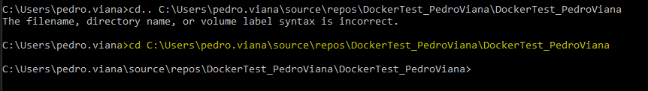

>docker images

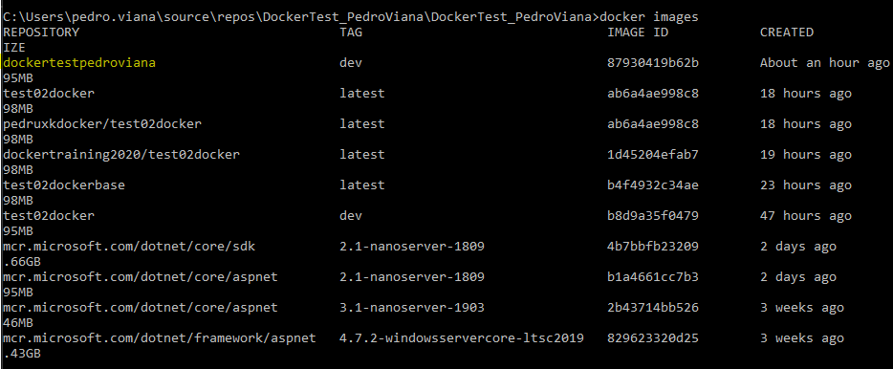

>docker run --name container_test01PV 87930419b62b

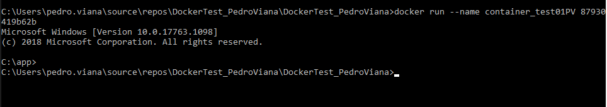

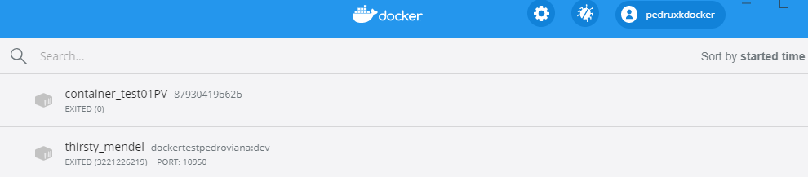

>cd..

>cd..

> cd DockerTest_PedroViana

> dir

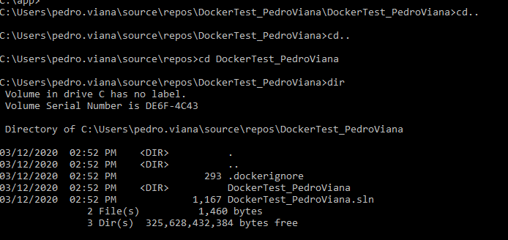

>docker build -f "C:\Users\pedro.viana\source\repos\DockerTest_PedroViana\DockerTest_PedroViana\Dockerfile" --force-rm -t pedrovianatestbase "C:\Users\pedro.viana\source\repos\DockerTest_PedroViana"

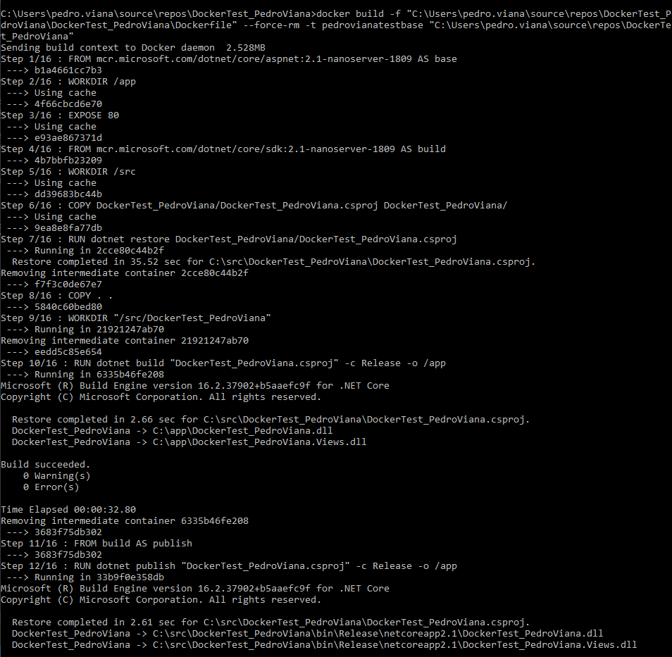

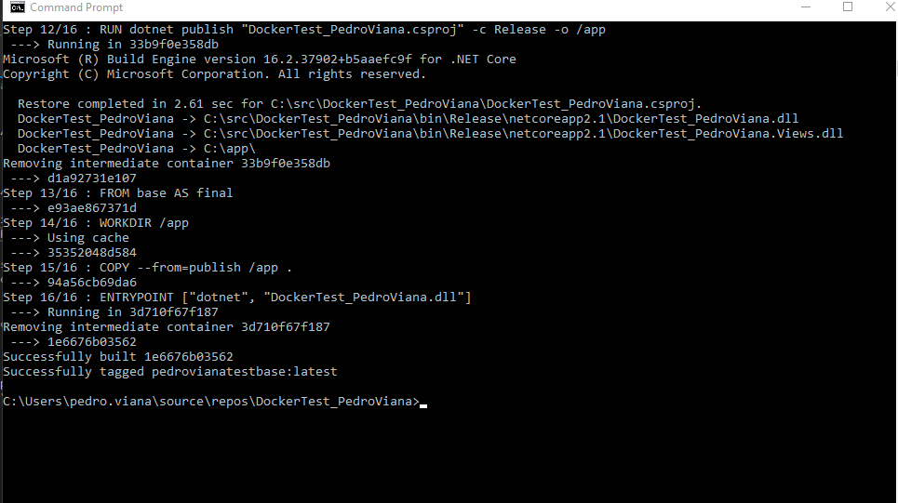

> docker images



>docker run --name containerPV1 -p 8091:80 1e6676b03562

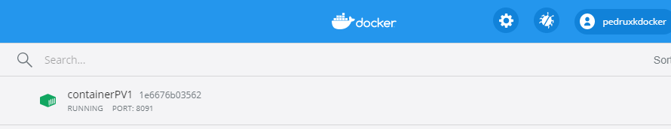

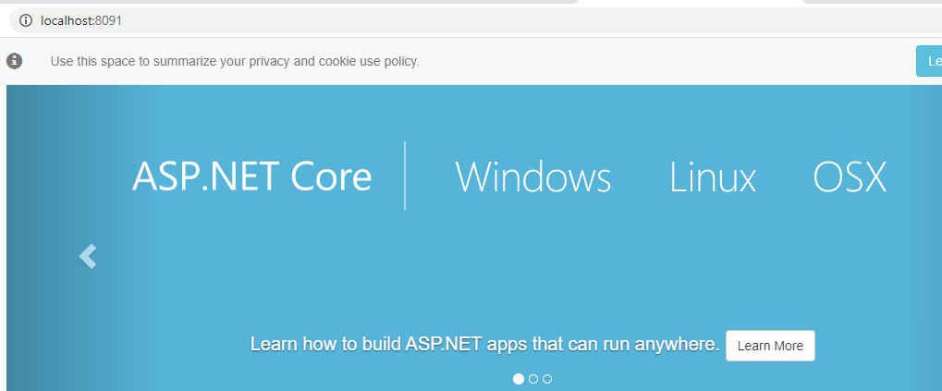

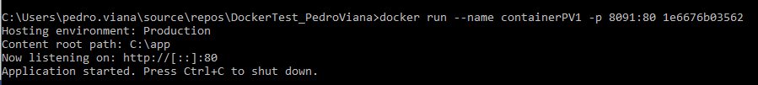

>docker build -f "C:\Users\pedro.viana\source\repos\DockerTest_PedroViana\DockerTest_PedroViana\Dockerfile" --force-rm -t pedrovianatestbase "C:\Users\pedro.viana\source\repos\DockerTest_PedroViana"

>docker images



>docker run --name containerPV3 -p 8093:80 af171da8e9e6

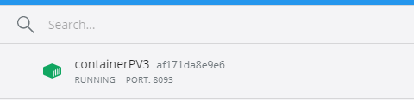

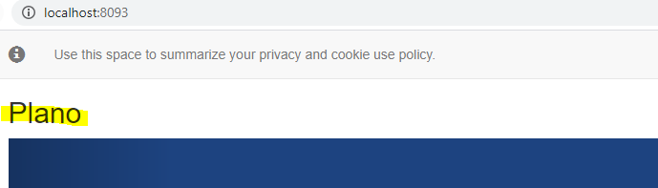

>docker run --name containerPV4 -e "AppSettings:storename"="Hello from AT" -p 8094:80 af171da8e9e6

