-- phpMyAdmin SQL Dump
-- version 5.2.1
-- https://www.phpmyadmin.net/
--
-- Host: 127.0.0.1
-- Generation Time: Apr 09, 2026 at 03:04 PM
-- Server version: 10.4.32-MariaDB
-- PHP Version: 8.2.12

SET SQL_MODE = "NO_AUTO_VALUE_ON_ZERO";
START TRANSACTION;
SET time_zone = "+00:00";

/*!40101 SET @OLD_CHARACTER_SET_CLIENT=@@CHARACTER_SET_CLIENT */;
/*!40101 SET @OLD_CHARACTER_SET_RESULTS=@@CHARACTER_SET_RESULTS */;
/*!40101 SET @OLD_COLLATION_CONNECTION=@@COLLATION_CONNECTION */;
/*!40101 SET NAMES utf8mb4 */;

--
-- Database: `winifred_bonio`
--

-- --------------------------------------------------------

--
-- Table structure for table `appointments`
--

CREATE TABLE `appointments` (
`appointment_id` int(11) NOT NULL,
`patient_id` int(11) DEFAULT NULL,
`doctor_name` varchar(100) DEFAULT NULL,
`appointment_date` date DEFAULT NULL,
`status` varchar(20) DEFAULT NULL
) ENGINE=InnoDB DEFAULT CHARSET=utf8mb4 COLLATE=utf8mb4_general_ci;

--
-- Dumping data for table `appointments`
--

INSERT INTO `appointments` (`appointment_id`, `patient_id`, `doctor_name`, `appointment_date`, `status`) VALUES
(201, 101, 'Dr. Garcia', '2025-03-10', 'Completed'),
(202, 102, 'Dr. Ramos', '2025-03-11', 'Scheduled'),
(203, 101, 'Dr. Cruz', '2025-03-15', 'Scheduled'),
(204, 103, 'Dr. Garcia', '2025-03-18', 'Cancelled');

-- --------------------------------------------------------

--
-- Table structure for table `patients`
--

CREATE TABLE `patients` (
`patient_id` int(11) NOT NULL,
`patient_name` varchar(100) DEFAULT NULL,
`city` varchar(50) DEFAULT NULL,
`contact_number` varchar(20) DEFAULT NULL
) ENGINE=InnoDB DEFAULT CHARSET=utf8mb4 COLLATE=utf8mb4_general_ci;

--
-- Dumping data for table `patients`
--

INSERT INTO `patients` (`patient_id`, `patient_name`, `city`, `contact_number`) VALUES
(101, 'Maria Santos', 'Cebu', '09123456781'),
(102, 'Juan Dela Cruz', 'Bohol', '09123456782'),
(103, 'Ana Reyes', 'Cebu', '09123456783'),
(104, 'Mark Lopez', 'Dumaguete', '09123456784'),
(105, 'Carla Gomez', 'Bohol', '09123456785');

--
-- Indexes for dumped tables
--

--
-- Indexes for table `appointments`
--
ALTER TABLE `appointments`
ADD PRIMARY KEY (`appointment_id`),
ADD KEY `patient_id` (`patient_id`);

--
-- Indexes for table `patients`
--
ALTER TABLE `patients`
ADD PRIMARY KEY (`patient_id`);

--
-- Constraints for dumped tables
--

--
-- Constraints for table `appointments`
--
ALTER TABLE `appointments`
ADD CONSTRAINT `appointments_ibfk_1` FOREIGN KEY (`patient_id`) REFERENCES `patients` (`patient_id`);
COMMIT;

/*!40101 SET CHARACTER_SET_CLIENT=@OLD_CHARACTER_SET_CLIENT */;
/*!40101 SET CHARACTER_SET_RESULTS=@OLD_CHARACTER_SET_RESULTS */;
/*!40101 SET COLLATION_CONNECTION=@OLD_COLLATION_CONNECTION */;

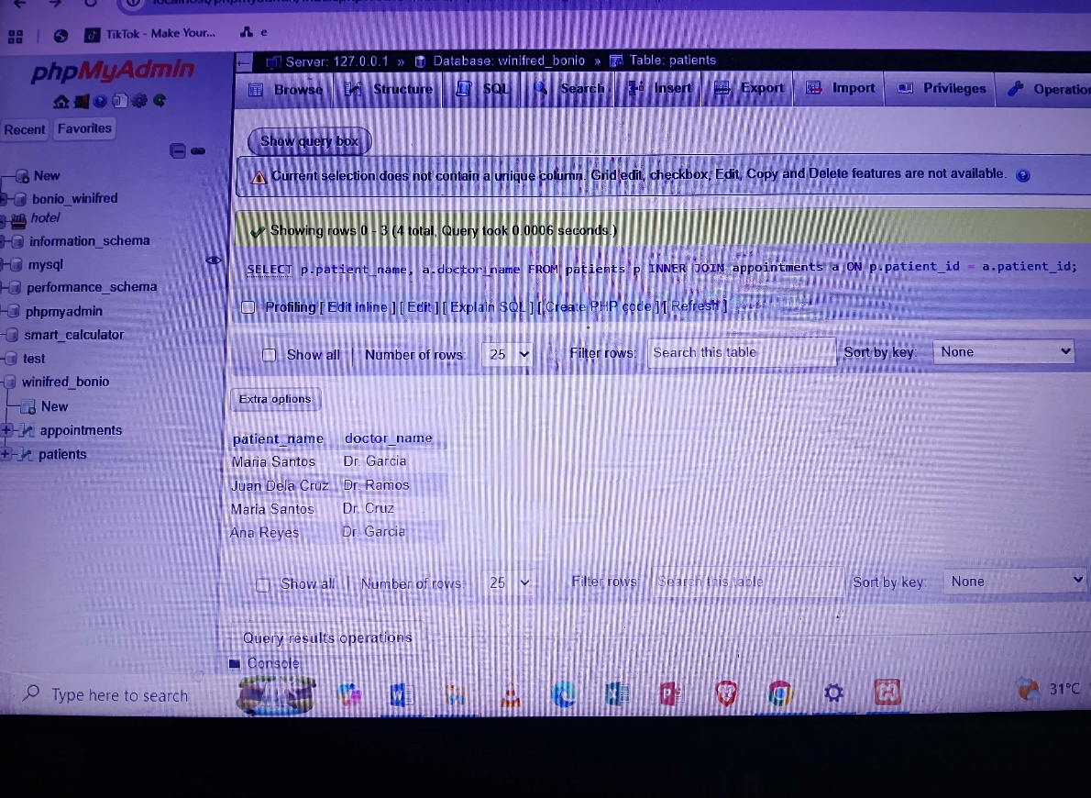
Problem No. 1 Result:

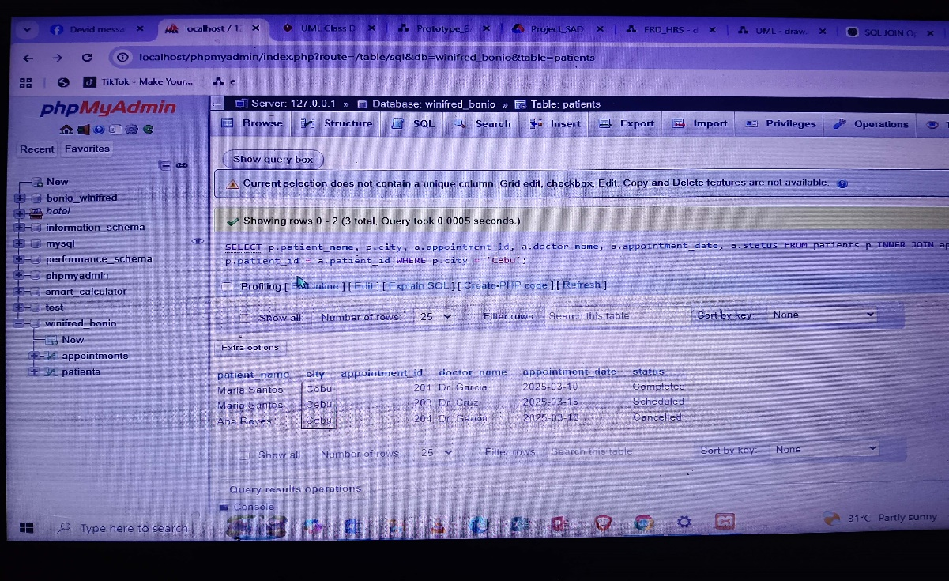
Problem No. 2 Result:

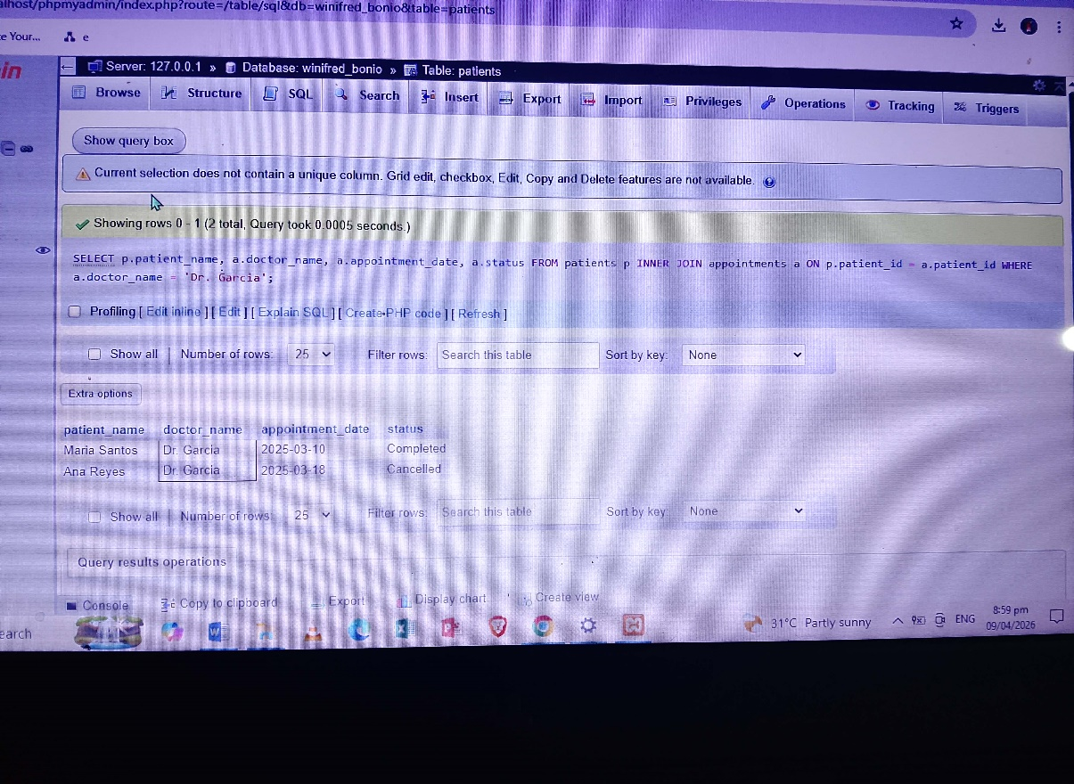
Problem No. 3 Result:

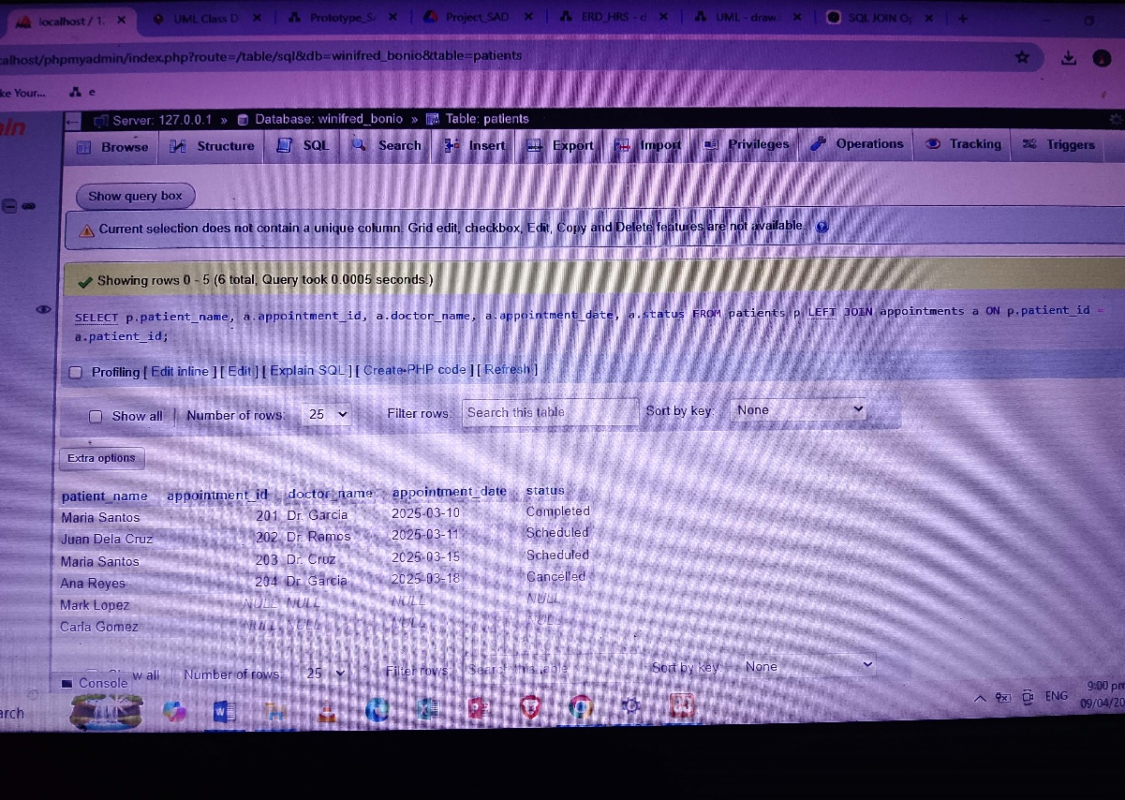
Problem No. 4 Result:
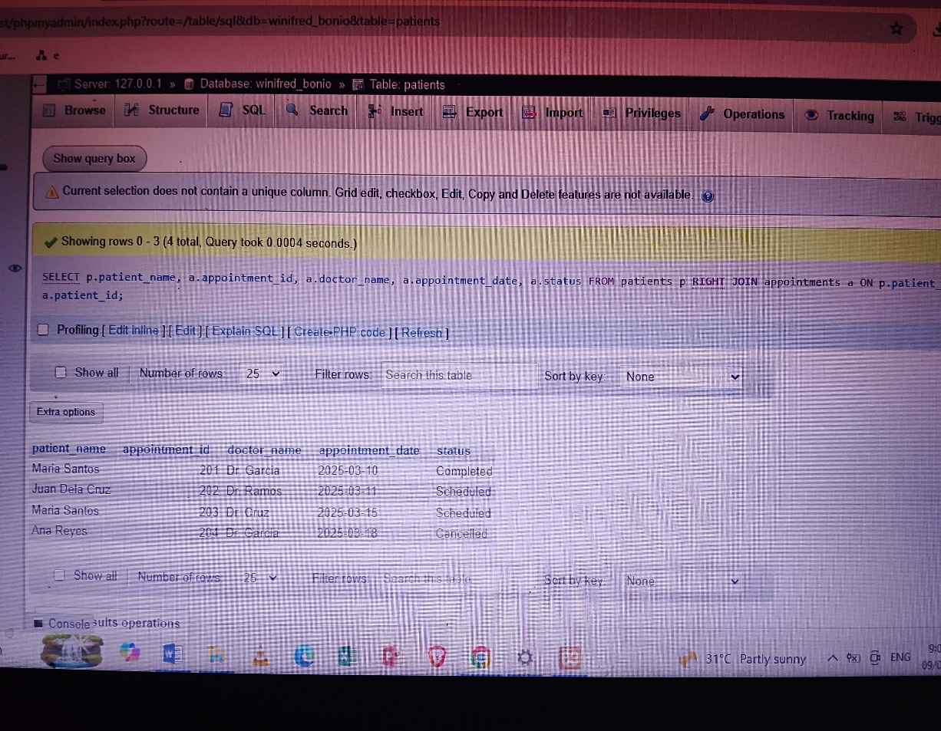
Problem No. 5 Result:

