

**SCHOOL OF COMPUTING**

**UNIVERSITI UTARA MALAYSIA**

**STIA1113 PROGRAMMING 1**

**PROJECT (30%)**

**FIRST SEMESTER SESSION 2019/2020 (A201)**

|  |  |  |
| --- | --- | --- |
|  | **NAME** | **MATRIC NUMBER** |
| 1. | Chong Chee Twau | 278751 |
| 2. | Nah Chun Khai | 278798 |
| 3. | Pee Foo Ye | 278802 |
| 4. | Nur Qurratu Aini Binti Md Rusdi | 279068 |
| 5. | Lee Tzong Ying | 279093 |

Date of Submission : 25/1/2021

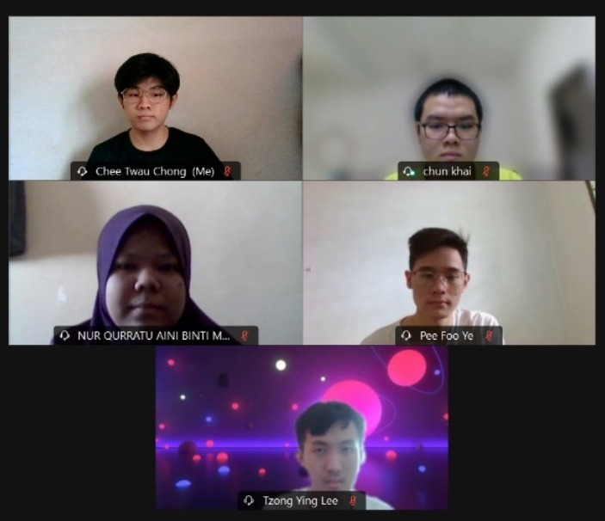

Table of Contents

Background of the Project 4

UML Class Diagram 6

Program Description 7

The Code 19

The Sample Run 29

**Background of the project**

For group assignment, our topic is about food or drinks. Food could be defined as the source of nutritious or nourishment for humans, animals as well as all living things to ensure their life growth process and produce energy for them in daily routine. Drinks could be defined as an important liquid for human and animals that could be swallowed to get refreshment and keep them living. The branches included in this topic are bread, cake, rice, desserts and fruits. Firstly, there are some well-known types of bread, which is made by the process of mixing and baking of flour, yeast and water such as white bread, wheat bread, whole grain bread, rye bread, French bread and hot-dog bread. Besides, cake is a kind of sweet food with soft texture which is made from mixing and baking of flour, eggs, sugar and other embellishment ingredients with some famous example such as blackforest cake, carrot cake and redvelvet cake. Furthermore, rice is often seen as a root of food in Asia region which is from a swamp grass. White rice, brown rice, red rice, black rice, jasmine rice, basmati rice, japonica rice, glutinous rice and wild rice are some of the examples of rice. The favourite of the majority youngster, desserts are defined as a sweet food that often being eat at the end part of a meal. The main category of desserts are cookies, cakes, puddings and pastries. Lastly, fruits, a fresh product that yield by a tree or plants, often with seed and taken as food for human and animals such as apple, orange and pineapple.

|  |  |  |
| --- | --- | --- |
| **Food / Drinks** | | |
| The Bread House | Bread | White bread, Wheat bread, Whole grain bread, Rye bread, French bread, Hot-dog bread |
| The Cake House | Cake | Blackforest cake, Carrot cake, Redvelvet cake |
| The Rice House | Rice | White rice, Brown rice, Red rice, Black rice, Jasmine rice, Basmati rice, Japonica rice, Glutinous rice, Wild rice |
| The Desserts House | Desserts | Cookies, Cakes, Puddings, Pastries |
| The Fruits House | Fruits | Apple, Orange, Pineapple |

In our project, we create a program that could first select the category of food or drinks that we want to buy, then we would get the list of products with corresponding price. We can fill in the quantity of items we want and if we want to buy another kind of food or drinks at the same time, we need to choose ‘yes’ when program request our answer about whether we want to add new order. Program will come out a selection that enable us to choose again the number with respect to each category of food or drinks we want. The same process will proceed until we refuse to continue buying and a ‘no’ is selected when the same program come out. The program would print out the final price after considering the discount offered, which is 20% if total price is more than RM100 and 10% if total price is less than RM100. The discount received would also being printed out for the customer to check and we need to insert the amount of money we paid after we see the price. Finally, program would proceed in calculating the amount of money that need to be exchanged if the money paid is enough while if the amount of money is not enough, program will ask us to re-enter it. An appreciation with sentences “Thank you very much!” after the payment is made and the business deal is completed.

UML class diagram

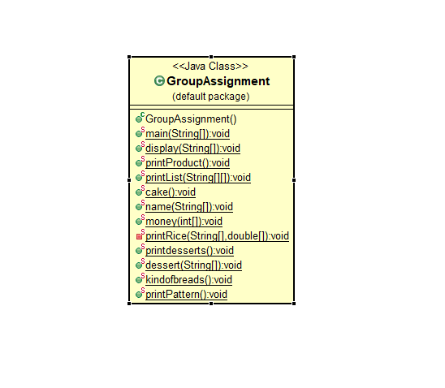

**Program descriptions**

Welcome to “Various Foodstuff” Selling System. This user manual is prepared as a comprehensible user guide to provide a better user experience.

1. First and foremost, once you run the system, the system will welcome the user to Group Five, which is the group who make this program. After that, system will require the user to insert their personal detail, including name, age and gender.

1. After the user insert the detail, system will print out the detail again for the user to check, if it is correct, the user may continue by choosing one of the types of foodstuff provided that he or she want to buy. The user needs to insert the number of corresponding foodstuffs, either 1 for bread, 2 for cake, 3 for rice, 4 for desserts or 5 for fruits.

1. 0 also could be inserted, means the user may wish to leave the system. By the way, thank you! Please come again!

1. If the user wishs to buy bread, he or she may insert “1” in the system. Welcome to The Bread House! The user will be provided with the name and price of the products that offer for sale by The Bread House. Then, the system will ask the user about the quantity of bread wanted to buy, he or she just need to insert the amount they want.

1. After finish entering the amount, system will sum up the total and show the price that need to be paid. Since it is a “Various Foodstuff” Selling System, maybe the user just wants to add these ordered items in their cart and continuing buying other foodstuffs, So, do you want to add new order? The user needs to insert “y” means yes to continue buying or “n” means no to stop buying.

1. We do hope the user to continue buying but if the user wishs to stop and proceed to payment phase by inserting “n”, system will straight away proceed with payment phase. In this phase, system will print out “The total price is”, “Discount received”, “Price to be paid” and the user could insert the amount they want to pay.

1. Do not try to be cunning and give an insufficient amount of money as if the system sense that the amount paid by the customer is not enough to pay the bill, It will ask the customer to re-enter the payment amount.

1. The system will calculate and print out the total amount of money that need to be exchanged. Before the user leave, thank you very much to shop at “Various Foodstuff” Selling System, which is production of Group 5.

1. While, if the user wants to continue buying, he or she can insert “y” and system will come out the same page which is shown in step 2.

After buying bread by selecting “1”, let us have a look at foodstuff number two, which is cake.

1. If the user would like to buy cake, the user may insert “2” in the system. Then, the system will show the ‘Welcome to The Cake House!’ and the lists of cake and price in details. After that, the system will ask the user about how much quantity of cake that the user wanted to buy, the user just need to insert the amount they want.

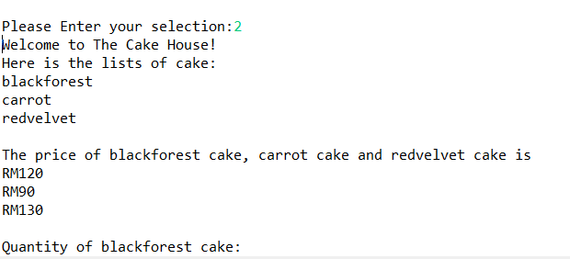

1. After finish entering the amount, the system will sum up the total and show the total price to the user for doing payment. Since it is a “Various Foodstuff” Selling System, maybe the user just wants to add these ordered items in their cart and continuing buying other foodstuffs. So, do you want to add new order? The user needs to insert “y” means yes to continue buying or “n” means no to stop buying.

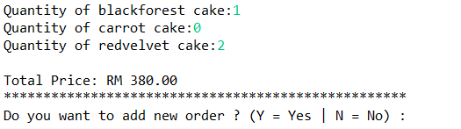

1. If the user would like to stop add new order and proceed to payment phase by inserting “n”, system will straight away proceed with payment phase. In this phase, system will print out “The total price is”, “Discount received”, “Price to be paid” and the user could insert the amount they want to pay.

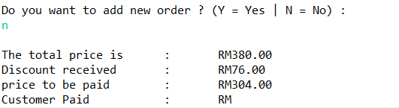

1. Do not try to be cunning and give an insufficient amount of money as if the system sense that the amount paid by the user is not enough to pay the bill, the system will ask the user to re-enter the payment amount.

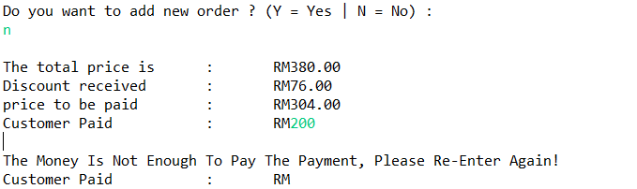

1. The system will calculate and print out the total amount of money that need to be exchanged. Before the user leave, thank you very much to shop at “Various Foodstuff” Selling System, which is production of Group 5.

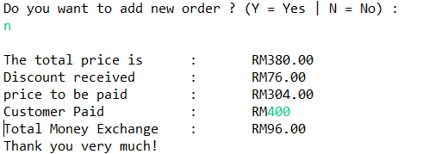

After buying cake by selecting “2”, let us have a look at foodstuff number three, which is rice.

1. The user may insert “3” for buying rice in the system. After that, the phrase ‘Welcome to The Rice House!’ and each type of rice with price will be shown at below. To double confirm, the user will be required to insert either “y” to continue buying rice or “n” to stop buying rice. After the user insert y to continue buying rice, the user may insert the quantities of each types of rice when the system asking the question.

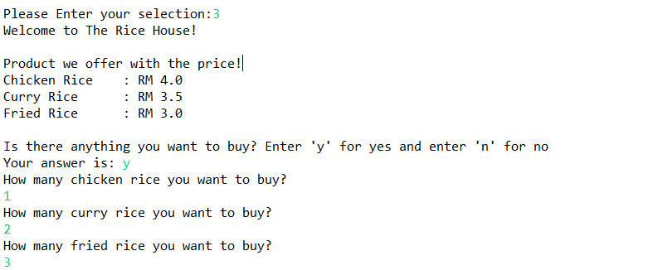

1. The system will total up and show the price to the user for payment purpose after they inserted the quantities of each type of rice needed. To make user easier to use our system, user will be required to insert either “y” to continue buying if they have other things to buy or “n” to stop buying and make payment.

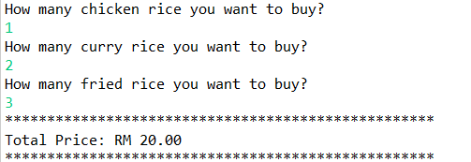

1. If the user inserts “n” to stop buying, system will straight away proceed to payment section. System will show the total price, discount received, and the price to be paid, and the user have to insert the amount they want to pay.

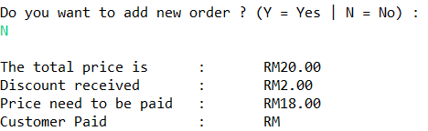

1. If the amount paid by the user is not enough to pay the bill, system will ask the user to re-enter the amount. Thus, the user is not allowed to give an insufficient amount of money to pay the bill.

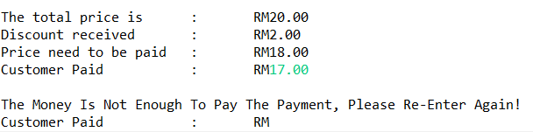

1. The system will calculate the balance need to pay back to user. The phrase “Thank you very much!” will be shown which build by group 5.

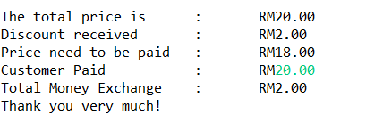

After buying rice by selecting “3”, let us have a look at foodstuff number four, which is dessert.

1. The user may insert “4” for buying desserts in the system. Then the system will show “Welcome to The Desserts House!” and the list menu of each type of desserts that are available. It also show the price of each these desserts. After that, the system will ask which desserts that user want to buy and the user need to insert the quantity of the each desserts that want to buy.

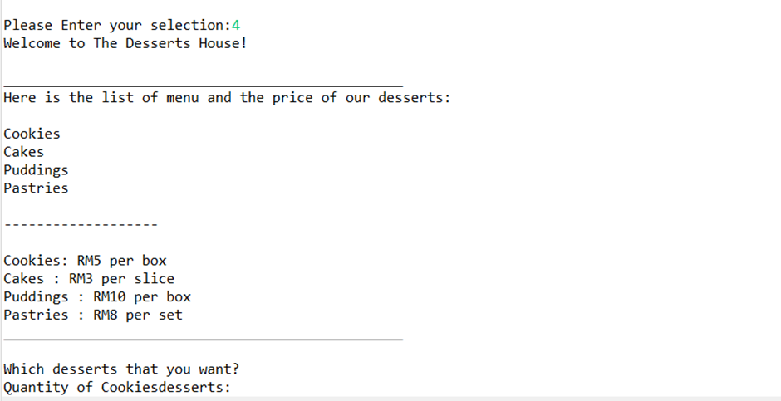

1. After finish entering the amount, the system will sum up the total and show the total price to the user for doing payment. Since it is a “Various Foodstuff” Selling System, maybe the user just wants to add these ordered items in their cart and continuing buying other foodstuffs. So, do you want to add new order? The user needs to insert “y” means yes to continue buying or “n” means no to stop buying.

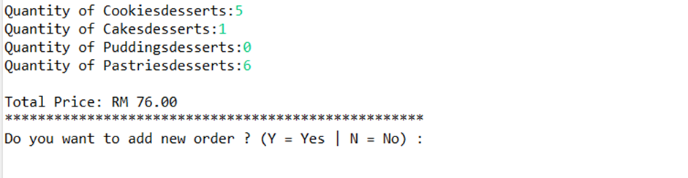

1. Again, we really do hope the user to continue buying but if the user want to stop and proceed to payment phase by inserting “N”, system will straight away proceed with payment phase. In this phase, system will print out “The total price is”, “Discount received”, “Price to be paid” and the user could insert the amount they want to pay.

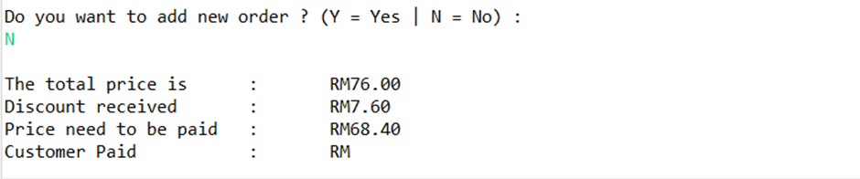

1. If the user pay the amount is not enough, the system will ask the user to re-enter the amount. So, the user can’t be cunning and give insufficient money.

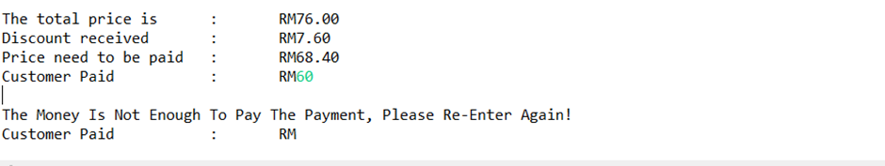

1. The system will calculate and print out the total amount of money that need to be exchanged. Then, the system will show thank you very much to shop at “Various Foodstuff” Selling System, which is production of Group 5.

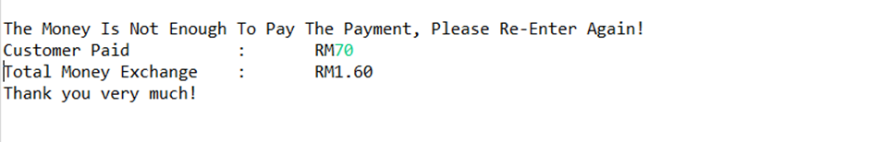

After buying desserts by selecting “4”, let us have a look at foodstuff number five, which is fruits.

1. The user may insert “5” for buying fruits in the system. Then the system will show “Welcome to The Fruit House!” and the list menu of each type of fruits that are available. It also show the price of each fruits sold. After that, the system will ask which fruits that user want to buy and the user need to insert the quantity of the fruits customer want to buy.

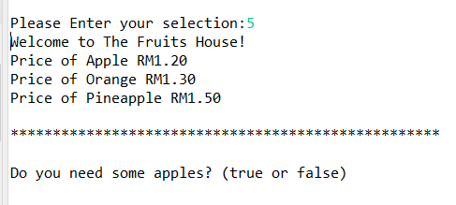

1. After finish entering the amount, the system will sum up and show the total number of each fruits bought and total price to the customer for doing payment. Since it is a “Various Foodstuff” Selling System, the user may want to more of these ordered items in their cart and continuing buying other foodstuffs. So, if they want to continue buying other food, customer just need to insert “y” means yes to continue buying or “n” means no to stop buying.

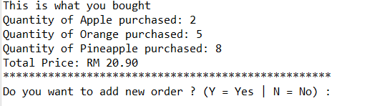

1. When the customer had their final decision and stops buying more, system will straight away proceed with payment phase. In this phase, system will print out “The total price is”, “Discount received”, “Price to be paid” and the user could insert the amount of money they want to pay.

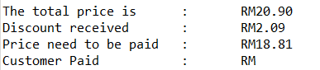

1. If the payment is not enough, the system will ask the user to re-enter the amount. This can prevent most of the customers from trying to evading the payment.

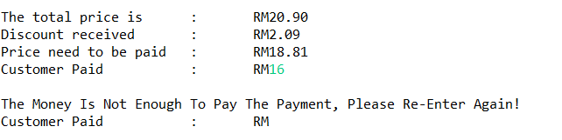

1. After the customer have paid enough or overpaid, system will calculate and print out the total amount of money that need to be exchanged. Then, the system will show “Thank you very much to shop at ‘Various Foodstuff’ Selling System”, which is production of Group 5.

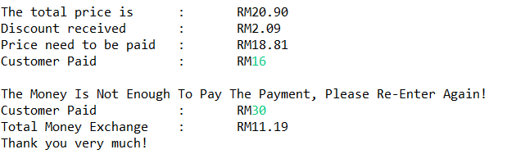

**The code**

**package** project1;

**import** java.util.Scanner;

**public** **class** project1 {

**public** **static** **void** main(String[] args) {

String[] hi = {"Welcome", "To", "Group", "Five!"};

*display*(hi);

}

**public** **static** **void** display(String[] input) {

Scanner in = **new** Scanner (System.***in***);

**for**(**int** counter = 0; counter < input.length; counter++) {

System.***out***.format("%s ",input[counter]);

}

String name, gender, ages;

System.***out***.format("\n\n");

System.***out***.print("What Is Your Name : ");

name = in.nextLine();

System.***out***.println("Hello " + name + "!");

System.***out***.print("How old are you : ");

ages = in.nextLine();

System.***out***.println("You are " + ages +" years old!");

System.***out***.print("Whats Is Your gender (Female/Male) : ");

gender = in.nextLine();

System.***out***.println();

System.***out***.println("===============================");

System.***out***.println("YOUR DETAIL:");

String[] data1 = {"Name", "Age", "Gender"};

String[] data2 = {name, ages, gender};

**for**(**int** i=0;i<data1.length;i++){

System.***out***.println(data1[i] + "\t: " + data2[i]);

}

System.***out***.println("===============================");

System.***out***.println();

*printProduct*();

}

**public** **static** **void** printProduct() {

**char** neworder;

**double** totalPrice = 0;

**do** {

Scanner in = **new** Scanner (System.***in***);

Scanner input = **new** Scanner (System.***in***);

**int** selection;

System.***out***.println("We are offering five different kinds of foodstuff!");

System.***out***.println("\n\tWhat would you like to buy?");

System.***out***.println("\t================================");

System.***out***.println("\t1. Bread!");

System.***out***.println("\t2. Cake!");

System.***out***.println("\t3. Rice!");

System.***out***.println("\t4. Desserts!");

System.***out***.println("\t5. Fruits!");

System.***out***.println("\t0. Log out!");

System.***out***.println("\t================================");

System.***out***.println();

System.***out***.print("Please Enter your selection:");

selection = in.nextInt();

**if**(selection == 0) {

System.***out***.println();

System.***out***.println("\tThank You! Please Come Again!");

System.*exit*(0);

}

**while**(selection < 0 || selection > 5) {

System.***out***.println("\n\tWhat would you like to buy?");

System.***out***.println("\t================================");

System.***out***.println("\t1. Bread!");

System.***out***.println("\t2. Cake!");

System.***out***.println("\t3. Rice!");

System.***out***.println("\t4. Desserts!");

System.***out***.println("\t5. Fruits!");

System.***out***.println("\t0. Log out!");

System.***out***.println("\t================================");

System.***out***.println();

System.***out***.print("Please Enter your selection:");

selection = in.nextInt();

}

//1

**if**(selection == 1) {

System.***out***.println("*****************************");

System.***out***.println("Welcome to The Bread House!");

System.***out***.println("*****************************");

*kindofbreads*();//Using methods

System.***out***.println();

**int** num1, num2, num3, num4, num5, num6, ans;

**double** sum1 = 0;

System.***out***.println("Quantity of Item wanted: ");

System.***out***.print("White Bread =");

num1 = in.nextInt();

System.***out***.print("Wheat Bread =");

num2 = in.nextInt();

System.***out***.print("Whole Grain Bread =");

num3 = in.nextInt();

System.***out***.print("Rye Bread =");

num4 = in.nextInt();

System.***out***.print("French Bread =");

num5 = in.nextInt();

System.***out***.print("Hot-Dog Bread =");

num6 = in.nextInt();

System.***out***.println();

System.***out***.println();

sum1 = ((num1*5) + (num2*7) + (num3*9) + (num4*3) + (num5*10) + (num6*13));

totalPrice += sum1;

System.***out***.format("Total Price: RM %.2f\n",sum1);

//2

}**else** **if**(selection == 2) {

System.***out***.println("Welcome to The Cake House!");

Scanner in1 = **new** Scanner(System.***in***);

String[] cake = {"blackforest","carrot","redvelvet"};

**int**[] price = {120,90,130};

*cake*();

System.***out***.print("Quantity of "+cake[0]+ " cake:");

**int** qcake1 = in.nextInt();

System.***out***.print("Quantity of "+cake[1]+ " cake:");

**int** qcake2 = in.nextInt();

System.***out***.print("Quantity of "+cake[2]+ " cake:");

**int** qcake3 = in.nextInt();

System.***out***.println();

**double** sum2 = 0;

sum2 = (price[0]*qcake1)+(price[1]*qcake2)+(price[2]*qcake3);

totalPrice += sum2;

System.***out***.format("Total Price: RM %.2f\n",sum2);

//3

}**else** **if**(selection == 3) {

Scanner input3 = **new** Scanner (System.***in***);

System.***out***.println("Welcome to The Rice House!");

Scanner input2 = **new** Scanner (System.***in***);

System.***out***.println();

System.***out***.println("Product we offer with the price!");

String[] product = {"Chicken Rice", "Curry Rice", "Fried Rice"};

**double**[] price1 = {4.00,3.50,3.00};

*printRice*(product,price1);

{

System.***out***.println();

System.***out***.print("Is there anything you want to buy? ");

**double** chickenRice = 4.00;

**double** curryRice = 3.50;

**double** friedRice = 3.00;

**int** q_item1, q_item2, q_item3;

**double** p_item1 = 0, p_item2 = 0, p_item3 = 0;

System.***out***.println("Enter 'y' for yes and enter 'n' for no" );

System.***out***.print("Your answer is: ");

**char** answer1 = input2.next().charAt(0);

**if** (answer1 == 'y') {

System.***out***.println("How many chicken rice do you want to order?");

q_item1 = input2.nextInt();

p_item1 = chickenRice * q_item1;

System.***out***.println("How many curry rice do you want to order?");

q_item2 = input2.nextInt();

p_item2 = curryRice * q_item2;

System.***out***.println("How many fried rice do you want to order?");

q_item3 = input2.nextInt();

p_item3 = friedRice * q_item3;

}**else** **if** (answer1 == 'n') {

System.***out***.println("Thank You, please come again!");

}

**int** l=1, j=0;

**while** (l <50) {

l = j++;

System.***out***.print("*");

}

System.***out***.println();

**double** sum3 = 0;

sum3 = p_item1 + p_item2 + p_item3;

totalPrice += sum3;

System.***out***.format("Total Price: RM %.2f\n",sum3);

}

//4

}**else** **if**(selection == 4) {

System.***out***.println("Welcome to The Desserts House!");

Scanner in2 = **new** Scanner (System.***in***);

System.***out***.println();

**for**(**int** f=1; f <50; f++) {

System.***out***.print("_");}

System.***out***.println();

System.***out***.println("Here is the list of menu and the price of our desserts:");

String[] desserts = {"Cookies","Cakes","Puddings","Pastries"};

System.***out***.println();

*dessert*(desserts);

System.***out***.println();

System.***out***.println("-------------------");

System.***out***.println();

*printdesserts*();

**for**(**int** f=1; f <50; f++) {

System.***out***.print("_");}

System.***out***.println();

System.***out***.println();

System.***out***.println("Which desserts that you want?");

System.***out***.print("Quantity of "+ desserts[0] + " desserts:");

**int** quantity1 = in2.nextInt();

System.***out***.print("Quantity of "+ desserts[1]+ " desserts:");

**int** quantity2 = in2.nextInt();

System.***out***.print("Quantity of "+ desserts[2]+ " desserts:");

**int** quantity3 = in2.nextInt();

System.***out***.print("Quantity of "+ desserts[3]+ " desserts:");

**int** quantity4 = in2.nextInt();

**int**[] pricedesserts = {5,3,10,8};

**int** pdesserts1,pdesserts2,pdesserts3,pdesserts4;

pdesserts1 = pricedesserts[0] * quantity1;

pdesserts2 = pricedesserts[1] * quantity2;

pdesserts3 = pricedesserts[2] * quantity3;

pdesserts4 = pricedesserts[3] * quantity4;

System.***out***.println();

**double** sum4 = 0;

sum4 = (pdesserts1 + pdesserts2 + pdesserts3 + pdesserts4);

totalPrice += sum4;

System.***out***.format("Total Price: RM %.2f\n", sum4);

//5

}**else** **if**(selection == 5) {

System.***out***.println("Welcome to The Fruits House!");

Scanner in3 = **new** Scanner (System.***in***);

String [] fruit = {"Apple","Orange","Pineapple"};

String [][] product = {{"Price of Apple","Price of Orange","Price of Pineapple"},{"RM1.20","RM1.30","RM1.50"}};

*printList*(product);

System.***out***.println();

*printPattern*();

System.***out***.println();

System.***out***.println("Do you need some apples? (true or false)");

**boolean** apple = in3.nextBoolean();

System.***out***.println("Do you need some oranges? (true or false)");

**boolean** orange = in3.nextBoolean();

System.***out***.println("Do you need some pineapples? (true or false)");

**boolean** pineapple = in3.nextBoolean();

**double** sum5 = 0;;

**if**(apple && !(orange || pineapple)) {

Scanner in4 = **new** Scanner (System.***in***);

System.***out***.println("Enter the quantity of apples you want to purchase:");

**int** quantity3 = in4.nextInt();

**double** price4 = 1.20;

**double** total = quantity3*price4 ;

System.***out***.println("Total price: RM" + total );

sum5 = total;

System.***out***.println("This is what you bought");

System.***out***.println("Quantity of " + fruit[0] + " purchased: " + quantity3);

}

**else** **if**(orange && !(apple || pineapple)) {

Scanner in5 = **new** Scanner (System.***in***);

System.***out***.println("Enter the quantity of oranges purchase:");

**int** quantity3 = in5.nextInt();

**double** price5 = 1.30;

**double** total = quantity3*price5;

System.***out***.println("Total price: RM" + total + "0");

sum5 = total;

System.***out***.println("This is what you bought");

System.***out***.println("Quantity of " + fruit[1] + " purchased: " + quantity3);

}

**else** **if**(pineapple && !(apple || orange)) {

Scanner in6 = **new** Scanner (System.***in***);

System.***out***.println("Enter the quantity of pineapple purchase:");

**int** quantity3 = in6.nextInt();

**double** price6 = 1.50;

**double** total = quantity3*price6;

System.***out***.println("Total price: RM" + total + "0");

sum5 = total;

System.***out***.println("This is what you bought");

System.***out***.println("Quantity of " + fruit[2] + " purchased: " + quantity3);

}

**else** **if**(orange && pineapple && !(apple)) {

Scanner in7 = **new** Scanner (System.***in***);

System.***out***.println("Enter the quantity of orange you want to puchase:");

**int** quantity3 = in7.nextInt();

System.***out***.println("Enter the quantity of pineapple you want to purchase:");

**int** quantity4 = in7.nextInt();

**double** price5 = 1.30;

**double** price6 = 1.50;

**double** total [] = {(quantity3*price5), (quantity4*price6)};

**double** total1 = 0;

**for**(**int** i=0; i<total.length;i++) {

total1 = total1 + total[i];

}

sum5 = total1;

System.***out***.println("This is what you bought");

System.***out***.println("Quantity of " + fruit[1] + " purchased: " + quantity3);

System.***out***.println("Quantity of " + fruit[2] + " purchased: " + quantity4);

}

**else** **if**(apple && pineapple && !(orange)) {

Scanner in8 = **new** Scanner (System.***in***);

System.***out***.println("Enter the quantity of apples you want to purchase:");

**int** quantity3 = in8.nextInt();

System.***out***.println("Enter the quantity of pineapple you want to purchase:");

**int** quantity4 = in8.nextInt();

**double** price4 = 1.20;

**double** price6 = 1.50;

**double** total [] = {(quantity3*price4), (quantity4*price6)};

**double** total1 = 0;

**for**(**int** i=0; i<total.length;i++) {

total1 = total1 + total[i];}

sum5 = total1;

System.***out***.println("This is what you bought");

System.***out***.println("Quantity of " + fruit[0] + " purchased: " + quantity3);

System.***out***.println("Quantity of " + fruit[2] + " purchased: " + quantity4);

}

**else** **if**(apple && orange && !(pineapple)) {

Scanner in9 = **new** Scanner (System.***in***);

System.***out***.println("Enter the quantity of apples you want to purchase:");

**int** quantity3 = in9.nextInt();

System.***out***.println("Enter the quantity of oranges you want to purchase:");

**int** quantity4 = in9.nextInt();

**double** price4 = 1.20;

**double** price5 = 1.30;

**double** total [] = {(quantity3*price4), (quantity4*price5)};

**double** total1 = 0;

**for**(**int** i=0; i<total.length;i++) {

total1 = total1 + total[i];}

sum5 = total1;

System.***out***.println("This is what you bought");

System.***out***.println("Quantity of " + fruit[0] + " purchased: " + quantity3);

System.***out***.println("Quantity of " + fruit[1] + " purchased: "+ quantity4);

}

**else** **if**(apple && orange && pineapple) {

Scanner inn = **new** Scanner (System.***in***);

System.***out***.println("Enter the quantity of apples you want to purchase:");

**int** quantity3 = inn.nextInt();

System.***out***.println("Enter the quantity of oranges you want to purchase:");

**int** quantity4 = inn.nextInt();

System.***out***.println("Enter the quantity of pineapples you want to purchase:");

**int** quantity5 = inn.nextInt();

**double** price4 = 1.20;

**double** price5 = 1.30;

**double** price6 = 1.50;

**double** total [] = {(quantity3*price4), (quantity4*price5), (quantity5*price6)};

**for**(**int** i=0; i<total.length;i++) {

sum5 = sum5 + total[i];}

System.***out***.println("This is what you bought");

System.***out***.println("Quantity of " + fruit[0] + " purchased: " + quantity3);

System.***out***.println("Quantity of " + fruit[1] + " purchased: " + quantity4);

System.***out***.println("Quantity of " + fruit[2] + " purchased: " + quantity5);

}

totalPrice += sum5;

System.***out***.format("Total Price: RM %.2f\n",sum5);

}

//Do-While Loop for new order

*printPattern*();

System.***out***.println("Do you want to add new order ? (Y = Yes | N = No) :");

neworder = input.next().charAt(0);

}**while**(neworder == 'Y' || neworder == 'y');

System.***out***.println();

//payment

System.***out***.format("The total price is : RM%.2f\n",totalPrice);

//Discount

**double** discount = 0;

**double** total = 0;

**double** discountRate = 0;

**double** customerPaid = 0;

**double** totalExchange = 0;

Scanner input4 = **new** Scanner (System.***in***);

**if** (totalPrice > 100) {

discountRate = 0.2;

}

**else** {

discountRate = 0.1;

}

discount = totalPrice * discountRate;

total = (totalPrice - discount);

System.***out***.format("Discount received : RM%.2f\n",discount);

System.***out***.format("Price need to be paid : RM%.2f\n",total);

System.***out***.print("Customer Paid : RM");

customerPaid = input4.nextDouble();

**while**(customerPaid < total) {

System.***out***.println();

System.***out***.println("The Money Is Not Enough To Pay The Payment, Please Re-Enter Again!");

System.***out***.print("Customer Paid : RM");

customerPaid = input4.nextDouble();

}

totalExchange = customerPaid - total;

System.***out***.format("Total Money Exchange : RM%.2f",totalExchange);

System.***out***.println();

System.***out***.println("Thank you very much!");

}

**public** **static** **void** printList(String[][]x) {

System.***out***.println(x[0][0] + " " + x[1][0]);

System.***out***.println(x[0][1] + " " + x[1][1]);

System.***out***.println(x[0][2] + " " + x[1][2]);

}

**public** **static** **void** cake() {

System.***out***.println("Here is the lists of cake: " );

String[] cake = {"blackforest","carrot","redvelvet"};

**int**[] price = {120,90,130};

*name* (cake);

System.***out***.println();

*money* (price);

System.***out***.println();

}

**public** **static** **void** name (String[] a) {

**for** (**int** i = 0; i<a.length;i++) {

System.***out***.println(a[i]);

}

}

**public** **static** **void** money (**int**[] b) {

System.***out***.println("The price of blackforest cake, carrot cake and redvelvet cake is " );

**for** (**int** j =0; j<b.length;j++) {

System.***out***.println("RM"+ b[j]+" ");

}

}

**private** **static** **void** printRice(String[]product,**double**[] price) {

**for** (**int** i = 0 ; i< product.length;i++) {

System.***out***.println(product[i] + "\t: RM " + price[i] +" /pack.");

}

}

**public** **static** **void** printdesserts() {

**int**[] pricedesserts = {5,3,10,8};

System.***out***.println("Cookies: RM"+ pricedesserts[0]+ " per box");

System.***out***.println("Cakes : RM"+ pricedesserts[1]+ " per slice");

System.***out***.println("Puddings : RM"+ pricedesserts[2]+ " per box ");

System.***out***.println("Pastries : RM"+ pricedesserts[3]+ " per set");

}

**public** **static** **void** dessert(String[] d) {

**for** (**int** i = 0; i<d.length;i++) {

System.***out***.println(d[i]);

}

}

**public** **static** **void** kindofbreads() {

System.***out***.println("Product we provide with the price!");

//Array

String[] breads = **new** String[6];

breads[0] = "White bread = RM5.00";

breads[1] = "Wheat bread = RM7.00";

breads[2] = "Whole Grain bread = RM9.00";

breads[3] = "Rye Bread = RM3.00";

breads[4] = "French Bread = RM10.00";

breads[5] = "Hot-Dog Bread = RM13.00";

//Repetition Structure

**for**(**int** j=0; j<breads.length; j++){

System.***out***.println(breads[j]);

}

}

**public** **static** **void** printPattern() {

**int** i=1, j=0;

**while** (i <50) {

i = j++;

System.***out***.print("*");

}

System.***out***.println();

}

}

**The sample run**



