Nama Tim : Blank

Anggota Tim : - Richie 191110368

- Alvin Goliandi 191110325

Judul Prototype : Morass

Deskripsi Prototype : Morass merupakan aplikasi berbasis website dengan tema Digital Game Online Shop yang dikembangkan dengan framework Laravel dalam penggunaan bahasa pemrograman HTML, CSS, JS, PHP

Link Github : [PeeOops/Morass: Laravel Digital Game Online Shop Project (github.com)](https://github.com/PeeOops/Morass)

List User Story :

User Login Register

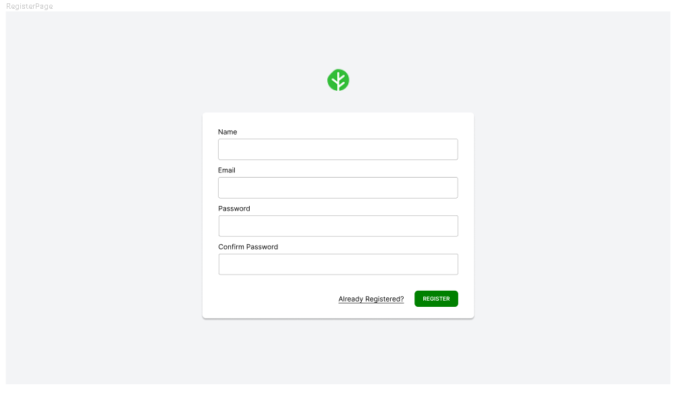

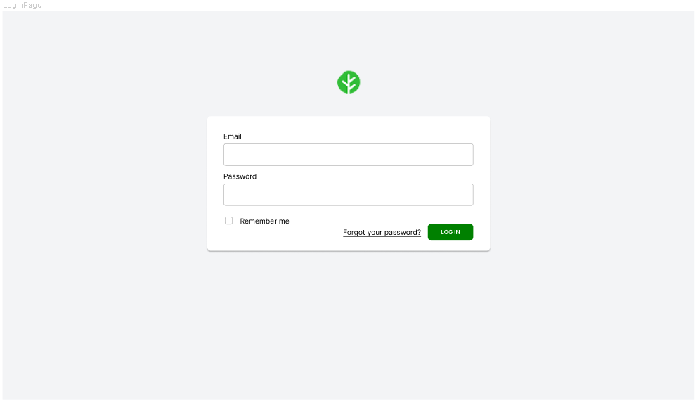

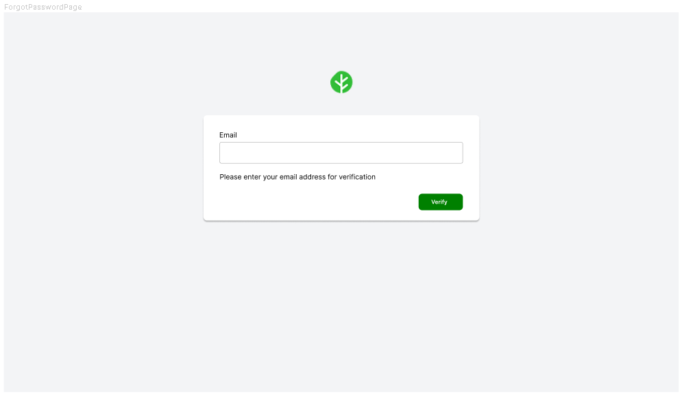

* As a user, I can login using my credentials that have been entered in register page so that I could access the web app using my own credentials
* As a user,i can reset my password if i have forgotten my password so that i can gain my access back to the web app

User Shop / Product Page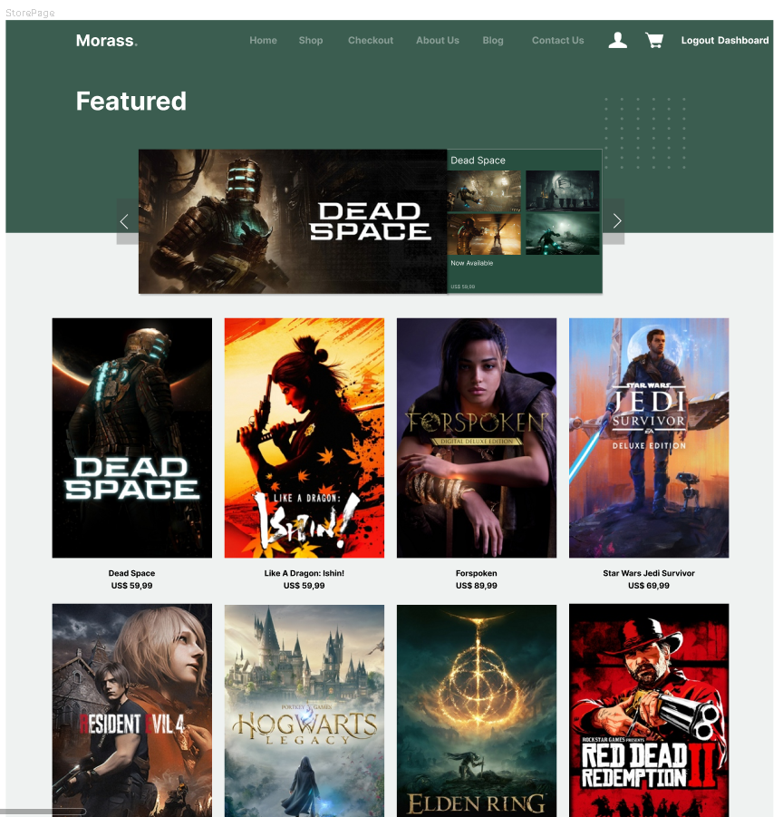

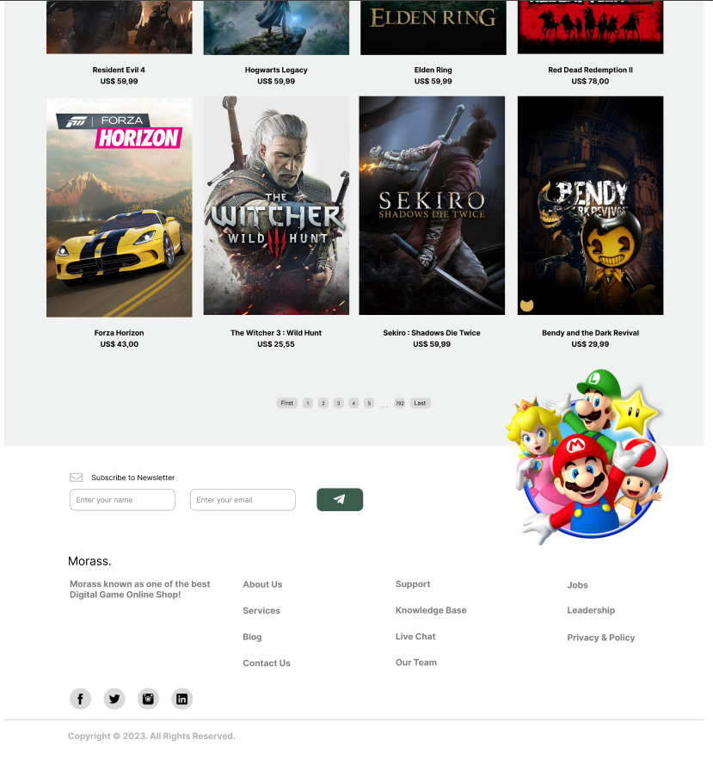  
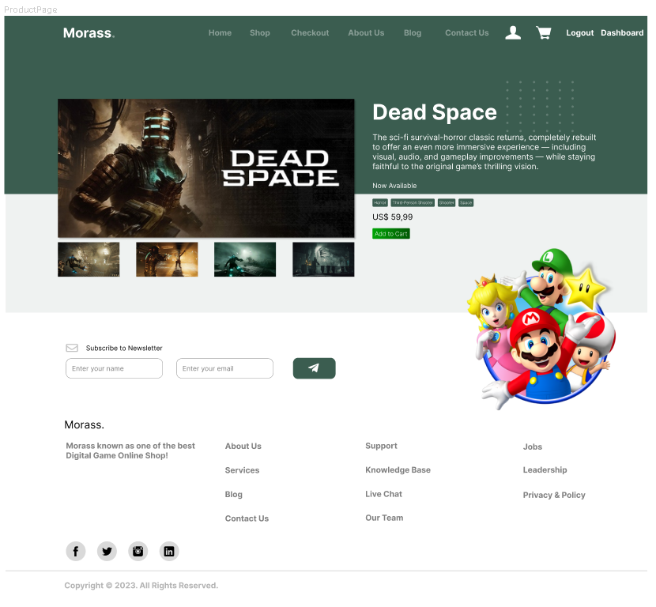

* As a user, i can view the list of games so that i can see the game that i want
* As a user, i can go to the next page of the games list so that i can save more data without loading all the games
* As a user, i can see the details of the games so that i can decide whether i want to buy the game or not

User Cart Page

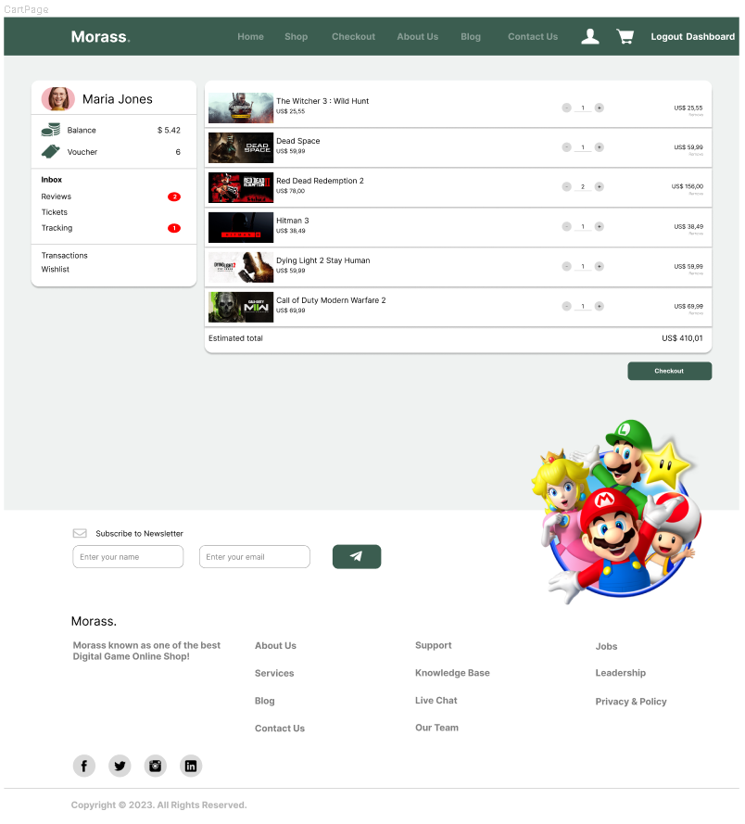

* As a user, i can view my shopping cart so that i can see what games i',m buying
* As a user, i can remove games from my shopping cart so that i can remove the game that i don’t want to buy
* As a user, i can edit the quantity of the games so that i can buy more than 1 copy of the game

User Blog Page

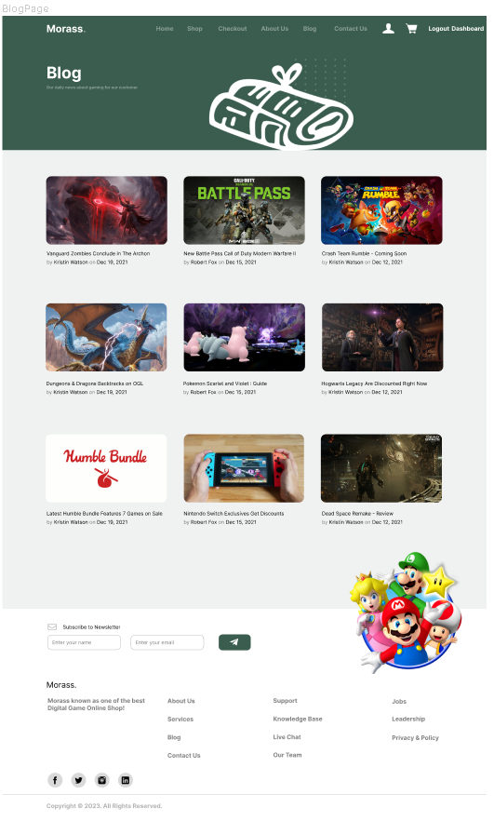

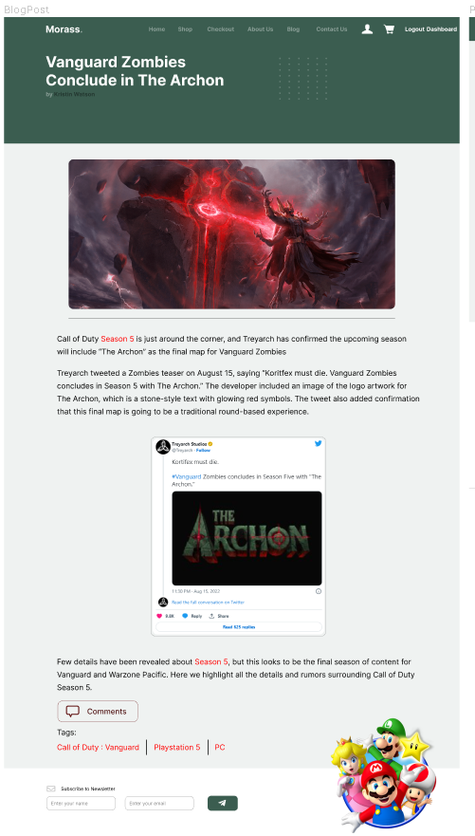

* As a user, i can read some blog post about gaming so that i keep updated of daily gaming news from the website

User Checkout Page

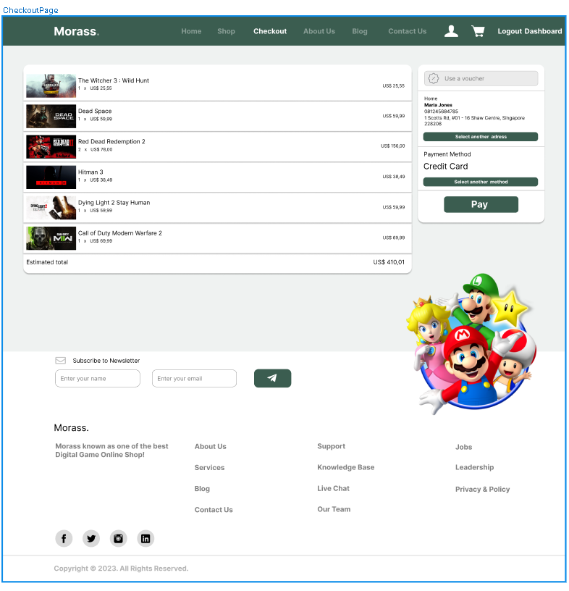

* As a user, i can use my owned voucher so that i could save more money when buying the game
* As a user, i can change my address so that i could send the game to another address
* As a user, i can change my payment method so that i could use another payment method that i owned

User Profile Page

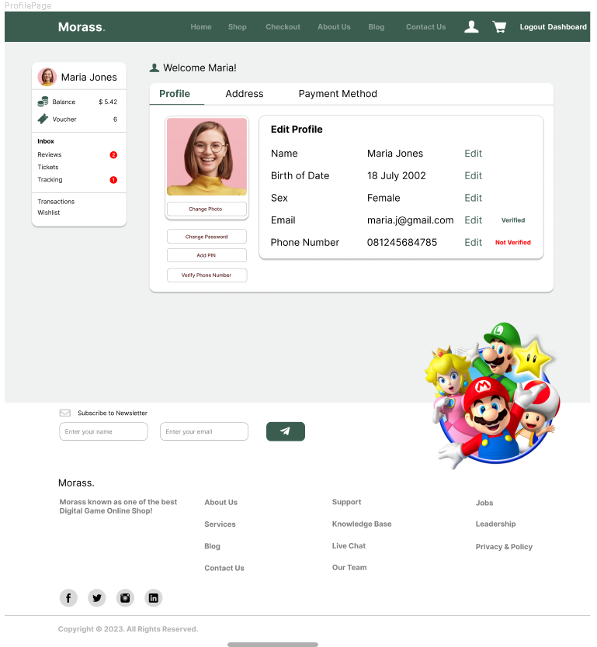

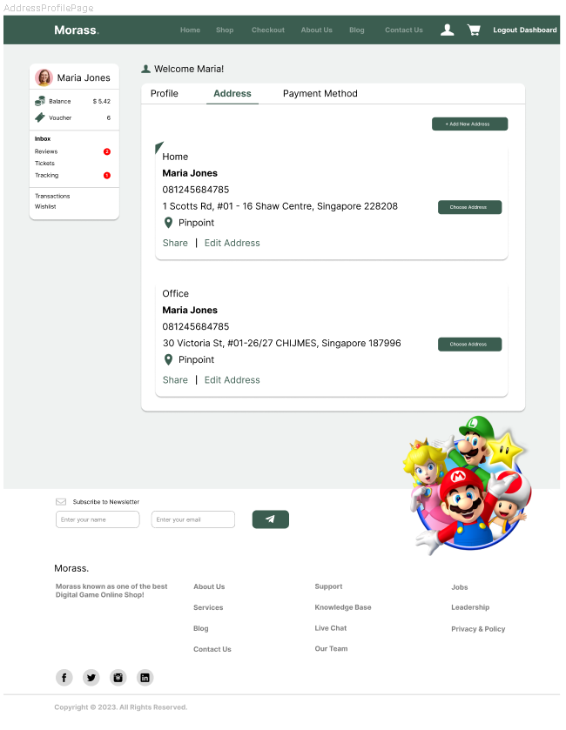

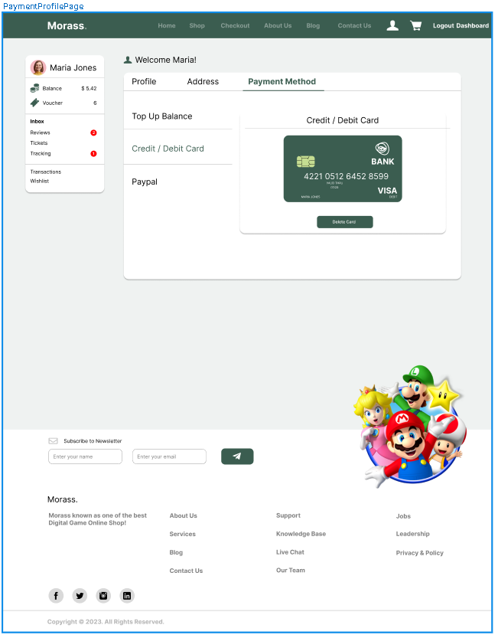

* As a user, I can edit my profile data so that I am able to change my profile picture, name and even my security
* As a user, I can select and add new address to my profile so that I can freely change my pickup destination wherever I want
* As a user, I can select and add my payment method so that I can use which method is comfortable for me

Admin Login

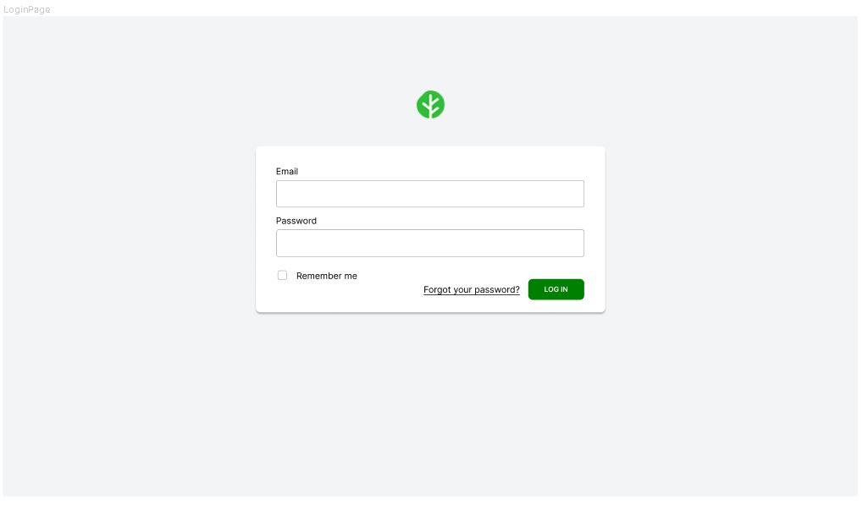

* As a Admin, I can login using my credentials that have been registered so that I could access the web app with admin account

Admin Dashboard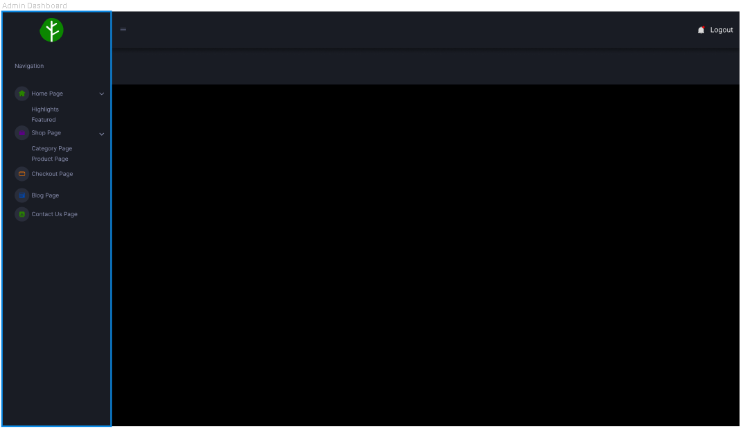

* As an Admin, I can access the admin dashboard so that i could access and edit data in the admin dashboard

Admin Category

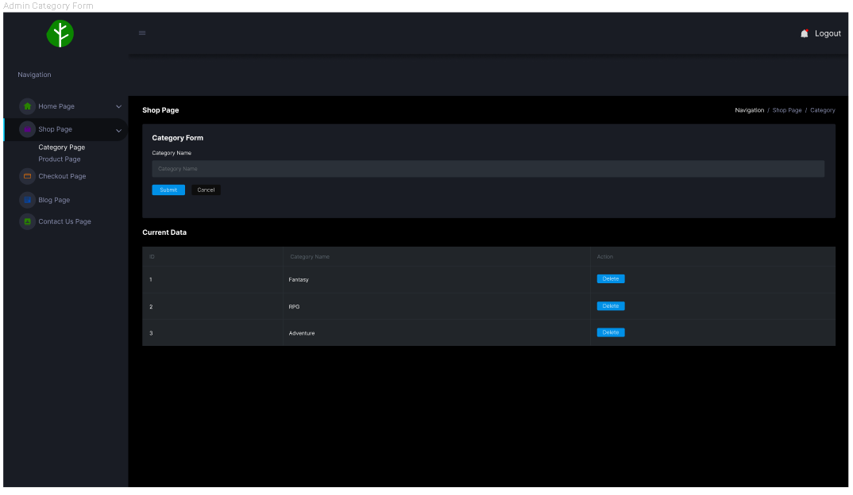

* As an Admin, I can add a new category for games so that i could categorize our games
* As an Admin, i can delete a category so that i could remove unwanted or unused category

Admin Product

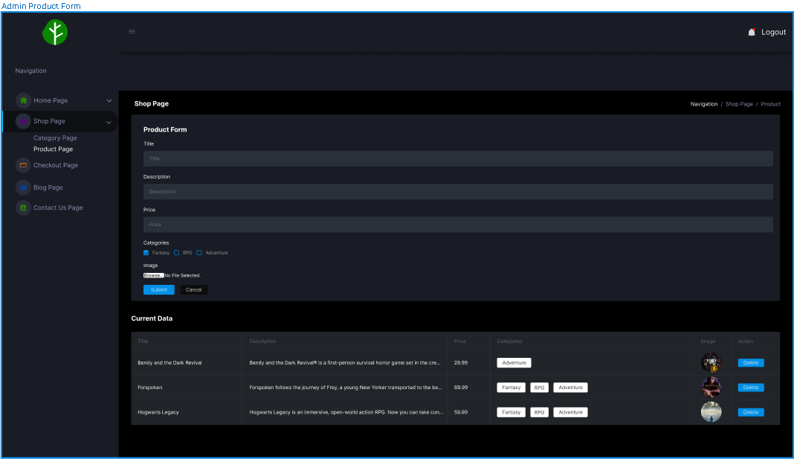

* As an Admin, I can add a new product so that i could add more products on our shop
* As an Admin, i can delete a product so that i could remove a sold out product

Admin Checkout

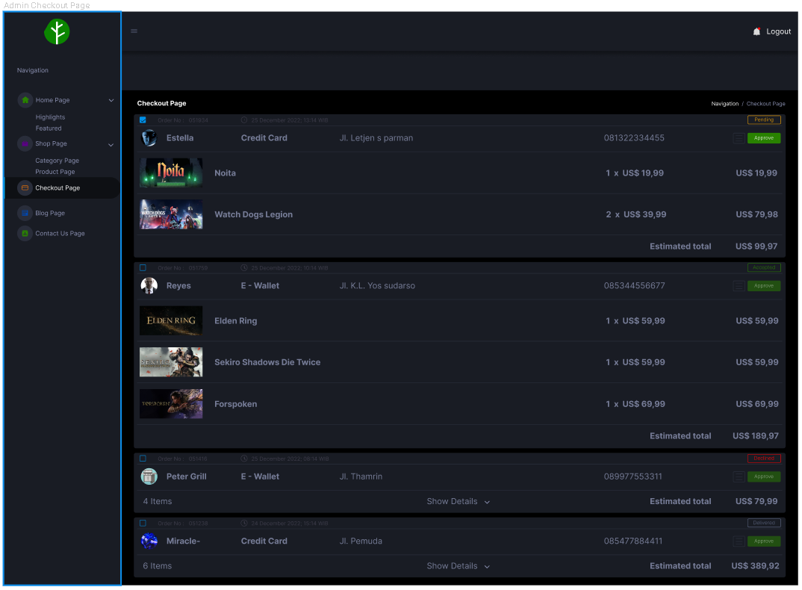

* As an Admin, I can view all checked out carts so that i could see how many orders i have
* As an Admin, i can approve, reject orders so that i could accept or reject orders

Admin Home Page

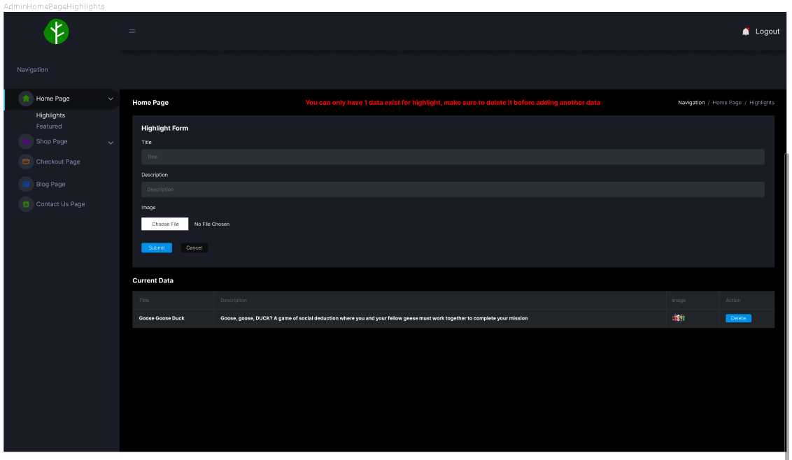

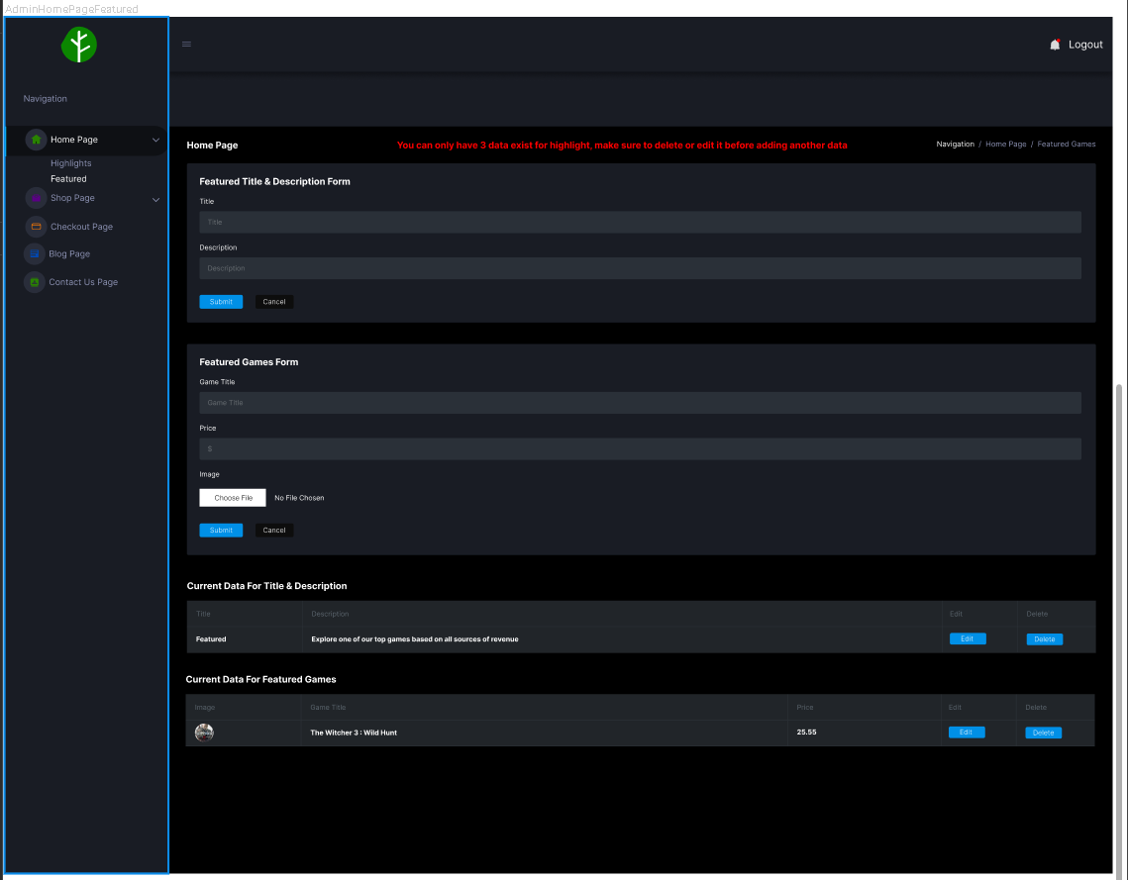

* As an Admin, I can Add and Delete Highlight Homepage so that I can change it based on highlighted product
* As an Admin, I can add and delete Featured Games on Homepage so that I can show trending games

Admin Contact Us

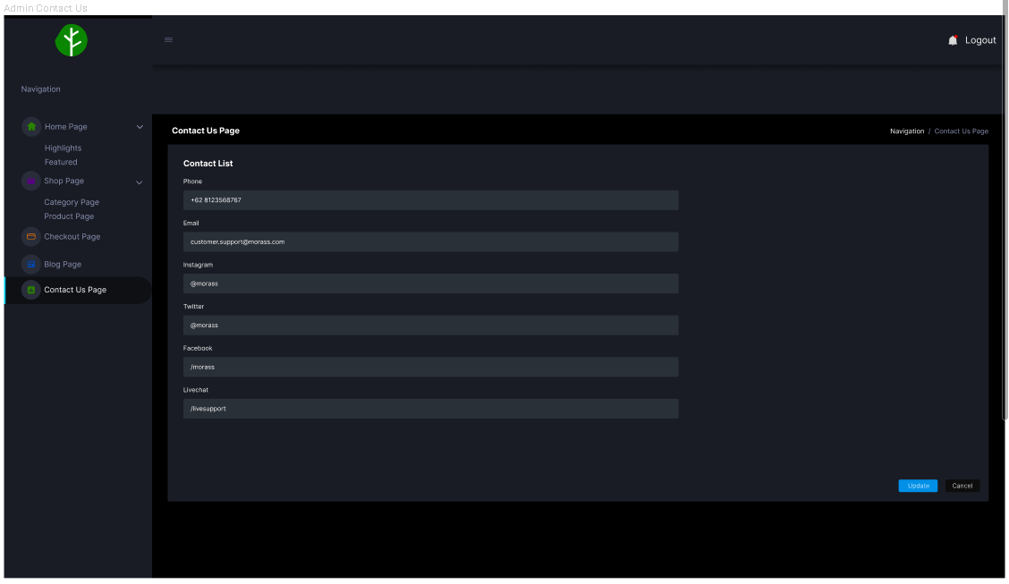

* As an Admin, I can edit the data on the contact us page so that i could renew our contacts

Admin Blog Page

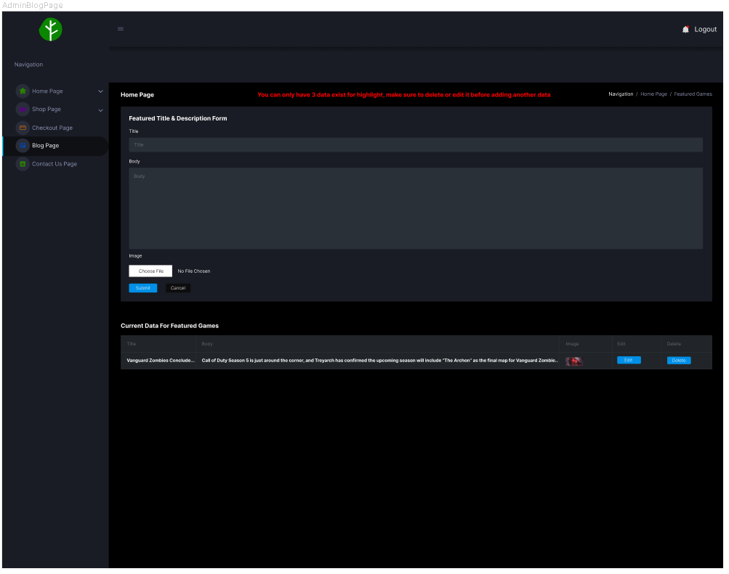

* As an admin, I can add, edit and delete blog content so that I can give an up to date news for user

Link Trello : [Morass | Digital Game Online Shop | Trello](https://trello.com/b/kyD8WQwE/morass-digital-game-online-shop)