<Title>

A Capstone Project
Presented to the Faculty of the
Information and Communications Technology Program
STI College - General Santos Inc.

In Partial Fulfillment
of the Requirements for the Degree
Bachelor of Science in Information Technology
<name>
<name>
<name>
<name>

October 2026

ENDORSEMENT FORM FOR ORAL DEFENSE

TITLE OF RESEARCH: <title>

NAME OF PROPONENTS: <name>
<name>
<name>
<name>

In Partial Fulfilment of the Requirements
for the degree Bachelor of Science in Information Technology
has been examined and is recommended for Oral Defense.

ENDORSED BY:

<Capstone Adviser’s Given Name MI. Family Name>
Capstone Project Adviser

APPROVED FOR ORAL DEFENSE:

<Capstone Project Coordinator’s Given Name MI. Family Name>
Capstone Project Coordinator

NOTED BY:

Mr. Anthony Mark F. Silong, MIT
Program Head

<Date of Oral Defense>

APPROVAL SHEET
This capstone project titled <Research Title>, prepared and submitted by < Researcher’s Given Name MI. Family Name>, < Researcher’s Given Name MI. Family Name>, < Researcher’s Given Name MI. Family Name>, and < Researcher’s Given Name MI. Family Name>, in partial fulfillment of the requirements for the degree of Bachelor of Science in <Program>, has been examined and is recommended for acceptance and approval.
<Capstone Project Adviser’s Given Name MI. Family Name>
Capstone Project Adviser
Accepted and approved by the Capstone Project Review Panel
in partial fulfillment of the requirements for the degree of
Bachelor of Science in <Program>

< Panelist’s Given Name MI. Family Name> | < Panelist’s Given Name MI. Family Name>
Panel Member | Panel Member

< Panelist’s Given Name MI. Family Name>
Lead Panelist

Noted:
<Capstone Project Coordinator’s Given Name MI. Family Name> | <Program Head’s Given Name MI. Family Name>
Capstone Project Coordinator | Program Head

<Date of Oral Defense>

Acknowledgements
The researchers would like to thank the following:
Capstone Project Coordinator, <state his/her contributions to your research>;
Capstone Project Adviser, <state his/her contributions to your research>;
Capstone Project Review Panel, <state their contributions to your research>;
Parents and/or Guardian, <state their contributions to your research>;
Friends and inspirations, <state their contributions to your research>; and
Others <state his/her contributions to your research>.

Abstract
Title of research: <title>

Researchers: <name>
<name>
<name>
<name>
Degree: Bachelor of Science in Information Technology

Date of Completion: <Month year of graduation>

Keywords: Java programming, educational game, game-based learning, variables and data types, Godot Engine

Beginning Information Technology students often find their first programming course difficult because concepts such as variables, data types and Java's strict syntax are abstract and are usually practiced through text exercises that give little immediate feedback. This capstone project developed Code Odyssey, a two-dimensional educational platformer game in which players solve obstacles by typing real Java statements into an in-game terminal operated by Byte, a companion robot.
The game was built with the Godot Engine 4 and GDScript using an iterative development approach. Its first level, Variables, has seven rooms that teach printing with System.out.println, declaring variables of the String, int, double, boolean and char types, and changing variables that already exist. Each correct statement changes the level: a gate opens, a bridge builds itself block by block, a fan starts and a path appears. Byte checks every line step by step and explains the first mistake in beginner-friendly words, then gives a hint, a fill-in-the-blank answer and an optional answer that costs a star. Four heroes with different abilities are rescued along the way, and a final exam room asks the player to reuse every variable with new values.
The game was verified with an automated playthrough test of 75 checks covering every room, the code checker, the hints and the rescues, as well as tests that other heroes cannot skip each puzzle; all checks passed. <Summarize the ISO/IEC 25010 evaluation results here: number of respondents, overall weighted mean and its interpretation.> <State the main conclusion and recommendation in one or two sentences.>

Table of Contents
 |  | Page
Title Page |  | i
Endorsement form for Oral Defense |  | ii
Abstract |  | iii
Approval Sheet |  | iv
Acknowledgments |  | v
Table of Contents |  | vi
List of Figures |  | vii
List of Tables |  | viii
List of Notations |  | ix
Introduction |  | 1
 | Project Context
 | Purpose and Description
 | Objectives
Scope and Limitations
Review of Related Literature/Studies/Systems
Methodology
 | Technical Background
 | Requirements Analysis
 | Requirements Documentation
 | Design of Software, System, Product, and/or Processes
 | Development
Results and Discussion
 | Testing
 | Description of Prototype
 | Implementation Plan
 | Implementation Results
Conclusion
References
Appendices
 | Resource Persons
 | Relevant Source Code
 | Evaluation Tool/Test Documents
 | Sample Input/Output/Reports
 | User’s Guide
 | Personal Technical Vitae

List of Figures
Figure 1. Conceptual framework of Code Odyssey
Figure 2. System architecture
Figure 3. Flowchart of checking a line of code
Figure 4. Iterative development cycle used in the project
Figure 5. Main menu
Figure 6. Gameplay in Room 0, Wake Up
Figure 7. Byte's terminal checking lines of Java
Figure 8. Chest window with a manual book
Figure 9. Two-page book reader
Figure 10. The final exam room, made of six sections

List of Tables
Table 1. Comparison of related systems with Code Odyssey
Table 2. Technologies used
Table 3. Calendar of activities
Table 4. Hardware requirements
Table 5. Software requirements
Table 6. Functional requirements
Table 7. Non-functional requirements
Table 8. Design of Level 1
Table 9. Results of the automated playthrough test
Table 10. Problems found during testing and their fixes
Table 11. Implementation plan
Table 12. Interpretation of the weighted mean
Table 13. Summary of evaluation results
Table 14. Evaluation questionnaire
Table 15. Checks of the automated playthrough test
Table 16. Sample inputs and Byte's replies
Table 17. Controls
Table 18. Heroes and their abilities

List of Notations
Notation | Meaning
2D | Two-dimensional
CC0 | Creative Commons Zero, a public-domain dedication for free assets
char | Java data type for one character, e.g. 'B'
double | Java data type for numbers with decimals, e.g. 1.5
GDScript | The scripting language of the Godot Engine
HP | Health points
HUD | Heads-up display: the on-screen hero, health, stamina and fruit information
int | Java data type for whole numbers, e.g. 11
IPO | Input-Process-Output
ISO/IEC 25010 | International standard for software product quality
String | Java data type for text in double quotes, e.g. "Sarah"
boolean | Java data type with only two values, true or false

Introduction

Project Context
Programming is one of the core skills of an Information Technology graduate, and in many IT programs Java is the first language students meet. The first weeks of a programming course introduce ideas that have no everyday equivalent: a variable as a named box that stores a value, the type that decides what kind of value fits in that box, and a strict syntax in which one missing semicolon or one wrongly capitalized letter stops the whole program. Studies of novice programmers have long reported that learning to program is difficult and that many beginners struggle with exactly these basics (Robins, Rountree, & Rountree, 2003; Jenkins, 2002; Lahtinen, Ala-Mutka, & Järvinen, 2005).
These topics are usually practiced through lectures and written exercises. When a student makes a mistake, the feedback comes from a compiler message written for professionals, or from a checked paper days later. Students can lose interest before the concepts become familiar, and the abstract nature of a variable makes it hard to see why the rules matter.
Games offer a different setting. Well-designed games hold attention through challenge, curiosity and immediate feedback (Malone, 1981), and many authors argue that the way players learn the rules of a game can be used for learning in school subjects (Gee, 2003; Prensky, 2001). Several games and environments already teach programming, but many of them use visual blocks or icons instead of typed code, focus on general problem solving rather than a specific language, or require an internet connection.
The researchers therefore developed Code Odyssey, a two-dimensional platformer in which typing real Java statements is the way to move forward. Instead of only reading about variables, the player declares int bridgeLength = 11; and watches a bridge build itself across a pit, or changes jumpPower = 1.0; so the hero stops hitting a spiked ceiling. Byte, a small robot companion, checks every line step by step and explains mistakes in simple words, so errors become part of the game rather than a reason to give up.

Purpose and Description
The purpose of this capstone project is to help beginner students learn and practice the declaration and use of Java variables and basic data types through an engaging game in which their code has a visible effect.
Code Odyssey is a single-player 2D platformer for Windows built with the Godot Engine 4. The player controls one of four heroes, pixel-art versions of the researchers, each with a special ability: Chelzy can wall-jump, Sarah can dash, April can double jump and Kervin can sprint. A fifth hero, Psalm, who can shrink, is drawn and animated but is not in Level 1 yet. The game starts with Chelzy only; the other heroes are rescued room by room, and the next room always needs the hero who was just rescued, so the player must switch heroes with a line of code such as hero = "Sarah";.
At any time the player can press E to open Byte's terminal and type one line of Java. Byte checks the line in small steps (semicolon, type, name, value, allowed range) and shows a checklist with the first failed step explained. Correct lines change the level through code gadgets: a gate opens when the player prints a message, a bridge is built with an int, a jump becomes higher with a double, a fan is switched with a boolean and one of three paths appears with a char. Players who are stuck receive the room's hint after three wrong tries and a fill-in-the-blank version of the answer after five; a Show answer button reveals the full answer but costs one of the three stars awarded at the end of the level.
The first level, Variables, consists of six rooms and a final exam room twice as wide and twice as tall as a normal room, in which every variable must be changed again with a new value. Manual books found in chests teach each topic in a two-page book reader, fruit must be collected to open doors and rescue heroes, and health potions, checkpoints, music and sound effects support the play experience.
The project is intended to benefit beginner IT students, who get a motivating way to practice Java fundamentals; programming instructors, who get a supplementary activity for their introductory lessons; and future researchers, who may extend the game to later topics such as operators, conditions and loops.

Objectives
General Objective
To develop Code Odyssey, a 2D educational platformer game that teaches beginner students how to declare, use and change Java variables of the basic data types.
Specific Objectives
1. To design and develop a game level whose obstacles are solved by typing Java statements (printing, declaring a variable and changing an existing variable) in an in-game terminal.
2. To implement a code checker that validates each statement step by step and gives beginner-friendly feedback, a hint, a fill-in-the-blank answer and an optional Show answer that affects the player's stars.
3. To connect the String, int, double, boolean and char data types to game mechanics: switching heroes, building a bridge, changing jump height, switching a fan and choosing a path.
4. To provide in-game learning materials (manual books) and progress feedback (fruit, stars and mistakes).
5. To test the game through automated playthrough testing and to evaluate it using the ISO/IEC 25010 software quality characteristics.

Scope and Limitations
Scope. The project covers the following:
• Level 1, Variables: six rooms and a final exam room with six sections, checkpoints and a level-complete screen showing stars, fruit, time and mistakes.
• Java topics: System.out.println with text, declaring variables of the String, int, double, boolean and char types, changing a variable that already exists, case sensitivity, quotation rules and value ranges.
• Four playable heroes with abilities that use stamina, health, health potions, a five-slot hotbar, manual chests and a two-page book reader.
• Byte's terminal with step-by-step feedback, hints after three wrong tries, fill-in-the-blank answers after five, Show answer with a star penalty, and automatic correction of redeclarations.
• Music, sound effects, and Music and Sound volume settings; progress and settings saved on the computer.
• A single-player, offline game for Windows computers using a keyboard and mouse, in English.
Limitations. The project does not cover the following:
• The game does not compile or run real Java. Byte understands a defined subset of statements, one statement per line, and only the variables used by the level (hero, bridgeLength, jumpPower, fanOn and path).
• Expressions and operators, conditions, loops, methods, arrays and classes are not covered; these are planned for future levels.
• Only Level 1 is complete. Art for later levels is included in the project but those levels are outside the scope of this study.
• There are no online accounts, leaderboards or teacher dashboards; progress is saved only on the computer where the game is played.
• Game controllers, touch screens and mobile devices are not supported.
• Art, fonts and audio are free third-party assets (Pixel Frog's Pixel Adventure, Minecraftia and CC0 audio from OpenGameArt). The exceptions, made for this game, are the heroes (drawn in the style of Pixel Frog's art), Byte and the manual book icons; the researchers did not create original music.
• The evaluation is limited to the respondents selected by the researchers <state the number and kind of respondents, e.g., first-year BSIT students and IT instructors of STI College - General Santos>.

Review of Related Literature/Studies/Systems

Difficulties of Novice Programmers
Learning to program is widely recognized as difficult. Robins, Rountree and Rountree (2003) reviewed research on novice programmers and noted that beginners often know individual language features but struggle to combine them into working programs, and that their mental models of what a program does are often fragile. Jenkins (2002) argued that programming is hard to learn because it requires several skills at once and because many students lose motivation early.
Lahtinen, Ala-Mutka and Järvinen (2005) surveyed students and teachers and found that practical, hands-on situations helped learning more than lectures, and that understanding how to design a program and find one's own errors was among the hardest parts. These findings support an approach in which students practice by doing and receive feedback on each mistake.
Kelleher and Pausch (2005) classified programming environments and languages made for beginners. They described two common strategies: simplifying the mechanics of writing code, for example with blocks instead of typed text, and making programming more motivating by placing it in a context the learner cares about, such as storytelling or games. Code Odyssey follows the second strategy while keeping typed Java, and reduces the mechanics problem through Byte's step-by-step checking.

Game-Based Learning and Motivation
Malone (1981) studied why computer games are captivating and proposed challenge, fantasy and curiosity as the main elements of intrinsically motivating instruction. Csikszentmihalyi (1990) described flow, a state of deep involvement that occurs when the difficulty of a task matches the person's skill and feedback is immediate. Both ideas guided the room-by-room difficulty of Code Odyssey and its instant reactions to code.
Prensky (2001) argued that digital game-based learning suits learners who grew up with games, and Gee (2003) described learning principles found in good video games, such as learning by doing, receiving information just in time and being allowed to fail with low consequences. In Code Odyssey, manuals and hints arrive when the player needs them, and falling into a pit only returns the player to the last checkpoint with the variables still set.
Connolly, Boyle, MacArthur, Hainey and Boyle (2012) reviewed empirical studies on computer games and serious games and reported that playing games is linked to a range of learning and motivational outcomes, while also noting the need for stronger evidence. Deterding, Dixon, Khaled and Nacke (2011) distinguished gamification, adding game elements to non-game contexts, from full games. Code Odyssey is a full game in which the learning content is part of the core mechanic rather than an added score or badge.

Related Systems
Scratch is a block-based programming environment developed at the MIT Media Lab in which learners snap blocks together to create animations and games (Resnick et al., 2009). It removes syntax errors completely, which helps beginners, but it does not teach the text syntax of a language like Java.
Lightbot is a puzzle game in which the player programs a robot with icon commands to light up tiles. It teaches sequencing, procedures and loops, but without a text-based programming language.
CodeCombat is a web-based game in which players type real code, such as Python or JavaScript, to control a hero in a fantasy world. It is the closest to Code Odyssey in using typed code, but it requires an internet connection and its lessons follow its own course structure.
Human Resource Machine (Tomorrow Corporation, 2015) is a commercial puzzle game in which the player solves tasks with an assembly-like visual language. It develops logical thinking but does not teach a mainstream language's syntax.
Vahldick, Mendes and Marcelino (2014) reviewed games designed to improve introductory programming competencies and found a wide variety of approaches, many of them focused on general concepts rather than language syntax. This supports the gap that Code Odyssey addresses: typed Java syntax for beginners, inside a platformer, with feedback on every step of a statement.

Local Studies
<Add related local (Philippine) studies and systems here, as required by your adviser, with their citations. Summarize what each study did and how Code Odyssey is similar or different.>

Synthesis
The reviewed literature shows that beginners struggle with programming fundamentals and need practice with immediate feedback, and that games can provide motivation, challenge and low-cost failure. Existing systems either avoid typed syntax (Scratch, Lightbot, Human Resource Machine) or require an internet connection (CodeCombat). Table 1 compares these systems with Code Odyssey.
Table 1. Comparison of related systems with Code Odyssey
Feature | Scratch | Lightbot | CodeCombat | Human Resource Machine | Code Odyssey
Typed text code | No (blocks) | No (icons) | Yes | No (visual commands) | Yes (Java)
Focus on Java variables and data types | No | No | No | No | Yes
Step-by-step explanation of errors | Not needed | Not needed | Error messages | Not needed | Yes (Byte)
Platformer gameplay with hero abilities | No | No | No | No | Yes
Works offline | Yes (app) | Yes (app) | No | Yes | Yes

METHODOLOGY

Technical Background
Code Odyssey was developed with the Godot Engine 4.7, a free and open-source game engine, and its scripting language GDScript. The game uses Godot's scene and node system: every object (the player, Byte, a gadget, a room) is a scene that can be reused, and objects communicate through signals. The game renders at 640 × 360 pixels and is scaled up by whole numbers to keep the pixel art sharp, using Godot's Compatibility (OpenGL 3.3) renderer so that it runs on older computers.
Byte's terminal does not run a Java compiler. A component called the CommandChecker reads one line and recognizes three kinds of statements: a declaration (Type name = value;), a change to an existing variable (name = value;) and a print statement (System.out.println(...);). A VariableLibrary lists the variables a level allows, with each variable's type and allowed values. When a line is correct the terminal emits a signal, variable_set, and the code gadgets in the player's current room react to it. Two global scripts (autoloads) keep game state and settings (Game) and play music and sound effects (Sound).
The rooms of Level 1 are written as text maps in a level generator script, one character per 16-pixel tile, and the generator builds the level scene from them. A separate automated test script plays through the level by simulating keyboard input and checks that every puzzle can only be solved the intended way.
Technologies to be Used
Table 2. Technologies used
Technology | Purpose
Godot Engine 4.7.2 | Game engine: scenes, physics, rendering, audio, exporting the game
GDScript | Programming language for all game logic, the code checker and the test scripts
Git and GitHub | Version control and backup of the project
Pixel Adventure 1 and 2 (Pixel Frog) | Tiles, traps, items and backgrounds
Hero sprites made for this game (tools/make_team_sprites.gd, tools/make_team_heroes.gd) | The heroes and their animations: pixel-art versions of the researchers in Pixel Frog's style
Minecraftia font and pixel fonts | Text in the book reader, chest window and HUD
CC0 audio from OpenGameArt | Music and sound effects (Juhani Junkala / SubspaceAudio, cosmac)
Claude Code (AI coding assistant) | Assisted in writing and testing code under the researchers' direction <keep, edit or remove according to your school's AI-use policy>
Microsoft Word | Writing the manuscript

Calendar of Activities
Table 3 shows the activities of the project. <Fill in the dates of your own schedule.>
Table 3. Calendar of activities
Activity | Start | End
Title proposal and approval
Requirements gathering and review of related literature
Game and level design (design document, room plans)
Development of core systems (heroes, terminal, code checker)
Development of gadgets and Level 1 rooms
Redesign after playtesting (floors, traps, final exam)
Book reader, health potions, music and sound effects
Testing and debugging (automated and manual)
Evaluation with respondents
Manuscript writing and revisions
Final oral defense

Resources
Hardware Resources
Table 4. Hardware requirements
Hardware | Minimum requirement to play
Processor | Dual-core 64-bit processor, 2.0 GHz or faster
Memory | 4 GB RAM
Graphics | Graphics card or integrated graphics supporting OpenGL 3.3
Storage | 200 MB of free space
Display | 1280 × 720 or higher
Input | Keyboard and mouse
Audio | Speakers or headphones (optional)

The game was developed on <describe the researchers' development computer(s): processor, memory, graphics card and operating system>.
Software Resources
Table 5. Software requirements
Software | Use
Windows 10 or 11 (64-bit) | Operating system for development and playing
Godot Engine 4.7.2 | Development environment and export of the Windows build
Git, GitHub Desktop | Version control
Microsoft Word | Documentation

Requirements Analysis
The researchers first identified the target users: first-year IT students who are taking or have just taken their first Java course, and instructors who teach that course. The review of related literature showed that beginners struggle most with syntax rules and with understanding what a variable is, and that they benefit from practice with immediate, specific feedback.
From these findings the topic of the first level was limited to variables and data types. For each data type the researchers looked for a game mechanic in which the value has a visible meaning: a whole number of bridge blocks (int), a decimal jump height (double), a switch that is on or off (boolean), a letter choosing a path (char) and a hero's name (String). The common beginner mistakes that Byte must explain were listed (missing semicolon, wrong capitalization, missing or wrong quotes, decimals in an int, a type written again when changing a variable) and turned into the checker's steps.
The requirements were refined during development through repeated playtesting by the researchers and feedback from the adviser <add any other sources, such as interviews or surveys, if you conducted them>. For example, playtesting showed that players could skip puzzles with a high jumpPower, which led to the anti-skip requirements listed below.

Requirements Documentation

Functional Requirements
Table 6. Functional requirements
ID | Functional requirement
FR1 | The player can move, jump and use the current hero's ability (wall jump, dash, double jump or sprint).
FR2 | The player can open Byte's terminal at any time, type one line of Java and run it with Enter.
FR3 | The system checks the line step by step and shows a checklist; a failed step is explained in simple words.
FR4 | A correct declaration or change sets the variable and makes the gadgets in the current room react.
FR5 | Writing the type again for an existing variable is refused and Byte puts the corrected line in the input.
FR6 | After three wrong tries in a room the hint is shown; after five, the answer with blanks; Show answer reveals the answer and costs a star.
FR7 | Heroes are rescued at flags once every fruit in the room is collected, with a cutscene explaining the ability.
FR8 | Exit doors and the goal stay locked until the room's or the exam's fruit is collected.
FR9 | Touching a pit or a deadly trap returns the player to the last checkpoint; variables stay set.
FR10 | Chests hold manual books that can be moved to the hotbar and read in a two-page book reader.
FR11 | Health potions heal 30 HP when touched; a chest throws one out when first opened.
FR12 | The level-complete screen shows stars (3 minus answers shown, at least 1), fruit, time and mistakes.
FR13 | Progress (rescued heroes, best stars) and settings (volume, full screen) are saved.
FR14 | The game can be paused; the pause menu has Music and Sound volume sliders.

Non-Functional Requirements
Table 7. Non-functional requirements
Quality | Requirement
Usability | Byte's messages use short, plain English and name the exact fix (e.g., "Add ; at the end.").
Learnability | Each room introduces one new idea; signs and manuals explain it before it is needed.
Reliability | Every puzzle can only be passed the intended way; this is checked by the automated test.
Performance | The game runs smoothly on the minimum hardware in Table 4.
Portability | Runs on Windows; Godot can also export to Linux and macOS in future versions.
Maintainability | Rooms are text maps and every script is documented, so new rooms are added by editing text.

Storyboard Description
The storyboard follows the screens a player sees in order.
1. Main menu. The title, Code Odyssey, with Play, Continue, Settings and Quit, and the four heroes standing on the ground (Figure 5).
2. Wake Up (Room 0). The player starts as Chelzy next to a chest. A closed gate blocks the way; the sign says to print a message (Figure 6).
3. Byte's terminal. Pressing E opens the terminal. Each line is shown with Byte's checklist; mistakes are explained and correct lines change the level (Figure 7).
4. Chest and manual. Pressing F at a chest opens the chest window; the manual book is moved to the hotbar and read with a left click in the two-page book reader (Figures 8 and 9).
5. Rescue. With all the room's fruit collected, touching the flag starts a cutscene: Byte introduces the rescued hero and a card shows the new ability.
6. Rooms 1 to 5. Each room teaches one data type and needs the newly rescued hero; rooms 3 to 5 end with crates that open when all fruit is collected.
7. Final exam. A large room of six sections in which every variable is changed again.
8. Level complete. The results screen shows the stars earned, fruit, time and mistakes.

Design of Software, System, Product, and/or Processes
Figure 1 shows the conceptual framework of the project in Input-Process-Output form.
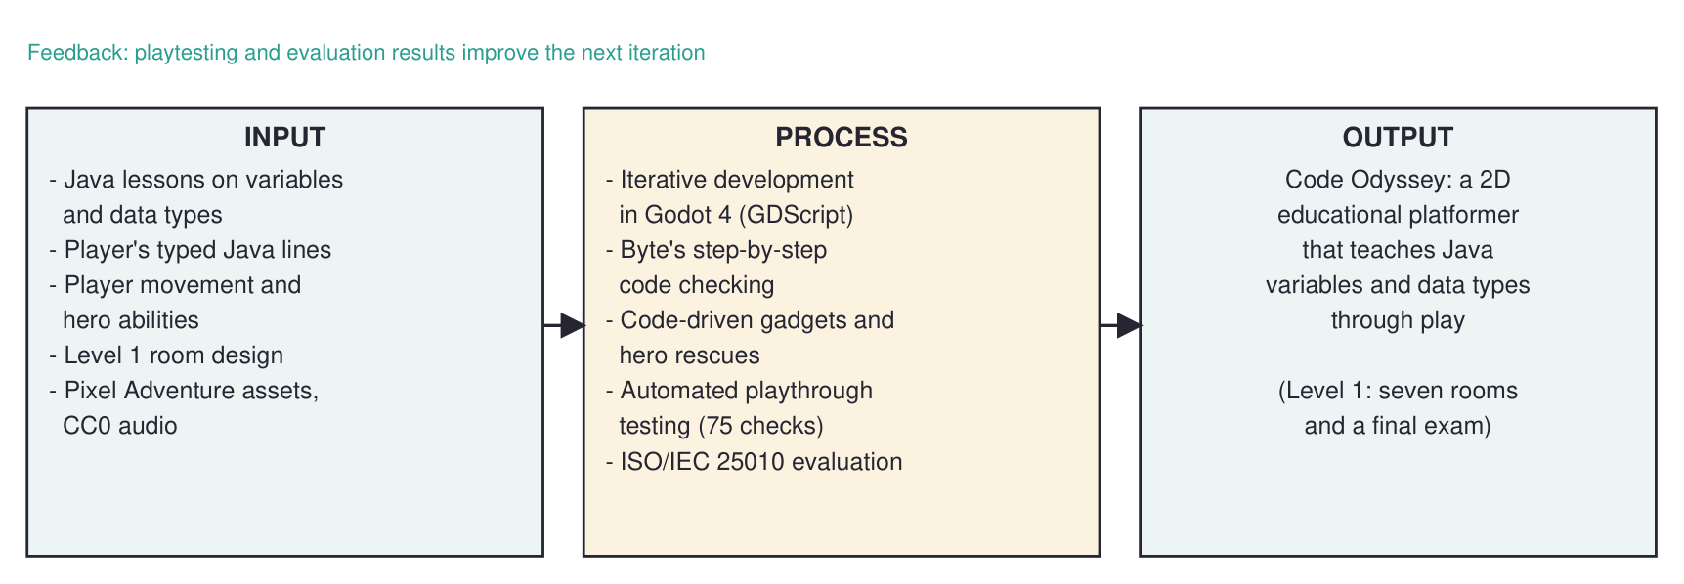
Figure 1. Conceptual framework of Code Odyssey
Figure 2 shows the main parts of the game and how they communicate. The player's typed line goes from the terminal to the CommandChecker; a correct line is announced through the variable_set signal, and only the gadgets in the player's current room react, so a later room can reuse a variable without undoing an earlier puzzle.
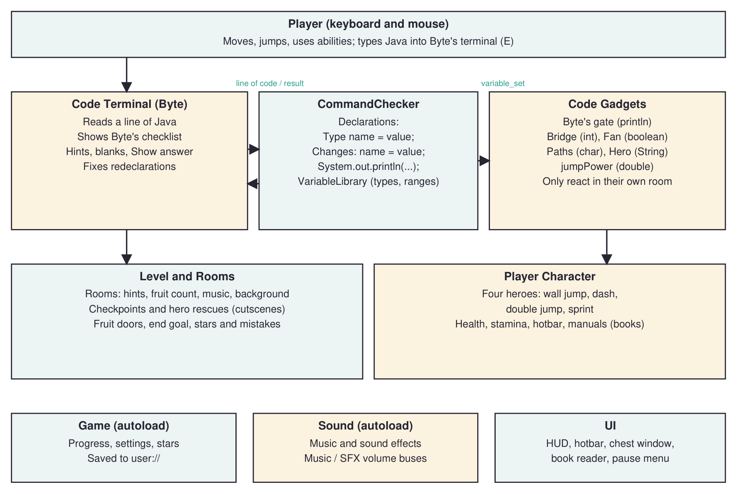
Figure 2. System architecture
Figure 3 shows how Byte checks one line of code.
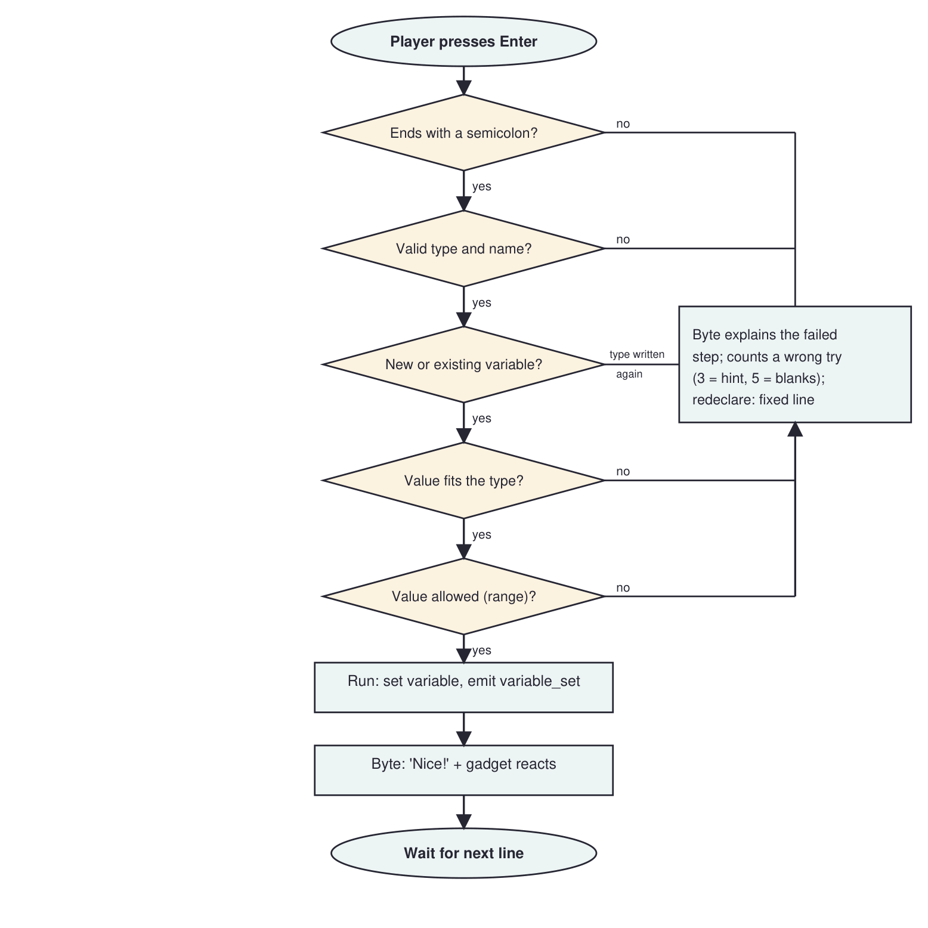
Figure 3. Flowchart of checking a line of code
Table 8 summarizes the design of Level 1. Every room teaches one concept, needs one hero and uses one kind of trap; the final exam mixes all of them.
Table 8. Design of Level 1
Room | Java concept | Code that solves it | Hero needed | Trap
0 Wake Up | A statement, the semicolon | System.out.println("Hello Byte"); | Chelzy (wall jump) | Spikes
1 The Wide Gap | Declaring a String | String hero = "Sarah"; | Sarah (dash) | Saws
2 The Broken Bridge | int; changing a variable | int bridgeLength = 11;  hero = "April"; | April (double jump) | Spiked balls
3 The High Ledge | double | double jumpPower = 2.0; | Kervin (sprint), April | Falling platforms
4 The Fan Shaft | boolean | boolean fanOn = true; | Any | Rock Heads
5 Three Paths | char; changing it | char path = 'B'; | Sarah (dash) | Spike Heads
6 Final Exam | Changing every variable | hero = "April"; jumpPower = 1.0;  bridgeLength = 12; fanOn = false;  path = 'C'; System.out.println("I can code!"); | All four | All, plus fire and fans

Development

Development Approach
The project used an iterative and incremental development approach (Sommerville, 2016). Instead of building the whole game at once, the researchers built it in small increments, each one planned, designed, built, tested and reviewed before the next (Figure 4). This suited a game, because how fun and how clear a room is can only be judged by playing it, and playtesting often changed the design.
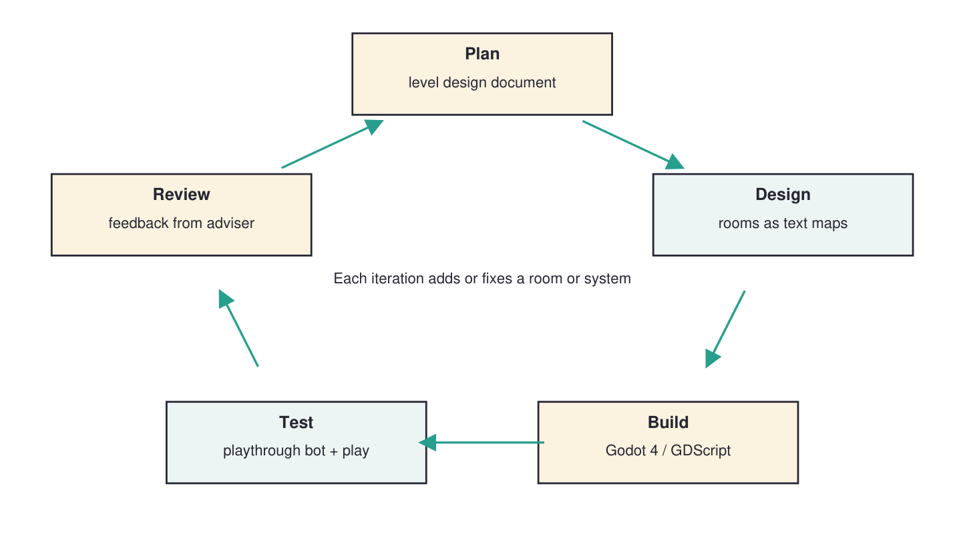
Figure 4. Iterative development cycle used in the project

Development Procedure
1. Planning. A level design document defined the goal of Level 1, the hero unlock order, the rooms and their puzzles, the hint and star rules and the checkpoint behavior.
2. Core systems. The player and the four heroes, health and stamina, the hotbar, Byte, the code terminal, the CommandChecker and the VariableLibrary were built and tested in a test room.
3. Gadgets. Byte's gate, the self-building bridge, the fan, the A/B/C path platforms, falling platforms, spikes, saws, Rock and Spike Heads, spiked balls and fire blocks were made as reusable scenes.
4. Level 1. The rooms were built with a level generator from text maps, then restyled after the Pixel Adventure demo with framed rooms and doorways.
5. Redesign after playtesting. Rooms were given floors, one trap type each, fruit-locked rescues and doors, a rescue cutscene, and the 2 × 2 screen final exam. Gadgets were limited to their own room so that the exam could reuse every variable.
6. Anti-skip and balancing. Playtesting showed that April with a jumpPower of 2.0 could skip puzzles. Hero-only obstacles were moved into low crawlspaces, the double jump was made independent of jumpPower and the dash was lengthened; the automated test was extended to try every obstacle with the wrong heroes.
7. Supporting features. The two-page book reader, health potions, music, sound effects and volume settings were added.
8. Testing. The automated playthrough test and manual playtesting were run after each change.
9. Evaluation. <Describe how the evaluation was or will be conducted: respondents, sampling, the questionnaire in Appendix C and the statistical treatment.>

RESULTS AND DISCUSSION

Testing
The game was tested in two ways. First, the researchers played the level manually after every change and recorded problems. Second, an automated playthrough test was written in GDScript (tools/test_level1.gd). It loads Level 1, presses keys like a player, types lines into Byte's terminal and checks the results. For each puzzle it checks both that the intended solution works and that wrong approaches fail, including attempts by the other heroes at the highest jumpPower. The test backs up and restores the player's save file. Table 9 summarizes the result of the final run; the full list of checks is in Appendix C.
Table 9. Results of the automated playthrough test
Area tested | Checks | Passed
Room 0 | 6 | 6
Room 1 | 6 | 6
Room 2 | 9 | 9
Room 3 | 10 | 10
Room 4 | 4 | 4
Room 5 | 5 | 5
Final exam | 29 | 29
Health potions and chests | 3 | 3
Start, goal and level complete | 3 | 3
Total | 75 | 75

Manual playtesting found several problems that were then fixed and added to the automated test. Table 10 lists the most important ones.
Table 10. Problems found during testing and their fixes
Problem found | Fix
The bridge accepted 12 blocks for an 11-block gap. | The number must fit the gap exactly; a too-long bridge jams and collapses and Byte explains why.
Writing String hero = "April"; again was refused without help. | Byte keeps Java's rule but puts the corrected line hero = "April"; in the input.
Chelzy could climb walls meant to be impassable, even through spikes. | Wall spikes send the player to the checkpoint; walls that are run into keep a bare bottom.
April with jumpPower 2.0 could skip most puzzles. | Hero-only obstacles were placed in low crawlspaces and the double jump no longer uses jumpPower.
Sarah's dash caught on the corner of the far ledge. | The dash was lengthened to 0.3 s and drifts up 2 px.
Reusing a variable in the final exam changed earlier rooms. | Gadgets react only to code typed in their own room or exam zone.
The background did not fade between rooms and later showed a still copy. | The background shader was corrected.

Description of Prototype
The prototype is a playable Windows build of Code Odyssey with the complete first level. Its main screens are described below.
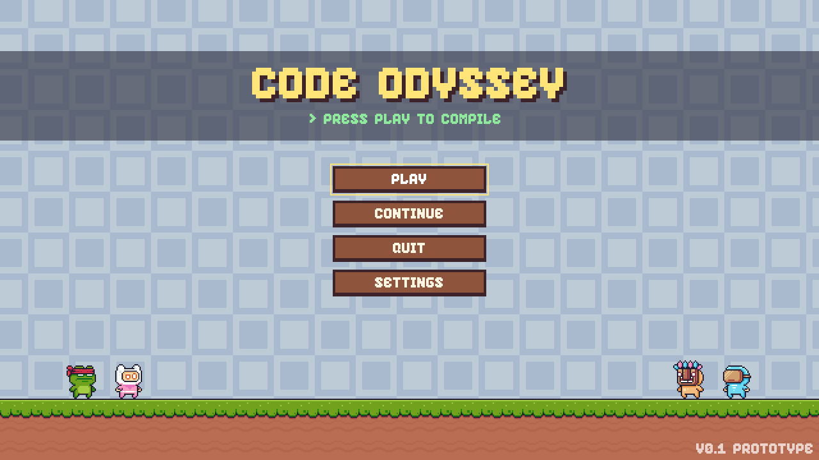
Figure 5. Main menu
The main menu (Figure 5) shows the title over a scrolling background with the four heroes. Settings has Volume, Music and Sounds sliders and a full-screen switch.
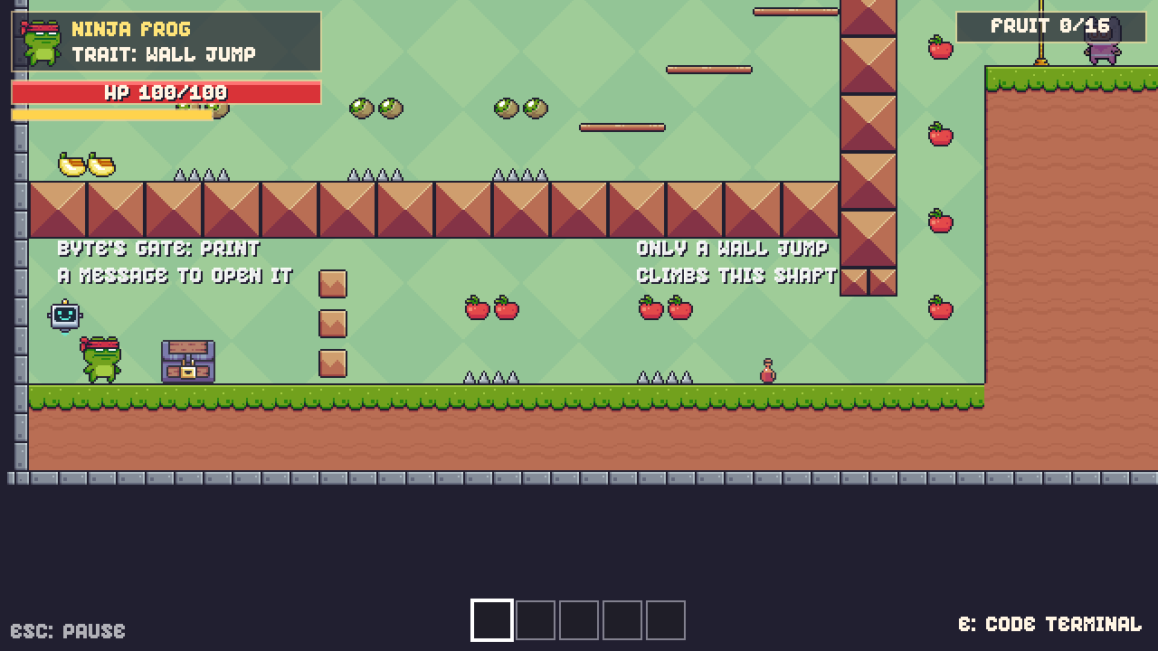
Figure 6. Gameplay in Room 0, Wake Up
During play (Figure 6) the HUD shows the current hero and trait, health and stamina, the fruit collected in the room, and the hotbar. The waiting hero stands next to the flag with a fruit counter.
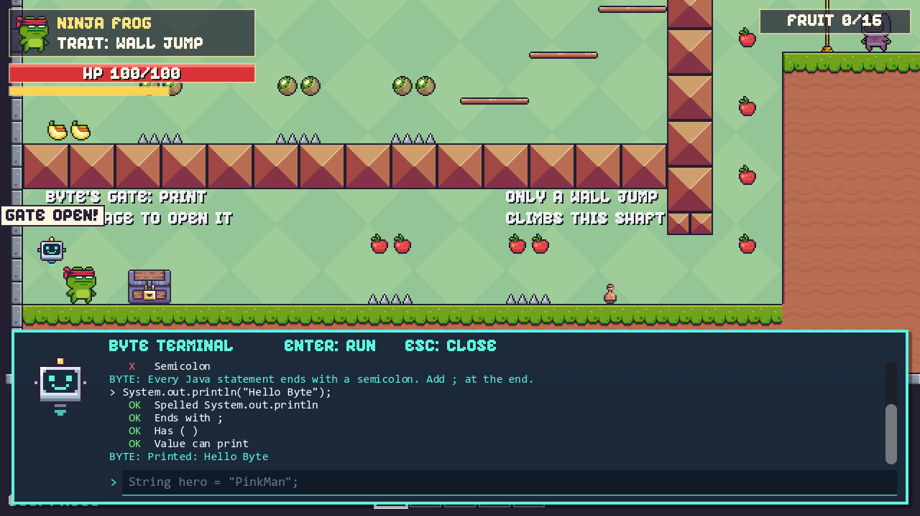
Figure 7. Byte's terminal checking lines of Java
Figure 7 shows Byte's terminal after three tries: a misspelled System, a missing semicolon, and the correct line, which opened the gate.
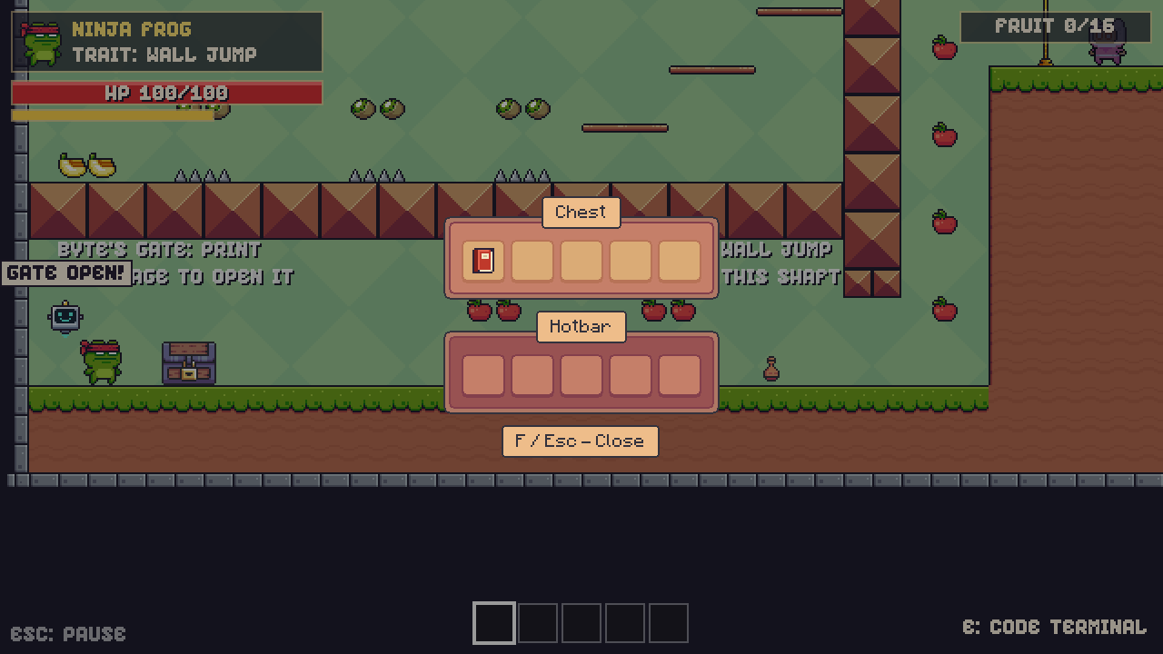
Figure 8. Chest window with a manual book
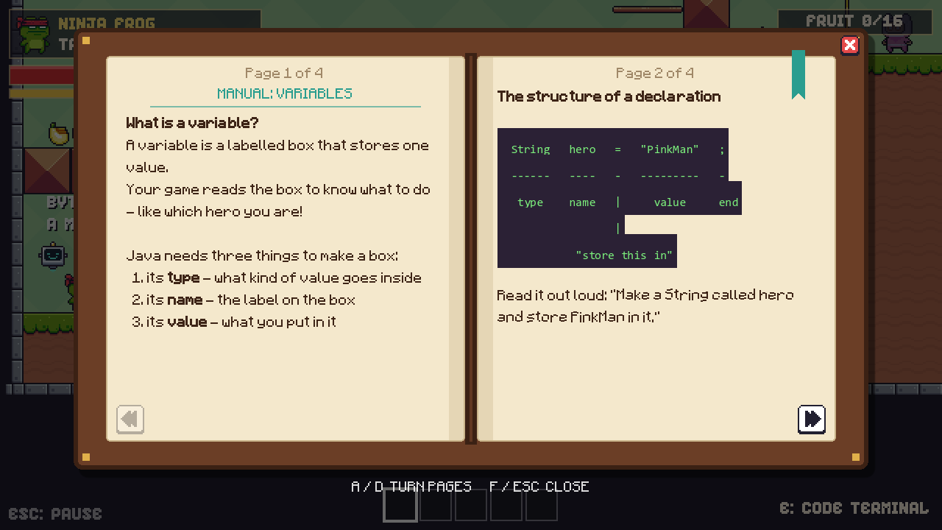
Figure 9. Two-page book reader
Chests (Figure 8) hold manual books, which are read in a two-page book reader (Figure 9) with code examples shown on a dark strip like Byte's terminal.
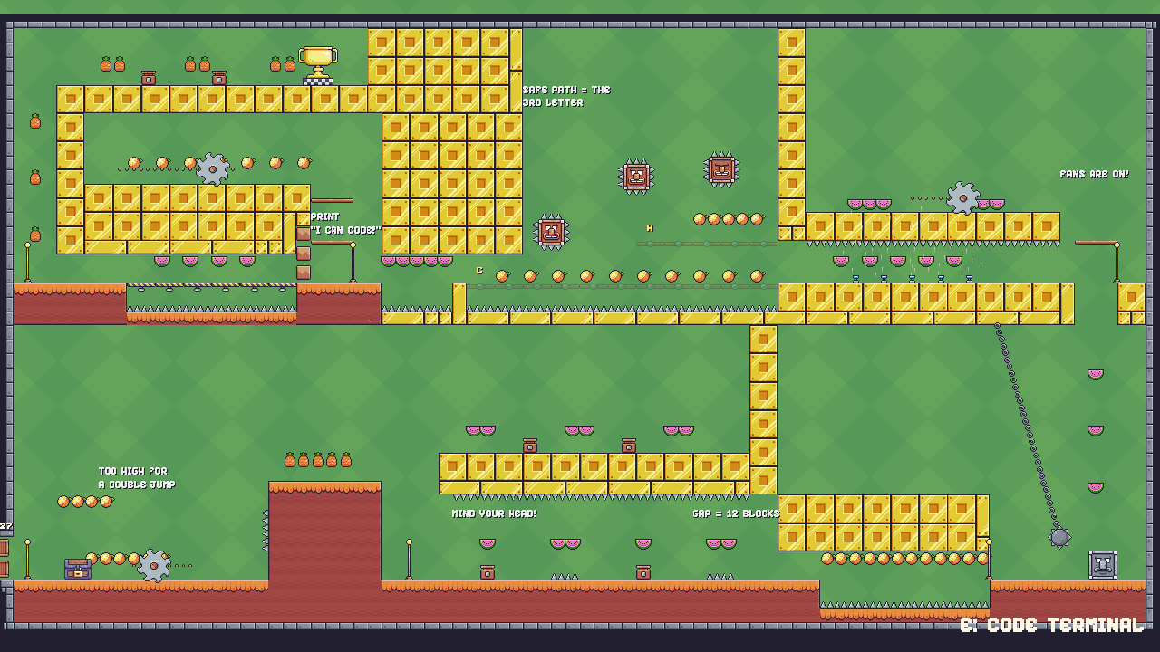
Figure 10. The final exam room, made of six sections
The final exam (Figure 10) fits two screens by two screens. The player enters at the bottom left, climbs the high wall as April, lowers jumpPower for the spiked tunnel, builds a 12-block bridge, rides a Rock Head up, turns off the fans, chooses path C, prints "I can code!" to open the last gate, sprints over the falling floor as Kervin and wall-jumps up to the goal as Chelzy.

Implementation Plan
Code Odyssey will be deployed as a stand-alone Windows program. The researchers will export a release build from Godot (a single executable and data file) and copy it to the computers that will be used, either through a USB drive or a shared folder. No installation, internet connection or database is needed; progress is saved in the user's application data folder.
Table 11. Implementation plan
Task | Description | Responsible | Schedule
Prepare the build | Export the Windows release build and test it on a computer without Godot | Researchers
Prepare the computers | Copy the game to the laboratory computers and check sound and display | Researchers, laboratory staff
Orientation | Short briefing for instructors and students: controls, Byte's terminal, the user's guide | Researchers
Pilot use and evaluation | Respondents play Level 1 and answer the ISO/IEC 25010 questionnaire | Researchers, respondents
Feedback and fixes | Fix reported problems and release an updated build | Researchers

Resources needed: the computers listed in Table 4, the release build, printed copies of the user's guide (Appendix E) and the evaluation questionnaire (Appendix C). <Add the site (e.g., the computer laboratory of STI College - General Santos) and the dates.>

Implementation Results
<Present the evaluation results here after the evaluation. Do not fill this table with made-up numbers.> The respondents rated the game using the questionnaire in Appendix C on a five-point scale, interpreted with Table 12.
Table 12. Interpretation of the weighted mean
Mean range | Interpretation
4.21 – 5.00 | Strongly Agree / Excellent
3.41 – 4.20 | Agree / Very Good
2.61 – 3.40 | Neutral / Good
1.81 – 2.60 | Disagree / Fair
1.00 – 1.80 | Strongly Disagree / Poor

Table 13. Summary of evaluation results
ISO/IEC 25010 characteristic | Weighted mean | Interpretation
Functional suitability
Performance efficiency
Compatibility
Usability
Reliability
Security
Maintainability
Portability
Overall

<Discuss the results: which characteristics were rated highest and lowest, and why, using the respondents' comments.>

Conclusion
Summary
The researchers developed Code Odyssey, a 2D educational platformer for Windows in which beginner students practice Java variables and data types by typing statements that change the game world. The first level has six rooms and a final exam that cover printing, declaring String, int, double, boolean and char variables, and changing existing variables. Byte, the companion robot, checks each line step by step, explains the first mistake, and offers hints, fill-in-the-blank answers and a Show answer option tied to the star rating. Four heroes with different abilities, manual books, fruit, checkpoints, health potions, music and sound effects complete the experience. An automated playthrough test of 75 checks passed, confirming that each puzzle works as intended and cannot be skipped by the other heroes. <Summarize the evaluation results.>
Conclusions
1. A platformer level whose obstacles are solved by typing Java statements was successfully developed: each of the five basic data types and println is tied to a visible game mechanic.
2. Byte's step-by-step code checker detects the common beginner mistakes identified during requirements analysis and explains each one with a specific fix, and the hint, blanks and Show answer features give players a way forward without removing the challenge.
3. Automated playthrough testing showed that the level can be completed as designed and that hero-only obstacles and code puzzles cannot be bypassed.
4. <Conclusion based on the ISO/IEC 25010 evaluation results.>
Recommendations
• Add levels for the next topics: arithmetic and string operators, conditions (if/else), loops and methods.
• Allow expressions in Byte's terminal, such as bridgeLength = 5 + 6;, so players see how Java evaluates them.
• Add a teacher view or exportable report of each student's mistakes to help instructors see common problems.
• Support game controllers and offer a web or Android version so more students can play.
• Add accessibility options such as larger text, color-blind-friendly hints and a Filipino translation.
• Conduct a longer study comparing the quiz scores of students who played the game with those who did not.

References
Connolly, T. M., Boyle, E. A., MacArthur, E., Hainey, T., & Boyle, J. M. (2012). A systematic literature review of empirical evidence on computer games and serious games. Computers & Education, 59(2), 661–686.
Csikszentmihalyi, M. (1990). Flow: The psychology of optimal experience. Harper & Row.
Deterding, S., Dixon, D., Khaled, R., & Nacke, L. (2011). From game design elements to gamefulness: Defining "gamification". In Proceedings of the 15th International Academic MindTrek Conference (pp. 9–15). ACM.
Gee, J. P. (2003). What video games have to teach us about learning and literacy. Palgrave Macmillan.
Godot Engine. (n.d.). Godot Engine 4 documentation. https://docs.godotengine.org
International Organization for Standardization. (2011). Systems and software engineering — Systems and software Quality Requirements and Evaluation (SQuaRE) — System and software quality models (ISO/IEC Standard No. 25010:2011).
Jenkins, T. (2002). On the difficulty of learning to program. In Proceedings of the 3rd Annual Conference of the LTSN Centre for Information and Computer Sciences (pp. 53–58).
Kelleher, C., & Pausch, R. (2005). Lowering the barriers to programming: A taxonomy of programming environments and languages for novice programmers. ACM Computing Surveys, 37(2), 83–137.
Lahtinen, E., Ala-Mutka, K., & Järvinen, H.-M. (2005). A study of the difficulties of novice programmers. In Proceedings of the 10th Annual SIGCSE Conference on Innovation and Technology in Computer Science Education (pp. 14–18). ACM.
Malone, T. W. (1981). Toward a theory of intrinsically motivating instruction. Cognitive Science, 5(4), 333–369.
Pixel Frog. (n.d.). Pixel Adventure 1 [Game assets]. itch.io. https://pixelfrog-assets.itch.io/pixel-adventure-1
Prensky, M. (2001). Digital game-based learning. McGraw-Hill.
Resnick, M., Maloney, J., Monroy-Hernández, A., Rusk, N., Eastmond, E., Brennan, K., Millner, A., Rosenbaum, E., Silver, J., Silverman, B., & Kafai, Y. (2009). Scratch: Programming for all. Communications of the ACM, 52(11), 60–67.
Robins, A., Rountree, J., & Rountree, N. (2003). Learning and teaching programming: A review and discussion. Computer Science Education, 13(2), 137–172.
Sommerville, I. (2016). Software engineering (10th ed.). Pearson.
Tomorrow Corporation. (2015). Human resource machine [Video game]. Tomorrow Corporation.
Vahldick, A., Mendes, A. J., & Marcelino, M. J. (2014). A review of games designed to improve introductory computer programming competencies. In 2014 IEEE Frontiers in Education Conference (FIE) (pp. 1–7). IEEE.
<Add your local studies and any other sources you cite, in alphabetical order. Each in-text citation must appear here.>

Appendices

Appendix A. reSOURCE PERSONS
<List the resource persons who helped the project (name, position, institution and how they helped).>

Appendix B. relevant source code
B.1 Checking a declaration or a change (scripts/terminal/command_checker.gd, excerpt)
func checkassignment(line: String, unlocked: Array, declared: Array) -> Dictionary:
if not line.ends_with(";"):
return _fail("Semicolon", "Every Java statement ends with a semicolon. Add ; at the end.")
_pass("Ends with ;")
var body := line.trimsuffix(";").stripedges()
var eq := body.find("=")
if eq == -1:
return _fail("Assignment", "I need an = to store a value, like: String hero = \"Sarah\";")
...
if declaring:
if name in declared and not allow_redeclare:
var fixed := "%s = %s;" % [name, value_text]
var result := _fail("New variable", "%s already exists, so Java won't make it again. "
+ "To change it, leave out the type: %s I put it in for you - press Enter." % [name, fixed])
result["fix"] = fixed
return result
...
var parsed := parsevalue(type, value_text)
if parsed.has("error"):
return _fail("Value", parsed["error"])
_pass("Value fits " + type)

B.2 Gadgets react only in their own room (scripts/gadgets/code_gadget.gd, excerpt)
func onvariableset(varname: String, value: Variant) -> void:
if varname == variablename and playeris_here():
onvalue(value)

func playeris_here() -> bool:
var player := gettree().getfirstnodein_group("player") as Node2D
if _room == null or player == null:
return true
for room in gettree().getnodesingroup("room"):
if room.sameplace(room) and room.contains(player.global_position, DOORWAY):
return true
return false

B.3 The bridge builds itself from an int (scripts/gadgets/code_bridge.gd, excerpt)
func onvalue(value: Variant) -> void:
var wanted := clampi(int(value), 0, max_blocks)
if gapblocks > 0 and wanted > gapblocks:
toolong(wanted) # builds to the far side, jams and collapses; Byte explains why
return
_target = wanted
if not _building:
_build() # adds or removes one block at a time

B.4 A room written as a text map (tools/build_level1.gd, Room 0)
Each character is one 16-pixel tile: # ground, B building blocks, = floating bar, f fruit, ^ spikes, s start, h chest, g Byte's gate, k rescue flag, > doorway.
........................................
............................BB.........>
.........................===BB.........>
............................BB.f...k...>
......................===...BB...#######
.....ff....ff...ff..........BB...#######
...................===......BB.f.#######
.ff..^^....^^...^^..........BB...#######
BBBBBBBBBBBBBBBBBBBBBBBBBBBBBB...#######
BBBBBBBBBBBBBBBBBBBBBBBBBBBBBB.f.#######
............................BB...#######
...............ff....ff........f.#######
..s..h....g....^^....^^..........#######
########################################

APPENDIX C. EVALUATION TOOL/TEST DOCUMENTS
C.1 Evaluation questionnaire (ISO/IEC 25010)
Directions: Please rate Code Odyssey on each statement by checking one box. 5 – Strongly Agree, 4 – Agree, 3 – Neutral, 2 – Disagree, 1 – Strongly Disagree. <Adjust the items to your adviser's required instrument.>
Table 14. Evaluation questionnaire
Statement | 5 | 4 | 3 | 2 | 1
Functional suitability
The game's puzzles respond correctly to the Java statements I type.
Byte's feedback correctly identifies the mistake in my code.
The game covers the topics it promises (variables and data types).
Performance efficiency
The game runs smoothly without lag.
The game loads quickly.
Compatibility
The game runs properly on the computer I used.
The game works with the keyboard and mouse without problems.
Usability
The controls are easy to learn.
Byte's messages are easy to understand.
The hints and manuals help me when I am stuck.
The game is enjoyable and makes me want to continue.
Reliability
The game does not crash or freeze.
My progress and settings are saved correctly.
Security
The game does not ask for or collect personal information.
Maintainability
The game is organized so that new levels and puzzles can be added. (for IT experts)
Portability
The game is easy to copy and run on another Windows computer.

Comments and suggestions: ______________________________________________
C.2 Automated playthrough test (tools/test_level1.gd)
Table 15. Checks of the automated playthrough test
No. | Check | Result
1 | starts with Chelzy only | Passed
2 | R0 gate blocks the way | Passed
3 | R0 gate opens with println | Passed
4 | Potion stays put at full HP | Passed
5 | Potion heals 30 HP when hurt | Passed
6 | Opening a chest throws out a potion | Passed
7 | R0 a normal jump can't reach the plateau | Passed
8 | R0 Chelzy wall-jumps up the shaft | Passed
9 | R0 flag won't rescue Sarah until all fruit | Passed
10 | R0 all fruit + flag: cutscene, then Sarah joins | Passed
11 | R1 Chelzy can't cross the gap | Passed
12 | R1 String hero = "Sarah" switches hero | Passed
13 | R1 Sarah dashes over the gap | Passed
14 | R1 cheat: April at jumpPower 2.0 can't cross | Passed
15 | R1 cheat: Kervin at jumpPower 2.0 can't cross | Passed
16 | R1 all fruit + flag rescues April | Passed
17 | R2 Sarah can't dash over the pit (low ceiling) | Passed
18 | R2 walks across the 11-block bridge | Passed
19 | R2 Chelzy can't wall-climb the step | Passed
20 | R2 Sarah's jump can't reach the step | Passed
21 | R2 redeclaring hero is refused | Passed
22 | R2 Byte puts the fixed line in the input | Passed
23 | R2 hero = "April" switches hero | Passed
24 | R2 April double-jumps onto the step | Passed
25 | R2 all fruit + flag rescues Kervin | Passed
26 | R3 exit door is shut while fruit is missing | Passed
27 | R3 exit door opens with all the fruit | Passed
28 | R3 walking over the falling floor fails | Passed
29 | R3 cheat: April at 2.0 can't hop the falling floor | Passed
30 | R3 cheat: Sarah can't dash the falling floor | Passed
31 | R3 Kervin sprints across | Passed
32 | R3 double jump alone can't reach the ledge | Passed
33 | R3 cheat: kervin at jumpPower 2.0 can't reach the ledge | Passed
34 | R3 cheat: sarah at jumpPower 2.0 can't reach the ledge | Passed
35 | R3 jumpPower 2.0 + double jump reaches the ledge | Passed
36 | R4 fan is off: nothing happens | Passed
37 | R4 fan lifts the player above the platform | Passed
38 | R4 steps off the fan onto the platform | Passed
39 | R4 Rock Head elevator reaches the top floor | Passed
40 | R5 no path chosen: you can't get across | Passed
41 | R5 path = 'A' makes path A solid | Passed
42 | R5 cheat: april at jumpPower 2.0 can't cross the dash gap | Passed
43 | R5 cheat: kervin at jumpPower 2.0 can't cross the dash gap | Passed
44 | R5 path B + dash reaches the exit | Passed
45 | Exam 1 cheat: sarah at jumpPower 2.0 can't climb the wall | Passed
46 | Exam 1 cheat: kervin at jumpPower 2.0 can't climb the wall | Passed
47 | Exam 1: double jump at 1.0 can't climb the wall | Passed
48 | Exam 1: writing double again is refused | Passed
49 | Exam 1: April at jumpPower 2.0 climbs the wall | Passed
50 | Exam 2: at 2.0 a jump hits the ceiling spikes | Passed
51 | Exam 2: at 1.0 the jump is safe | Passed
52 | Exam 2: runs the tunnel | Passed
53 | Exam 3 cheat: kervin at jumpPower 2.0 can't cross without the bridge | Passed
54 | Exam 3 cheat: april at jumpPower 2.0 can't cross without the bridge | Passed
55 | Exam 3 cheat: sarah at jumpPower 2.0 can't cross without the bridge | Passed
56 | Exam 3: Room 2's bridge keeps its 11 blocks | Passed
57 | Exam 3: walks across the 12-block bridge | Passed
58 | Exam 3: Rock Head elevator rises to the fan trap | Passed
59 | Exam 4: fans on: you can't get through | Passed
60 | Exam 4: Room 4's fan stays on | Passed
61 | Exam 4: fans off: walk through | Passed
62 | Exam 5: path = 'C' from the fan corridor reaches the paths | Passed
63 | Exam 5 cheat: april at jumpPower 2.0 can't cross the dash gap | Passed
64 | Exam 5 cheat: kervin at jumpPower 2.0 can't cross the dash gap | Passed
65 | Exam 5: path C + dash reaches the last ledge | Passed
66 | Exam 6: the gate blocks the way | Passed
67 | Exam 6: the gate needs the exact text | Passed
68 | Exam 6: "I can code!" opens the gate | Passed
69 | Exam 6: walking over the falling floor fails | Passed
70 | Exam 6 cheat: April at 2.0 can't hop the falling floor | Passed
71 | Exam 6: Kervin sprints across | Passed
72 | Exam 6 cheat: April at 2.0 can't jump up the shaft | Passed
73 | Exam 6: Chelzy wall-jumps up to the goal floor | Passed
74 | Goal won't finish while exam fruit is missing | Passed
75 | Level complete screen | Passed

APPENDIX D. SAMPLE INPUT/OUTPUT/REPORTS
The table shows lines typed in Byte's terminal and Byte's replies, taken from the game's code checker.
Table 16. Sample inputs and Byte's replies
Input (typed line) | Byte's checklist and reply
System.out.println("Hello Byte"); | OK Spelled System.out.println, OK Ends with ;, OK Has ( ), OK Value can print  Printed: Hello Byte
system.out.println("Hello Byte"); | X Spelling  Java is case-sensitive. System starts with a capital S.
String hero = "Sarah" | X Semicolon  Every Java statement ends with a semicolon. Add ; at the end.
string hero = "Sarah"; | OK Ends with ;, X Type  Java is case-sensitive. Write String, not string.
String hero = "Sarah"; | OK Ends with ;, OK Type is String, OK Name is hero, OK Value fits String, OK Hero found  Nice! You made hero and stored Sarah in it.
String hero = "April";  (hero already exists) | OK Ends with ;, OK Type is String, X New variable  hero already exists, so Java won't make it again. To change it, leave out the type: hero = "April"; I put it in for you - press Enter.
hero = "April"; | OK Ends with ;, OK Changing hero, OK Value fits String, OK Hero found  Nice! hero changed to April.
int bridgeLength = 5.5; | OK Ends with ;, OK Type is int, OK Name is bridgeLength, X Value  5.5 has a decimal point. int only holds whole numbers - use double.
int bridgeLength = "11"; | OK Ends with ;, OK Type is int, OK Name is bridgeLength, X Value  Numbers don't use quotes. Write it without the quotes.
bridgeLength = 9;  (not declared yet) | OK Ends with ;, X Declared  Java doesn't know bridgeLength yet. Make it first with its type: int bridgeLength = 9;
double jumpPower = 3.0; | OK Ends with ;, OK Type is double, OK Name is jumpPower, OK Value fits double, X Range  jumpPower must be between 1.0 and 2.0.
boolean fanOn = True; | OK Ends with ;, OK Type is boolean, OK Name is fanOn, X Value  Write true or false in lowercase.
char path = "B"; | OK Ends with ;, OK Type is char, OK Name is path, X Value  Double quotes are for String. A char uses single quotes, like 'A'.
int bridge length = 11; | OK Ends with ;, X Variable name  Variable names can't have spaces. Try joining the words: myHero.

APPENDIX E. USER’S GUIDE
Starting the game. Open the Code Odyssey program. On the main menu, choose Play to start a new game or Continue to keep your rescued heroes. Settings has the volume sliders and the full-screen switch.
Table 17. Controls
Key | Action
A / D or Left / Right | Move
Space, W or Up | Jump (hold longer to jump higher)
Shift | Use the hero's ability: Sarah dashes, Kervin sprints while held
E or Tab | Open Byte's terminal; Enter runs the line; Up / Down recall earlier lines; Esc closes
F | Open a chest, close a book
1 – 5 | Choose a hotbar slot
Left click | Use the item in your hand (read a manual)
Esc | Pause; the pause menu has Music and Sound sliders

Table 18. Heroes and their abilities
Hero | Ability | How to use it
Chelzy | Wall jump | Jump toward a wall, then jump again while touching it
Sarah | Dash | Press Shift to dash forward; dash across gaps in low crawlspaces
April | Double jump | Jump again in the air
Kervin | Sprint | Hold Shift while running; needed on falling floors
Psalm | Shrink | Planned; not in Level 1 yet

How to play.
1. Read the signs in each room; they tell you what is needed.
2. Open chests with F and read the manual books for each topic.
3. Press E and type a line of Java. Read Byte's checklist: a red X shows the step to fix.
4. Switch heroes with hero = "Sarah"; (after a hero is rescued). Once a variable exists, change it without the type.
5. Collect every fruit in a room to rescue its hero or open its exit crates.
6. If you are stuck, Byte gives a hint after three wrong tries and the answer with blanks after five. Show answer gives the full answer but costs a star.
7. Touch red potions to heal 30 HP. Falling into spikes returns you to the last flag; your variables stay set.
8. Finish the final exam and touch the trophy to complete the level.

APPENDIX F. PERSONAL TECHNICAL VITAE
Curriculum Vitae of
<GIVEN NAME MI. FAMILY NAME>
<complete address>
<email address>
contact number either cellular phone or landline or both

EDUCATIONAL BACKGROUND
Level | Inclusive Dates | Name of school/ Institution
Tertiary | month year
Vocational/Technical | month year
High School | month year
Elementary | month year

PROFESSIONAL OR VOLUNTEER EXPERIENCE
Inclusive Dates | Nature of Experience/  Job Title | Name and Address of Company or Organization
month year
month year
month year
month year
Listed in reverse chronological order (most recent first).

AFFILIATIONS
Inclusive Dates | Name of Organization | Position
month year
month year
month year
month year
Listed in reverse chronological order (most recent first).

SKILLS
SKILLS | Level of Competency | Date Acquired
 |  | month year
 |  | month year
 |  | month year

TRAININGS, SEMINARS, OR WORKSHOPS ATTENDED
Inclusive Dates | Title of Training, Seminar, or Workshop
month year
month year
month year
month year
Listed in reverse chronological order (most recent first).

