Week 1 Assignment — Process Documentation
Sam Shii · ss19608

AI Disclosure: I originally documented the process in plain, informal language. To improve readability and presentation for your review, I used chatgpt to polish the wording and format based on my original notes, without changing the underlying content.

1. The Assignment
For week one we had to set up a place to keep our class documentation, watch the tutorials, and then model an object that is bigger than a 1.5-inch cube but still fits inside a 3-inch cube, using at least five of the commands we covered in class. We also had to document the whole process with screenshots and dimensions.
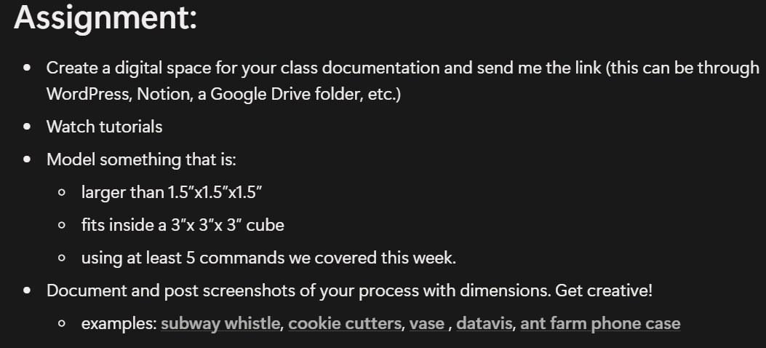
The assignment brief

2. What I Made
I knew I wanted to make a piece of architecture in the very beginning, just like those in the exhibitions they have demos of building before an actual building was made, I’d like to imitate that.
But I did not know what exactly I would end up making at the beginning, so I started off with a quarter of a circle, then slowly turned it into a mini 3d complex which I found geometrically satisfying.
I worked in millimeters the whole time and only converted to inches at the very end to check that the size was legal.

3. Step by Step

Step 1 — Sketch: two circles
I opened a sketch on the top plane and drew two circles from the same center point, 50 mm on the outside and 40 mm on the inside. That ring in between is the seed of the whole model.
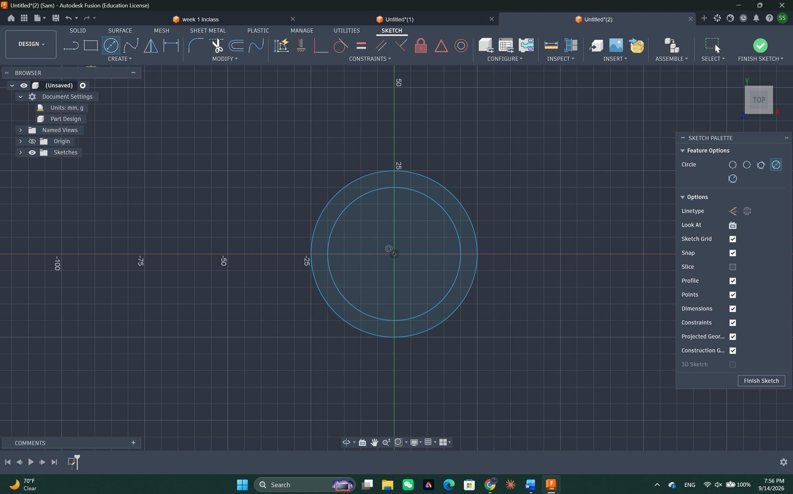
Two concentric circles, Ø50 mm and Ø40 mm, on the top plane

Step 2 — Selecting one quarter of the ring
Instead of using the whole ring, I only picked one quarter of it. Fusion reports that region as 176.715 square millimeters, which is exactly a quarter of the ring area, so I knew I had grabbed the right profile.
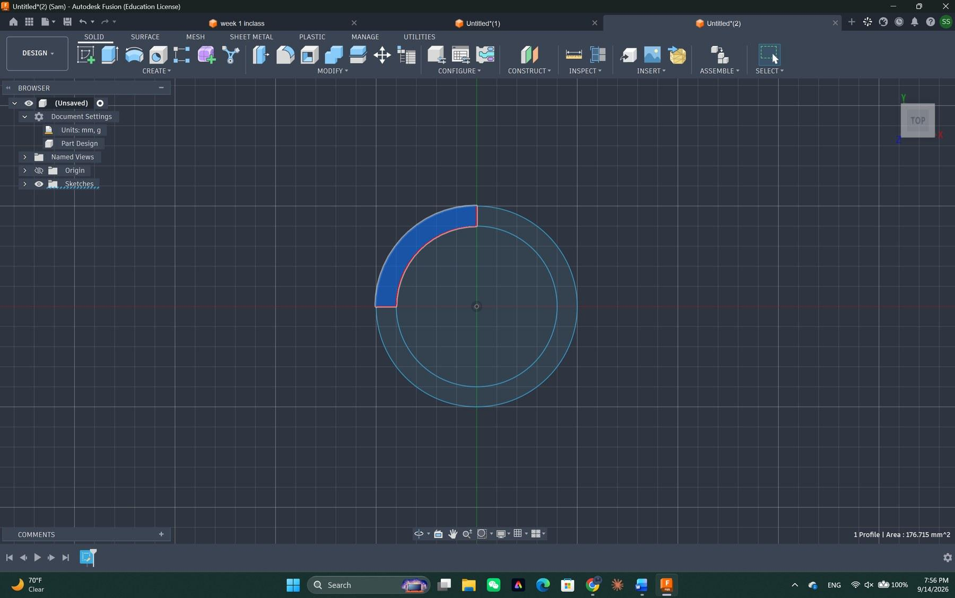
One quarter of the ring selected — profile area 176.715 mm²

Step 3 — Extrude
I extruded that quarter ring into a solid. At this point it is still a plain curved wall with straight, boring sides.
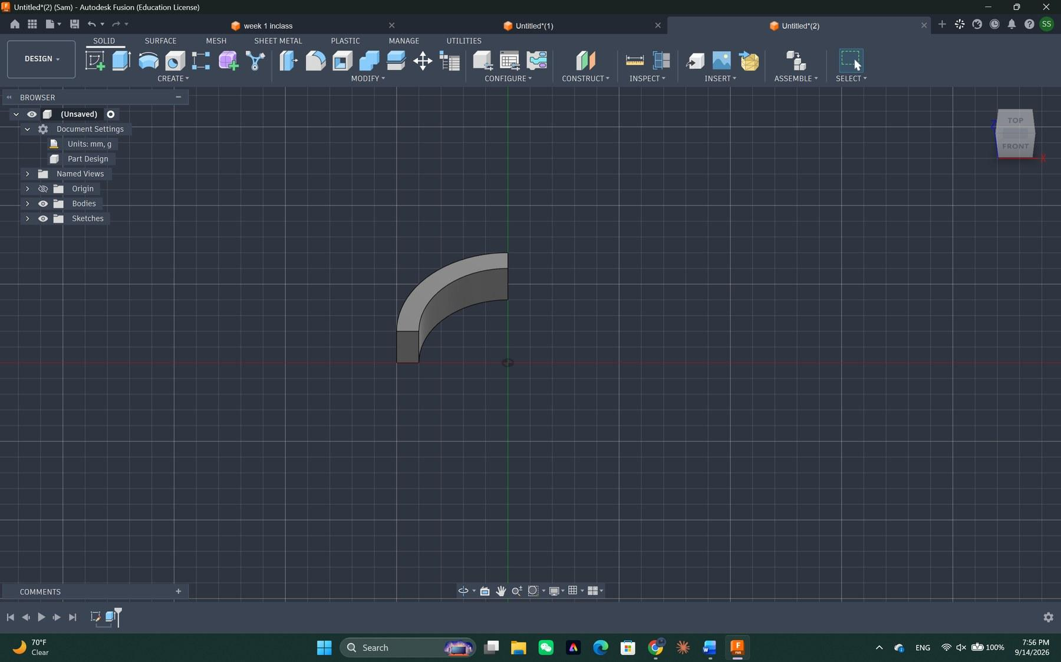
The quarter ring extruded into a solid body

Step 4 — Draft
This is the command that gave the piece its character. I ran Draft at 40 degrees, one side only, with Tangent Chain turned on so the draft follows the curve all the way around instead of stopping at one face. The flat inner wall tilted inward and turned into a funnel-like surface.
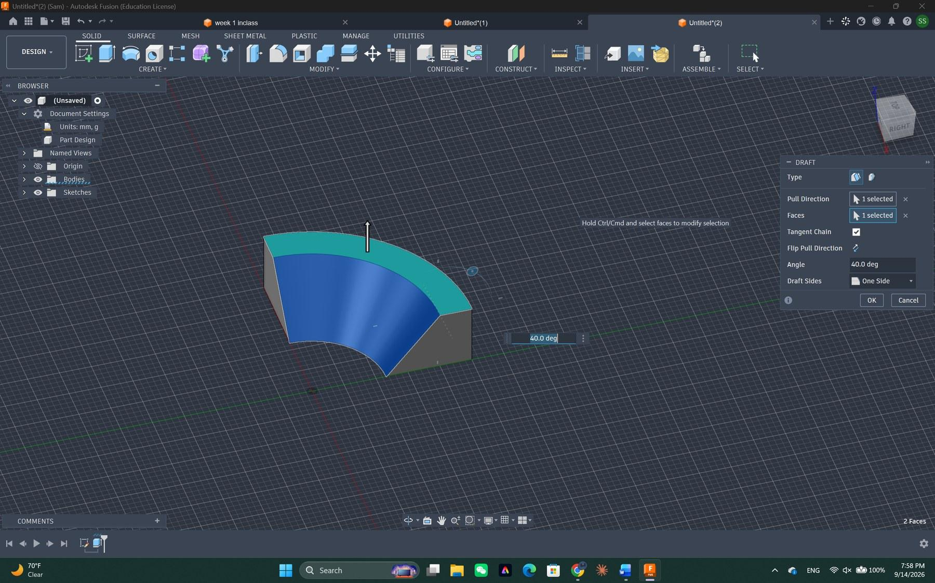
Draft: 40°, One Side, Tangent Chain on, 2 faces
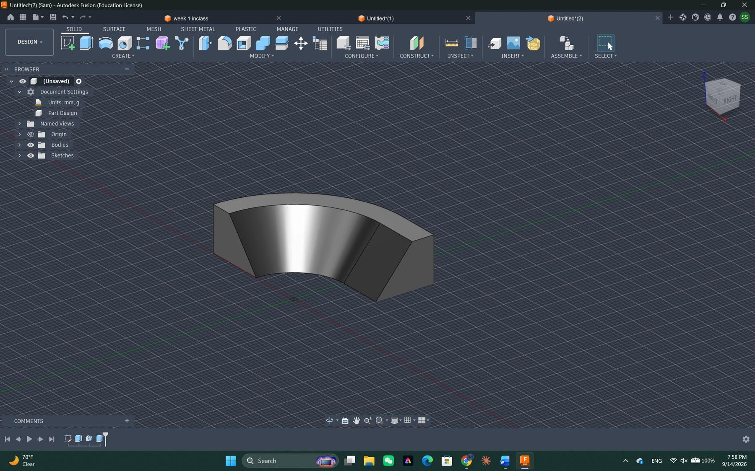
After the draft — the straight wall is now a sloped, scooped surface

Step 5 — Extrude the other side
I extruded the other side and brought the form around until it read as one closed, bowl-shaped body instead of a single wedge.
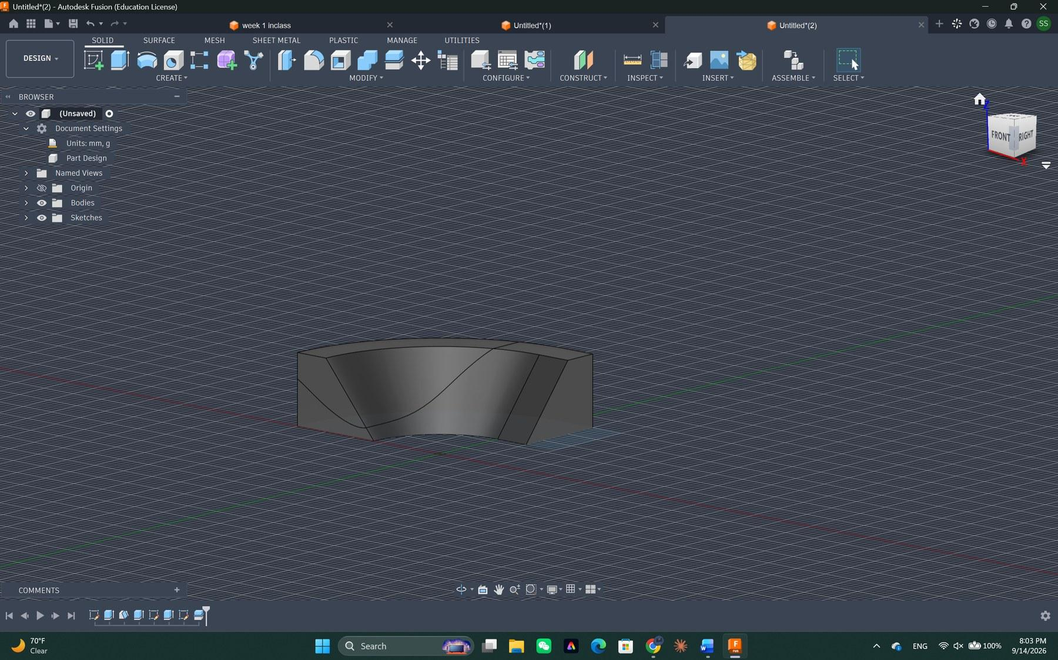
The form closed up into a full bowl-like body

Step 6 — Split Body and separate
Then I used Split Body to cut the form into separate pieces and pulled the pieces apart. That gap between the upper shell and the lower base is deliberate — it is the space I later filled with columns.
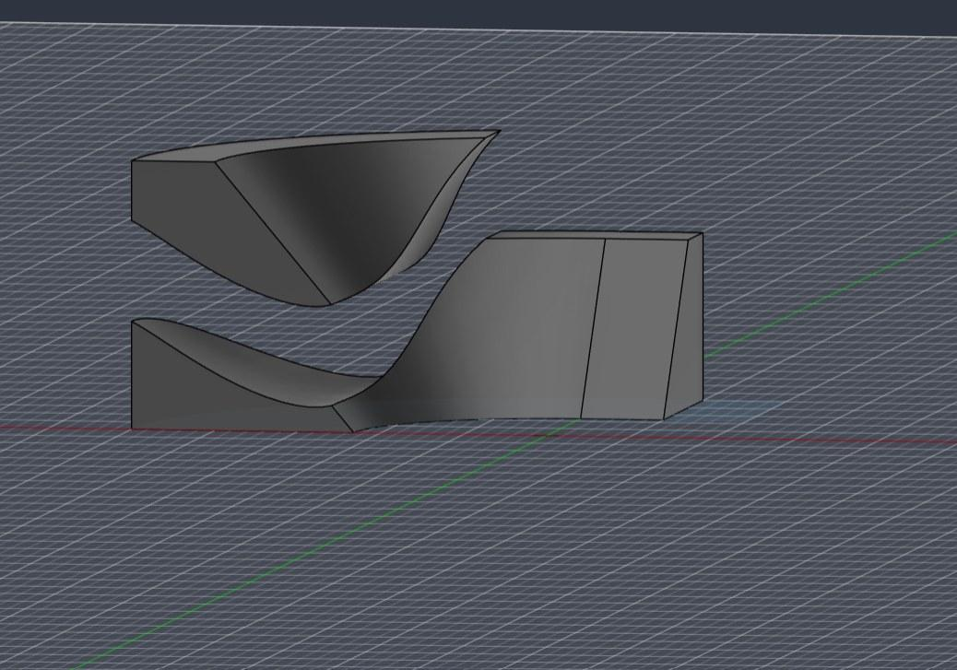
Split Body, then the two halves moved apart to open up a gap

Step 7 — A cone for the column
For the columns I sketched a small circle and drafted it into a cone, so each column is narrow at the bottom and flares out at the top. One cone is all I needed to model by hand.
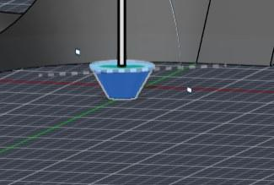
A single drafted cone — the master column

Step 8 — Circular Pattern
I used Circular Pattern to spin that one cone around a center axis, and in a couple of seconds I had a whole ring of identical columns. This is the part where the model started to feel like a building.
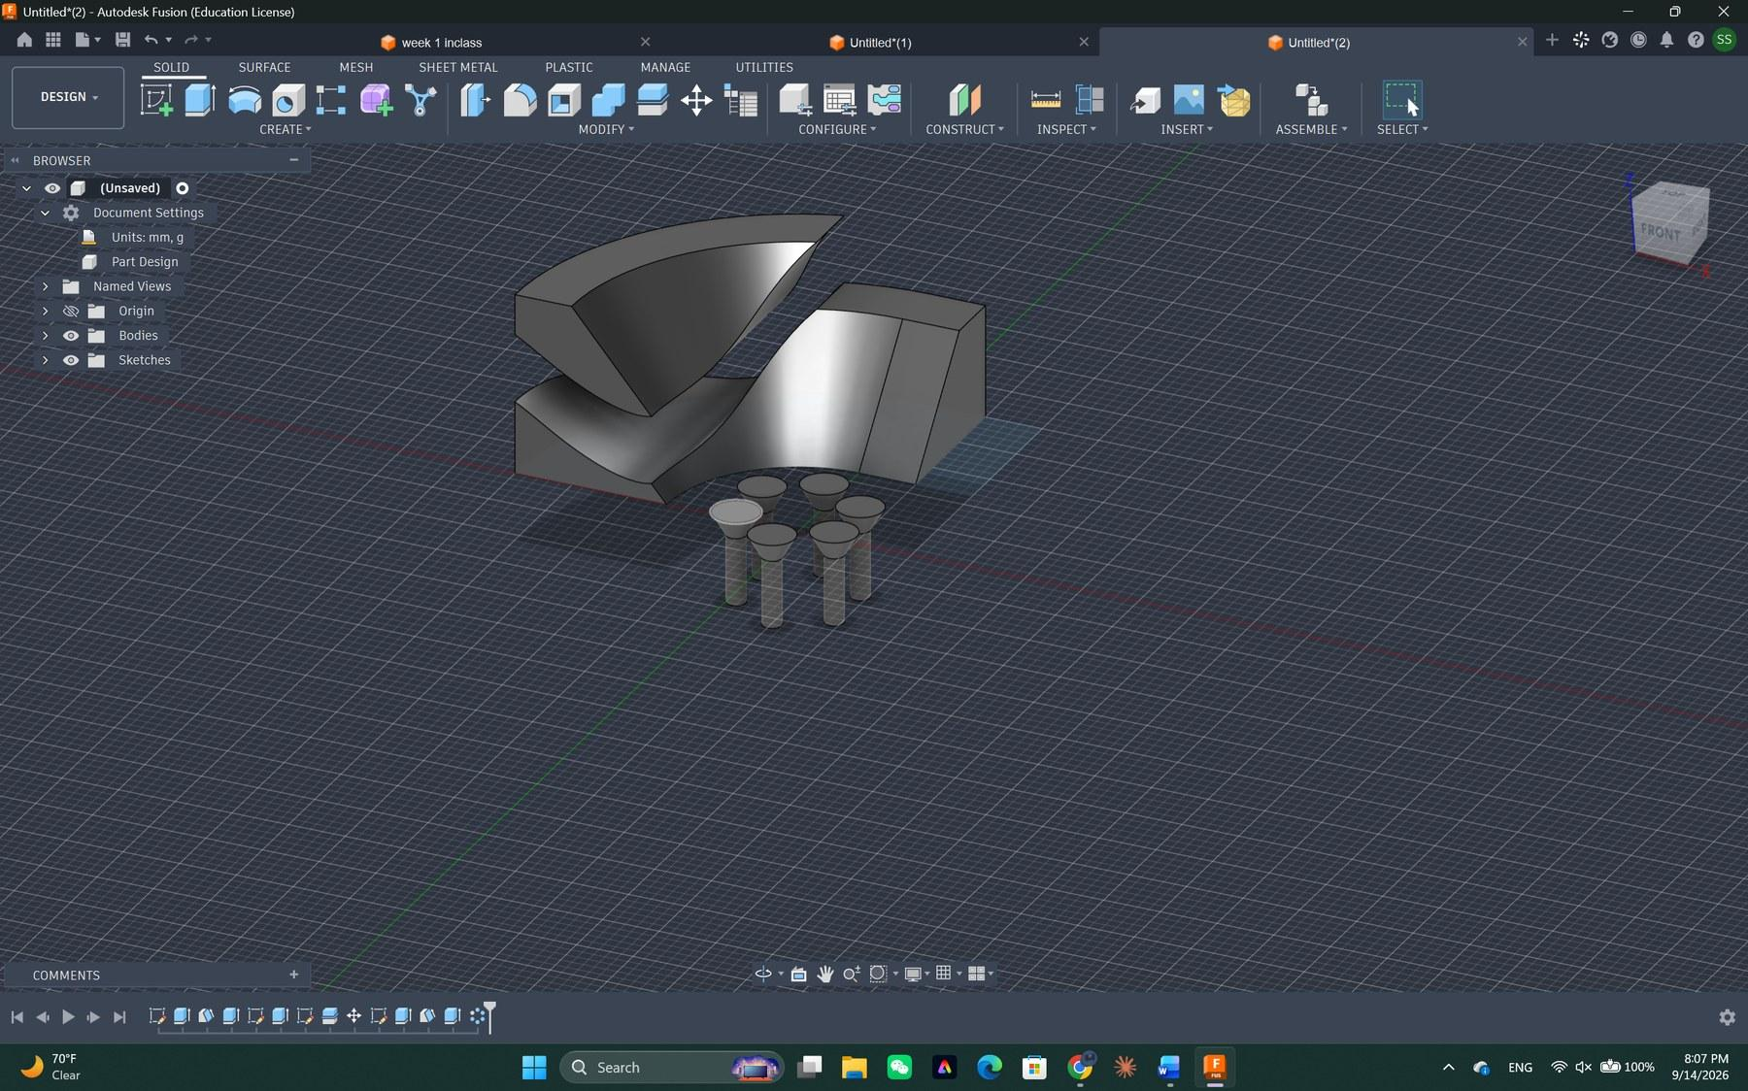
Circular Pattern turns one cone into a ring of columns

Step 9 — Move / Copy, then adjust
I extruded the bottom of the columns and patterned them again to multiply them. Then I selected five bodies at once and used Move/Copy to slide them into position, so the columns actually land on the base and carry the shell above.
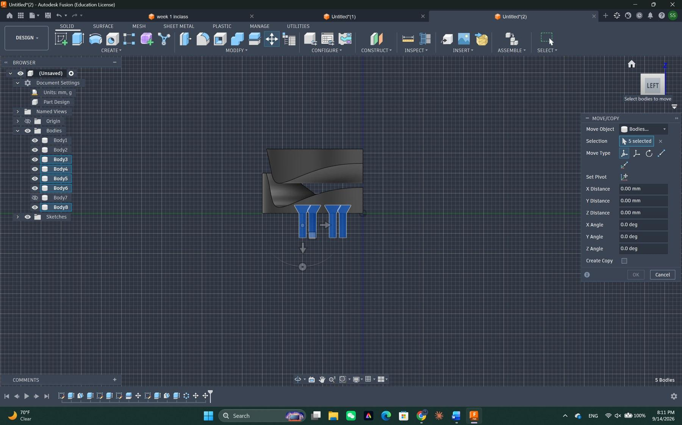
Move/Copy with five bodies selected
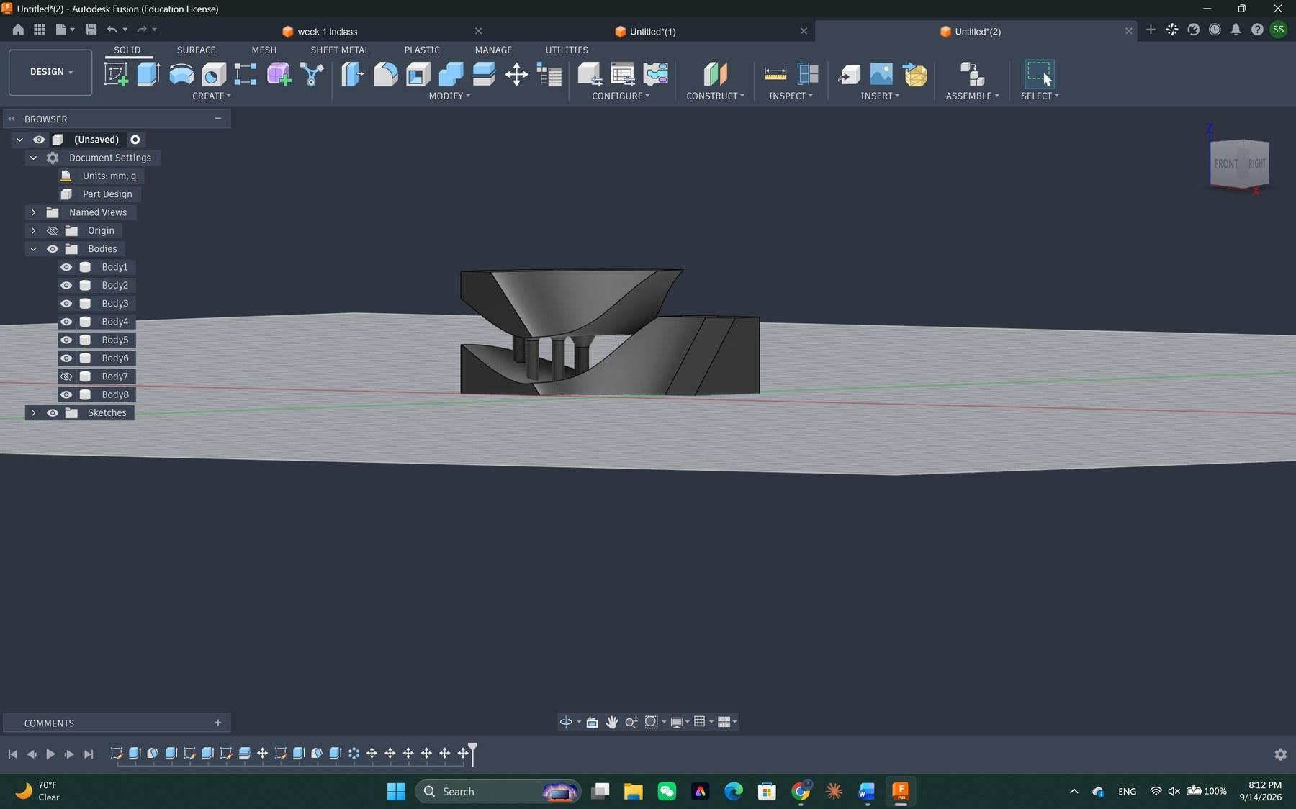
The columns now hold up the upper shell, with daylight between the two halves

Step 10 — Shell
I shelled the side wall to hollow it out. That gave the edge a few visible layers instead of one thick lump, and it made the whole thing look lighter.
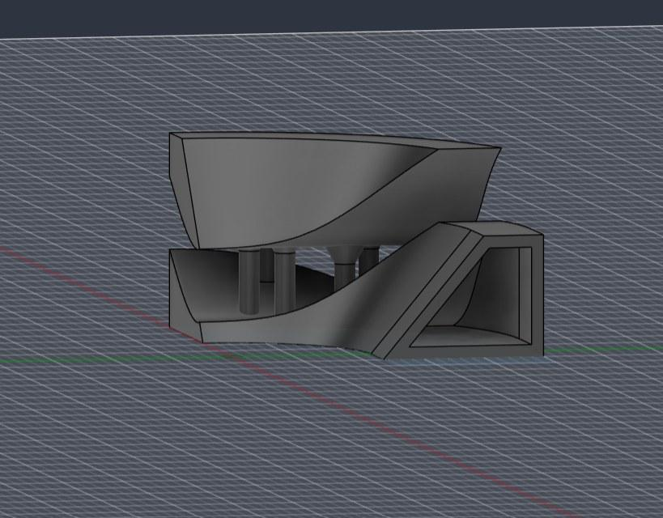
The side shelled out into thin layers

Step 11 — Add a box and draft it
I added a box next to the form and drafted that too, so the wall leans back instead of standing straight up. A leaning wall next to a round shell gives the model some tension.
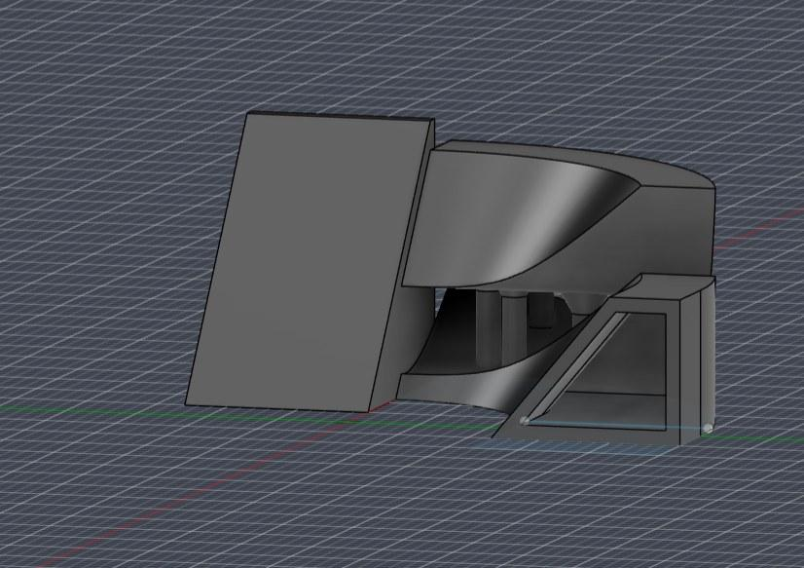
A box added beside the form and drafted so it leans
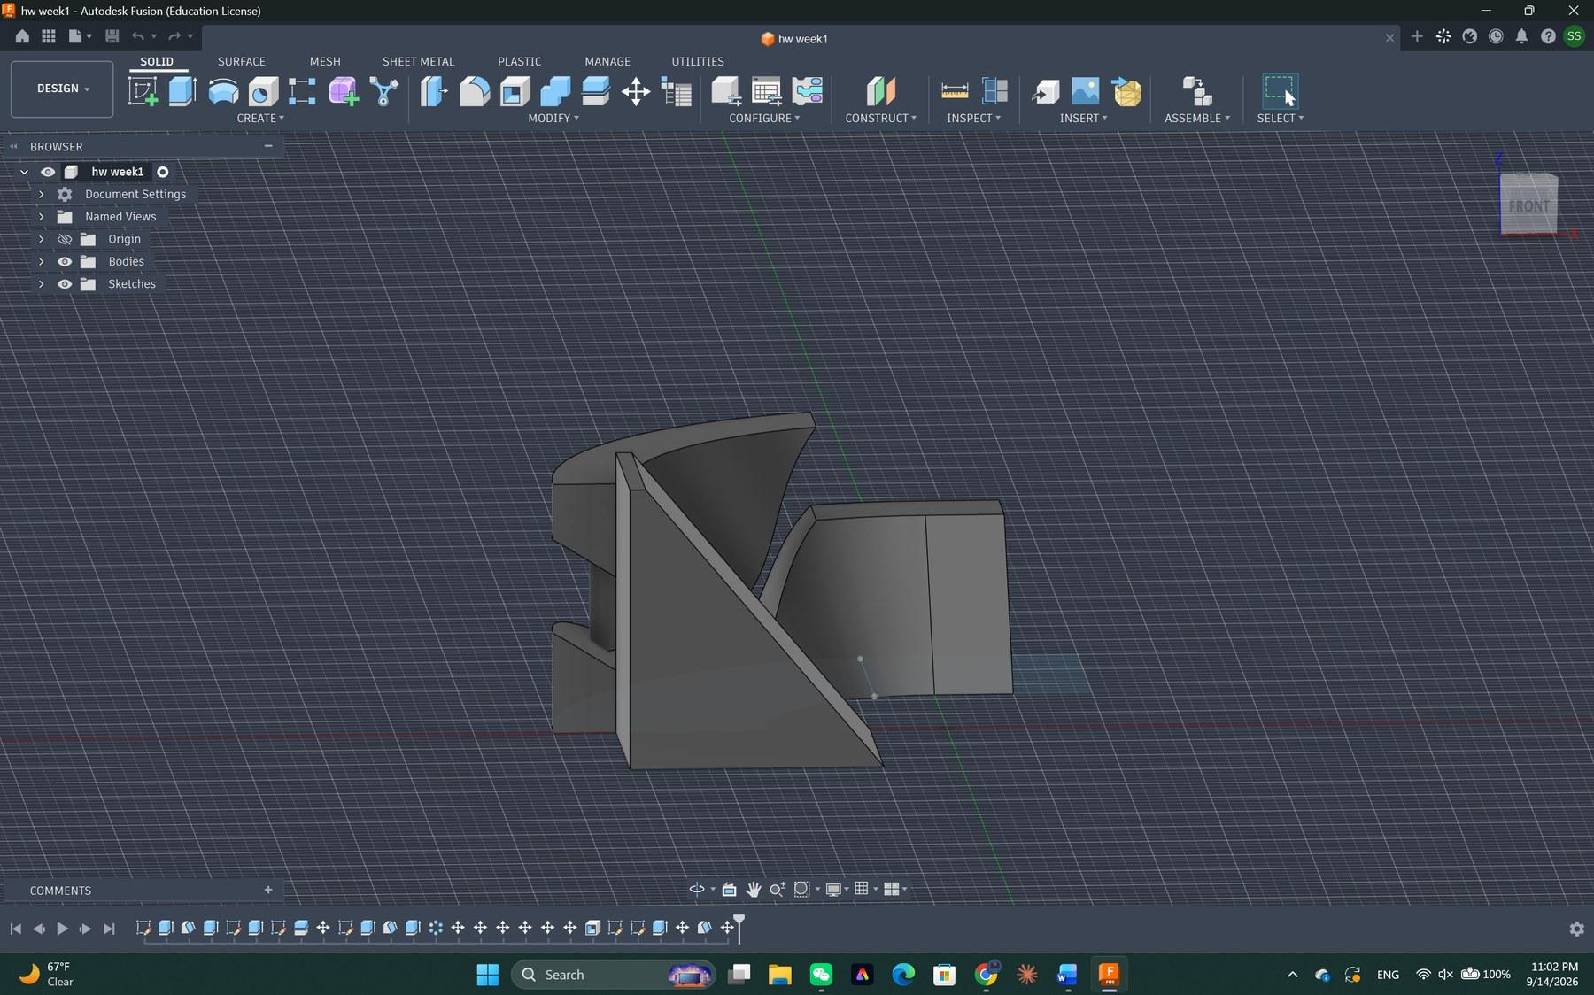
The drafted box seen against the main body

Step 12 — Position it and cut
I moved the box into place with Move/Copy and then cut it against the main body. That cut is what gave the leaning front wall its final profile.
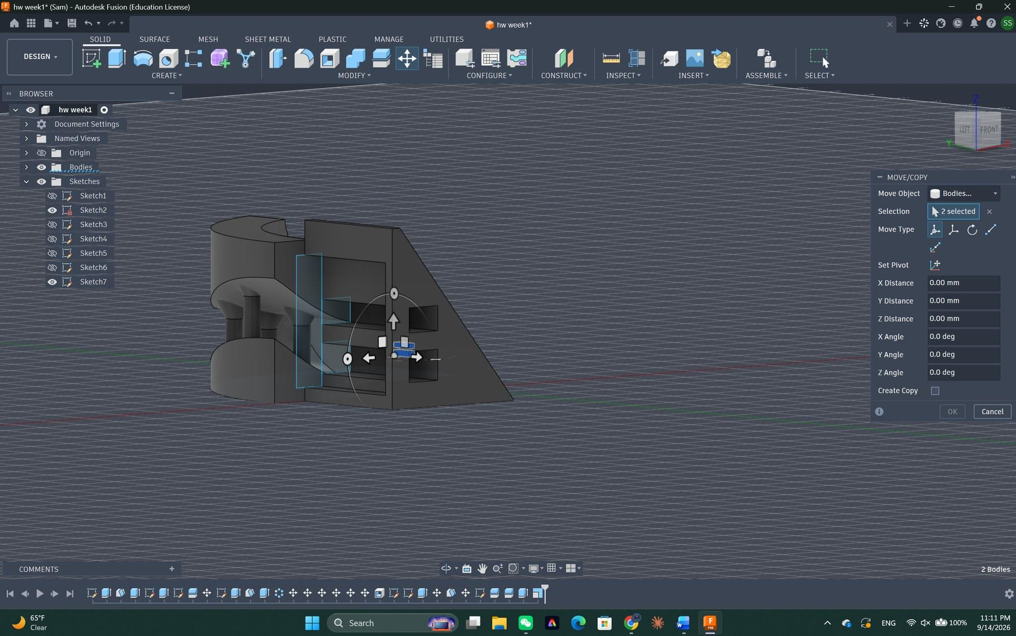
Move/Copy with two bodies selected, positioning the wall before the cut

Step 13 — Rectangular Pattern of small rectangles
Next I sketched one small rectangle and used a rectangular pattern to turn it into a full grid. The grid is not part of the object — it is a cutting tool, a comb I push into the wall.
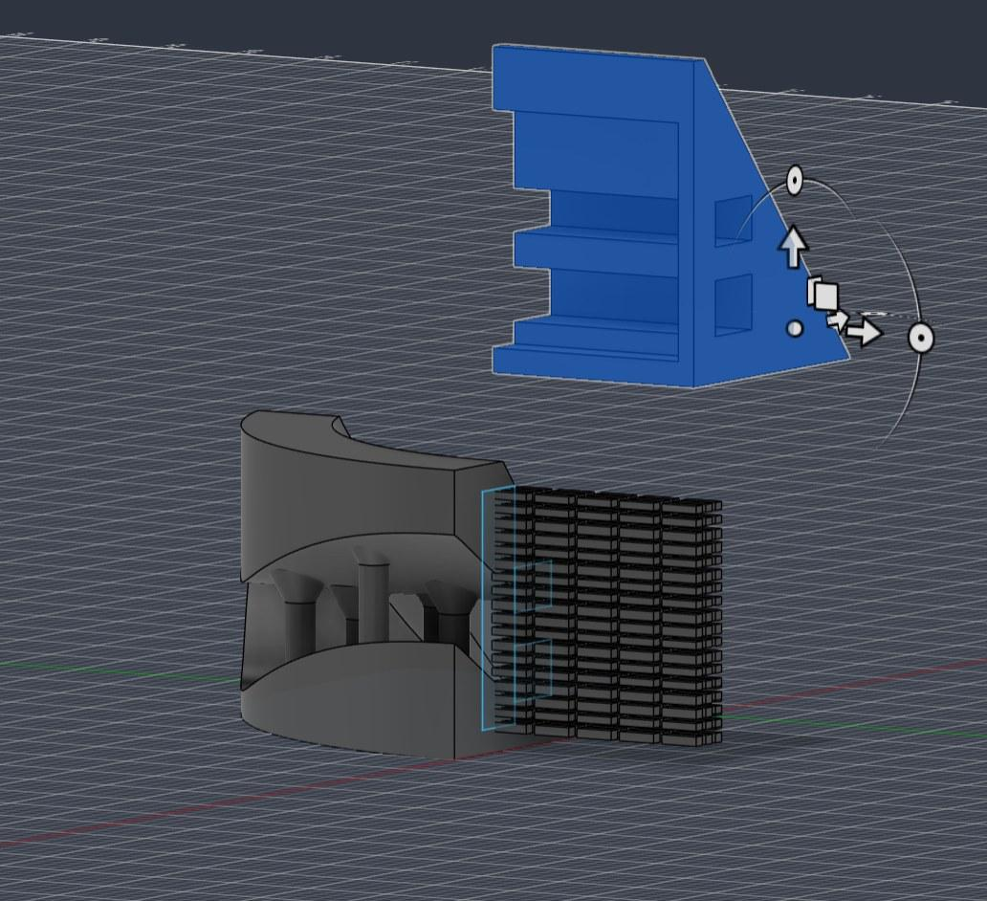
The patterned grid of small rectangles, sitting next to the drafted wall (blue)

Step 14 — Cut the slots
I cut that grid 6 mm deep into the wall. What comes out is a band of narrow horizontal slots — it reads like a vent, or like a stack of tiny windows in a facade. By this point the browser is full of pattern bodies, which is a bit messy but it works.
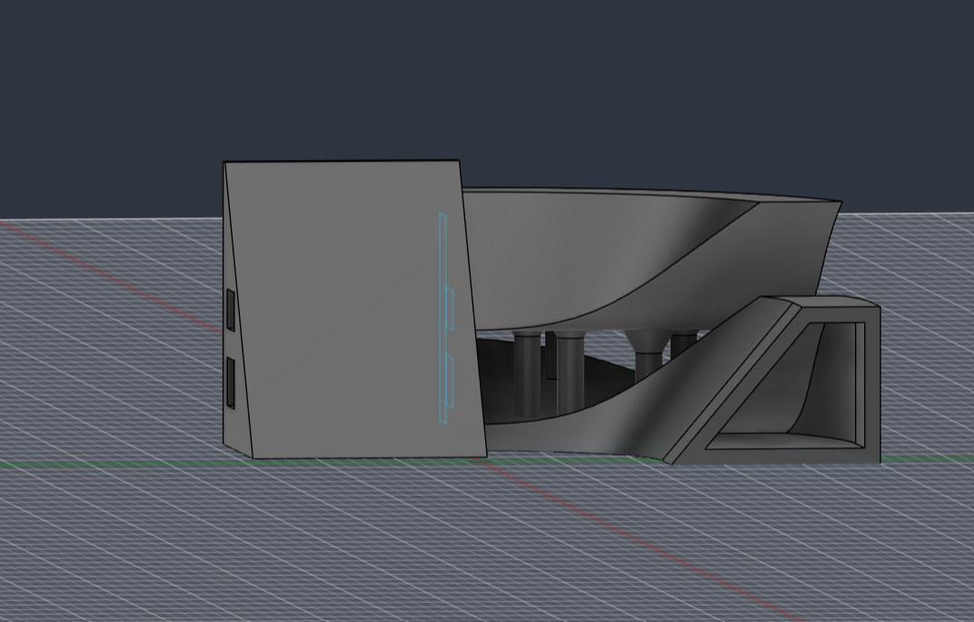
Front view — the slots cut into the leaning wall
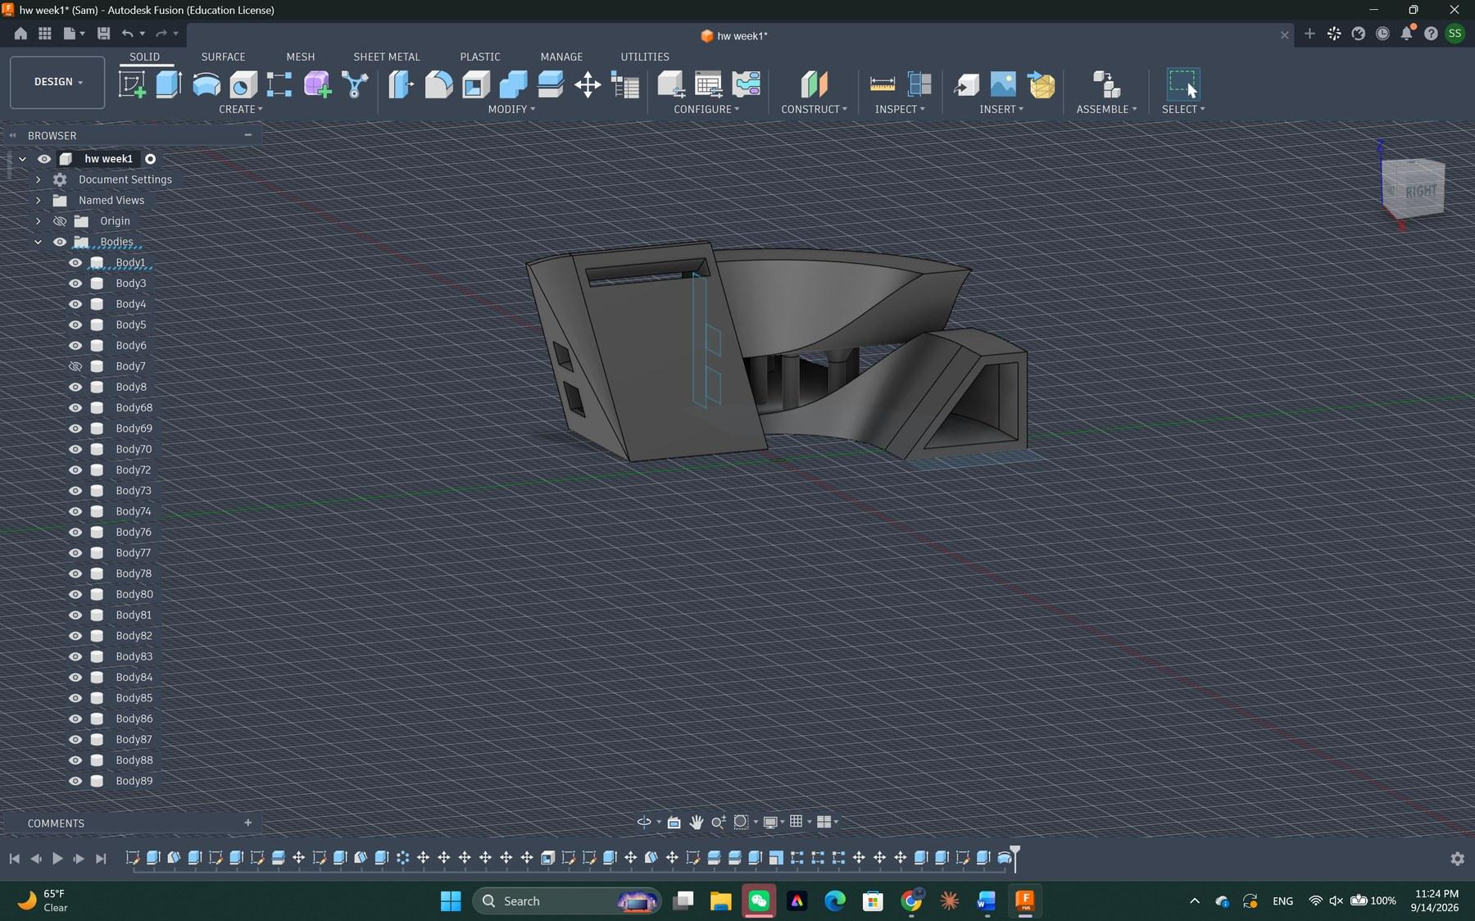
The body list after the pattern and the cut

Step 15 — Rotate the side to curve it
Finally I rotated the side panel so the edge curves instead of running dead straight. That small move is what ties the flat, angular wall back into the round part of the model.
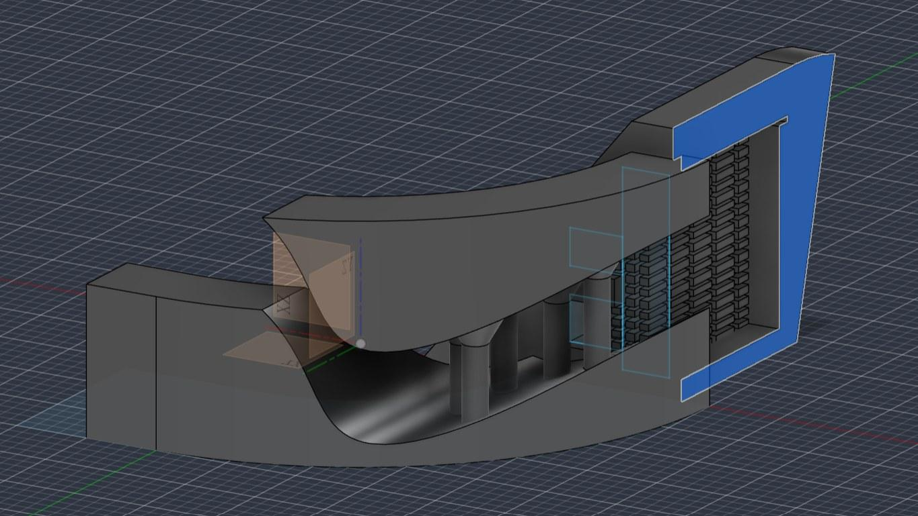
Rotating the side so the edge follows a curve
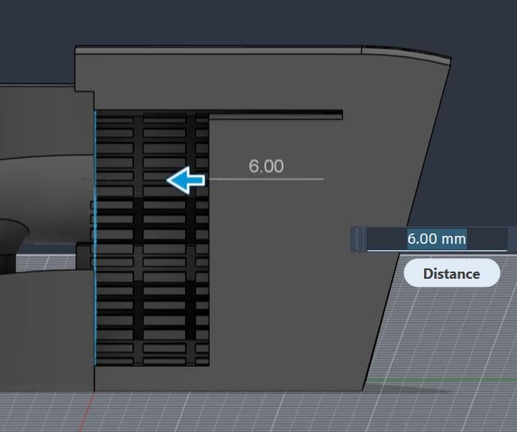
The slot cut measured at 6.00 mm deep

4. Final Dimensions
To check the size I drew a bounding rectangle over the model in the top view and measured the height from the side. The footprint came out at 74.000 mm by 53.000 mm, and the overall height is 41.16 mm.
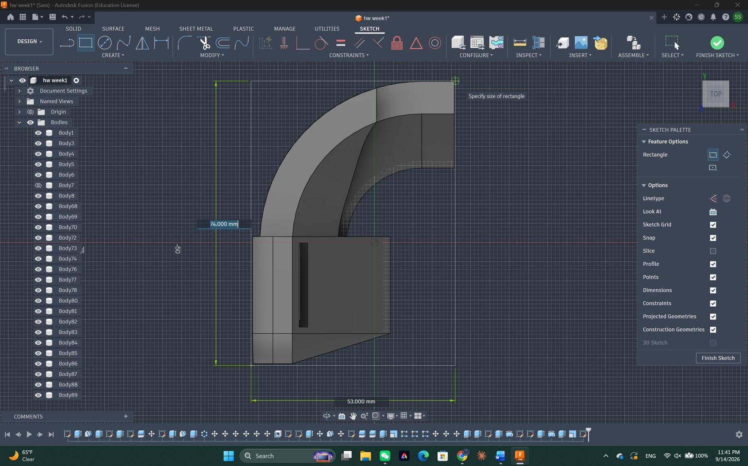
Top view — footprint measured at 74.000 mm × 53.000 mm
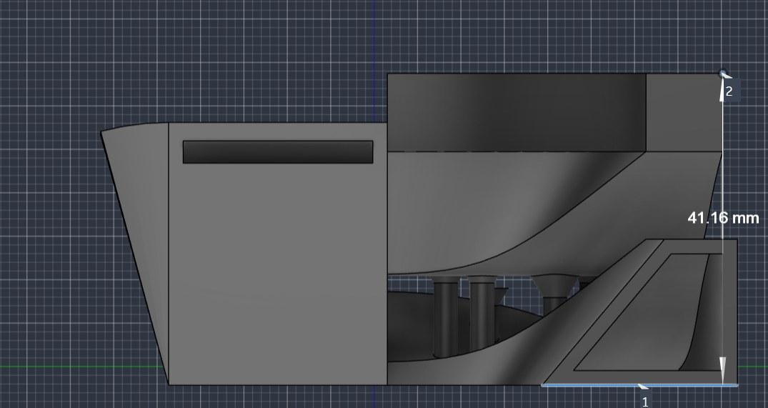
Side view — overall height 41.16 mm
Final size: 74 × 53 × 41 mm.

Axis | Millimeters | Inches | Check
X (width) | 74.00 mm | 2.91 in | fits in 3 in
Y (depth) | 53.00 mm | 2.09 in | fits in 3 in
Z (height) | 41.16 mm | 1.62 in | over 1.5 in

So the shortest side is 1.62 inches, which is over the 1.5-inch minimum, and the longest side is 2.91 inches, which still slides inside a 3-inch cube. Both requirements are met.

5. Commands Used
The assignment asked for at least five commands. I ended up leaning on about eleven:
- Sketch — Circle and Rectangle (the two circles, the cone profile, the small rectangles, the bounding box)
- Extrude — to turn the quarter ring, the columns and the box into solids
- Draft — 40° with Tangent Chain, the command that shaped the whole piece
- Split Body — to break the form into an upper shell and a lower base
- Move / Copy — to separate the halves and position the columns and the wall
- Circular Pattern — to array one cone into a ring of columns
- Rectangular Pattern — to array one small rectangle into a cutting grid
- Shell — to hollow the side wall into layers
- Combine / Cut — to cut the box and the slot grid into the main body
- Press Pull — to set the slot depth at 6.00 mm
- Measure — to confirm 74 × 53 × 41 mm at the end

_________________________________________________________________________________
Lastly there’s a question I would like to ask:
When using patterns in Fusion, I sometimes end up with dozens of separate bodies, and many of them are not physically connected, so I cannot simply use Combine to join them. And unable to do so slows my PC so much. Is there a better way to organize or manage these separate patterned bodies without cluttering the Browser?

