Sushi Soy-Sauce Dipping Station
Sam Shii ss19608
AI Disclosure: To improve readability and presentation for your review, I used claude to polish the wording and format based on my original notes, without changing the underlying content.

1. The Problem
Dipping sushi into soy sauce sounds trivial, but it is the most fragile moment of a sushi meal. I started by sketching the failure out, frame by frame, the way it actually happens at the table.
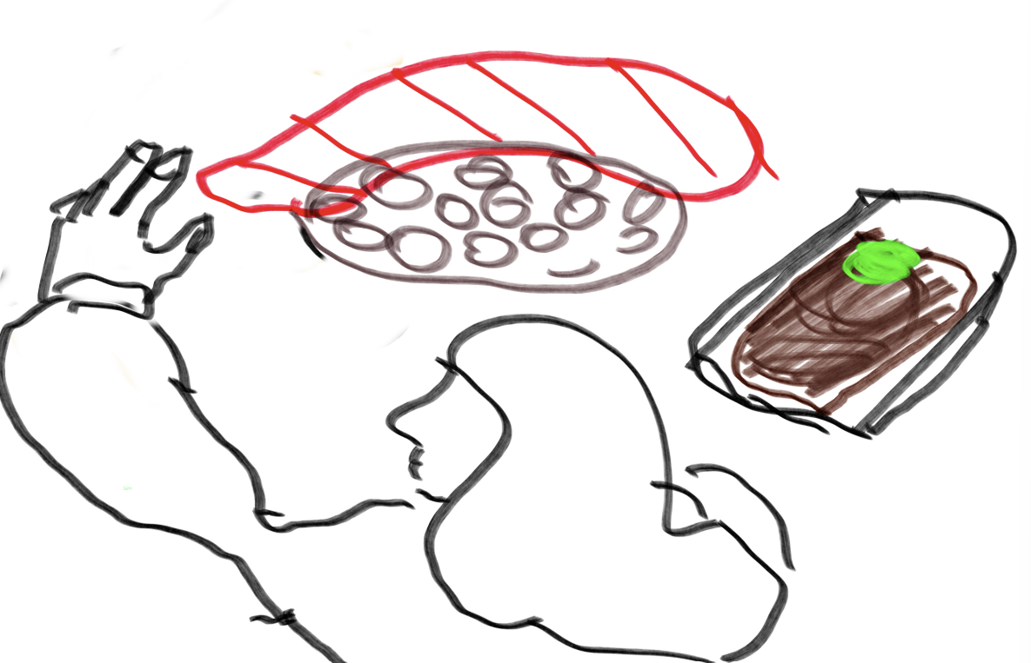
Sketch 1 — When you eat sushi, you have to dip the piece into soy sauce before eating it. That means lifting a soft, top-heavy object and carrying it over to a shallow dish.
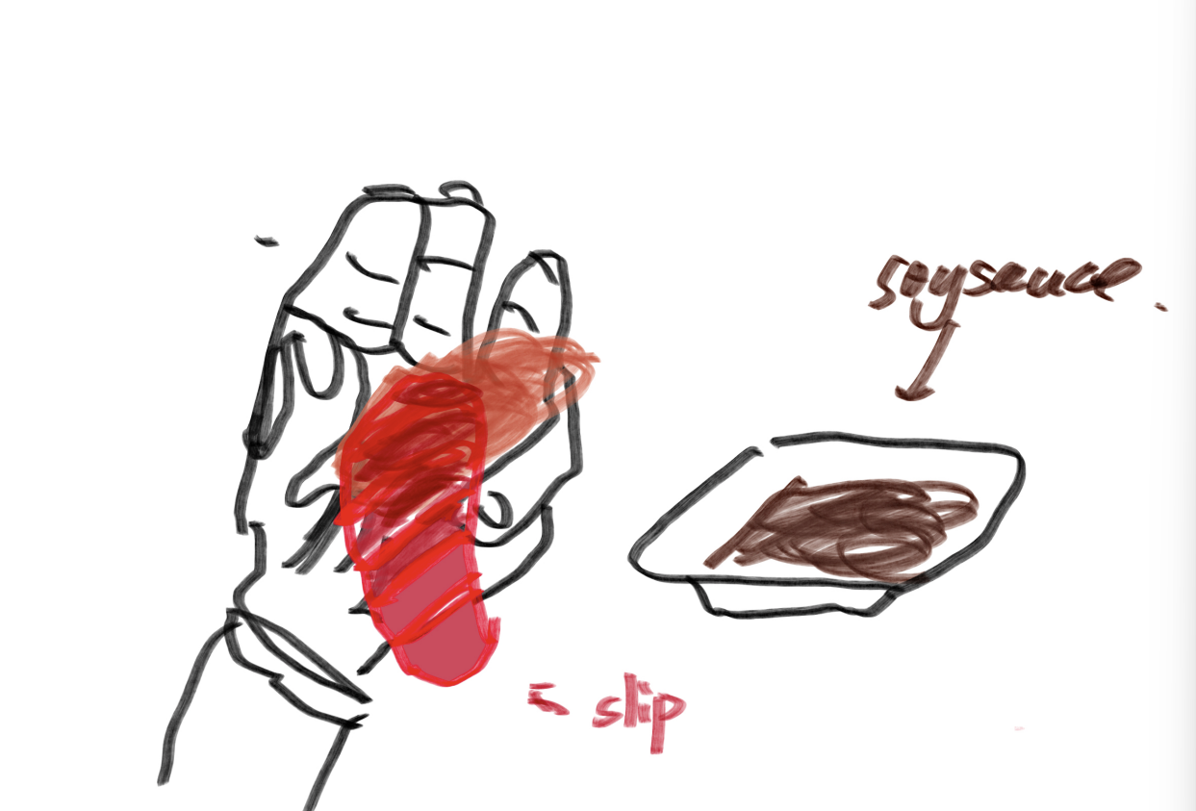
Sketch 2 — Any improper way of handling the piece while it is tilted lets the sashimi slide off the rice. Nothing holds the two together except a thin smear of wasabi.
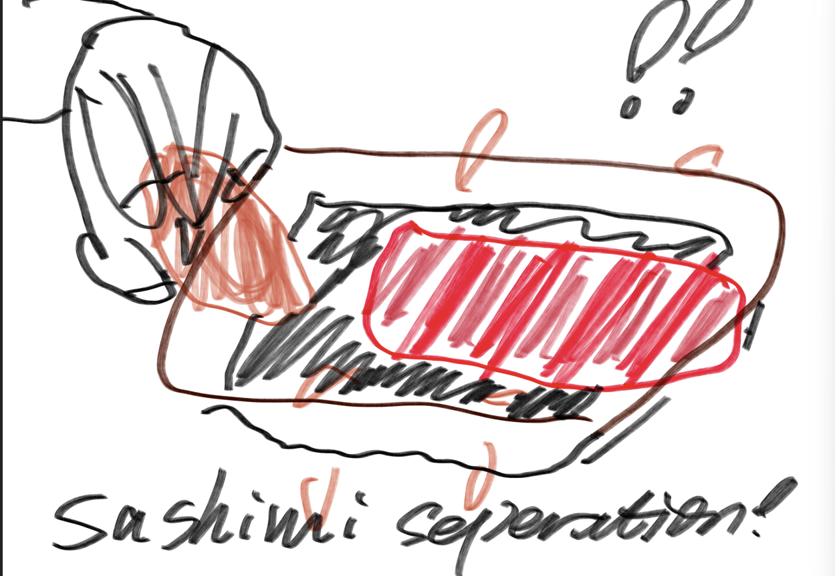
Sketch 3 — "Sashimi separation." In the worst case the fish falls into the soy sauce and is severed from the rice ball completely: the slice is over-salted, the rice is dry, and the bite is ruined.
Sketching it made the root cause obvious. The sushi has to travel to the sauce, and travelling is exactly what breaks it. Every design that keeps that trip — a deeper dish, a wider dish, a better grip — is still fighting gravity with a loose stack of rice and fish.
So I inverted the problem: keep the sushi completely still, and bring the sauce to it instead.

2. The Idea
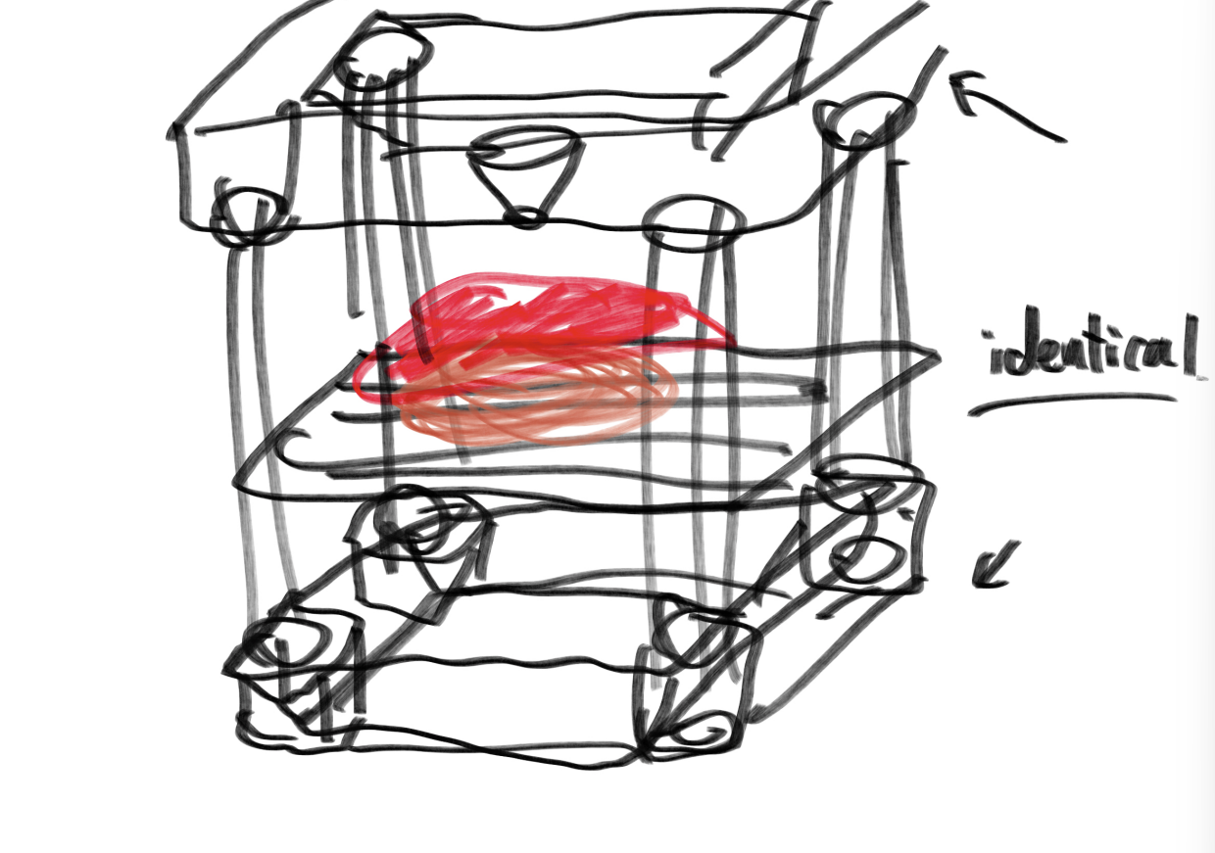
Sketch 4 — First concept. Two identical funnels, one above and one below, with the sushi resting on a scaffold in the middle.
The object is a sushi soy-sauce dipping station made of two identical funnels and one scaffold (a perforated tray on four pillars) that holds the sushi between them. Each funnel has a small drain hole in the bottom of its cone and a flat slide — the puller — that plugs that hole until you want the sauce to move.

How you use it
- Put the piece of sushi on the tray in the middle of the scaffold.
- Pour soy sauce into the upper funnel. Its puller is closed, so the sauce simply pools in the cone.
- Withdraw the puller. The sauce drains through the 2 mm hole, falls onto the sashimi, runs through the openings in the tray, and is caught by the lower funnel.
- The lower funnel keeps its puller closed, so the sauce collects there instead of leaking onto the table.
- To dip again, swap the two funnels. Because they are identical, the one that just collected the sauce becomes the one that pours it — no sauce is wasted and nothing has to be refilled.
The sushi never moves, never tilts, and is never gripped. The sauce does all the travelling.
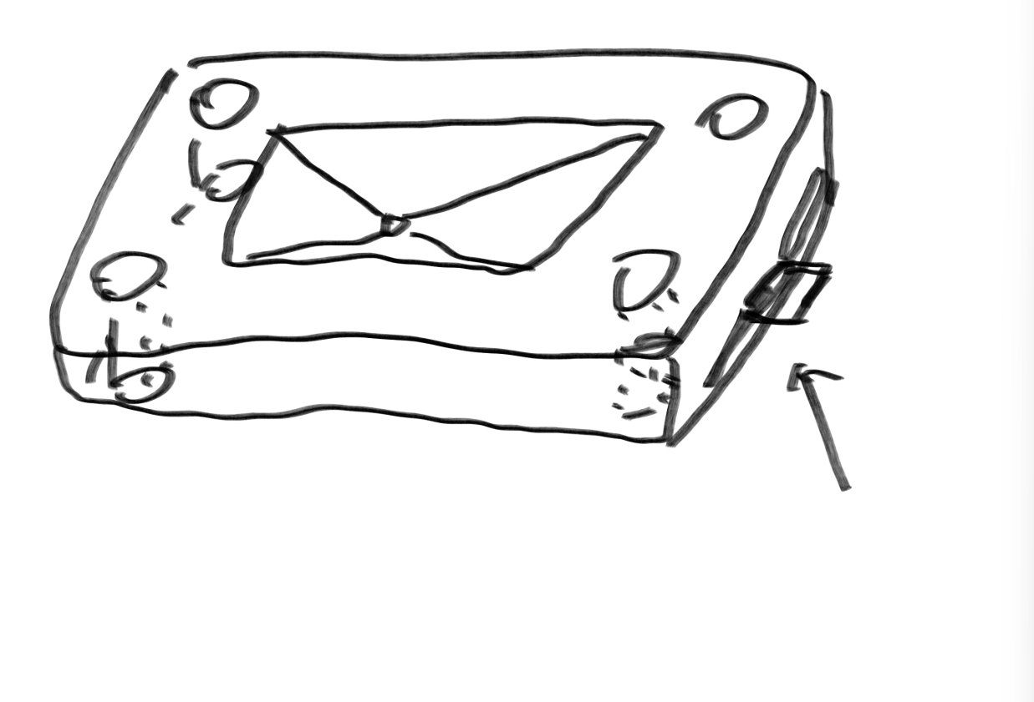
Sketch 5 — The funnel from above: four corner holes for the pillars, the drafted inner cone with the drain hole at its lowest point, and the puller slot entering from the right-hand side.
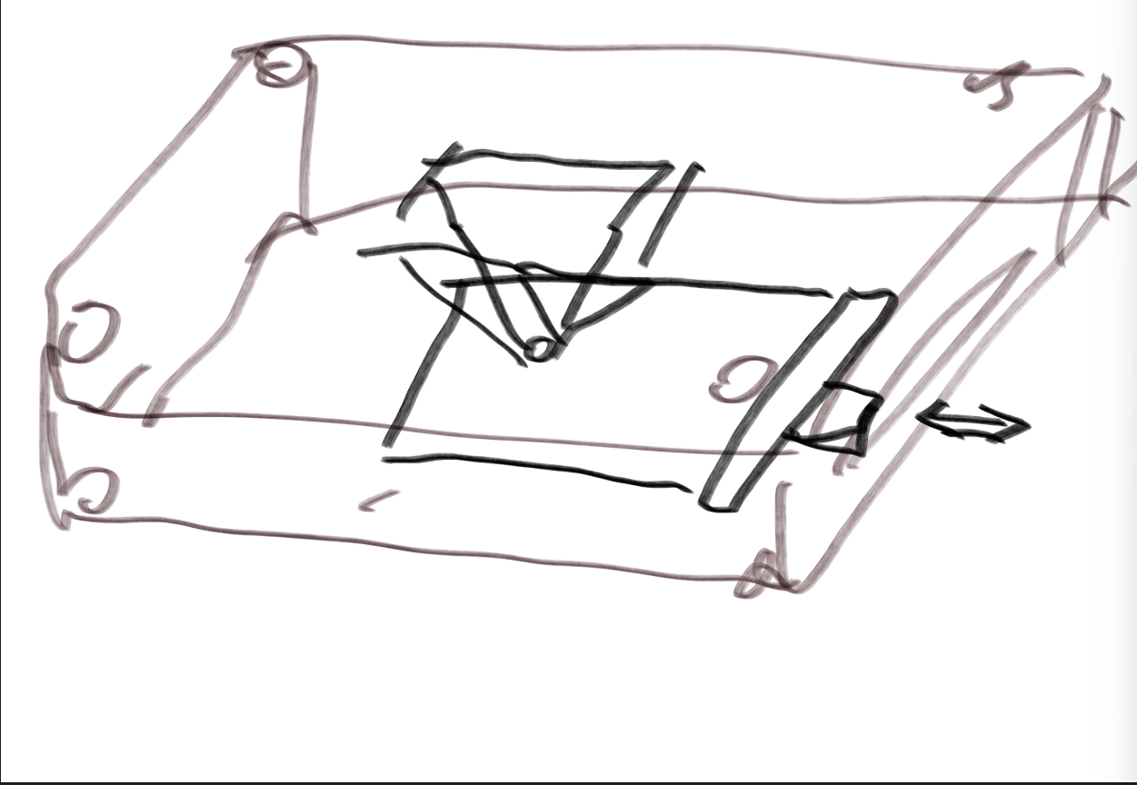
Sketch 6 — A closer look at where the puller sits. It slides in horizontally, just under the bottom of the cone, and seals the drain hole from below.
The puller has a slight bend at its outer end so it can be gripped and withdrawn smoothly, without the user having to reach over the sauce or press down on the funnel.

How the parts fit together
Every joint in this object is a clearance fit — nothing is glued, and nothing is a permanent joint. This is what lets the two funnels be swapped over and over during a meal:
- Puller ↔ funnel. The puller was scaled to 0.99 of the slot it runs in, so it slides freely but still covers the drain hole when pushed home.
- Pillars ↔ funnels. The four corner holes in both funnels are slightly larger than the ⌀10 mm pillars, so a funnel can be lifted straight off and refitted in any orientation.
- Tray ↔ pillars. The tray sits on the pillars at mid-height, dividing the stack into an upper pouring half and a lower catching half.
Symmetry is doing real work here. The funnel sketch is constrained to be perfectly symmetrical — all four corner circles sit at the midpoints of the diagonals and all diagonals are equal — because any asymmetry would cause alignment trouble every time the funnels are swapped.

3. Modeling Process
Below is the step-by-step record of building the model in Autodesk Fusion.

3.1 The funnel
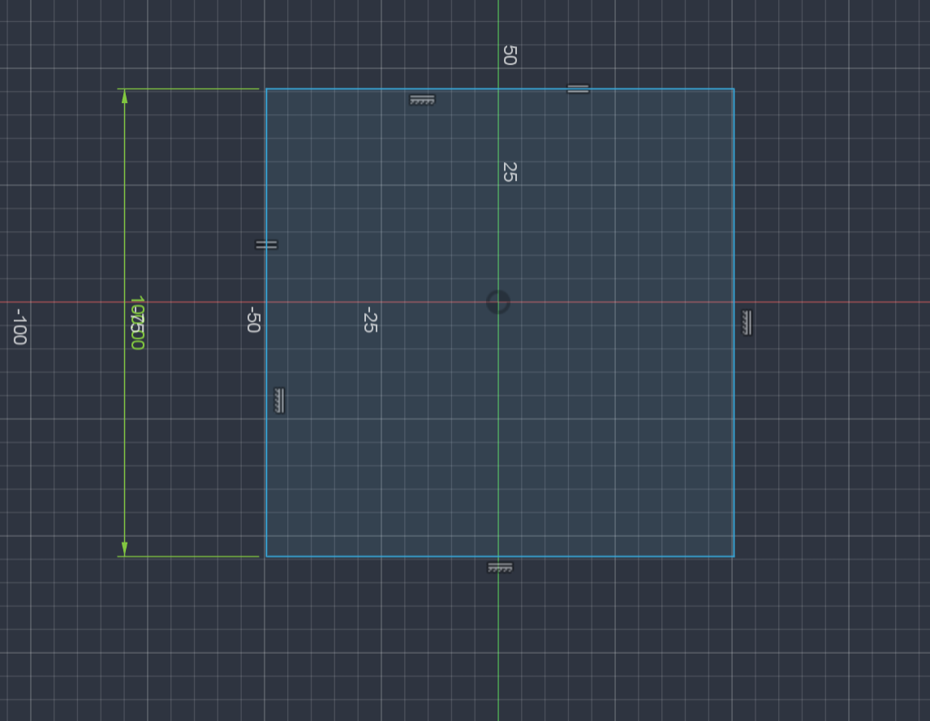
Step 1 — Start from a 100 × 100 mm square: the footprint of the whole object.
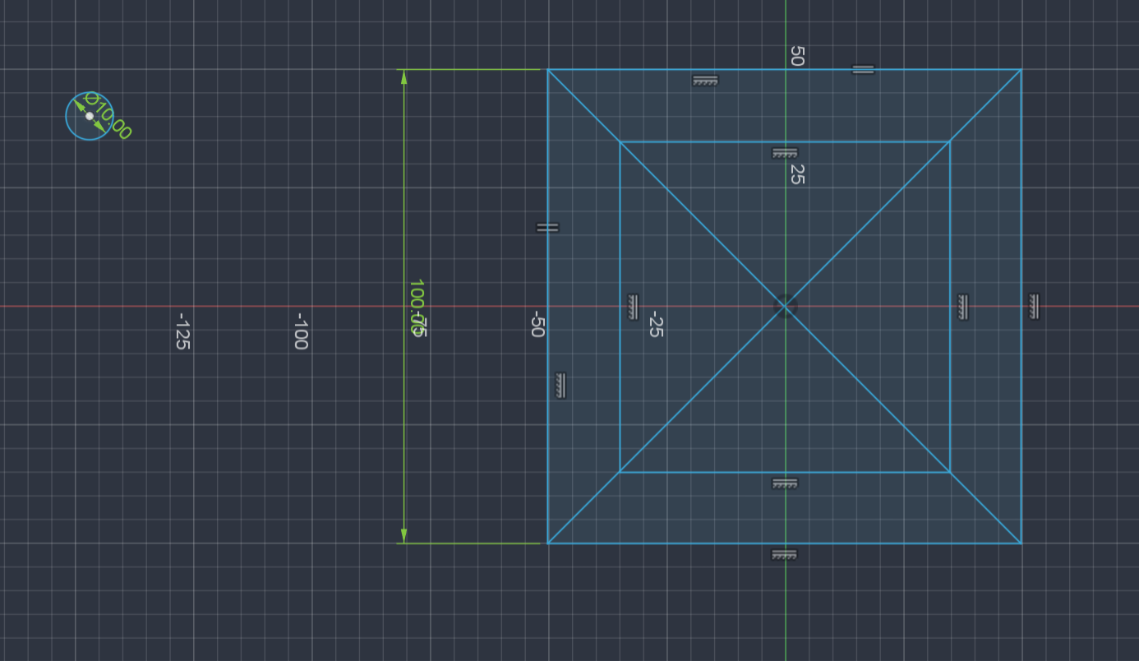
Step 2 — Offset an inner square and draw both diagonals as construction lines, keeping the sketch perfectly symmetrical (asymmetry causes alignment trouble while using the gadget).
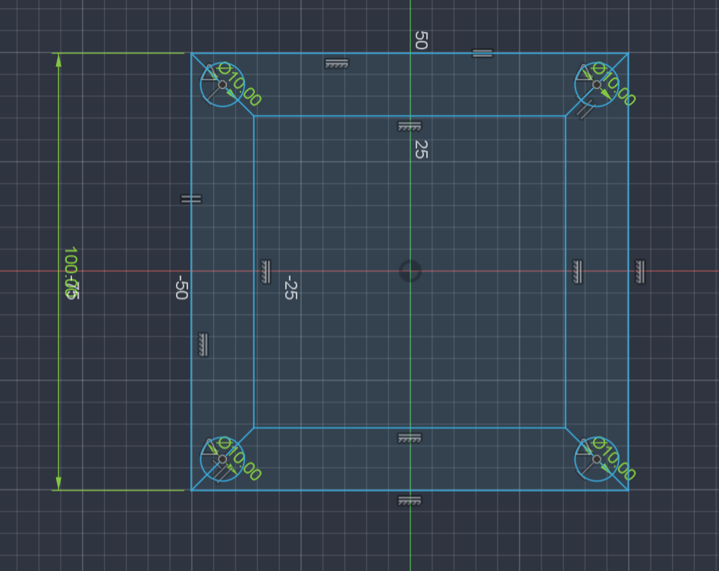
Step 3 — Add ⌀10 mm circles at the four corners, then add constraints: all circles sit at the midpoints of the diagonal lines, and all diagonal lines are equal.
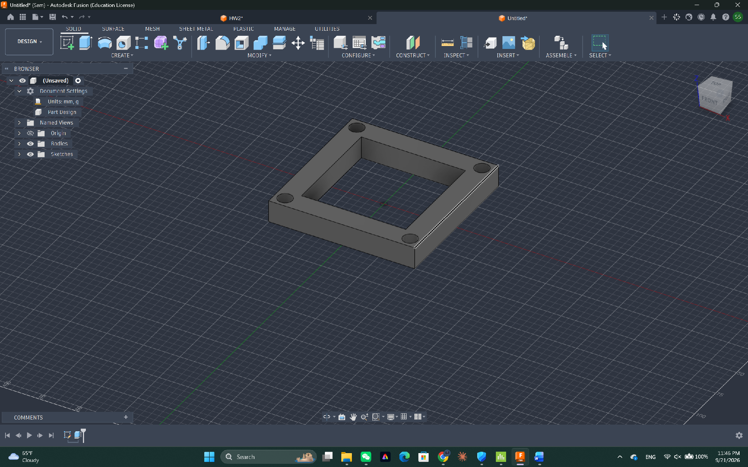
Step 4 — Extrude the outer ring 15 mm to form the wall of the funnel.
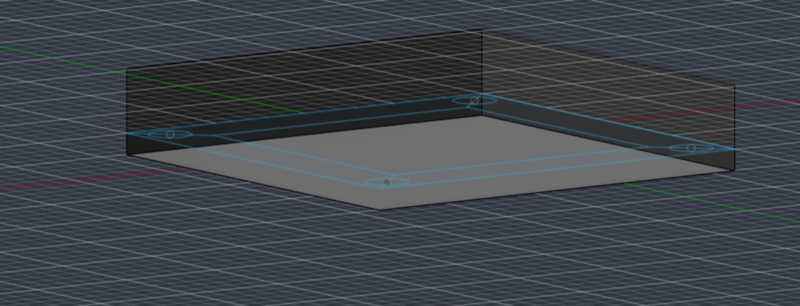
Step 5 — Extrude the bottom 5 mm to close the funnel off underneath.
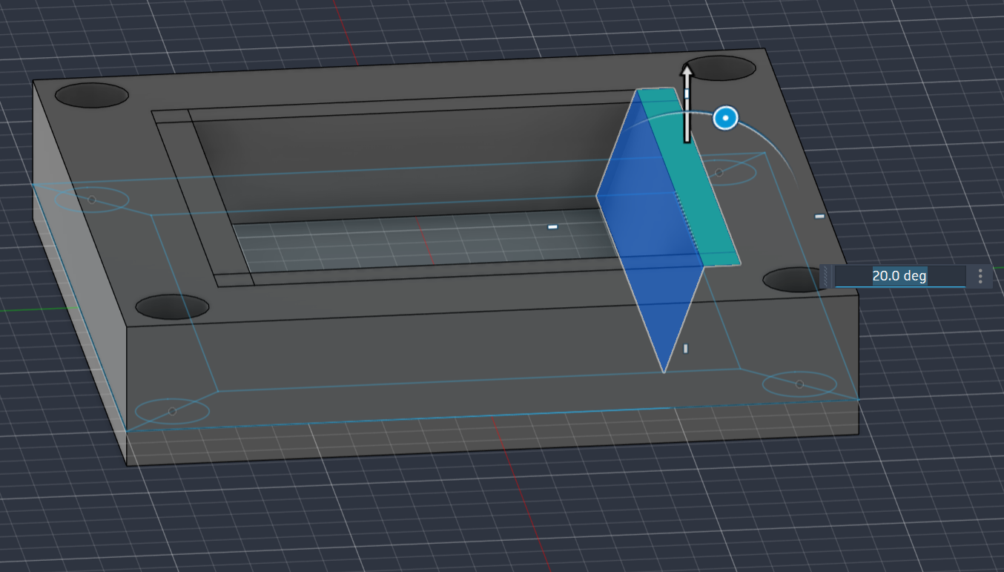
Step 6 — Extend all four inner sides by 5 mm with a 20° draft angle, turning the cavity into a cone that feeds everything toward the centre.
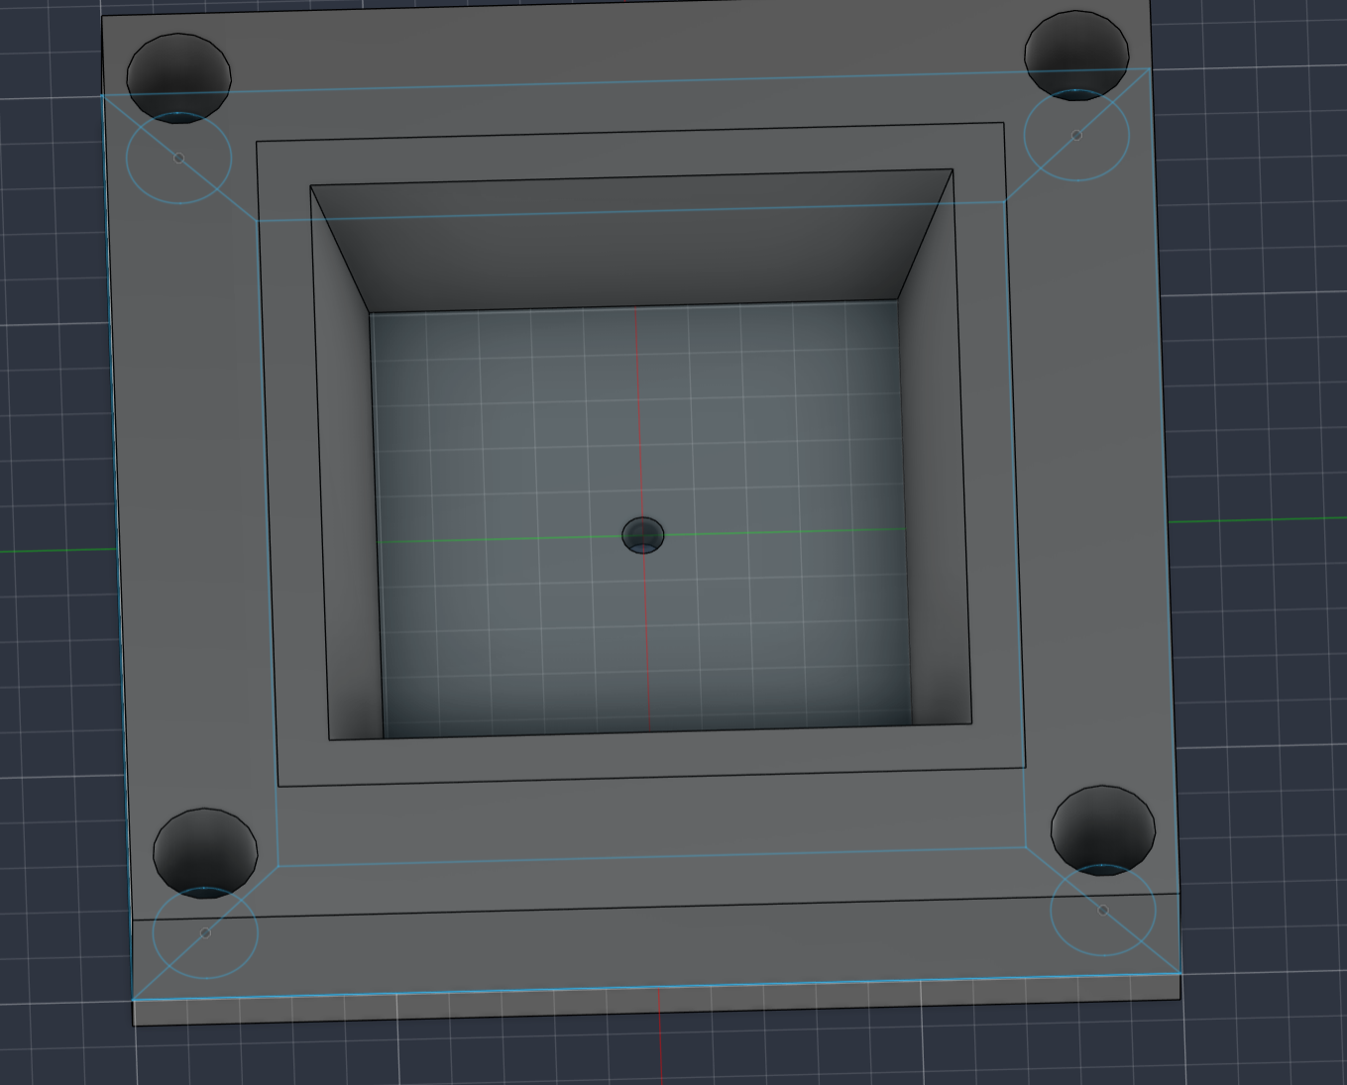
Step 7 — Drill the sauce-dipping hole, ⌀2 mm, at the lowest point of the cone. Small enough to drip rather than pour.
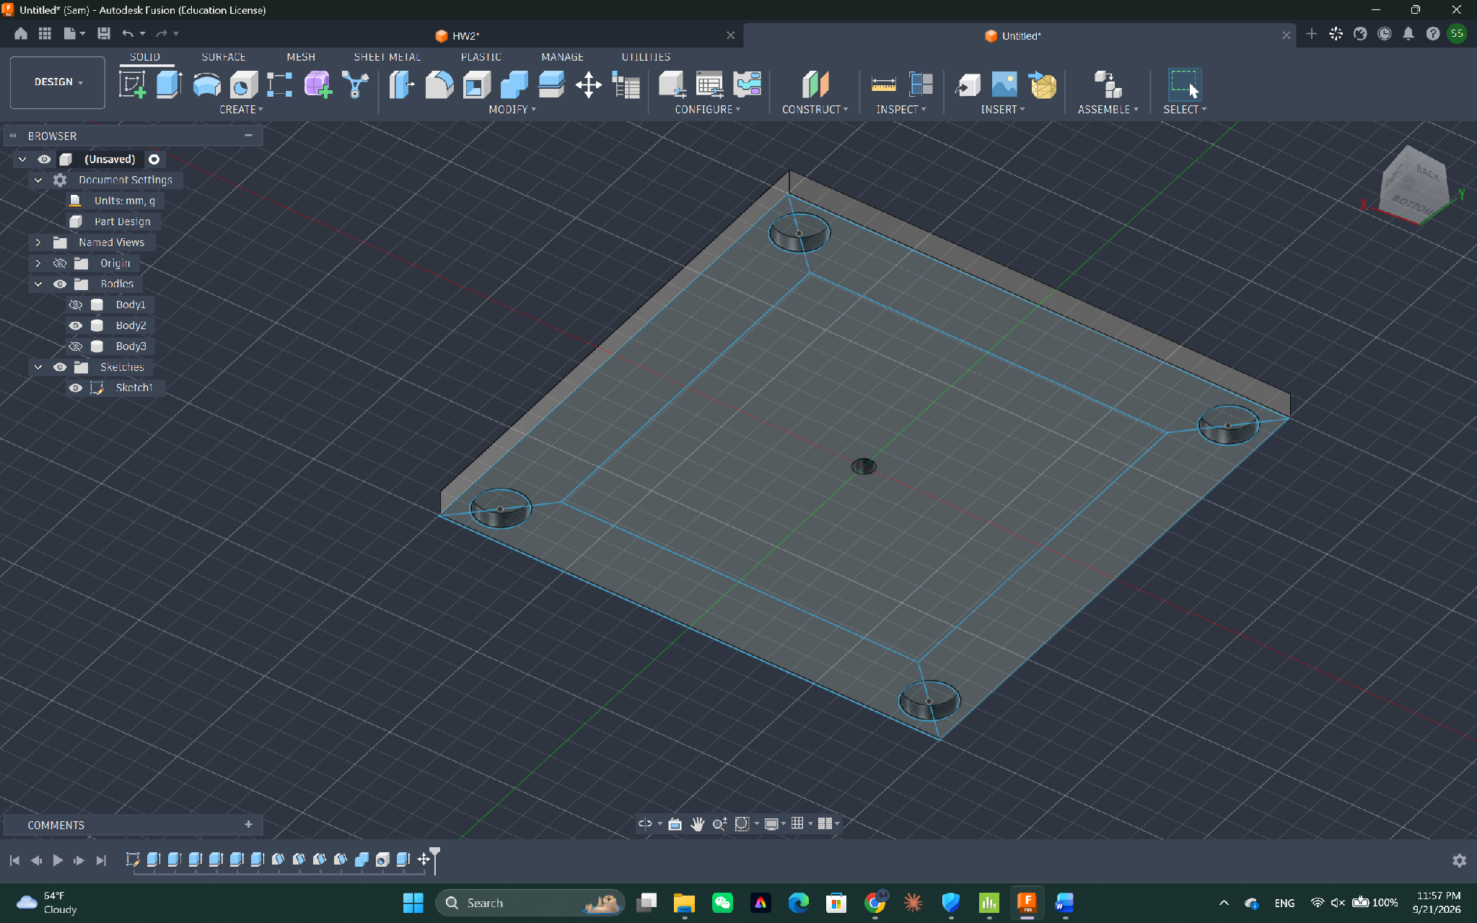
Step 8 — The bottom face carries the same four corner holes, which is how the funnel receives the pillars of the scaffold.
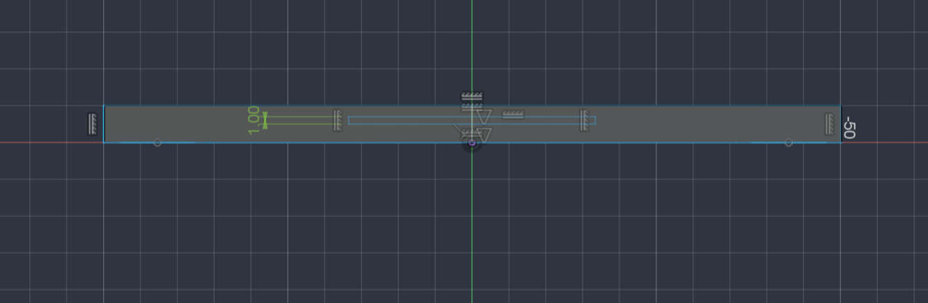
Step 9 — On the lower side, open a slot (a "sink") for the puller to slide through — visible here as the 1 mm gap in the side view.
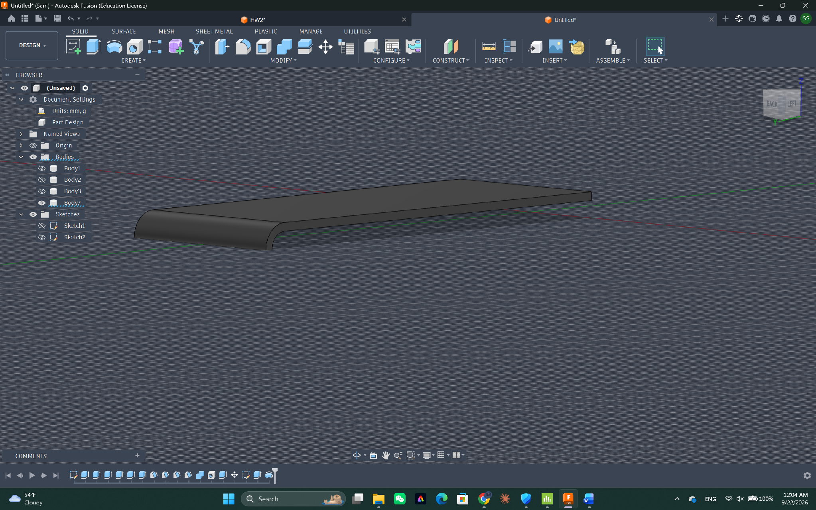
Step 10 — The puller itself: a thin flat slide with a slight bend at the outer end so it can be gripped and withdrawn easily.
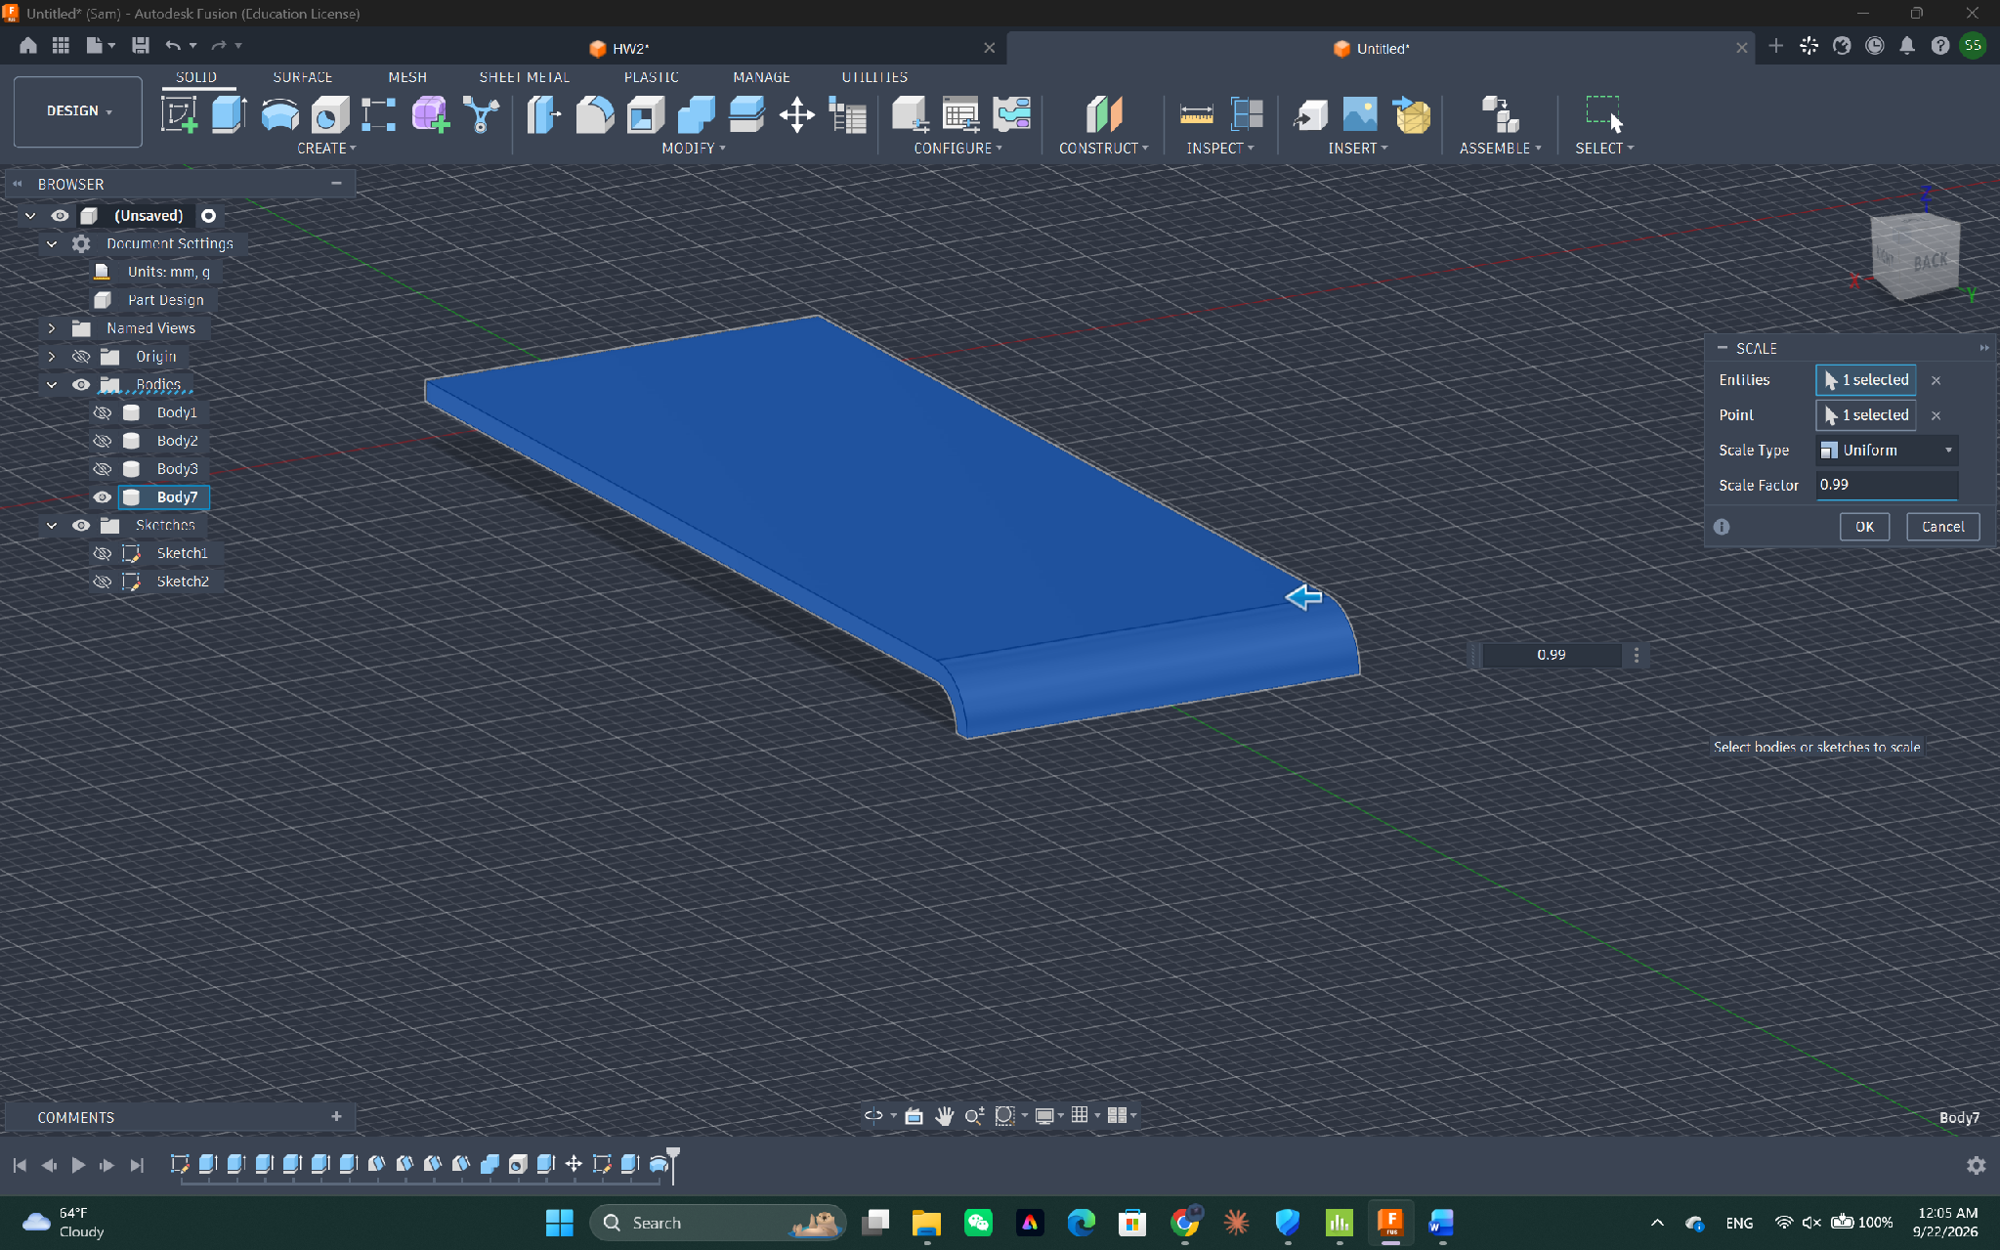
Step 11 — Scale the puller uniformly to 0.99 so it is slightly smaller than the slot and can be pulled smoothly — the clearance that makes this a working fit rather than a jam.
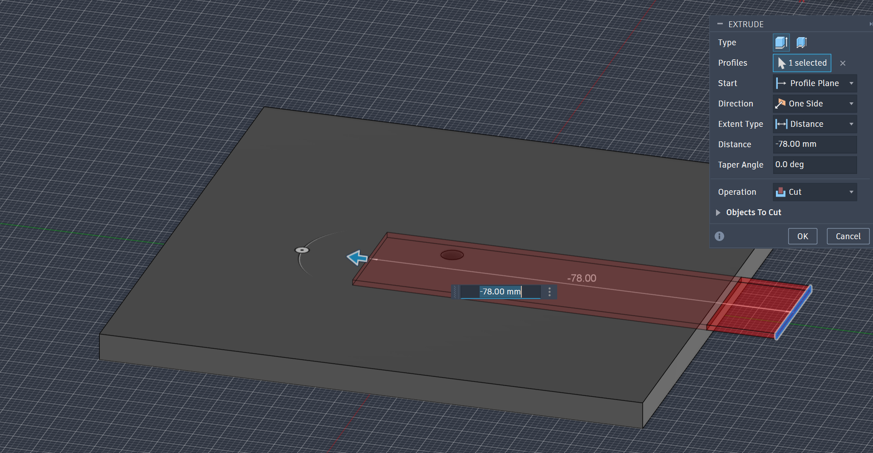
Step 12 — Cut the slot: an extrude-cut of −78 mm driven by the puller profile, so the channel matches the part exactly.
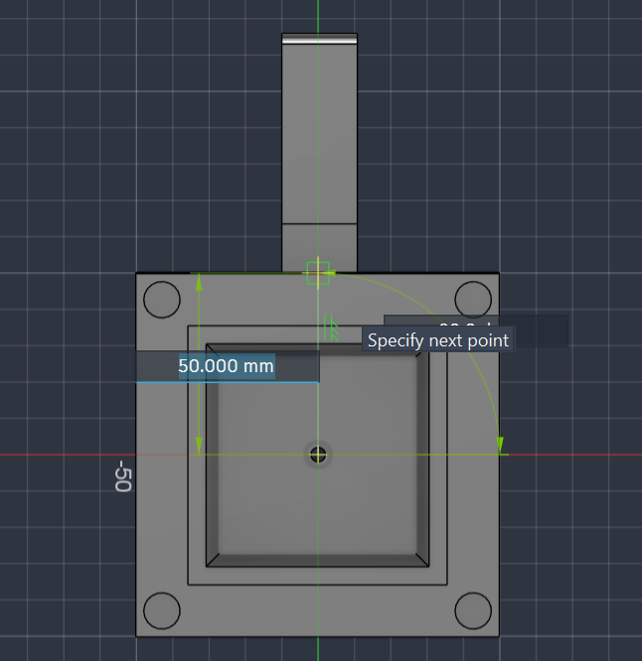
Step 13 — Top view with the puller inserted, positioned 50 mm from the edge so it passes directly under the drain hole.
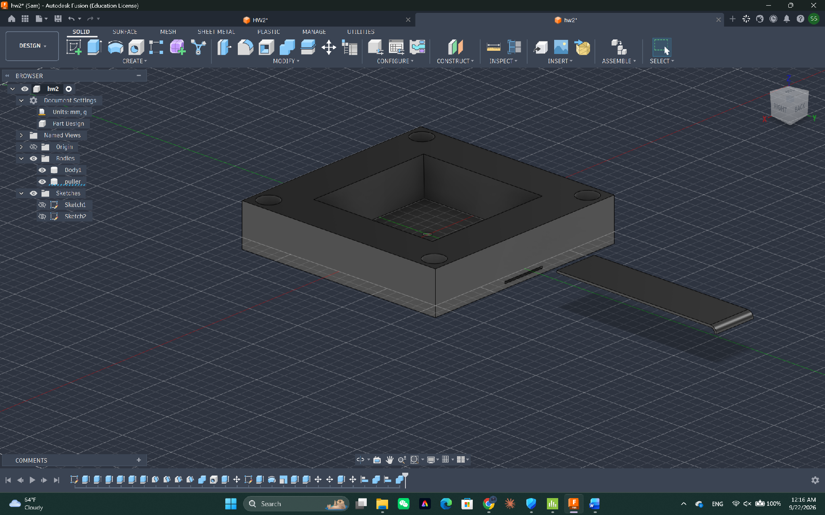
Step 14 — Combine the bodies so the funnel reads as one whole part, with the puller as a separate body inside it.
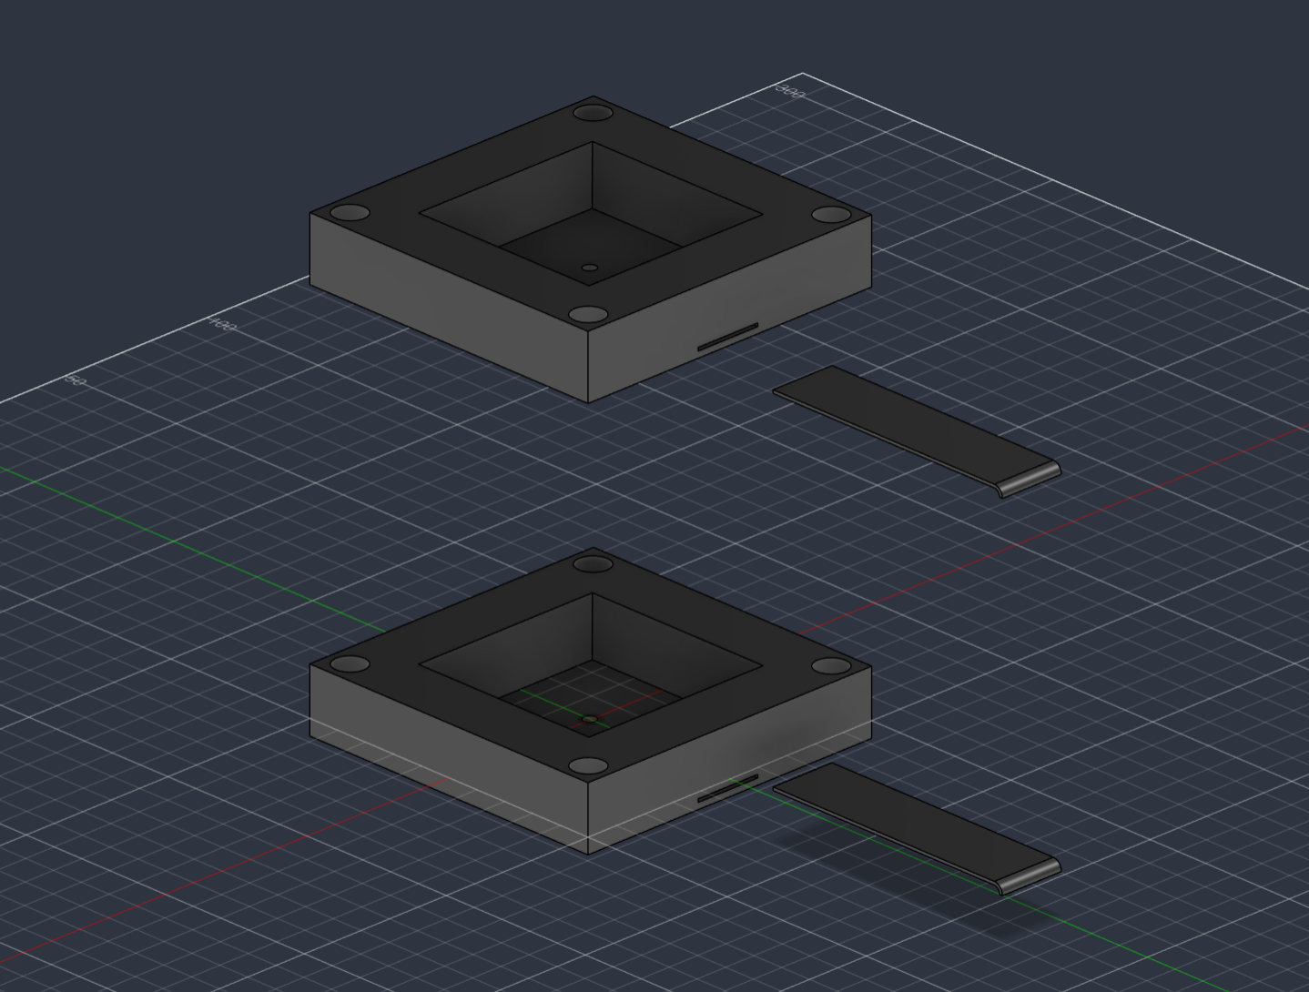
Step 15 — Duplicate the finished funnel. The second copy is identical, which is the whole point: the two halves are interchangeable.

3.2 The scaffold
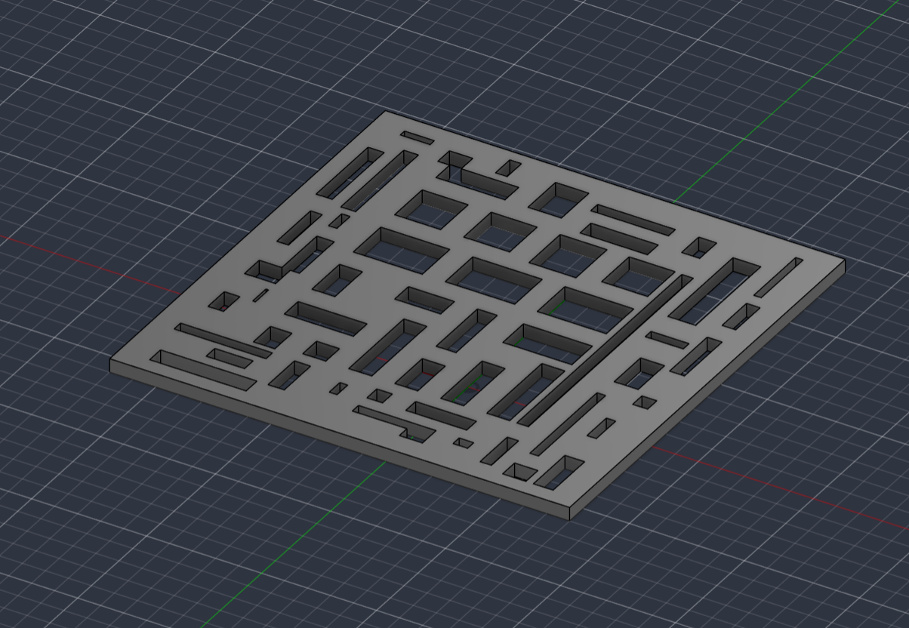
Step 16 — The sushi plate. The sushi sits on top, and the openings let the soy sauce run straight through to the funnel below instead of pooling under the rice.
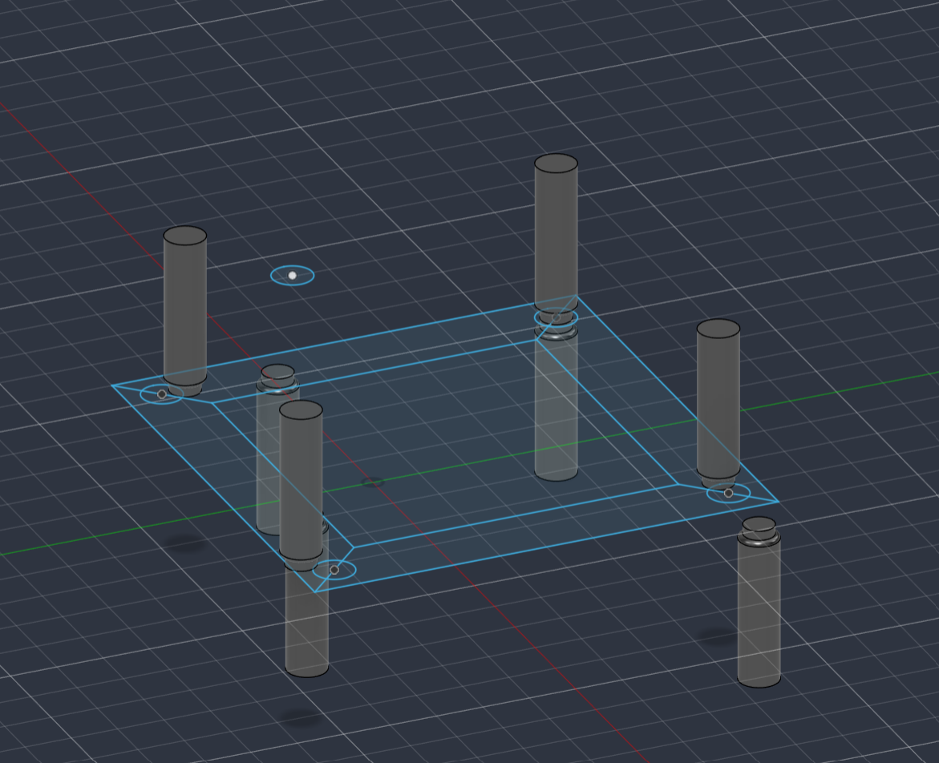
Step 17 — Make the pillars: four ⌀10 mm cylinders that set the spacing between the two funnels.
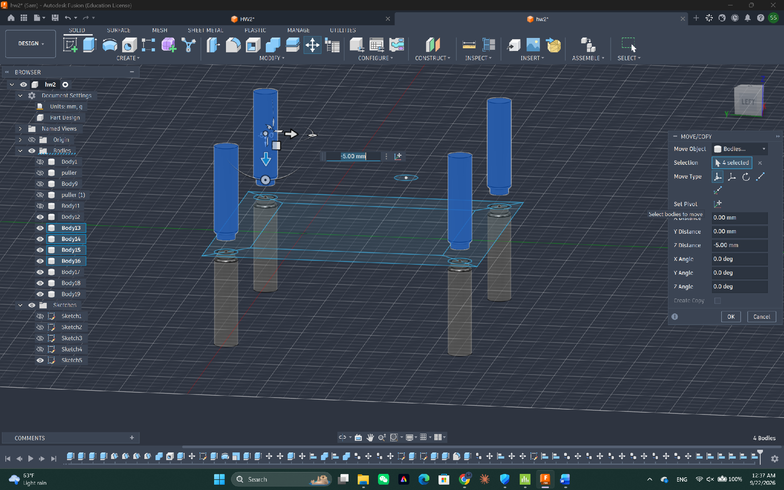
Step 18 — Align the pillars onto the frame using Move/Copy, dropping the selected bodies −5 mm in Z so they seat into the plate.
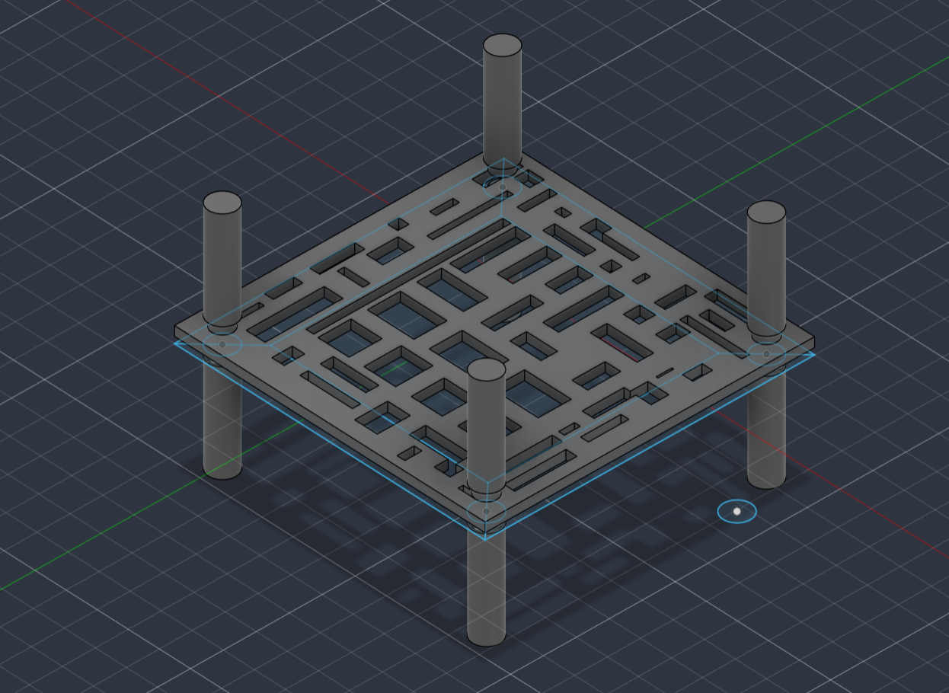
Step 19 — Fit the plate to the correct position along the pillars — at mid-height, so there is room to pour above and room to collect below.
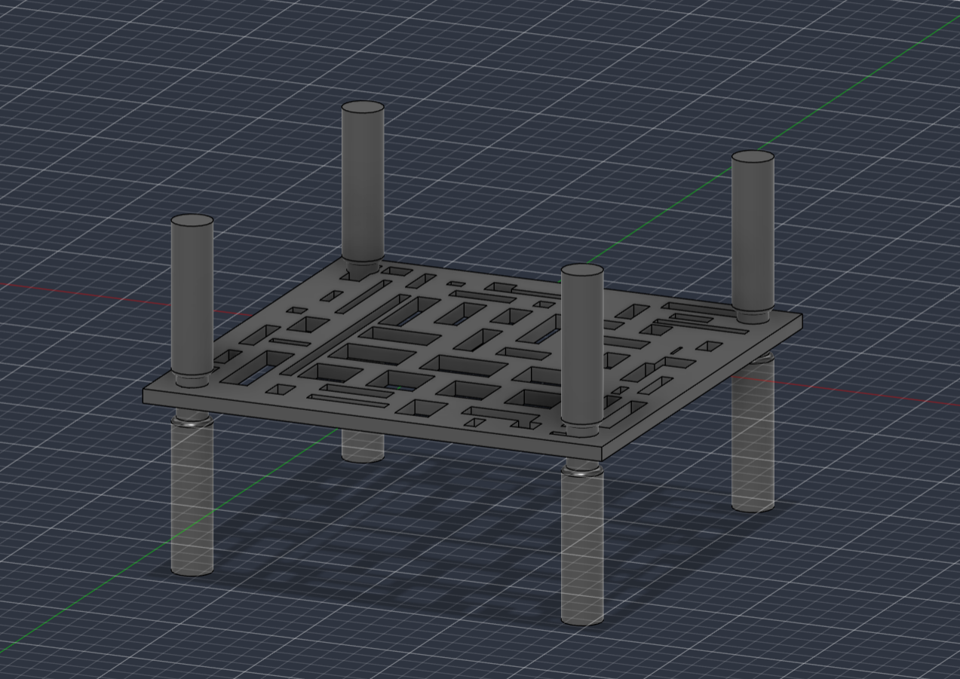
Step 20 — Join the plate and pillars into a single scaffold part.

3.3 Assembly
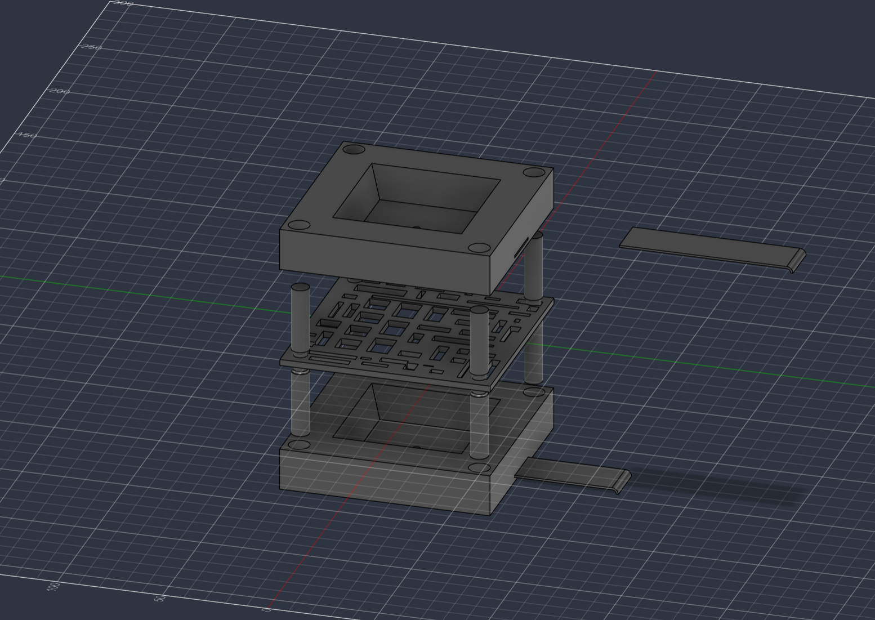
Step 21 — The finished assembly. Upper funnel (inverted, ready to pour), scaffold with the sushi tray in the middle, lower funnel with its puller closed to catch the sauce.

4. The Finished Model
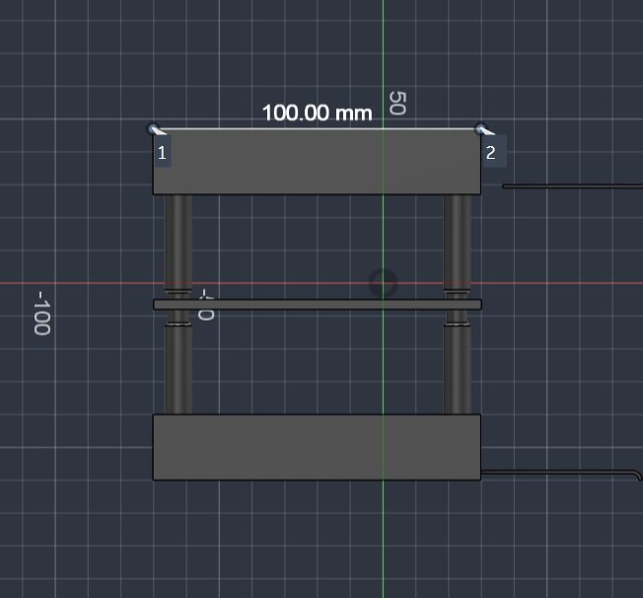
Width check — 100.00 mm across the funnel.
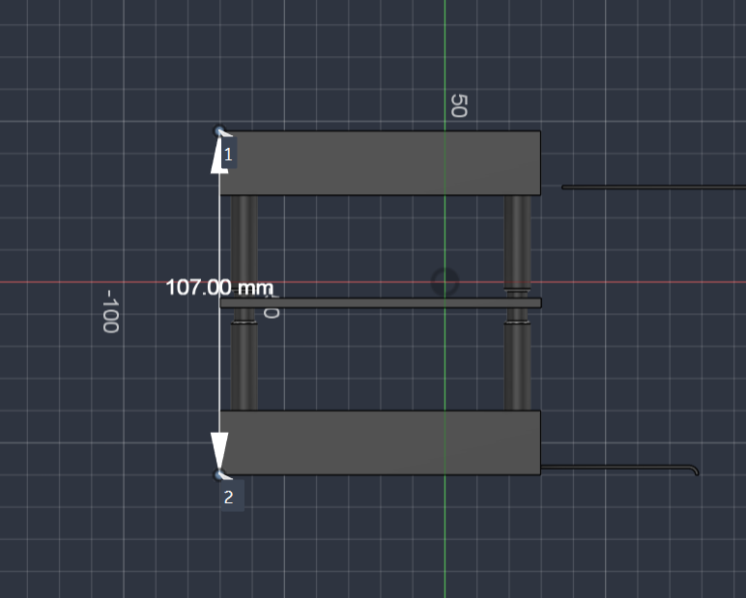
Height check — 107.00 mm from the bottom face of the lower funnel to the top face of the upper funnel.
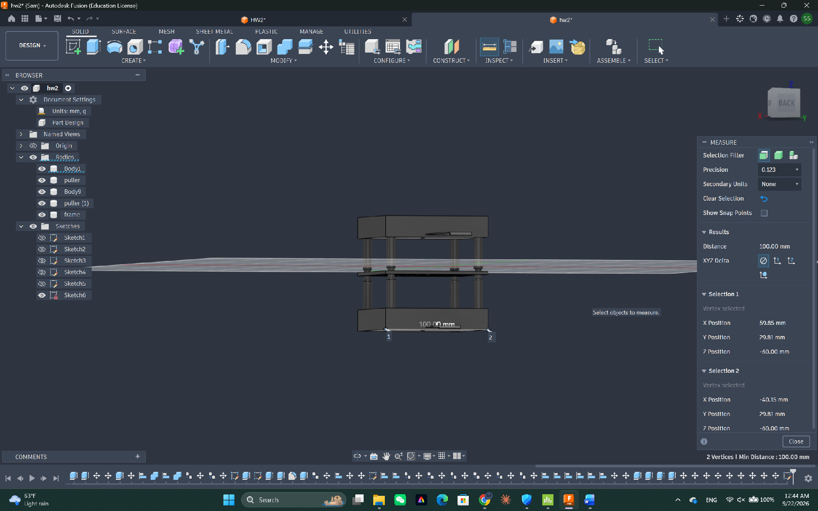
Measuring the final assembly in Fusion. The browser shows the five bodies: two funnels, two pullers and the frame.

Specifications
Item | Value
Overall size | 100 × 100 × 107 mm (10.0 × 10.0 × 10.7 cm) — above the 8 × 8 × 8 cm minimum
Unique parts | 3 — funnel, puller, scaffold (tray + pillars)
Printed pieces | 5 — 2 funnels, 2 pullers, 1 scaffold
Key fits | Puller in slot (scaled 0.99); pillars in ⌀10 mm corner holes
Funnel features | 15 mm wall, 5 mm base, 20° internal draft, ⌀2 mm drain hole

Assignment check. The object is composed of more than two parts that fit together — the puller slides into the funnel, and both funnels slide onto the scaffold's pillars — and at 100 × 100 × 107 mm it is comfortably larger than 8 × 8 × 8 cm.

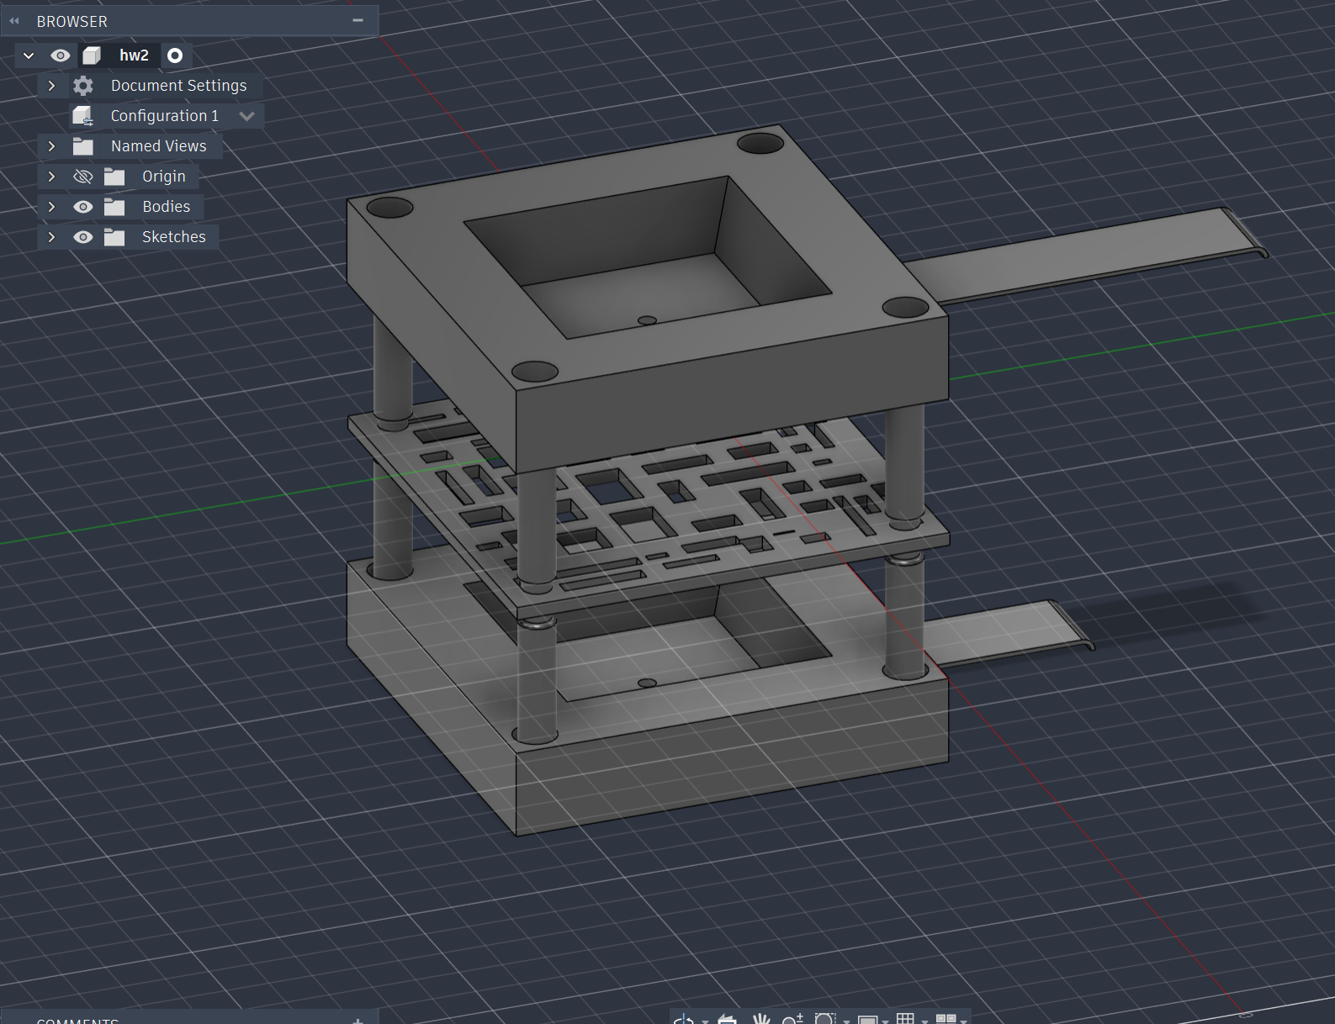
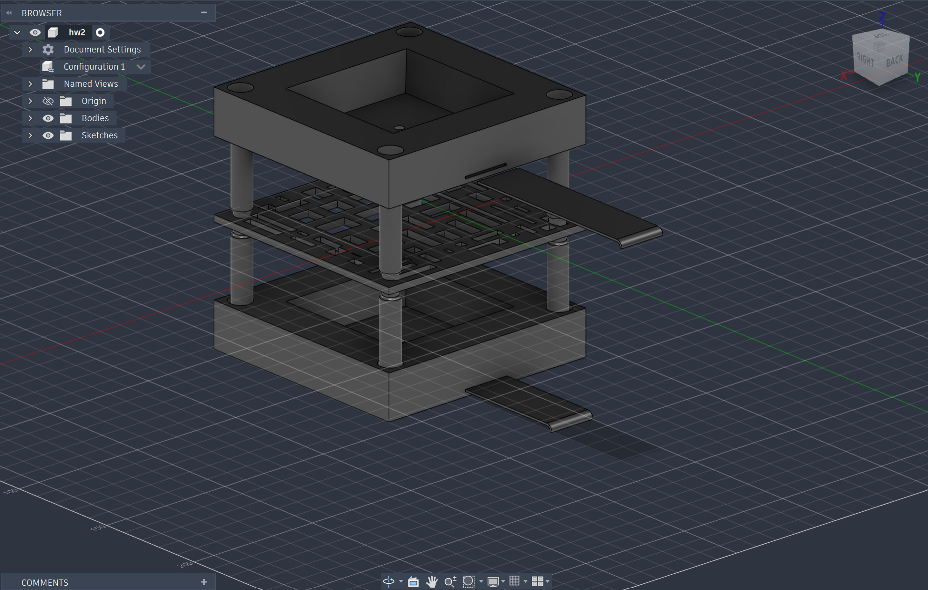
Mugshots

