Tennis Ball Pea Pod Holder
Sam ss19608

1. Idea
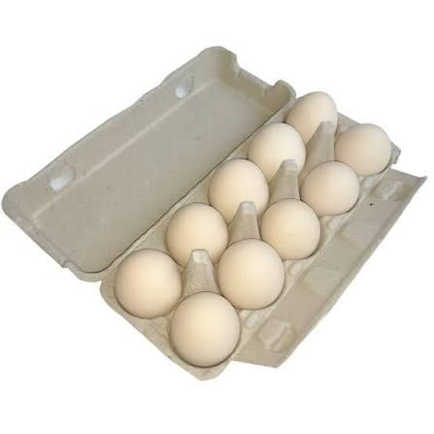
I wanted a holder that keeps 3 tennis balls together and can hang on a wall. An egg carton gave me the idea: each ball sits in its own round pocket, like peas in a pod.

My sketches: My original idea was to imitate the egg box, but it would be boring. Then I realize the tennis is green, just like pea beans, why not make the egg box green, which is just like a pea pod.

I followed this thought and carried out the whole modelling and printing.
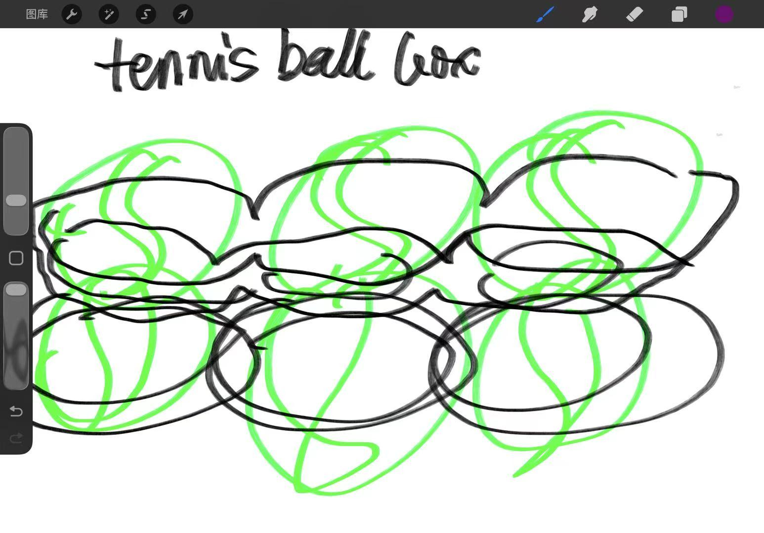

2. Measurements
I looked up the official tennis ball size: 2.70–2.85 in (about 69–72 mm) across. I used this size for the pockets so the balls fit snugly.
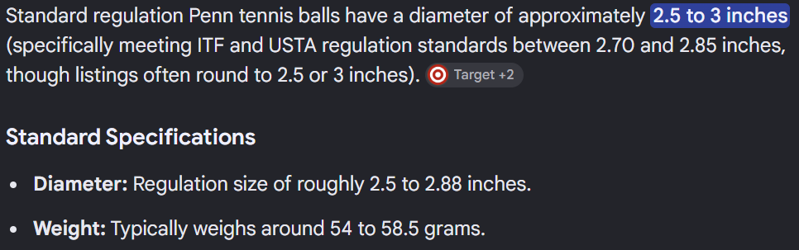
3. Modeling in Fusion
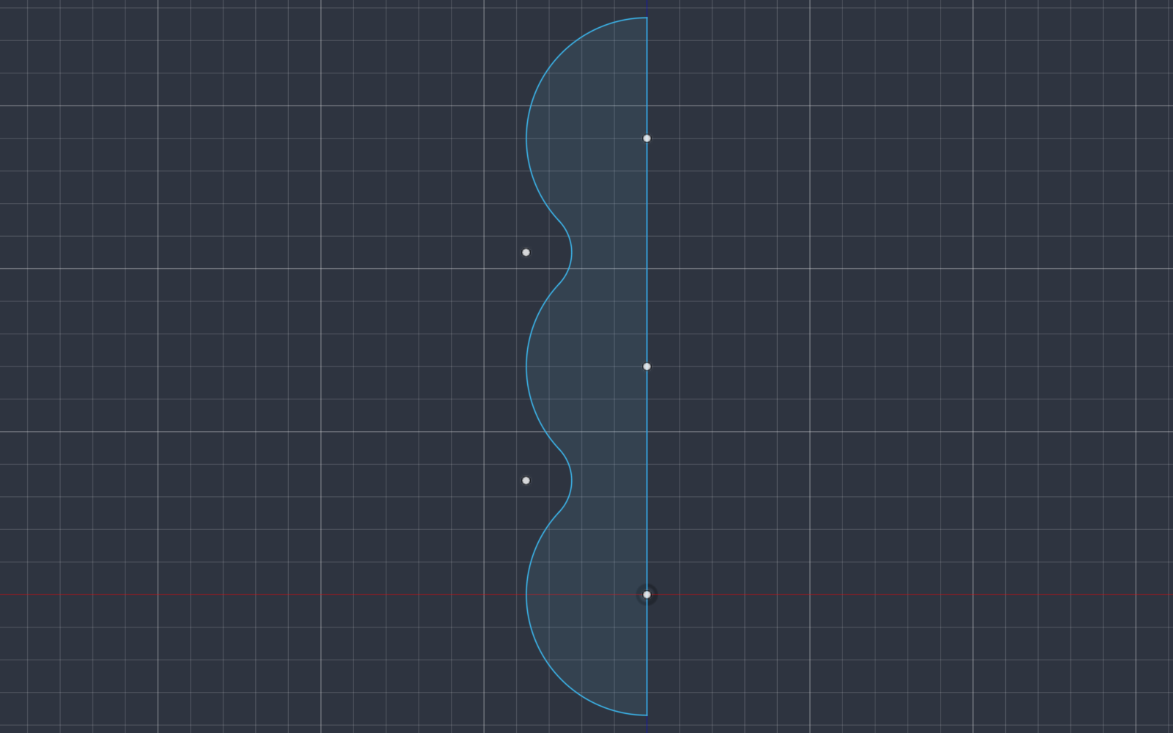
Step 1 – Sketch the outline: three ball-sized circles in a row. Draw only half of the shape.
(an R=37 arc around each ball center, joined by concave R=14 waist arcs that are tangent to both neighbours.)
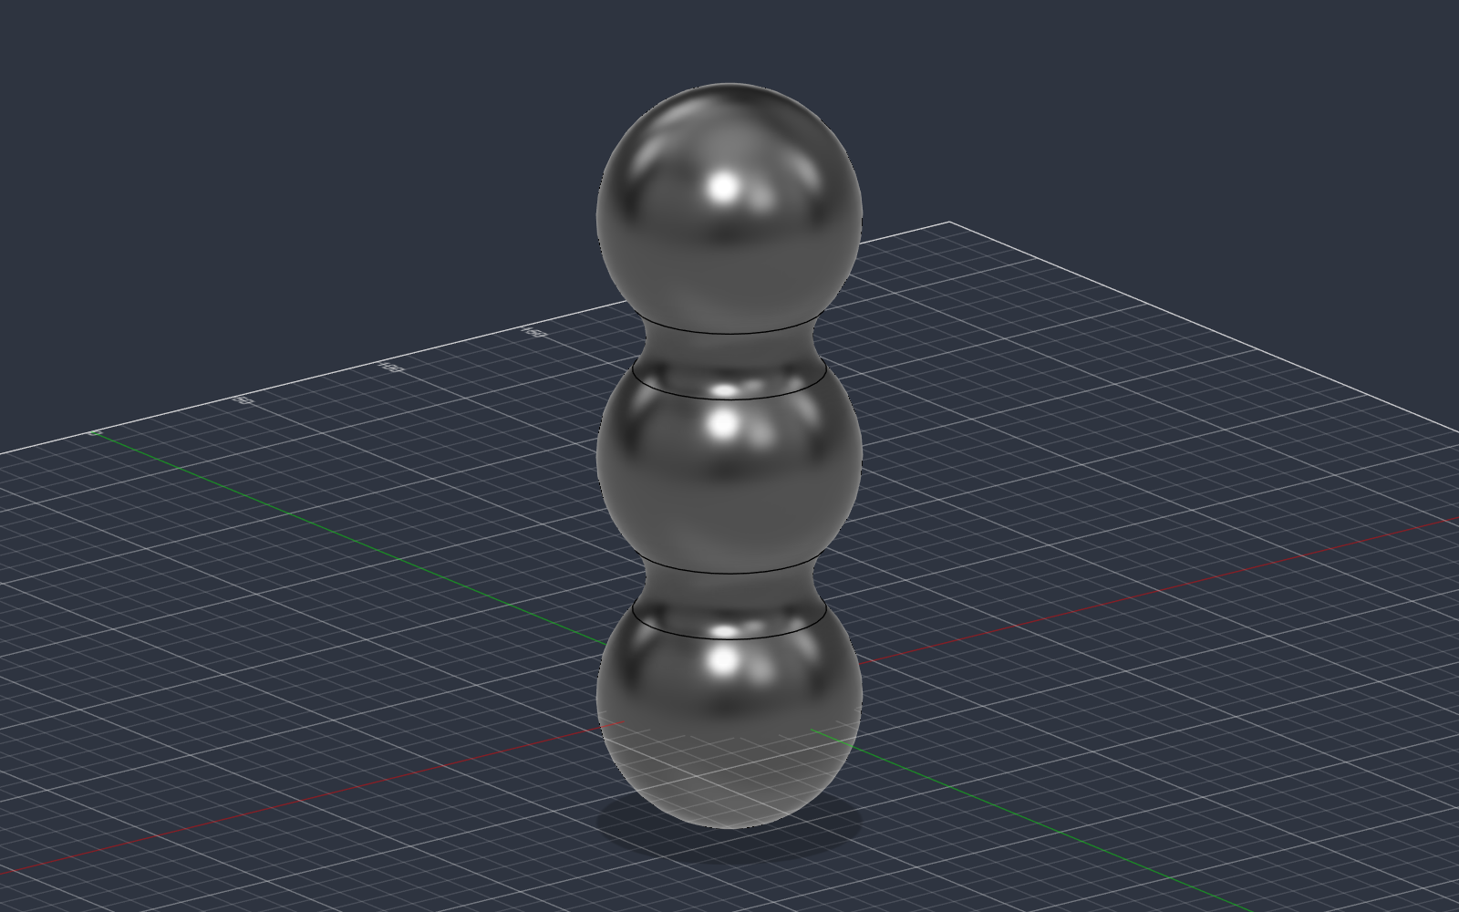
Step 2 – Revolve the sketch to turn it into a 3D pod.
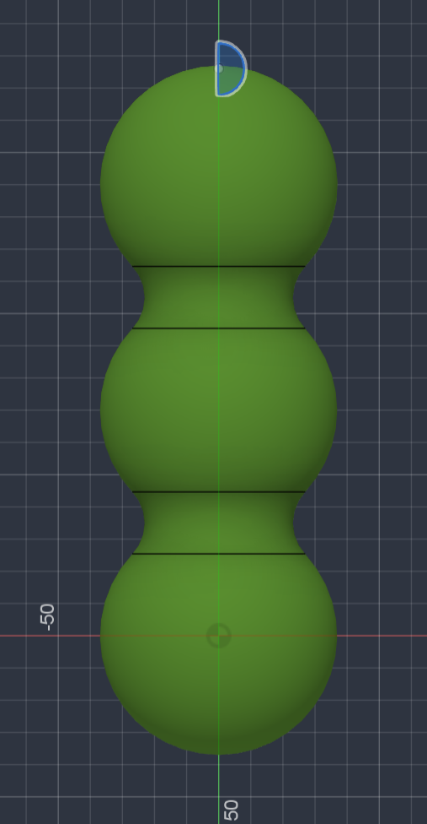
Step 3 – Make the stem at the top, also with Revolve.
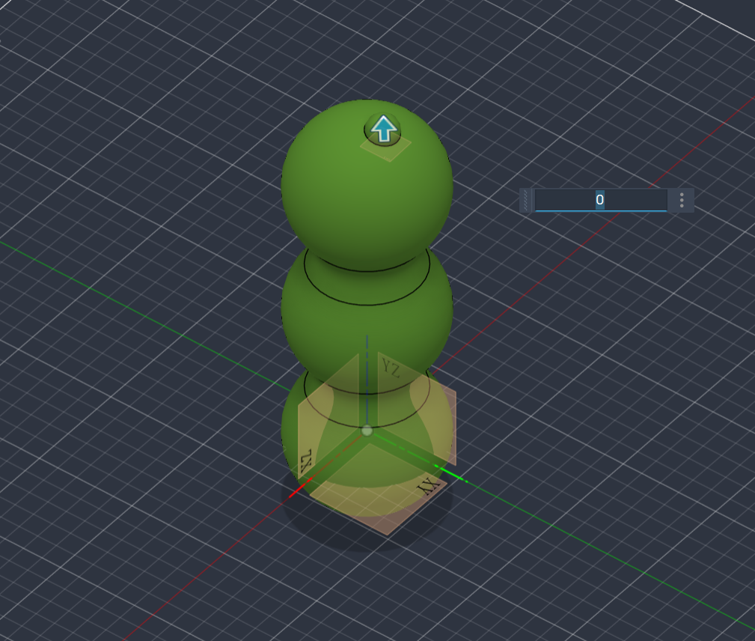
Step 4 – Create a construction plane at the top of the stem.
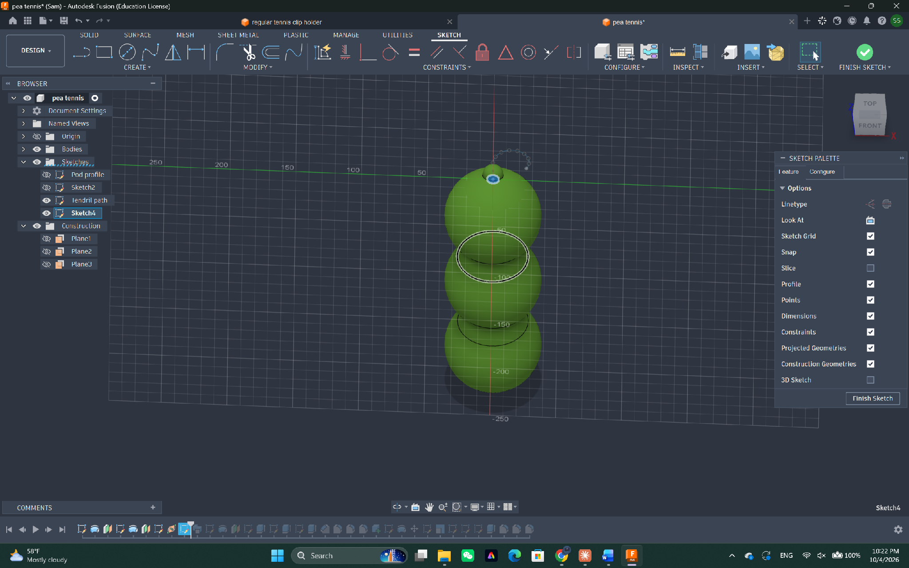
Step 5 – Draw a circle on that plane.
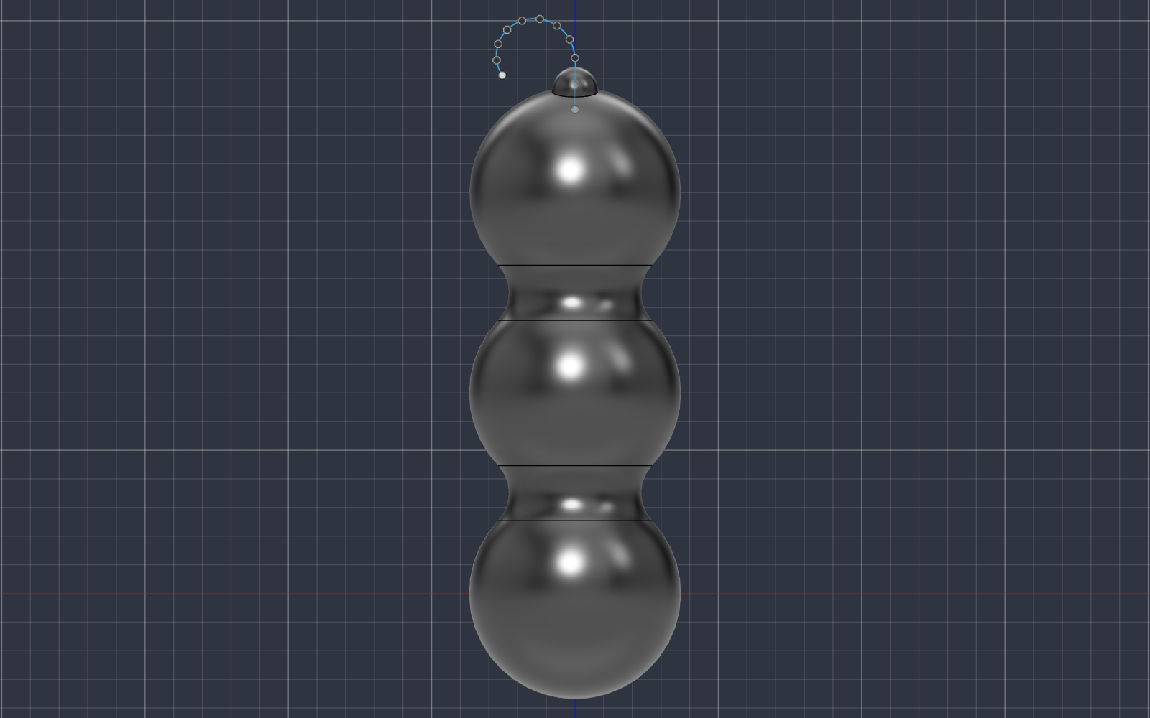
Step 6 – Draw a curved path, then Sweep the circle along it to make the hook.
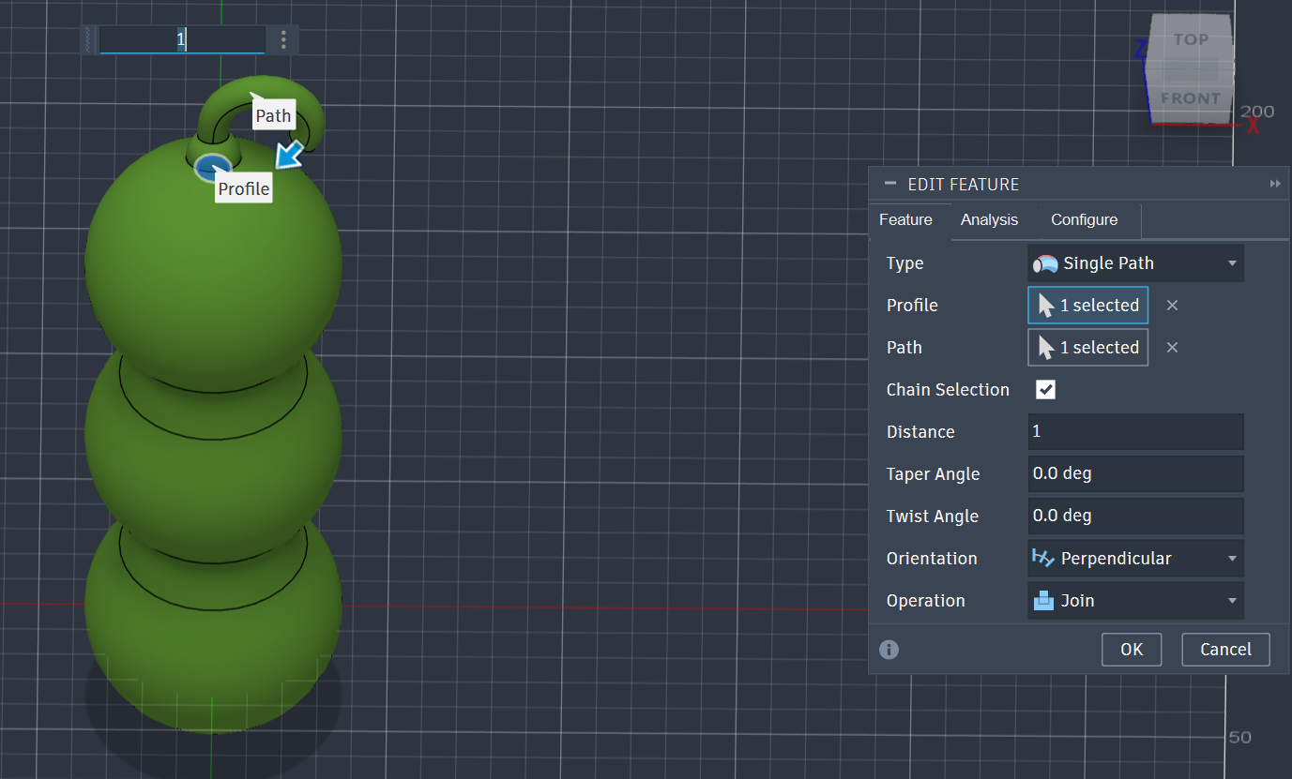
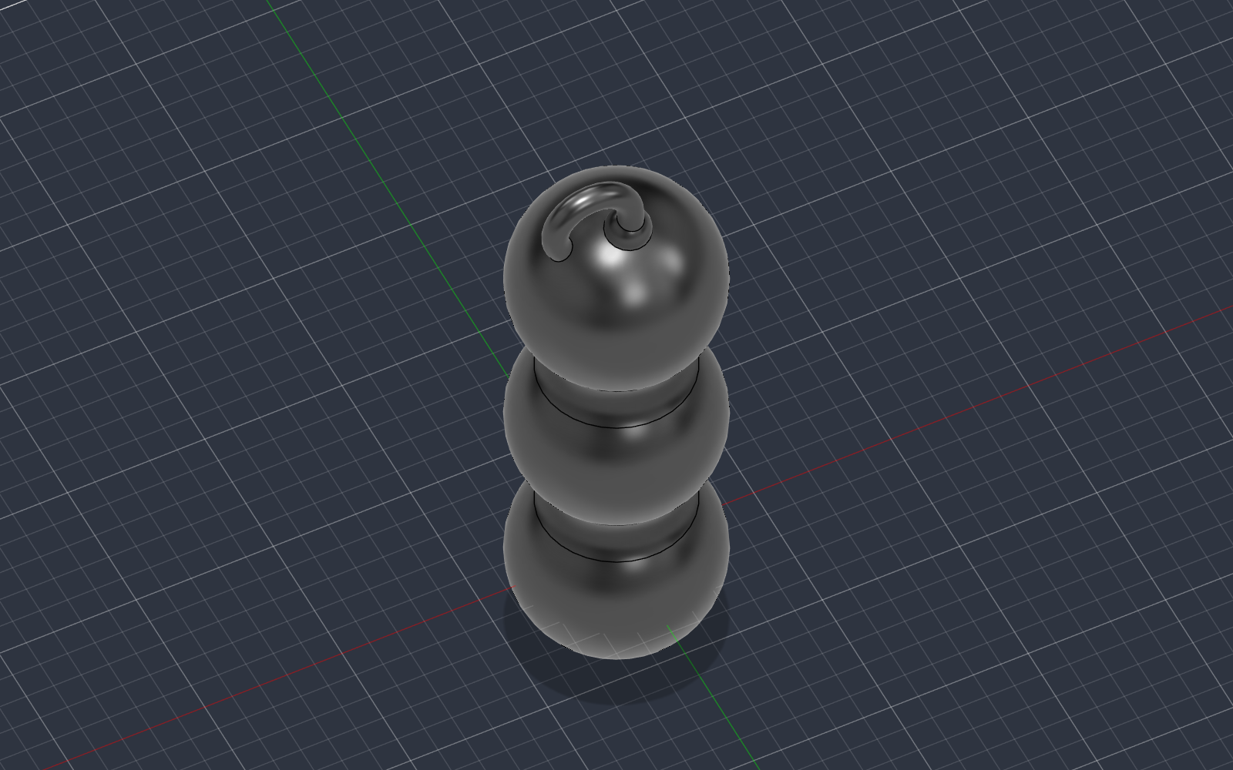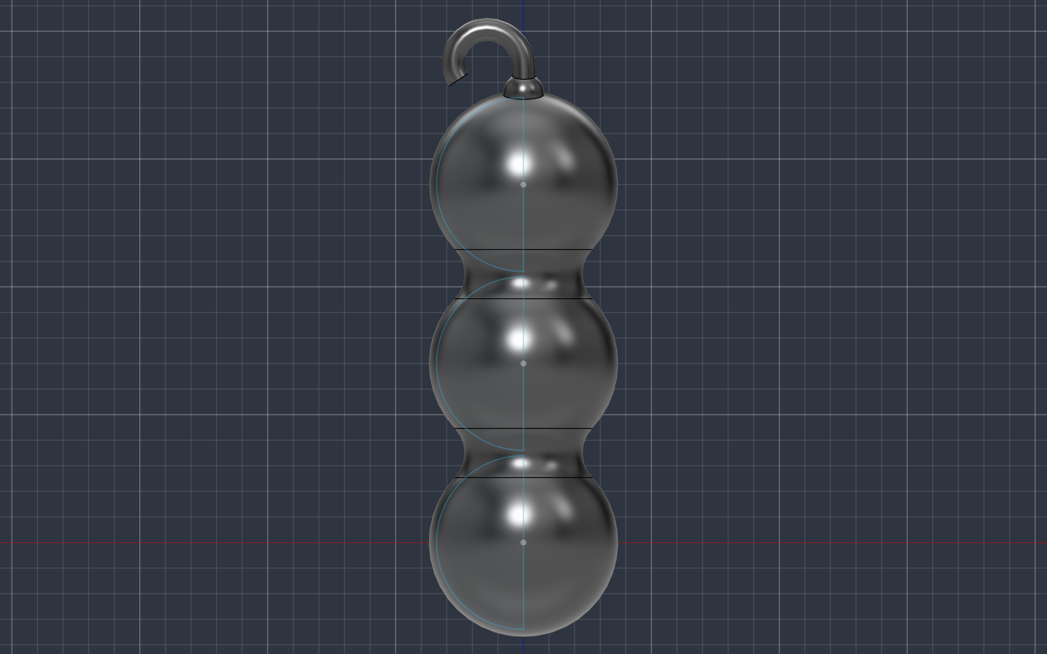
Step 7 – Put a tennis ball model(R=33.5mm) inside to check that it fits.
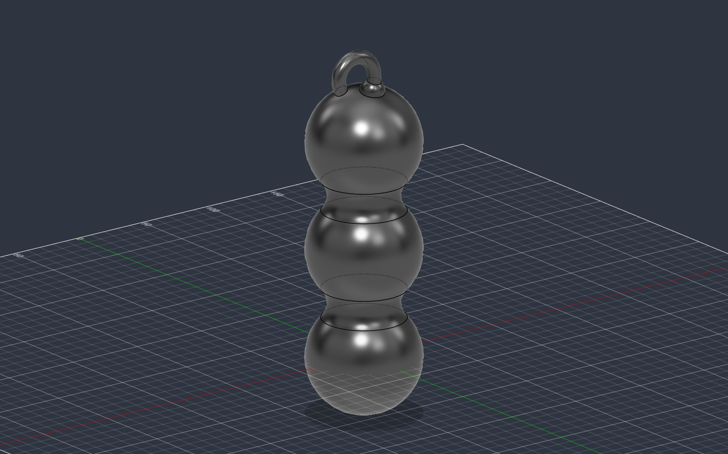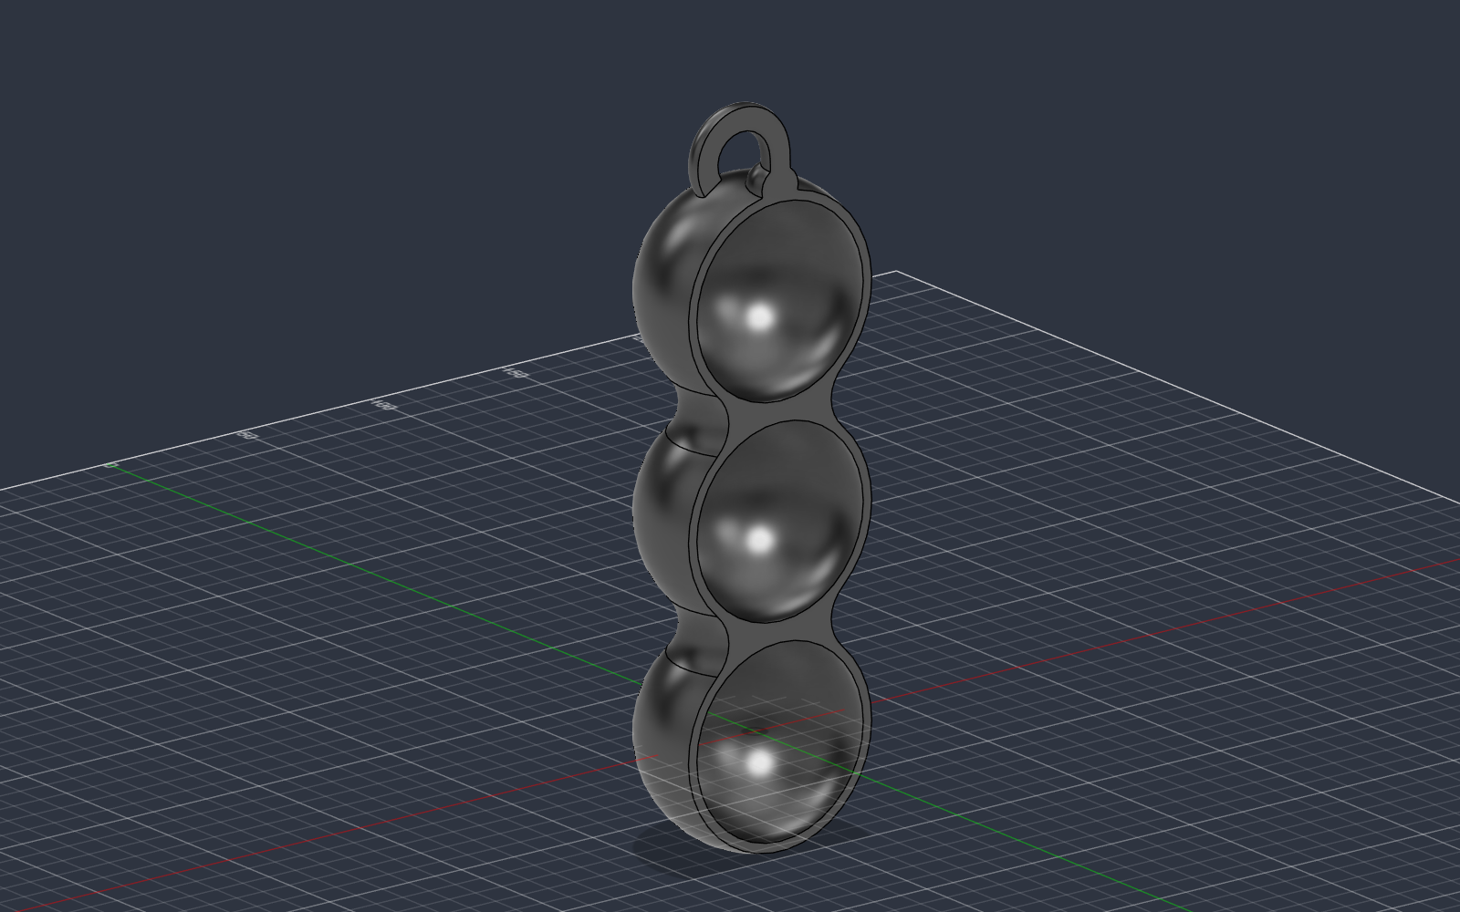
Step 8 – Cut off one third of the pod (not half). The opening is a little smaller than the ball, so you can press the ball in and it won't fall out.
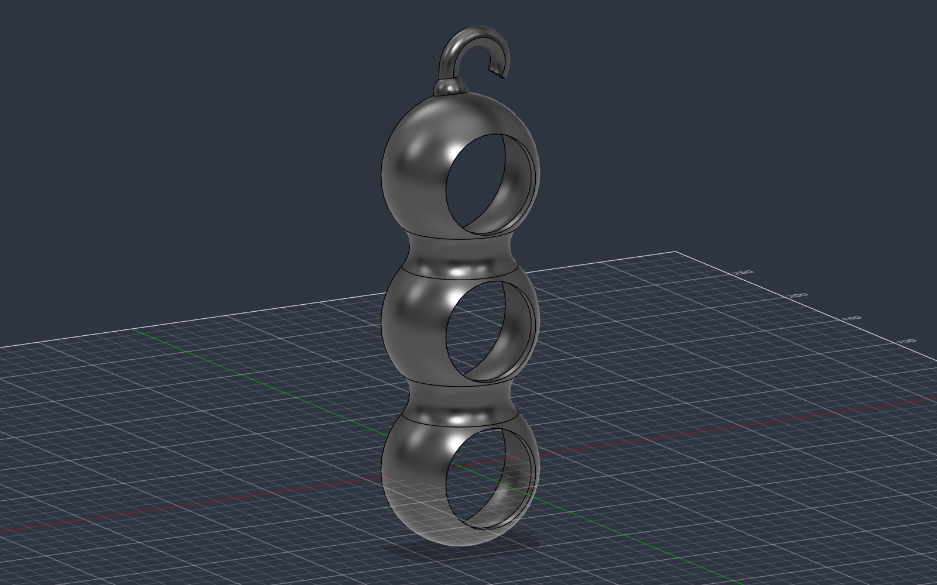
Step 9 – Trim the other side the same way so it looks balanced.
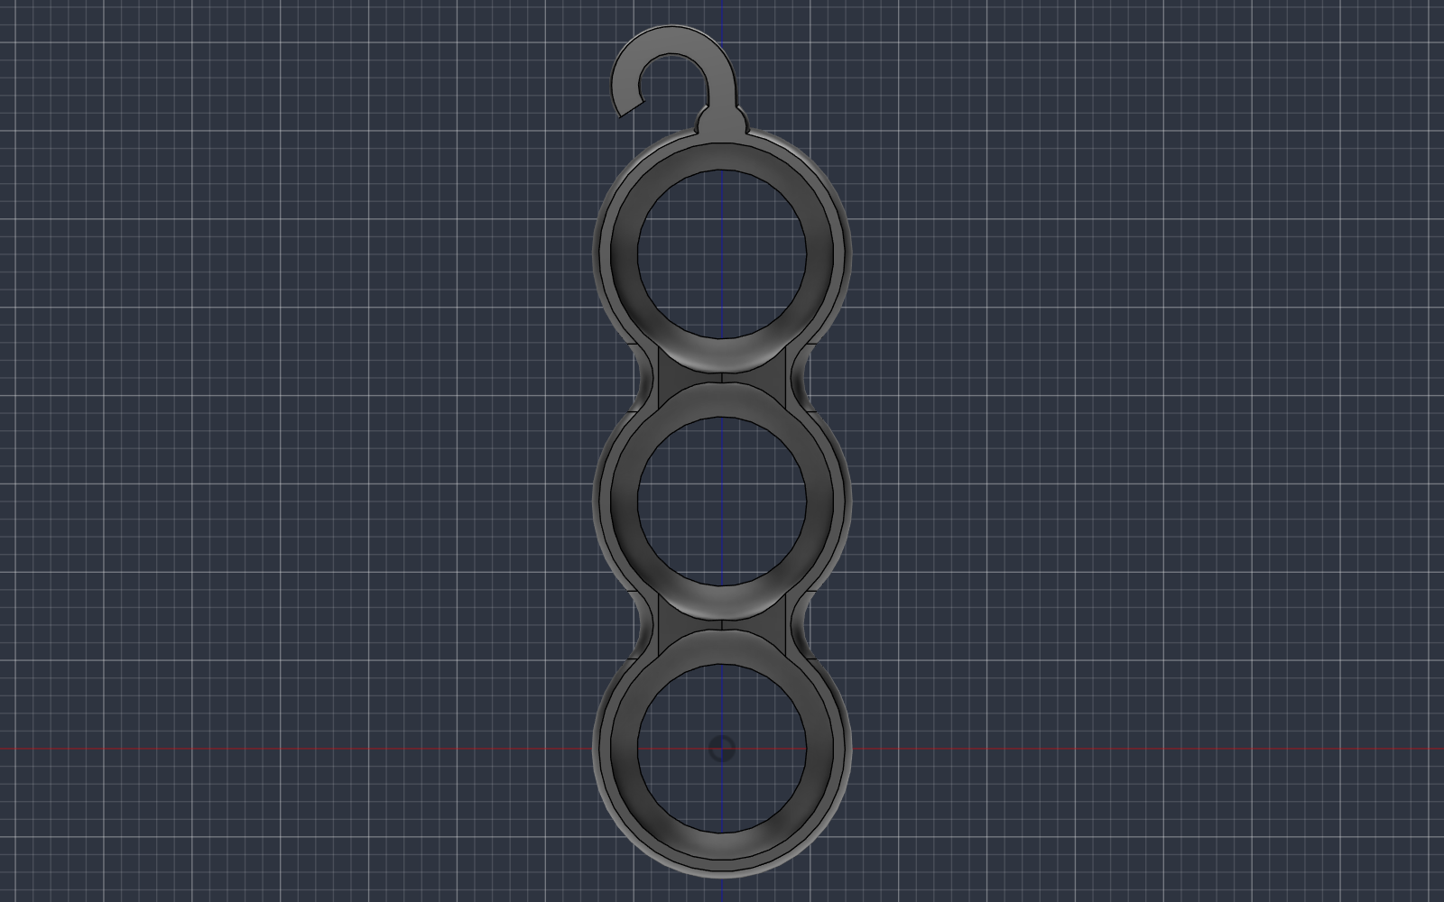
Step 10 – Use a triangle-shaped block to cut away the extra parts between the pockets.
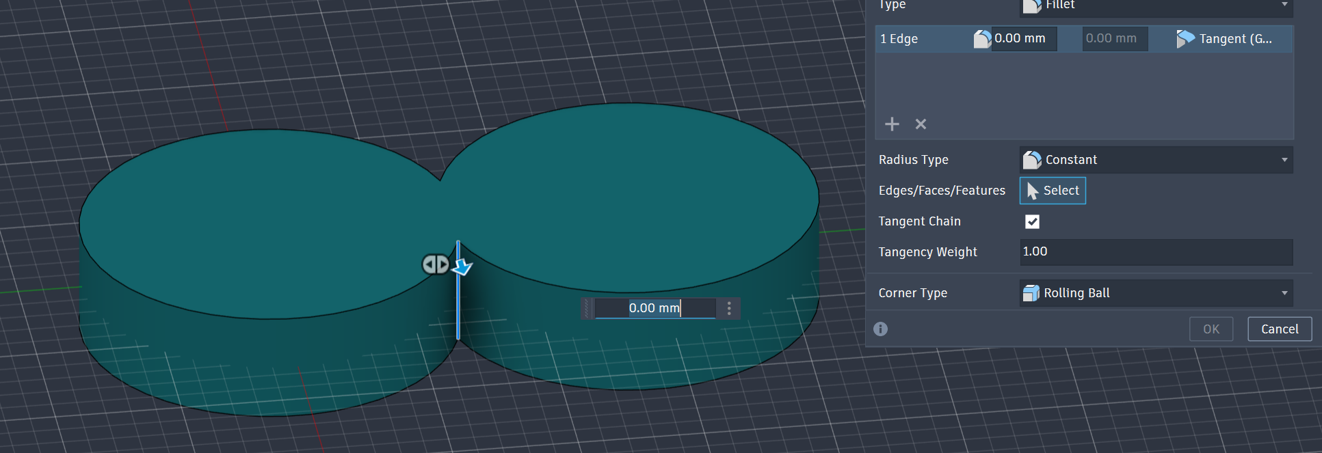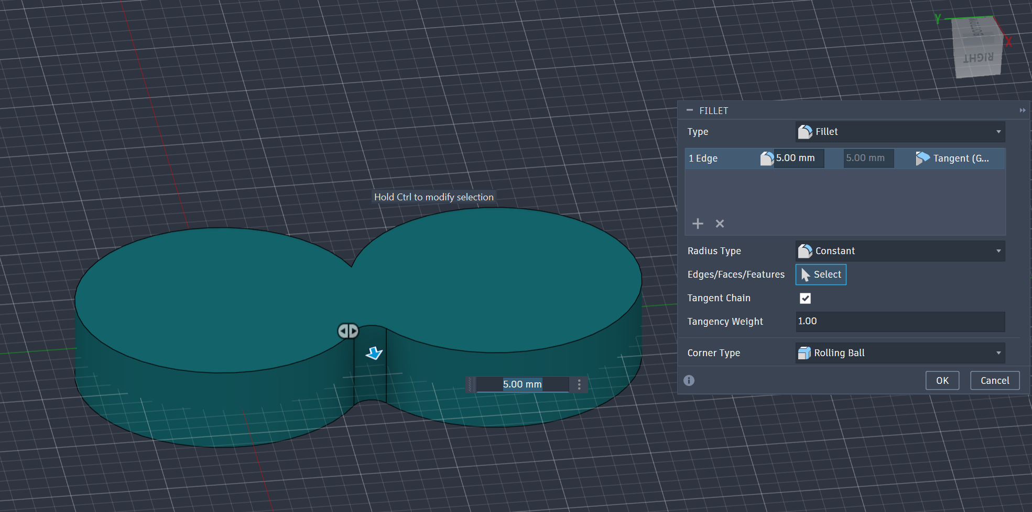
Step 11 – Fillet the edges to make them smooth by the up two pictures’ technique
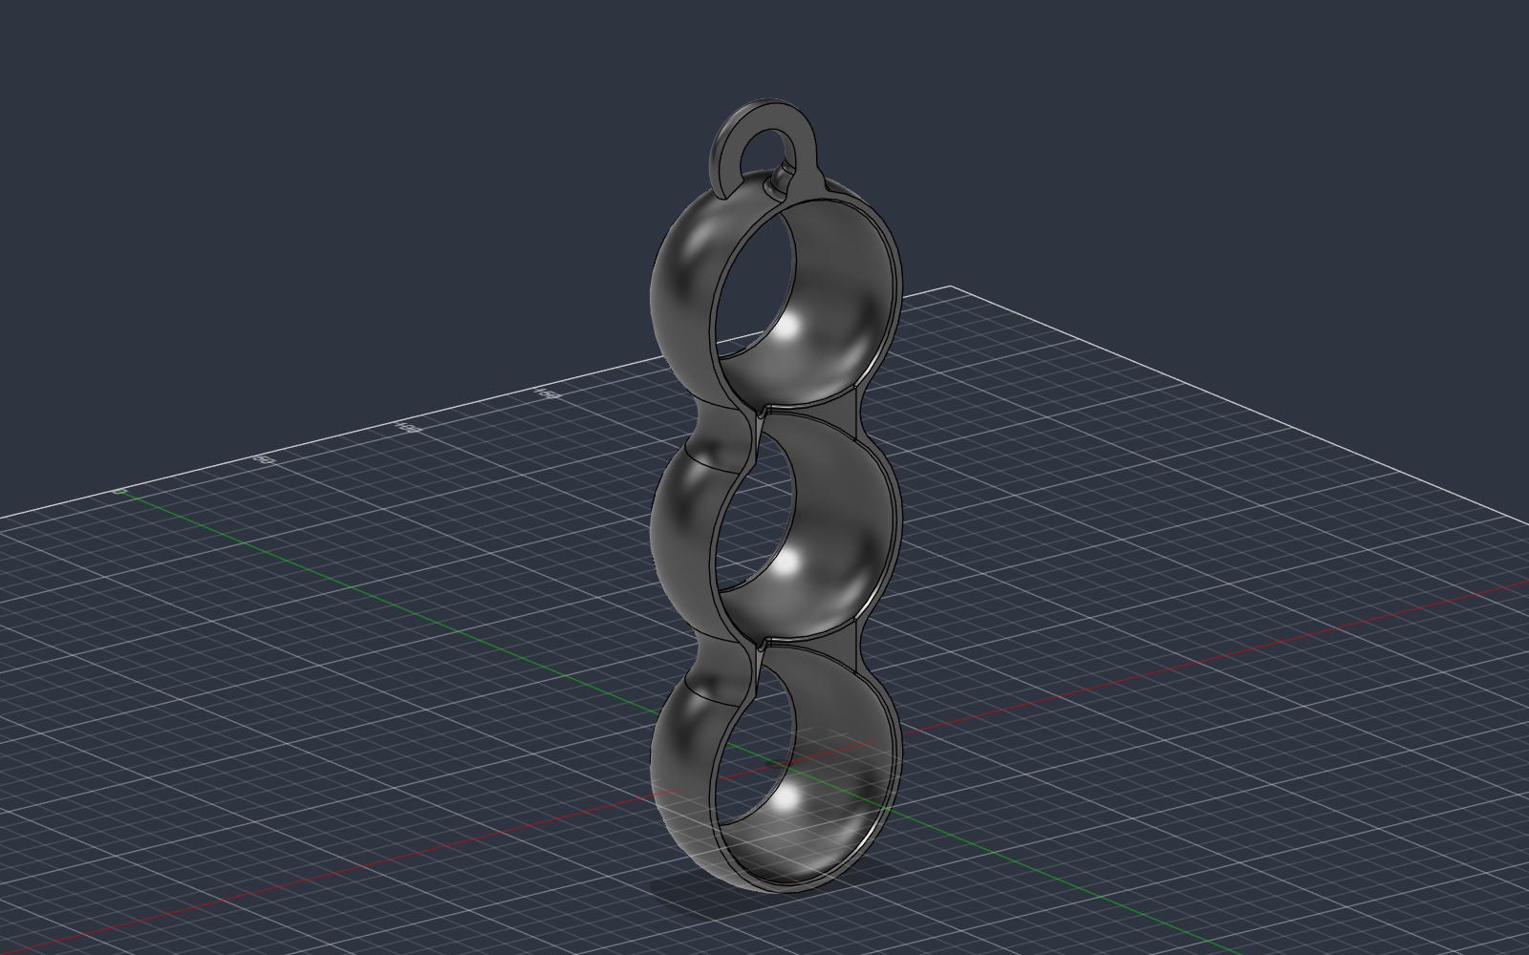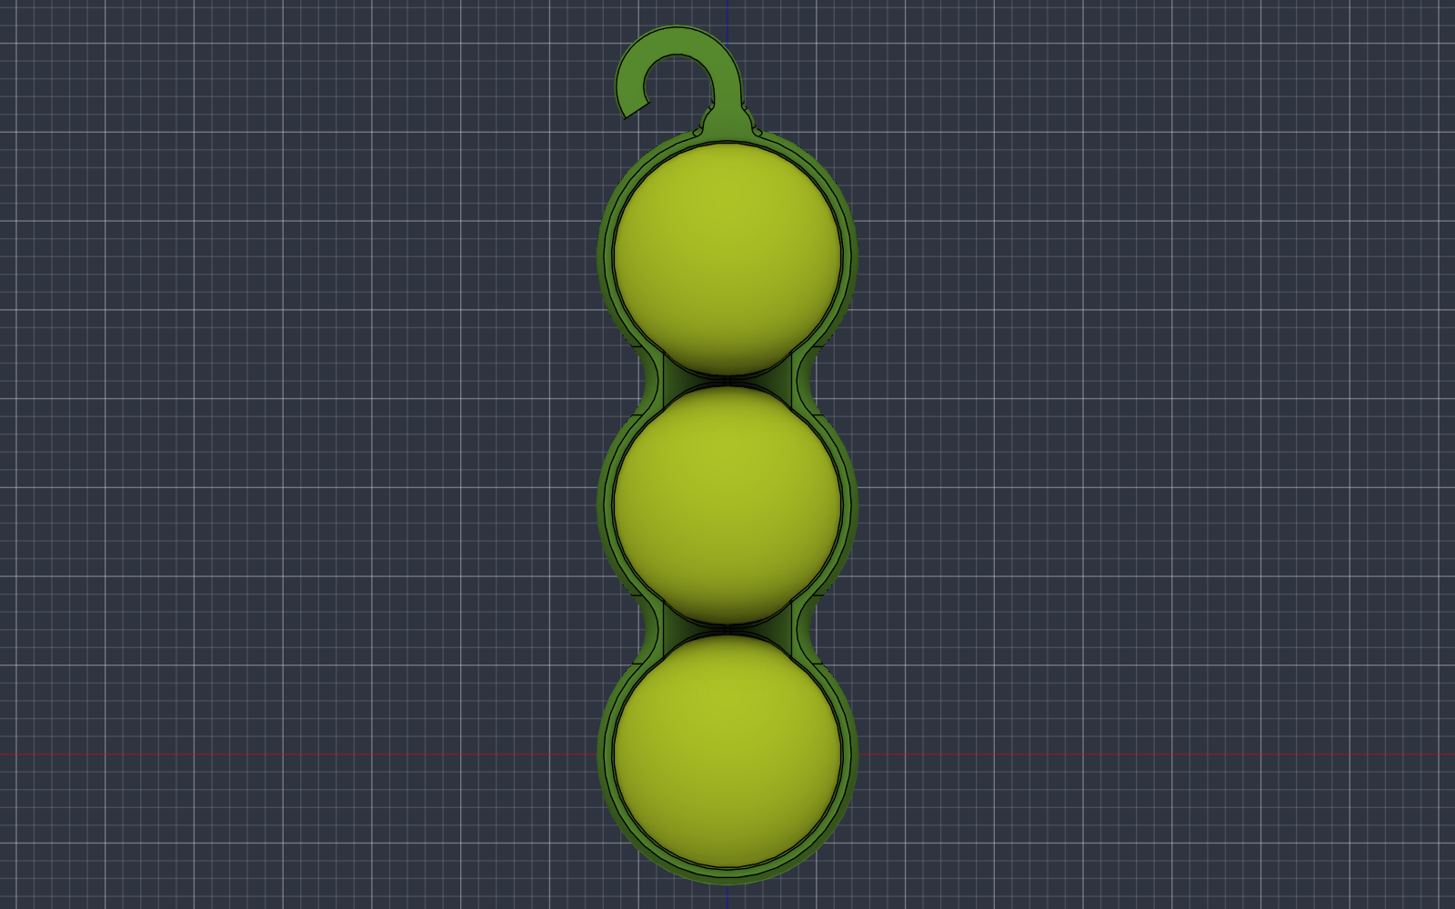
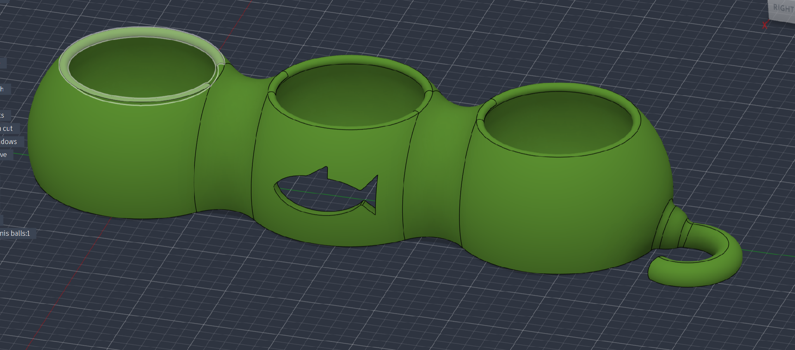
Step 12 – Project a fish shape onto the side and cut it out as decoration. (I left the fish out of the print in case it failed.)
4. Print & Fit
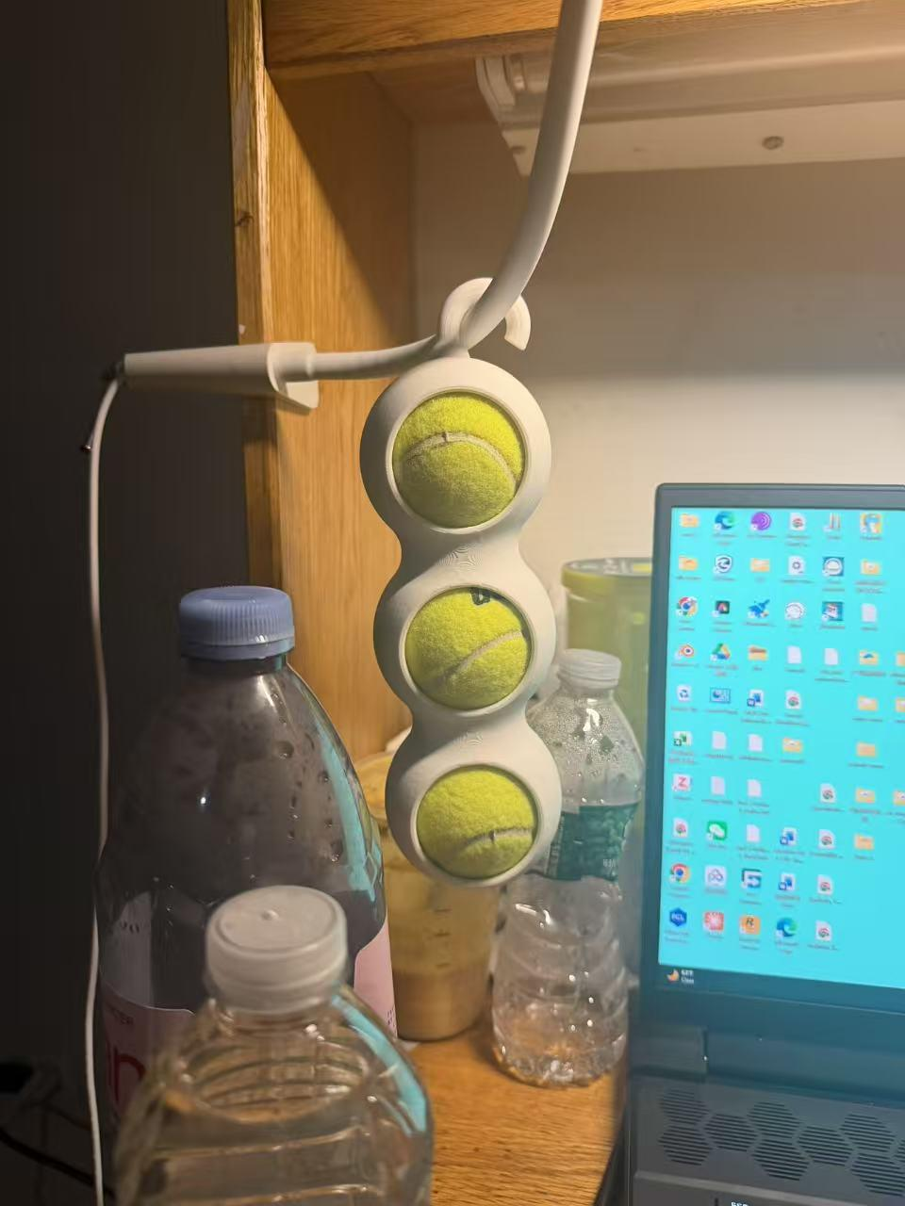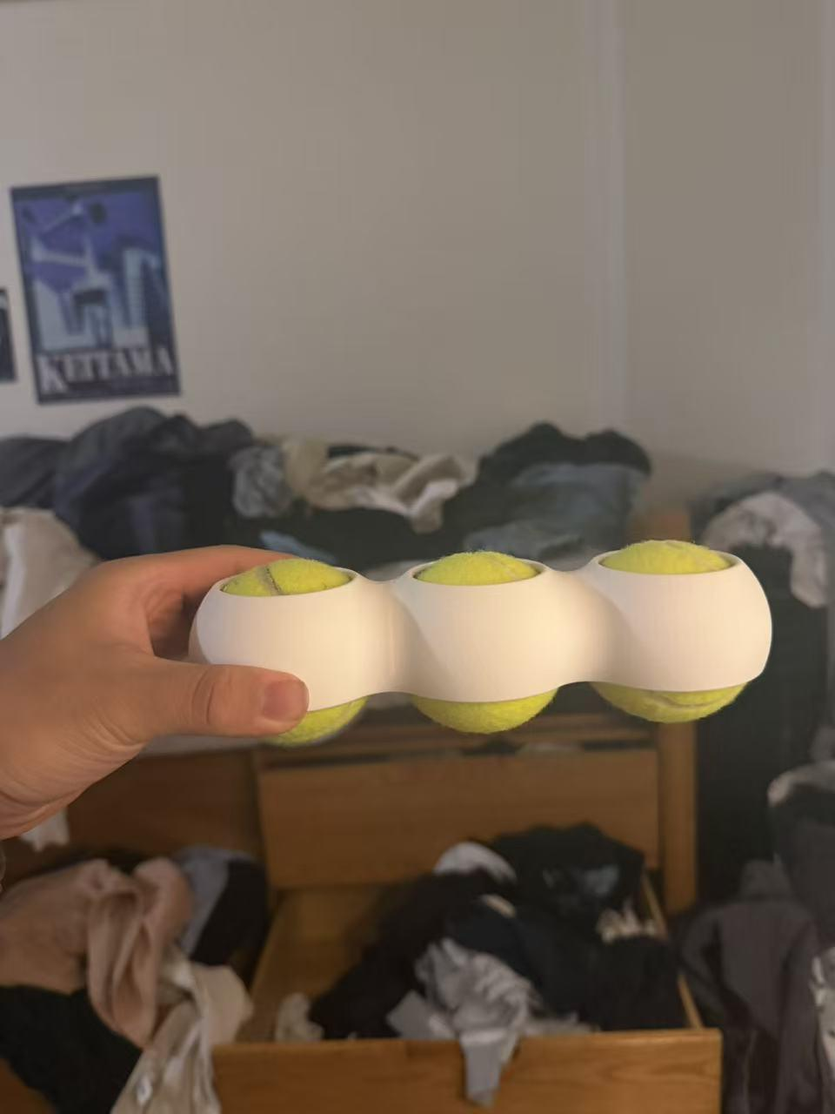
It fits! The balls press in firmly, stay in place, and are easy to take out. The hook lets me hang it almost anywhere.
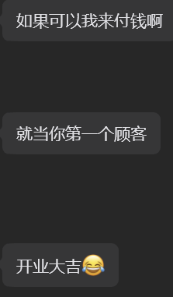
A friend already wants to buy one! (I will charge him 20 dollars)

