Week 4 — Final Project Ideation & Print Iteration
Sam Shii ss19608
AI disclosure: For the final project drafting, I brainstormed the idea with Claude AI for quantitative data analysis for the helmet vulnerability and composition of the documentation.
My final project is a transparent medieval helmet printed on the voxel printer at NYU's LaGuardia Studio, with decoration printed inside the clear walls.

Final project idea: a transparent voxel-printed helmet
I'm designing a medieval helmet with a rounded skull, a long neck guard, and a beak-shaped visor that swings down on side pivots. It will be printed in clear resin on the studio's multi-material printer. That printer can place color and material voxel by voxel, so patterns can sit inside the transparent wall, like a scene suspended in a glass block.
The question driving the design is simple: if this were real armor, where would it actually get hit? I want the decoration to follow that answer.
- Areas that take the most blows stay smooth and thick, so a blade would glance off.
- Areas that are rarely hit get the densest internal patterns.
The result should read as a data visualization you can wear: the pattern density on the helmet is a map of medieval battle damage.

Research: where medieval fighters were hit
The head was the most-hit part of the body in all three battlefield graves I looked at, so the helmet is the hardest piece to decorate. My first plan was to train a model on photos of damaged armor. I dropped it: surviving armor is mostly parade or tournament pieces, and photos can't separate sword cuts from rust and restoration. Skeletons from mass graves are a more honest record.
Site | Sample | What the bones show
Visby, Gotland, 1361 | 1,185 individuals | 456 cut wounds and 126 arrow wounds, mostly on the lower body; shields covered the torso. Head cuts mostly came from above.
Towton, Yorkshire, 1461 | 28 skulls | 27 skulls had battle wounds. Torsos had none; arm wounds were mostly forearm parries.
Sidon, Lebanon, 13th c. | 25+ individuals, 100 injured bones | Wounds concentrated on the skull, neck and shoulders, more on the back than the front.
Two patterns matter for a helmet. Blows land on the crown and face most, and the left side is hit more than the right because most attackers were right-handed. I combined the three sites into a relative score per body part (head 1.00, face 0.62, back of neck 0.37, throat 0.10). These scores are my own encoding of the papers' descriptions, not their raw counts.

Sketches
I drew three helmet concepts, then merged the shell of concept 2 with the visor of concept 3 into one design and broke it into parts.
Concept 1: hinged visor and mail. A pointed skull with a flat visor hinged at the top. The visor has a toothed eye slit and three cross-shaped breathing holes. A mail curtain (aventail) hangs below to cover the neck.
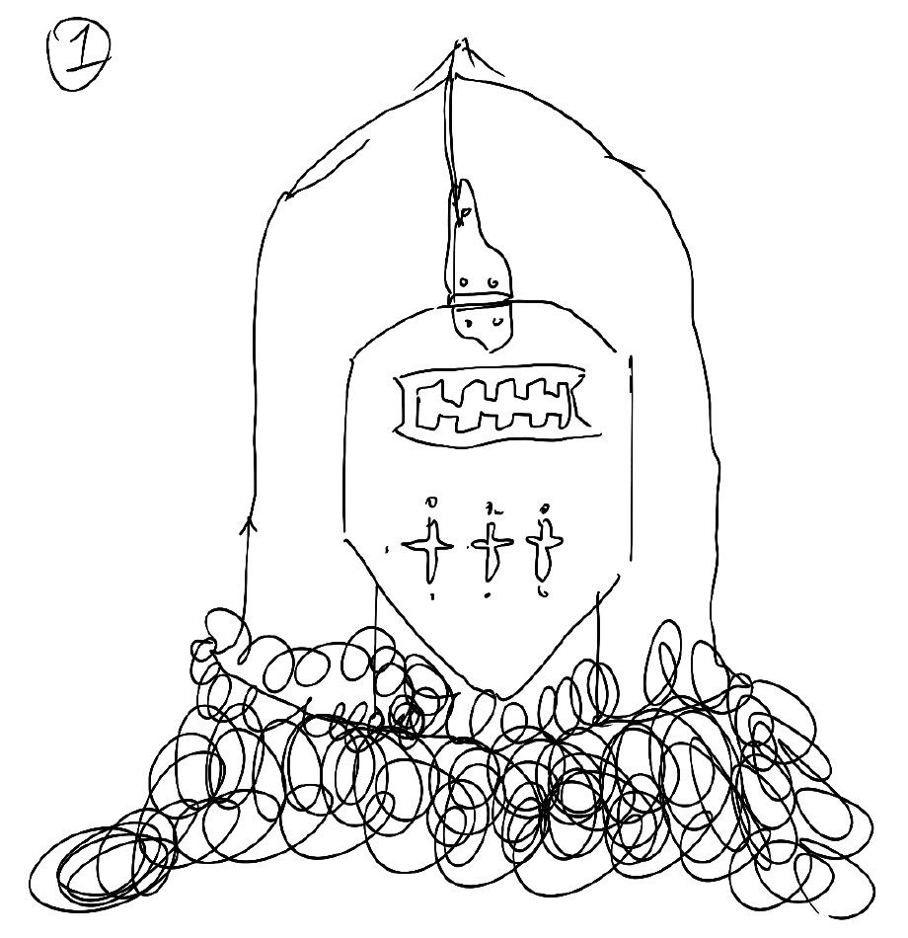
Concept 2: pointed skull, side-pivot visor. A tall pointed skull and a long sweeping neck guard. The visor pivots at the temple and has an eye slit and round breathing holes.
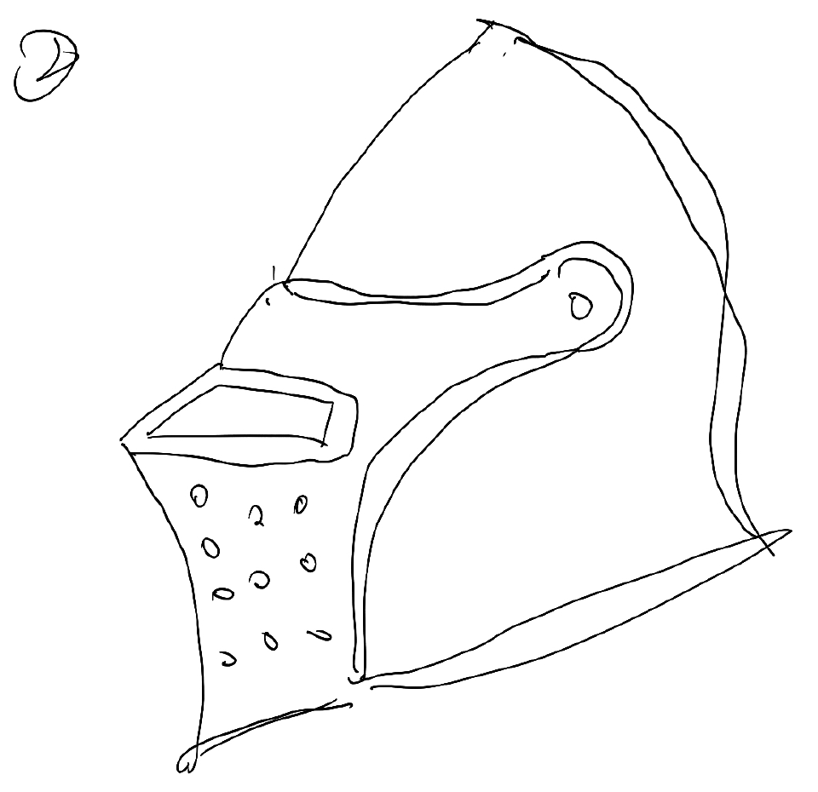
Concept 3: rounded skull, beak visor. A rounder skull with a pointed, beak-shaped visor, drawn here swung up and open.
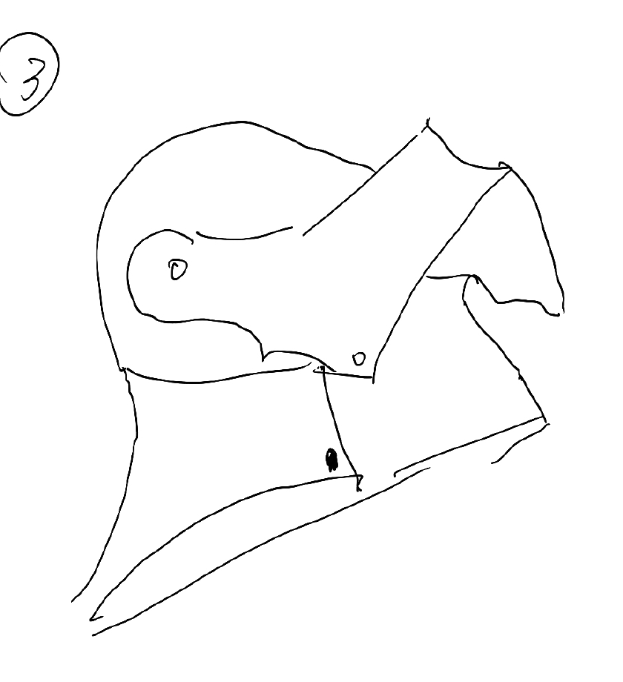
Mechanism. A top-down view of the shell around the head, a side view of the concept 2 shell with the concept 3 visor rotating down on its pivot, and a front view with the visor pulled down. The line through the top-down view marks the center of the shell.
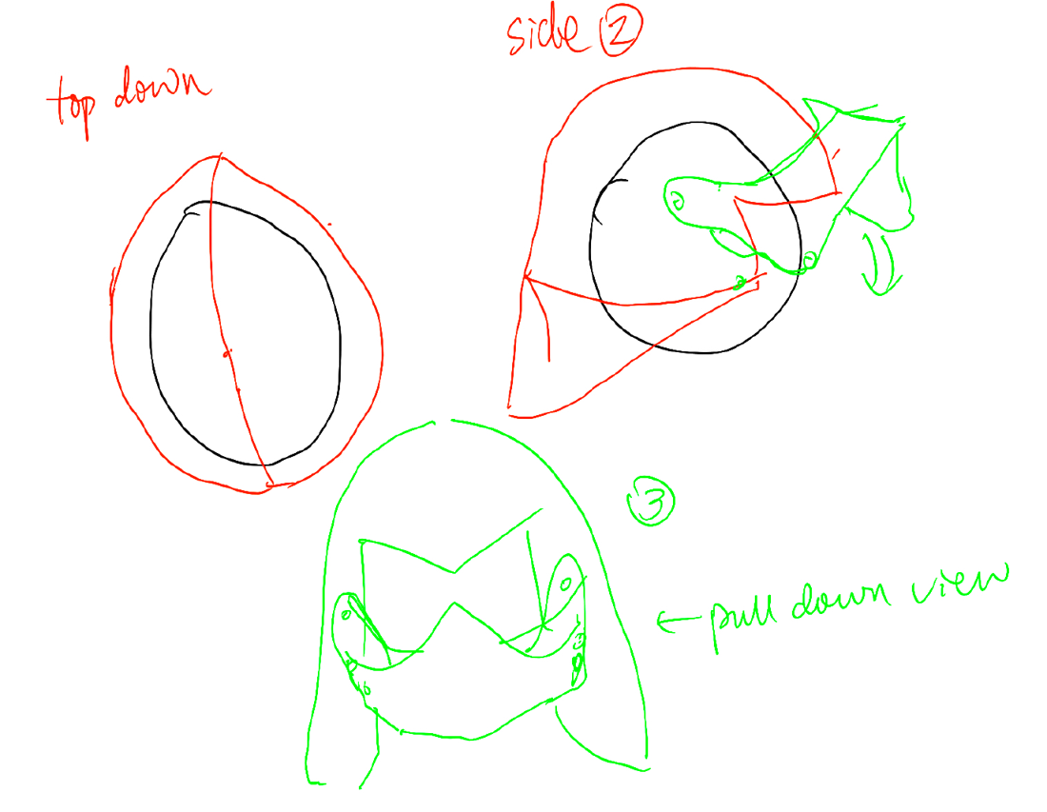
Parts list. Part 1 is the shell (skull and neck guard). Part 2 is the visor with a pivot hole at each end. Optional add-ons: a cushion for head protection, leather belts to hold the helmet on, and a different material for decoration.
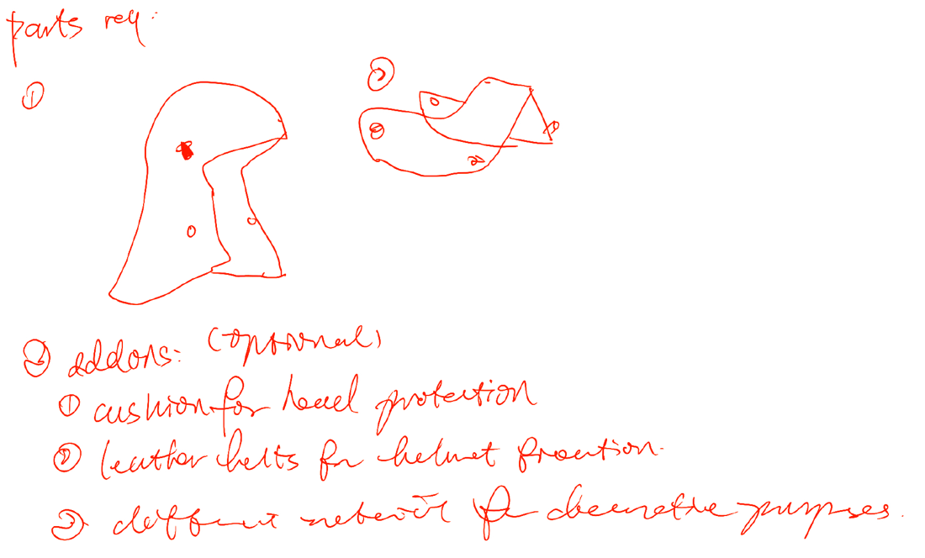

Mapping the hit data onto my sketches
Most of the helmet's outer surface lands in the plain zone, so the patterns move inside the clear wall. The outside stays smooth everywhere; what changes from zone to zone is how dense the internal voxel pattern is.
- Gray (plain): smooth and thick, little or no internal pattern.
- Diagonal lines (sparse): light relief and a sparse internal pattern.
- Wave texture (dense): the densest internal voxel pattern.
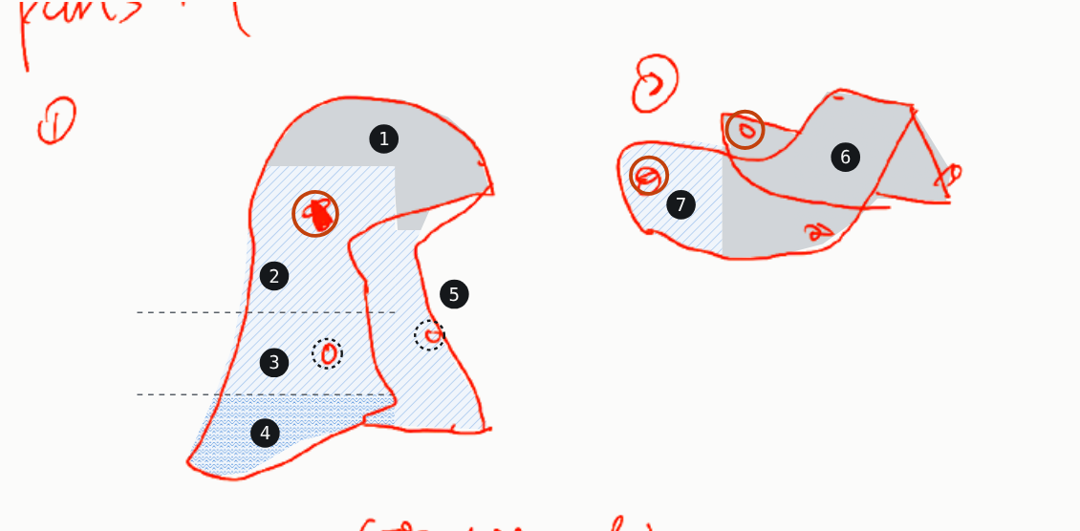
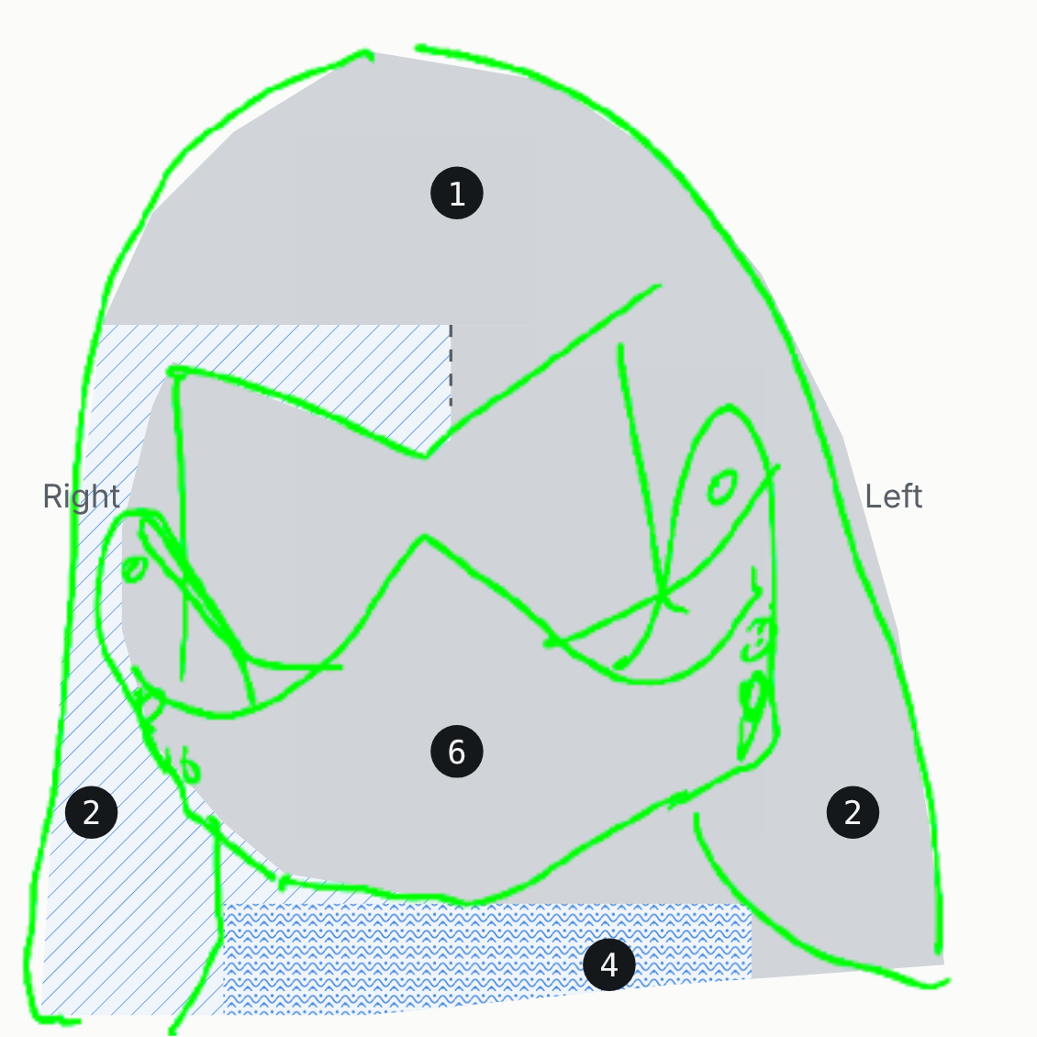
# | Zone | Treatment | Why
1 | Crown and brow peak | Plain, thick | Head cuts mostly came from above (Visby).
2 | Sides of the skull | Right side sparse, left side plain | Right-handed attackers hit the left side more. The parts sketch shows the right side.
3 | Back neck guard | Sparse | Back of the neck scores 0.37; heavy at Sidon.
4 | Lower flare | Dense | Sits over the shoulders and throat, 0.10–0.25. Safest outer area.
5 | Front cheek edge | Sparse | Jaw area, partly covered when the visor is down.
6 | Visor beak and face plate | Plain, thick | Face scores 0.62; Towton has several face-splitting wounds.
7 | Visor pivot arms | Sparse | Set back on the side, hit less than the face.
— | Pivot disc (add-on 3) | Different material | A colored medallion; historic helmets often decorated this spot.
— | Two side holes (add-on 2) | Rivets | Anchor points for the leather chin strap.
— | Inside of shell and visor | Densest | Never struck, and seen most clearly through the clear wall.

Checking the idea against the 10 principles of good design
The idea holds up best on innovation, honesty and understandability. It is weakest on usefulness and environmental impact, which I need to address in the next round.
Principle | How the helmet meets it | What I still need to watch
Innovative | Uses voxel printing to put decoration inside a clear wall, which metal armor can't do. | Make sure the voxel pattern is the focus, not a gimmick.
Useful | Works as a wearable display piece that teaches where real fighters were hit. | Clear resin is brittle, so it can't protect anyone. I'll frame it as a display piece.
Aesthetic | The pattern density follows real data, so the decoration has a reason to be where it is. | Keep the plain zones calm so the patterned zones read clearly.
Understandable | Smooth means "hit often" and dense means "rarely hit": one visual rule. | Add a small legend or label when it's displayed.
Unobtrusive | The outer surface stays smooth; patterns sit inside. | Avoid adding surface relief everywhere.
Honest | The plain areas are plain because blows landed there, not to hide anything. | State that the scores are my encoding of published descriptions.
Long-lasting | Based on a historical form that has looked right for 600 years. | Avoid trendy color choices in the voxel pattern.
Thorough to the last detail | Pivot disc, strap holes and inner surfaces each have a planned role. | Check the visor's clearance as it swings down on its pivots.
Environmentally friendly | Split into two halves to avoid wasted build height. | PolyJet uses a lot of support material. Plan print orientation to minimize it.
As little design as possible | One shell, one visor, three optional add-ons. | Pick one visor: concept 1's slit and crosses or concept 3's beak, not both.

Fabrication plan and next steps
The helmet is taller than the printer's 200 mm build height, so the shell has to be split. The build tray is 490 × 390 × 200 mm.
- Split the shell along its center line. The line in my top-down sketch becomes the seam. Each half prints lying on its side, about 120–140 mm thick.
- Turn the seam into a raised center ridge. It hides the joint, stiffens the shell and helps a blade from above glance off.
- Print the visor separately. Pins go through the two pivot holes; leave clearance along the swing path from my mechanism sketch.
- Keep the pattern 1–2 mm below the surface. Clear prints come out cloudy and need sanding and polishing, so the pattern must sit deep enough to survive that.
- Add-ons stay off the printer. The cushion is an EVA foam or leather liner; the chin strap is riveted leather.
This plan meets the final project requirements: three printed parts (two shell halves and the visor), well over 100 × 100 × 100 mm, at least two materials (clear resin plus leather and foam), and sanding and polishing as post-processing.
Next steps:
- Choose the final visor: concept 3's beak, or bring over concept 1's toothed slit and cross breathing holes
- Model the shell and visor in Fusion from my head measurements
- Confirm the printer model, materials and cost with LaGuardia Studio staff
- Print a small test piece to see how the internal voxel pattern reads through clear resin

Part 2: Week 3 print — feedback and reprint
My Week 3 print was a wall-mounted tennis ball holder shaped like a pea pod, with pockets like an egg carton and a decorative fish cutout. Going into the critique, I already knew one weak spot: the slicer didn't add supports under the fish cutout, so its top edge could sag.
Feedback from classmates
Feedback | From | Change I made
The top edge of the fish cutout sagged and looked messy. | Myself | Reshaped the top of the cutout into a 45° point so it prints without supports.
The balls sit a little loose and could roll out if the holder gets bumped. | Myself | Narrowed each pocket opening by 1 mm so the ball clicks in.
The pod shape reads well, but the fish is hard to see from across the room. | Myself | Made the fish about 20% larger and cut it all the way through.
The screw holes on the back split the thin wall. | Myself | Added countersunk holes and thickened the back plate to 4 mm.
Adjustments and reprint
- Fish cutout: the pointed top printed clean with no supports and no sagging.
- Fit: the narrower openings hold each ball with a light snap and still release with one hand.
- Reprint settings: Bambu P2S, PLA, 0.2 mm layer height, 3 walls, 15% infill, no supports.
The second print took about 40 minutes less than the first because it no longer needed support material.
What I learned
- Designing for the printer saves more time than fixing prints afterward. Angling overhangs to 45° removed the need for supports entirely.
- Small tolerances matter: a 1 mm change in the pocket opening was the difference between "loose" and "snaps in."
- Getting outside eyes early helps. I was focused on the fish cutout and missed the weak screw holes until someone pointed them out.

