Week 5 Progress: Final Project Helmet
Sam Shii (ss19608)
Overview
This week I started modeling my final project, a medieval bascinet-style helmet. I built the main shell, cut out the face opening, split the body so it can be printed, lofted a visor, and started on the hinge. It’s still rough, but the overall form and all the main parts are now in place.
1. Sketch the shell profile
I started with a 2D profile of one half of the helmet wall. The wall is 10 mm thick and the profile is 300 mm tall. I’ll adjust the height later.
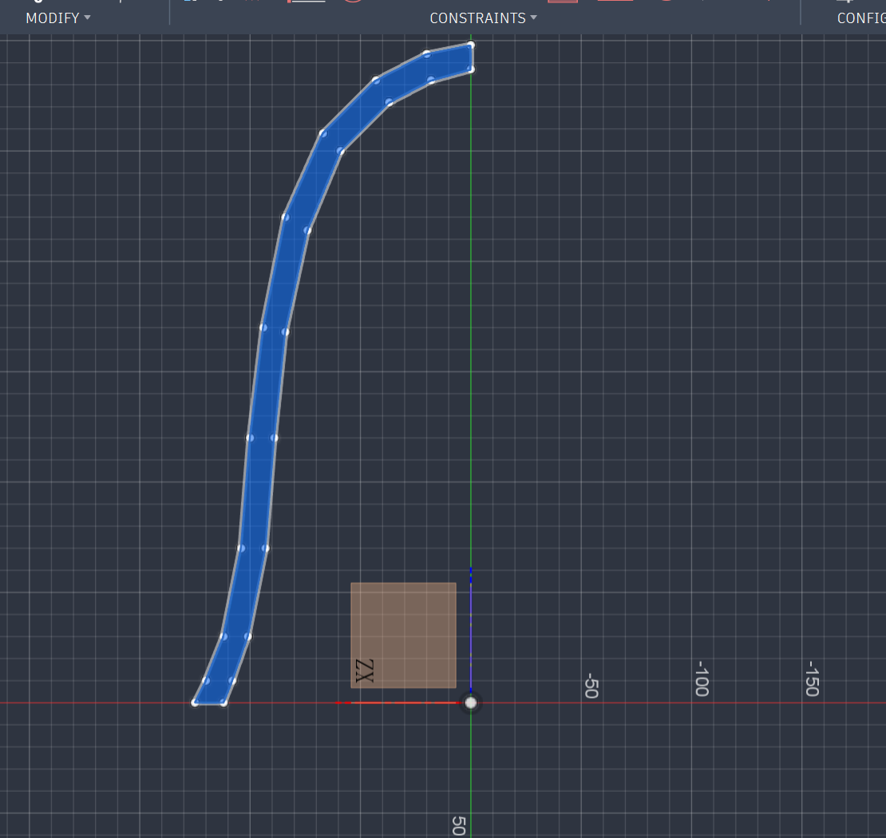
Figure 1. Half-profile of the helmet shell (10 mm wall, 300 mm tall).
2. Revolve the shell
I revolved the profile around the vertical axis to get the bell-shaped shell. The bottom opening is 200 mm wide. Then I added a new plane in front of the helmet and sketched the outline of the face opening on it.
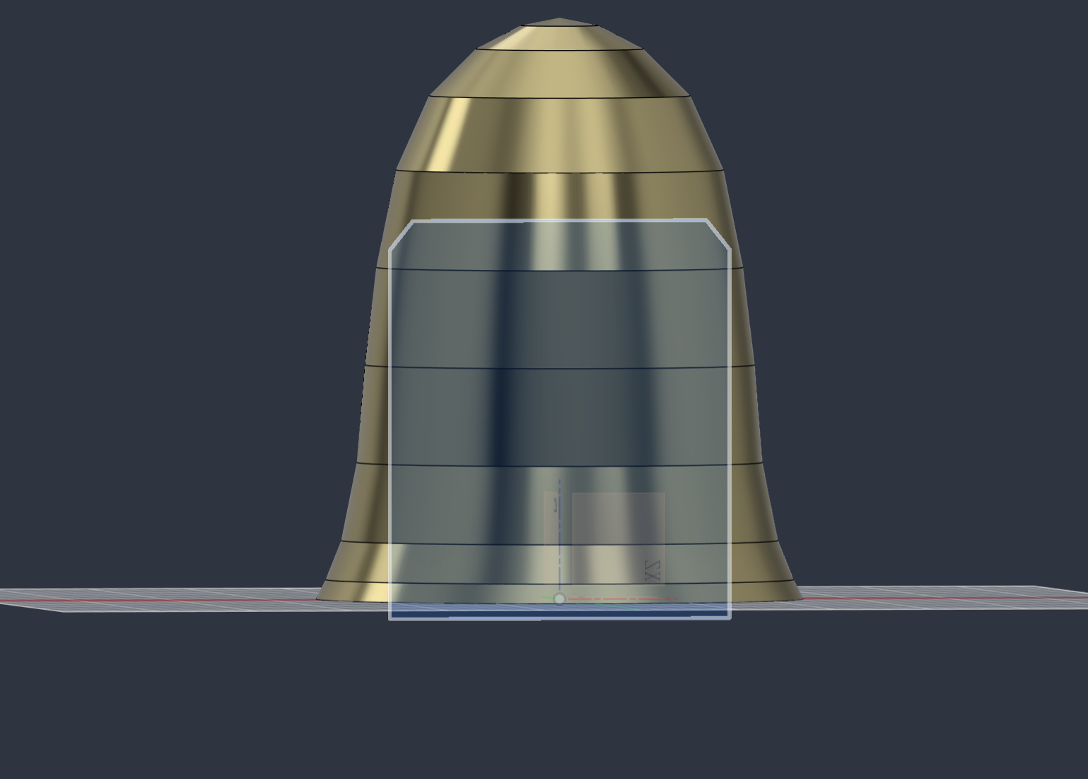
Figure 2. Revolved shell, with the face-opening sketch on a new plane in front.
3. Cut the face opening
Using that sketch, I cut the face area out of the front of the shell.
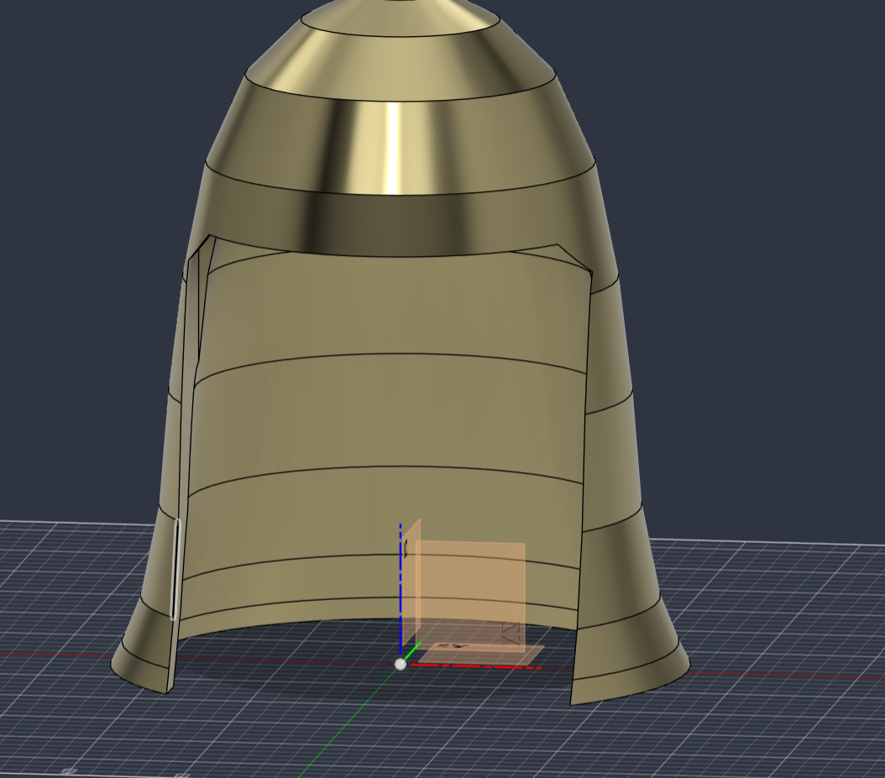
Figure 3. Shell after cutting out the face opening.
4. Split the body for printing
To make the helmet printable, I split the body into separate parts using an angled splitting plane (shown in red).
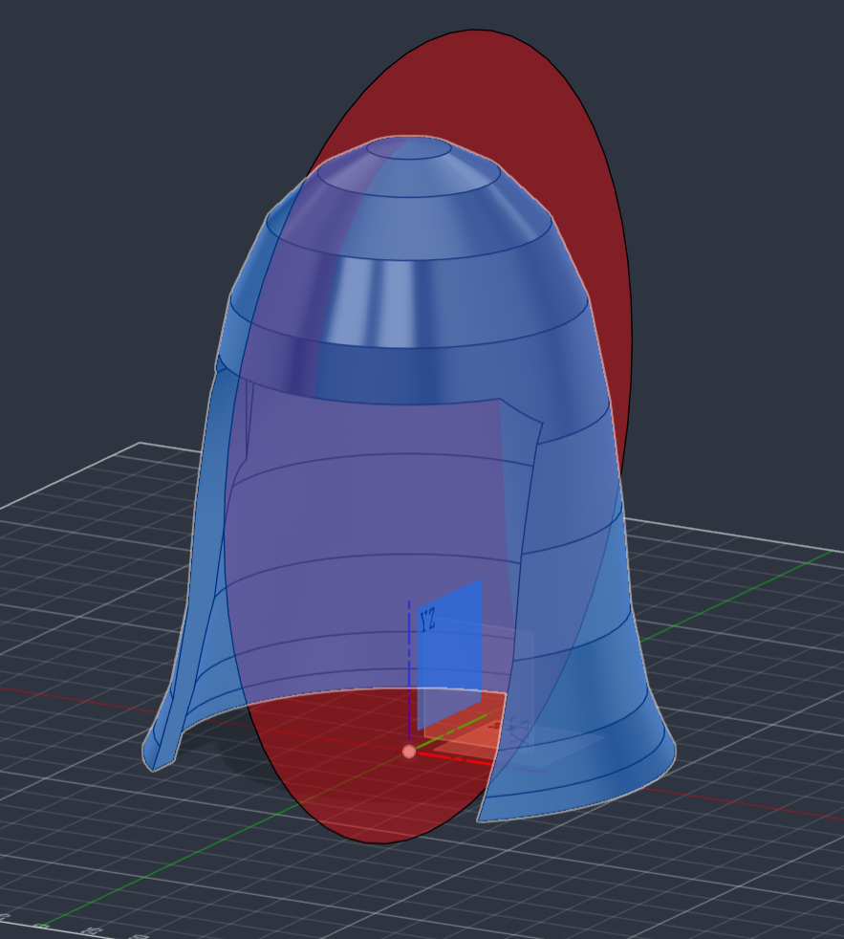
Figure 4. Splitting plane used to divide the shell into printable parts.
5. Loft the visor
For the visor (the face mask) I used the lofting technique from class. I drew two profile sketches on two different planes (Figures 5 and 6), then lofted between them to get the curved visor (Figure 7).
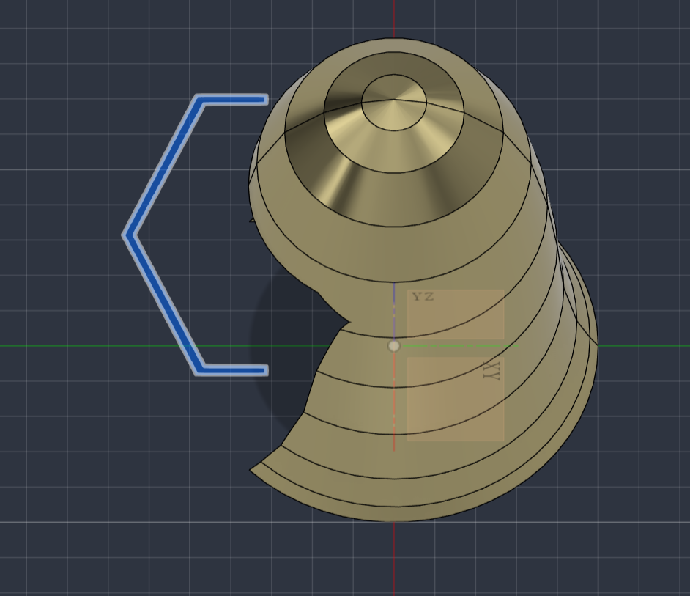
Figure 5. First visor profile sketch (top view).
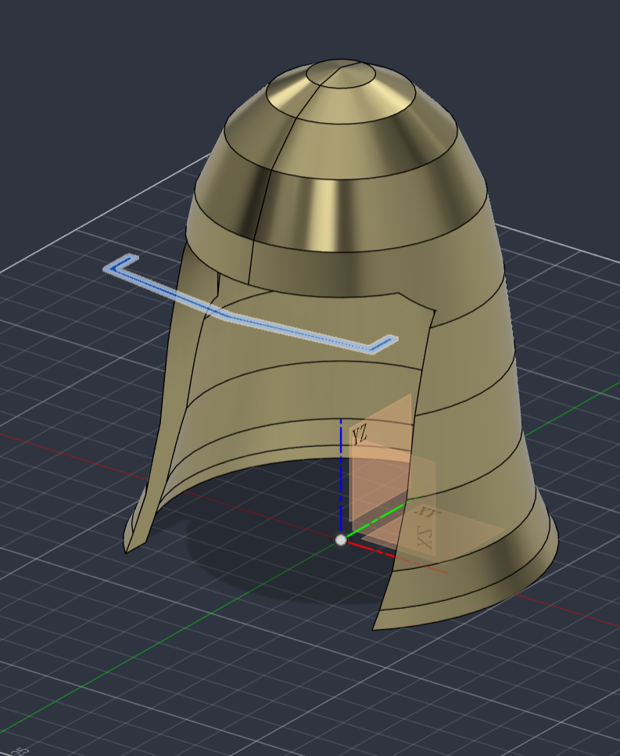
Figure 6. Second visor profile sketch, on a separate plane.
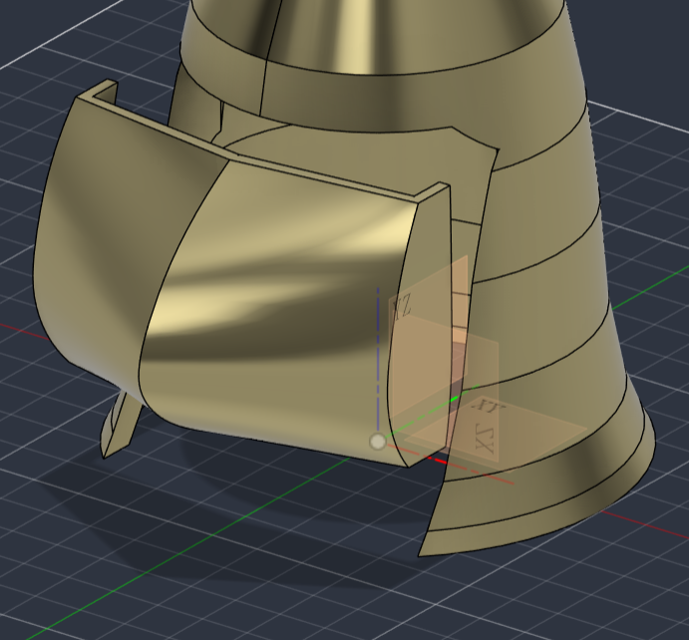
Figure 7. Visor created by lofting between the two profiles.
To check this week: whether the visor can actually swing up to the top of the helmet without hitting the shell.
6. Add the hinge
I added hinge arms that connect the visor to the sides of the helmet. The holes are for bolts. The bolts aren’t modeled yet, and the hinge still needs its finishing details.
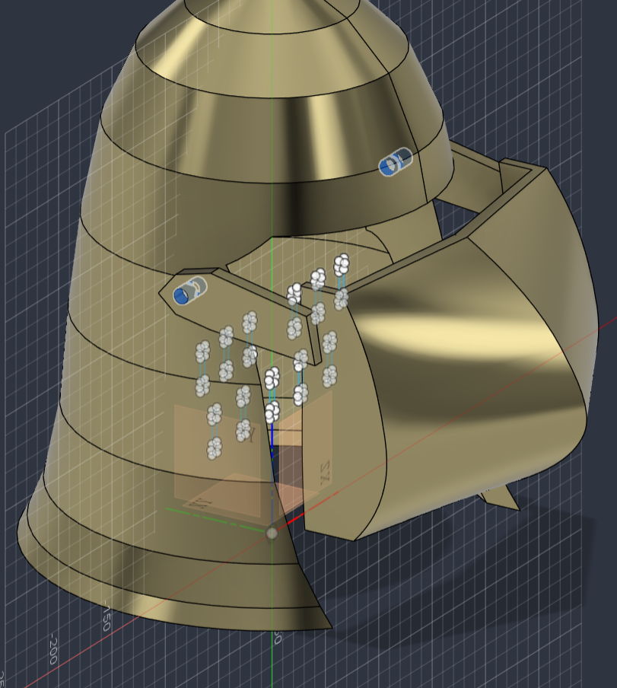
Figure 8. Hinge arms with bolt holes (bolts not modeled yet).
Current state
This is where the helmet stands right now. The shell, face opening, visor, hinge and breathing slots are all there, but the model is still a bit rough and needs refining.
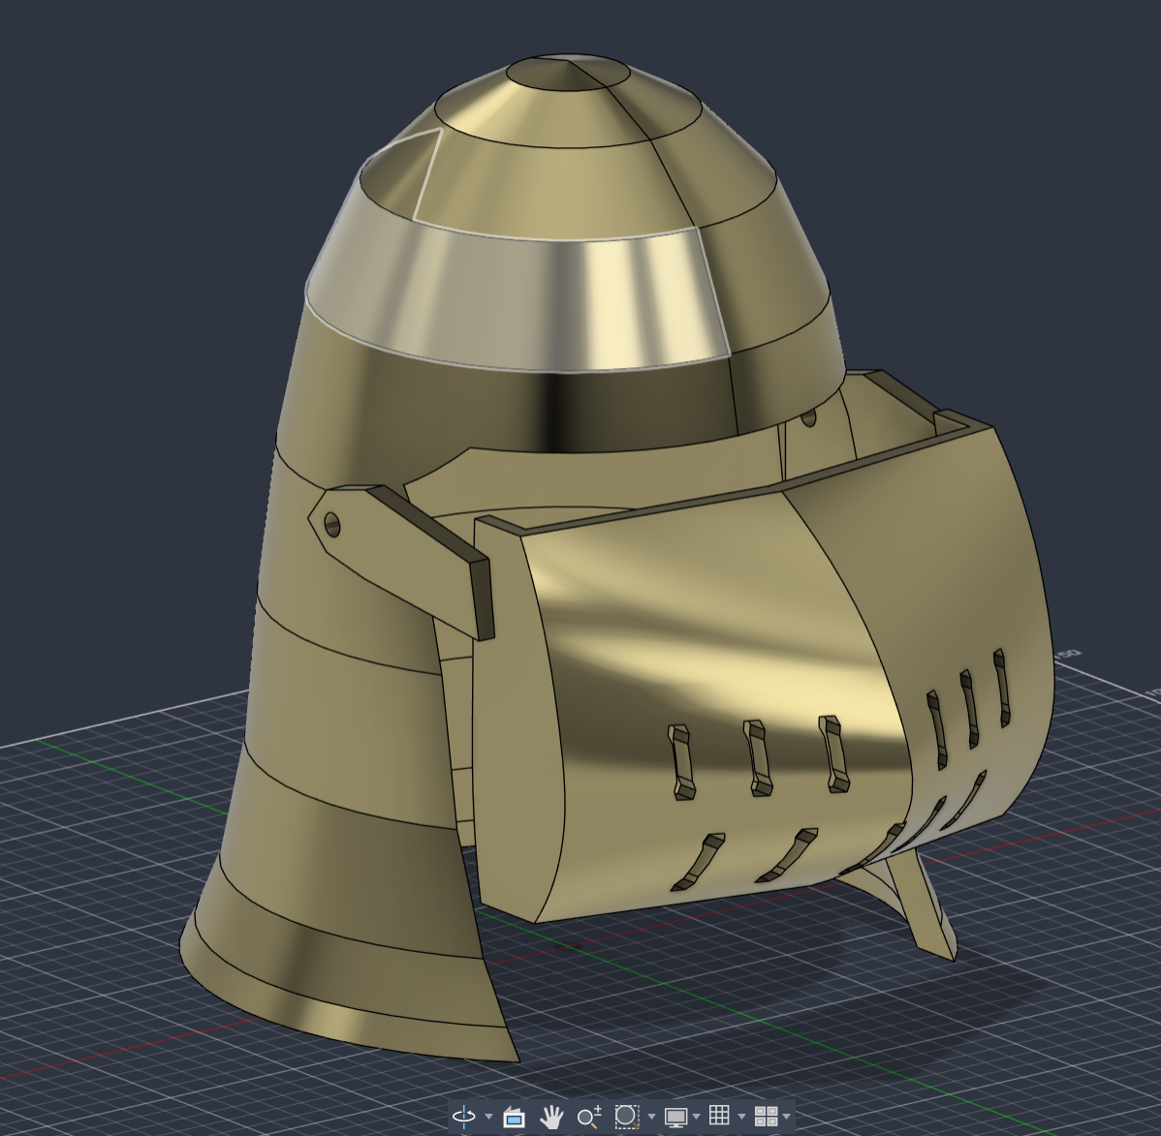
Figure 9. Work-in-progress helmet at the end of Week 5.
Next steps
!!add more details and hollow out some parts! To make it look better 🙂

•Check that the visor can rotate all the way up without colliding with the shell.
•Finish the hinge details and model the bolts.
•Adjust the overall height (currently 300 mm) and clean up the surfaces so it looks less rough.

