Seismic Sonar
Hearing the Earth move — an interactive visualization that adds a sonic channel to the USGS earthquake feed
InfoVis — Final Project Report · [Member A, Nxxxxxxxx] · [Member B, Nxxxxxxxx]

Overview
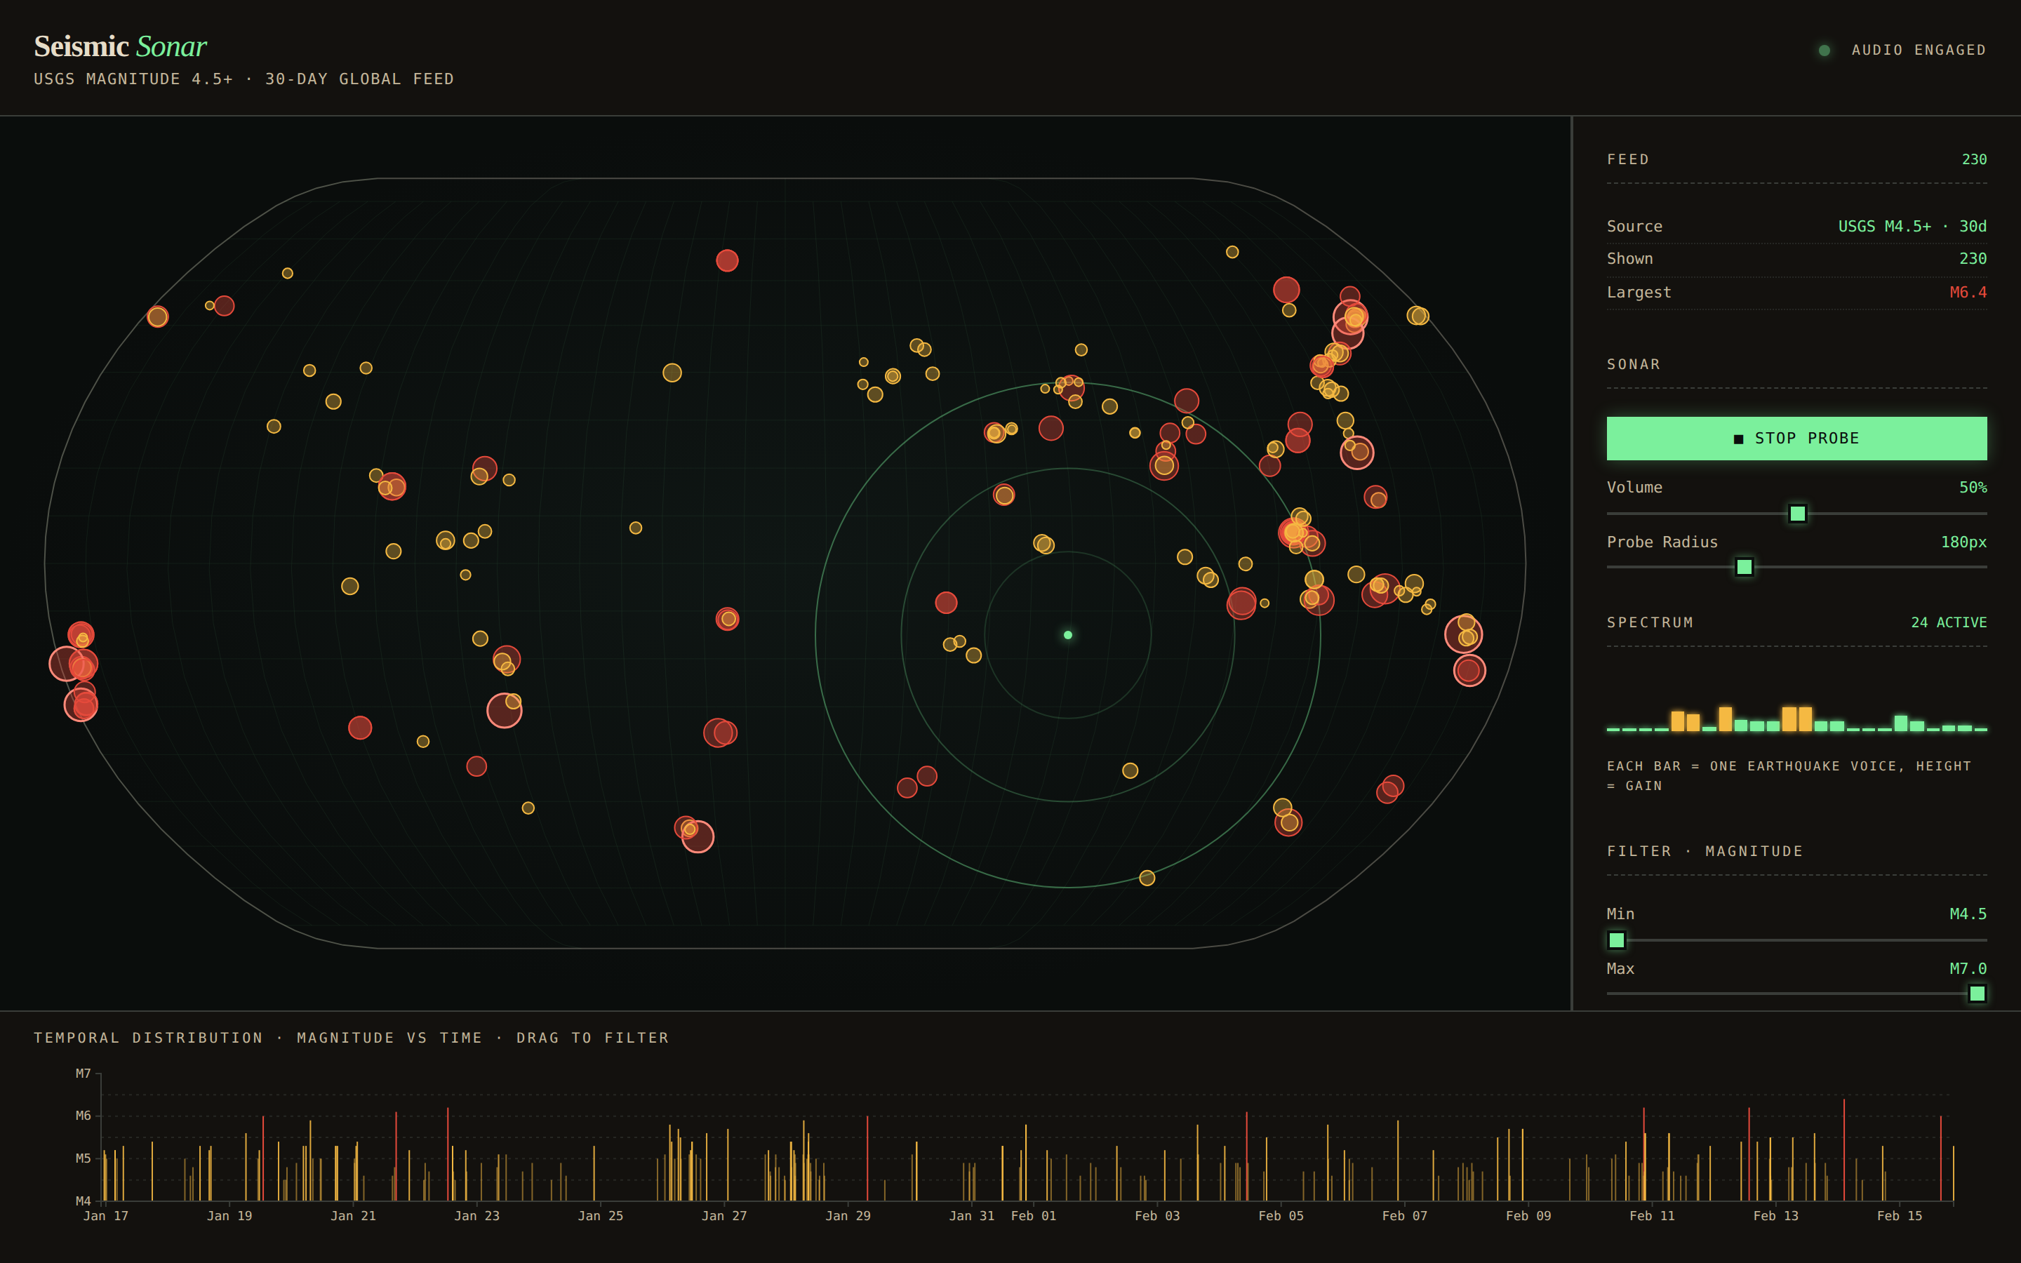
Figure 1. The instrument in use. Cursor over Indonesia triggers 24 active voices; their combined gain produces the amber/green VU-style spectrum in the side panel.
Seismic Sonar is a browser-based interactive visualization of every magnitude-4.5+ earthquake on Earth over a rolling 30-day window. It has three coordinated views — a world map, a temporal strip, and a status panel — but its distinguishing feature is sonification: the cursor behaves as a sonar probe, and each earthquake becomes an always-running audio voice whose loudness tracks the probe's distance to it. A user can sweep the map and hear the structure of global seismicity — dense swarms as chords, isolated large events as low single tones, silent regions as pink-noise quiet.
The project is built with Next.js 14, React 18, D3 v7 and the native Web Audio API. No audio library is used; we wrote the synthesis layer from scratch because the gain-per-voice modulation it needs is not something higher-level libraries expose cleanly.

Data
Source: USGS Earthquake Hazards Program. Public GeoJSON feed: earthquake.usgs.gov/earthquakes/feed/v1.0/summary/4.5_month.geojson.
Scale: ~400–500 events per 30-day window (the version we ship captures 230 events snapshotted at project time). Records are quantitative-geospatial (longitude, latitude, depth-km), quantitative-temporal (UTC milliseconds), quantitative-ordinal (magnitude 4.5–7+), and include auxiliary categorical fields (place name, tsunami flag, felt-report count, significance score).
Preprocessing: a Python script (scripts/process_data.py) fetches the GeoJSON, strips unused fields, sorts by time ascending, and writes a compact JSON blob to public/data/earthquakes.json. No joins, derived aggregates, or geocoding are required. At runtime the client prefers the bundled snapshot (so the demo works offline) and falls back to the live USGS feed if the snapshot is missing.

Goals and tasks
Domain goal: let a non-specialist audience perceive the geographic and temporal structure of recent global seismicity — the obvious Ring-of-Fire concentration, differences between subduction zones and mid-ocean ridges, the rarity of truly large events — without having to read tables.
Abstract tasks (after Munzner):
- Locate-by-area — identify spatial clusters of earthquakes on the globe.
- Compare distributions — contrast activity in two regions (e.g. Indonesia vs the Atlantic).
- Find extremum — spot the largest magnitude event in the dataset or in a sub-range.
- Select sub-range — filter events by time window.
- Lookup — retrieve the full detail for a single event.
The sonification primarily supports the first two. A stationary cursor over Java produces a dense, bright chord; over the South Atlantic it produces near-silence. This pre-attentive comparison is harder to do with markers alone because dense clusters overlap and require interaction to disambiguate. The traditional views support tasks 3–5 directly.

Visualization

View 1 — Geo-map (primary)
Natural Earth projection centered on (0, 0). One circle per earthquake. Size encodes magnitude with a square-root scale (3–16 px radius over M4.5–7.0) — sqrt so that area, which is the channel the eye actually reads, is linear in magnitude. Color encodes a magnitude tier rather than magnitude itself: amber (#f5b942) for M 4.5–5.2, crimson (#e54a3b) for M ≥ 5.2, with a brighter outline for M ≥ 6. A three-color categorical ramp is more effective than a continuous ramp for this task because users don't need to read precise values off the map — magnitude has a tooltip — but they do need to locate the "big ones" at a glance.
Cursor paints three concentric phosphor-green probe rings centered on the mouse, at 33%, 66%, and 100% of the probe radius. The outer ring is the audio cutoff; events inside it contribute audio, events outside do not. A dashed line connects the probe to the nearest marker within hover-range. The projection is chosen for its balanced area/shape distortion — a Mercator would exaggerate Japan and Russia, a Robinson would under-weight the tropics.

View 2 — Timeline
A magnitude-vs-time strip across the full window. Each event is a vertical tick from its (time, magnitude) down to the baseline. Ticks share the geo-map's color ramp. A d3-brush lets the user drag a time range; on release, the range filters both the map and the audio. The axis is labeled with month/day at roughly one label per 110 px. The y-axis uses "M4, M5, M6, M7" labels with dashed guide lines to keep the vertical scale readable at a glance.

View 3 — Sonar / status panel
A vertical stack containing (top to bottom): feed summary with total/visible/largest readouts; audio controls (start/stop, volume, probe-radius sliders); the live 24-bar spectrum; the magnitude min/max sliders; the "nearest five to probe" list with distances in pixels; the selected-event detail card; and a legend. The spectrum colors its bars green / amber / crimson based on gain magnitude, giving a second redundant encoding of how loud each voice currently is.

Coordination
All three views share state in the top-level Page component. Hovering a tick in the timeline highlights that event in the map; hovering a marker in the map highlights its tick in the timeline; clicking in either selects the event and fills the detail card. Brushing the timeline both re-renders the map (filtered set) and filters which voices can contribute audio.
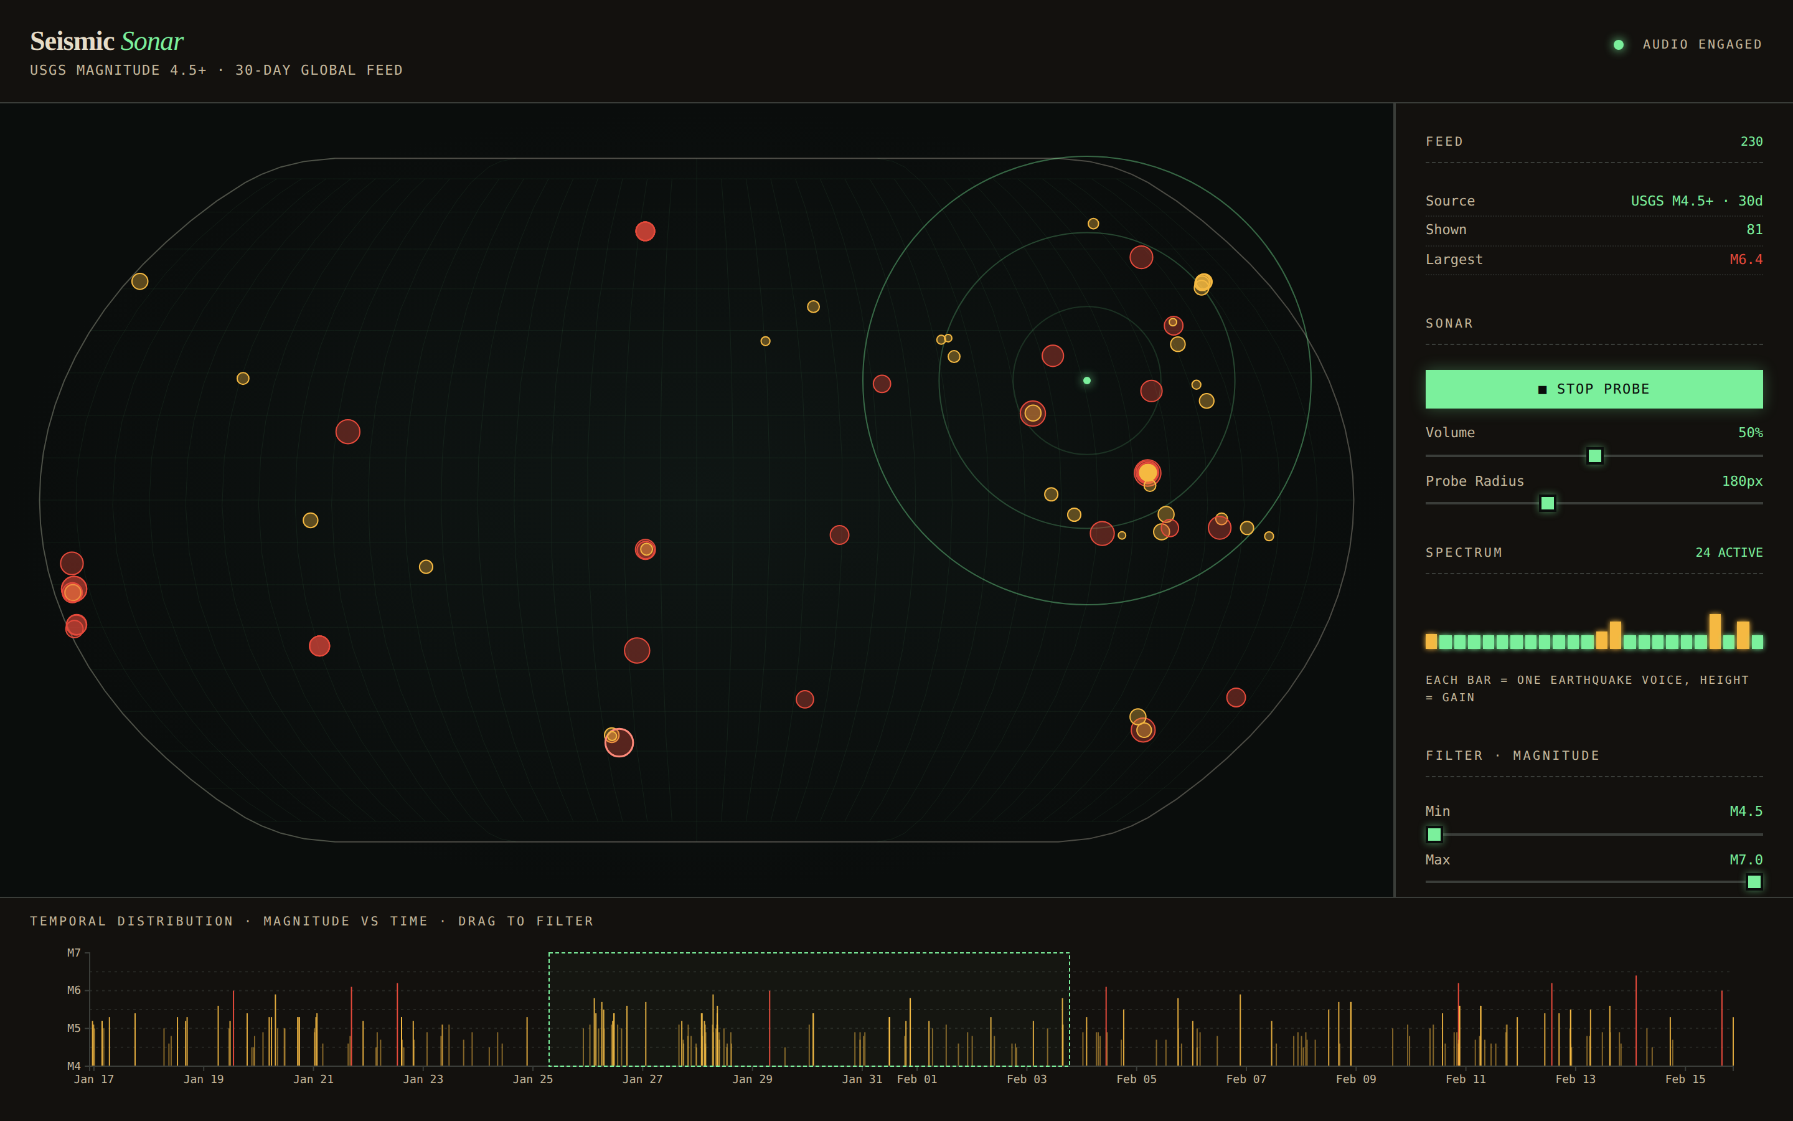
Figure 2. Linked views. The timeline brush (phosphor dashed box, lower right) has isolated Jan 25 – Feb 3; the map shows the 81 events in that window; the probe over the western Pacific shows 24 voices currently audible.

Reflection

What changed from the proposal
The submitted project is close to the proposal, with three adjustments:
- Magnitude is encoded as a tier, not a continuous hue. We initially planned a continuous interpolated ramp (amber → red). In practice this made the whole map look red-orange at a distance and erased the visual distinction between the 80% of events that are small and the 20% that matter. A three-tier categorical ramp reads better.
- The spectrum panel was added. It was not in the original proposal, but early tests showed that new users couldn't tell whether the silence they heard meant the engine was broken or genuinely quiet. The 24-bar spectrum provides a visual confirmation that the audio system is alive and what it is currently doing — a necessary redundancy for the sonification channel.
- No stereo panning. A stretch goal was left-right panning based on screen-x. We implemented and removed it: with ~200 voices running, the panning added more cognitive load than spatial information, and the map's x-axis is already a clearer left-right cue than a speaker pan.

Technical reflections
The main technical challenge was running 200+ Web Audio voices smoothly. Creating and destroying oscillators per frame produces audible clicks; we solved this by starting every voice once at mount and modulating gain to zero when out of range. This uses more CPU than a lazy approach but is click-free and simpler. The second challenge was not letting the soundscape become fatiguing: a pink-noise bed, a quadratic (not linear) distance falloff, and a gentle 40 ms time constant on the gain ramp keep the sound pleasant even during rapid cursor motion.
The CSS grid layout went through two iterations. The first version used auto-placed children, which worked in development but collapsed when Next.js's production build reordered class output. The final layout uses grid-template-areas — explicit, verbose, but robust.

Visualization-goal reflections
The question we can't fully answer in a written report is whether sonification actually helps comparison or whether it only impresses at the demo. Informal testing with three classmates suggests the effect is real but modest: all three correctly identified that Indonesia is louder than the Atlantic without being told in advance what the sound encoded. Two of them spontaneously asked whether they could "record a walk" over the globe — which is exactly the stretch goal we dropped, and worth revisiting.
If we had another week, we would add: (a) a recorded auto-walk that plays the entire globe as a 30-second composition for anyone who lands on the page; (b) a small accessibility mode that replaces the audio channel with a tactile pulse on supported devices; (c) a second dataset toggle — global volcanic activity — which would use the same framework and help demonstrate that the sonification approach is general, not a one-off trick.

