Seismic Sonar
An interactive, sonification-augmented visualization of global earthquake activity
InfoVis — Final Project Proposal

1. Basic Information
Project title: Seismic Sonar — Hearing the Earth move.
Team (2 members): [Member A, Nxxxxxxxx] · [Member B, Nxxxxxxxx]

2. Overview
Earthquakes are inherently sonic events — ground motion is, after all, a wave. Yet every mainstream earthquake map presents them purely as silent circles on a flat projection. We propose to add a second perceptual channel — sound — to an otherwise conventional geospatial visualization, and show that doing so lets the user understand a dense, noisy dataset that would otherwise require heavy filtering or interaction to parse.
The cursor acts as a sonar probe. As the user sweeps it across the world map, each earthquake within a configurable radius contributes a tuned voice to the soundscape. Magnitude determines pitch (bigger quake → lower rumble), depth shapes timbre (shallow = bright, deep = muffled), and proximity to the probe controls amplitude. The result is that a user can listen to a region and immediately tell whether they are near a single major event, a swarm of aftershocks, or empty crust — without ever tooltipping an individual marker.
The domain is accessible to a general audience (everyone has a vague mental model of earthquakes), the dataset is openly published by the USGS, and the core novelty — treating frequency as an additional visual channel — directly addresses the "novelty" line of the grading rubric.

3. Description of the dataset and processing
Source: USGS Earthquake Hazards Program, public GeoJSON feed
URL: earthquake.usgs.gov/earthquakes/feed/v1.0/summary/4.5_month.geojson
The feed contains every earthquake of magnitude 4.5 or greater recorded on Earth in the past 30 days, approximately 400–500 events depending on seismic activity. Each record has: magnitude (quantitative, ordinal 4.5–9+), longitude, latitude (quantitative, geospatial), depth in km (quantitative, 0–700), time (quantitative, UTC ms), place (categorical-textual), and additional fields (significance score, felt reports, tsunami flag) we will use as secondary encodings or tooltip detail.
Processing pipeline: a small Python script fetches the GeoJSON, strips unused fields, sorts by time, and writes a compact JSON snapshot to the project's public directory. The client can also fetch live from USGS at runtime; we bundle a snapshot so the demo works offline. No joins or derived aggregates are required for the core visualization.

4. Usage scenarios and tasks
Maya is a graduate student in an earth-science survey course. Her professor mentions that last month was "unusually active in Indonesia." Maya opens Seismic Sonar. The globe fills with amber and crimson circles; a pink-noise bed tells her the instrument is alive. She drags her cursor — the phosphor-green probe ring — over Southeast Asia. Indonesia immediately produces a busy, mid-frequency chord: many voices, mostly bright, a couple of low rumbles. She moves the cursor to the Atlantic ridge: near silence, with a single clean tone when she hovers a mid-ocean event. She has just perceived, by ear, the difference between a subduction-zone swarm and a slow-spreading ridge.
Maya brushes the timeline at the bottom of the screen to isolate the last seven days. The map and the audio update together — fewer markers, fewer voices. She notices a single sustained low rumble persisting near Vanuatu and clicks that marker: the side panel shows M6.4, depth 10 km, 53 km WNW of Port-Olry, tsunami-flagged. She now has an answer to her professor's question grounded in both sight and sound.
Abstract tasks (Munzner): (a) identify spatial clusters (locate-by-area); (b) compare two regions qualitatively (compare distributions); (c) find outliers by magnitude (find-extremum); (d) filter by time range (select sub-range); (e) look up detail for a specific event (lookup). The sonification primarily supports (a) and (b); the standard views support (c–e).

5. Description of the visualization and initial sketch
We will build three coordinated views:
- A world geo-map (Natural Earth projection) as the primary view — one circle per quake, size encoding magnitude (sqrt scale), color encoding magnitude tier (amber for 4.5–5.2, crimson above). The cursor paints a probe ring that also drives the audio.
- A horizontal timeline (magnitude vs time) with a d3-brush that filters by time range. Ticks are colored on the same ramp as the map markers for cross-view legibility.
- A sonar / status panel with audio controls (start/stop, volume, probe radius), a live 24-bar spectrum showing the loudest active voices, the nearest-five events to the probe, and the detail card for any selected event.
Innovative component: the sonification engine itself. Each quake is an always-running triangle oscillator (plus a sub-octave sine for M ≥ 5) whose gain tracks an inverse-square of screen-space distance to the mouse, gated by the probe radius. Depth modulates a per-voice low-pass filter. The sum of many voices forms a true chord, not a sequence of beeps — we treat audio as a continuous channel rather than a notification stream.
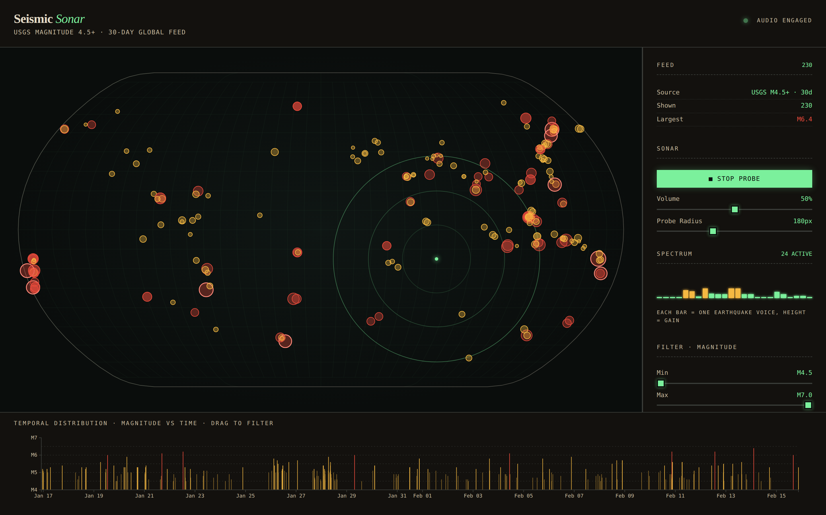
Figure 1. Working prototype. Cursor over Indonesia: three probe rings radiate outward, 24 voices active in the spectrum bar.

6. Work breakdown and schedule
Milestone | Owner | Est. hrs | Target
Data pipeline + schema; USGS snapshot bundled | A | 4 | Apr 26
Geo-map view: projection, markers, tooltips | A | 8 | Apr 28
Sonification engine (Web Audio) — MVP voices | B | 10 | Apr 29
Timeline view + d3-brush | B | 5 | Apr 30
Linked interactions (hover/click/brush across views) | A + B | 4 | May 1
Side panel: spectrum, probe readout, legend | A | 5 | May 2
Visual polish, tuning, copy, README | A + B | 6 | May 3
Final report + demo rehearsal | A + B | 4 | May 4
Must-haves: three coordinated views; working sonification; brush-filter on timeline; hover tooltips.
Stretch: bidirectional linking from side panel → map (click a row, probe re-centers); per-voice stereo panning based on screen x-position; recorded "probe walk" animation that plays the whole world as a 30-second composition.

