How Americans like their steak

Peer Christensen

24/1/2017

The data used for this report came from.........

## Steak preparation preference by region

steak_reg=prop.table(table(steak_survey$region,steak_survey$steak_prep),1)  
steak_reg=steak_reg[,order=c(5,4,3,2,1)]  
par(mfrow=c(3,3),mar=c(3,3,3,3))  
cols=brewer.pal(5,"OrRd")  
for (i in seq(9)) {barplot(steak_reg[i,],main=dimnames(steak_reg)[[1]][i],col=cols)}

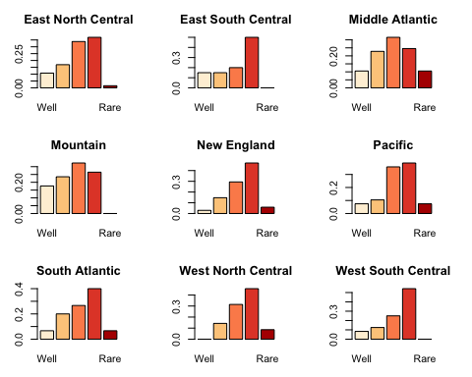

## By gender

steak_gen=prop.table(table(steak_survey$female,steak_survey$steak_prep),1)  
steak_gen=steak_gen[,order=c(5,4,3,2,1)]  
par(mfrow=c(1,2))  
barplot(steak_gen[2,],col=brewer.pal(5,"RdPu"),main="Women")  
barplot(steak_gen[1,],col=brewer.pal(5,"Blues"),main="Men")

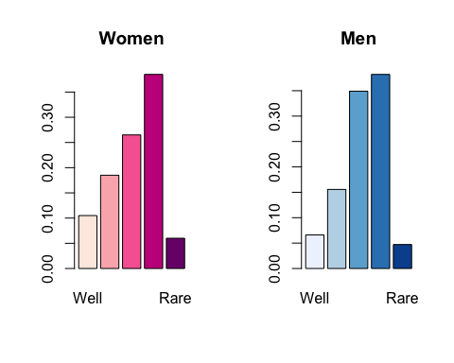

## Smokers vs. non-smokers

steak_smoke=prop.table(table(steak_survey$smoke,steak_survey$steak_prep),1)  
steak_smoke=steak_smoke[,order=c(5,4,3,2,1)]  
par(mfrow=c(1,2))  
barplot(steak_smoke[2,],col=brewer.pal(5,"Greys"),main="Smokers")  
barplot(steak_smoke[1,],col=brewer.pal(5,"Greens"),main="Non-smokers")

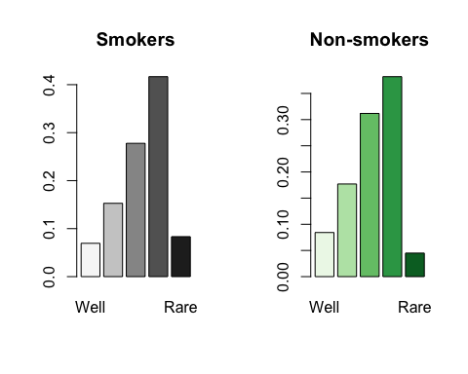

## Gamblers vs. non-gamblers

steak_gamble=prop.table(table(steak_survey$gamble,steak_survey$steak_prep),1)  
steak_gamble=steak_gamble[,order=c(5,4,3,2,1)]  
par(mfrow=c(1,2))  
barplot(steak_gamble[2,],col=brewer.pal(5,"Spectral"),main="Gamblers")  
barplot(steak_gamble[1,],col=brewer.pal(5,"PiYG"),main="Non-gamblers")

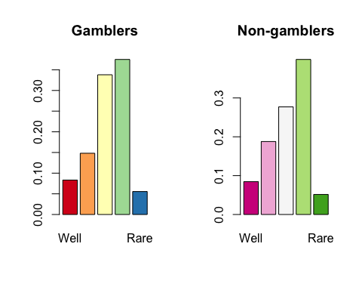

## Drinkers vs. non-drinkers

steak_alcohol=prop.table(table(steak_survey$alcohol,steak_survey$steak_prep),1)  
steak_alcohol=steak_alcohol[,order=c(5,4,3,2,1)]  
par(mfrow=c(1,2))  
barplot(steak_alcohol[2,],col=brewer.pal(5,"BuPu"),main="Drinkers")  
barplot(steak_alcohol[1,],col=brewer.pal(5,"PuRd"),main="Non-drinkers")

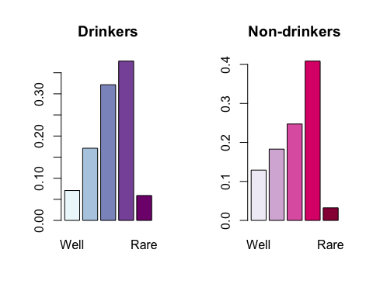

## By age

steak_age=prop.table(table(steak_survey$age,steak_survey$steak_prep),1)  
steak_age=steak_age[,order=c(5,4,3,2,1)]  
par(mfrow=c(1,4),mar=c(3,3,3,3))  
cols=brewer.pal(5,"YlGn")  
for (i in seq(4)) {barplot(steak_age[i,],main=dimnames(steak_age)[[1]][i],col=cols)}

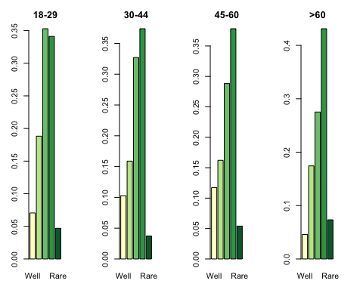

## By household income group

steak_hhold_income=prop.table(table(steak_survey$hhold_income,steak_survey$steak_prep),1)  
steak_hhold_income=steak_hhold_income[,order=c(5,4,3,2,1)]  
par(mfrow=c(1,5),mar=c(3,3,3,3))  
cols=brewer.pal(5,"Reds")  
for (i in seq(5)) {barplot(steak_hhold_income[i,],main=dimnames(steak_hhold_income)[[1]][i],col=cols)}

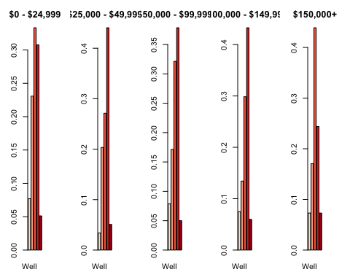

## By level of education

steak_educ=prop.table(table(steak_survey$educ,steak_survey$steak_prep),1)  
steak_educ=steak_educ[,order=c(5,4,3,2,1)]  
par(mfrow=c(1,4),mar=c(3,3,3,3))  
cols=brewer.pal(5,"GnBu")  
#drop less than High school level - only one respondent  
for (i in seq(2,5)) {barplot(steak_educ[i,],main=dimnames(steak_educ)[[1]][i],col=cols)}

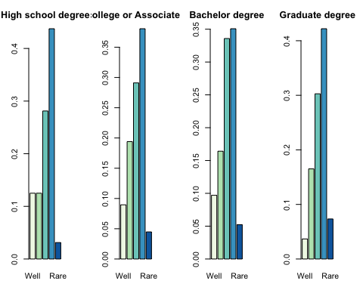

## By awesomeness

For this visualization, we create a new variable to distinguish people who enjoy smoking, gambling and drinking, from those who do not like fun. All respondents who do not fit into these categories are disregarded.

steak_survey$champs=with(steak_survey,  
 ifelse(gamble==T & smoke==T & alcohol==T,T,NA))  
steak_survey$champs[steak_survey$gamble==F &   
 steak_survey$smoke==F & steak_survey$alcohol==F] = F  
steak_champs=prop.table(table(steak_survey$champs,steak_survey$steak_prep),1)  
steak_champs=steak_champs[,order=c(5,4,3,2,1)]  
par(mfrow=c(1,2))  
barplot(steak_champs[2,],col=brewer.pal(5,"YlOrBr"),main="Champs")  
barplot(steak_champs[1,],col=brewer.pal(5,"Purples"),main="Non-champs")

