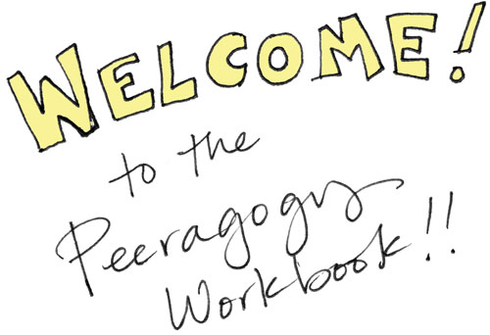
Welcome to the Peeragogy Workbook! This booklet is designed to introduce you to our fun, exciting world of peer learning and peer production!!

You may already be familiar with these terms, or they may be new to you. Either way, don't worry!!!

If they are new, consider the following 2 examples.

- Peer learning: Joe Corneli needs to get from the suburbs of Chicago to the north side of the city. He gets on the commuter train and transfers to the purple “L” at Davis Street in Evanston. He plans to change to the red line at Howard Street, but the train says “Loop” and he asks another passenger whether it will stop at Howard. She says it will, but that he can save an hour of his time by riding express to the city and then coming back two stops! Joe makes it to his meeting with Charlie with plenty of time to spare.

- Peer production: Two cavewomen see lightning strike a tree and produce fire! Walking up to it they notice the heat and think “Wouldn’t it be nice to have fire for our family at night!” Once the rain clears, they find some dry sticks and start working together to figure out how they can use them to start their own flame. After hours of trial and error, BOOM they’ve got fire! The news travels fast. :)

Peeragogy is an approach to learning and working together on projects ranging from the mundane to the monumental. Peer learning and peer production are probably as old as humanity itself, but they take on new importance in the digital age.

The Peeragogy Project is an informal learning project with members worldwide. Three members of the project share their welcoming messages below.

Lisa Snow MacDonald: Welcome to peeragogy! It’s kind of a weird name, but it’s enormously powerful in providing to you some understanding of other ways of working together.

Dorotea Mar: Your contributions would be really welcome if you participate respectfully and harmoniously with other peers. It can change your life and improve your well-being and make everything better.

Paola Ricaurte Quijano: Welcome to the Peeragogy Project! We are a group of enthusiastic people that love to learn and are trying to find the best ways to learn together.

A Peeragogy Interview

Paola Ricaurte Quijano: Hi! I’m Paola, I’m from Ecuador. I work at Tecnológico de Monterrey, a private university in Mexico City, and I love to learn with everybody!
Dorotea Mar: Hello. I’m in Berlin now and I really like the peeragogical atmosphere of collaboration and I think we are really improving ways of collaboration and peer production, so that’s why I’m here.
Lisa Snow MacDonald: Hello. This is Lisa from Los Angeles. My background is media psychology and I’m interested in peeragogy as it relates to business.
What is peer learning/production?
PRQ Well, peer learning. learning with peers, learning from peers and trying to make things together or make things happen together. I think that for me, the most important thing I’ve learned from this experience is that you can achieve more when you work together and set goals together.
LSM I think what peeragogy does is it allows us to recognize the value of those connections. A lot of other ways of working are more individualized. It goes back to a concept of 1 + 1 = 2, which is very rational and very measured and is kind of a dominant way of thinking in our society today, whereas peer to peer learning and production recognize the value of those connections. You may not be able to measure it with a yardstick, but we understand that there is value in those connections. So it’s basically acknowledging that when it comes to learning/collaborative environments if constructed the right way if working well it can be 1 + 1 = 3 or 1 + 1 = 4. That type of situation, which is really different from the way we’re used to thinking about things. And I think that’s really the value of what we’re doing and the potential of what we could hopefully unlock.


More specifically, what is peeragogy and/or what is the Peeragogy Project?
PRQ This is a project that began spontaneously. We didn’t have a plan at the beginning. We just talked about the things that concerned us the most. What do you need if you want to learn with others, how to learn better? what do you want to learn? Where do you want to learn? When do you want to learn? Basic questions that can be answered in many ways. We don’t have a strict line. We have a map, maybe, but a map that can be walked through by many different paths. Paths that you choose can be related to the people you are working with. I think it’s been a great experience for us. As Lisa said, we have been recognizing the talents and strengths of every person that has contributed and participated in this project.
LSM OK. I’ll take my best shot with this. Going back to what I said earlier and building off what other people have said. Because we don’t have a good mental construct in our heads as far of how this works and measurement is difficult. We haven’t learned how to measure these connections. I think what peeragogy and the Peeragogy Project can do is it can establish what people have said about focusing on the process. It can help people understand the process better. Because this lack of structure can be uncomfortable for people. We need to understand when that discomfort is acceptable, so they don’t revert and become counter-productive participants in the process. The map analogy is really good too that Paola just mentioned. It’s not about providing a direct path.
If you’re on a trip trying to get from LA to Chicago, there’s many paths you can take. What's important is making sure you’re monitoring your resources and you’re taking care of things along the way. You can drift off course. 1 + 1 can equal 0 if things don’t work out well. So, what peeragogy and the Peeragogy Project can do is provide some structure and framework around the unstructured way that things can be done, so people trying to make sure it’s constructive and beneficial have some guidelines and some things to watch out for.



Example: Howard Rheingold Grows a Learning Network
When I started using social media in the classroom, I looked for and began to learn from more experienced educators. First, I read and then tried to comment usefully on their blog posts and tweets. When I began to understand who knew what in the world of social media in education, I narrowed my focus to the most knowledgeable and adventurous among them. I paid attention to the people the savviest social media educators paid attention to. I added and subtracted voices from my attention network, listened and followed, then commented and opened conversations. When I found something I thought would interest the friends and strangers I was learning from, I passed along my own learning through my blogs and Twitter stream. I asked questions, asked for help, and eventually started providing answers and assistance to those who seemed to know less than I. The teachers I had been learning from had a name for what I was doing — “growing a personal learning network.” So I started looking for and learning from people who talked about HOW to grow a “PLN” as the enthusiasts called them.

How do you do peeragogy?
DM I think I do a lot of peeragogy and I’m very happy about it because I learn so much from my group and from myself in this group that I like to apply it to other projects that I’m in or all the coworking/coliving projects or anything basically. Especially the principle of mutual respect that is still remaining after a very long time. And the really nice relating to each other. The main principle is mutual respect and openness, mutual space not constrained by time/space. And the process. And what I meant by the details, in each detail there is value that we promote. Let’s say how we manage the Peeragogy Page or Community (See “How to Get Involved”, below.). These seem to be details, but they’re actually really important. So if we pay attention to all these, every little thing matters, and this is how I do it. I try to be very careful about basically everything.

Example: Learner, know thyself.
When he joined the Peeragogy project in 2012, Charles Jeffrey Danoff did a brief self-evaluation about what makes him interested in learning:
- Context. I resist being groomed for some unforeseeable future rather than for a specific purpose.
- Timing and sequence. I find learning fun when I’m studying something as a way to procrastinate on another pressing assignment.
- Social reinforcement. Getting tips from peers on how to navigate a snowboard around moguls was more fun for me than my Dad showing me the proper way to buff the car’s leather seats on chore day.
- Experiential awareness. In high school, it was not fun to sit and compose a 30-page reading journal for Frankenstein. But owing in part to those types of prior experiences, I now find writing pleasurable and it’s fun to learn how to write better.

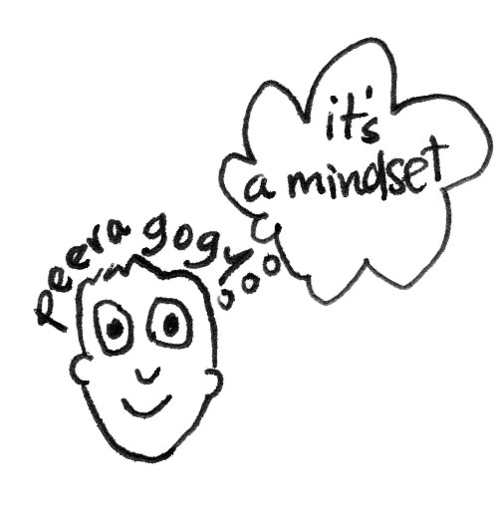
PRQ I think peeragogy is more like a mindset. I think we have to change the way we relate to others and the way we understand the possibilities of learning. For example, I’m a teacher and, of course, my teaching practice tries to support collaborative, creative learning. So, I expect my students to take care of their own learning by making decisions about most aspects of the learning process. Program their own learning goals. The Blackboards, the environments they want to use. The activities and also the assessments. I’m trying to give them conditions to decide how they want to learn and what they want to learn and how they want to learn it. And for me it’s been a very interesting experience. They are usually not used to making decisions about the process in a formal environment. At the beginning of the semester you give them everything and usually they just follow guidelines and criteria for the class. I have been trying with them to change this way of doing things. They feel insecure, because they really do not know how or what they want to do. So, that process of making decisions together is very rich and very meaningful for everybody.

Example: Metacognition and Mindfulness

Alan Schoenfeld: “What (exactly) are you doing? Can you describe it precisely? Why are you doing it? How does it fit into the solution? How does it help you? What will you do with the outcome when you obtain it?”

When do you do peeragogy?
DM I think always. I really like that during the hangouts we don’t have agendas usually. We just get creative. And whatever happens it’s the right thing. We just work together and somehow the right things happen. I think we’re always doing peeragogy when we do things in open, collaborative, ways if we’re not trying to restrict it with too much structure in the Hangouts or anything we do basically.
PRQ I basically agree with Dorotea. The where and when questions are related. If you’re thinking about where, you’re thinking about when. So if where is everywhere, and then your when is also always, so I agree. Anywhere, everywhere, all the time. It’s an ongoing process. It’s not something you can say NOW I’m applying peeragogy, but not for others. At least from my point of view. If you believe in peeragogy in a sense in that sense that you believe in a way of doing things or making things happen, you cannot shuffle or break yourself into 2 people or 2 different persons and say I’m not working with peeragogy now. It’s hard to split yourself in 2.
LSM In business there are personalities, and people who will tend to adapt and prefer a peeragogical model. They tend to be more collaborative just by nature. Other personalities are not, and that’s why what we’re doing here is valuable. There’s often not recognition of these two different styles of working that’s conscious. In a business environment it’s not necessarily voluntary and people coming together united by a single goal. In biz you get different personalities tossed together, so understanding these rules and raising differences to the surface could be very valuable for the business to make other people’s lives better in the business environment.

DM There are many collaborative projects that aim to do something of this kind, but they are not as much into it as we are in a sense. They notice something or promote something that we do also, but they do not pay attention to other things that we consider important. Some people have natural tendencies to be peeragogical, and some people are not so transparent in the way they do things, but I think it’s really beneficial, especially for collaborative projects. Everyone can learn a bit of that and do it if they bring more awareness to how they do things and what they think and not just focus on some part of it, but see things in a bigger picture in a sense, so I think people do it in little different ways and sometimes they do the opposite, but I think our role would be to bring more awareness to the details and process. And if people resonate with it they can say yes it makes sense and they can do it this way, but still I think it would help to focus attention on all that could be done in a peeragogical way, Bring more awareness to roles, would help to focus attention to all that could be done in a peeragogical way and maybe is not because there’s not enough awareness of the process. In general my answer is most people are able to do it, but maybe they just don’t know yet.

Example: Jay Cross on Setting Sail
If I were an instructional designer in a moribund training department, I’d polish up my resume and head over to marketing. Colearning can differentiate services, increase product usage, strengthen customer relationships, and reduce the cost of handholding. It’s cheaper and more useful than advertising. But instead of just making a copy of today’s boring educational practices, build something based on interaction and camaraderie, perhaps with some healthy competition thrown in. Again, the emphasis should always be on learning in order to do something!

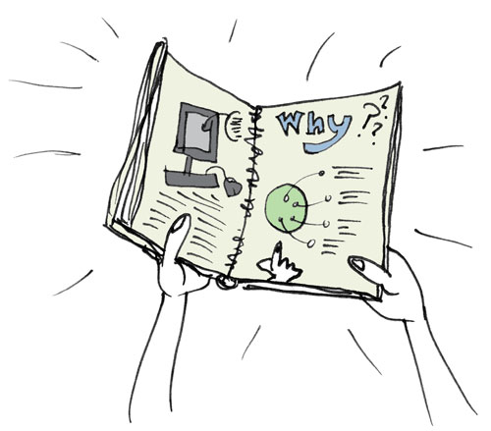
Why do you do peeragogy?
PRQ Why? Well as said before, I believe in peeragogy. I believe it’s a good way to learn. Maybe it’s the best way. I think I wasn’t aware of that before joining the group. I have always been a selflearner, I have been working mostly alone. After I began working with the group, I understood that you grow working with a group. You achieve things that you aren’t able to achieve alone. I think there’s a growing awareness of the value of collaboration in every setting and environment. There are more and more learning communities everywhere in every place in the world that are also learning that are that doing things together and deciding things together is best way that you could be in this world! I think we are living in hard times so we need more and more the sense that we are not alone and that we cannot solve problems alone.
How did you join the Peeragogy project?

PRQ How did I join? Actually after taking Howard Rheingold’s course on Mind Amplifiers back in 2012 he invited us to join this group. As I said before there was not a plan, just an open question of how to best learn with others. That’s how it began. We had many sessions, discussing about many things. The Peeragogy Handbook (http://peeragogy.org) was the product of that process. We have been working with the Handbook, releasing new version every year and trying to see what would be the best way to go farther and what would be the future of our collaboration as a group/team?
LSM A couple friends of mine were involved in P2P learning. They were invited to a conference at UCI. Howard was at the event and they were familiar with him. We ended up in obscure classroom and he started talking about principles that were peeragogy related, while I don’t know if it provided much value to my friends, it sounded a lot like what I saw in business and he mentioned the group. So after that, I spoke to you guys and, it’s pretty random.
DM I think many paths led to me joining it. I was doing research on Open Science and I have lots of academic experiences and I always wanted to improve the way things work and somehow I wanted to do it and make it more creative. I resonated a lot with the Peeragogy Project on many levels, so somehow I just joined, I think it was serendipity of some kind.


This interview was conducted on December 15th, 2014. The transcript was edited. You can watch the whole interview online at http://is.gd/peeragogyworkbook_interviews.
We've given you some examples but this wouldn't be a proper workbook without an exercise. Pick at least one thing you're good at and one thing you want to improve at from the selection below (or write in your own alternative answers):

Exercise: How do you see yourself fitting in?

Potential roles in your peer-learning project
- Leader, Co-Leader, Manager, Co-Manager, Team Member, Worker
- Content Creator, Author, Content Processor, Reviewer, Editor
- Presentation Creator, Designer, Graphics, Applications
- Planner, Project Manager, Coordinator, Attendee, Participant
- Mediator, Moderator, Facilitator, Proponent, Advocate, Representative, Contributor, Activist, _____________

Potential contributions
- Create, Originate, Research, Aggregate
- Develop, Design, Integrate, Refine, Convert
- Write, Edit, Format, _______________

Potential motivations
- Acquisition of training or support in a topic or field;
- Building relationships with interesting people;
- Finding professional opportunities;
- Creating or bolstering a personal network;
- More organized and rational thinking through dialog;
- Feedback about your understanding of the topic;
- ________________________________________________.

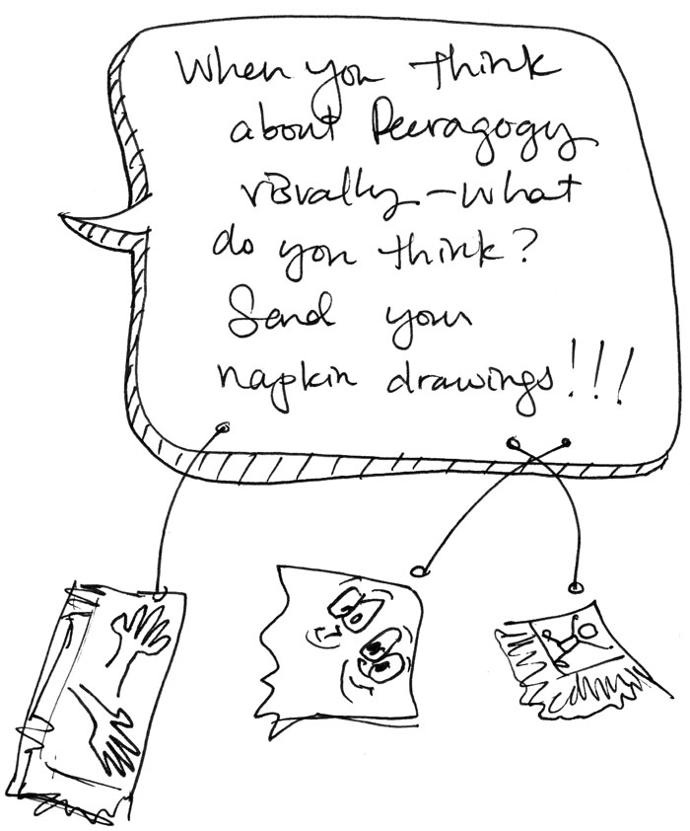

How-To Get Involved in the Peeragogy Project

To join us, please say hi!

E-mail to:
peeragogy@googlegroups.com

Write to:
Peeragogy Project
c/o Pierce Press
PO Box 206
Arlington, MA 02476

Join a Google Hangout at 18:00 GMT on Mondays @:
https://plus.google.com/+PeeragogyOrgHandbook

We have multiple opportunities for peers to contribute. Here’s our current “Top Seven” list:

- Site: Google+ Peeragogy Handbook page
  - What happens: Coordinating Hangouts on Air, G+ news updates
  - Who’s in charge: Charlotte Pierce & Charlie Danoff
  - URL: https://plus.google.com/+PeeragogyOrgHandbook/posts
  - Status: Active

- Site: Peeragogy mailing list
  - What happens: Chance for newcomers to introduce themselves! Meta-level coordination for the project, main point of contact with the email-o-sphere
  - Who’s in charge: Maintainer wanted!
  - URL: https://groups.google.com/forum/#!forum/peeragogy
  - Status: Active

- Site: Peeragogy.org
  - What happens: Maintain the “master” copy of the peeragogy handbook, share public news about the project.
  - Who’s in charge: Peeragogy Project
  - URL: http://Peeragogy.org
  - Status: Active

- Site: Google Drive Peeragogy Work Folder
  - What happens: Hive editing, working drafts to be delivered elsewhere when they are finished or for final polishing.
  - Who’s in charge: Peeragogy Project
  - URL: http://is.gd/peeragogydrive
  - Status: Active

- Site: Peeragogy In Action Google+ Community
  - What happens: Random posts related to Peeragogy, quick communications between members, news about events, hangouts, etc
  - Who’s in charge: Everyone
  - URL: http://goo.gl/4dRU92
  - Status: Active

- Site: Peeragogy YouTube Channel
  - What happens: videos posted here
  - Who’s in charge: Charlotte Pierce
  - URL: http://is.gd/peeragogyvideos
  - Status: Active

- Site: Git.io/Handbook
  - What happens: versioned storage of the LaTeX sources for the print version of the handbook and other derived formats and scripts
  - Who’s in charge: Maintainer wanted!
  - URL: http://git.io/Handbook
  - Status: Active

Do not worry about rules or trying to catch up! Just jump in! :)

“Peeragogy Workbook v1.1” © 2015, 2016 the authors

All rights dedicated to the Public Domain under the Creative Commons Zero license. You can view the license online at https://creativecommons.org/publicdomain/zero/1.0/.

Visuals by Amanda Lyons (http://visualsforchange.com/).
Booklet by Charlie Danoff, Paola Ricaurte Quijano, Lisa Snow MacDonald, Dorotea Mar, Joe Corneli and Charlotte Pierce.
Revised for Public Domain Day 2016, January 1st, 2016.

