**Program Structure**

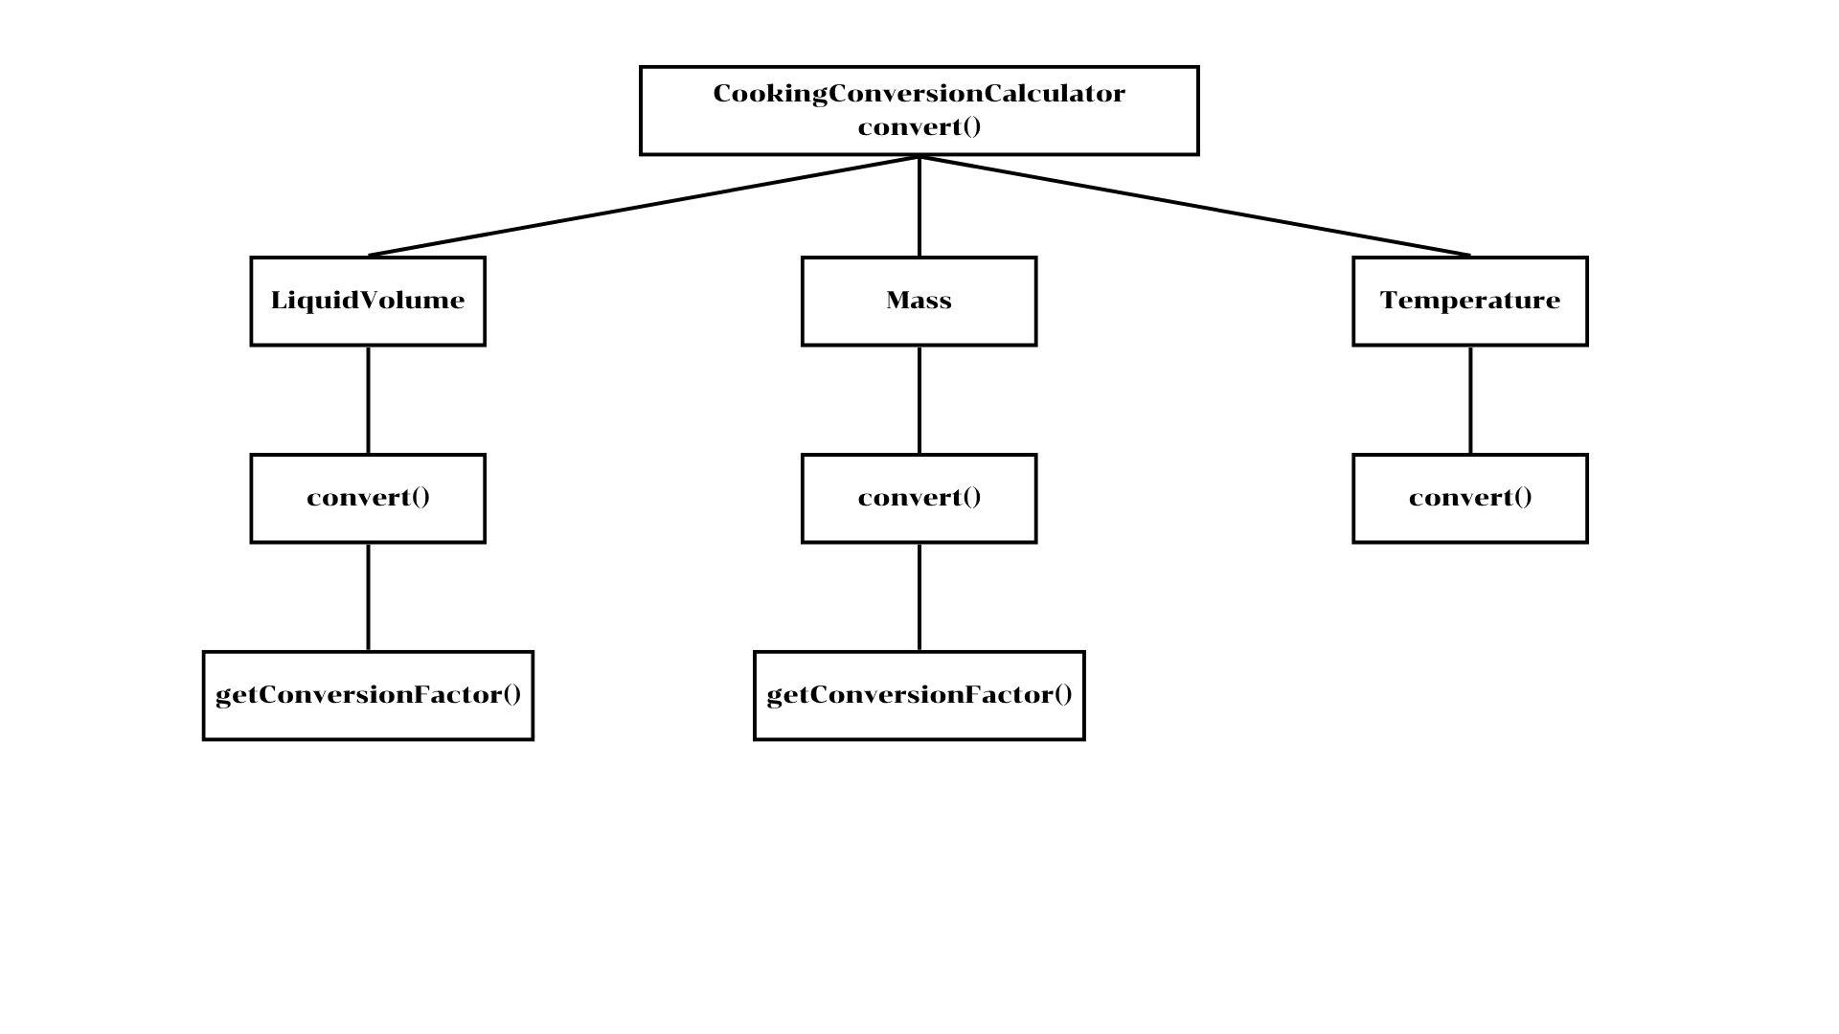

**Top-down Integration**

| Unit under test | List of Stubs/Drivers | result | Stub’s return value | Expected results | Actual results | Pass/Fail/No run |
| --- | --- | --- | --- | --- | --- | --- |
| Cooking  Conversion  Calculator | **Stubs:** Temperature  Converter , MassConverter, LiquidVolumeConverter | (212, "temperature", "fahrenheit", "celsius") | TempStub returns 100.0  Others return -1.0 | 100.0 | 100.0 | Pass |
| Cooking  Conversion  Calculator | **Real :** Temperature  Converter  **Stubs:** MassConverter, LiquidVolumeConverter | (212, "temperature", "fahrenheit", "celsius") | Mass Stubs Liquid Stubs return -1.0 (Not Called) | 100.0 | 0.0 | Fail |
| Cooking  Conversion  Calculator | **Real :** Temperature  Converter , MassConverter  **Stubs:** LiquidVolumeConverter | (2, "mass", "cup", "gram") | LiquidStub returns -1.0 (Not Called) | 250.0 | 250.0 | Pass |
| Cooking  Conversion  Calculator | **Real :** All components  **Stubs:** None | (1, "liquid", "cup", "ml") | (No Stubs) | 250.0 | 250.0 | Pass |

**Bottom-up Integration**

| Unit under test | List of Stubs/Drivers | result | Stub’s return value | Expected results | Actual results | Pass/Fail/No run |
| --- | --- | --- | --- | --- | --- | --- |
| Temperature  Converter | Driver | (212, "fahrenheit", "celsius") | (No Stubs) | 100.0 | 0.0 | Fail |
| MassConverter | Driver | (2, "cup", "gram") | (No Stubs) | 250.0 | 250.0 | Pass |
| LiquidVolume  Converter | Driver | (1, "cup", "ml") | (No Stubs) | 250.0 | 250.0 | Pass |
| Cooking  Conversion  Calculator | Driver | (100, "temperature", "celsius", "fahrenheit") | (No Stubs) | 212.0 | 0.0 | Fail |