**Step-by-step description of Image Analysis procedures**

**Fiji/ Image J**

Image analysis was performed using ImageJ software: (software version 1.54f). We recommend the Fiji distribution of the software. More information and an installation guide can be found here: <https://imagej.net/software/fiji/downloads>

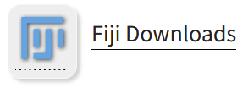

**Additional Plugins**

We made use of the ResultsToExcel plugin for our automated scripts. The following describes how to install the plugin for your copy of ImageJ.

1. Open ImageJ and from the help menu, select the Update… menu item.

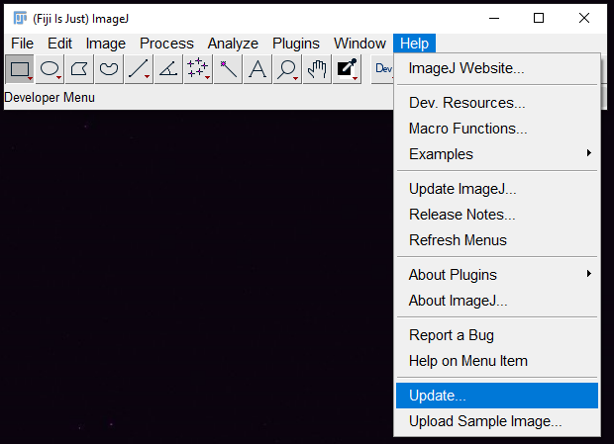

1. The ImageJ Updater window pops up. Select the button for Manage Update Sites.

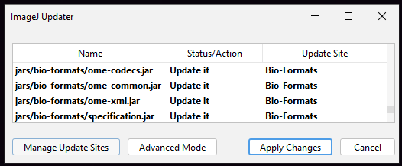

1. Scroll within the window to the plugin named ResultsToExcel (or use the search function). Place a checkmark in the box. Click Apply and Close. Following this, restart ImageJ.

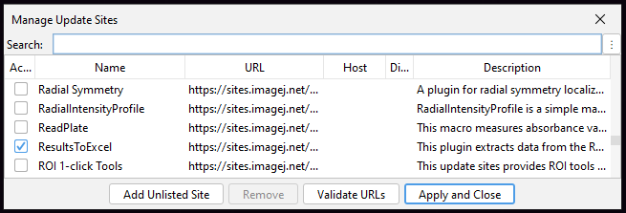

**Using one of the supplied macros**

When possible, we created automated scripts, referred to as macros, to aid with the analysis. We include two such macros here, with a basic description of how to use these scripts. We include test data, and an analysis walk-through. Lastly, we give a description of which parts of the script can be modified and adjusted to fit user images.

**Using supplied test datasets**

To access test datasets download the zipped archive from Zenodo:

<https://doi.org/10.5281/zenodo.10590829>

Download the zip folder and extract the files.

**Analysis of Stereomicroscope images to determine CCM lesion burden.**

This macro is used to quantify the superficially visible bloody regions on a mouse brain. This measurement can be useful to determine whether a given treatment leads to a reduction of superficially visible lesion burden. Additional deeper analysis is needed to address lesion burden that cannot be seen from the surface.

1. Harvest mouse brains and image them using an appropriate stereo microscope on a white/light background. Use consistent lighting and white balance parameters for each brain included in a given experimental analysis. Save images in .tif format.
2. Open ImageJ. Navigate to the folder containing the macro file. Select the **‘Macro_for_analysis_of_stereomicroscope_images.ijm’** file and drag the file icon over to the ImageJ window where the <<Drag and Drop> >message is shown.

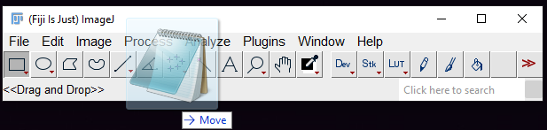

1. The Macro editor window will open with the script of the macro showing.

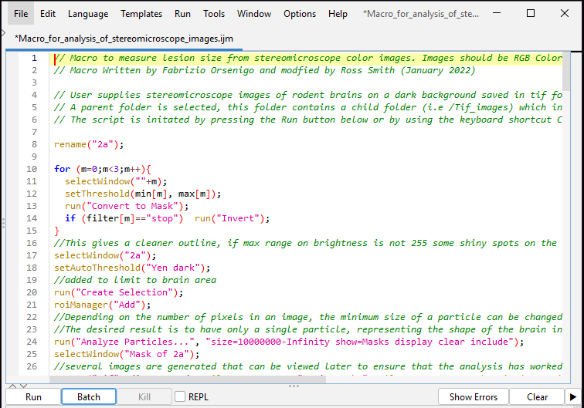

1. Press the Run button or use the keyboard shortcut Ctrl + R to start the macro. Select a parent folder for example ’/TestDataStereo/’. This folder should contain a child folder with tifs for example ‘/Tif_images/’.

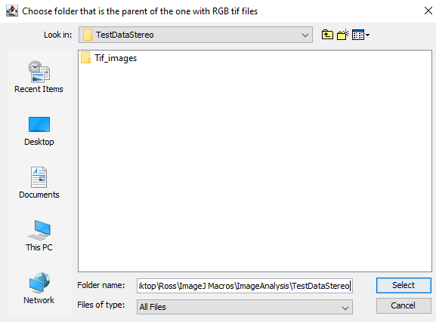

1. Create a montage grid by selecting some of the tif files to be placed in the top row of the grid. For example, selecting three of five images will make a 3 x 2 grid. Click OK.

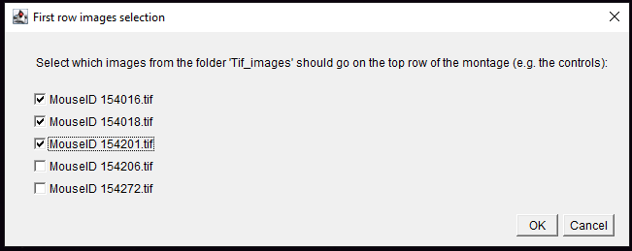

1. Use the threshold color window to manually choose parameters that select the regions of the images that you deem to contain lesions. The montage of all the images together allows the user to select one set of parameters that applies to the whole experiment. The parameters of the example below are set to:

Hue 20-220 Stop; Saturation 60-255 Pass; Brightness 0-145 Pass

Note that the Dark background box is unchecked.

The red overlay shows which pixels are being considered.

Click OK.

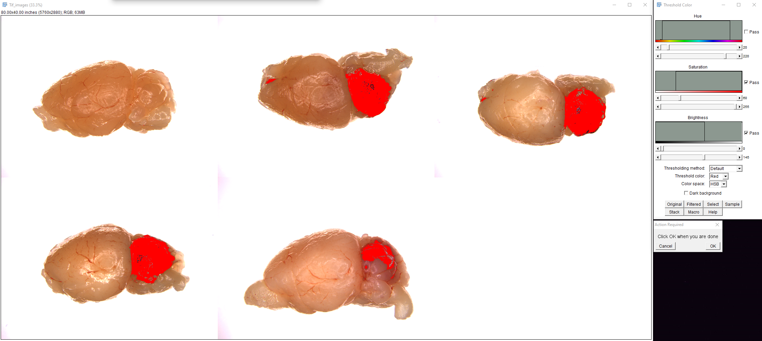

1. Add these values to the next dialog, and click OK.

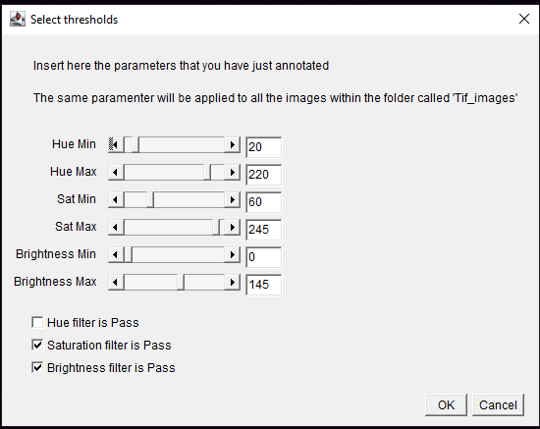

1. Now the macro will start to analyze each image. The macro will run in batch mode, which means images will not be displayed on the screen, but the results window will be updating during the running of the program. When the macro is completed, a message will appear to signal that it is done.

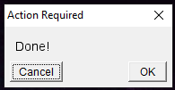

1. Now you will find an OUTPUT_from_CCM_stereo_macro folder which contains the date and the generated output files. You can explore the output by clicking into the folder.

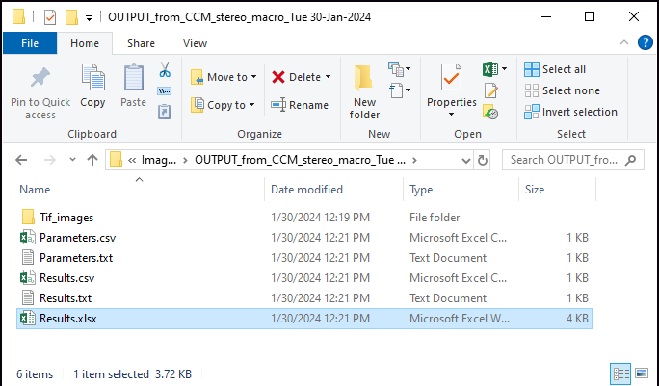

1. The Results.xlsx file contains each sample image. In this version of the code, sample results are separated by a line of NaN values.

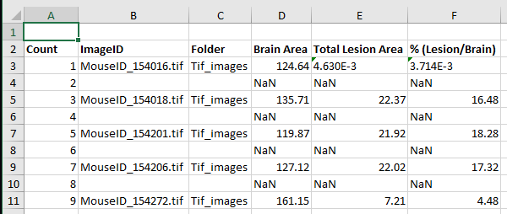

1. Viewing the merged output images will also give a quick indication of whether the script is accurately segmenting out the shape of the brain and which areas have been classified as lesion bearing.

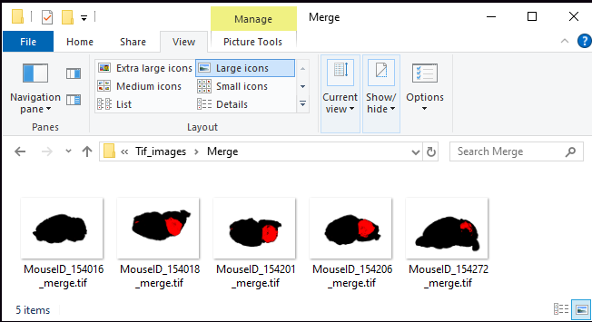

**Analysis of immunofluorescent images to determine and measure regions of interest**

This macro is used to analyze sagittal sections of mouse brain with immunofluorescent staining of selected targets, and can be adapted to many stainings. The localization of fluorescent signals can be used to gain a greater understanding of the mechanistic underpinnings of CCM disease. This macro uses a 4 channel LIF file as input and generates output files related to the presence of the positive staining in channels individually and in combination with other targets.

1. Harvest mouse brains and process them to generate immunfluorescently stained sections with appropriate fluorophores labeling targets of interest. Next image each brain section using a Leica DMi8 widefield microscope or Leica SP8 confocal microscope. Save each image for a given experiment into a Lieca project file with the extension .LIF. Use consistent image acquisition parameters (i.e. laser power, exposure, gain) for each section included in a given experimental analysis. Save images in .lif format.
2. Open ImageJ. Navigate to the folder containing the macro file. Select the **‘Macro_for_analysis_of_immunofluorescence_images.ijm’** file and drag the file icon over to the ImageJ window where the <<Drag and Drop> >message is shown.



1. The Macro editor window will open with the script of the macro showing.

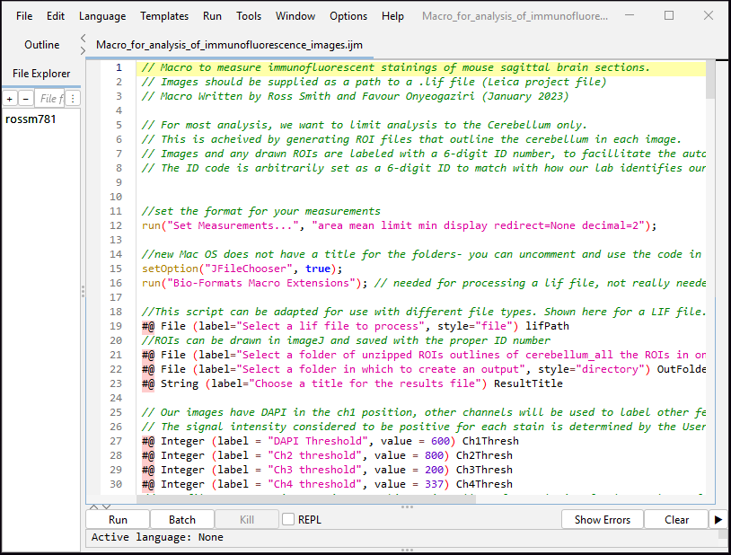

1. There are several places within the macro code where User modifications should be made to adapt the code for each experiment. To do so, use the macro editor window to scroll through the script, type into the script to edit. Save the macro with a new file name to mark that modifications have been made. Line numbers are shown to help guide:

**Line 143-146:** user can change the comments to indicate the marker for each channel

**Line 160-165**: user can select which channel to use as a vascular marker by changing the value of C4 to another channel instead. If the channel is changed in line 160, then the channel threshold should be updated also in line 161. The saved ROI can also be given a different name, if desired on line 165.

**Line 170-175:** as above, the user can select which channel to threshold. If the channel is updated in line 170, the threshold should be updated in line 171. ROI can be renamed in line 175.

**Line 178-199:** several User defined regions are constructed by selecting already generated ROIs by their index numbers, forming an array, and processing that array of binary masks to display only pixels that belong in each of the gathered individual ROIs. i.e. selecting all vessel pixels within the cerebellum region. Each newly generated ROI can be named by the User. Additional constructed regions can be conceived using the same and related construction operands such as:

roiManager("Combine"); // to combine two ROIs

roiManager("XOR"); // to select only pixels found in some but not all

**Line 203:** This macro as written is optimized for area measurements, but can also be modified to include other measurements like intensity. Select an image channel for measuring a set of ROIs of the User’s choosing.

**Line 206-213**: User can supply a list of ROI indices to be measured. Adjust the indices and add on to the list as needed to cover your desired Area quantifications.

**Line 216-219:** User can change the comments to indicate each measurement. If additional ROIs are added for measurement, additional Table.get() calls should be added.

**Line 225:** User can change which channel is used for generating the qc overlay images

**Line 232-243:** User can change which ROIs to add as an overlay to the qc image. Choosing ROIs by the appropriate index and then selecting a color or color hexcode.

**Line 255:** The results file is generated by making a column header for each piece of data collected for each image. Adjust the column titles in this line to reflect what has been measured. If more measurements are added, column titles should be added for them using a comma separator between each column title.

**Line 260:** The results for each sample are saved with this line. Following the pattern, add any additional measurements by concatenating the measurement variable (i.e. ‘name’ or ‘A1’) and a comma “,”.

**Line 283:** As above, the parameter file requires a header for each column. Adjust as necessary to save the parameters of your choosing.

**Line 288:** As above, adjust each saved parameter by concatenating the parameter variable (i.e. ‘TimeString’ or ‘Ch3Thresh’) and a comma “,”.

1. Press the Run button or use the keyboard shortcut Ctrl + R to start the macro. A dialog will appear with many places for User input.

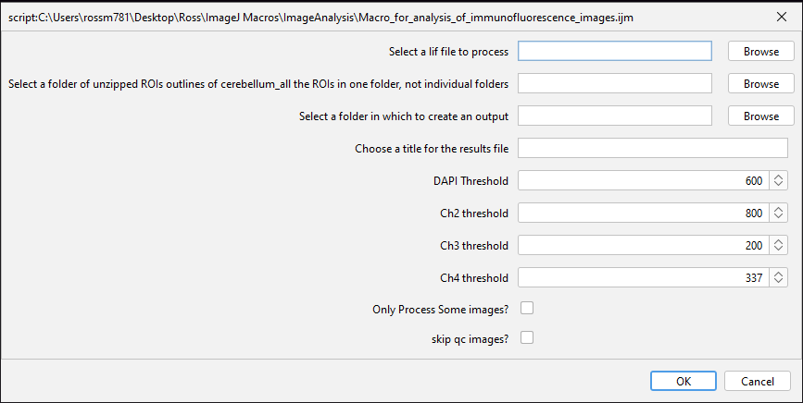

**g)**

**f)**

**e)**

**d)**

**c)**

**b)**

**a)**

a) Using the provided Browse buttons, select a .lif file to process.

b) Select a folder containing .roi files. There should be one roi file for each image to be processed and images and roi files should contain a matching 6-digit sample ID number in their titles.

c) User can decide where to place the output folder.

d) User can decide the name of the output excel file.

e) User decides an intensity value for each of the 4 channels found in each image. This intensity threshold is used to make a binary mask of the channel classifying pixels as positive for a given channel or negative for that channel. Intensity values selected are contingent upon how the imaging was conducted and the bit-depth of the images. Appropriate thresholds should be determined by investigating the experimental images and subjectively determining which value most accurately represents the experiment. The threshold will then be applied consistently to the entire experiment.

f) Lif files can contain many images, check this box if you want to limit the analysis to only a subset of the lif file images

g) The software generates some quality control (qc) images to allow for a quick visual inspection of the analysis results. Generating qc images is recommended, but to save diskspace and processing time, they can be skipped with this option.

1. Fill in the dialog and click OK. Now the macro will start to analyze each image. The macro will run in batch mode, which means images will not be displayed on the screen, but the results window will be updating during the running of the program.

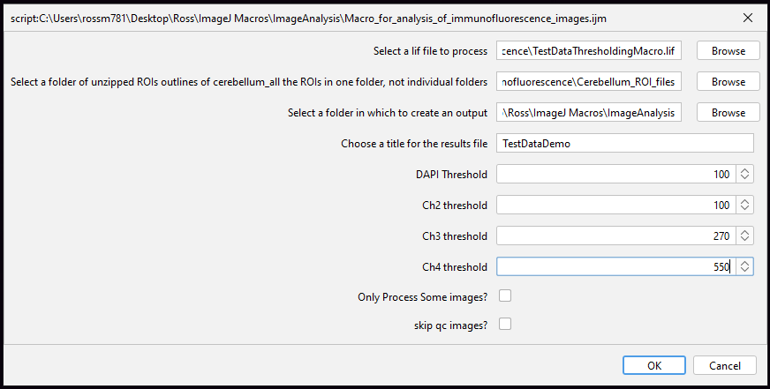

1. When the macro is completed, a message will appear to signal that it is finished. Several results window panels are open, and can be inspected. Clicking OK will prompt the User to clean up the result windows and leave a log file with the windows that were closed.

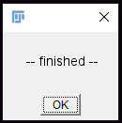

1. Output files can be inspected for quality.