RULES GAME PLAY


























Overview
The Order of Dharma is a battle between two CLANS to establish their DHARMA (spiritual path). You must outwit the other Clan members and eliminate them.
The catch is, you don't know your ally or your enemies.

Setup
Based on the number of players present, set aside an equal number of CLAN Cards, i.e., SURYA and CHANDRA Clan cards, and Phases cards.
Choose the cards starting with 1 and 2 rank cards and additional cards (in order). For a game with ODD number of players, include the MAAYAVI card. For example, if there are 4 players playing, you use rank 1 and 2 of Surya and Chandra Clan cards and if you are playing with 7 players, you use rank 1, 2, and 3 of Surya and Chandra Clan cards and the Maayavi card.
Shuffle the ABILITY Cards deck and place it in the centre alongside the GAME TRACKER board.
Each player should sit facing each other with cards in the centre and you are ready to play.

Game Play
Each round, players attempt to identify and eliminate rival CLAN members.
At the end of each round, all members of the CLAN with the highest ranked survivor go ahead in the GAME TRACKER.
The first player to reach the 5th stage in the GAME TRACKER wins the game! Each round includes the CLAN Card drafting, the ABILITY Cards distribution, the PHASES, and the CLAN Reveal.

To play:
Each player present will receive the PHASES Card which will be placed FACE-UP in front of them. You may begin with the CLAN drafting only after that.

Clan Card Drafting
First, shuffle the CLAN Cards deck and deal ONE face down to EACH player. You may look at your own CLAN Card but may not reveal it to other players.

Ability Card Distribution
Once CLAN Cards are distributed...
Deal THREE random ABILITY Cards to EACH player from the shuffled deck.
EACH player chooses ONE ABILITY Card out of three and passes the remaining TWO to the player on their right.
Each player chooses TWO out of Three ABILITY Cards in their hands and then discards the last card in the centre of the table.
Set aside any ABILITY Card that were not dealt this round and keep the discarded ABILITY Cards faced down separately, then move to the PHASES.

Phases
During the Phases, players play their Ability cards in different phases.
The Ability phase is broken down into six phases: 1. Drishti 2. Dyut 3. Tantra 4. Vadh 5. Yudh 6. Nirnay. Table discussion is encouraged in every step of the Ability phase!

During each phase of the Ability phase, you may choose to play any Ability cards you have corresponding to that phase.
To play an Ability card, place it face-up on the table. The number (or rank) on each card determines when it is resolved. Resolve all cards in that phase sequentially, following their respective rank order (e.g., 1-4 or 1-8, depending on the card set).
If no player reveals a card, move on to the next phase.
A player may choose not to play an Ability card – they may want to bluff that it's something else – but if an Ability card is skipped, it can't be played later in the round.
If at some point of the game, you are killed (eliminated) by any player, you must flip your Phases card to reveal that are eliminated.

Clan Reveal
After the FIFTH phase (YUDH) of PHASES, if you're still alive, reveal your CLAN Card in the NIRNAY phase! The CLAN with the highest ranked surviving player wins the round. 1 is the highest rank, followed by 2, then 3, and so on. Ties are broken by the next highest surviving player of the CLAN. When a CLAN wins, every member of the winning CLAN goes ahead in the GAME TRACKER (even if they were eliminated).
If MAAYAVI is alive before the NIRNAY phase, they may choose to join hands with either CLAN, and if they join the CLAN who wins in the NIRNAY phase, they also go ahead in the GAME TRACKER.

Winning the Game:
While you play each round as a team, you're all competing to be the ultimate WINNER!
At the end of any round, if you have reached the 5th stage of the GAME TRACKER, you will claim the VICTORY!
If multiple players reach the 5th stage together, those players share the victory.
A game of ORDER OF DHARMA can end quickly, so be ready to shuffle and play again!

KNOW YOUR CARDS

Phases (11 cards)
Phases Cards will show all the game PHASES in order of when the abilities will be played in the round. If you are killed in any phase,
you must flip this card to reveal that you have been eliminated for the round.

Clan Cards (11 cards)
Clan cards will be distributed randomly in each round, and you will know your clan for that round. The box contains 5 of each, SURYA and CHANDRA CLAN Cards, ranking 1 to 5, and one MAAYAVI Card.

Ability Cards (33 cards)
Ability cards deck must be shuffled before every round and must be distributed and played according to the Rulebook. In each phase, the abilities must be used in order of the rank of

Tantra
- Bhram - Look at two player's Clan cards, and you may swap them. They also can't look at their Clan cards after the swap for the rest of the game.
  - AAYNA does not work on Bhram.
- Mantra - Choose one player. That player discards all their Ability cards.
- Chhal - Look at one player's Clan card and you may choose to reveal it.
- Yagya - Randomly pick 3 cards from the discarded pile of Ability cards and keep one, play instantly if the phase has already passed otherwise keep to play it in its dedicated phase.
- Vighna - Impede progress tracker of one player by one progress or silent any player for rest of the round.
- Bhasm - Reveal your Clan card and kill any one player.
  - AAYNA and KAVACH do not work on Bhasm.

the Ability cards played in that phase. There are 8 Drishti, 4 Dyut, 6 Tantra, 6 Vadh, 6 Yudh, and 3 Special Ability cards.

Drishti
(1-4) Saadhak - If you play a Saadhak card, you may look at another player's Clan card. (5-8) Tapasvi - If you play a Tapasvi card, you may look at another player's Clan card and one Ability card (you can choose without looking if they have 2 Ability cards).

Dyut
(1-4) Play Dyut to guess another player's Clan. Dyut can be used in two ways:

Vadh

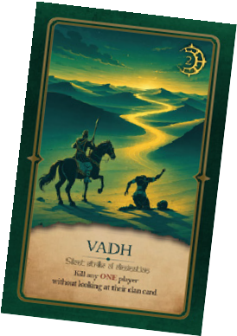

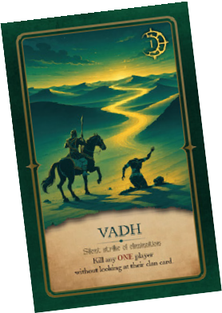
(1-6) Play this card and kill one player without seeing their Clan card.

Special Ability Cards
Yudh

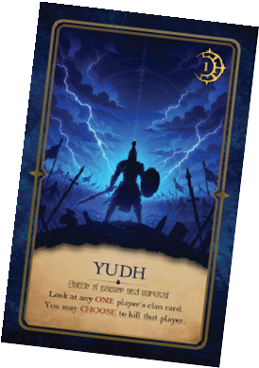

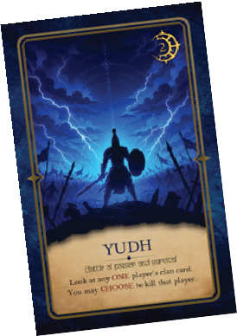
(1-6) Play this card and look at one player's Clan card and you may choose to kill them.




















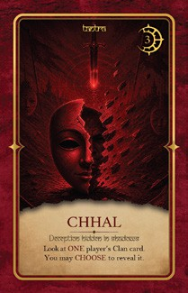
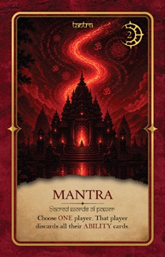
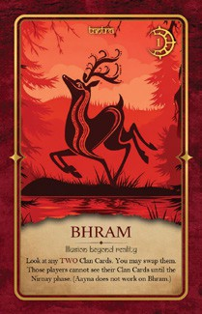

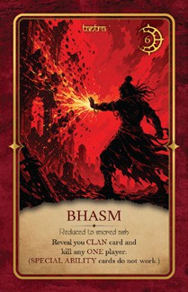
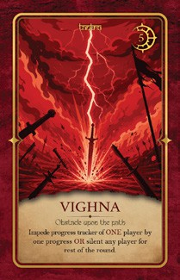
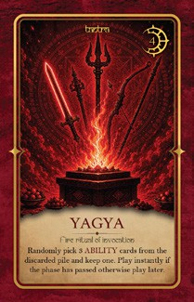



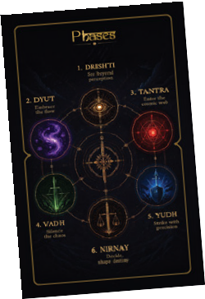


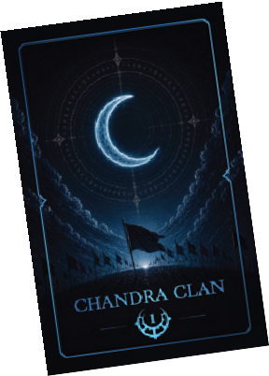

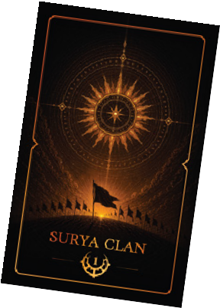

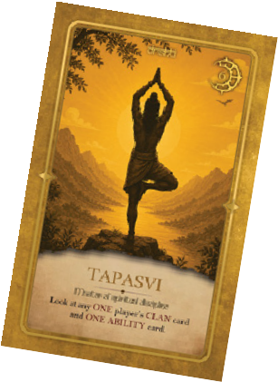

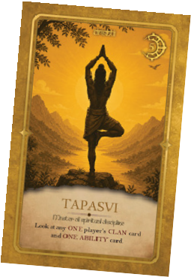

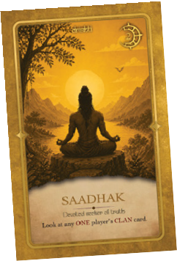

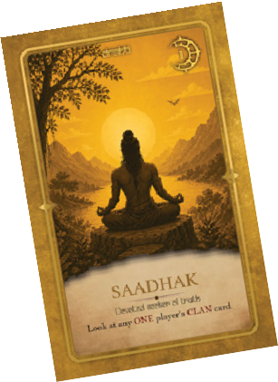
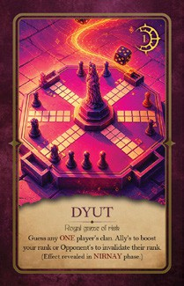

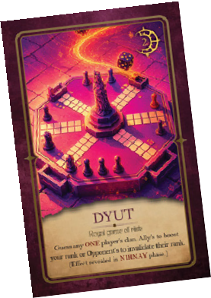

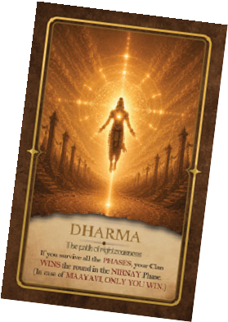
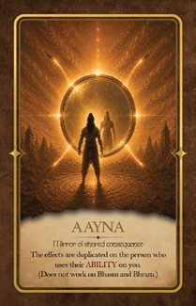


- Offense: If the player correctly guesses an opponent's Clan, their rank becomes ineffective in the Nirnay phase. However, they can still participate and use their ability cards.
- Defense: If a player with lower rank correctly guesses a higher rank teammate's Clan, both players share the same rank, taking the higher of the two.
  - If a higher-ranked player plays Dyut on a lower-ranked player of the same clan, there’s no effect.
  - If Dyut is played on you, you don't need to reveal the result until the Nirnay phase.
  - If Maayavi uses Dyut as an ability card, it does not have any effect.
  - You cannot use Dyut on a player if you have already used any Drishti card on them.
Aayna - The effects are duplicated on the person who used their Ability card on you. This card can be played in any phase. - 1 time use.
Kavach – This card protects the user from any ability used upon them. This card can be played in any phase. - 1 time use
Dharma – If the player who has this card survives until the Nirnay phase, wins the round for his team irrespective of highest ranking.

*If Maayavi has this card and chooses to not align with any other clan before the Nirnay phase, only Maayavi wins the round.

