Peggy Walsh

CIS 1415 – Final Project Screenshots

1. button.py – syntax error free. GUI button not compatible with Pygame.

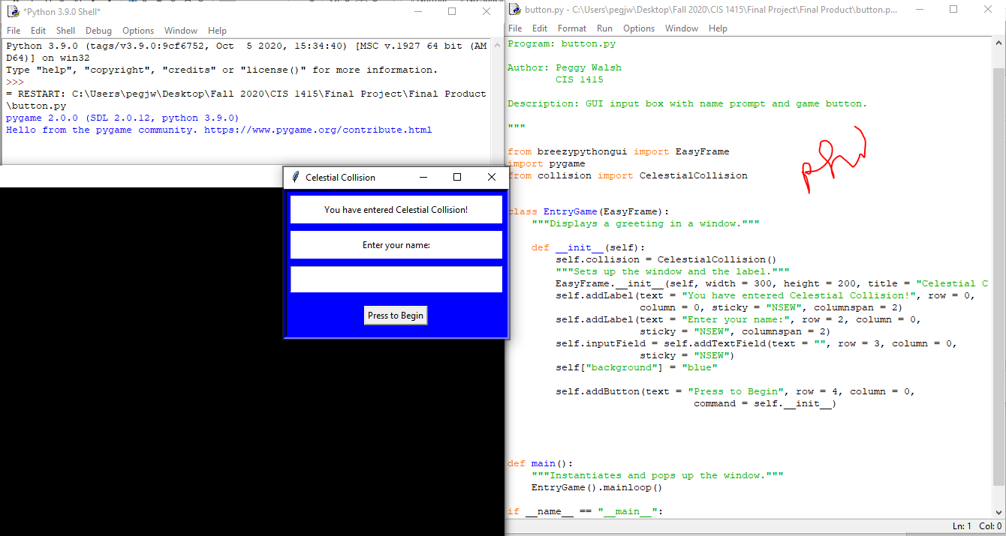

1. button2.py (Button Class) – syntax error free.

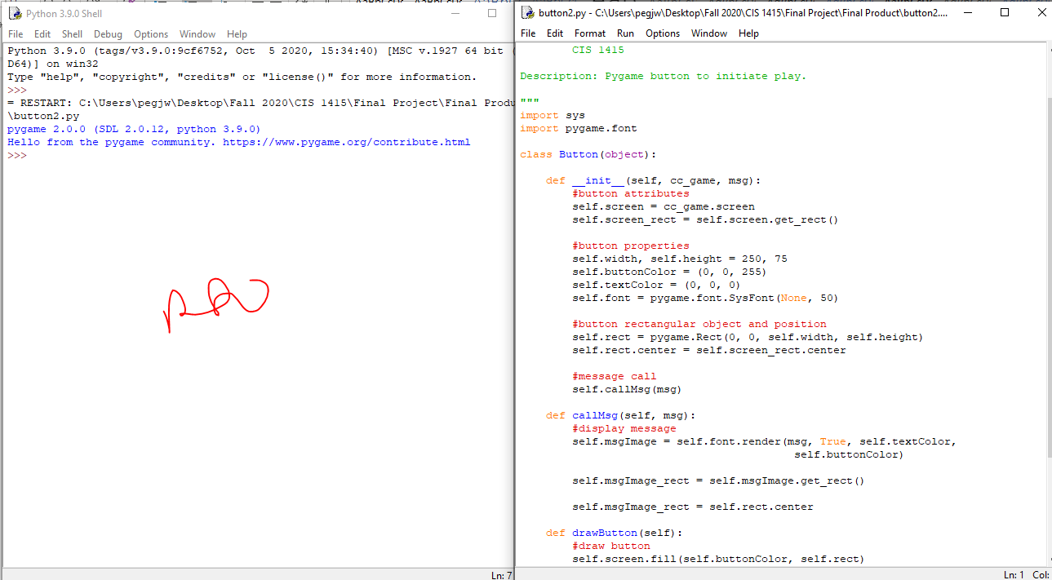

1. settings.py (Settings Class) – syntax error free.

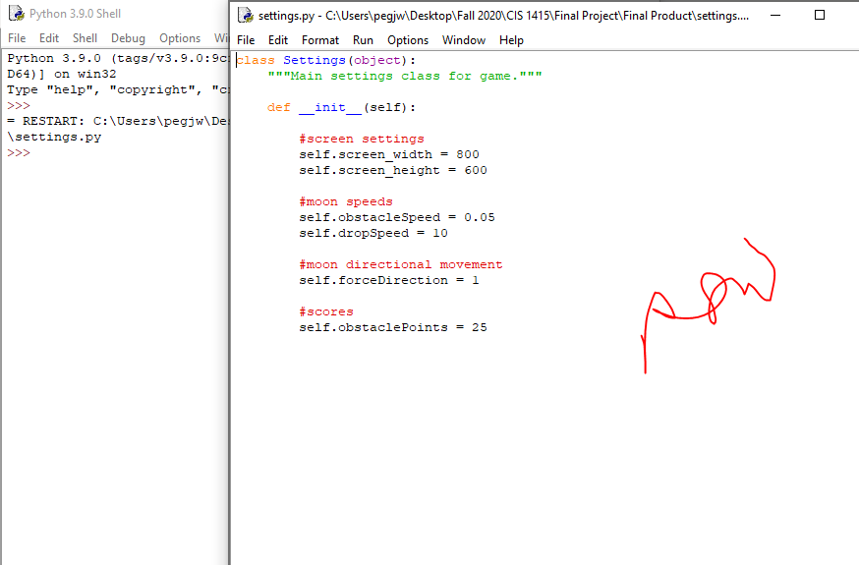

1. alien.py (Alien Class) – syntax error free.

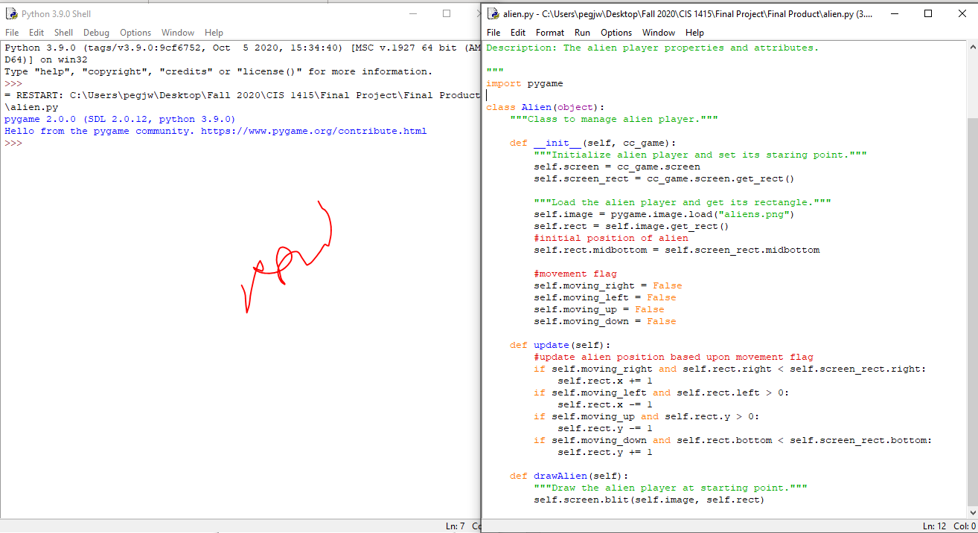

1. obstacle.py (Obstacle Class) – syntax error free.

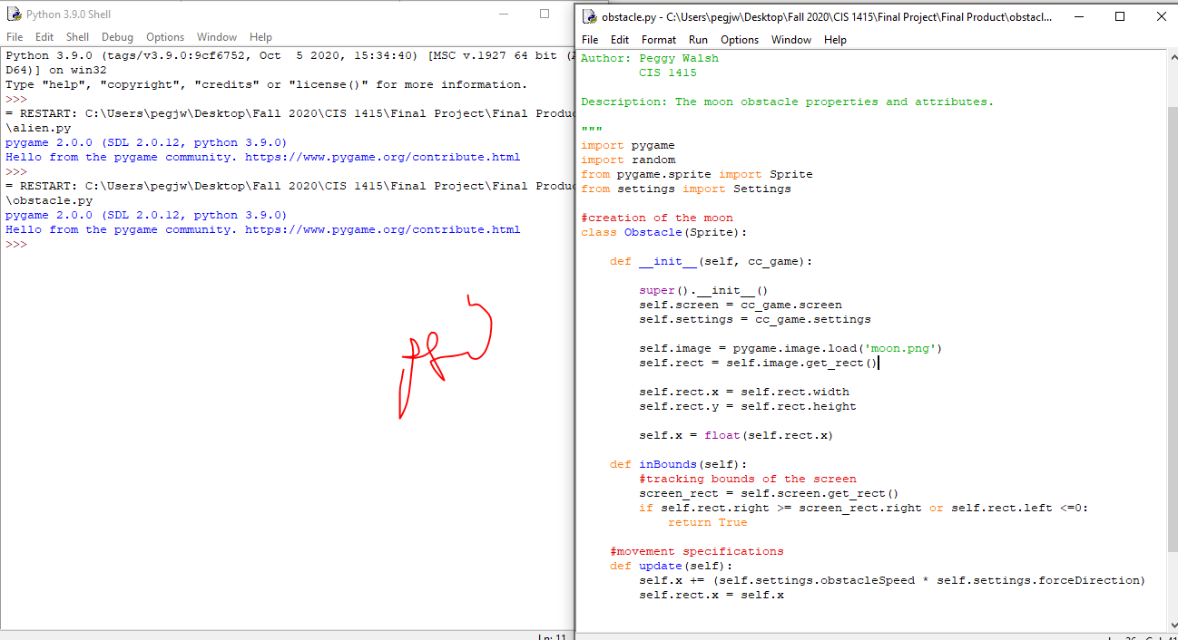

1. gametracking.py (GameTracking Class) – syntax error free.

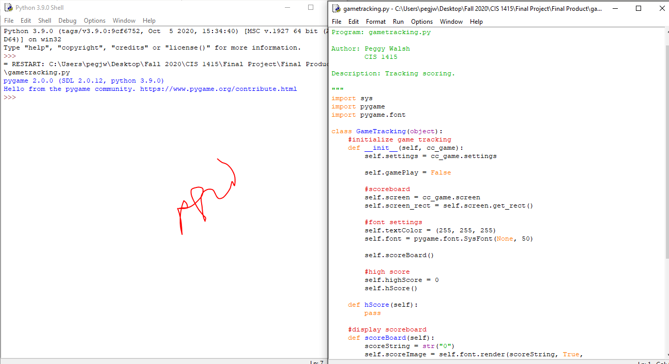

1. collision.py (CelestialCollision Class) – syntax error free. Logic errors present.

**Initiation game window:**

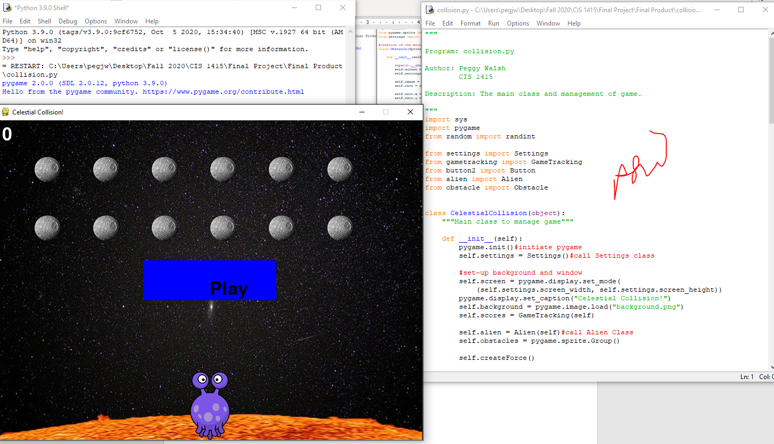

**Button pressed:**

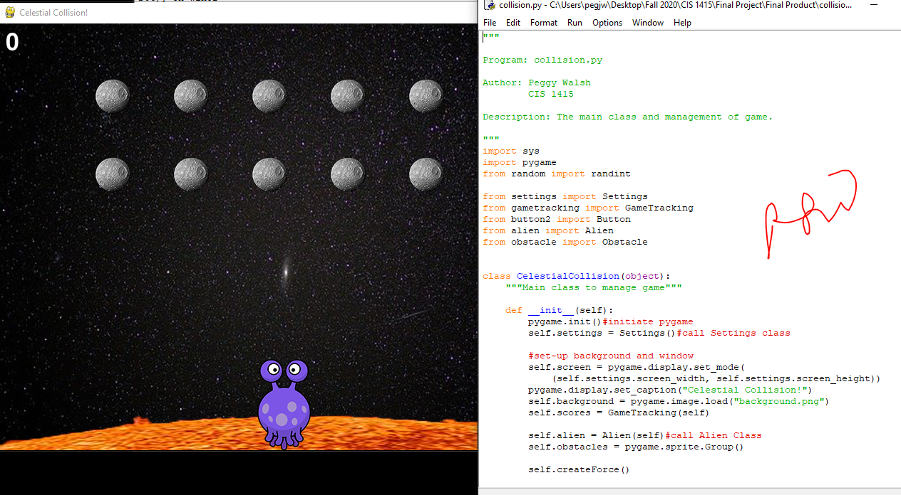

**Alien moves up, down, left, and right. Restricted movement to borders of window.**

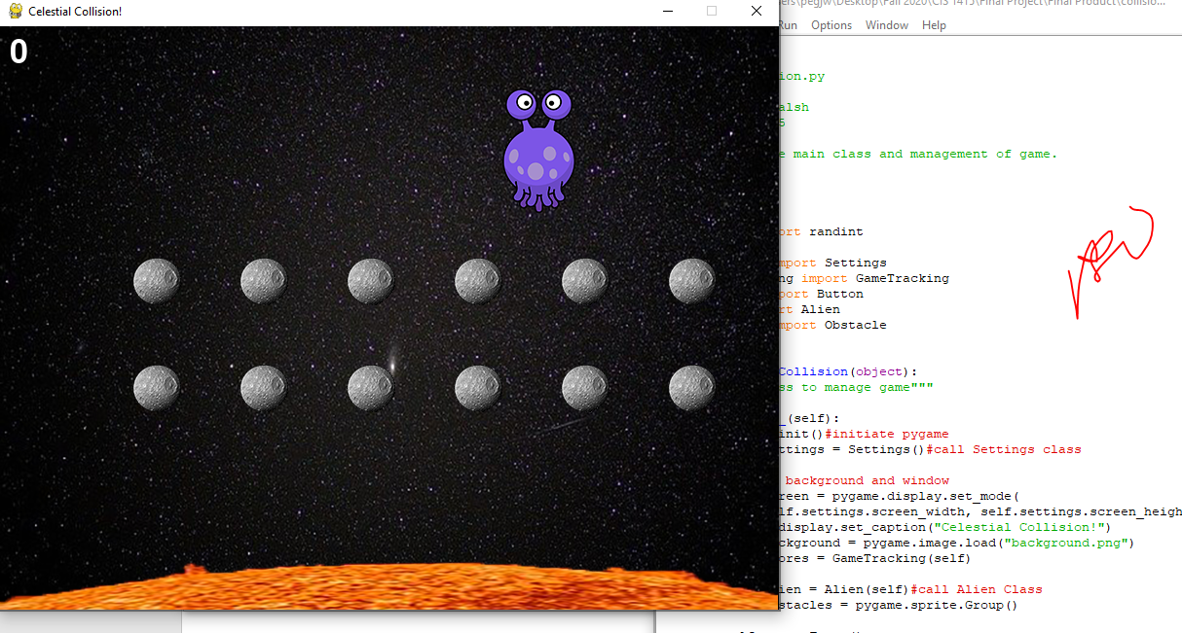

**Obstacles (moons) stuck in grid in main game. Created another file that was successful randomizing moons in free form (goal) but could not integrate into collision.py file without logic errors (see below).**

**movemoons.py**

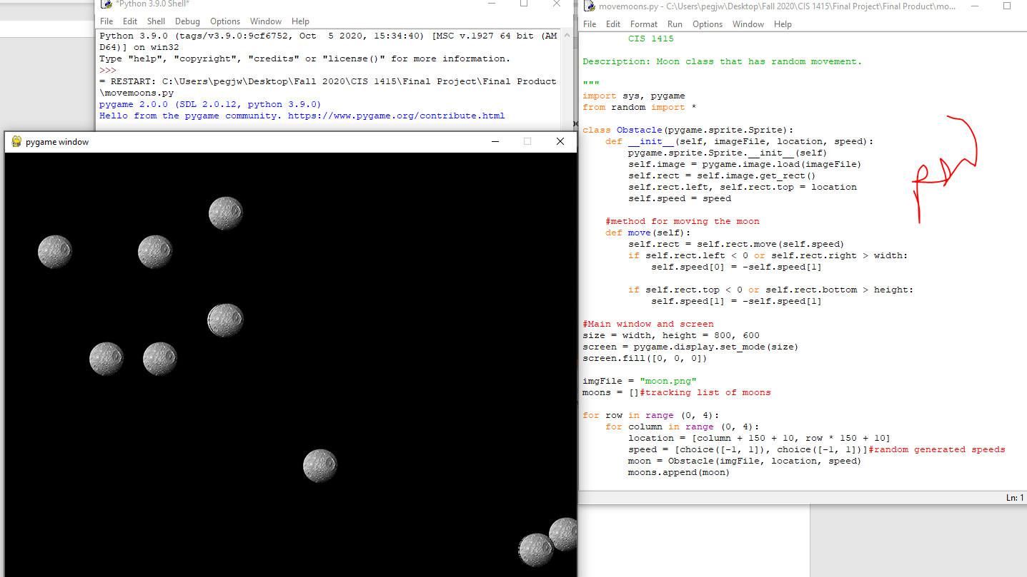

**Collision detection between moon and alien with logic errors and infinite loop. Scores/High Scores logic errors and incomplete.**

