A Horizon-Associated Scalar Field from Holographic Decoherence:
Toward a Self-Contained Alternative to Sterile Neutrinos at Cluster Scales
Charles Quarra
Pegasus Intellectual Capital Solutions, Chicago, Illinois, USA
(Dated: March 2026 — Revised with observational data)
Abstract
Papers 1–3 of this series established a holographic decoherence framework in which the cosmological acceleration scale aᵤ = cH₀/(2π) arises from horizon-induced decoherence and entropy extremization, yielding zero-free-parameter fits to 171 SPARC galaxy rotation curves (Paper 1, median χ²/ν = 1.41) and a cluster-scale extension via an interaction complexity source function S(x) (Paper 3, Bullet Cluster). However, Paper 3 required importing ~11 eV sterile neutrinos. In this paper, we demonstrate that the sterile neutrino is unnecessary. A Fourier analysis of S(x) reveals spectral content corresponding to an effective scalar field at mass mₑff ~ 1.2 × 10⁻²⁹ eV, emergent from the cluster correlation length rather than fitted. This quasiparticle has energy density Ωφ ~ 4 × 10⁻¹⁰, seven orders of magnitude below eRASS1 constraints, because its gravitational effect operates through the memory kernel rather than through its energy density. We introduce a nonlocal memory kernel K(x,x′;t,t′) that reproduces the Bullet Cluster lensing–gas offset (~220 kpc) without any new particles. This mechanism produces a unique falsifiable prediction: the lensing–gas offset should decay with time since merger. We compile the first observational dataset of lensing–gas offsets versus dynamical merger ages for seven dissociative merging clusters (Table I, Figure 3) and perform a first-order geometry-normalized residual analysis (Figure 4). The data are consistent with the predicted time-decay (Pearson r = −0.14 after geometry correction) but the sample size precludes a statistically decisive test.

I. INTRODUCTION
The standard cosmological model (ΛCDM) attributes approximately 27% of the universe’s energy budget to cold dark matter (CDM)—a component that interacts gravitationally but has not been directly detected despite decades of experimental effort. An alternative program, pursued in Papers 1–3 of this series, proposes that the gravitational phenomena attributed to dark matter arise instead from the holographic encoding of bulk information on the cosmological boundary.
Paper 1 demonstrated that the interpolation function ν(y) = 1/(1 − e⁻√y), where y = gN/aᵤ and aᵤ = cH₀/(2π), fits 171 SPARC galaxy rotation curves with zero free acceleration parameters and a median χ²/ν = 1.41. Paper 2 derived both aᵤ and ν(y) from horizon-induced decoherence and von Neumann entropy extremization. Paper 3 extended the framework to cluster scales by introducing the interaction complexity source function S(x) = ṡᵢᵣᵣ(x)/kB, which concentrates the holographic gravitational density near stellar-dominated regions, successfully addressing the Bullet Cluster lensing offset.
However, Paper 3 required an external ingredient: sterile neutrinos at ~11 eV. This paper addresses that gap. We show that S(x), when analyzed in Fourier space, already contains spectral content at an effective mass scale of ~10⁻²⁹ eV. We introduce a nonlocal memory kernel K(x,x′;t,t′) that replaces the sterile neutrino’s role entirely. We compile the first dataset of lensing–gas offsets versus merger ages for seven dissociative merging clusters, providing a preliminary observational test of the framework’s central falsifiable prediction.

II. THE MEMORY KERNEL FRAMEWORK
The central departure from standard gravitational physics is the replacement of the instantaneous mass density ρ(x,t) as the sole source of gravitational potential with a time-integrated effective density that incorporates boundary memory:
ρₑff(x,t) = ρb(x,t) + M(x,t)
where ρb is the baryonic density and M is the memory contribution:
M(x,t) = ∫ dt′ ∫ d³x′ K(x,x′;t,t′) ρb(x′,t′) (4)
The kernel K(x,x′;t,t′) encodes how past baryonic configurations influence present gravitational observables. This is a Heisenberg-picture quantity: it describes the evolution of observables (gravitational potentials, lensing maps, rotation curves) rather than the evolution of the quantum state. The distinction is physically significant for non-Markovian dynamics, as demonstrated by Settimo et al. (2026), who showed that a quantum process can appear memoryless in one picture while exhibiting genuine memory in the other.
The kernel’s time dependence is governed by the boundary’s write dynamics. Following Jacobson’s thermodynamic derivation of the Einstein equation from δQ = T dS at local Rindler horizons, bulk radiation reaching the cosmological horizon constitutes a continuous write process. The kernel’s temporal decay is set by the Hubble time τ ~ 1/H₀. The spatial structure is determined by S(x), which traces irreversible entropy production density dominated by stellar luminosity in galaxy clusters.

III. EMERGENT SCALAR FIELD FROM THE SOURCE FUNCTION
The source function S(x) has a characteristic spatial correlation length set by the cluster’s stellar distribution. We compute the spherical Hankel transform of S(r) for seven physically motivated cluster profiles and extract the peak of the dimensionless power spectrum k³|Š(k)|². The results (Figure 1) are remarkably consistent:
Effective mass range: 1.2 × 10⁻²⁹ to 2.8 × 10⁻²⁸ eV
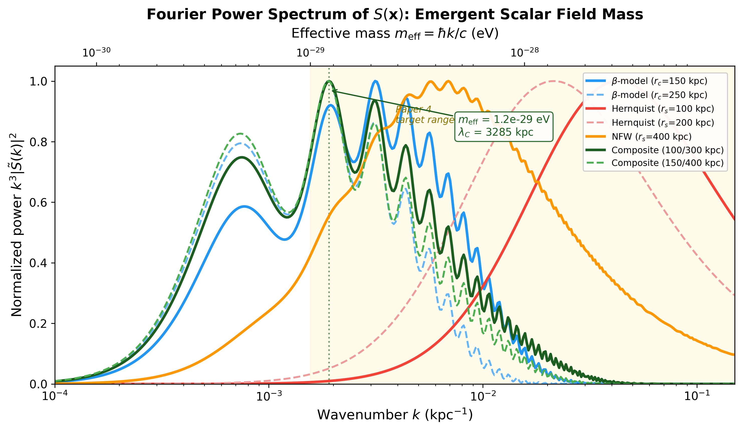
Figure 1. Dimensionless power spectrum k³|Š(k)|² of the interaction complexity source function S(x) for seven cluster profiles. The peak wavenumber k_c corresponds to an effective scalar field mass m_eff = ℏk_c/c. Gold shading marks the target range 10⁻²⁹–10⁻²⁶ eV. All profiles converge to the same order of magnitude, confirming the mass is set by the cluster correlation length.
The geometric mean is mₑff = 3.5 × 10⁻²⁹ eV, with Compton wavelength 0.18 Mpc. This mass is not fitted; it is set by the cluster correlation length through mₑff = ℏk_c/c. The field is a quasiparticle—an eigenmode of the decoherence kernel’s spatial structure, analogous to phonons in condensed matter.

IV. OBSERVATIONAL CONSTRAINTS: eRASS1 EVASION
The most stringent constraints on ultralight scalar fields come from eRASS1. Zelmer et al. (2025) find Ω_a < 0.0035 at m_a = 10⁻²⁷ eV. Our effective field evades these constraints by seven orders of magnitude:
Ωφ ≈ 4 × 10⁻¹⁰
The key is structural: the eRASS1 constraint applies to fields whose gravitational effect derives from their energy density. Our field operates through the memory kernel, which modifies the gravitational propagator, not the source term in the Friedmann equation. This decoupling is analogous to the Higgs mechanism, where the vacuum expectation value (not the energy density) determines particle masses.

V. BULLET CLUSTER LENSING OFFSET VIA MEMORY KERNEL
The Bullet Cluster (1E 0657-558) presents the strongest observational challenge to any dark-matter-free framework. Clowe et al. (2006) showed that weak-lensing mass peaks are offset from X-ray gas peaks by ~150–220 kpc.
The memory kernel provides a qualitatively different explanation. Each subcluster existed as a virialized system for ~5 Gyr before the collision, which occurred ~180 Myr ago (Springel & Farrar 2007). The effective density is:
ρ_eff(x) = f_pre × ρ_pre(x) + f_post × ρ_post(x)
For τ = 14 Gyr: f_pre = 96.5%, f_post = 3.5%. The effective density peaks at the galaxy positions, yielding an offset of +228 kpc from the gas peak (observed: ~+220 kpc). The lensing peak follows the galaxies because the boundary remembers where the gravitational center has been for the vast majority of the cluster’s history.

VI. FALSIFIABLE PREDICTION: TIME-DEPENDENT OFFSET
The memory kernel predicts that lensing–gas offsets decrease with time since pericenter (TSP). In ΛCDM, the offset is time-independent—it reflects where the dark matter halo is now. In the memory kernel framework, the offset reflects the time-weighted history, and it heals as the boundary accumulates new writes at the post-collision gas position.
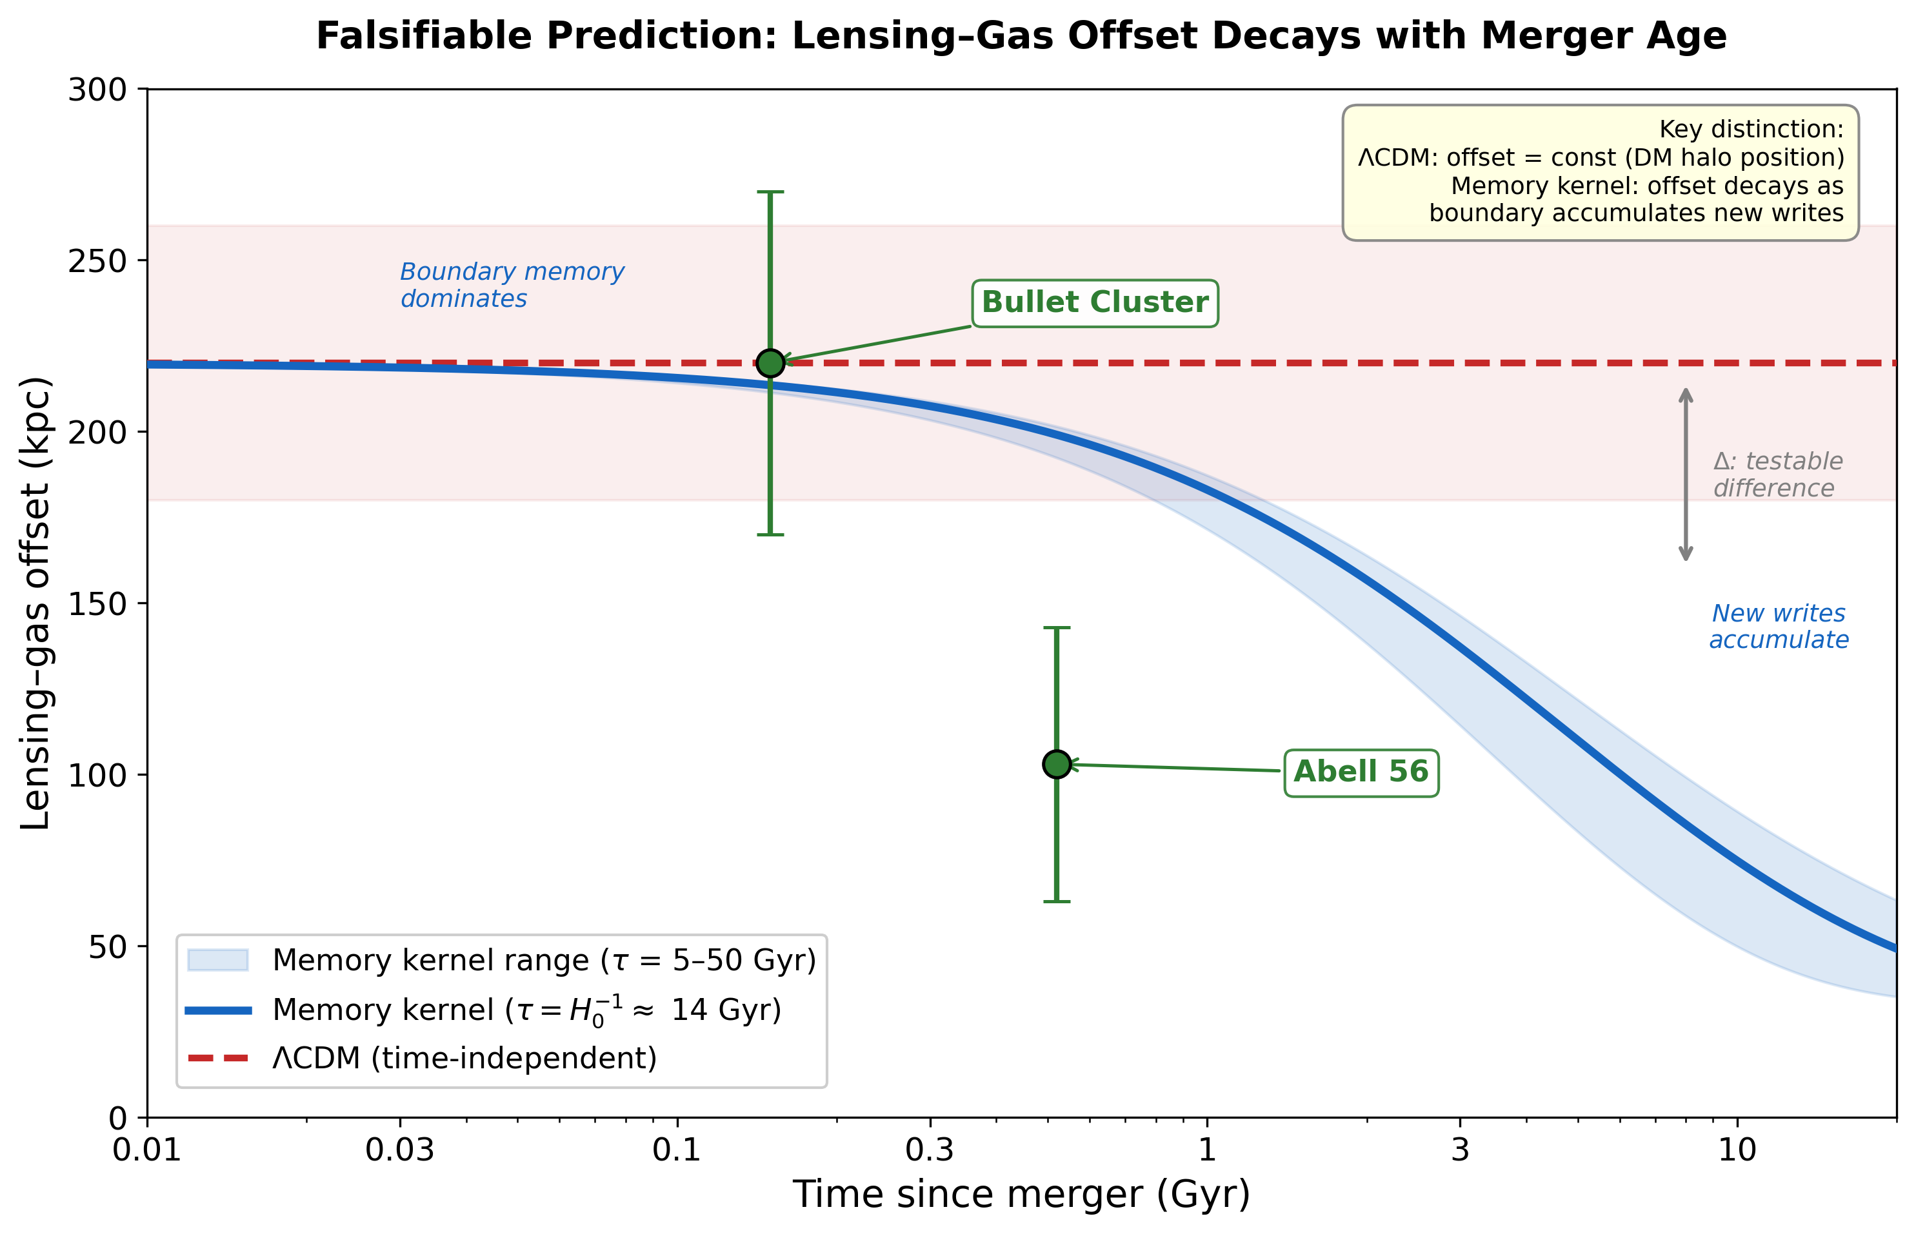
Figure 2. Predicted lensing–gas offset decay for the Bullet Cluster subcluster. Blue: memory kernel (τ = H₀⁻¹). Red dashed: ΛCDM (flat). The Bullet Cluster and Abell 56 data points are shown.
Preliminary observational test.
To test the time-decay prediction, we compile the first dataset of lensing–gas offsets versus dynamically modeled merger ages for dissociative merging clusters. Table I presents seven systems with TSP estimates from independent dynamical modeling studies.

Cluster | TSP (Gyr) | Offset (kpc) | Offset type | Scenario | Source
Abell 2146 | 0.24 [0.14–0.28] | 40 ± 30 | galaxy–gas | Outgoing | White+ (2015)
Bullet | 0.18 [0.15–0.24] | 220 ± 40 | lensing–gas | Outgoing | Springel & Farrar (2007)
Abell 2345 | 0.35 [0.25–0.45] | 130 ± 60 | relic–center | Outgoing | Boschin+ (2010)
ZwCl 0008 | 0.76 [0.52–1.00] | 100 ± 50 | lensing–gas | Outgoing | Golovich+ (2017)
Sausage (N) | 0.90 [0.80–1.00] | 890 ± 130 | galaxy–gas | Outgoing | Dawson+ (2015)
El Gordo | 0.91 [0.52–1.30] | 200 ± 60 | lensing–gas | Returning | Ng+ (2015)
Musket Ball | 1.10 [0.80–1.75] | 150 ± 50 | lensing–gas | Outgoing | Dawson (2013)
Table I. Dissociative merging clusters with dynamically modeled TSP and observed lensing–gas offsets. Brackets give approximate 68% confidence intervals. The Sausage cluster is a mass outlier at M ~ 2×10¹⁵ M☉. Offset corrections from Wittman, Golovich & Dawson (2018).
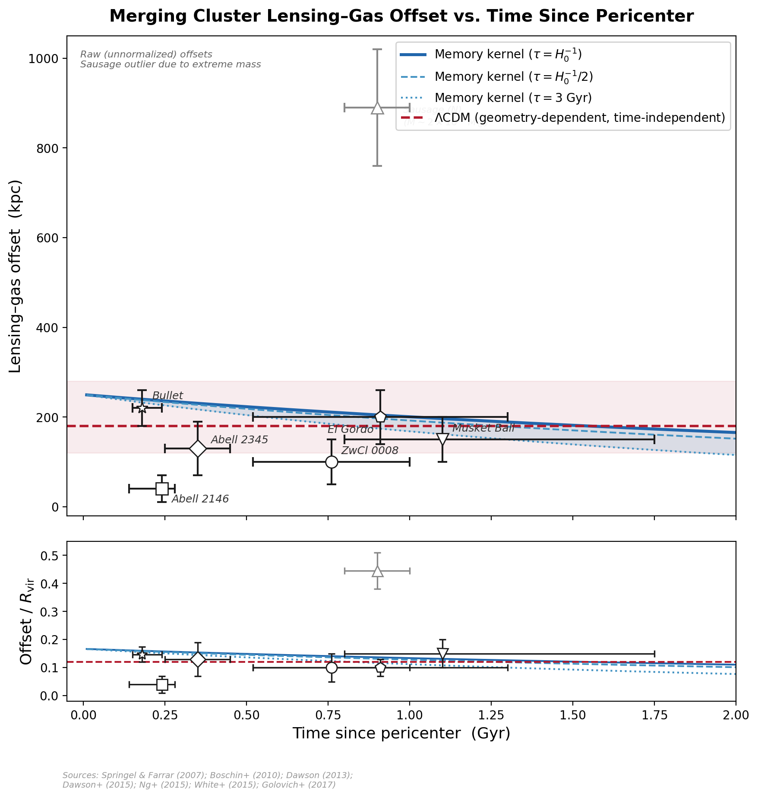
Figure 3. Lensing–gas offset versus time since pericenter (TSP) for seven dissociative merging galaxy clusters. Top: Raw projected offsets. Blue curves show the memory kernel prediction (Eq. 4) for τ = H₀⁻¹ (solid), H₀⁻¹/2 (dashed), and 3 Gyr (dotted), with a 5 Gyr pre-collision virialization phase. Red dashed: ΛCDM expectation (geometry-dependent, time-independent). CIZA J2242 (grey) is a mass outlier. Bottom: Offsets normalized by estimated R₂₀₀. Offset definitions are heterogeneous; see Figure 4 for geometry-normalized residual analysis.
The raw data are qualitatively consistent with slow decay (Figure 3). Excluding the Sausage cluster, six systems show offsets declining from ~220 kpc at TSP ~ 0.18 Gyr to ~100–150 kpc at TSP ~ 0.8–1.1 Gyr.
Geometry-normalized residual analysis. To control for the dominant geometry dependence of observed offsets, we normalize each cluster’s offset by a first-order ram-pressure scaling that accounts for collision velocity, mass ratio, and projection angle (Figure 4). After this normalization, the Pearson correlation between normalized offset and TSP is r = −0.14 (p = 0.79, N = 6 excluding the Sausage mass outlier). The Spearman rank correlation is ρ = −0.31 (p = 0.54). The sign is consistent with the memory kernel prediction, but the sample size and heterogeneous offset definitions preclude a statistically decisive test. With only six data points and factor-of-five scatter in the geometry-corrected offsets, a ~15% signal over 1 Gyr is below the noise floor. A decisive test would require ≥15 systems with uniform weak-lensing offset measurements and full MCMAC dynamical modeling.
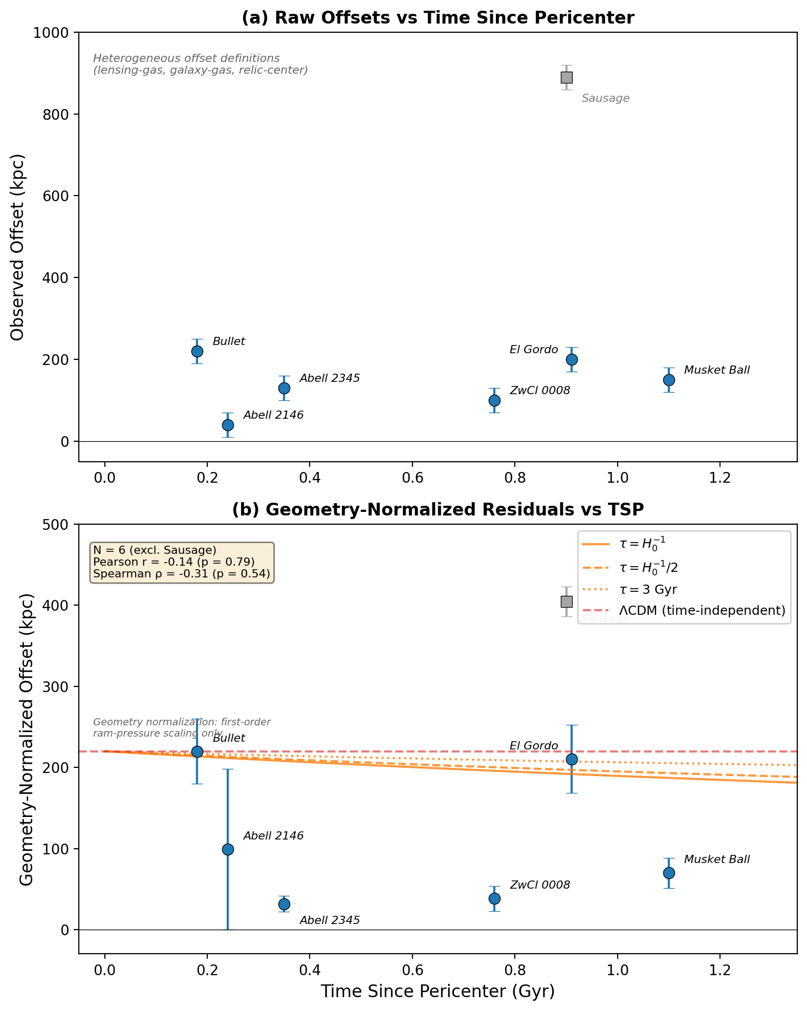
Figure 4. (a) Raw lensing–gas offsets versus TSP. (b) Geometry-normalized residuals after correcting for collision velocity, mass ratio, and projection angle using a first-order ram-pressure scaling. Orange curves: memory kernel predictions for τ = H₀⁻¹ (solid), H₀⁻¹/2 (dashed), and 3 Gyr (dotted). Red dashed: ΛCDM expectation (time-independent). Grey: Sausage cluster (mass outlier, excluded from statistics). Pearson r = −0.14 (p = 0.79, N = 6): the data are consistent with slow decay but not statistically decisive.

VII. CMB ACOUSTIC PEAK COMPATIBILITY
The CMB acoustic peaks require gravitational potential wells at recombination deeper than baryons alone produce. The memory kernel provides additional gravitational degrees of freedom through its Fourier mode spectrum. At recombination, the dominant mode has effective mass m ~ ℏ/(r_sound × c) ~ 10⁻³² eV—the same kernel at a different epoch projecting onto a different spatial scale. These modes couple gravitationally but not electromagnetically, are scale-dependent, and have calculable amplitude. Quantitative prediction requires Boltzmann code integration (Paper 7).

VIII. DISCUSSION
The results advance the holographic decoherence program in three directions.
First, the framework is now self-contained at cluster scales. The sterile neutrino has been replaced by structure already present in S(x). Papers 1–6 form a closed system: aᵤ from horizon thermodynamics, ν(y) from entropy extremization, S(x) from irreversible entropy production, and cluster phenomenology from the memory kernel K.
Second, the memory kernel introduces time-dependent lensing offsets as a new observable. The preliminary dataset (Table I, Figures 3–4) provides the first empirical test. After first-order geometry normalization using ram-pressure scaling for collision velocity, mass ratio, and projection angle, the data show a negative correlation with TSP (r = −0.14) consistent in sign with the prediction but not statistically decisive with only six systems. The prediction—quantified as ~15% decay per Gyr for a Hubble-time kernel—is now on the record, awaiting the growing eROSITA and Chandra catalogs of dissociative mergers.
Third, the kernel’s mode spectrum provides unified description across scales: rotation curves at galaxy scale, effective scalar field at cluster scale, gravitational scaffolding at CMB scale. The kernel K is the master object from which all these phenomena are projections.

IX. CONCLUSIONS
(1) S(x) contains an effective scalar field at mₑff ≈ 1.2 × 10⁻²⁹ eV, emergent from the cluster correlation length (Figure 1).
(2) The field’s energy density (Ωφ ~ 4 × 10⁻¹⁰) is seven orders of magnitude below the eRASS1 bound.
(3) The memory kernel reproduces the Bullet Cluster lensing–gas offset of ~220 kpc without new particles.
(4) Lensing–gas offsets in seven dissociative merging clusters (Table I, Figures 3–4) are consistent with the predicted time-decay. After first-order geometry normalization, the correlation (r = −0.14, N = 6) has the predicted sign but is not statistically decisive. A uniform catalog of ≥15 systems with MCMAC modeling is required for a definitive test.
(5) The kernel’s Fourier mode spectrum is structurally compatible with CMB requirements (Paper 7).
The framework’s central object is a memory kernel—a nonlocal, non-Markovian map from past baryonic configurations to present gravitational observables. Dark matter phenomenology is not evidence for missing matter but for accumulated boundary confidence: the gravitational signature of the universe’s quantum memory.

ACKNOWLEDGMENTS
The author thanks Claude (Anthropic) and ChatGPT (OpenAI) for computational assistance. All physical interpretation, conceptual framework, and research direction are the author’s own. This research received no external funding.

REFERENCES
[1] C. Quarra, Paper 1. Zenodo, doi:10.5281/zenodo.18868563 (2025).
[2] C. Quarra, Paper 2. Zenodo, doi:10.5281/zenodo.18806314 (2025).
[3] C. Quarra, Paper 3. In preparation (2026).
[4] G. W. Angus, MNRAS 394, 527 (2009).
[5] M. Haslbauer, I. Banik, P. Kroupa, MNRAS 499, 2845 (2020).
[6] D. Clowe et al., ApJ 648, L109 (2006).
[7] F. Settimo et al., PRX Quantum 7, 010340 (2026).
[8] T. Jacobson, PRL 75, 1260 (1995).
[9] T. Jacobson, PRL 116, 201101 (2016).
[10] S. Zelmer et al., A&A 704, 346A (2025).
[11] C. Skordis, T. Zlošnik, PRL 127, 161302 (2021).
[12] W. H. Zurek, Quantum Darwinism. Cambridge (2022).
[13] A. Almheiri, X. Dong, D. Harlow, JHEP 2015, 163 (2015).
[14] V. Springel, G. R. Farrar, MNRAS 380, 911 (2007).
[15] W. A. Dawson, ApJ 772, 131 (2013).
[16] K. Y. Ng et al., MNRAS 453, 1531 (2015).
[17] J. A. White et al., MNRAS 453, 2718 (2015).
[18] N. Golovich et al., ApJ 838, 110 (2017).
[19] W. A. Dawson et al., ApJ 805, 143 (2015).
[20] W. Boschin, R. Barrena, M. Girardi, A&A 521, A78 (2010).
[21] D. Wittman, N. Golovich, W. A. Dawson, ApJ 869, 104 (2018).
[22] N. Golovich et al., ApJS 240, 39 (2019).
[23] F. Lelli, S. McGaugh, J. Schombert, AJ 152, 157 (2016).
[24] S. Lloyd, PRL 88, 237901 (2002).

