FHIRBridge
UI Design Specification
Version 1.0 · June 2026 · Prepared by Product Design Team
CONFIDENTIAL — FOR DEVELOPMENT, QA, AND DESIGN USE

1. Introduction
1.1 Purpose
This document defines the complete User Interface Design Specification for FHIRBridge — a healthcare data integration platform. It is the single source of truth for all UI design decisions, covering every screen, component, interaction, color, typography, spacing, validation, and behavior.
1.2 Scope
Screen | Coverage
Authentication (Login, Forgot Password, Reset Password) | Full
Dashboard | Full
Workflow Builder / Pipeline Canvas | Full
Node Library Dialog | Full
Epic Source Wizard (Inline) | Full
User Management | Full
Error & Empty States | Full

1.3 Target Users
Role | How They Use This Document
Frontend Developer | Implements pixel-exact components from the spec
QA Engineer | Verifies components, states, and behaviors against the spec
UI/UX Designer | Reference for all visual decisions; source for design system
Product Owner | Validates delivered UI matches product intent
Accessibility Engineer | Ensures WCAG 2.1 AA compliance

1.4 Design Goals
- Clean, professional healthcare-grade UI that inspires confidence in clinical data workflows.
- Strict visual consistency — same spacing, color, and typography rules across every screen.
- Clarity over decoration — every visual element must serve a function.
- WCAG 2.1 AA accessibility for keyboard-only and screen-reader users.
- Desktop-first (pipeline tooling); usable on laptop screens at 1024px+.
- Immediate, unambiguous feedback for every user action.

2. Design Principles
Principle | Description | FHIRBridge Application
Clean Interface | Show only what is needed at each step | Collapsible sidebar, phase-gated node library, progressive wizard disclosure
Consistency | Same component looks/behaves identically everywhere | Shared SCSS tokens, reusable standalone Angular components
Accessibility | All users regardless of ability can operate every feature | WCAG 2.1 AA contrast, keyboard nav, ARIA labels
Responsive Design | Usable on desktop (1280px+) and laptop (1024px) | CSS grid collapse, sidebar auto-collapse at 1024px
Error Prevention | Design prevents errors before they occur | Inline validation, disabled on invalid forms, confirmation dialogs
User Feedback | Every action receives an immediate visual response | Toast notifications, button spinners, node status indicators
Minimal Clicks | Reduce friction for core pipeline workflows | Inline wizard, FAB for node add, single-click node connection
Modern Healthcare Theme | Professional, trustworthy color palette | Teal primary, clean whites, subtle shadows

3. Color Palette
All colors are specified as CSS custom properties (design tokens) in the :root block of styles.scss. Never hardcode hex values in component files.
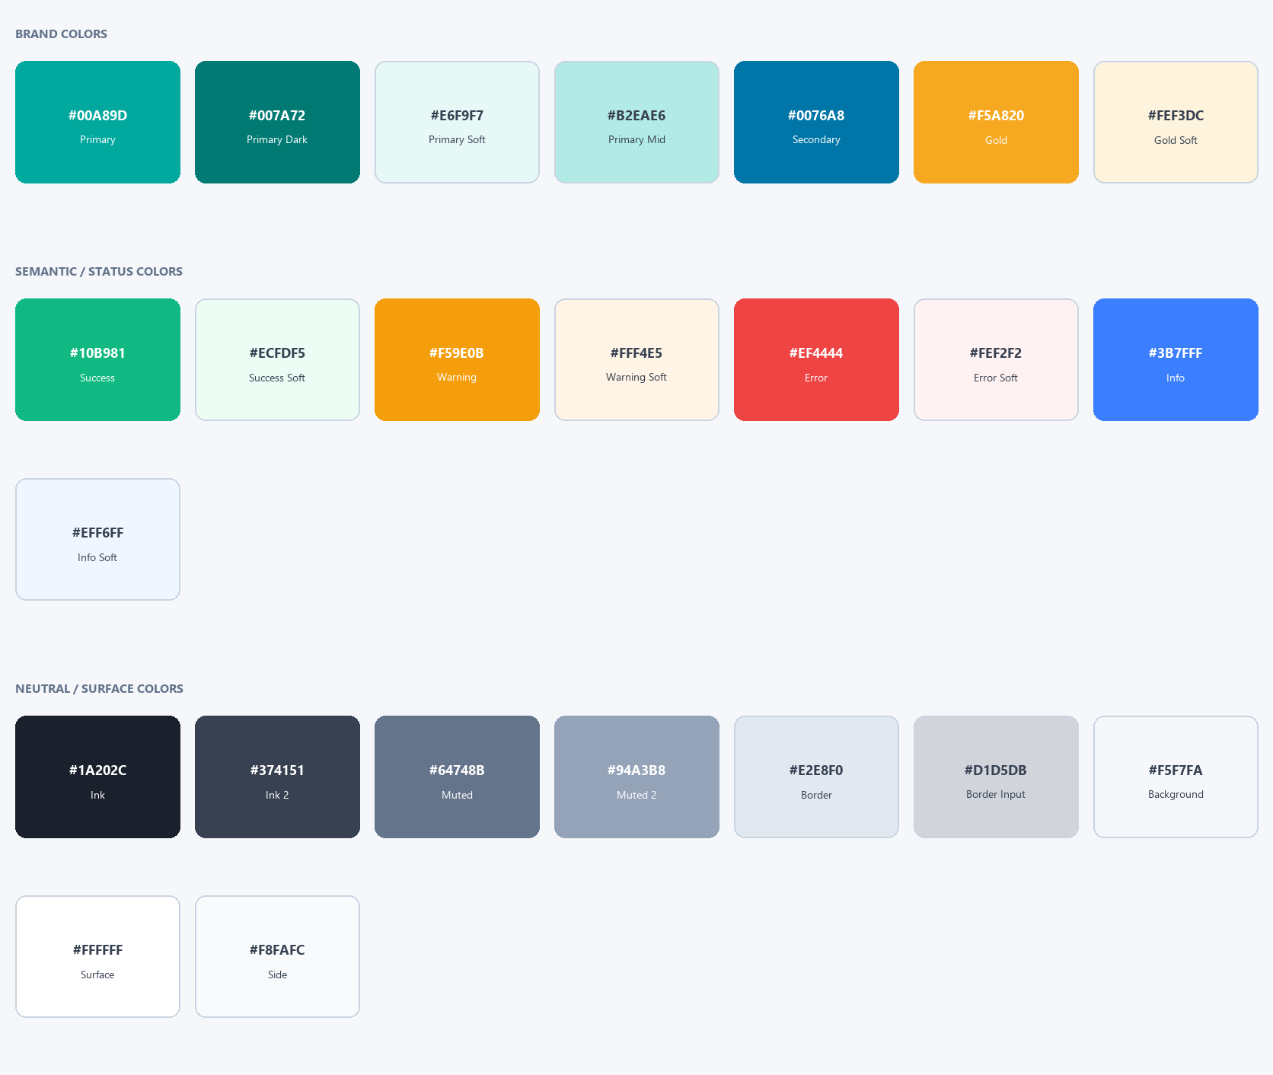
Figure: Complete FHIRBridge color palette — brand, semantic, and neutral colors
3.1 Brand Colors
Token | Hex | Usage
--color-primary | #00A89D | Primary actions, active nav, focus rings, links
--color-primary-dark | #007A72 | Hover on primary buttons and teal links
--color-primary-soft | #E6F9F7 | Active nav bg, selection highlight, tag fill
--color-primary-mid | #B2EAE6 | Border on teal-soft elements, chip borders
--color-secondary | #0076A8 | Phase badge gradient end, informational accent
--color-gold | #F5A820 | Accent warnings, highlights
--color-gold-soft | #FEF3DC | Gold background fills

3.2 Semantic / Status Colors
Token | Hex | Usage | Soft Background
--color-success | #10B981 | Completed, positive trends, success badge | #ECFDF5
--color-warning | #F59E0B | Warning, pending states, amber badge | #FFF4E5
--color-error | #EF4444 | Error, failed, destructive actions | #FEF2F2
--color-info | #3B7FFF | Informational highlights | #EFF6FF

3.3 Neutral / Surface Colors
Token | Hex | Usage
--color-ink | #1A202C | Primary text, headings
--color-ink-2 | #374151 | Secondary text, table cells
--color-muted | #64748B | Placeholder text, subtitles, labels
--color-muted-2 | #94A3B8 | Tertiary text, disabled labels
--color-border | #E2E8F0 | Standard borders, dividers
--color-bg | #F5F7FA | App/page background
--color-surface | #FFFFFF | Card, panel, modal backgrounds
--color-side | #F8FAFC | Sidebar, secondary surfaces

3.4 Interaction State Colors
State | Hex | When Applied
Hover (primary button) | #007A72 | Cursor over teal primary elements
Hover (surface) | #F8FAFC | Nav items, table rows, list items
Focus Ring | rgba(0,168,157,0.12) + #00A89D border | Keyboard focus on any interactive element
Pressed / Active | #006660 | Mousedown on primary button
Disabled Fill | #F1F5F9 | Disabled input / button background
Disabled Text | #94A3B8 | Disabled labels and button text
Error Border | #EF4444 | Invalid input border
Error Ring | rgba(239,68,68,0.10) | Invalid input focus ring

4. Typography
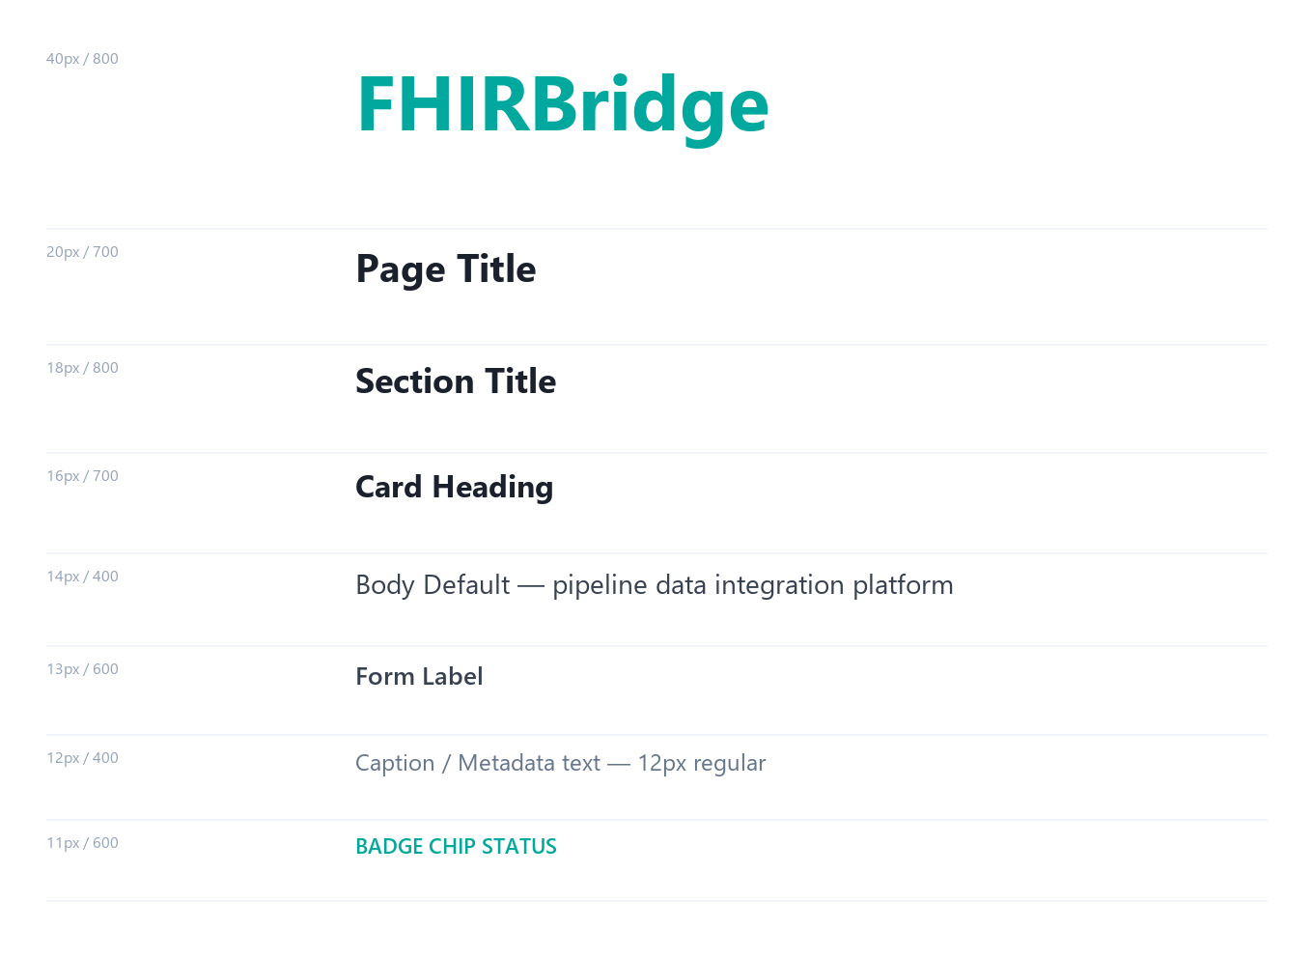
Figure: FHIRBridge type scale — all roles, sizes, and weights
4.1 Font Family
font-family: Inter, 'Segoe UI', system-ui, Arial, sans-serif;
-webkit-font-smoothing: antialiased;
4.2 Type Scale
Role | Size | Weight | Color | Element
Display | 40px | 800 | #00A89D | Cover page title
Page Title | 20px | 700 | #1A202C | Dashboard h1, page headers
Section Title | 18px | 800 | #1A202C | Panel h2, dialog titles
Card Heading | 16–17px | 700 | #1A202C | Card h3, wizard step title
KPI Value | 30px | 800 | #1A202C | Dashboard KPI numbers
Body Default | 14px | 400 | #374151 | Paragraphs, descriptions
Body Small | 13px | 400–500 | #374151 | Table cells, form hints
Form Label | 13px | 600 | #374151 | Input and select labels
Badge / Chip | 11–12px | 600–700 | varies | Status pills, phase badges
Monospace | 8–10px | 400 | #1E403E | Code blocks, endpoints

5. Spacing System
5.1 Base Scale (8px base unit)
Token | Value | Typical Use
--space-1 | 2px | Micro gaps between inline elements
--space-2 | 4px | Tight icon-label gap, badge internal padding
--space-4 | 8px | Icon-to-text gap, grid gap, chip padding
--space-6 | 12px | Button padding-x (small), sidebar item gap
--space-8 | 16px | Card padding, standard grid gap, form group gap
--space-9 | 20px | Section headings, topbar padding
--space-10 | 24px | Modal header, config panel padding
--space-11 | 28px | Page content padding
--space-12 | 32px | Large panel padding

5.2 Border Radius Scale
Value | Token | Usage
50% | --radius-full | Avatar circles, status dots
999px | --radius-pill | Pill badges, toggle tracks, FAB
18px | --radius-2xl | Node Library dialog
14px | --radius-modal | Modals, toasts
12px | --radius-card | KPI cards, stat tiles
8px | --radius-base | Buttons, inputs, dropdowns
6px | --radius-sm | Table action buttons

7. Button Specifications
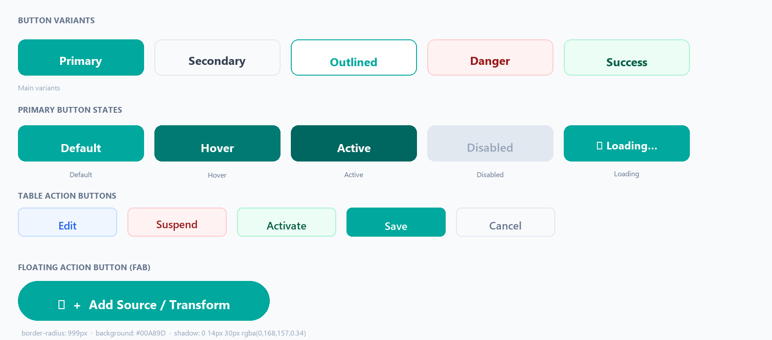
Figure: All button variants — primary, secondary, danger, table actions, FAB, and states
7.1 Primary Button
Property | Value
Background | #00A89D
Text Color | #FFFFFF
Font | 14–15px / 700 / Inter
Padding | 11px 26px (large) · 8px 18px (medium) · 6px 14px (small)
Border Radius | 8–10px
Hover Background | #007A72 + translateY(−1px)
Active Background | #006660 + translateY(0)
Focus Ring | 0 0 0 3px rgba(0,168,157,0.20) · border #00A89D
Disabled | Background #E2E8F0 · Text #94A3B8 · cursor not-allowed
Loading | Spinner 16px + "…" text · button disabled · width preserved
Min Touch Target | 44px height for accessibility

7.2 All Button Variants Summary
Button | Background | Text Color | Border | Hover Background | Radius
Primary | #00A89D | #FFFFFF | none | #007A72 | 8–10px
Secondary | #F8FAFC | #374151 | 1px #E2E8F0 | #E6F9F7 | 7–8px
Outlined / Ghost | transparent | #00A89D | 1.5px #00A89D | #E6F9F7 | 8px
Text Link | transparent | #00A89D | none | underline | 0
Danger | #FEF2F2 | #991B1B | 1px #FECACA | #FEE2E2 | 8px
Success Action | #ECFDF5 | #065F46 | 1px #A7F3D0 | #D1FAE5 | 8px
Edit (table) | #EFF6FF | #2563EB | 1px #BFDBFE | #DBEAFE | 6px
Suspend (table) | #FEF2F2 | #991B1B | 1px #FECACA | #FEE2E2 | 6px
Activate (table) | #ECFDF5 | #065F46 | 1px #A7F3D0 | #D1FAE5 | 6px
Save (table) | #00A89D | #FFFFFF | 1px #00A89D | #007A72 | 6px
Cancel (table) | #F8FAFC | #64748B | 1px #E2E8F0 | #F1F5F9 | 6px

ⓘ FAB (Add Module): border-radius 999px · background #00A89D · shadow 0 14px 30px rgba(0,168,157,0.34) · fixed bottom-center of canvas

8. Form Components
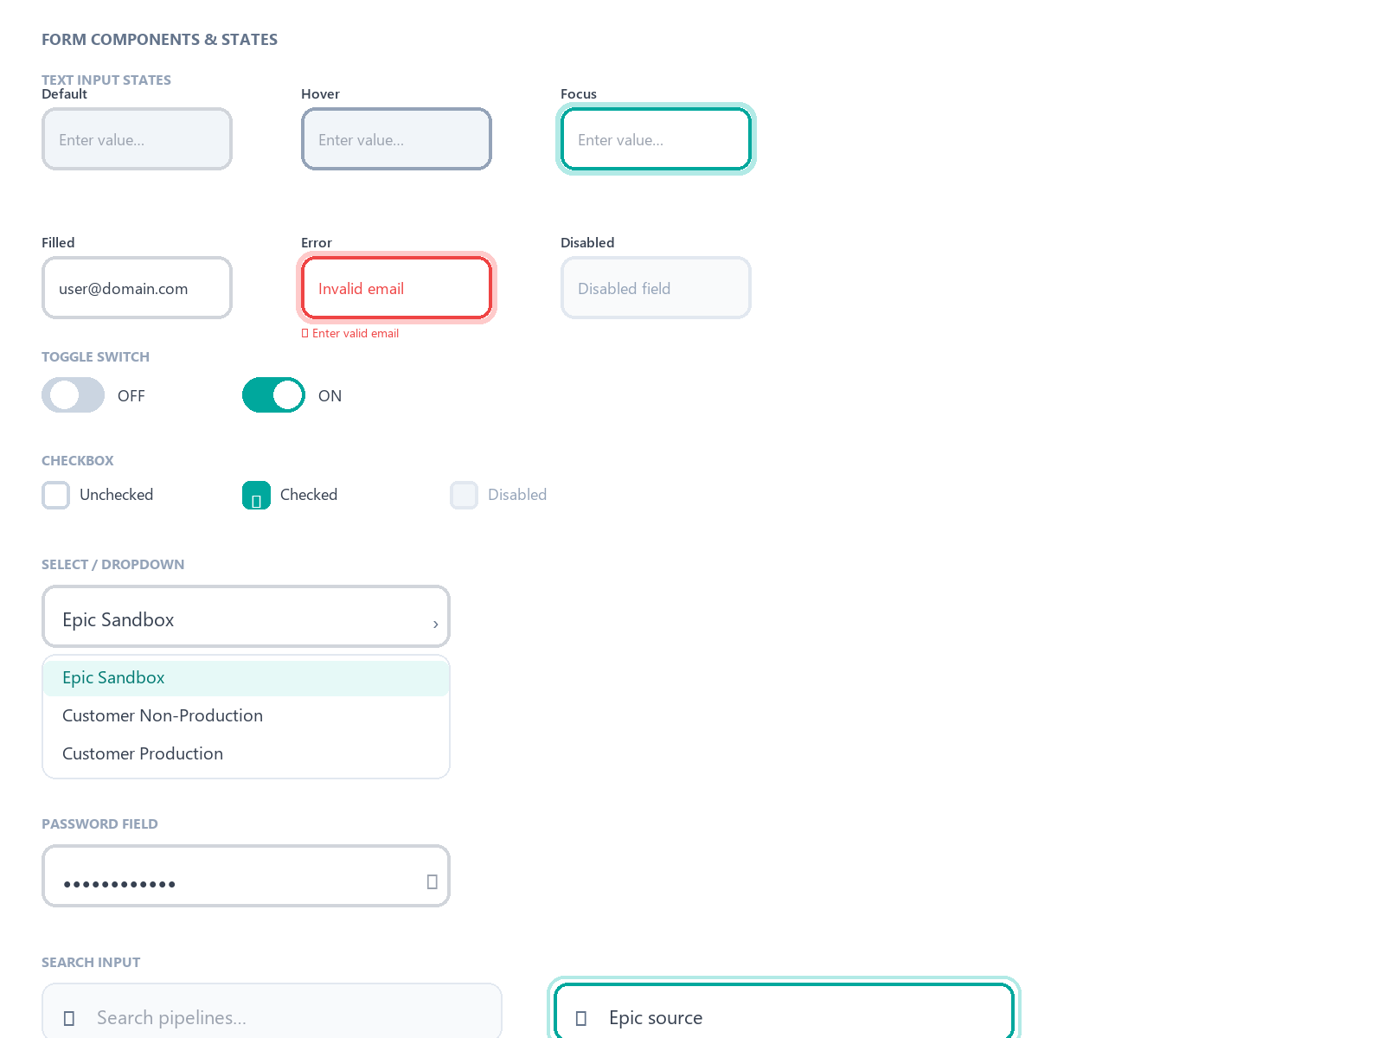
Figure: Form components — text input states, select dropdown, toggle switch, checkbox, password, search
8.1 Text Input — All States
State | Border | Background | Box-shadow
Default | 1.5px solid #D1D5DB | #FFFFFF | none
Hover | 1.5px solid #94A3B8 | #FFFFFF | none
Focus | 1.5px solid #00A89D | #FFFFFF | 0 0 0 3px rgba(0,168,157,0.12)
Filled | 1.5px solid #D1D5DB | #FFFFFF | none
Error | 1.5px solid #EF4444 | #FFFFFF | 0 0 0 3px rgba(239,68,68,0.10)
Disabled | 1px solid #E2E8F0 | #F9FAFB | none
Read-only | 1px solid #E2E8F0 | #F8FAFC | none

8.2 Toggle Switch
Property | Off State | On State
Track Color | #CBD5E1 | #00A89D
Track Size | 36×20px, border-radius 999px | —
Thumb Position | left: 3px | left: 19px
Thumb Color | #FFFFFF | #FFFFFF
Transition | background 200ms · left 200ms cubic-bezier(0.4,0,0.2,1) | —

8.3 Form Layout Rules
- Vertical label-above-input layout on all form fields.
- Two-column form-grid inside wizard cards (gap: 16px); full-width class spans both columns.
- Required indicator: <span class="req">*</span> in #00A89D after label text.
- Auto-populated (SMART Discovery) fields: "auto" green pill badge after label.
- Error messages appear below the field — never in a toast.
- Read-only fields: #F8FAFC background, non-editable cursor.

9. Status Badges & Pills
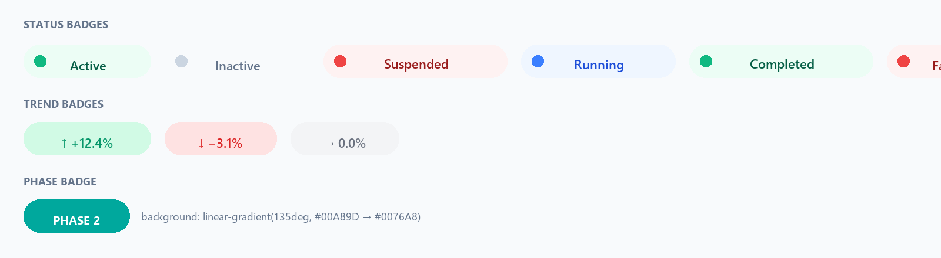
Figure: All status badges, trend badges, and Phase 2 gradient badge
Status | Background | Text Color | Dot Color
Active | #ECFDF5 | #065F46 | #10B981
Inactive | #F8FAFC | #64748B | #CBD5E1
Suspended | #FEF2F2 | #991B1B | #EF4444
Running | #EFF6FF | #1D4ED8 | #3B7FFF
Completed | #ECFDF5 | #065F46 | #10B981
Failed | #FEF2F2 | #991B1B | #EF4444
Queued | #FFF4E5 | #92400E | #F59E0B

10. Toast Notifications
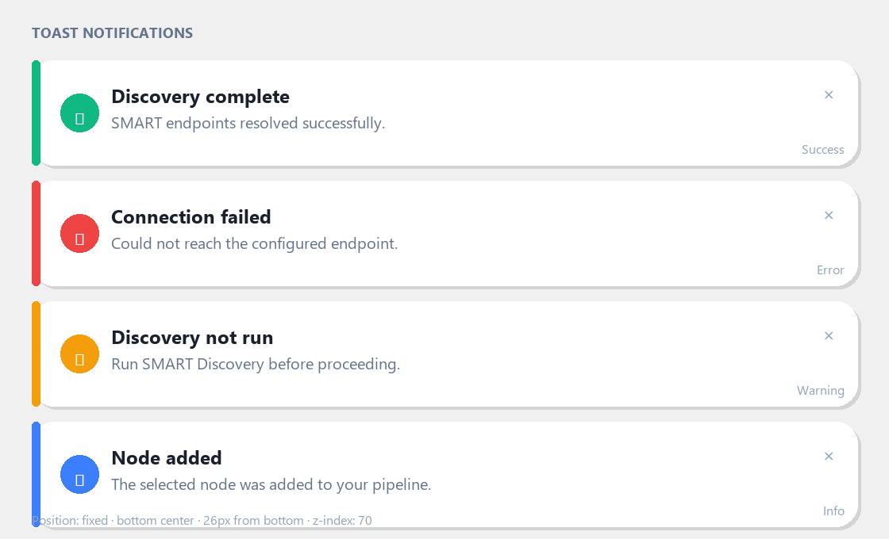
Figure: Toast notification variants — success, error, warning, info
Property | Value
Position | Fixed · bottom center · 26px from bottom
Width | min(520px, calc(100vw − 34px))
Border Radius | 14px
Shadow | 0 22px 55px rgba(18,20,27,0.18)
z-index | 70
Open Animation | opacity 0→1, translateY(8px)→translateY(0), 200ms ease
Auto-dismiss | 4s (success/info) · 6s (warning) · 8s (error)
Stacking | New toasts push up; max 3 visible simultaneously

Type | Left Border | Icon | Auto-dismiss
Success | 4px solid #10B981 | ✓ green | 4 seconds
Error | 4px solid #EF4444 | ✕ red | 8 seconds
Warning | 4px solid #F59E0B | ⚠ amber | 6 seconds
Info | 4px solid #3B7FFF | ℹ blue | 4 seconds

11. Modal Dialogs
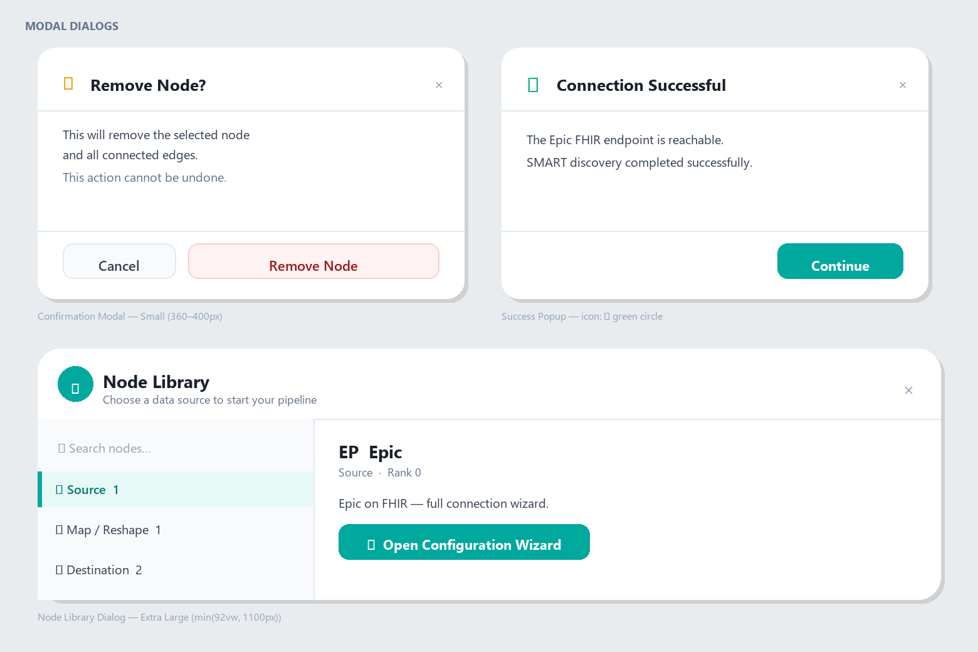
Figure: Modal dialogs — confirmation popup, success popup, and Node Library dialog layout
Size | Max Width | Max Height | Usage
Extra Large (XL) | min(92vw, 1100px) | min(88vh, 740px) | Node Library Dialog
Large (L) | min(1120px, calc(100vw−32px)) | min(92vh, 920px) | Epic Source Wizard
Medium (M) | 480–540px | auto | Invite User, Payload Preview
Small (S) | 360–400px | auto | Confirmation, Delete, Session Timeout

Property | Value
Background | #FFFFFF
Border Radius | 14–18px (by size)
Shadow (large) | 0 32px 80px rgba(0,0,0,0.18)
Backdrop (soft) | rgba(255,255,255,0.58) + blur(2px) — Node Library
Backdrop (dark) | rgba(15,23,42,0.50) + blur(3px) — Epic Wizard
Open Animation | opacity 0→1, scale(0.96)→scale(1), 220ms ease-out
Close Animation | opacity 1→0, scale(1)→scale(0.96), 150ms ease-in
ESC Key | Closes modal
Focus Trap | Tab cycles only within open modal

12. Validation Messages
12.1 Form Field Validation
Rule | Message Text | Trigger
Required empty | This field is required. | On blur or submit attempt
Invalid email | Enter a valid email address (e.g. user@domain.com). | Real-time on blur
Invalid URL | Enter a valid URL starting with https://. | On blur
Invalid Client ID | Enter a valid UUID (xxxxxxxx-xxxx-xxxx-xxxx-xxxxxxxxxxxx). | On blur
Password too short | Password must be at least 8 characters. | Real-time on change
Passwords mismatch | Passwords do not match. | Real-time on change
SMART not run | Run SMART Discovery before proceeding. | On Next click (wizard)
Max length | Maximum {n} characters allowed. | Real-time with counter

12.2 Connection & Auth Errors
Scenario | Message Text | Recovery Action
Connection failed | Could not reach the endpoint. Check the URL and try again. | Edit URL; retry Discover
Auth failed | Authentication failed. Verify Client ID and credentials. | Return to Step 2
FHIR unreachable | FHIR base URL not reachable. Check the environment URL. | Edit URL; re-run Discovery
Server error (500) | A server error occurred. Try again later. | Retry in toast
Network error | Unable to connect. Check your internet connection. | Retry in toast
Session expired | Your session has expired. Please sign in again. | Redirect to /auth/login

13. Error & Empty State Screens
State | Icon | Title | Body Text | Action Button
404 Not Found | 🔍 grey 60px | Page Not Found | The page does not exist or has been moved. | Go to Dashboard
403 Forbidden | 🔒 grey 60px | Access Denied | You do not have permission to view this page. | Go to Dashboard
500 Server Error | ⚠ amber 60px | Something Went Wrong | A server error occurred. Our team has been notified. | Refresh Page
No Internet | 📡 grey 60px | No Internet Connection | Check your network connection and try again. | Retry
Session Expired | ⏱ amber 60px | Session Expired | Your session has timed out for security. | Sign In Again
Empty Table | 📋 grey 60px | No pipelines yet | Create your first pipeline to get started. | + New Pipeline
Empty Canvas | ⬡ grey 60px | Start Building | Add a source node to begin your pipeline. | ⬡ + Add Source

ⓘ Skeleton loaders: animated linear-gradient shimmer #F1F5F9 → #E2E8F0 → #F1F5F9, 1.5s linear infinite. Empty state icon: 60–80px, #D1D5DB.

14. Canvas Node Design
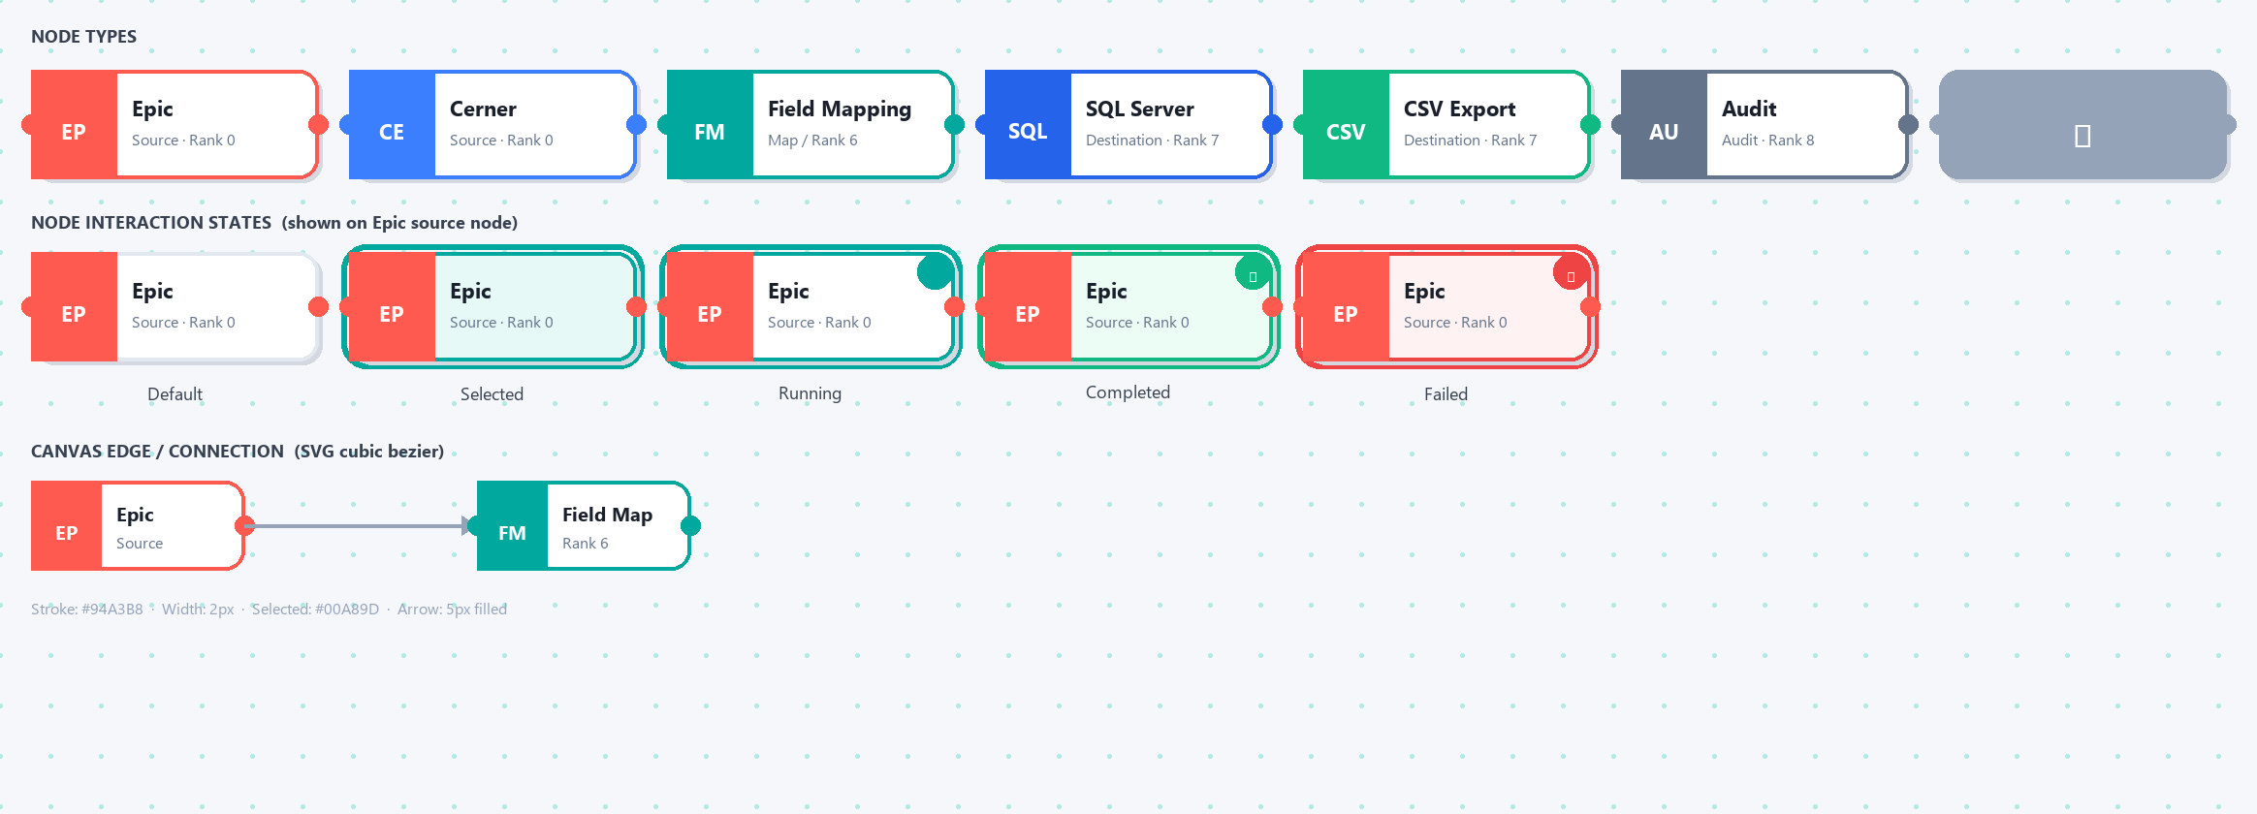
Figure: All node types (Source, Transform, Merge) with interaction states and canvas edge
14.1 Node Dimensions
Property | Source Node | Transform Node | Merge Node
Width | 150–180px | 160–180px | 120px
Height | 54–64px | 52–60px | 52px
Border Radius | 10–12px | 10px | 10px
Border (default) | 2px solid node-color | 2px solid rank-color | 2px solid #94A3B8
Abbr Area Width | ~44px (left) | ~36px (left) | Full width (centered ⊕)
Label Font | 12px / 700 / #1A202C | 12px / 700 / #1A202C | 11px / 600 / #64748B
Connection Handle | 8px circle, node-color border | Right side only | Both sides

14.2 Node Color Coding by Rank
Rank | Category | Color | Hex | Abbreviation
0 | Source — Epic | Epic Red | #FF5A4F | EP
0 | Source — Others | Blue | #3B7FFF | CE, AT, HL
2 | Validation | Indigo | #6366F1 | FV
3 | Normalize | Purple | #8B5CF6 | NM
4 | Terminology | Pink | #EC4899 | TM
5 | De-identify | Orange | #F97316 | DI
6 | Map/Reshape | Teal | #00A89D | FM
7 | Destination SQL | Steel Blue | #2563EB | SQL
7 | Destination CSV | Green | #10B981 | CSV
8 | Audit | Slate | #64748B | AU
9 | Analytics | Violet | #7C3AED | AN

14.3 Node Interaction States
State | Visual Change
Default | Standard border, white bg, shadow 0 2px 8px rgba(0,0,0,0.08)
Hover | Border brightens, shadow deepens 0 4px 16px rgba(0,0,0,0.14), cursor grab
Selected | 2px solid + 4px outer glow rgba(node-color,0.25)
Dragging | opacity 0.80, scale(1.03), cursor grabbing, deeper shadow
Running | Pulsing teal border animation, 1.5s ease-in-out infinite
Completed | Green border #10B981, ✓ badge top-right (white on green circle)
Failed | Red border #EF4444, ✕ badge top-right (white on red circle)
Disabled | opacity 0.38, cursor not-allowed
Invalid | Red dashed border, ⚠ amber badge top-right

15. Workflow Canvas
15.1 Canvas Background
Property | Value
Background | #F5F7FA
Dot Grid | radial-gradient 1px dots, rgba(0,168,157,0.15), 26×26px spacing
Canvas Size | 4000×2600px (virtual / infinite pan)
Cursor default | grab → grabbing when panning
Edge Type | SVG cubic bezier · stroke #94A3B8 · 2px width
Edge Selected | stroke #00A89D · 2.5px width
Edge Running | dashed animated, dash-offset 500ms infinite

15.2 Canvas Keyboard Shortcuts
Shortcut | Action
Ctrl+Z | Undo (stack depth 20)
Ctrl+Shift+Z / Ctrl+Y | Redo
Ctrl+D | Duplicate selected node
Backspace / Delete | Delete selected node (with confirmation)
Ctrl+= / Ctrl+− | Zoom in / out
Shift+Click | Multi-select nodes
Escape | Deselect / close context menu

16. Tables
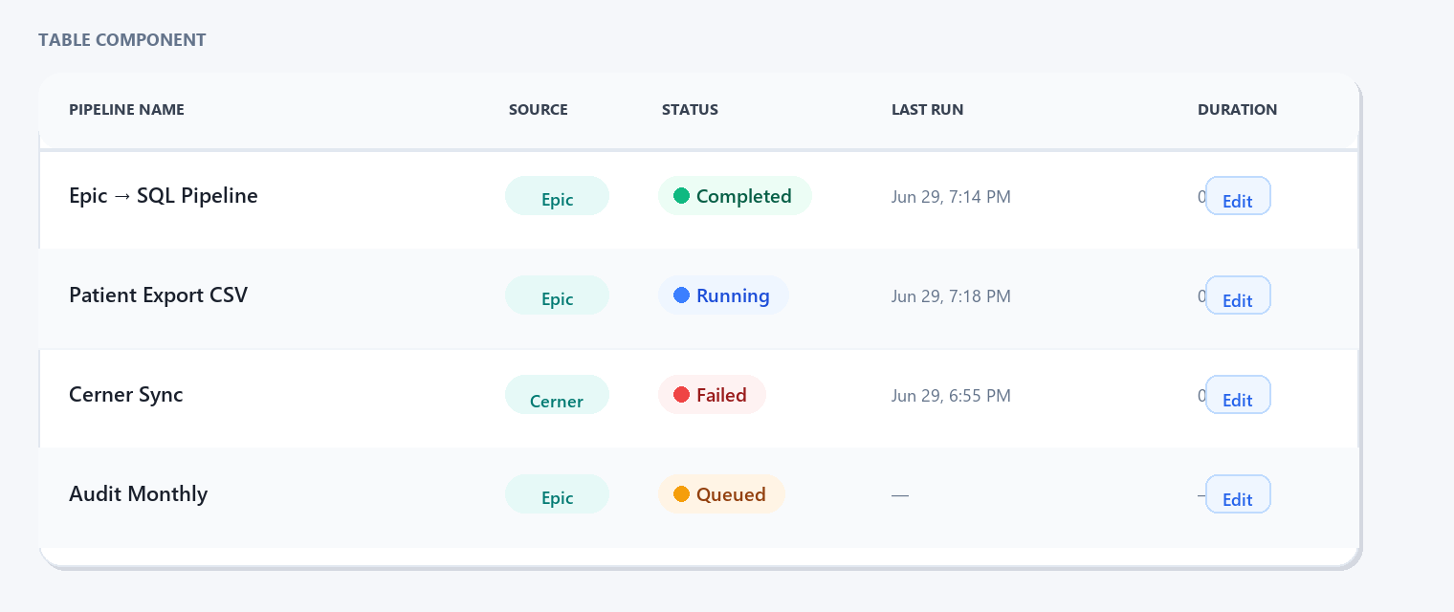
Figure: Table component — header, rows, status badges, and action buttons
Property | Value
Container | White card, border-radius 12px, border 1px #E2E8F0
Header Background | #F8FAFC, border-bottom 2px #E2E8F0
Header Font | 12px / 700 / #374151, uppercase, letter-spacing +0.05em
Row Height | ~52px
Row Hover | #F8FAFC
Row Selected | #E6F9F7
Sticky Header | position: sticky; top: 0; z-index: 1
Pagination | Prev/Next buttons + "Showing 1–20 of 150" + page size 10/20/50
Sorting | Sort arrows ↑↓; active column: teal arrow #00A89D
Loading | Skeleton shimmer rows (same count as page size)

17. Dashboard Cards
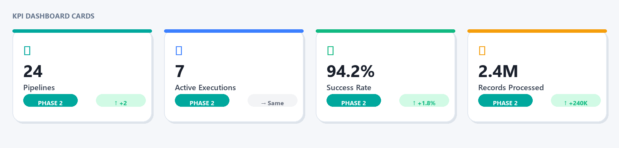
Figure: KPI dashboard cards — 4 cards with accent colors, values, Phase 2 badges, trend badges
KPI | Border Top | Icon Color | Accent
Total Pipelines | #00A89D (Teal) | #00A89D | --color-primary
Active Executions | #3B7FFF (Blue) | #3B7FFF | --color-info
Success Rate | #10B981 (Green) | #10B981 | --color-success
Records Processed | #F59E0B (Amber) | #F59E0B | --color-warning

Property | Value
Border Radius | 12px
Padding | 20px 22px 18px
Shadow (rest) | 0 1px 4px rgba(0,0,0,0.04)
Shadow (hover) | 0 6px 24px rgba(0,0,0,0.10)
Hover Transform | translateY(−2px)
KPI Value Font | 30px / 800 / #1A202C, letter-spacing −1px
Phase Badge | linear-gradient(135deg, #00A89D, #0076A8), 10.5px/700/uppercase
Trend Badge Up | #D1FAE5 bg · #059669 text · ↑ arrow · 11px/600
Trend Badge Down | #FEE2E2 bg · #DC2626 text · ↓ arrow · 11px/600

18. Navigation
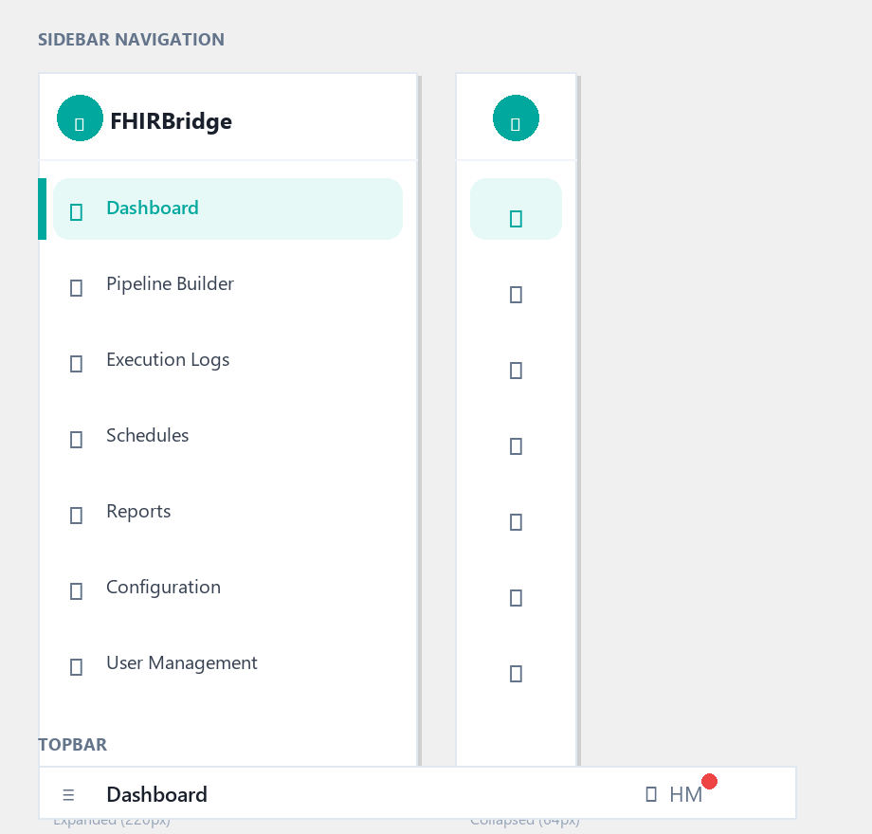
Figure: Sidebar navigation (expanded 220px and collapsed 64px) and topbar
Property | Value
Expanded Width | 220px
Collapsed Width | 64px
Background | #FFFFFF, border-right 1px #E2E8F0
Transition | width 200ms ease
Nav Item (default) | padding 10px 12px, border-radius 8px, 13px/500/#64748B
Nav Item (hover) | background #F8FAFC, color #1A202C
Nav Item (active) | background #E6F9F7, color #00A89D, font-weight 600, 3px left teal border
Topbar Height | 56px, sticky, z-index 10, border-bottom 1px #E2E8F0

19. UI States Reference
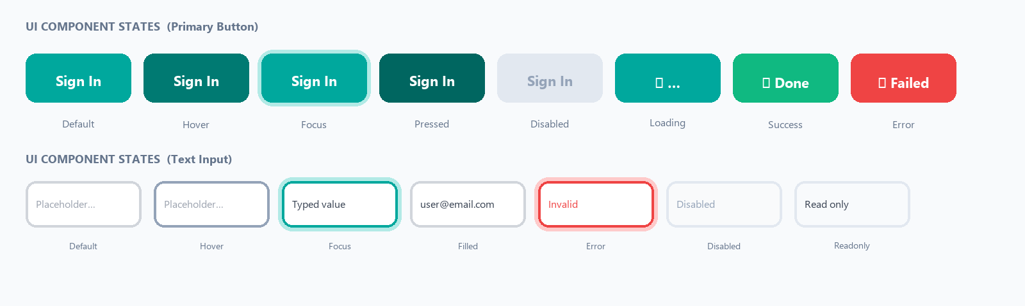
Figure: All UI states shown on Primary Button (top) and Text Input (bottom)
State | Visual Treatment
Default | Standard colors, no extra styling
Hover | Background lightens/darkens; transform on cards/buttons; border brightens
Focus | Teal ring 0 0 0 3px rgba(0,168,157,0.20), border #00A89D
Pressed / Active | Background darkens (#006660 primary); translateY(0)
Selected | Teal-soft background #E6F9F7 + teal left border
Disabled | #F1F5F9 bg, #94A3B8 text, #E2E8F0 border, opacity 0.6, cursor not-allowed
Loading | Spinner replaces icon/text; element disabled; skeleton for content areas
Success | Green #10B981 border/icon; brief pulse on node badge
Warning | Amber #F59E0B border/icon/badge; amber inline message
Error | Red #EF4444 border/icon; error message below field or in toast
Running | Pulsing teal border on node; animated dashed edge strokes
Completed | Static green border + ✓ badge on node
Empty | Empty state illustration + title + body + CTA button

20. Responsive Design
Breakpoint | Min Width | Sidebar | KPI Grid | Notes
Desktop | ≥ 1280px | 220px expanded | 4 equal columns | Full layout
Laptop | 1024–1279px | 64px auto-collapsed | 4 columns (tighter) | Scroll on overflow tables
Tablet | 768–1023px | 64px collapsed | 2×2 grid | Hide low-priority columns
Mobile | < 768px | Hidden | 1 column | Not supported — show banner

ⓘ FHIRBridge is a desktop-first tool. Mobile users see a warning banner recommending desktop use.

21. Accessibility (WCAG 2.1 AA)
21.1 Color Contrast Ratios
Color Combination | Ratio | WCAG Level
#FFFFFF on #00A89D | 3.0:1 | AA (large text / icons)
#1A202C on #FFFFFF | 16.1:1 | AAA
#374151 on #FFFFFF | 10.7:1 | AAA
#64748B on #FFFFFF | 5.9:1 | AA
#065F46 on #ECFDF5 | 7.2:1 | AAA
#991B1B on #FEF2F2 | 6.9:1 | AAA
#1D4ED8 on #EFF6FF | 5.8:1 | AA
#92400E on #FFF4E5 | 4.6:1 | AA

21.2 ARIA Requirements
- All inputs: <label for="id"> or aria-label.
- All icon buttons: aria-label="Close dialog", aria-label="Toggle visibility".
- Modals: role="dialog" aria-modal="true" aria-labelledby="modal-title".
- Wizard stepper: role="navigation" aria-label="Wizard steps"; current: aria-current="step".
- Canvas nodes: role="button" tabindex="0" aria-label="[Type] node, [status]".
- Toasts: role="alert" (error/warning) or role="status" (success/info).
- Form errors: aria-invalid="true" on input; aria-describedby linking to error message id.
- Loading spinner: aria-label="Loading" role="progressbar".
21.3 Focus Indicator
:focus-visible {
outline: none;
box-shadow: 0 0 0 3px rgba(0,168,157,0.20);
border-color: #00A89D;
}

22. Micro Animations
Animation | Trigger | Properties | Duration
Button hover lift | Cursor enters | translateY(0) → translateY(−1px) | 150ms ease
Card hover lift | Cursor enters card | translateY(0) → translateY(−2px) + shadow | 200ms ease
Modal open | Dialog mounts | opacity 0→1, scale(0.96)→scale(1) | 220ms ease-out
Modal close | Dialog unmounts | opacity 1→0, scale(1)→scale(0.96) | 150ms ease-in
Toast slide up | Toast appears | opacity 0→1, translateY(8px)→0 | 200ms ease
Sidebar collapse | Toggle click | width 220px ↔ 64px | 200ms ease
Node drop | Drop on canvas | scale(1.06) → scale(1) | 200ms spring
Loading spinner | Button async | rotate 360° infinite | 700ms linear
Skeleton shimmer | Content loading | background-position slide | 1.5s linear
Toggle switch | Click toggle | thumb left 3px→19px, grey→teal | 200ms cubic-bezier(0.4,0,0.2,1)
Status dot pulse | Running state | opacity+scale pulse infinite | 2s ease-in-out

ⓘ Performance rule: Animate only transform and opacity. Never animate top, left, width, height, or margin. Ensures 60fps on all hardware.

23. Design Tokens (CSS Custom Properties)
:root {
/* Colors */
--color-primary: #00A89D; --color-primary-dark: #007A72;
--color-primary-soft: #E6F9F7; --color-primary-mid: #B2EAE6;
--color-success: #10B981; --color-success-soft: #ECFDF5;
--color-warning: #F59E0B; --color-warning-soft: #FFF4E5;
--color-error: #EF4444; --color-error-soft: #FEF2F2;
--color-info: #3B7FFF; --color-info-soft: #EFF6FF;
--color-ink: #1A202C; --color-ink-2: #374151;
--color-muted: #64748B; --color-muted-2: #94A3B8;
--color-border: #E2E8F0; --color-border-input: #D1D5DB;
--color-bg: #F5F7FA; --color-surface: #FFFFFF;
--color-side: #F8FAFC;
/* Typography */
--font-family: Inter, 'Segoe UI', system-ui, Arial, sans-serif;
--font-mono: ui-monospace, 'SF Mono', Consolas, monospace;
/* Border Radius */
--radius-sm: 6px; --radius-base: 8px; --radius-md: 10px;
--radius-card: 12px; --radius-modal: 14px; --radius-2xl: 18px;
--radius-pill: 999px;
/* Spacing */
--space-1: 2px; --space-2: 4px; --space-4: 8px; --space-6: 12px;
--space-8: 16px; --space-9: 20px; --space-10: 24px; --space-12: 32px;
/* Shadows */
--shadow-xs: 0 1px 4px rgba(0,0,0,0.04);
--shadow-sm: 0 2px 12px rgba(0,0,0,0.06);
--shadow-md: 0 8px 32px rgba(0,0,0,0.10);
--shadow-lg: 0 24px 60px rgba(15,23,42,0.22);
--shadow-xl: 0 32px 80px rgba(0,0,0,0.18), 0 0 0 1px rgba(0,0,0,0.05);
/* Transitions */
--transition-fast: 100ms ease; --transition-base: 150ms ease;
--transition-slow: 200ms ease; --transition-modal: 220ms ease-out;
/* Z-Index */
--z-topbar: 10; --z-fab: 20; --z-dropdown: 30;
--z-backdrop: 50; --z-toast: 70; --z-modal: 200;
}

24. Developer Notes (Angular / SCSS)
24.1 Angular Component Rules
Guideline | Rule
Standalone components | All components use imports:[] — no NgModule declarations
Angular Signals | signal(), computed(), effect() for all reactive state
SCSS scoping | Each component has its own .scss; global tokens in styles.scss only
CSS token usage | Never hardcode hex in component SCSS; always use var(--color-primary)
No !important | Restructure selectors if specificity conflicts arise
viewChild refs | Access child methods (validate(), getValues()) via viewChild() signal ref
No console.log | Use ToastService.show() for user messages; remove all logs before commit

24.2 SCSS Naming Conventions
Pattern | Example | Usage
BEM prefix | nld-*, ew-*, kpi-* | Component-scoped prefix (nld=node-library-dialog, ew=epic-wizard)
State modifier | --wiz, --active, --disabled | Modifier classes on host or container
Form classes | form-field, form-grid, wiz-card | Consistent form layout across wizard steps
Animation classes | toast-in, spin, pulse-ring | Keyframe animation class names

24.3 State Management
State Type | Approach
Component-local UI (open/close/step) | signal() inside component class
Cross-component wizard state | WizardService — signal() properties, providedIn: root
Canvas nodes/edges/pan/zoom | PipelineStore — signal-based, providedIn: root
Phase config (enabled features) | PhaseConfigService — config object, providedIn: root
Form state | Angular Reactive Forms (nonNullable FormGroup)
Toast messages | ToastService.show(title, message) — one-liner from anywhere

FHIRBridge UI Design Specification · Version 1.0 · June 2026 · Pegasus One Health

