[1]

Effects of carbon emissions with Electric and Hybrid Vehicles

JiaYi He,*, IEEE*

# Abstract

The global transportation sector is a significant contributor to carbon dioxide (CO2) emissions, exacerbating the greenhouse effect and accelerating climate change. In response, many countries have implemented stringent measures to reduce CO2 emissions from conventional petrol and diesel vehicles[14]. The development of electric vehicles (EVs) has emerged as a critical solution for minimizing emissions[15]. EVs, when powered by cleaner energy sources, offer substantial environmental benefits by reducing CO2 emissions per kilometer compared to traditional vehicles. This paper examines the carbon emissions of both traditional and electric vehicles across six major regions, highlighting the differences in energy mix and carbon emission standards[8][2]. Through a comprehensive analysis of current renewable energy trends and the increasing adoption of EVs, this study provides insights into the potential for further reducing carbon emissions globally[4][3].

# introduction

As the problem of greenhouse effect and related climate change due to CO2 emissions, almost all the countries and districts decide to restrict CO2 emissions from conventional petrol vehicles and diesel [14]. Obviously, the best way to reach this purpose is to develop electric vehicles [15]. There are various types of electric vehicles, but compared with traditional electric vehicles, the biggest advantage must be their environmental protection, which will be demonstrated through the intuitive comparison of carbon emission g/km in the following data analysis link. As for carbon emission standards, each country has its own unique standards, which are closely related to the special geography, humanity, economy, and scientific and technological strength of different countries in different regions [8][12]. The emission data of six different countries and regions will be analyzed below, and a reasonable prediction will be made for the future tram market.

# Mexico

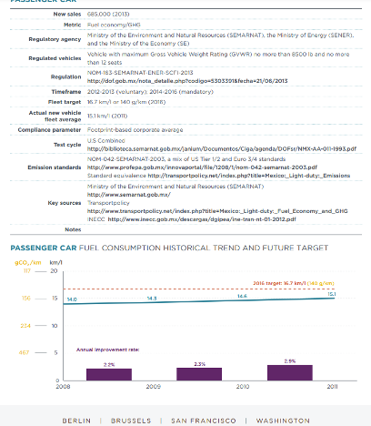

Fig. 1. Electrify use and carbon emissions in Mexico.

Mexico's carbon emissions are relatively stable, 140g/km, but because the domestic tram sales and the proportion are very small, as shown in the world tram sales chart, Mexico's future market share will be large, but limited by the slow economic development of Mexico, it is difficult to rapidly increase the proportion of trams in the short term [10].

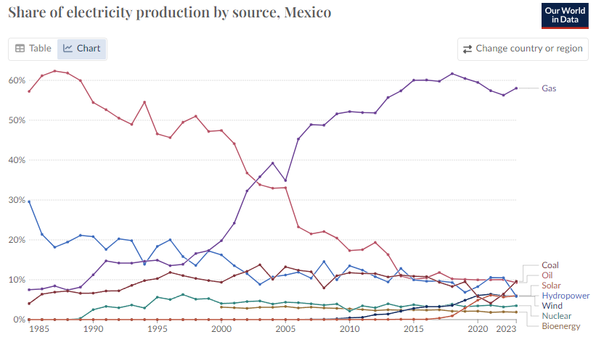

Fig. 2. Electrify use and carbon emissions in Mexico.

The trend in Mexico's power generation is clear: the share of natural gas is rising rapidly, accompanied by a rapid decline in oil generation. There is no obvious growth trend in wind and hydroelectric power generation, which has a certain relationship with Mexico's economic backwardness [10]. Mexico's carbon emissions are relatively stable, 140g/km, but because the domestic tram sales and the proportion are very small, as shown in the world tram sales chart, Mexico's future market share will be large, but limited by the slow economic development of Mexico, it is difficult to rapidly increase the proportion of trams in the short term [10].

# United Kingdom

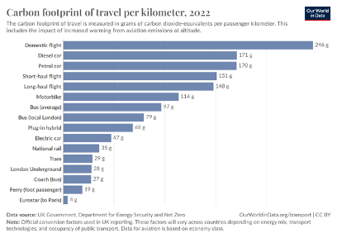

Fig. 3. Distribution of electricity use in the United Kingdom

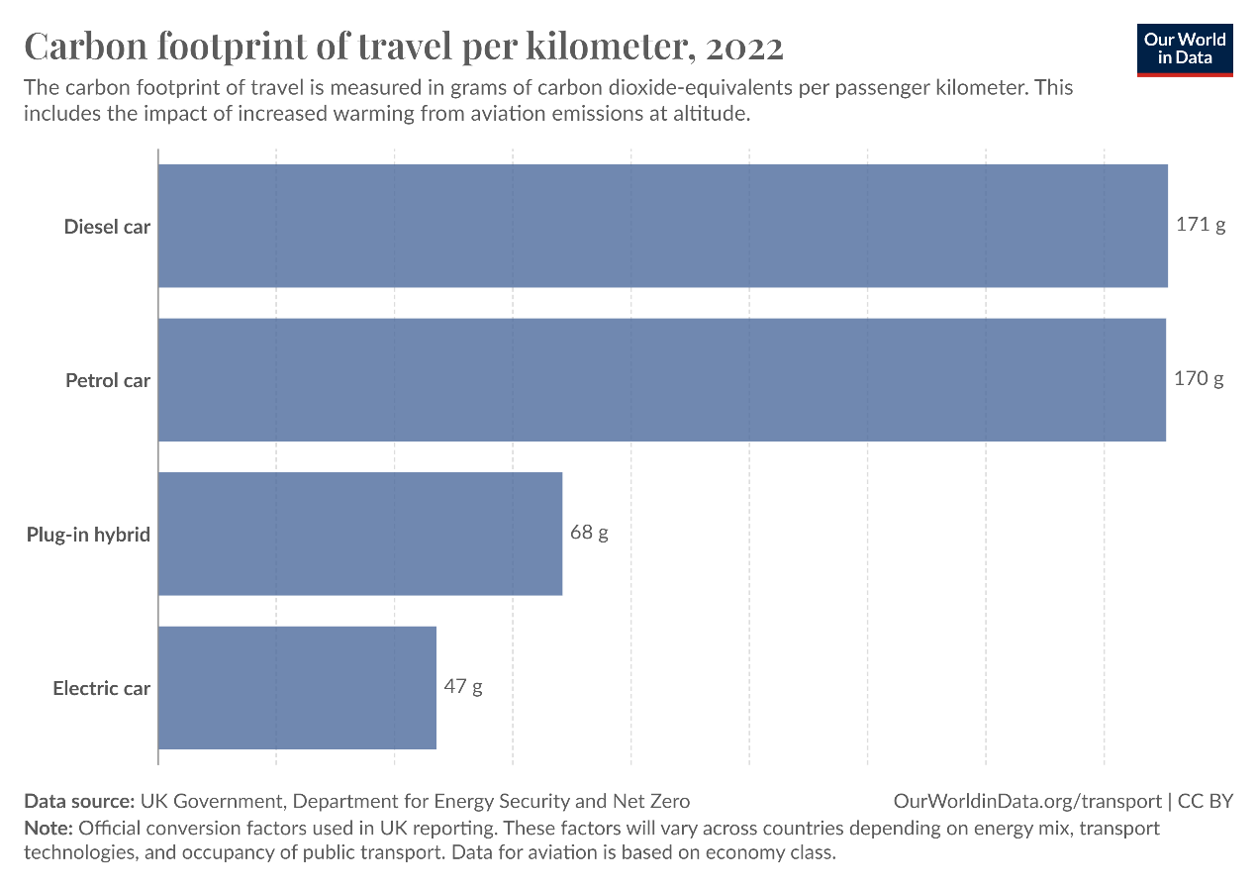

Fig. 4. Comparison of carbon emissions between traditional oil vehicles and new energy trams

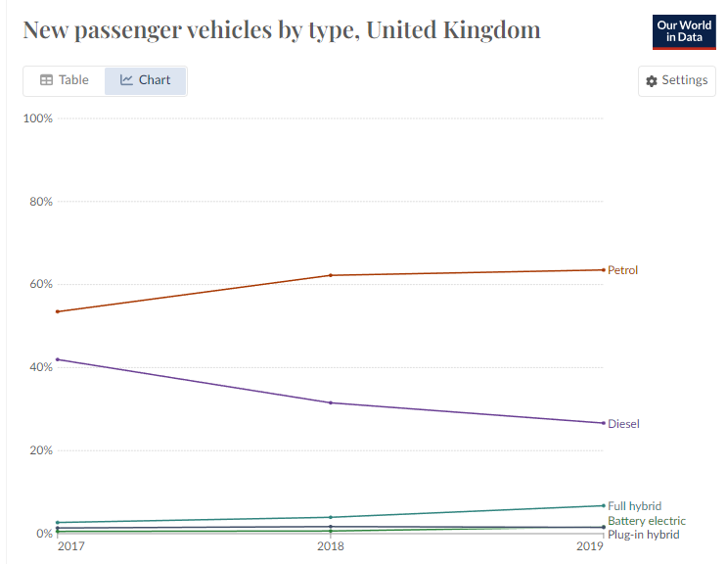

Fig. 5. Changes in sales of various types of cars in the UK in recent year.

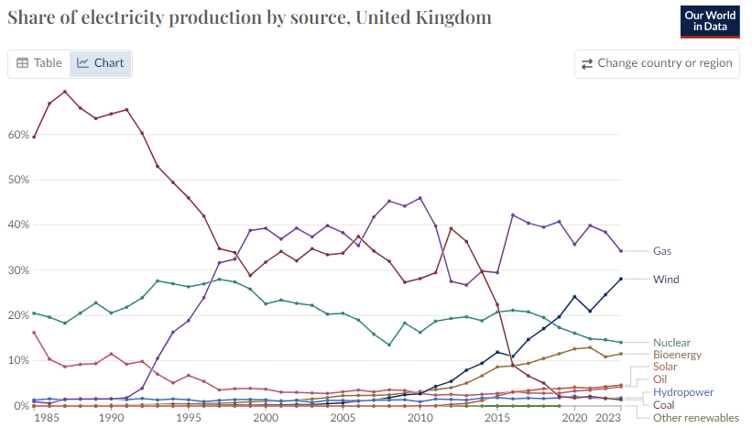

Fig. 6. Fuel mix picture

Figure 5 shows the change in the proportion of electricity generated in the UK, the most obvious trend is the increase of wind power, as the proportion of coal power decreased [7].  
Figure 4 shows the average and comparison of carbon emissions of different modes of transport in the UK, and it is obvious that traditional cars account for a very high proportion of carbon emissions [6]. The following is a detailed analysis of automobile carbon emissions: the carbon dioxide emissions of diesel and gasoline vehicles are close to each other, about 170g/km; Plug-in hybrids and pure trams have emissions of 68g/km and 47g/km respectively.  
As can be seen from Figure 4, there has been no significant increase in tram sales in the UK in recent years, and the decline of diesel vehicles is in line with the trend of decreasing the proportion of industry in the UK [6]. As a student who has studied in the UK, my personal experience is that British people tend to ride bicycles for short distance trips, while long-distance trips are not suitable for trams, which may be the reason for the low growth rate of trams in the UK. So overall, the UK electric vehicle development scenario is not very good, at least in the short-term development is not clear.

# Korea

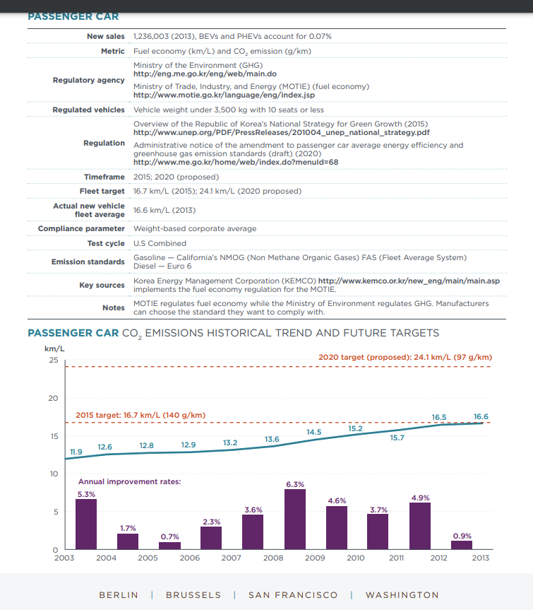

Fig. 7. Carbon emission trends in South Korea.

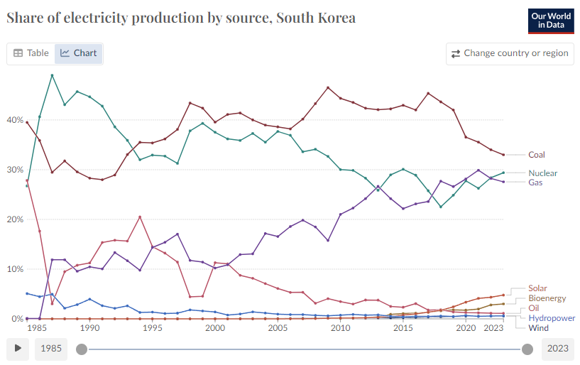

Fig. 8. Fuel mix of South Korea.

South Korea's power generation trend has been particularly marked by individual increases and decreases, such as the share of coal and nuclear energy has changed little over the past two decades, and only the share of natural gas has increased steadily and slowly [13]. Through the analysis of the world map, South Korea's tram sales have not changed much, the domestic market is relatively stable, and the development prospects are not broad [12].

# Europe Union

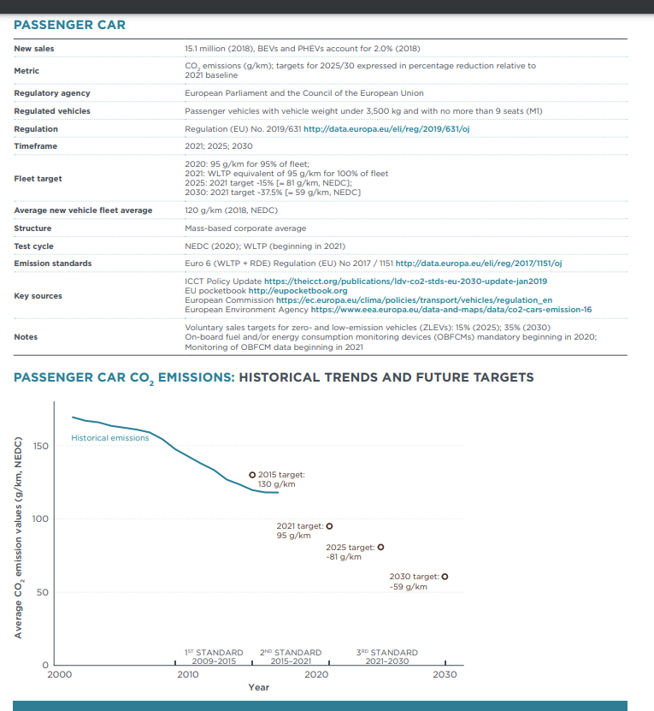

Fig. 9. Carbon emission targets and trends in EU.

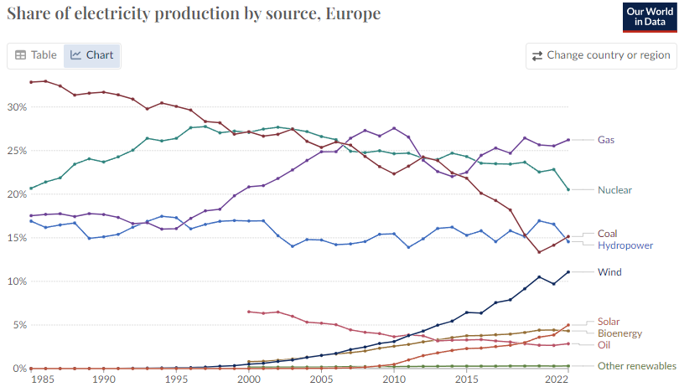

Fig. 10. Fuel mix of EU.

## From the perspective of power generation energy distribution, the proportion of clean energy generation such as wind and solar power in the EU is increasing, while the proportion of natural gas power generation remains high, and the proportion of coal power generation is constantly reduced [7]. Compared with other countries and regions, the EU has a relatively high share of nuclear power generation, at 20-25% [4].

## From the analysis of the EU carbon emission average and future targets, from 130g/km in 2015 (having reached the target) to a negative number in 2025, the EU plans to achieve carbon neutrality and self-recycling. This plan shows that the EU is relatively leading in the world in clean energy and carbon emission technology [4]. Moreover, from the proportion of tram sales in the EU (illustrated by the usage of trams in Germany), it can be found that the proportion of trams used by EU members is second only to China. The high use of electric cars and the leadership in clean energy technologies make the EU an important place to control carbon emissions [12].

# China

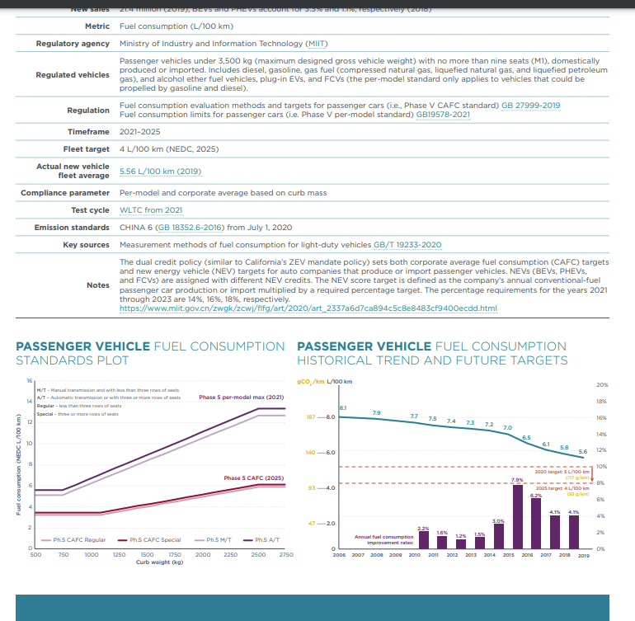

Fig. 11. Carbon emission target and distribution in China.

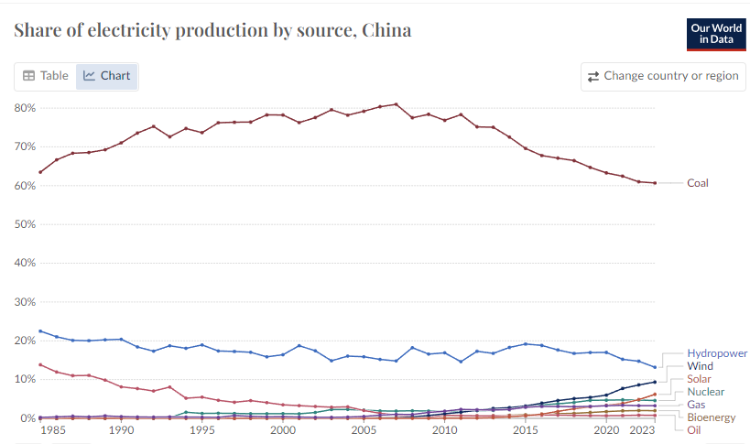

Fig. 12. Fuel mix of China.

It can be found in the proportion and distribution of power generation energy in China. The share of coal in conventional power generation remains high and stable. The share of clean energy sources, such as wind and solar power, is growing steadily, but hydropower still accounts for the largest share [9]. From the analysis of the average carbon emission in China, the current carbon emission is 5.56L/100km, which is 129.9g/km according to the international standard, while the target in 2025 is 93.5g/km [8]. This average carbon emission is very low in the global scope, and the specific reasons can be further analyzed to find out the Chinese tram market. China's tram sales are growing faster than any other country in the world and account for the highest proportion, which explains China's low average carbon emissions [12]. From the future trend analysis, there are still many areas in China with imperfect infrastructure, which leads to the limited use of trams, and China's national policy is to gradually stop production of traditional pure oil vehicles, so China's electric vehicle trend is very broad [9].

# Hong Kong

Fig. 13. Fuel mix for electricity generation in Hong Kong

Fig. 14. Electric vehicles in sell (Hong Kong)

Figure 13 shows the distribution of electricity production sources in Hong Kong from 2021 to 2023. As observed, gas and coal dominate the electricity production, with gas consistently accounting for over 50% and coal contributing around 40%. Renewable energy sources, such as wind and solar, make up a negligible share of electricity generation, indicating a low reliance on cleaner energy sources [2].

Figure 14 shows the growth in electric vehicle (EV) registrations in Hong Kong from 2010 to 2020. In 2010, the total EV registrations were only 162, representing a mere 0.02% of all vehicles. By 2020, EV registrations had surged to 18,361, accounting for 2.2% of all vehicles. The graph highlights a steady increase in EV adoption, driven by policy incentives and growing environmental awareness [5].

References

1. HUTAOQAQ 2024
2. Environmental Protection Department, Hong Kong, "EMFAC Hong Kong Vehicle Emission Calculation," *Environmental Protection Department*, 2022. Available: <https://www.epd.gov.hk/epd/english/environmentinhk/air/guide_ref/emfac_web_training/glossary.html>.
3. Environmental Protection Department, Hong Kong, "2022 Hong Kong Air Pollutant Emission Inventory Report," *Environmental Protection Department*, 2023. Available: <https://www.epd.gov.hk/epd/english/environmentinhk/air/data/emission_inve.html>.
4. European Environment Agency, "Monitoring CO2 emissions from new passenger cars and vans in Europe," *European Environment Agency*, 2020. Available: <https://www.eea.europa.eu/publications/co2-emissions-from-new-cars>。
5. International Council on Clean Transportation, "A global comparison of the life-cycle greenhouse gas emissions of combustion engine and electric passenger cars," *ICCT*, 2021. Available: <https://theicct.org/publications/global-LCA-passenger-cars-jul2021>
6. Department for Transport, UK, "Vehicle licensing statistics: 2022," *UK Government*, 2022. Available: <https://www.gov.uk/government/statistics/vehicle-licensing-statistics-2022>。
7. UK Department for Business, Energy & Industrial Strategy, "Energy Trends: UK electricity," *UK Government*, 2022. Available: <https://www.gov.uk/government/collections/energy-trends>
8. China Automotive Technology and Research Center (CATARC), "China’s Fuel Consumption and Emissions Standards for Light-Duty Vehicles," *CATARC*, 2021. Available: <http://www.catarc.ac.cn>.
9. National Energy Administration, "China Energy Statistical Yearbook 2022," *National Bureau of Statistics*, 2022. Available: <http://www.stats.gov.cn>.
10. Secretaría de Medio Ambiente y Recursos Naturales (SEMARNAT), "Mexico's Light-Duty Vehicle Emissions Standards," *SEMARNAT*, 2021. Available: <https://www.gob.mx/semarnat>.
11. International Council on Clean Transportation (ICCT), "A Global Comparison of the Life-Cycle Greenhouse Gas Emissions of Combustion Engine and Electric Passenger Cars," *ICCT*, 2021. Available: <https://theicct.org/publication/global-LCA-passenger-cars-jul2021>.
12. Ministry of Environment, South Korea, "South Korea’s Air Quality Improvement and Vehicle Emission Standards," *Ministry of Environment*, 2022. Available: <http://eng.me.go.kr/eng/web/index.do?menuId=202>.
13. International Energy Agency (IEA), "South Korea’s Energy and Emissions Statistics," *IEA*, 2021. Available: <https://www.iea.org/reports/korea-2020>.
14. **United Nations Framework Convention on Climate Change (UNFCCC)**, "The Paris Agreement and NDCs," *UNFCCC Official Report*, 2015. [Online]. Available: <https://unfccc.int/process-and-meetings/the-paris-agreement/the-paris-agreement>.
15. **International Energy Agency (IEA)**, "Global EV Outlook 2021: Accelerating ambitions despite the pandemic," *IEA Report*, 2021. [Online]. Available: <https://www.iea.org/reports/global-ev-outlook-2021>.

1. This paragraph of the first footnote will contain the date on which you submitted your paper for review. It will also contain support information, including sponsor and financial support acknowledgment. For example, “This work was supported in part by the U.S. Depart­ment of Com­merce under Grant BS123456”.

   The next few paragraphs should contain the authors’ current affiliations, including current address and e-mail. For example, F. A. Author is with the National Institute of Standards and Technology, Boulder, CO 80305 USA (e-mail: author@ boulder.nist.gov).

   S. B. Author, Jr., was with Rice University, Houston, TX 77005 USA. He is now with the Department of Physics, Colorado State University, Fort Collins, CO 80523 USA (e-mail: author@lamar.colostate.edu).

   T. C. Author is with the Electrical Engineering Department, University of Colorado, Boulder, CO 80309 USA, on leave from the National Research Institute for Metals, Tsukuba, Japan (e-mail: author@nrim.go.jp).