PRSA Retirement Options
Age 62 Current PRSA value €830,859 Prepared 27 August 2026
This illustration sets out how the fund may be taken at retirement: the tax-free and taxable elements of the 25% lump sum, the net amount received, and the options for the balance. All figures are illustrative and based on current Irish pension and taxation rules.
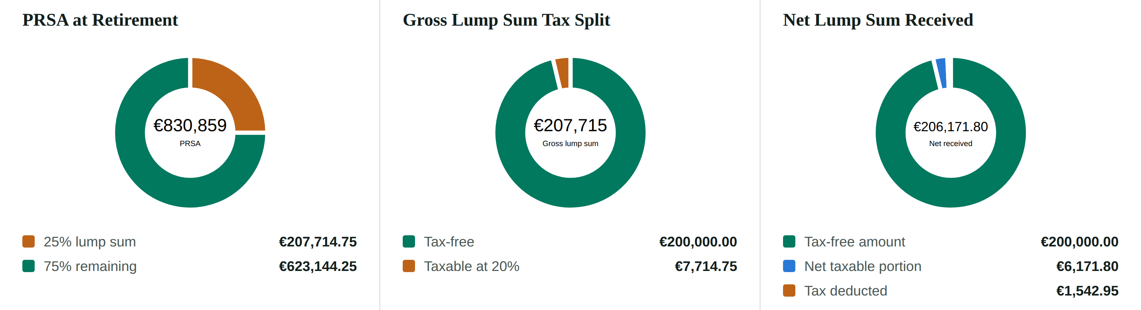
Options for the Remaining €623,144.25
Option | Amount | Income | Investment continues | Capital access | Tax treatment
Approved Retirement Fund | €623,144.25 | Flexible withdrawals | Yes | Yes | Withdrawals taxable under PAYE
Annuity | €623,144.25 | Guaranteed pension income | No | Generally no | Pension income taxable
Withdraw balance | €623,144.25 | No future pension fund retained | No | Immediate | Withdrawal taxable under PAYE
Illustrative Retirement Position
Current PRSA | €830,859.00
Gross 25% retirement lump sum | €207,714.75
Tax-free element* | €200,000.00
Taxable element* | €7,714.75
20% tax on taxable element* | €1,542.95
Net lump sum received* | €206,171.80
Remaining retirement fund | €623,144.25
Important Information
The figures shown are for illustrative purposes only and are based on current Irish pension and taxation rules. Pension, taxation and Revenue rules may change in the future and may affect the options available and the tax treatment applying at retirement. Investment values can rise as well as fall and you may get back less than the amount invested. Past performance is not a reliable guide to future performance.
Any retirement decision should be based on your personal circumstances, objectives, risk profile and the rules applying at the time benefits are taken. *The tax-free lump sum figures assume no previous retirement lump sums have used any of the €200,000 lifetime tax-free limit.

