Logbook evidence:
Project folder:
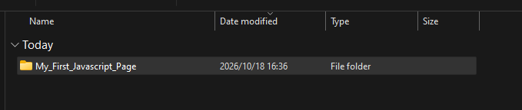
Files: HTML, CSS and Javascript:
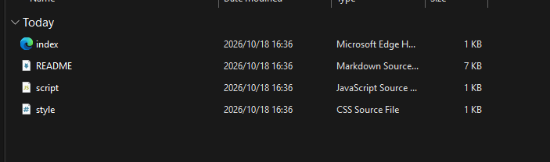
HTML code:
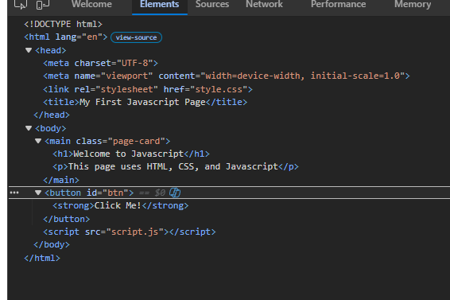
CSS:
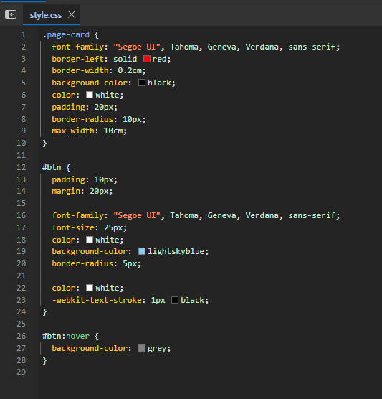

Javascript:
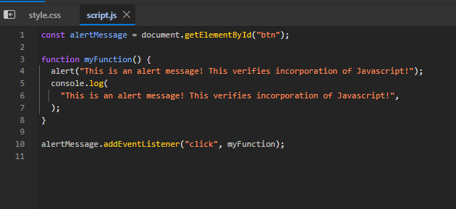

Run the application:
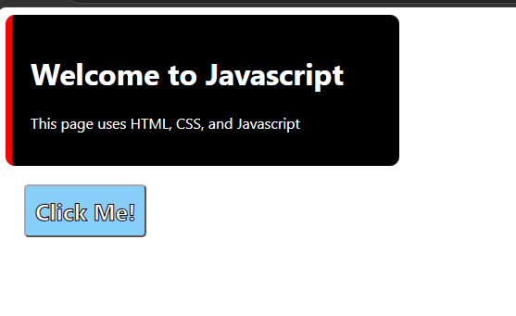
Click the button, displays an alert message:
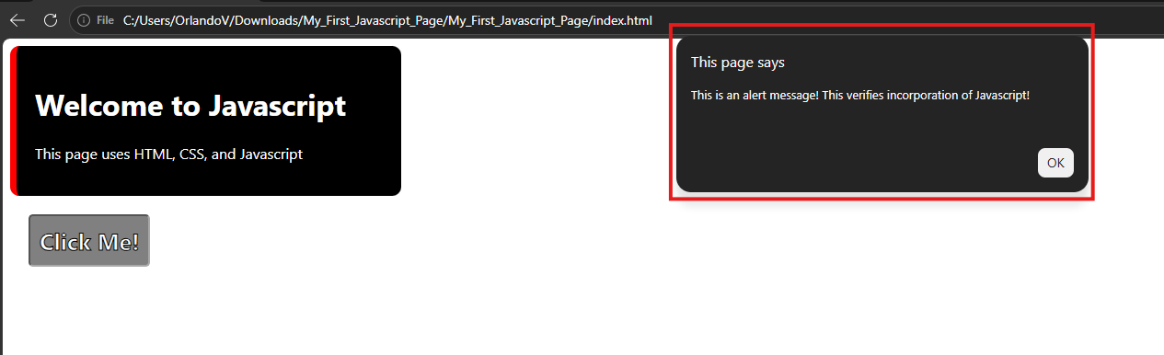
A message is written inside the console:
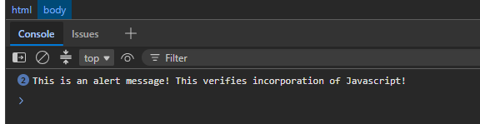

Linked files:



