Trained on query: 1- count, 2- exist

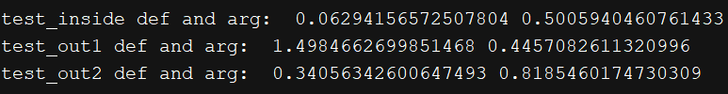

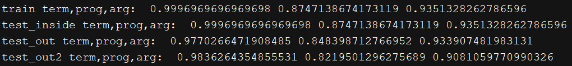

Trained on count 1- query 2-exist



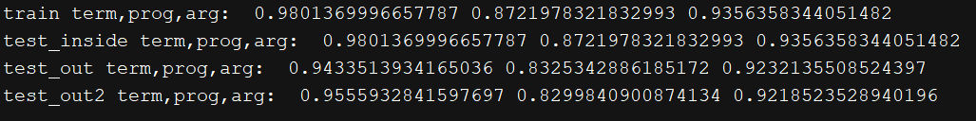

Trained on exist 1- count 2-query

