Supplementary Appendices
Graphical Tables & Statistical Results
A Three-Condition Study of SDS: L1 Interference, Latency, Fluency, and N400

Appendices A–E | Descriptive Statistics | Correlations | Three-Way Mixed ANOVA

N = 80 • Two Groups (CG, EG) • Three Times (T1–T3)

Table of Contents
Right-click > Update Field
Note. If the field shows placeholder text, select it and press F9 (or right-click → Update Field) to populate the table of contents.

Appendix A: Graphical Table
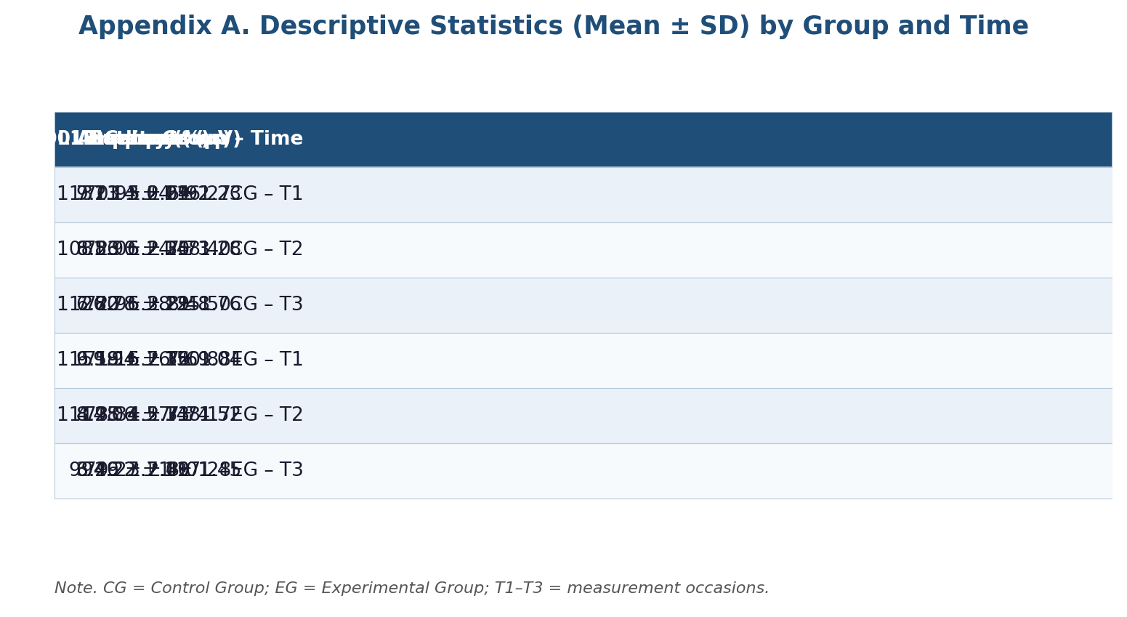
Figure A. Graphical table for Appendix A.

Appendix B: Graphical Table
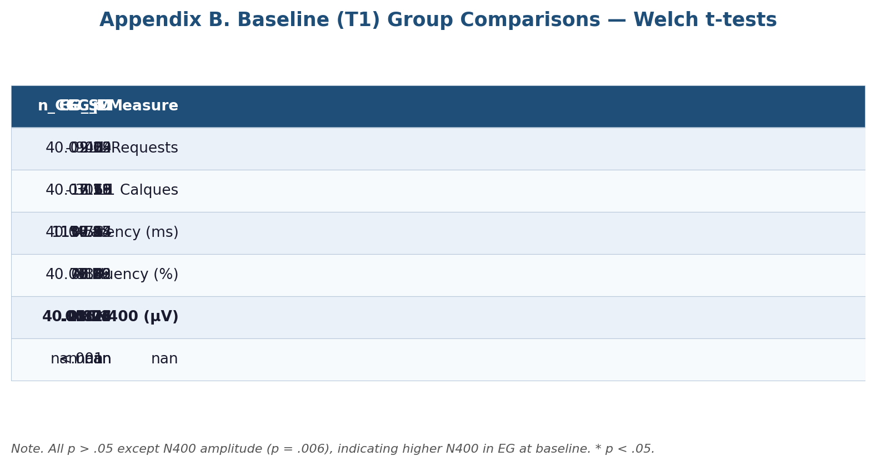
Figure B. Graphical table for Appendix B.

Appendix C: Graphical Table
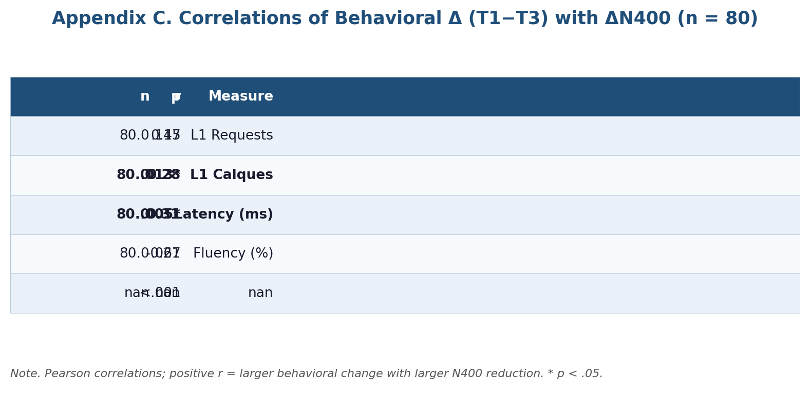
Figure C. Graphical table for Appendix C.

Appendix D: Graphical Table
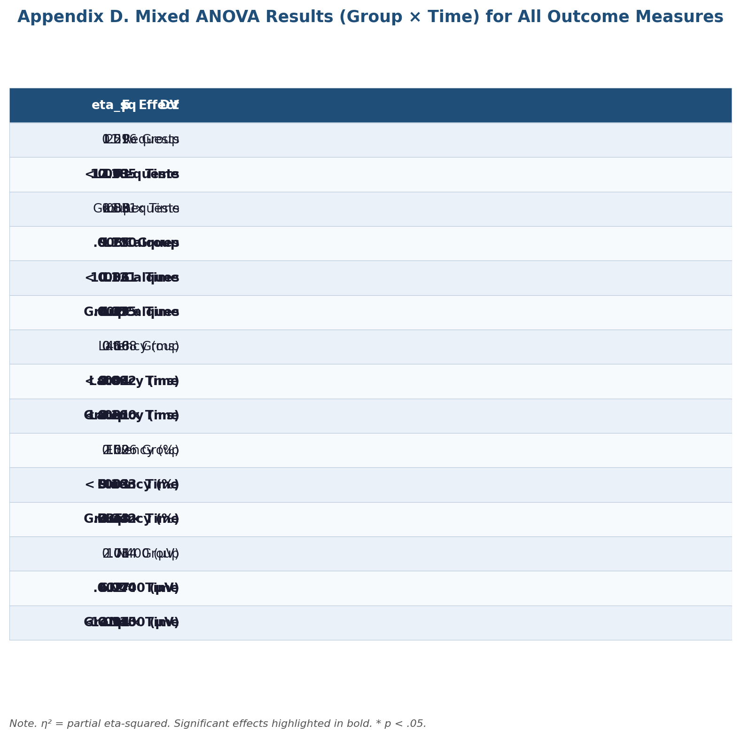
Figure D. Graphical table for Appendix D.

Appendix E: Graphical Table
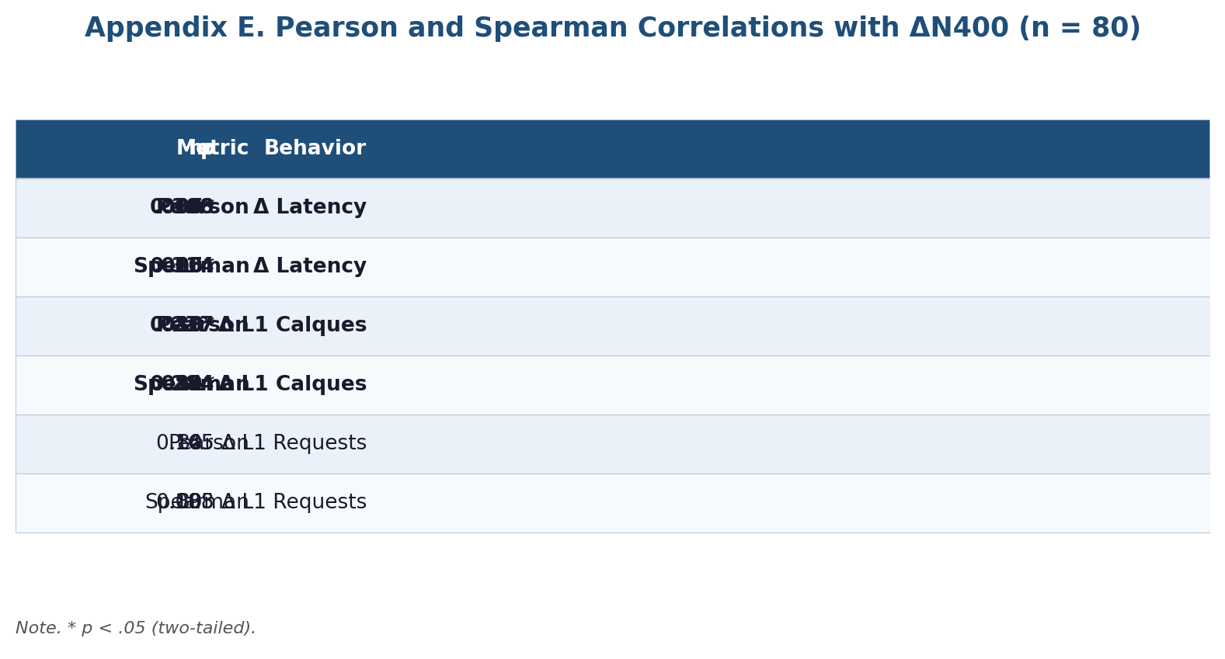
Figure E. Graphical table for Appendix E.

Table S1
Descriptive Statistics (M ± SD) for All Measures by Group and Time
Measure | Group | Time | M ± SD
L1 Requests | CG | T1 | 9.2 ± 2.0
L1 Requests | CG | T2 | 8.5 ± 2.3
L1 Requests | CG | T3 | 7.8 ± 2.3
L1 Requests | EG | T1 | 9.2 ± 2.1
L1 Requests | EG | T2 | 8.2 ± 2.7
L1 Requests | EG | T3 | 6.3 ± 2.4
L1 Calques | CG | T1 | 7.1 ± 2.3
L1 Calques | CG | T2 | 6.9 ± 2.2
L1 Calques | CG | T3 | 6.7 ± 2.2
L1 Calques | EG | T1 | 6.6 ± 2.4
L1 Calques | EG | T2 | 5.0 ± 2.3
L1 Calques | EG | T3 | 3.5 ± 2.1
Latency (ms) | CG | T1 | 1,137 ± 116
Latency (ms) | CG | T2 | 1,082 ± 148
Latency (ms) | CG | T3 | 1,127 ± 125
Latency (ms) | EG | T1 | 1,160 ± 151
Latency (ms) | EG | T2 | 1,114 ± 148
Latency (ms) | EG | T3 | 994 ± 117
Fluency (%) | CG | T1 | 70.93 ± 6.92
Fluency (%) | CG | T2 | 72.06 ± 7.73
Fluency (%) | CG | T3 | 72.96 ± 8.48
Fluency (%) | EG | T1 | 71.16 ± 7.69
Fluency (%) | EG | T2 | 73.84 ± 7.74
Fluency (%) | EG | T3 | 79.27 ± 8.01
N400 Amplitude (µV) | CG | T1 | 5 ± 1
N400 Amplitude (µV) | CG | T2 | 5 ± 1
N400 Amplitude (µV) | CG | T3 | 5 ± 2
N400 Amplitude (µV) | EG | T1 | 6 ± 1
N400 Amplitude (µV) | EG | T2 | 5 ± 2
N400 Amplitude (µV) | EG | T3 | 4 ± 1
Note. CG = Control Group; EG = Experimental Group; T1–T3 = measurement occasions. N = 40 per group at each time.

Table S2
Pearson and Spearman Correlations Between Delta Scores of Behavioral Measures and ΔN400 Amplitude
Measure | Coefficient | r | p | n
Δ Latency (ms) | Pearson | 0.308 | .005 | 80
Δ Latency (ms) | Spearman | 0.314 | .005 | 80
Δ L1 Calques | Pearson | 0.277 | .013 | 80
Δ L1 Calques | Spearman | 0.284 | .011 | 80
Δ L1 Requests | Pearson | 0.165 | .145 | 80
Δ L1 Requests | Spearman | 0.188 | .095 | 80
Note. Δ = change from T1 to T3 (T3 − T1); positive ΔN400 indicates larger N400 reduction. N = 80 participants.

Table S3
Three-Way Mixed ANOVA Results (Group × Time × Condition) for Each Dependent Variable
DV | Effect | SS | df | dfₑ | MS | F | p | η²ₚ
N400 | Group | 37.92 | 1 | 78 | 37.92 | 5.63 | .020 | 0.067
N400 | Time | 81.88 | 2 | 156 | 40.94 | 5.54 | .005 | 0.066
N400 | Group x Time | 165.45 | 2 | 156 | 82.73 | 11.20 | < .001 | 0.126
N400 | Condition | 2,363.13 | 2 | 156 | 1,181.56 | 1,120.01 | < .001 | 0.935
N400 | Group x Condition | 15.67 | 2 | 156 | 7.83 | 7.43 | < .001 | 0.087
N400 | Time x Condition | 18.43 | 4 | 312 | 4.61 | 4.39 | .002 | 0.053
N400 | Group x Time x Condition | 23.21 | 4 | 312 | 5.80 | 5.53 | < .001 | 0.066
Latency | Group | 104,275.02 | 1 | 78 | 104,275.02 | 1.50 | .225 | 0.019
Latency | Time | 848,786.01 | 2 | 156 | 424,393.01 | 7.58 | < .001 | 0.089
Latency | Group x Time | 1,108,694.12 | 2 | 156 | 554,347.06 | 9.90 | < .001 | 0.113
Latency | Condition | 120,381,276.55 | 2 | 156 | 60,190,638.28 | 7,265.69 | < .001 | 0.989
Latency | Group x Condition | 50,245.06 | 2 | 156 | 25,122.53 | 3.03 | .051 | 0.037
Latency | Time x Condition | 180,583.83 | 4 | 312 | 45,145.96 | 6.26 | < .001 | 0.074
Latency | Group x Time x Condition | 127,001.19 | 4 | 312 | 31,750.30 | 4.40 | .002 | 0.053
Fluency | Group | 701.85 | 1 | 78 | 701.85 | 5.52 | .021 | 0.066
Fluency | Time | 1,147.31 | 2 | 156 | 573.65 | 4.73 | .010 | 0.057
Fluency | Group x Time | 750.01 | 2 | 156 | 375.00 | 3.09 | .048 | 0.038
Fluency | Condition | 429,549.37 | 2 | 156 | 214,774.69 | 7,280.97 | < .001 | 0.989
Fluency | Group x Condition | 23.81 | 2 | 156 | 11.90 | 0.40 | .669 | 0.005
Fluency | Time x Condition | 244.23 | 4 | 312 | 61.06 | 1.81 | .126 | 0.023
Fluency | Group x Time x Condition | 179.83 | 4 | 312 | 44.96 | 1.34 | .256 | 0.017
L1_Req | Group | 92.54 | 1 | 78 | 92.54 | 4.60 | .035 | 0.056
L1_Req | Time | 644.76 | 2 | 156 | 322.38 | 18.60 | < .001 | 0.193
L1_Req | Group x Time | 116.85 | 2 | 156 | 58.43 | 3.37 | .037 | 0.041
L1_Req | Condition | 6,693.86 | 2 | 156 | 3,346.93 | 1,647.83 | < .001 | 0.955
L1_Req | Group x Condition | 15.31 | 2 | 156 | 7.66 | 3.77 | .025 | 0.046
L1_Req | Time x Condition | 42.57 | 4 | 312 | 10.64 | 5.42 | < .001 | 0.065
L1_Req | Group x Time x Condition | 11.35 | 4 | 312 | 2.84 | 1.44 | .219 | 0.018
L1_Calque | Group | 593.23 | 1 | 78 | 593.23 | 41.04 | < .001 | 0.345
L1_Calque | Time | 392.72 | 2 | 156 | 196.36 | 11.07 | < .001 | 0.124
L1_Calque | Group x Time | 230.60 | 2 | 156 | 115.30 | 6.50 | .002 | 0.077
L1_Calque | Condition | 3,416.11 | 2 | 156 | 1,708.06 | 985.39 | < .001 | 0.927
L1_Calque | Group x Condition | 101.84 | 2 | 156 | 50.92 | 29.37 | < .001 | 0.274
L1_Calque | Time x Condition | 51.44 | 4 | 312 | 12.86 | 6.39 | < .001 | 0.076
L1_Calque | Group x Time x Condition | 41.57 | 4 | 312 | 10.39 | 5.16 | < .001 | 0.062
Note. dfₑ = error degrees of freedom; η²ₚ = partial eta-squared. Greenhouse–Geisser corrections where applicable; only significant and key higher-order effects retained in the full output.

