ME218 Lab2 Pei-Chen, Wu pcwu1023

Part 1: An IR Signal Source

1.1)



(In the experiment, the actual R is 3.88K Ω and 983K Ω.)

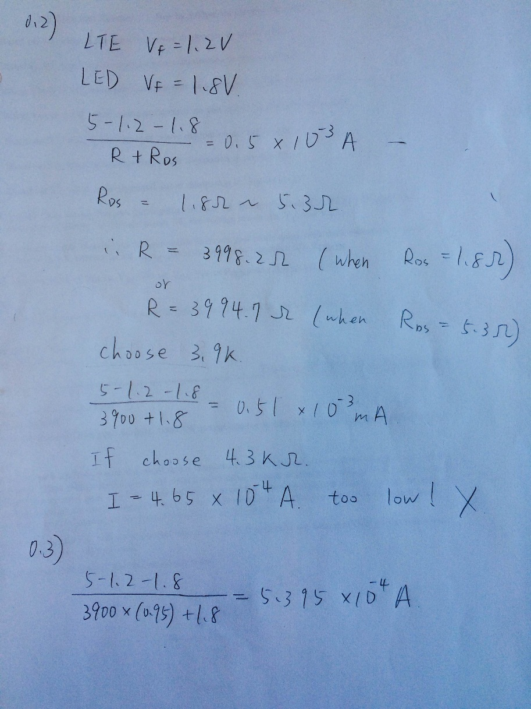

1.3)

Result of V1. V1max = 2.88V; V1min = 2.22V;

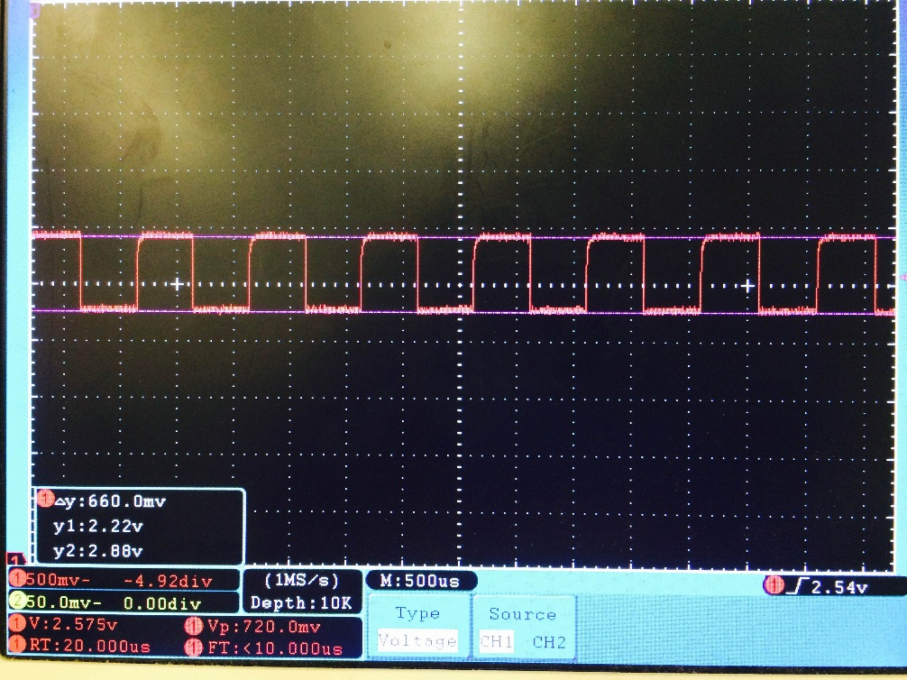

Result of V2. V2max = 2.88V; V2min = 0V;

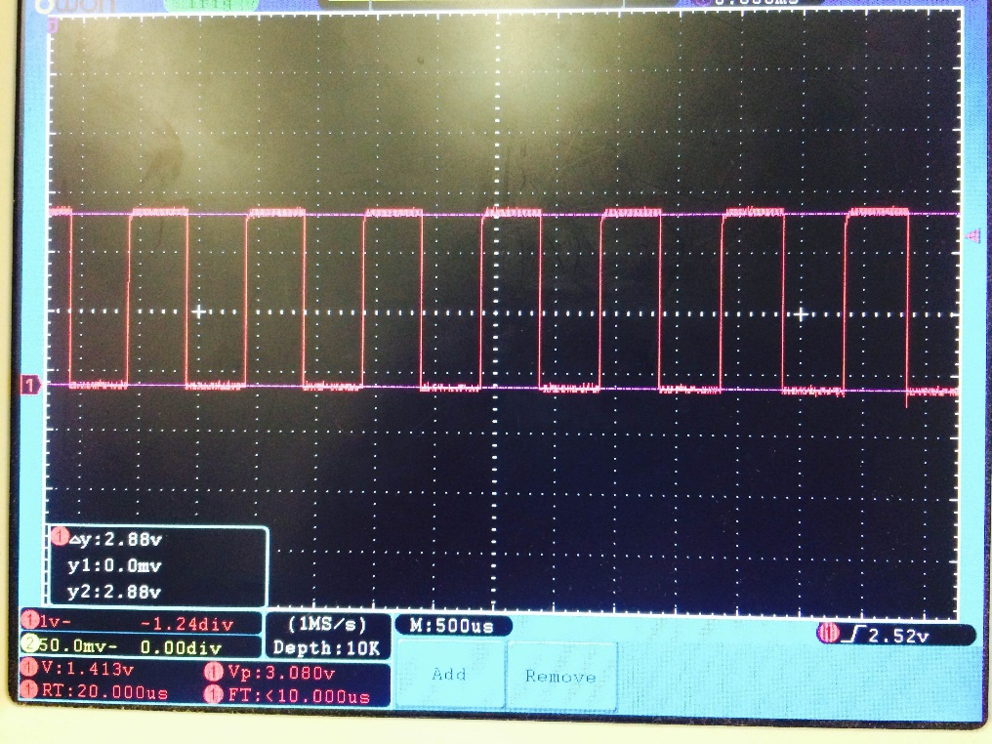

So, the peak current is 0.742mA.

1.4) Rise times = 10µs; fall times = 120ns;

Part 2: Capturing a Usable Signal

2.1)

(In the experiment, the sourcing circuit’s R = 2.13K Ω)

The circuit is photo-transistor sourcing configuration. The require peak to peal voltage is 0.5V, so the pull down resistor is 2.2KΩ to produce not very large voltage.

The disadvantage of this circuit is the production of current is nonlinear, so the voltage drop across the resistance is nonlinear. In the following parts, adding an op-amp holds the voltage difference of transistor being equal to constant 2.5V, so the production of current is linear.

2.2) 0.5V peak to peak

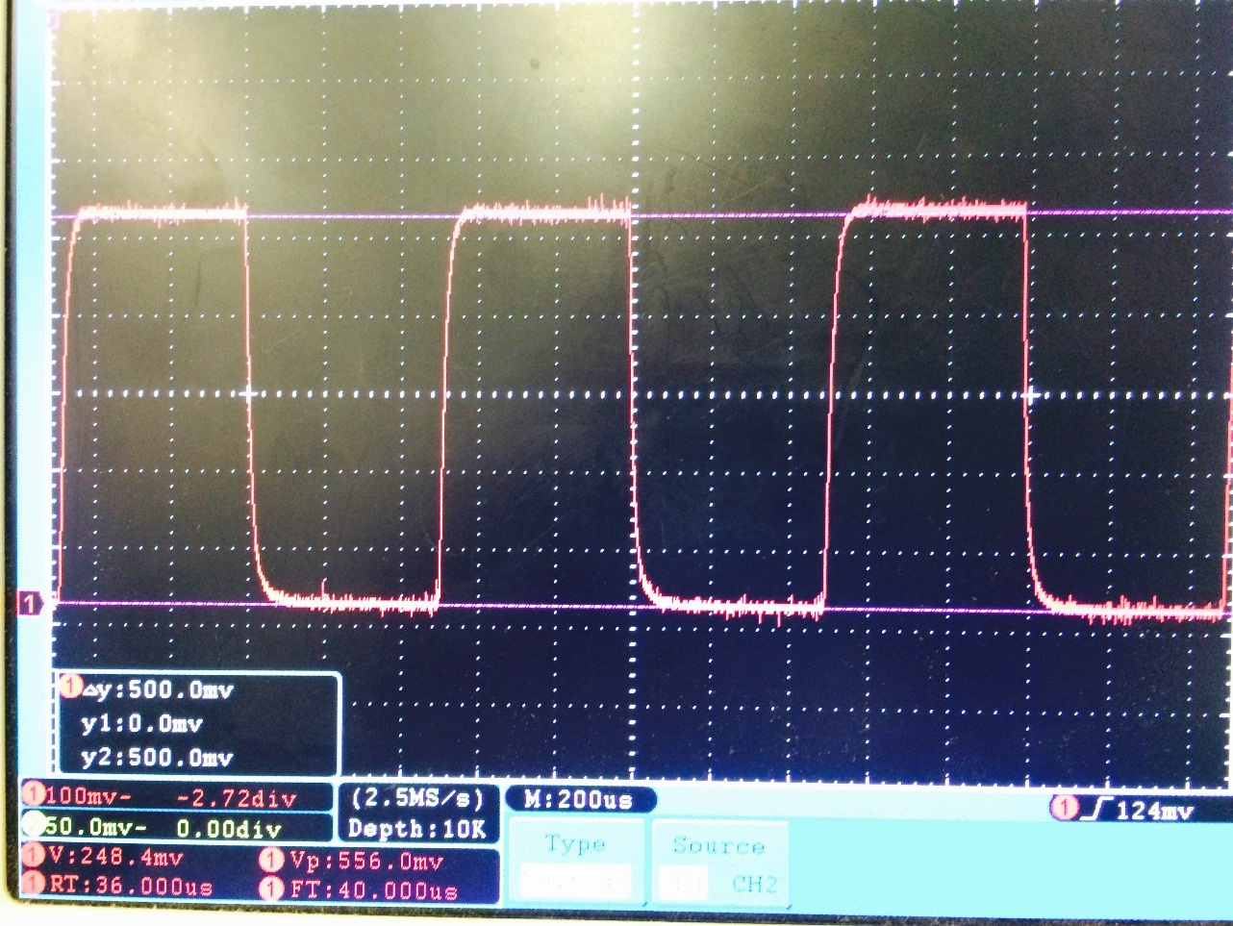

2.3)

Rise time = 30µs; fall times = 32µs;

(In the experiment, 1KHz had been applied to the circuit, not 100Hz.)

2.4) In the experiment, the actual R3 = 45K Ω, R1 = 29K Ω, R2 = 30.2K Ω.



2.5) 2.0V peak to peak

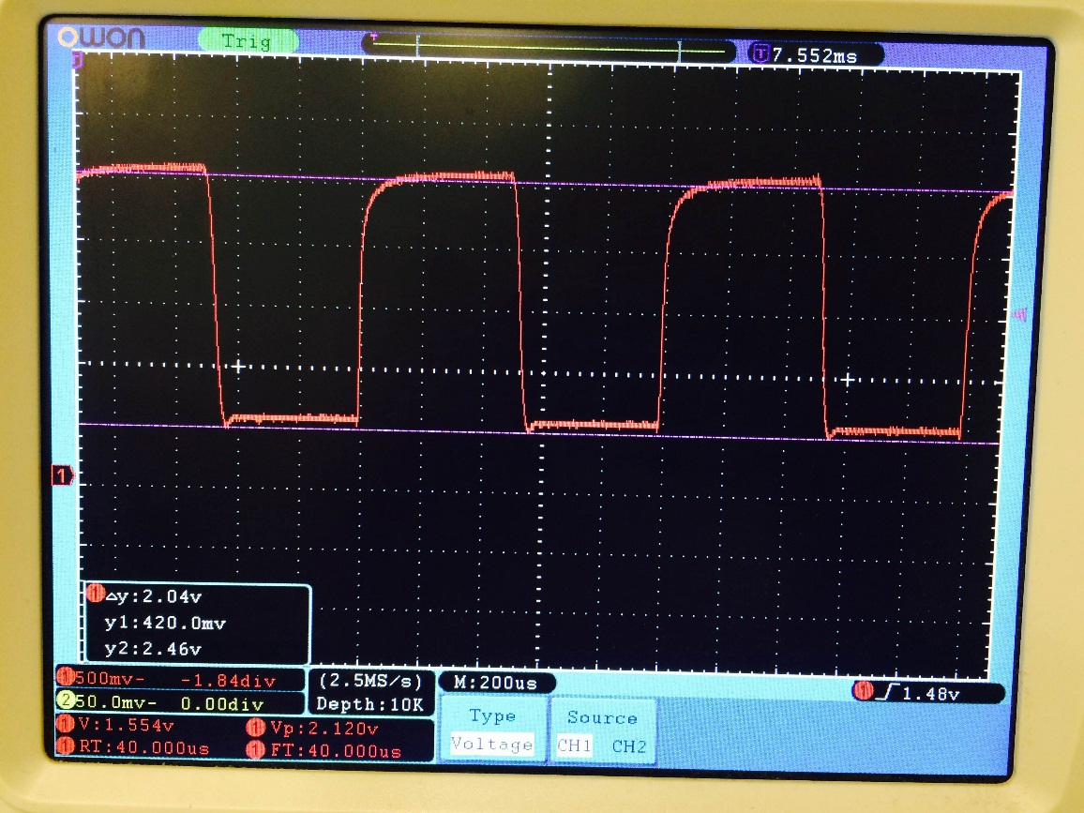

2.6)

Rise times = 42 µs; fall times = 35 µs;

2.7) & 2.8) Replacing the circuit to LM6144

Rise times = 28 µs; fall times = µs;

2.9) Design a trans-resistive circuit to detect IR by using photo-diode.



In the experiment, the actual R1 = 6.8K Ω, R2 = 984Ω, R2 = 305K Ω.

In the circuit, the voltage of non-inverting input is about 1V producing a reverse current through the diode. Applying larger R3 and moving the diode closer to the IR LED to produce larger Vout to hit the requirement peak to peak voltage = 2.0V.

2.10) 2.0V peak to peak

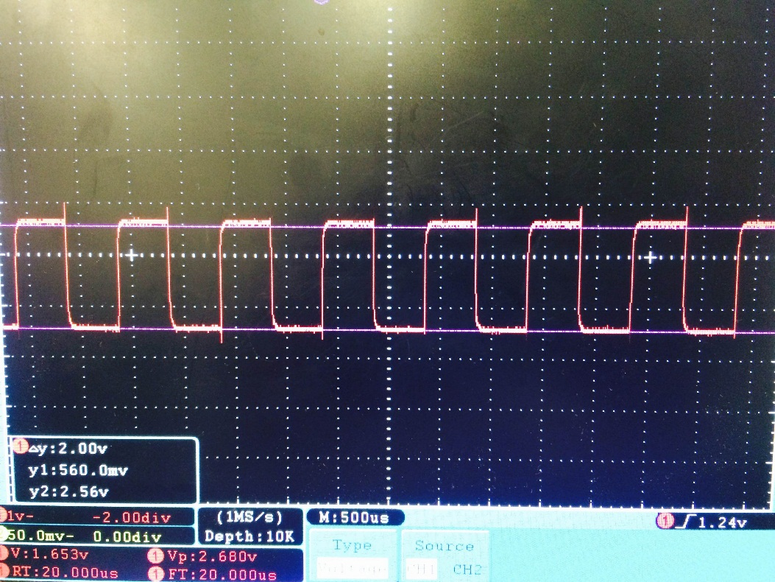

2.11)

Rise times = 8.9µs; fall times = 11µs;

Part 3: Creating a Digital Representation

3.1) In the experiment, the actual R3 = 88.9K Ω, R1 = 9.3KΩ, R2 = 6.7KΩ.



From the previous results of trans-resistive circuit, we can observe that the voltage is between 0.42V to 2.04V. Therefore, the following procedure is for designing comparator circuit and determining values for R1, R2, and R3.

1. VA1 = 2.2V
2. VA2 = 2.0V
3. ∆VA = 0.2V
4. N = 0.0909
5. R3 = 100KΩ
6. R1 = NR3 = 9090.9Ω (choose 10KΩ)
7. R2 = 6547.01Ω (choose 6.9KΩ)
8. Rpu = 3.3KΩ

3.2)

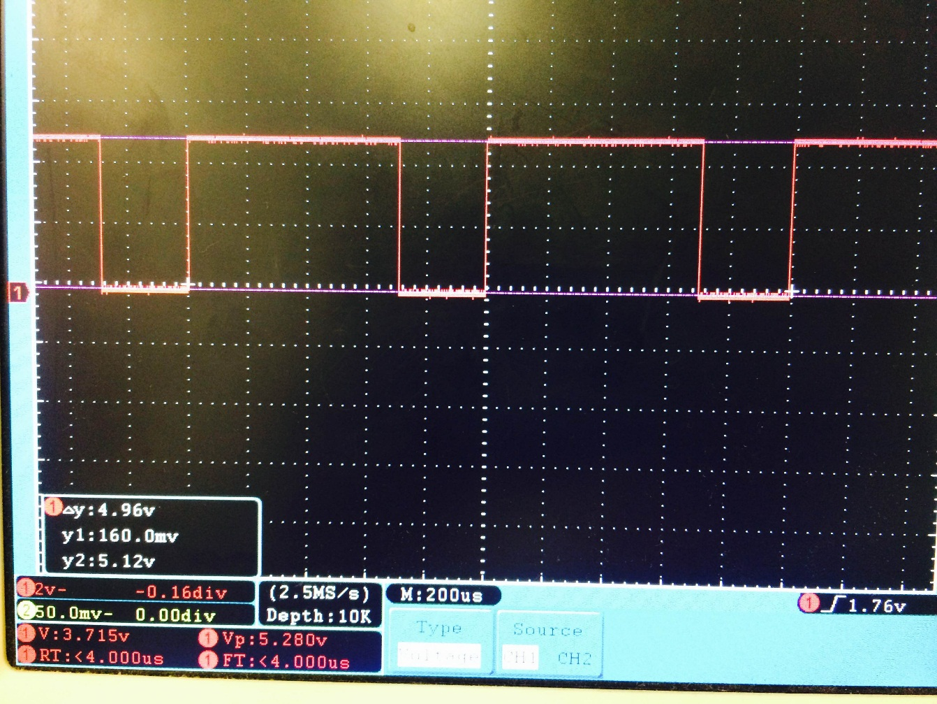

3.3)

Rise times = 2µs; fall times = 400ns;