Lab Assignment Number 7
Submitted By: Pei-Chen Wu
Part 0: Pre-Lab (Revised)
  - Design a circuit to drive the DC motor using Drive-Brake mode.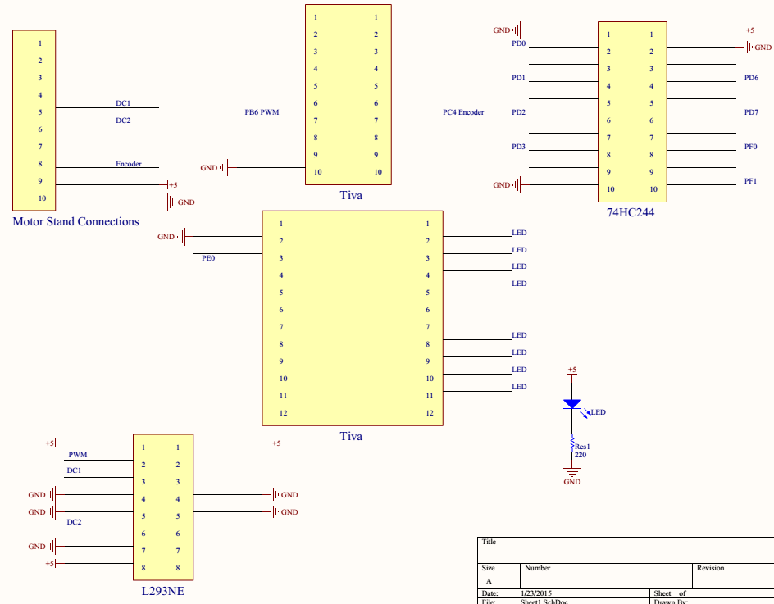
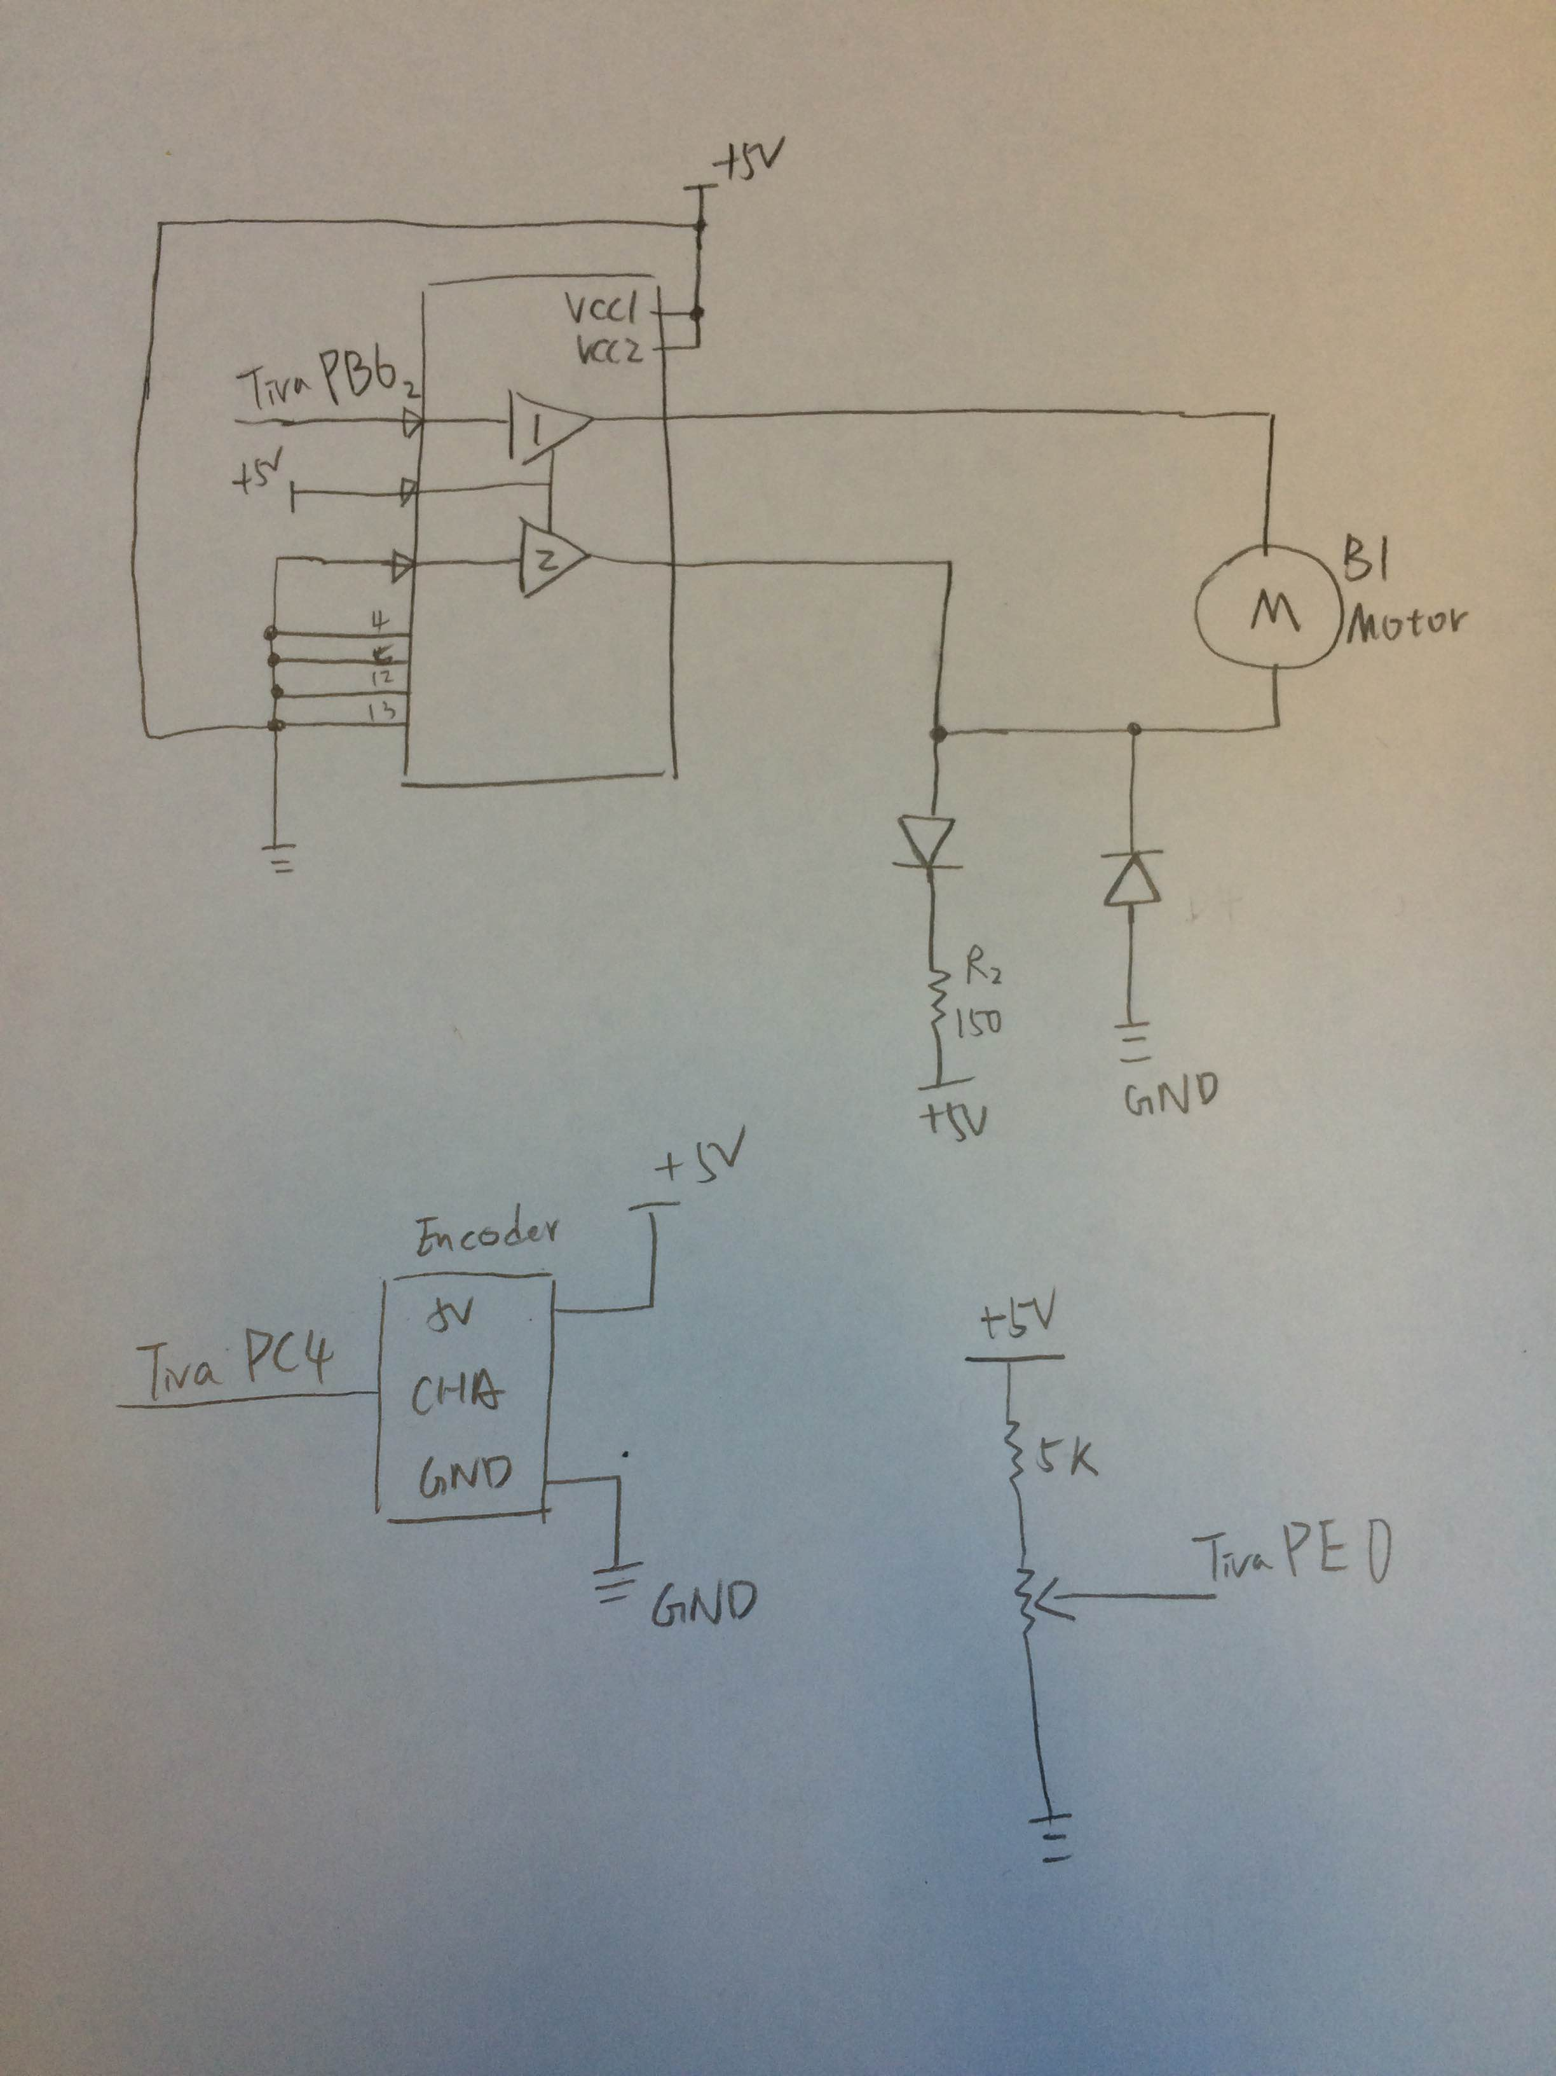

Port |  | Port
1 Port B0 |  | 20 Port A2
2 Port B1 |  | 19 Port A3
3 Port B2 |  | 18 Port A4
4 Port B3 |  | 17 Port A5
5 Port B4 |  | 16 Port A6
6 Port B5 |  | 15 Port A7
7 Port B6 | PWM 1A | 14 Port C4 | Encoder
8 Port B7 |  | 13 Port C5
9 NC |  | 12 Port C6
10 GND |  | 11 Port C7

Port |  | Port
1 NC |  | 24 NC
2 GND |  | 23 Port D0 | LED0
3 Port E0 | Potentiometer | 22 Port D1 | LED1
4 Port E1 |  | 21 Port D2 | LED2
5 Port B2 |  | 20 Port D3 | LED3
6 Port E3 |  | 19 NC | LED4
7 Port E4 |  | 18 NC
8 Port E5 |  | 17 Port D6 | LED5
9 Port F4 |  | 16 Port D7 | LED6
10 Port F3 |  | 15 Port F0 | LED7
11 Port F2 |  | 14 Port F1 | LED8
12 NC |  | 13 NC

0.2) Figure out how you will measure the electrical time constant of the motor as requested in Part 1.1. We will cover the PWM subsystem in lecture on Thursday
Step
- measure the total resistor
- Rmotor is the internal resistance of the motor coil.
- Rsense = 10 Ohm
- Electrical Time Constant τ = Lmotor/Rmotor
- Calculate steady state current through Rsense should = Vcc/Rtotal
- Check for the voltage across Rsense to rise above 63% of the steady-state Vsense=> the time constant τ’ = Lmotor/ (Rsense + Rmotor)
- Lmotor=τ ‘* (Rsense + Rmotor)=> τ = Lmotor/Rmotor (Get real motor electrical time constant)
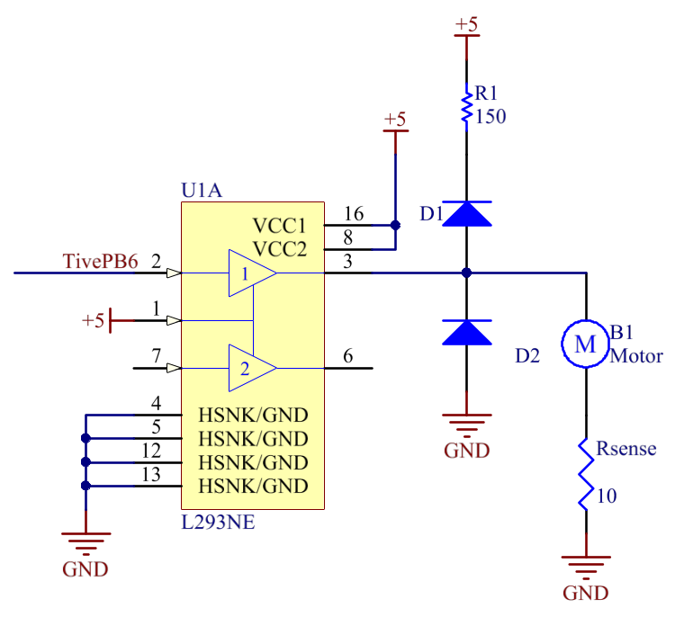
  - Design the software that you will use for Part 1. Include pseudo code for program(s).

Include InputCapture.h
Initialize InputCapture
Initialize Encoder Timer 100ms

Run AD Service :
If ThisEvent is ES_TIMEOUT && Event Param is AD Timer
Declare unsigned int variable = AD_Read();
Post an event to Motor.c and save the param = AD_input value;
End

Include InputCapture.h
Initialize LED0-7 Ports
Initialize InputCapture
Initialize Encoder Timer
Run Motor Service :
If ThisEvent is Motor Drive
Update Motor Speed
End
If ThisEvent is ES_TIMEOUT && Event Param is Encoder Timer
Declare unsigned int variable period = getPeriod();
Calculating RPM = 80000/period
Turn on LED base on the RPM value
End

0.4) Design the software that you will use for Part 2. Include pseudo code for program(s).
Using AD Service to read the potentiometer value.
Post an event to Motor.c. And convert the potentiometer value to rpm value.

Interrupt Initialized
Set Module variable des_rpm, cur_rpm, Diff_rpm, Sum_of_diff_rpm, des_duty

PI control function:
Cur_rpm = 80000/get_Period();
Diff_rpm = des_rpm - cur_rpm.
Sum_of_diff_rpm += Diff_rpm
Des_duty = kp * Diff_rpm + ki * Sum_of_diff_rpm
If(des_duty > 100){
Des_duty = 100.
Sum_off_diff_rpm -= Diff _rpm.
}
If(des_duty = 0){
Des_duty = 0.
Des_duty = 100. Sum_off_diff_rpm -= Diff _rpm.
}
SetDuty(Des_duty);

Funciton: Set des_rpm (uint32_t rpm) {
Set rpm is equal to des_rpm.
}

Part 1: Driving a DC Motor Using PWM
  - To get the best performance out of the motor, it is useful to know the electrical time constant. For minimum current ripple, you will want to set the PWM frequency to at least a frequency of one over the electrical time constant. Implement the necessary software to help you to measure the electrical time constant of the motor on the lab bench.
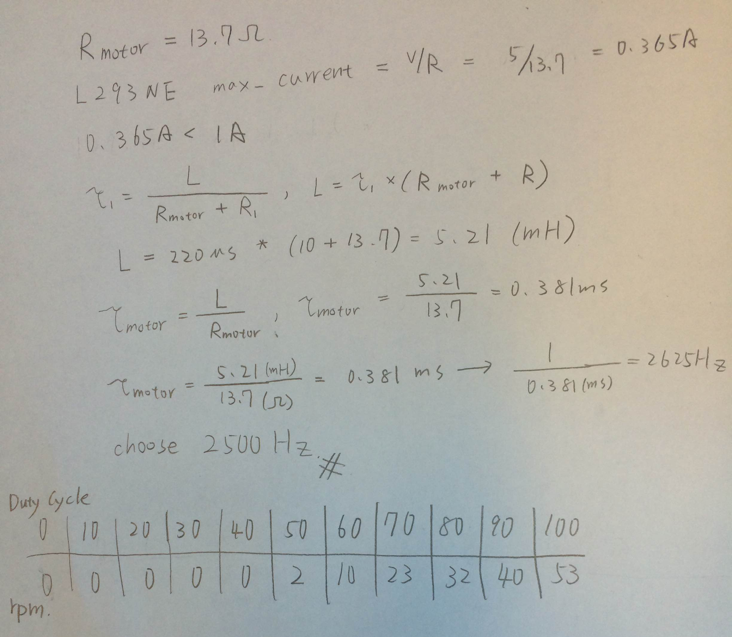
  - Implement your DC motor driver design from Part 0.1 and Event Driven software design to read the A/D converter connected to the potentiometer and adjust the speed. Hook it up to the motor and get the motor to run with the speed controlled by the potentiometer. Set the PWM frequency based on the time constant that you determined in part 1.1
Read Source Code.

  - Map the DC vs RPM transfer function for the motor/driver combination.
Duty Cycle (%) | Motor Speed (RPM)
0 | 0
10 | 0
20 | 0
30 | 0
40 | 0
50 | 2
60 | 10
70 | 23
80 | 32
90 | 40
100 | 53

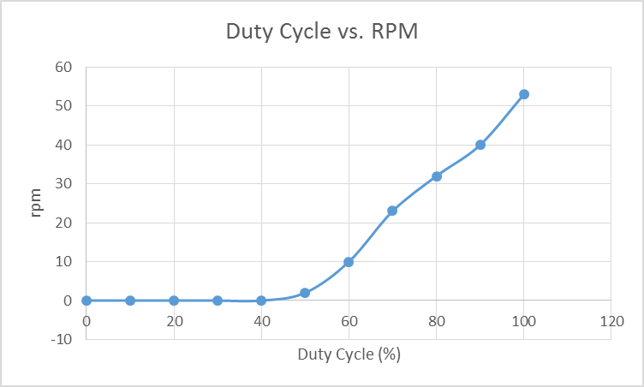
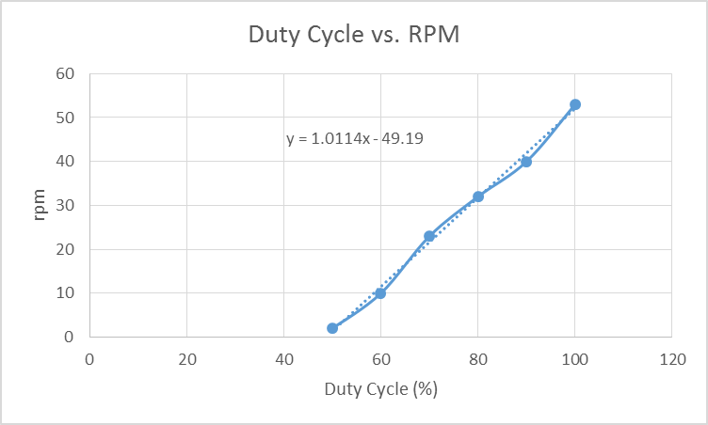

Source Code:
/****************************************************************************

Header file for ADService Flat Sate Machine
based on the Gen2 Events and Services Framework

****************************************************************************/

#ifndef ADService_H
#define ADService_H

// Event Definitions
#include "ES_Configure.h" /* gets us event definitions */
#include "ES_Types.h" /* gets bool type for returns */

// typedefs for the states
// State definitions for use with the query function
typedef enum { Reading } ADServiceState_t ;

// Public Function Prototypes

bool InitADService ( uint8_t Priority );
bool PostADService( ES_Event ThisEvent );
ES_Event RunADService( ES_Event ThisEvent );
ADServiceState_t QueryADService ( void );
uint32_t getDutyCycle(void);

#endif /* ADService_H */

/****************************************************************************
Module
ADService.c

Revision
1.0.1

Description
This is a ADService file for implementing flat state machines of ADService under the
Gen2 Events and Services Framework.
ADService is used to keep doing analog read and controling the time period of each step of motor.

Notes

History
When Who What/Why
-------------- --- --------
01/15/12 11:12 jec revisions for Gen2 framework
11/07/11 11:26 jec made the queue static
10/30/11 17:59 jec fixed references to CurrentEvent in RunTemplateSM()
10/23/11 18:20 jec began conversion from SMTemplate.c (02/20/07 rev)
****************************************************************************/
/*----------------------------- Include Files -----------------------------*/
/* include header files for this state machine as well as any machines at the
next lower level in the hierarchy that are sub-machines to this machine
*/
#include "ES_Configure.h"
#include "ES_Framework.h"
#include "ES_Types.h"

#include "termio.h"
#include "inc/hw_memmap.h"
#include "inc/hw_types.h"
#include "inc/hw_gpio.h"
#include "inc/hw_sysctl.h"
#include "driverlib/gpio.h"
#include "driverlib/interrupt.h"

#include "PWMTiva.h"
#include "ADCSWTrigger.h"
#include "ES_Timers.h"
#include "ADService.h"
#include "Motor.h"

/*----------------------------- Module Defines ----------------------------*/

/*---------------------------- Module Functions ---------------------------*/
/* prototypes for private functions for this machine.They should be functions
relevant to the behavior of this state machine
*/

/*---------------------------- Module Variables ---------------------------*/
// everybody needs a state variable, you may need others as well.
// type of state variable should match htat of enum in header file
static ADServiceState_t CurrentState;

//Set the initial values
uint16_t AD_COUNT = 100;

//Testing for the difference of Potentiometer value
static uint32_t PotentioMeterValue = 0;
static uint32_t LastPotentioMeterValue = 0;

// with the introduction of Gen2, we need a module level Priority var as well
static uint8_t ADServicePriority;

static uint32_t DutyCycle = 0;
/*------------------------------ Module Code ------------------------------*/
/****************************************************************************
Function
InitADService

Parameters
uint8_t : the priorty of this service

Returns
bool, false if error in initialization, true otherwise

Description
Saves away the priority, sets up the initial transition and does any
other required initialization for this state machine
Notes

Author
J. Edward Carryer, 10/23/11, 18:55
****************************************************************************/
bool InitADService ( uint8_t Priority )
{
ES_Event ThisEvent;

ADServicePriority = Priority;
// put us into the Initial PseudoState
CurrentState = Reading;
// post the initial transition event
ThisEvent.EventType = ES_INIT;
//Initialize Analog read pin : PE0
ADC0_InitSWTriggerSeq3(3);
ES_Timer_InitTimer(ADTimer, AD_COUNT);
if (ES_PostToService( ADServicePriority, ThisEvent) == true)
{
return true;
}else
{
return false;
}
}

/****************************************************************************
Function
PostADService

Parameters
EF_Event ThisEvent , the event to post to the queue

Returns
boolean False if the Enqueue operation failed, True otherwise

Description
Posts an event to this state machine's queue
Notes

Author
J. Edward Carryer, 10/23/11, 19:25
****************************************************************************/
bool PostADService( ES_Event ThisEvent )
{
return ES_PostToService( ADServicePriority, ThisEvent);
}

/****************************************************************************
Function
RunADService

Parameters
ES_Event : the event to process

Returns
ES_Event, ES_NO_EVENT if no error ES_ERROR otherwise

Description
The run function keeps initialize a ADtimer to read the analog input, and mapping the analog read value to
the time period of each step of motor in order to control the speed.
Notes
uses nested switch/case to implement the machine.
Author
J. Edward Carryer, 01/15/12, 15:23
****************************************************************************/
ES_Event RunADService( ES_Event ThisEvent )
{
ES_Event ReturnEvent;
ReturnEvent.EventType = ES_NO_EVENT; // assume no errors

ES_Event PostEvent;

if(ThisEvent.EventType == ES_TIMEOUT)
{
if(ThisEvent.EventParam == ADTimer)
{
PotentioMeterValue = ADC0_InSeq3(); //Read Port PE0
//Maximum reading value = 4045; (Empirical value)
ES_Timer_InitTimer(ADTimer, AD_COUNT);
PostEvent.EventType = Motor;
PostMotorService(PostEvent);
}
}
}
return ReturnEvent;
}

/****************************************************************************
Function
QueryADService

Parameters
None

Returns
TemplateState_t The current state of the Template state machine

Description
returns the current state of the Template state machine
Notes

Author
J. Edward Carryer, 10/23/11, 19:21
****************************************************************************/
ADServiceState_t QueryADService ( void )
{
return(CurrentState);
}

/***************************************************************************
private functions
***************************************************************************/
uint32_t getDutyCycle(){
return DutyCycle;
}

/****************************************************************************

Header file for StepService Flat Sate Machine
based on the Gen2 Events and Services Framework

****************************************************************************/

#ifndef Motor_H
#define Motor_H

// Event Definitions
#include "ES_Configure.h" /* gets us event definitions */
#include "ES_Types.h" /* gets bool type for returns */

// typedefs for the states
// State definitions for use with the query function
typedef enum { MotorDrive } MotorState_t ;

// Public Function Prototypes

bool InitMotor ( uint8_t Priority );
bool PostMotorService( ES_Event ThisEvent );
ES_Event RunMotor( ES_Event ThisEvent );
MotorState_t QueryMotor ( void );

#endif /* Motor_H */

/****************************************************************************
Module
Motor.c

Revision
1.0.1

Description
This is a StepService file for implementing flat state machines under the
Gen2 Events and Services Framework.

Notes

History
When Who What/Why
-------------- --- --------
01/15/12 11:12 jec revisions for Gen2 framework
11/07/11 11:26 jec made the queue static
10/30/11 17:59 jec fixed references to CurrentEvent in RunTemplateSM()
10/23/11 18:20 jec began conversion from SMTemplate.c (02/20/07 rev)
****************************************************************************/
/*----------------------------- Include Files -----------------------------*/
/* include header files for this state machine as well as any machines at the
next lower level in the hierarchy that are sub-machines to this machine
*/
#include "ES_Configure.h"
#include "ES_Framework.h"
#include "ES_Types.h"

#include "EnablePA25_PB23_PD7_PF0.h"
#include "termio.h"
#include "inc/hw_memmap.h"
#include "inc/hw_types.h"
#include "inc/hw_gpio.h"
#include "inc/hw_sysctl.h"
#include "driverlib/gpio.h"
#include "driverlib/interrupt.h"

#include "Motor.h"
#include "ADCSWTrigger.h"
#include "PWMDemo.h"
#include "InputCapture.h"
#include "ADService.h"
/*----------------------------- Module Defines ----------------------------*/
#define ALL_BITS (0xff<<2)

/*---------------------------- Module Functions ---------------------------*/
/* prototypes for private functions for this machine.They should be functions
relevant to the behavior of this state machine
*/
static void LED_Lightup(uint32_t rpm);
/*---------------------------- Module Variables ---------------------------*/
// everybody needs a state variable, you may need others as well.
// type of state variable should match htat of enum in header file
static MotorState_t CurrentState;

// with the introduction of Gen2, we need a module level Priority var as well
static uint8_t MotorPriority;

#define EncoderTime 100

static uint16_t Para;

static void InitPorts(void){

PortFunctionInit();

//Port PD0-PD3, PD6,PD7, PF1, PF1
HWREG(SYSCTL_RCGCGPIO) |= (SYSCTL_RCGCGPIO_R3 | SYSCTL_RCGCGPIO_R5 ); //Initialize Port D & F

HWREG(SYSCTL_RCGCGPIO);

HWREG(GPIO_PORTD_BASE+GPIO_O_DEN) |= (GPIO_PIN_0 | GPIO_PIN_1 | GPIO_PIN_2 | GPIO_PIN_3 | GPIO_PIN_6 | GPIO_PIN_7); //PD0,1,2,3,6,7
HWREG(GPIO_PORTD_BASE+GPIO_O_DIR) |= (GPIO_PIN_0 | GPIO_PIN_1 | GPIO_PIN_2 | GPIO_PIN_3 | GPIO_PIN_6 | GPIO_PIN_7); //Output

HWREG(GPIO_PORTF_BASE+GPIO_O_DEN) |= (GPIO_PIN_0 | GPIO_PIN_1 ); //PF0,1
HWREG(GPIO_PORTF_BASE+GPIO_O_DIR) |= (GPIO_PIN_0 | GPIO_PIN_1 ); //Output

}

/*------------------------------ Module Code ------------------------------*/
/****************************************************************************
Function
InitStepService

Parameters
uint8_t : the priorty of this service

Returns
bool, false if error in initialization, true otherwise

Description
Saves away the priority, sets up the initial transition and does any
other required initialization for this state machine
Notes

Author
J. Edward Carryer, 10/23/11, 18:55
****************************************************************************/
bool InitMotor ( uint8_t Priority )
{
ES_Event ThisEvent;

MotorPriority = Priority;
// put us into the Initial PseudoState
CurrentState = MotorDrive;
// post the initial transition event
ThisEvent.EventType = ES_INIT;

InitPorts();
InitPWMDemo();
InitInputCapturePeriod();

ES_Timer_InitTimer(EncoderTimer, EncoderTime);

if (ES_PostToService( MotorPriority, ThisEvent) == true)
{
return true;
}else
{
return false;
}
}

/****************************************************************************
Function
PostStepService

Parameters
EF_Event ThisEvent , the event to post to the queue

Returns
boolean False if the Enqueue operation failed, True otherwise

Description
Posts an event to this state machine's queue
Notes

Author
J. Edward Carryer, 10/23/11, 19:25
****************************************************************************/
bool PostMotorService( ES_Event ThisEvent )
{
return ES_PostToService( MotorPriority, ThisEvent);
}

/****************************************************************************
Function
RunStepService

Parameters
ES_Event : the event to process

Returns
ES_Event, ES_NO_EVENT if no error ES_ERROR otherwise

Description
add your description here
Notes
uses nested switch/case to implement the machine.
Author
J. Edward Carryer, 01/15/12, 15:23
****************************************************************************/
ES_Event RunMotor( ES_Event ThisEvent )
{
ES_Event ReturnEvent;
ReturnEvent.EventType = ES_NO_EVENT; // assume no errors

if(ThisEvent.EventType == Motor)
{
Para = ThisEvent.EventParam;
SetPWMDuty(Para);
}
else if(ThisEvent.EventType == ES_TIMEOUT && ThisEvent.EventParam == EncoderTimer)
{
uint32_t period = GetPeriod();
uint32_t rpm = 800000/period;
printf("RPM : %d DutyCycle : %d \n\r", rpm, getDutyCycle()); //getDutyCycle() is in the ADService
LED_Lightup(rpm);
ES_Timer_InitTimer(EncoderTimer, EncoderTime);
}
return ReturnEvent;
}

/****************************************************************************
Function
QueryStepService

Parameters
None

Returns
StepServiceState_t The current state of the StepService state machine

Description
returns the current state of the StepService state machine
Notes

Author
J. Edward Carryer, 10/23/11, 19:21
****************************************************************************/
MotorState_t QueryStepService ( void )
{
return(CurrentState);
}

/***************************************************************************
private functions
***************************************************************************/
static void LED_Lightup(uint32_t rpm){
if(rpm <= 20){
HWREG(GPIO_PORTD_BASE + (GPIO_O_DATA+ALL_BITS)) |= (BIT0HI | BIT1HI | BIT2HI | BIT3HI | BIT6HI | BIT7HI);
HWREG(GPIO_PORTF_BASE + (GPIO_O_DATA+ALL_BITS)) |= (BIT0HI | BIT1HI);
}
else if(rpm > 20 && rpm <= 25){
HWREG(GPIO_PORTD_BASE + (GPIO_O_DATA+ALL_BITS)) |= (BIT0HI | BIT1HI | BIT2HI | BIT3HI | BIT6HI | BIT7HI);
HWREG(GPIO_PORTF_BASE + (GPIO_O_DATA+ALL_BITS)) |= (BIT0HI);
HWREG(GPIO_PORTF_BASE + (GPIO_O_DATA+ALL_BITS)) &= ~(BIT1HI);
}
else if(rpm > 25 && rpm <= 30){
HWREG(GPIO_PORTD_BASE + (GPIO_O_DATA+ALL_BITS)) |= (BIT0HI | BIT1HI | BIT2HI | BIT3HI | BIT6HI | BIT7HI);
HWREG(GPIO_PORTF_BASE + (GPIO_O_DATA+ALL_BITS)) &= ~(BIT0HI | BIT1HI);
}
else if(rpm > 30 && rpm <= 35){
HWREG(GPIO_PORTD_BASE + (GPIO_O_DATA+ALL_BITS)) |= (BIT0HI | BIT1HI | BIT2HI | BIT3HI | BIT6HI);
HWREG(GPIO_PORTD_BASE + (GPIO_O_DATA+ALL_BITS)) &= ~(BIT7HI);
HWREG(GPIO_PORTF_BASE + (GPIO_O_DATA+ALL_BITS)) &= ~(BIT0HI | BIT1HI);
}
else if(rpm > 35 && rpm <= 40){
HWREG(GPIO_PORTD_BASE + (GPIO_O_DATA+ALL_BITS)) |= (BIT0HI | BIT1HI | BIT2HI | BIT3HI);
HWREG(GPIO_PORTD_BASE + (GPIO_O_DATA+ALL_BITS)) &= ~(BIT6HI | BIT7HI);
HWREG(GPIO_PORTF_BASE + (GPIO_O_DATA+ALL_BITS)) &= ~(BIT0HI | BIT1HI);
}
else if(rpm > 40 && rpm <= 45){
HWREG(GPIO_PORTD_BASE + (GPIO_O_DATA+ALL_BITS)) |= (BIT0HI | BIT1HI | BIT2HI);
HWREG(GPIO_PORTD_BASE + (GPIO_O_DATA+ALL_BITS)) &= ~(BIT3HI | BIT6HI | BIT7HI);
HWREG(GPIO_PORTF_BASE + (GPIO_O_DATA+ALL_BITS)) &= ~(BIT0HI | BIT1HI);
}
else if(rpm > 48 && rpm <= 53){
HWREG(GPIO_PORTD_BASE + (GPIO_O_DATA+ALL_BITS)) |= (BIT0HI | BIT1HI);
HWREG(GPIO_PORTD_BASE + (GPIO_O_DATA+ALL_BITS)) &= ~(BIT2HI | BIT3HI | BIT6HI | BIT7HI);
HWREG(GPIO_PORTF_BASE + (GPIO_O_DATA+ALL_BITS)) &= ~(BIT0HI | BIT1HI);
}
else if(rpm > 54){
HWREG(GPIO_PORTD_BASE + (GPIO_O_DATA+ALL_BITS)) |= (BIT0HI);
HWREG(GPIO_PORTD_BASE + (GPIO_O_DATA+ALL_BITS)) &= ~(BIT1HI | BIT2HI | BIT3HI | BIT6HI | BIT7HI);
HWREG(GPIO_PORTF_BASE + (GPIO_O_DATA+ALL_BITS)) &= ~(BIT0HI | BIT1HI);
}
}

#ifndef PWMDEMO_H
#define PWMDEMO_H

#include <stdint.h>

void InitPWMDemo( void );
void Set100_0DC(void);
void SetPWMDuty( unsigned int pwm_value );
void SetPWMPeriod( uint32_t NewPeriod );
void SetPWMPulseWidth (uint32_t NewWidth );

#endif

#include <stdint.h>

#include "inc/hw_memmap.h"
#include "inc/hw_gpio.h"
#include "inc/hw_pwm.h"
#include "inc/hw_sysctl.h"
#include "inc/hw_types.h"
#include "bitdefs.h"

#include "PWMDemo.h"

//250Hz : PeriodInMS = 4 PWMTicksPerMS = 40000/32
//500Hz : PeriodInMS = 2 PWMTicksPerMS = 40000/32
//1000Hz : PeriodInMS = 1 PWMTicksPerMS = 40000/32
//2000Hz : PeriodInMS = 1 PWMTicksPerMS = 20000/32
//10000Hz : PeriodInMS = 1 PWMTicksPerMS = 4000/32

// 40,000 ticks per mS assumes a 40Mhz clock, we will use SysClk/32 for PWM
#define PWMTicksPerMS 40000/32
// set 200 Hz frequency so 5mS period
#define PeriodInMS 4

#define BitsPerNibble 4

// we will use PWM module 0 for this demo and program it for up/down counting

void InitPWMDemo( void ){
volatile uint32_t Dummy; // use volatile to avoid over-optimization

// start by enabling the clock to the PWM Module (PWM0)
HWREG(SYSCTL_RCGCPWM) |= SYSCTL_RCGCPWM_R0;

// enable the clock to Port B
HWREG(SYSCTL_RCGCGPIO) |= SYSCTL_RCGCGPIO_R1;

// Select the PWM clock as System Clock/32
HWREG(SYSCTL_RCC) = (HWREG(SYSCTL_RCC) & ~SYSCTL_RCC_PWMDIV_M) |
(SYSCTL_RCC_USEPWMDIV | SYSCTL_RCC_PWMDIV_32);

// make sure that the PWM module clock has gotten going
while ((HWREG(SYSCTL_PRPWM) & SYSCTL_PRPWM_R0) != SYSCTL_PRPWM_R0)
;

// disable the PWM while initializing
HWREG( PWM0_BASE+PWM_O_0_CTL ) = 0;

// program generator A to go to 0 at rising comare A, 1 on falling compare A
HWREG( PWM0_BASE+PWM_O_0_GENA) =
(PWM_0_GENA_ACTCMPAU_ZERO | PWM_0_GENA_ACTCMPAD_ONE );

// program generator B to go to 0 at rising comare B, 1 on falling compare B
HWREG( PWM0_BASE+PWM_O_0_GENB) =
(PWM_0_GENA_ACTCMPBU_ZERO | PWM_0_GENA_ACTCMPBD_ONE );

// Set the PWM period. Since we are counting both up & down, we initialize
// the load register to 1/2 the desired total period
HWREG( PWM0_BASE+PWM_O_0_LOAD) = ((PeriodInMS * PWMTicksPerMS)-1)>>1;

// Set the initial Duty cycle on A to 50% by programming the compare value
// to 1/2 the period to count up (or down)
HWREG( PWM0_BASE+PWM_O_0_CMPA) = ((PeriodInMS * PWMTicksPerMS)-1)>>2;

// Set the initial Duty cycle on B to 25% by programming the compare value
// to 1/4 the period
HWREG( PWM0_BASE+PWM_O_0_CMPB) = ((PeriodInMS * PWMTicksPerMS)-1)>>3;

// set changes to the PWM output Enables to be locally syncronized to a
// zero count
HWREG(PWM0_BASE+PWM_O_ENUPD) = (HWREG(PWM0_BASE+PWM_O_ENUPD) &
~(PWM_ENUPD_ENUPD0_M | PWM_ENUPD_ENUPD1_M)) |
(PWM_ENUPD_ENUPD0_LSYNC | PWM_ENUPD_ENUPD1_LSYNC);

// enable the PWM outputs
HWREG( PWM0_BASE+PWM_O_ENABLE) |= (PWM_ENABLE_PWM1EN | PWM_ENABLE_PWM0EN);

// now configure the Port B pins to be PWM outputs
// start by selecting the alternate function for PB6 & 7
HWREG(GPIO_PORTB_BASE+GPIO_O_AFSEL) |= (BIT7HI | BIT6HI);

// now choose to map PWM to those pins, this is a mux value of 4 that we
// want to use for specifying the function on bits 6 & 7
HWREG(GPIO_PORTB_BASE+GPIO_O_PCTL) =
(HWREG(GPIO_PORTB_BASE+GPIO_O_PCTL) & 0x00fffff) + (4<<(7*BitsPerNibble)) +
(4<<(6*BitsPerNibble));

// Enable pins 6 & 7 on Port B for digital I/O
HWREG(GPIO_PORTB_BASE+GPIO_O_DEN) |= (BIT7HI | BIT6HI);

// make pins 6 & 7 on Port B into outputs
HWREG(GPIO_PORTB_BASE+GPIO_O_DIR) |= (BIT7HI |BIT6HI);

// set the up/down count mode and enable the PWM generator
HWREG(PWM0_BASE+ PWM_O_0_CTL) |= (PWM_0_CTL_MODE | PWM_0_CTL_ENABLE);

}

void Set100_0DC(void){
// Set the Duty cycle on A to 0% by programming the compare value
// to 0. However, since the CmpADn action (set to one) wins, we also
// need to disable the output
HWREG( PWM0_BASE+PWM_O_0_CMPA) = 0;
HWREG( PWM0_BASE+PWM_O_ENABLE) &= ~PWM_ENABLE_PWM0EN;

// Set the Duty cycle on B to 100% by programming the compare value
// to the load value. Since the CmpBDn action (set to one) wins, we get 100%
HWREG( PWM0_BASE+PWM_O_0_CMPB) = HWREG( PWM0_BASE+PWM_O_0_LOAD);

}

void SetPWMDuty(unsigned int pwm_value){
/*
Set the duty cycle on A to 0% by programming the compare value to 0. However, since the CmpADn action (set to one) wins,
we also need to disable the output
*/
if(pwm_value == 0){
HWREG( PWM0_BASE + PWM_O_0_CMPA ) = 0;
HWREG( PWM0_BASE + PWM_O_ENABLE ) &= ~PWM_ENABLE_PWM0EN;
}
else if(pwm_value == 100){
/*
Set the duty cycle on B to 100% by programming the compare value to the load value. Since the CmpBDn action (set to one) wins,
we get 100%
*/
HWREG(PWM0_BASE + PWM_O_0_CMPA) = HWREG(PWM0_BASE + PWM_O_0_LOAD);
HWREG(PWM0_BASE+PWM_O_ENABLE) |= PWM_ENABLE_PWM0EN;
}
else {
HWREG(PWM0_BASE + PWM_O_0_CMPA) = (((PeriodInMS * PWMTicksPerMS) - 1) >> 1 )* pwm_value/100;
HWREG(PWM0_BASE+PWM_O_ENABLE) |= PWM_ENABLE_PWM0EN;
}
}
#ifndef _IntSample_H_
#define _IntSample_H_

#include <stdint.h>

void InitInputCapturePeriod( void );
void InputCaptureResponse( void );
uint32_t GetPeriod( void );

#endif //_IntSample_H_

#include <stdint.h>

#include "inc/hw_memmap.h"
#include "inc/hw_timer.h"
#include "inc/hw_sysctl.h"
#include "inc/hw_nvic.h"
#include "inc/hw_types.h"
#include "inc/hw_gpio.h"
#include "bitdefs.h"

#include "InputCapture.h"

// 40,000 ticks per mS assumes a 40Mhz clock
#define TicksPerMS 40000

static uint32_t Period;
static uint32_t LastCapture;

// we will use Timer A in Wide Timer 0 to capture the input

void InitInputCapturePeriod( void ){

// start by enabling the clock to the timer (Wide Timer 0)
HWREG(SYSCTL_RCGCWTIMER) |= SYSCTL_RCGCWTIMER_R0;
// enable the clock to Port C
HWREG(SYSCTL_RCGCGPIO) |= SYSCTL_RCGCGPIO_R2;
// since we added this Port C clock init, we can immediately start
// into configuring the timer, no need for further delay

// make sure that timer (Timer A) is disabled before configuring
HWREG(WTIMER0_BASE+TIMER_O_CTL) &= ~TIMER_CTL_TAEN;

// set it up in 32bit wide (individual, not concatenated) mode
// the constant name derives from the 16/32 bit timer, but this is a 32/64
// bit timer so we are setting the 32bit mode
HWREG(WTIMER0_BASE+TIMER_O_CFG) = TIMER_CFG_16_BIT;

// we want to use the full 32 bit count, so initialize the Interval Load
// register to 0xffff.ffff (its default value :-)
HWREG(WTIMER0_BASE+TIMER_O_TAILR) = 0xffffffff;

// we don't want any prescaler (it is unnecessary with a 32 bit count)
// HWREG(WTIMER0_BASE+TIMER_O_TAPR) = 0;

// set up timer A in capture mode (TAMR=3, TAAMS = 0),
// for edge time (TACMR = 1) and up-counting (TACDIR = 1)
HWREG(WTIMER0_BASE+TIMER_O_TAMR) =
(HWREG(WTIMER0_BASE+TIMER_O_TAMR) & ~TIMER_TAMR_TAAMS) |
(TIMER_TAMR_TACDIR | TIMER_TAMR_TACMR | TIMER_TAMR_TAMR_CAP);

// To set the event to rising edge, we need to modify the TAEVENT bits
// in GPTMCTL. Rising edge = 00, so we clear the TAEVENT bits
HWREG(WTIMER0_BASE+TIMER_O_CTL) &= ~TIMER_CTL_TAEVENT_M;

// Now Set up the port to do the capture (clock was enabled earlier)
// start by setting the alternate function for Port C bit 4 (WT0CCP0)
HWREG(GPIO_PORTC_BASE+GPIO_O_AFSEL) |= BIT4HI;

// Then, map bit 4's alternate function to WT0CCP0
// 7 is the mux value to select WT0CCP0, 16 to shift it over to the
// right nibble for bit 4 (4 bits/nibble * 4 bits)
HWREG(GPIO_PORTC_BASE+GPIO_O_PCTL) =
(HWREG(GPIO_PORTC_BASE+GPIO_O_PCTL) & 0xfff0ffff) + (7<<16);

// Enable pin on Port C for digital I/O
HWREG(GPIO_PORTC_BASE+GPIO_O_DEN) |= BIT4HI;

// make pin 4 on Port C into an input
HWREG(GPIO_PORTC_BASE+GPIO_O_DIR) &= BIT4LO;

// back to the timer to enable a local capture interrupt
HWREG(WTIMER0_BASE+TIMER_O_IMR) |= TIMER_IMR_CAEIM;

// enable the Timer A in Wide Timer 0 interrupt in the NVIC
// it is interrupt number 94 so appears in EN2 at bit 30
HWREG(NVIC_EN2) |= BIT30HI;

// make sure interrupts are enabled globally
__enable_irq();

// now kick the timer off by enabling it and enabling the timer to
// stall while stopped by the debugger
HWREG(WTIMER0_BASE+TIMER_O_CTL) |= (TIMER_CTL_TAEN | TIMER_CTL_TASTALL);

}

void InputCaptureResponse( void ){
uint32_t ThisCapture;

// start by clearing the source of the interrupt, the input capture event
HWREG(WTIMER0_BASE+TIMER_O_ICR) = TIMER_ICR_CAECINT;
// now grab the captured value and calculate the period
ThisCapture = HWREG(WTIMER0_BASE+TIMER_O_TAR);
Period = ThisCapture - LastCapture;

// update LastCapture to prepare for the next edge
LastCapture = ThisCapture;
}

uint32_t GetPeriod( void ){
return Period;
}

Part 2: Implementing Closed Loop Speed Control

2.1) Using your code from Part 1 as a base, add a periodic interrupt response routine set to fire at 20 ms intervals. In the interrupt response routine, implement a minimal proportional plus integral control law to calculate and program a new duty cycle every 20 ms. Be sure that you structure your code so that it does not cause you to lose an input capture interrupt (hint: make the control law interrupt a lower priority than the encoder interrupt). For calculating your control law, it is OK to use floats.
2.2) Tune the gains on your system to provide a quick and stable startup and maintain speed in the presence of an external disturbance (dragging a finger on the wheel attached to the motor).
Kp = 0.8, ki=0.5
Source Code:
/****************************************************************************

Header file for StepService Flat Sate Machine
based on the Gen2 Events and Services Framework

****************************************************************************/

#ifndef Motor_H
#define Motor_H

// Event Definitions
#include "ES_Configure.h" /* gets us event definitions */
#include "ES_Types.h" /* gets bool type for returns */

// typedefs for the states
// State definitions for use with the query function
typedef enum { MotorDrive } MotorState_t ;

// Public Function Prototypes

bool InitMotor ( uint8_t Priority );
bool PostMotorService( ES_Event ThisEvent );
ES_Event RunMotor( ES_Event ThisEvent );
MotorState_t QueryMotor ( void );

#endif /* Motor_H */

#ifndef _IntSample_H_
#define _IntSample_H_

#include <stdint.h>

void InitPeriodicInt( void );
void PeriodicIntResponse( void );
uint32_t GetTimeoutCount( void );
void SetDesiredRPM(uint32_t desiredRPM);

#endif //_IntSample_H_

/****************************************************************************
Module
Motor.c

Revision
1.0.1

Description
This is a StepService file for implementing flat state machines under the
Gen2 Events and Services Framework.

Notes

History
When Who What/Why
-------------- --- --------
01/15/12 11:12 jec revisions for Gen2 framework
11/07/11 11:26 jec made the queue static
10/30/11 17:59 jec fixed references to CurrentEvent in RunTemplateSM()
10/23/11 18:20 jec began conversion from SMTemplate.c (02/20/07 rev)
****************************************************************************/
/*----------------------------- Include Files -----------------------------*/
/* include header files for this state machine as well as any machines at the
next lower level in the hierarchy that are sub-machines to this machine
*/
#include "ES_Configure.h"
#include "ES_Framework.h"
#include "ES_Types.h"

#include "EnablePA25_PB23_PD7_PF0.h"
#include "termio.h"
#include "inc/hw_memmap.h"
#include "inc/hw_types.h"
#include "inc/hw_gpio.h"
#include "inc/hw_sysctl.h"
#include "driverlib/gpio.h"
#include "driverlib/interrupt.h"

#include "Motor.h"
#include "ADCSWTrigger.h"
#include "PWMDemo.h"
#include "InputCapture.h"
#include "ADService.h"

#include "IntSample.h"

/*----------------------------- Module Defines ----------------------------*/
#define ALL_BITS (0xff<<2)

/*---------------------------- Module Functions ---------------------------*/
/* prototypes for private functions for this machine.They should be functions
relevant to the behavior of this state machine
*/
static void LED_Lightup(uint32_t rpm);
/*---------------------------- Module Variables ---------------------------*/
// everybody needs a state variable, you may need others as well.
// type of state variable should match htat of enum in header file
static MotorState_t CurrentState;

// with the introduction of Gen2, we need a module level Priority var as well
static uint8_t MotorPriority;

#define EncoderTime 100

static uint16_t Para;
static uint32_t period;

static void InitPorts(void){

PortFunctionInit();

//Port PD0-PD3, PD6,PD7, PF1, PF1
HWREG(SYSCTL_RCGCGPIO) |= (SYSCTL_RCGCGPIO_R3 | SYSCTL_RCGCGPIO_R5 ); //Initialize Port D & F

HWREG(SYSCTL_RCGCGPIO);

HWREG(GPIO_PORTD_BASE+GPIO_O_DEN) |= (GPIO_PIN_0 | GPIO_PIN_1 | GPIO_PIN_2 | GPIO_PIN_3 | GPIO_PIN_6 | GPIO_PIN_7); //PD0,1,2,3,6,7
HWREG(GPIO_PORTD_BASE+GPIO_O_DIR) |= (GPIO_PIN_0 | GPIO_PIN_1 | GPIO_PIN_2 | GPIO_PIN_3 | GPIO_PIN_6 | GPIO_PIN_7); //Output

HWREG(GPIO_PORTF_BASE+GPIO_O_DEN) |= (GPIO_PIN_0 | GPIO_PIN_1 ); //PF0,1
HWREG(GPIO_PORTF_BASE+GPIO_O_DIR) |= (GPIO_PIN_0 | GPIO_PIN_1 ); //Output

}

/*------------------------------ Module Code ------------------------------*/
/****************************************************************************
Function
InitStepService

Parameters
uint8_t : the priorty of this service

Returns
bool, false if error in initialization, true otherwise

Description
Saves away the priority, sets up the initial transition and does any
other required initialization for this state machine
Notes

Author
J. Edward Carryer, 10/23/11, 18:55
****************************************************************************/
bool InitMotor ( uint8_t Priority )
{
ES_Event ThisEvent;

MotorPriority = Priority;
// put us into the Initial PseudoState
CurrentState = MotorDrive;
// post the initial transition event
ThisEvent.EventType = ES_INIT;

InitPorts();
InitPWMDemo();
InitInputCapturePeriod();

InitPeriodicInt();//start the wide timer B

ES_Timer_InitTimer(EncoderTimer, EncoderTime);

if (ES_PostToService( MotorPriority, ThisEvent) == true)
{
return true;
}else
{
return false;
}
}

/****************************************************************************
Function
PostStepService

Parameters
EF_Event ThisEvent , the event to post to the queue

Returns
boolean False if the Enqueue operation failed, True otherwise

Description
Posts an event to this state machine's queue
Notes

Author
J. Edward Carryer, 10/23/11, 19:25
****************************************************************************/
bool PostMotorService( ES_Event ThisEvent )
{
return ES_PostToService( MotorPriority, ThisEvent);
}

/****************************************************************************
Function
RunStepService

Parameters
ES_Event : the event to process

Returns
ES_Event, ES_NO_EVENT if no error ES_ERROR otherwise

Description
add your description here
Notes
uses nested switch/case to implement the machine.
Author
J. Edward Carryer, 01/15/12, 15:23
****************************************************************************/
ES_Event RunMotor( ES_Event ThisEvent )
{
ES_Event ReturnEvent;
ReturnEvent.EventType = ES_NO_EVENT; // assume no errors

if(ThisEvent.EventType == Motor)
{
Para = ThisEvent.EventParam;
uint32_t RPM;
RPM = Para/65;
SetDesiredRPM(RPM);
}
else if(ThisEvent.EventType == ES_TIMEOUT && ThisEvent.EventParam == EncoderTimer)
{
period = GetPeriod();
uint32_t rpm = 800000/period;
LED_Lightup(rpm);
ES_Timer_InitTimer(EncoderTimer, EncoderTime);
}
return ReturnEvent;
}

/****************************************************************************
Function
QueryStepService

Parameters
None

Returns
StepServiceState_t The current state of the StepService state machine

Description
returns the current state of the StepService state machine
Notes

Author
J. Edward Carryer, 10/23/11, 19:21
****************************************************************************/
MotorState_t QueryStepService ( void )
{
return(CurrentState);
}

/***************************************************************************
private functions
***************************************************************************/
static void LED_Lightup(uint32_t rpm){
if(rpm <= 20){
HWREG(GPIO_PORTD_BASE + (GPIO_O_DATA+ALL_BITS)) |= (BIT0HI | BIT1HI | BIT2HI | BIT3HI | BIT6HI | BIT7HI);
HWREG(GPIO_PORTF_BASE + (GPIO_O_DATA+ALL_BITS)) |= (BIT0HI | BIT1HI);
}
else if(rpm > 20 && rpm <= 25){
HWREG(GPIO_PORTD_BASE + (GPIO_O_DATA+ALL_BITS)) |= (BIT0HI | BIT1HI | BIT2HI | BIT3HI | BIT6HI | BIT7HI);
HWREG(GPIO_PORTF_BASE + (GPIO_O_DATA+ALL_BITS)) |= (BIT0HI);
HWREG(GPIO_PORTF_BASE + (GPIO_O_DATA+ALL_BITS)) &= ~(BIT1HI);
}
else if(rpm > 25 && rpm <= 30){
HWREG(GPIO_PORTD_BASE + (GPIO_O_DATA+ALL_BITS)) |= (BIT0HI | BIT1HI | BIT2HI | BIT3HI | BIT6HI | BIT7HI);
HWREG(GPIO_PORTF_BASE + (GPIO_O_DATA+ALL_BITS)) &= ~(BIT0HI | BIT1HI);
}
else if(rpm > 30 && rpm <= 35){
HWREG(GPIO_PORTD_BASE + (GPIO_O_DATA+ALL_BITS)) |= (BIT0HI | BIT1HI | BIT2HI | BIT3HI | BIT6HI);
HWREG(GPIO_PORTD_BASE + (GPIO_O_DATA+ALL_BITS)) &= ~(BIT7HI);
HWREG(GPIO_PORTF_BASE + (GPIO_O_DATA+ALL_BITS)) &= ~(BIT0HI | BIT1HI);
}
else if(rpm > 35 && rpm <= 40){
HWREG(GPIO_PORTD_BASE + (GPIO_O_DATA+ALL_BITS)) |= (BIT0HI | BIT1HI | BIT2HI | BIT3HI);
HWREG(GPIO_PORTD_BASE + (GPIO_O_DATA+ALL_BITS)) &= ~(BIT6HI | BIT7HI);
HWREG(GPIO_PORTF_BASE + (GPIO_O_DATA+ALL_BITS)) &= ~(BIT0HI | BIT1HI);
}
else if(rpm > 40 && rpm <= 45){
HWREG(GPIO_PORTD_BASE + (GPIO_O_DATA+ALL_BITS)) |= (BIT0HI | BIT1HI | BIT2HI);
HWREG(GPIO_PORTD_BASE + (GPIO_O_DATA+ALL_BITS)) &= ~(BIT3HI | BIT6HI | BIT7HI);
HWREG(GPIO_PORTF_BASE + (GPIO_O_DATA+ALL_BITS)) &= ~(BIT0HI | BIT1HI);
}
else if(rpm > 48 && rpm <= 53){
HWREG(GPIO_PORTD_BASE + (GPIO_O_DATA+ALL_BITS)) |= (BIT0HI | BIT1HI);
HWREG(GPIO_PORTD_BASE + (GPIO_O_DATA+ALL_BITS)) &= ~(BIT2HI | BIT3HI | BIT6HI | BIT7HI);
HWREG(GPIO_PORTF_BASE + (GPIO_O_DATA+ALL_BITS)) &= ~(BIT0HI | BIT1HI);
}
else if(rpm > 54){
HWREG(GPIO_PORTD_BASE + (GPIO_O_DATA+ALL_BITS)) |= (BIT0HI);
HWREG(GPIO_PORTD_BASE + (GPIO_O_DATA+ALL_BITS)) &= ~(BIT1HI | BIT2HI | BIT3HI | BIT6HI | BIT7HI);
HWREG(GPIO_PORTF_BASE + (GPIO_O_DATA+ALL_BITS)) &= ~(BIT0HI | BIT1HI);
}
}

#include <stdint.h>
#include <stdbool.h>
#include <stdio.h>
#include "inc/hw_memmap.h"
#include "inc/hw_timer.h"
#include "inc/hw_sysctl.h"
#include "inc/hw_nvic.h"
#include "inc/hw_types.h"
#include "inc/hw_gpio.h"
#include "bitdefs.h"
#include "driverlib/sysctl.h"
#include "driverlib/gpio.h"
#include "driverlib/interrupt.h"
#include "utils/uartstdio.h"
#include "driverlib/pwm.h"
#include "driverlib/pin_map.h"
#include "ES_Configure.h"
#include "ES_Framework.h"
#include "ES_DeferRecall.h"
#include "termio.h"
#include "ADCSWTrigger.h"
#include "InputCapture.h"
#include "PWMDemo.h"
#include "IntSample.h"

// 40,000 ticks per mS assumes a 40Mhz clock
#define TicksPerMS 40000

static uint32_t TimeoutCount;

uint8_t PIDTimes=0;

static uint32_t des_RPM;

static int SumRPMError;
static int CurrentRPMError;
static float control_RPM;

float Kp =0.8,Ki=0.5;

// we will use Timer A in Wide Timer 0 to generate the interrupt

void InitPeriodicInt( void ){
des_RPM = 0;
SumRPMError=0;
volatile uint32_t Dummy;
// start by enabling the clock to the timer (Wide Timer 0)
HWREG(SYSCTL_RCGCWTIMER) |= SYSCTL_RCGCWTIMER_R0;
Dummy = HWREG(SYSCTL_RCGCGPIO);
// make sure that timer (Timer B) is disabled before configuring
HWREG(WTIMER0_BASE+TIMER_O_CTL) &= ~TIMER_CTL_TBEN;
// set it up in 32bit wide (individual, not concatenated) mode
// the constant name derives from the 16/32 bit timer, but this is a 32/64
// bit timer so we are setting the 32bit mode
HWREG(WTIMER0_BASE+TIMER_O_CFG) = TIMER_CFG_16_BIT;
// we want to use the full 32 bit count, so initialize the Interval Load
// set up timer B in capture mode
HWREG(WTIMER0_BASE+TIMER_O_TBMR) =
(HWREG(WTIMER0_BASE+TIMER_O_TBMR)& ~TIMER_TBMR_TBMR_M)|
TIMER_TBMR_TBMR_PERIOD;
// enable the Timer B in Wide Timer 0 interrupt in the NVIC
// it is interrupt number 95 so appears in EN2 at bit 31
HWREG(WTIMER0_BASE+TIMER_O_TBILR) = TicksPerMS*20;
HWREG(WTIMER0_BASE+TIMER_O_IMR) |= TIMER_IMR_TBTOIM;
HWREG(NVIC_EN2) = BIT31HI;
// 95= 4n+3 n=23
HWREG(NVIC_PRI23) = ((HWREG(NVIC_PRI23)&(~NVIC_PRI23_INTD_M)) | BIT29HI);
// make sure interrupts are enabled globally
__enable_irq();
HWREG(WTIMER0_BASE+TIMER_O_CTL) |= (TIMER_CTL_TBEN | TIMER_CTL_TBSTALL);
}

void PeriodicIntResponse( void ){
//start by clearing the source of the interrupt
HWREG(WTIMER0_BASE+TIMER_O_ICR) = TIMER_ICR_TBTOCINT;

uint32_t cur_rpm = 800000/GetPeriod();

CurrentRPMError = des_RPM - cur_rpm; //get the current error between desired and current

SumRPMError += CurrentRPMError; //sum the all error

control_RPM = Kp*CurrentRPMError+ Ki * SumRPMError; //calculate the request duty

if(control_RPM>100)
{
control_RPM = 100;
SumRPMError -=CurrentRPMError; //anti-windup
}
else if (control_RPM < 0)
{
control_RPM = 0;
SumRPMError-=CurrentRPMError; //anti-windup
}

//printf("DesiredRPM,%d\n\r",des_RPM);
//printf("CurrentRPM,%d\n\r",cur_rpm);
printf("control_duty,%f\n\r",control_RPM);

SetPWMDuty(control_RPM); //set duty
}

void SetDesiredRPM(uint32_t desiredRPM){
des_RPM = desiredRPM;
}

uint32_t GetTimeoutCount( void ){
return TimeoutCount;
}

