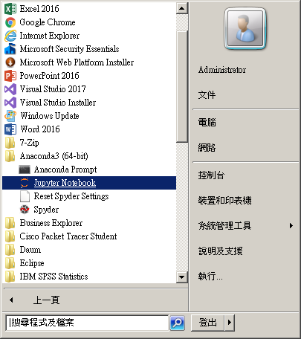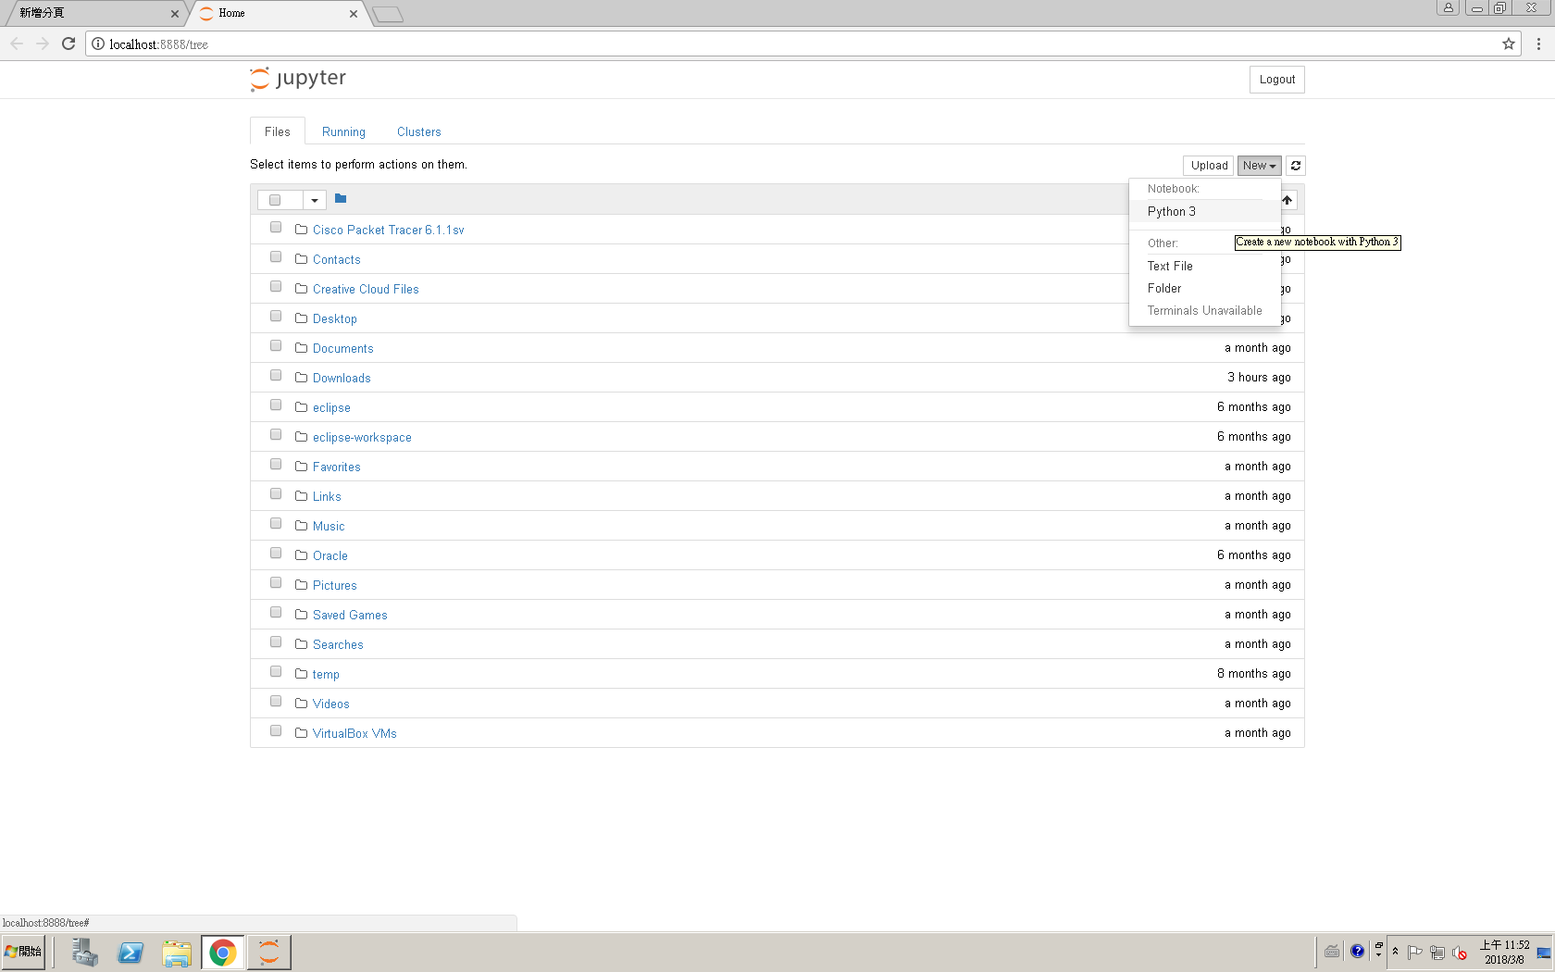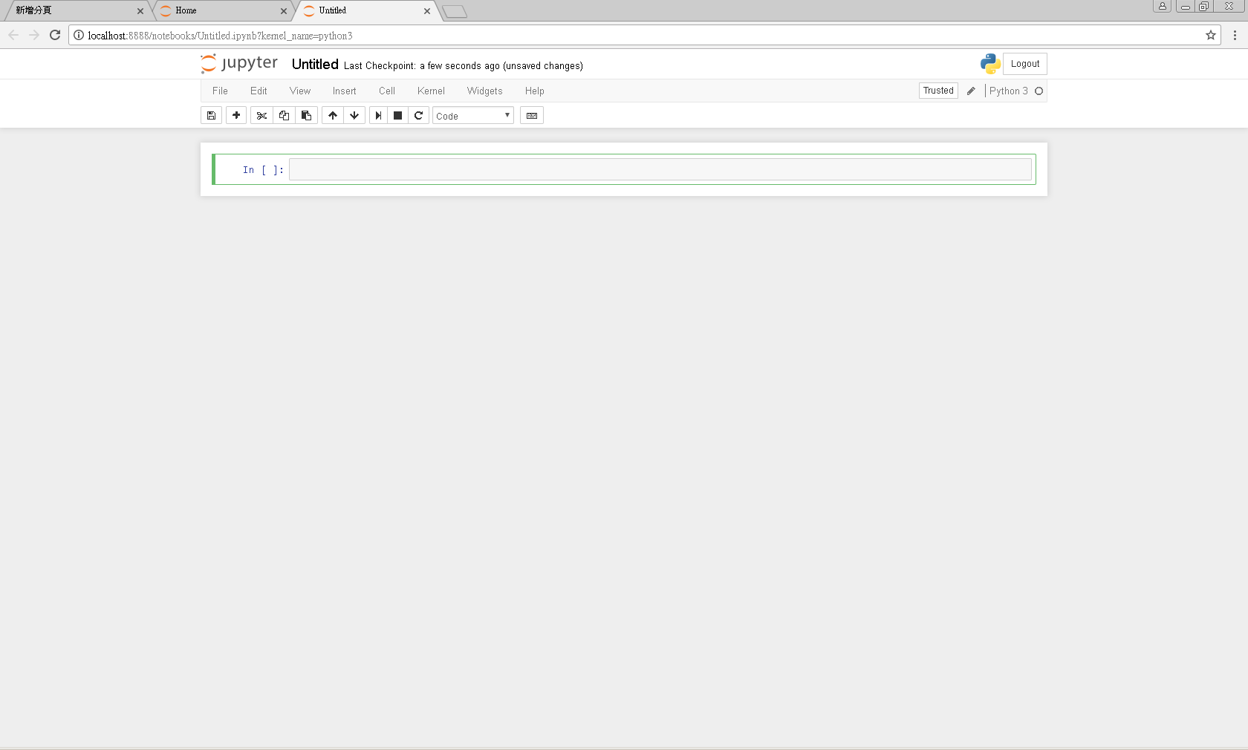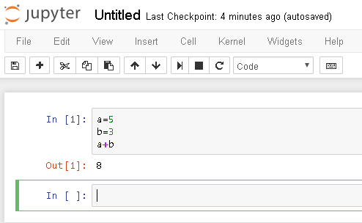shift+enter執行

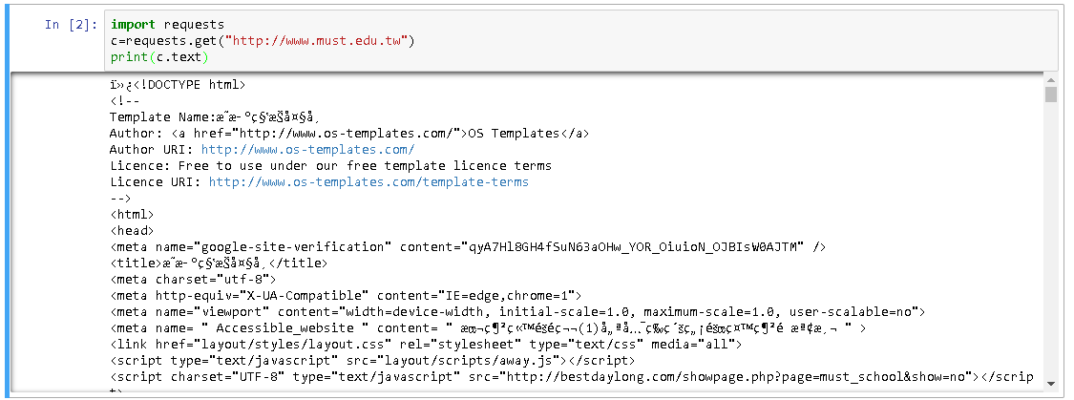

0315 儲存檔案

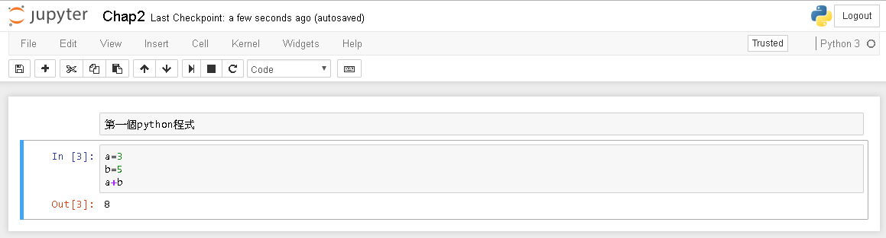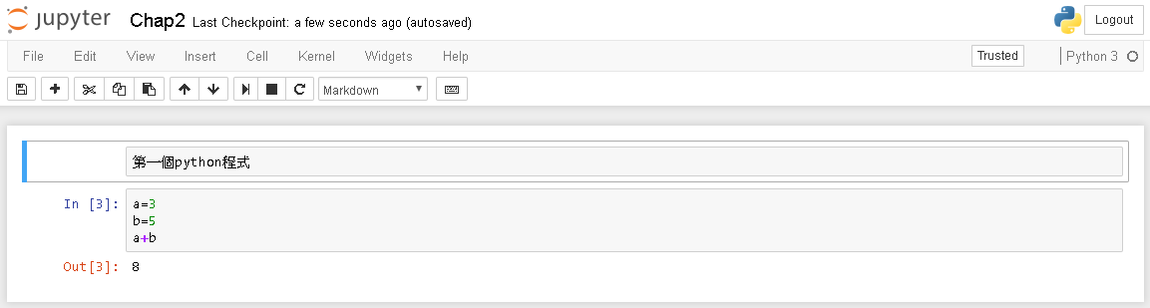

註解

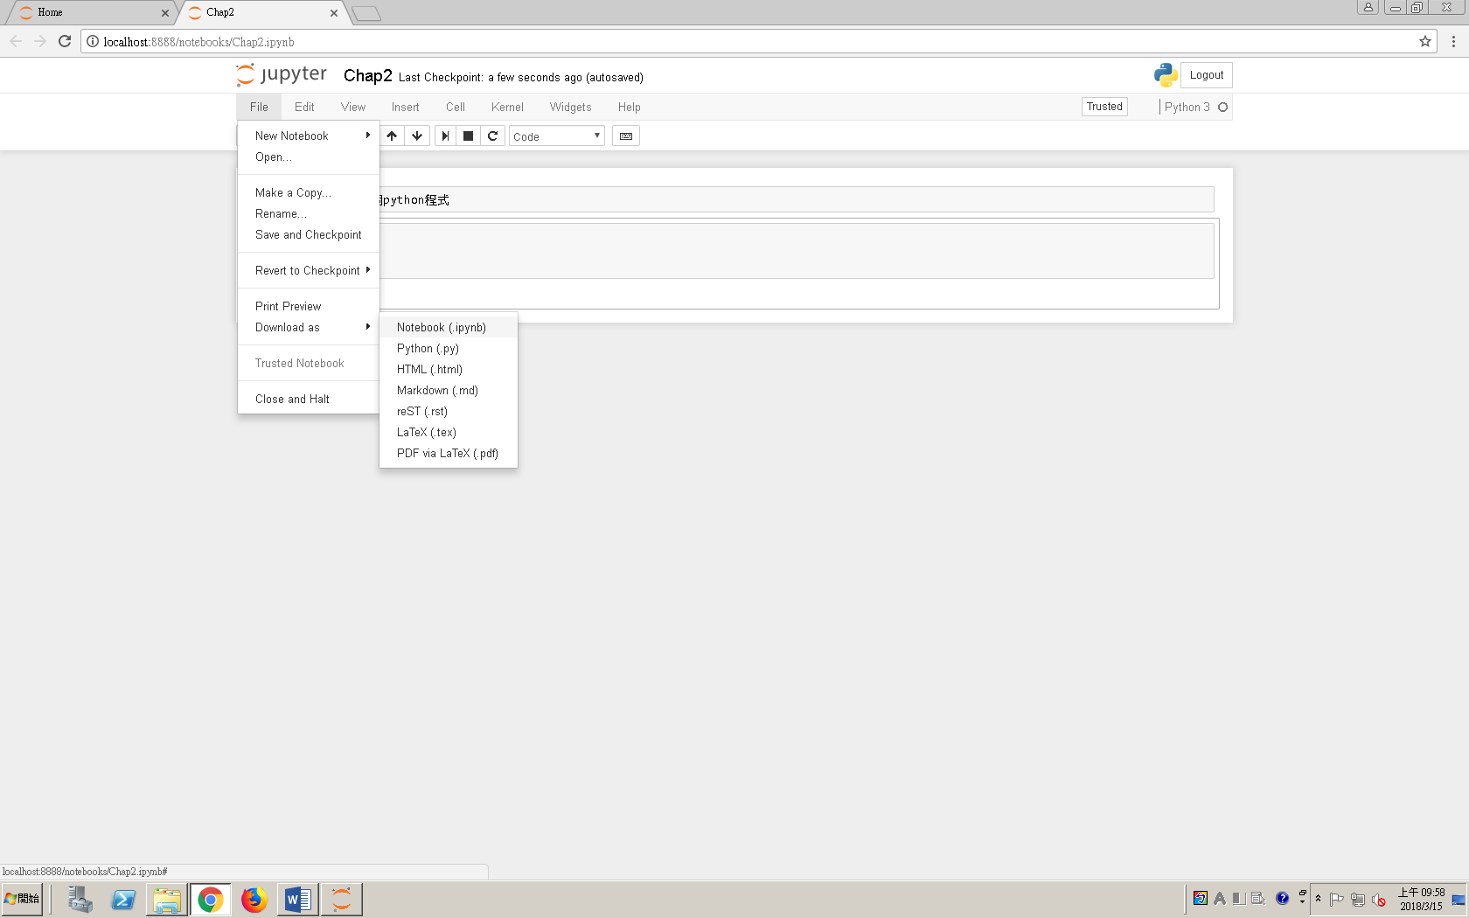

開舊檔

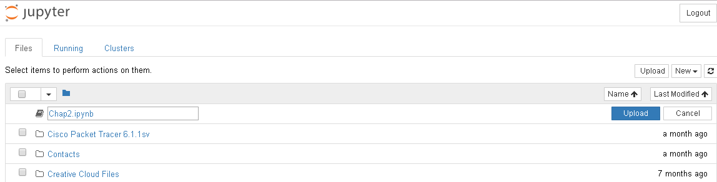

**註解**

#單行

‘’’ 3個單引號多行註解

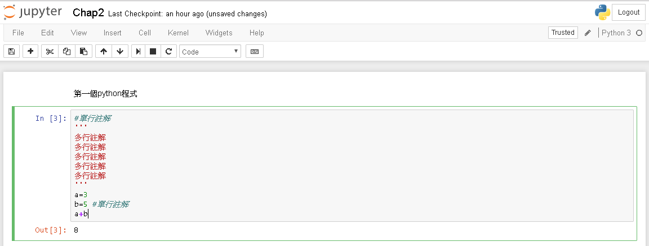

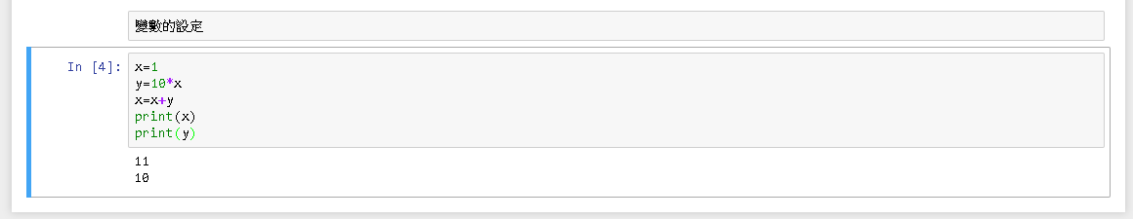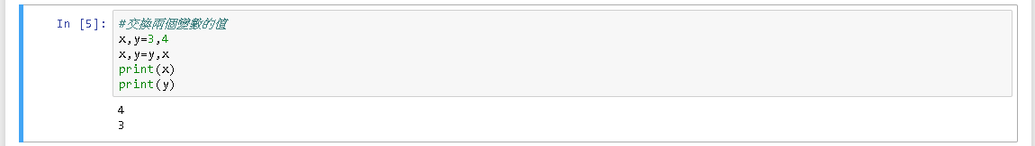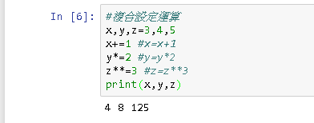 z**3 表z的3次方

三角形的面積

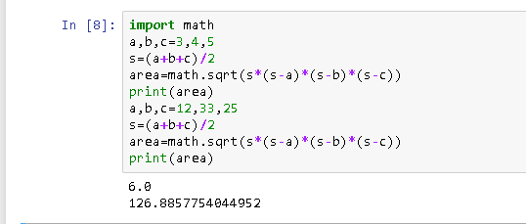

0322

Python不需要宣告變數型態

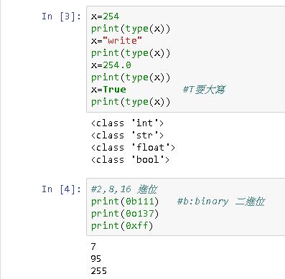 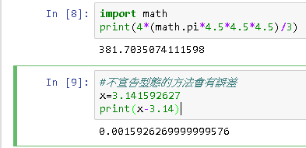

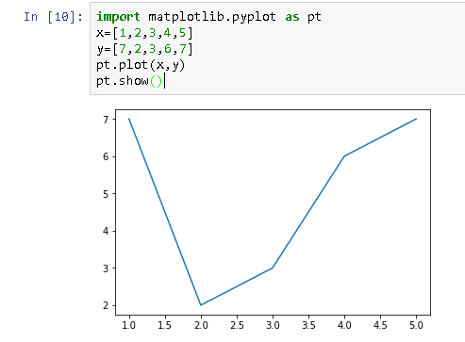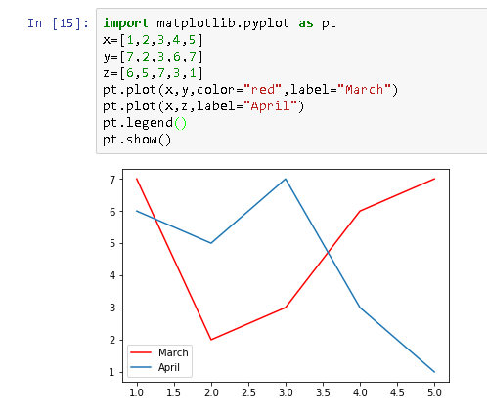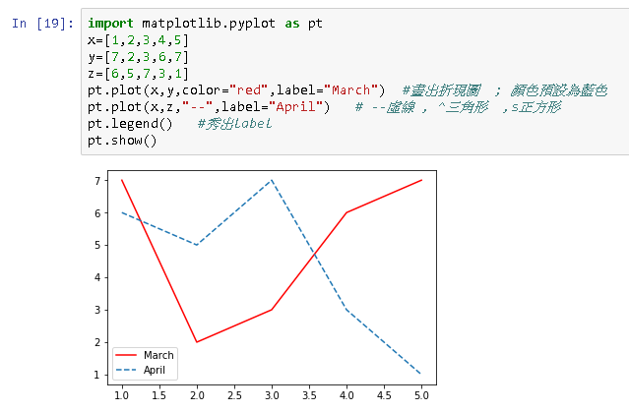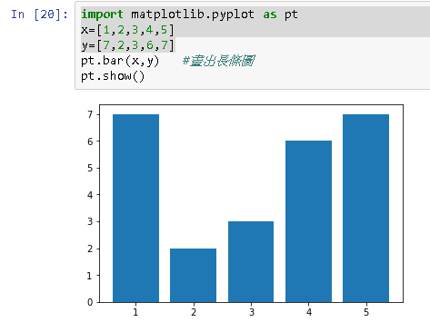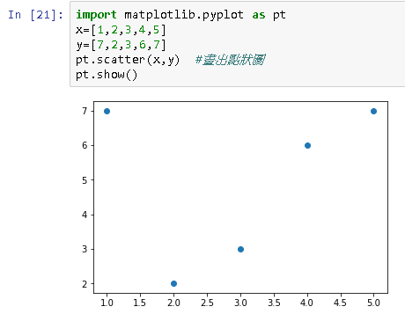

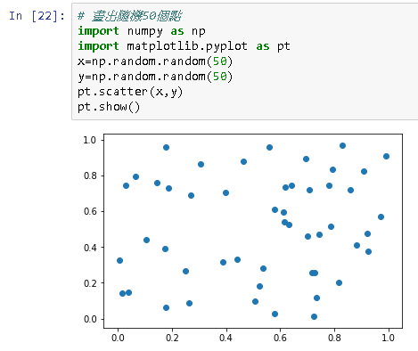

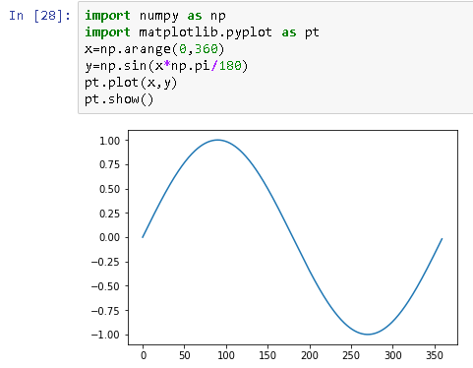 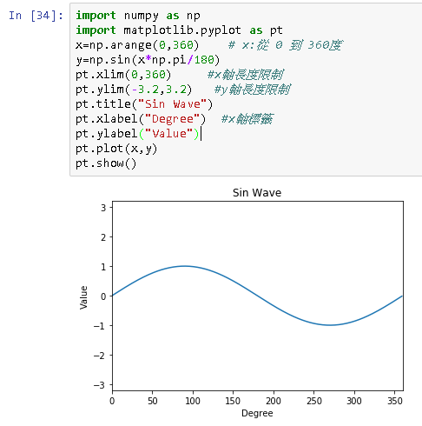

Sin 曲線

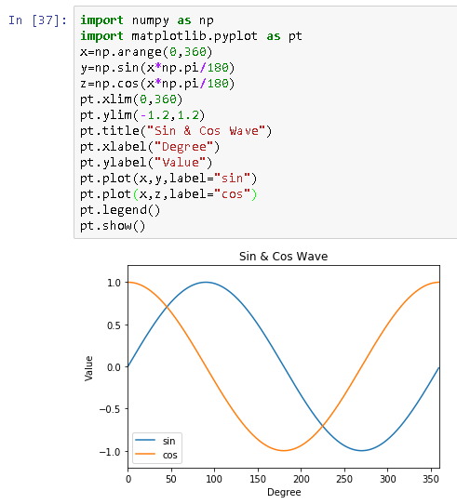

Sin 加 Cos 曲線

0329

<http://scikit-learn.org/>

機器學習網站

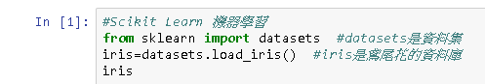

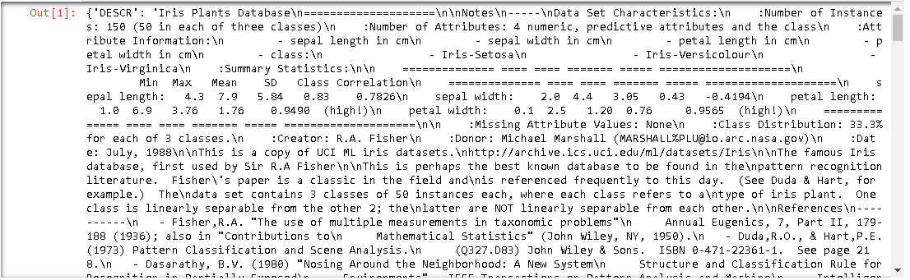

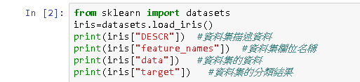

Iris Plants Database

====================

Notes

-----

Data Set Characteristics:

:Number of Instances: 150 (50 in each of three classes)

:Number of Attributes: 4 numeric, predictive attributes and the class

:Attribute Information:

- sepal length in cm

- sepal width in cm

- petal length in cm

- petal width in cm

- class:

- Iris-Setosa

- Iris-Versicolour

- Iris-Virginica

:Summary Statistics:

============== ==== ==== ======= ===== ====================

Min Max Mean SD Class Correlation

============== ==== ==== ======= ===== ====================

sepal length: 4.3 7.9 5.84 0.83 0.7826

sepal width: 2.0 4.4 3.05 0.43 -0.4194

petal length: 1.0 6.9 3.76 1.76 0.9490 (high!)

petal width: 0.1 2.5 1.20 0.76 0.9565 (high!)

============== ==== ==== ======= ===== ====================

:Missing Attribute Values: None

:Class Distribution: 33.3% for each of 3 classes.

:Creator: R.A. Fisher

:Donor: Michael Marshall (MARSHALL%PLU@io.arc.nasa.gov)

:Date: July, 1988

This is a copy of UCI ML iris datasets.

http://archive.ics.uci.edu/ml/datasets/Iris

The famous Iris database, first used by Sir R.A Fisher

This is perhaps the best known database to be found in the

pattern recognition literature. Fisher's paper is a classic in the field and

is referenced frequently to this day. (See Duda & Hart, for example.) The

data set contains 3 classes of 50 instances each, where each class refers to a

type of iris plant. One class is linearly separable from the other 2; the

latter are NOT linearly separable from each other.

References

----------

- Fisher,R.A. "The use of multiple measurements in taxonomic problems"

Annual Eugenics, 7, Part II, 179-188 (1936); also in "Contributions to

Mathematical Statistics" (John Wiley, NY, 1950).

- Duda,R.O., & Hart,P.E. (1973) Pattern Classification and Scene Analysis.

(Q327.D83) John Wiley & Sons. ISBN 0-471-22361-1. See page 218.

- Dasarathy, B.V. (1980) "Nosing Around the Neighborhood: A New System

Structure and Classification Rule for Recognition in Partially Exposed

Environments". IEEE Transactions on Pattern Analysis and Machine

Intelligence, Vol. PAMI-2, No. 1, 67-71.

- Gates, G.W. (1972) "The Reduced Nearest Neighbor Rule". IEEE Transactions

on Information Theory, May 1972, 431-433.

- See also: 1988 MLC Proceedings, 54-64. Cheeseman et al"s AUTOCLASS II

conceptual clustering system finds 3 classes in the data.

- Many, many more ...

['sepal length (cm)', 'sepal width (cm)', 'petal length (cm)', 'petal width (cm)']

[[ 5.1 3.5 1.4 0.2]

[ 4.9 3. 1.4 0.2]

[ 4.7 3.2 1.3 0.2]

[ 4.6 3.1 1.5 0.2]

[ 5. 3.6 1.4 0.2]

[ 5.4 3.9 1.7 0.4]

[ 4.6 3.4 1.4 0.3]

[ 5. 3.4 1.5 0.2]

[ 4.4 2.9 1.4 0.2]

[ 4.9 3.1 1.5 0.1]

[ 5.4 3.7 1.5 0.2]

[ 4.8 3.4 1.6 0.2]

[ 4.8 3. 1.4 0.1]

[ 4.3 3. 1.1 0.1]

[ 5.8 4. 1.2 0.2]

[ 5.7 4.4 1.5 0.4]

[ 5.4 3.9 1.3 0.4]

[ 5.1 3.5 1.4 0.3]

[ 5.7 3.8 1.7 0.3]

[ 5.1 3.8 1.5 0.3]

[ 5.4 3.4 1.7 0.2]

[ 5.1 3.7 1.5 0.4]

[ 4.6 3.6 1. 0.2]

[ 5.1 3.3 1.7 0.5]

[ 4.8 3.4 1.9 0.2]

[ 5. 3. 1.6 0.2]

[ 5. 3.4 1.6 0.4]

[ 5.2 3.5 1.5 0.2]

[ 5.2 3.4 1.4 0.2]

[ 4.7 3.2 1.6 0.2]

[ 4.8 3.1 1.6 0.2]

[ 5.4 3.4 1.5 0.4]

[ 5.2 4.1 1.5 0.1]

[ 5.5 4.2 1.4 0.2]

[ 4.9 3.1 1.5 0.1]

[ 5. 3.2 1.2 0.2]

[ 5.5 3.5 1.3 0.2]

[ 4.9 3.1 1.5 0.1]

[ 4.4 3. 1.3 0.2]

[ 5.1 3.4 1.5 0.2]

[ 5. 3.5 1.3 0.3]

[ 4.5 2.3 1.3 0.3]

[ 4.4 3.2 1.3 0.2]

[ 5. 3.5 1.6 0.6]

[ 5.1 3.8 1.9 0.4]

[ 4.8 3. 1.4 0.3]

[ 5.1 3.8 1.6 0.2]

[ 4.6 3.2 1.4 0.2]

[ 5.3 3.7 1.5 0.2]

[ 5. 3.3 1.4 0.2]

[ 7. 3.2 4.7 1.4]

[ 6.4 3.2 4.5 1.5]

[ 6.9 3.1 4.9 1.5]

[ 5.5 2.3 4. 1.3]

[ 6.5 2.8 4.6 1.5]

[ 5.7 2.8 4.5 1.3]

[ 6.3 3.3 4.7 1.6]

[ 4.9 2.4 3.3 1. ]

[ 6.6 2.9 4.6 1.3]

[ 5.2 2.7 3.9 1.4]

[ 5. 2. 3.5 1. ]

[ 5.9 3. 4.2 1.5]

[ 6. 2.2 4. 1. ]

[ 6.1 2.9 4.7 1.4]

[ 5.6 2.9 3.6 1.3]

[ 6.7 3.1 4.4 1.4]

[ 5.6 3. 4.5 1.5]

[ 5.8 2.7 4.1 1. ]

[ 6.2 2.2 4.5 1.5]

[ 5.6 2.5 3.9 1.1]

[ 5.9 3.2 4.8 1.8]

[ 6.1 2.8 4. 1.3]

[ 6.3 2.5 4.9 1.5]

[ 6.1 2.8 4.7 1.2]

[ 6.4 2.9 4.3 1.3]

[ 6.6 3. 4.4 1.4]

[ 6.8 2.8 4.8 1.4]

[ 6.7 3. 5. 1.7]

[ 6. 2.9 4.5 1.5]

[ 5.7 2.6 3.5 1. ]

[ 5.5 2.4 3.8 1.1]

[ 5.5 2.4 3.7 1. ]

[ 5.8 2.7 3.9 1.2]

[ 6. 2.7 5.1 1.6]

[ 5.4 3. 4.5 1.5]

[ 6. 3.4 4.5 1.6]

[ 6.7 3.1 4.7 1.5]

[ 6.3 2.3 4.4 1.3]

[ 5.6 3. 4.1 1.3]

[ 5.5 2.5 4. 1.3]

[ 5.5 2.6 4.4 1.2]

[ 6.1 3. 4.6 1.4]

[ 5.8 2.6 4. 1.2]

[ 5. 2.3 3.3 1. ]

[ 5.6 2.7 4.2 1.3]

[ 5.7 3. 4.2 1.2]

[ 5.7 2.9 4.2 1.3]

[ 6.2 2.9 4.3 1.3]

[ 5.1 2.5 3. 1.1]

[ 5.7 2.8 4.1 1.3]

[ 6.3 3.3 6. 2.5]

[ 5.8 2.7 5.1 1.9]

[ 7.1 3. 5.9 2.1]

[ 6.3 2.9 5.6 1.8]

[ 6.5 3. 5.8 2.2]

[ 7.6 3. 6.6 2.1]

[ 4.9 2.5 4.5 1.7]

[ 7.3 2.9 6.3 1.8]

[ 6.7 2.5 5.8 1.8]

[ 7.2 3.6 6.1 2.5]

[ 6.5 3.2 5.1 2. ]

[ 6.4 2.7 5.3 1.9]

[ 6.8 3. 5.5 2.1]

[ 5.7 2.5 5. 2. ]

[ 5.8 2.8 5.1 2.4]

[ 6.4 3.2 5.3 2.3]

[ 6.5 3. 5.5 1.8]

[ 7.7 3.8 6.7 2.2]

[ 7.7 2.6 6.9 2.3]

[ 6. 2.2 5. 1.5]

[ 6.9 3.2 5.7 2.3]

[ 5.6 2.8 4.9 2. ]

[ 7.7 2.8 6.7 2. ]

[ 6.3 2.7 4.9 1.8]

[ 6.7 3.3 5.7 2.1]

[ 7.2 3.2 6. 1.8]

[ 6.2 2.8 4.8 1.8]

[ 6.1 3. 4.9 1.8]

[ 6.4 2.8 5.6 2.1]

[ 7.2 3. 5.8 1.6]

[ 7.4 2.8 6.1 1.9]

[ 7.9 3.8 6.4 2. ]

[ 6.4 2.8 5.6 2.2]

[ 6.3 2.8 5.1 1.5]

[ 6.1 2.6 5.6 1.4]

[ 7.7 3. 6.1 2.3]

[ 6.3 3.4 5.6 2.4]

[ 6.4 3.1 5.5 1.8]

[ 6. 3. 4.8 1.8]

[ 6.9 3.1 5.4 2.1]

[ 6.7 3.1 5.6 2.4]

[ 6.9 3.1 5.1 2.3]

[ 5.8 2.7 5.1 1.9]

[ 6.8 3.2 5.9 2.3]

[ 6.7 3.3 5.7 2.5]

[ 6.7 3. 5.2 2.3]

[ 6.3 2.5 5. 1.9]

[ 6.5 3. 5.2 2. ]

[ 6.2 3.4 5.4 2.3]

[ 5.9 3. 5.1 1.8]]

[0 0 0 0 0 0 0 0 0 0 0 0 0 0 0 0 0 0 0 0 0 0 0 0 0 0 0 0 0 0 0 0 0 0 0 0 0

0 0 0 0 0 0 0 0 0 0 0 0 0 1 1 1 1 1 1 1 1 1 1 1 1 1 1 1 1 1 1 1 1 1 1 1 1

1 1 1 1 1 1 1 1 1 1 1 1 1 1 1 1 1 1 1 1 1 1 1 1 1 1 2 2 2 2 2 2 2 2 2 2 2

2 2 2 2 2 2 2 2 2 2 2 2 2 2 2 2 2 2 2 2 2 2 2 2 2 2 2 2 2 2 2 2 2 2 2 2 2

2 2]

0412 scikit learn & KMeans演算法0412-1

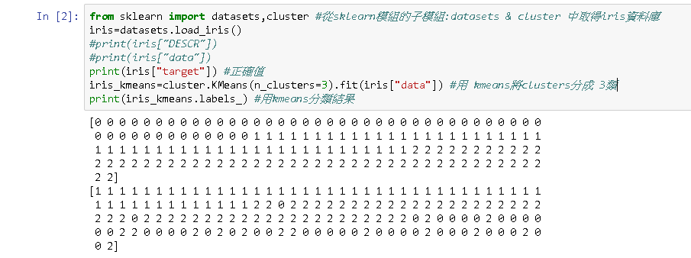

有些錯

正確

0412-2

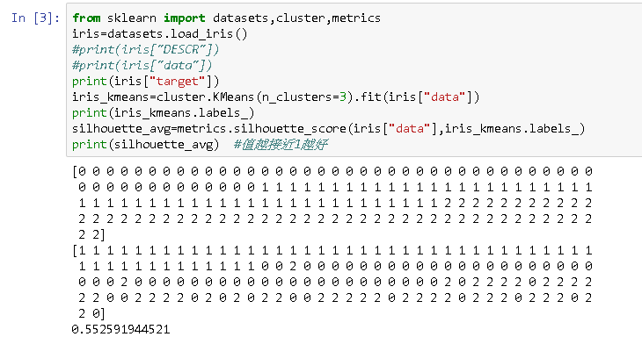

續上，利用silhouette觀察分成幾類最接近正確值，結果越接近1越好

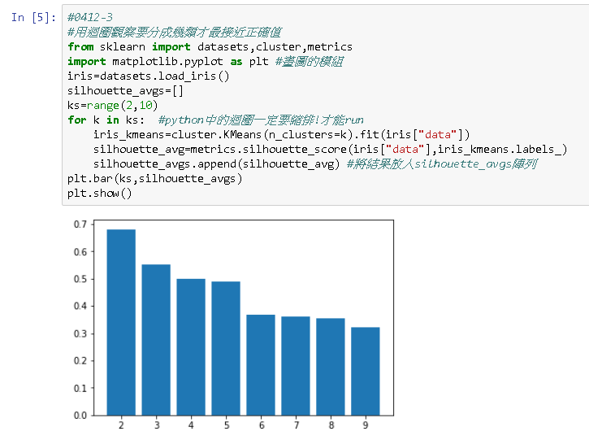

續上，用silhouette和迴圈觀察要分成幾類材最接近正確值。

所以分2類最接近

svm分群法

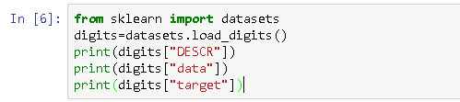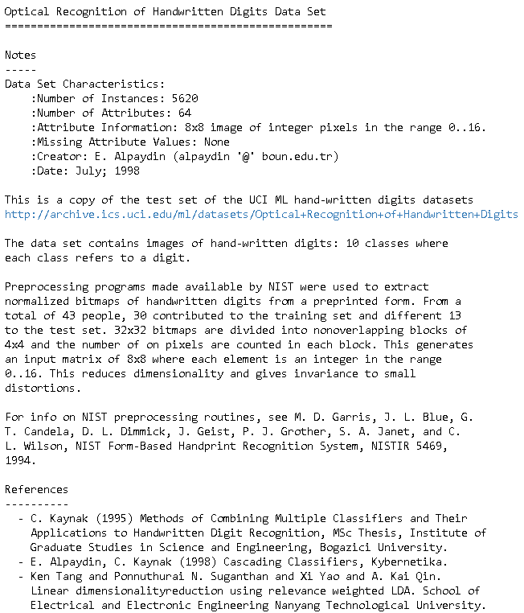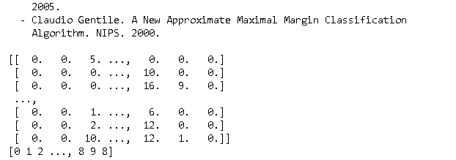

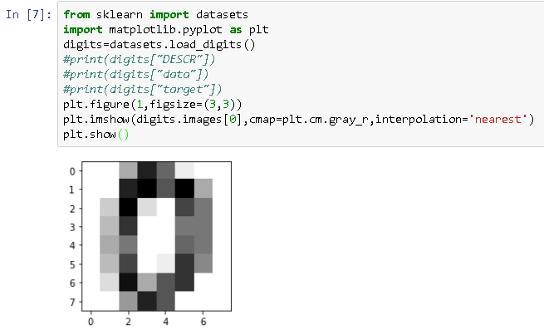

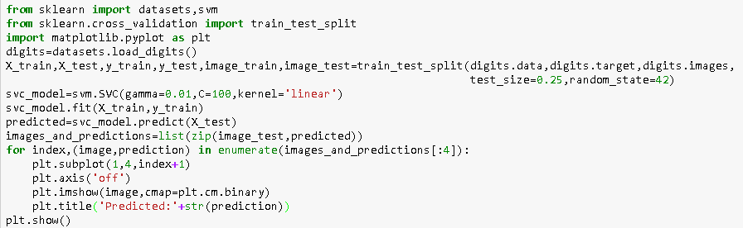

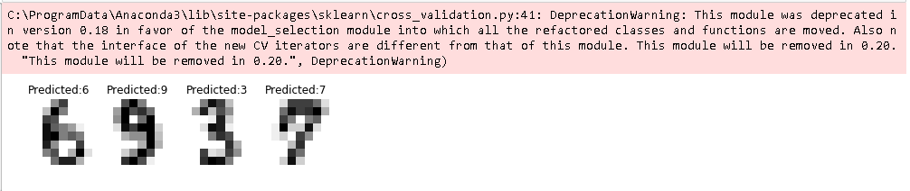

0503

註冊github帳號

