R中坐标轴截断的不同实现方式

庄闪闪

# plotrix包

[R语言作图——坐标轴截断画图](http://blog.sina.com.cn/s/blog_6a4ee1ad0102x5at.html)

利用gap.barplot()进进行绘制，将gap参数设置为90，420进行y轴截断，可加入参数axis.break()对截断形状进行修改

library(plotrix)

## Warning: package 'plotrix' was built under R version 3.6.3

w <- c(75, 64.4, 47.3, 66.9, 456, 80.6, 70, 55.8, 57.9, 561, 58.6, 61.2, 50.3, 54.6, 57.8)  
x <- c(1:15)  
gap.barplot(w,gap=c(90,420),xaxlab=x,ytics=c(50,70,450,500),col=rainbow(15),xlab ="mumbers", ylab = "height", main="test image")

## ylim -282.7 231

axis.break(2,90,breakcol="snow",style="gap")##去掉中间的那两道横线；  
axis.break(2,90*(1+0.02),breakcol="black",style="slash")##在左侧Y轴把gap位置换成slash；  
axis.break(4,90*(1+0.02),breakcol="black",style="slash")##在右侧Y轴把gap位置换成slash；

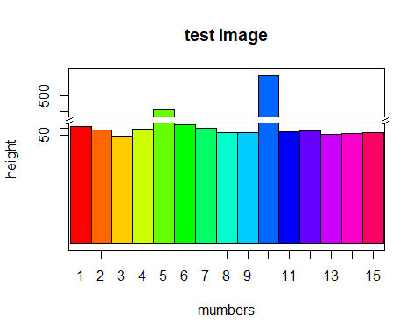

* 其他案例

twogrp<-c(rnorm(10)+4,rnorm(10)+20)  
gap.barplot(twogrp,gap=c(8,16),xlab="Index",ytics=c(3,6,17,20),  
 ylab="Group values",main="Barplot with gap")

## ylim -5.598 14.15

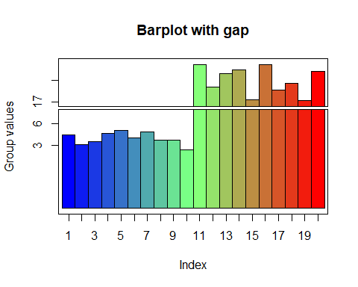

gap.barplot(twogrp,gap=c(8,16),xlab="Index",ytics=c(3,6,17,20),  
 ylab="Group values",horiz=TRUE,main="Horizontal barplot with gap")

## ylim -5.598 14.15

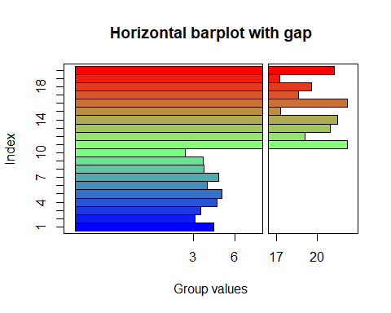

# ggplot包

[ggplot坐标轴截断](https://www.jianshu.com/p/0e4fa8849479)

library(ggplot2)  
set.seed(123)  
d <- data.frame(  
 x = 1:20,   
 y = c(rnorm(5) + 4, rnorm(5) + 20, rnorm(5) + 5, rnorm(5) + 22)  
)  
  
ggplot(d, aes(x, y)) + geom_col()

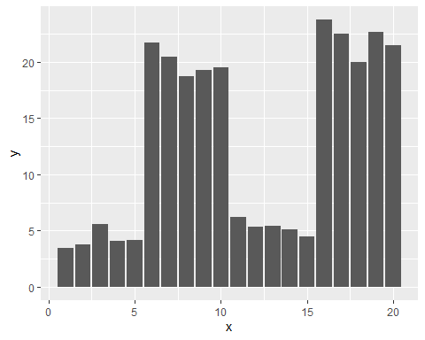

library(dplyr)  
  
breaks = c(7, 17)  
d$type <- NA  
d$type[d$y < breaks[1]] = "small"  
d$type[d$y > breaks[2]] = "big"  
  
d <- filter(d, type == 'big') %>%   
 mutate(type = "small", y = breaks[1]) %>%   
 bind_rows(d)  
  
mymin = function(y) ifelse(y <= breaks[1], 0, breaks[2])   
p <- ggplot(d, aes(x, y)) +   
 geom_rect(aes(xmin = x - .4, xmax = x + .4, ymin = mymin(y), ymax = y)) +  
 facet_grid(type ~ ., scales = "free") +   
 theme(strip.text=element_blank())#去除text  
p

