The diagrams shows the . The y axis ‘count’ shows the number of collisions occurred, and is ranged from 0 to 30. The x axis ‘time’ is ranged from 0 to 10000 with bin width of 100 seconds.

A roughly decreasing trend can be observed from all three graphs during the first 1000 (2000 for the easy environment) seconds. It shows that the algorithm did help with our agents ability of obstacle avoidance. However, we can see that after the initial decreasing period is over, the number of collisions rises sharply to nearly reach the level before any learning was done, then the value just fluctuates with no clear trend.

Not surprisingly when comparing the three figures side by side, the histogram for ‘easy’ environment in figure 1 has the lowest overall number of collisions. However, the training seems to have least improvement on this environment as it still had the same amount of collisions before any training was done, at around 9300 seconds the collision number was even higher than before.

The ‘medium’ environment in figure 2 started out with a much higher number of collisions, which was slightly decreased by the learning process, and in the end the collision number was very similar to the histogram of ‘easy’ environment, in some cases even lower. The training helped bring down the highest number of collisions by about 5, which is still far from the goal of eliminating all the collisions.

The ‘hard’ environment has the highest overall number of collisions. The training had some effects as the collision number never reached the level before any training was done, still the effects was very limited.

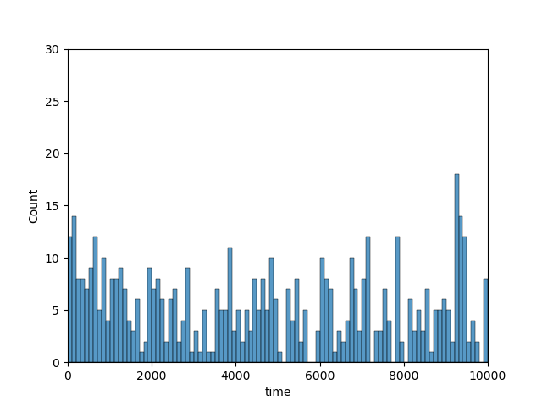

Figure 1

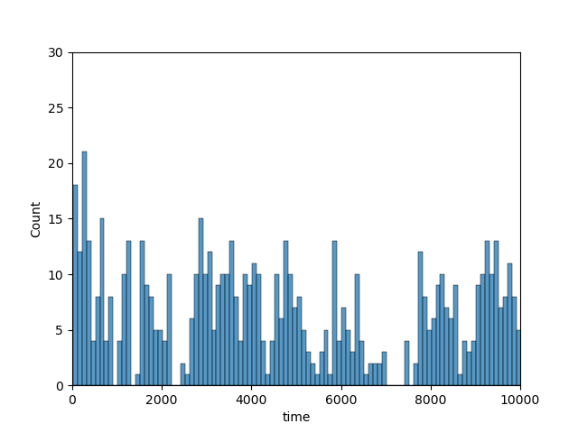

Figure 2

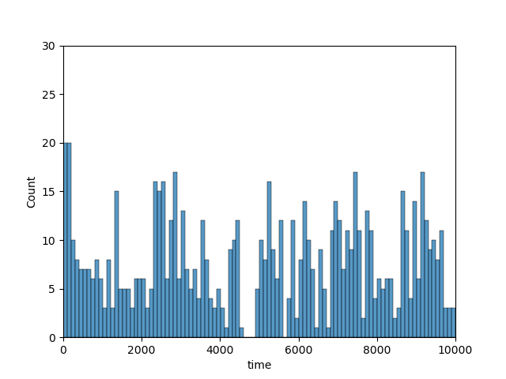

Figure 3