Obfuscated GATE build instructions

1stBarrier installation

Download 1stBarrier MINI edition from http://www.jproof.com/products/1stBarrierMINI.html

Unzip the JAR file

Obfuscate GATE classes

Follow the standard GATE build process and before making the gate.jar execute 1st Barrier obfuscator over the gate.* classes. It is important that you obfuscate only the gate.* classes and not any 3rd party classes.

Run the standard GATE build process (up to the "make jar" step):

$ ./configure

$ make clean

$ make depend

$ make

Create a temporary jar file for the gate.* classes:

$ cd $GATE_HOME/classes

$ jar cvf gate_classes.jar gate/*

Start the 1st Barrier obfuscator:

$ java - jar 1stBarrierMINI.jar

Set 1stBarrier options (see screenshot):

- In the Advanced tab check "Do not rename classes"
- In the Advanced tab check "Compress JAR file"
- In the Basic tab set the input jar (gate_classes.jar)
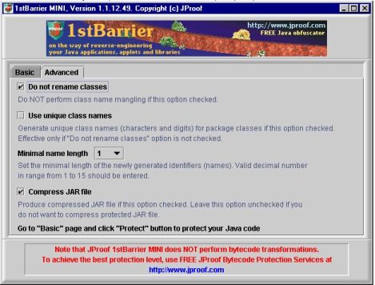

Run the obfuscator

Remove the temporary files (gate_classes.map, gate_classes.log, gate_classes.jar.old)

Replace the GATE_HOME/classes/gate directory classes with the obfuscated ones

$ rm $GATE_HOME/classes/gate

$ jar xvf gate_classes.jar

Continue the GATE build process:

$ make jar

Verify that GATE runs (either "make test" or with the GUI)

Sample obfuscated output

The following sample is the java source generated from a decompiler (such as Mocha) for the obfuscated gate.persist.OracleDataStore class. It is important that:

- Public methods are not obfuscated
- Public constants are not obfuscated
- Class names/packages are not renamed

/* Decompiled by Mocha from OracleDataStore.class */

package gate.persist;

import gate.*;
import gate.corpora.*;
import gate.security.*;
import gate.util.*;
import java.io.*;
import java.sql.*;
import java.util.*;
import oracle.jdbc.driver.*;
import oracle.sql.*;
import gate.annotation.DatabaseAnnotationSetImpl;
import gate.annotation.EventAwareAnnotationSet;
import gate.creole.ResourceInstantiationException;
import gate.event.DatastoreEvent;
import gate.event.DatastoreListener;
import java.net.URL;
import junit.framework.Assert;

public synchronized class OracleDataStore extends JDBCDataStore
{
private static final String LThtlF = "GATE Oracle datastore";
private static final String ltHtlF = "ora_ds.gif";
private static final boolean LtHtlF = false;
private static final int lTHtlF = 1;
private static final int LTHtlF = 0;
private static final int lthTlF = 10;
private static final int LthTlF = 4000;
private static final int lThTlF = 3;
private static final int LThTlF = 1333;
private static final int ltHTlF = 16384;

public OracleDataStore()
{
datastoreComment = "GATE Oracle datastore";
iconName = "ora_ds.gif";
}

public void setStorageUrl(String string)
throws PersistenceException
{
super.setStorageUrl(string);
}

…….

private Long LThtlf(Long long1, int i, String string1, Object object, int j, CallableStatement callableStatement)
throws PersistenceException
{
Long long2;
long2 = null;
try
{
callableStatement.setLong(1, long1.longValue());
callableStatement.setLong(2, (long)i);
callableStatement.setString(3, string1);
callableStatement.setNull(4, 2);
callableStatement.setNull(5, 12);
callableStatement.setLong(6, (long)j);
callableStatement.registerOutParameter(7, -5);
switch (j)
{
case 103:
boolean flag = ((Boolean)object).booleanValue();
callableStatement.setLong(4, (flag != 0) ? 1L : 0L);
break;

case 101:
callableStatement.setLong(4, (long)((Integer)object).intValue());
break;

case 102:
callableStatement.setLong(4, ((Long)object).longValue());
break;

case 106:
Double double = (Double)object;
callableStatement.setDouble(4, double.doubleValue());
break;

case 104:
String string2 = (String)object;
if (lthTlf(string2))
callableStatement.setString(5, string2);
break;

case 100:
case 105:
break;

default:
throw new IllegalArgumentException("unsuppoeted feature type");
}
callableStatement.execute();
long2 = new Long(callableStatement.getLong(7));
}
catch (SQLException e)
{
switch (e.getErrorCode())
{
case 20115:
throw new PersistenceException("can't create feature [step 1],[invalid feature type] in DB: [" + e.getMessage() + "]");

default:
throw new PersistenceException("can't create feature [step 1] in DB: [" + e.getMessage() + "]");
}
}
return long2;
pop local1
throw local1;
pop local2
endfinalize local2
}

