Instructions to extract the features for a
Social Network

Introduction and Motivation

The following document details how to extract the basic features of a social network using GATE. The main idea and motivation behind this is to use additional features with the help of Named Entities to discover the links between people. Often it may be the case that a lot people are linked socially even though there isn’t any direct collaboration between them. An example of this is researchers belonging to the same university. Take for instance the computer science department at the University of Sheffield. There are various labs in the department and the researchers often collaborate. But there are many researchers who have never collaborated or co-authored a paper together. Hence if we were to attempt to discover their social networks using co-authorship as a metric we would miss out on a large number of researchers who in fact belong to the same social network or peer group by the fact that they are in the same department or the same university or even the same city.

In this document we explain a method to probabilistically link different persons and to find their social network based on a number of different parameters and rank each of these parameters based on the strength of the link. The following are the different parameters used to discover the network:

- Person
- Organization
- Location

These basic entities can be used to effectively summarize a person’s social network.

The following Processing Resources (PRs) in GATE are used to support this:

- Google API PR
This is used to query the web to find the pages for a person
- Web Crawler PR
This is used to expand the graph starting from the pages obtained from google
Or to start a fresh crawl from the persons homepage
- Probability PR
This PR ranks each of the entities based on the probability with which they occur in the corpus

Another interesting observation was that if these entities found do not follow a power law distribution then it may be difficult to distinguish the entities that must be considered to create accurate links. However if they do follow a power law distribution, in that case the entities that are highest in probability may be used to create the semantic links for the different researchers.

Basic Steps

The basic steps to run the system are as follows:

- Load the Google PR
- Load the Crawler PR
- Create separate pipelines for each.
- Provide the persons name as a query to Google

Once the above steps are accomplished you can get the Google corpus containing all the documents from the search results. The following diagram illustrates this.

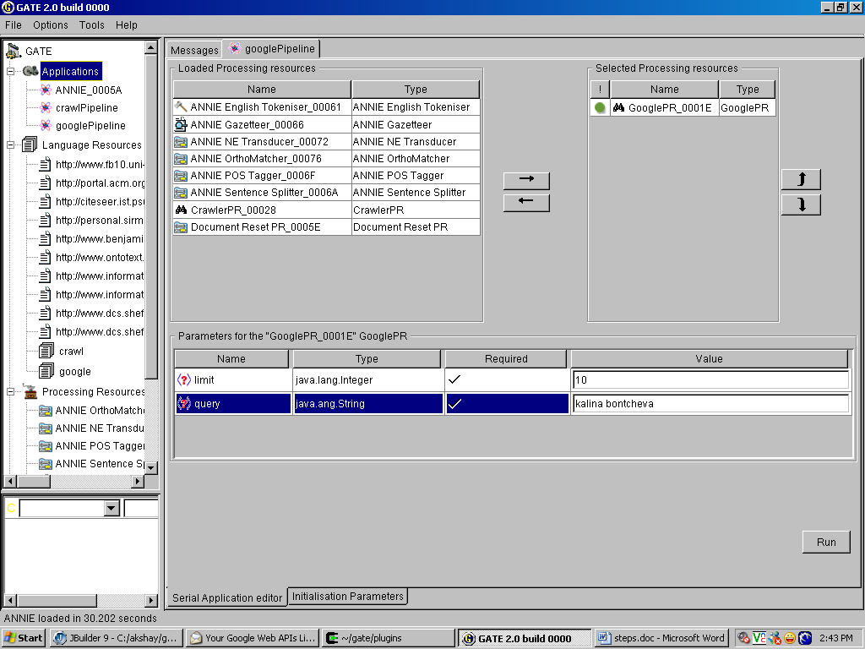
Figure 1 Query Google for the Researcher and get the pages.

- OPTIONALLY at this step you may chose to first run the Crawler and expand the graph. The instructions to do this are similar to those detailed in the documentation for the crawler PR.
- Once this is done then the next step is to Load ANNIE and to annotate the corpus.
- Next the Probability PR needs to be loaded. For this PR specify the runtime parameter as
  - Person/ Organization/ Location
  - The corpus selected
Upon running this PR in a new pipeline you will find the list of entities ranked according to their probability distributions.
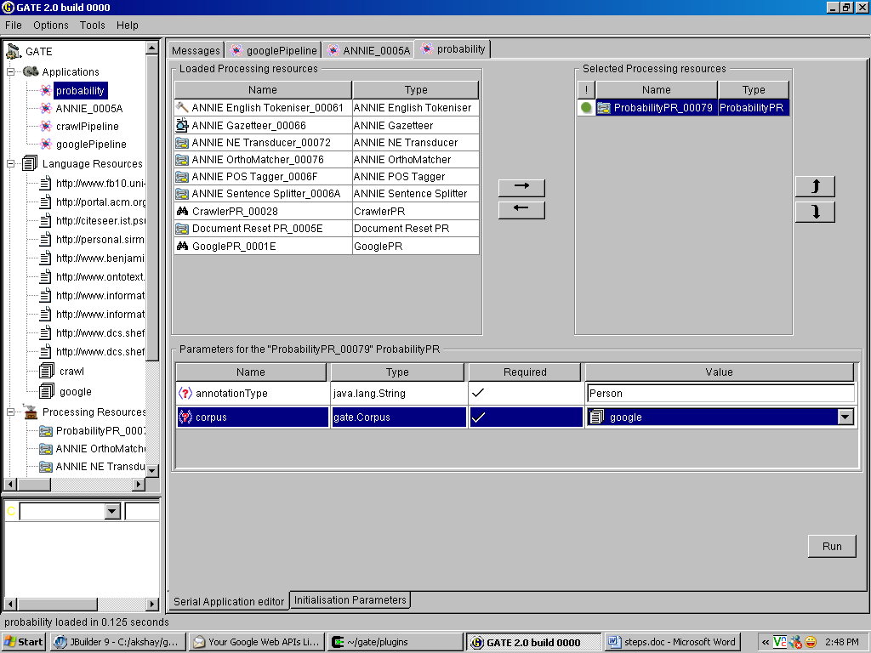
Figure 2 Load the Probability PR and select corpus on which it is to be run
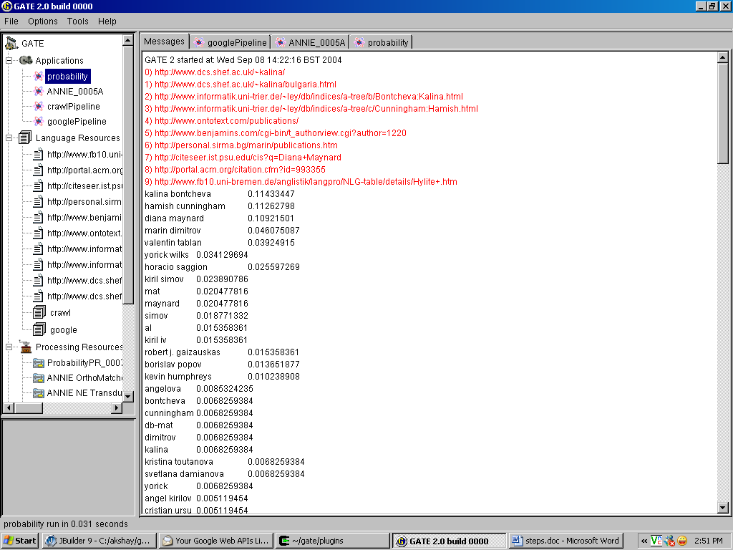
Figure 3 The Entities found in the Corpus ranked according to the probabilities.

