Hints, Tips and Resources

Fox Brook Lite/Stellarton

27September 2011

Revision 0.1

# 

INFORMATION IN THIS DOCUMENT IS PROVIDED IN CONNECTION WITH INTEL® PRODUCTS. NO LICENSE, EXPRESS OR IMPLIED, BY ESTOPPEL OR OTHERWISE, TO ANY INTELLECTUAL PROPERTY RIGHTS IS GRANTED BY THIS DOCUMENT. EXCEPT AS PROVIDED IN INTEL'S TERMS AND CONDITIONS OF SALE FOR SUCH PRODUCTS, INTEL ASSUMES NO LIABILITY WHATSOEVER, AND INTEL DISCLAIMS ANY EXPRESS OR IMPLIED WARRANTY, RELATING TO SALE AND/OR USE OF INTEL PRODUCTS INCLUDING LIABILITY OR WARRANTIES RELATING TO FITNESS FOR A PARTICULAR PURPOSE, MERCHANTABILITY, OR INFRINGEMENT OF ANY PATENT, COPYRIGHT OR OTHER INTELLECTUAL PROPERTY RIGHT.

UNLESS OTHERWISE AGREED IN WRITING BY INTEL, THE INTEL PRODUCTS ARE NOT DESIGNED NOR INTENDED FORANYAPPLICATION IN WHICH THE FAILURE OF THE INTEL PRODUCT COULD CREATE A SITUATION WHERE PERSONAL INJURY OR DEATH MAY OCCUR.

Intel may make changes to specifications and product descriptions at any time, without notice. Designers must not rely on the absence or characteristics of any features or instructions marked "reserved" or "undefined." Intel reserves these for future definition and shall have no responsibility whatsoever for conflicts or incompatibilities arising from future changes to them. The information here is subject to change without notice. Do not finalize a design with this information.

The products described in this document may contain design defects or errors known as errata which may cause the product to deviate from published specifications. Current characterized errata are available on request.

Contact your local Intel sales office or your distributor to obtain the latest specifications and before placing your product order.

This document contains information on products in the design phase of development.

Intel and the Intel logo are trademarks of Intel Corporation in the U.S. and other countries.

*Other names and brands may be claimed as the property of others.

Copyright © 2008 Intel Corporation. All rights reserved.

Contents

1 Introduction 4

1.1 Hints, Tips and Resources 4

1.2 About the Development Kit 4

2 Intel Embedded Web Site-Hardware 6

2.1 Registering for the site 6

2.2 Documents 8

2.3 Documents 9

2.3.1 Reference Documents Available on the Site 9

2.3.2 Reference Documents Not on the Site 9

3 Getting the kit/board setup 11

3.1 Hard Drive 11

3.2 Communicating between Atom Processor and Aria FPGA 11

3.2.1 PCIe IP 11

4 Software Downloads 12

4.1 Intel® Embedded Media and Graphics Driver (Intel® EMGD) 12

4.2 Intel® Software Network 12

4.2.1 Resources for Academics 12

4.2.2 Resources for Students 12

5 IP (Intellectual Property) Libraries 14

5.1 Altera 14

5.1.1 PCIe IP 14

6 Specifications 15

6.1 HSMC connectors 15

7 Additional resources 16

7.1 Altera® University Program 16

7.2 Terasic 16

7.3 Boards With Benefits 16

7.4 System Level Solutions 16

7.5 More Than IP 17

7.6 Nial Stewart Developments 17

7.7 Microtronix 17

8 Contact Info 18

# Introduction

The Intel® Atom™ Processor E6x5C Series product line is a set of products based around a Multi-Chip Package (MCP) that integrates the Intel® Atom™ Processor E6xx Series LPIA1-class IA CPU with an FPGA. The flexibility of the FPGA allows the user to rapidly re-target Intel® Atom™ Processor E6x5C Series designs to different applications in which the volumes may not justify a full custom ASIC development. The added flexibility allows the Intel® Atom™ Processor E6x5C Series to address a wide range of needs.

For example, one could use the FPGA to implement I/O functionality for a particular segment yielding a system-on-package (SoP) solution; or you could use the FPGA to implement acceleration functionality that provides value to a specific application. As a result of the configurability that the FPGA affords, specific products in the Intel® Atom™ Processor E6x5C Series product line share a common physical implementation (the MCP) but implement different functionality through different software, firmware, and FPGA bit file loads.

## Hints, Tips and Resources

This is meant to be a “living” document that includes information for the Fox Brook Lite (or Stellarton) development board kit that you requested for your curriculum development. The board contains an Intel® embedded Atom processor along with an Altera FPGA (Field Programmable Gate Array) in a single package.

***If you happen to require additional information or know of a resource that is not mentioned in this document, please contact us so that we can include the information in the next revision of the document.***

## About the Development Kit

The development kit includes the following:

* Fox Brook Lite Reference Validation Platform with Intel® Stellarton MCP
* Pictou Personality Card
* Pre-installed jumpers
* SPI flash mounted and flashed with reference Fox Brook BIOS
* PCIe Graphics Card
* SATA 80 GB Hard Drive (preloaded with Fedora 11 OS)
* SD Flash (8GB) for Pictou card
* SATA cable & power cable
* USB cable and USB header cables
* Serial port DB9 null modem cable
* Serial port header break out cable
* 150W 12V AC/DC Power Supply Brick

In addition to this kit there are some additional resources that are available for you and your students.[1] This document attempts to provide you with information about these resources.

# Intel Embedded Web Site-Hardware

Click on or paste the following url into your browser-

<http://edc.intel.com/Platforms/Atom-E6x5C/#hardware>

If you have not used this resource before, you will have to register to access this site.

## Registering for the site

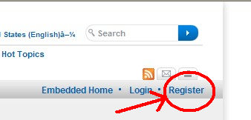

You should see the Register button on the left side of your screen.

There are two types of registration, privileged (red) and basic (green) shown in the picture below. You may want to register as a “privileged user” to have access to confidential documents that are available with the privileged registrations. Since your university has signed an NDA with Intel, you should be able to access Intel Confidential material. We are working on this issue of how to share the information (for teaching materials, publications, etc).

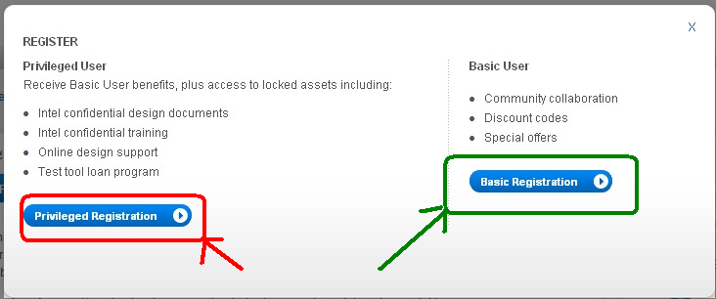

After registering for the site, you should be able to access the web site and resources. If you have any difficulties, please contact us.

## Documents

There are many resources available on this site.[2] A sample screen shot of the web page for the E6x5C (which is used in the Fox Brook Lite Board) is shown below. You can click on the “Technical Documents” tab to find documentation.

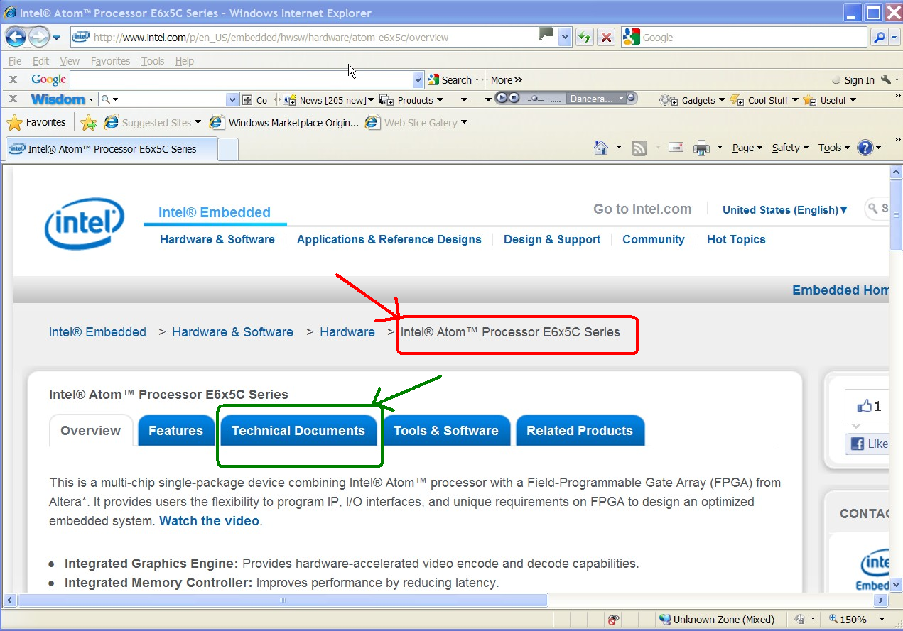

## Documents

There are many resources available on this site.[3]

### Reference Documents Available on the Site

Some documents that may be useful are listed in the following table.

|  |  |
| --- | --- |
| Document/File | Document Revision |
| Datasheet for Arria II* Devices | December 2010 |
| EP2AGXE6XXFPGA Device Handbook Volume 1: Device  Interfaces and Integration | December 2010 |
| EP2AGX6XXFPGA Device Handbook Volume 2: Transceivers | December 2010 |

### Reference Documents Not on the Site

If you see something listed with the notation:

“Contact your Intel Field Representative for the latest version of this document.”

Please contact Joy Shetler (see contact info below) or the Intel representative for your school.

To obtain these documents, your university should have a recent Non-Disclosure Agreement (NDA) on file with Intel. This NDA could be filed for an individual professor, a department, college or at the university level (such as provost, dean, vice-president, president, etc) so that it would provide either specific or blanket coverage for the confidential material to be accessed.

|  |  |
| --- | --- |
| Document/File | Document Revision |
| *Intel® Fox Brook Development Kit User’s Manual* †; Document  Number 447729 | TBD |
| EP2AGXE6XX FPGA pin mapping spreadsheet  (464895_E6x5C_EP2AGXE6XXFPGA_pin_mapping_r1.0.xlsx) | TBD |
| Fox Brook reference validation platform (RVP) schematic  (447522_FoxBrook_RVP_Schematic_RevB5) | TBD |
| *Mapping Altera* FPGA Pins to Intel® Atom™ Processor E6x5C* | TBD |

# Getting the Kit/Board Setup

TBA - Introduction

## Hard Drive

The hard drive is pre-loaded with the Fedora 11 Operating System. The user id and passwd combination for this hard drive is:

User id: root

Passwd: welcome

## Communicating between Atom Processor and Aria FPGA

On the Intel® Atom™ Processor E6x5C Series, the FPGA is designed and programmed with Altera Quartus* II Subscription Edition Software. The FPGA is accessed in the software by choosing the device EP2AGXE6XXFPGA.

### PCIe IP

The Atom processor communicates to the Aria FPGA through a PCIe port. Information about the PCIe port within the Atom processor is provided within the Intel specifications. More details about the PCIe IP for the Aria FPGA can be found on the Altera web page below.

Altera - http://www.altera.com/technology/high_speed/protocols/pci_exp/pro-pci_exp.html

# Software Downloads

The hard drive enclosed with the Fox Brook Lite development kit has been pre-loaded with Fedora 11. There are many other Operating Systems which will work with this board, but this OS was chosen as it matches the OS used for the Inforce (or Tunnel Creek) board (which you may have received from Intel).

## Intel® Embedded Media and Graphics Driver (Intel® EMGD)

Intel® Embedded Media and Graphics Driver (Intel® EMGD) specifically targets the needs of embedded platforms that use the Intel® System Controller Hub US15W, US15WP and US15WPT or the Intel® Atom™ Processor E6xx Series.

<http://edc.intel.com/Software/Downloads/EMGD/>

## Intel® Software Network

TBA – Introduction To be added later

### Resources for Academics

Many Intel software tools are available for deep discounts to the academic community. The following web site contains some of the latest software tools supported by Intel:

<http://software.intel.com/en-us/articles/intel-academic-developer-program>

### Resources for Students

“Intel has created Student Suites for all of our development tools under a single user license to allow students to get access to our tools at the lowest possible cost. We offer the student suites at prices ranging from $49 to $129 per user depending on the operating system required. There are no functional differences in the student suites. This is a specially priced package available to students.   
  
A student is defined as full and part-time matriculated students of a higher education institution defined as a public or private, vocational school, correspondence school, junior college, college, university, or scientific or technical institution.”

<http://software.intel.com/en-us/articles/intel-academic-developer-program/#student>

Additional resources are available to the academic community:

http://software.intel.com/en-us/articles/intel-academic-community

# IP (Intellectual Property) Libraries

## Altera

Altera has a set of IP libraries available at the following web site:

http://www.altera.com/support/ip/ips-index.html

### PCIe IP

A specific example of an IP library is the PCIe IP developed by Altera - http://www.altera.com/products/ip/iup/pci-express/m-alt-pcie8.html

# Specifications

Altera SOPC Builder User Guide (UG-01096-1.0), December

2010

Altera PCI Express Compiler User Guide (UG-PCI10605-2.8), http://www.altera.com

December 2010

Altera USB-Blaster Download Cable User Guide (UG-USB81204-

2.5), April 2009

## HSMC connectors

<http://www.altera.com/literature/ds/hsmc_spec.pdf>

# Additional resources

**The web sites below, contain additional resources that might be useful for your particular needs.**

## Altera® University Program

Altera® University Program provides complete support for introducing students to digital technology. The support includes hardware, software, and teaching materials.

<http://www.altera.com/education/univ/unv-index.html>

## Terasic

Terasic is dedicated to providing a wide range of various FPGA based boards for academic and to industry that combine quality, performance, and low cost.

This company markets an assortment of “daughter” cards that can be used with the Fox Brook Lite board (using an HSMC High Speed Mezzanine Card interface).

http://www.terasic.com.cn/en/

## Boards With Benefits

This website is the entrance to a unique community dedicated to the Intel® processors featuring the Atom™ core, their documentation, availability, projects, boards, forums, consultant classified ads, and more.

<http://boardswithbenefits.com/>

## System Level Solutions

SLS provides a wide range of specialized design tools, IP cores, and products. This webpage lists several “daughter” cards with HSMC interfaces.

<http://www.slscorp.com/products/hsmc-snap-on-boards.html>

## More Than IP

MorethanIP is a privately owned and profitable design and IP (Intellectual Property) house concentrating on high-speed communications, serial backplane and embedded system technologies.

<http://www.morethanip.com/index.htm>

## Nial Stewart Developments

<http://www.nialstewartdevelopments.co.uk/products.htm>

## Microtronix

http://www.microtronix.com/FPGA/daughter_cards.htm

# Contact Info

Technical Issues for Stellarton/Fox Brook Lite Platform - Joy Shetler, PhD

[joy.shetler@intel.com](mailto:joy.shetler@intel.com)

Office phone: (480)552-0972

Other needs and resources - Your Intel representative for your University Program

1. Intel does not take responsibility for content or materials available on external websites or by other companies or entities.
2. You may have to join the user group to access the site.
3. You may have to join the user group to access the site. You will want to register as a “privileged user”.