**WHAT IS REACT**

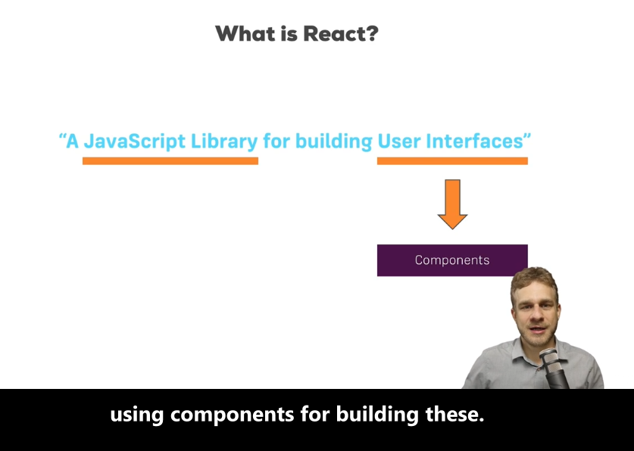

Components are easy to manage and reuseable.