Open-loop u(t) Experiment Report
Paper-setting Transformer control trained by PMP/KKT optimality gaps
This report focuses on the time-dependent open-loop control policy u_theta(t): [0,T] -> [0,u_max]. The feedback case u(t,N) is intentionally excluded because it has different optimality conditions.
1. Model and Training Objective
We use the population dynamics and cost from the manuscript:
dN_i/dt = (r_i - phi_i u(t) - M_i G(N(t))) N_i(t)
G(N) = log(1 + (1/m) sum_k N_k)
J(u) = alpha^T N(T) + int_0^T [ beta^T N(t) + gamma u(t) ] dt
Reported parameters: T=10, m=21, u_max=3, alpha=1, beta=0.1, gamma=20, and N_i(0)=10. The control is represented by a small Transformer encoder over normalized time: u_theta(t_k)=u_max sigma(g_theta(t_k)).
Given u_theta(t), we roll out N_theta(t), solve the costate equation backward, and compute the switching function
psi(t) = H_u(N, lambda, u) = gamma - sum_i phi_i lambda_i(t) N_i(t).
component | role
non-singular KKT loss | enforces u=0 when psi>0 and u=u_max when psi<0
singular loss | near psi=0, matches u_theta(t) to the singular candidate u_sing(N(t))

Here q(t) is a smooth weight that switches between the singular condition near psi(t)=0 and the boundary KKT condition away from psi(t)=0.
2. Learned u(t), N(t), and N(u)
The learned control starts high, transitions to a lower interior/singular-like region, and increases again near the terminal portion.
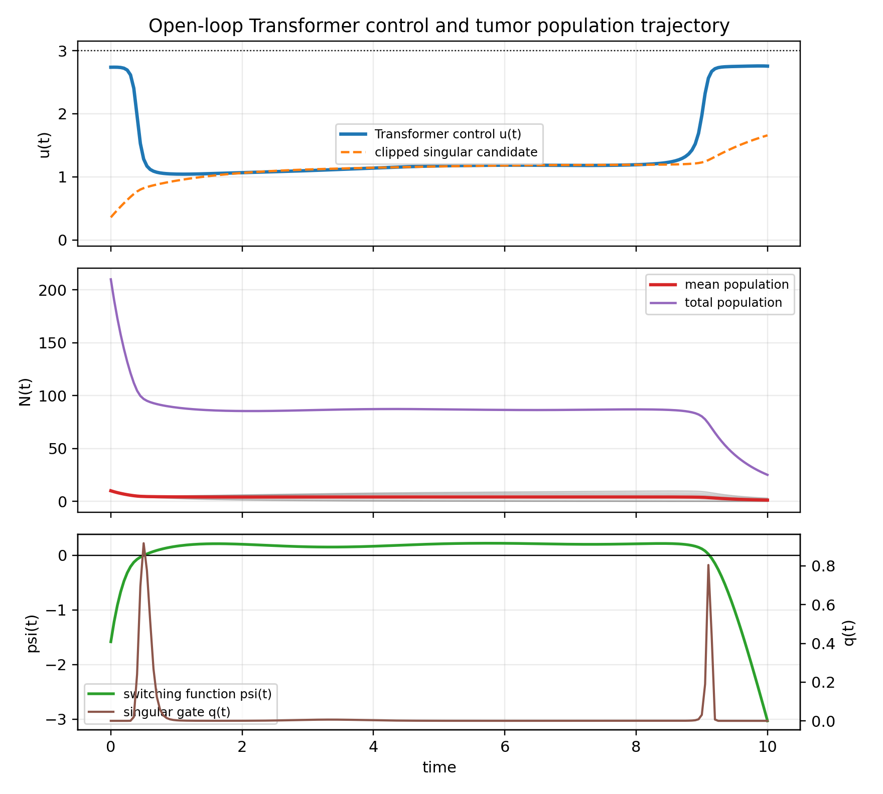
The N(u) phase plot shows population directly against the applied control value; color indicates time.
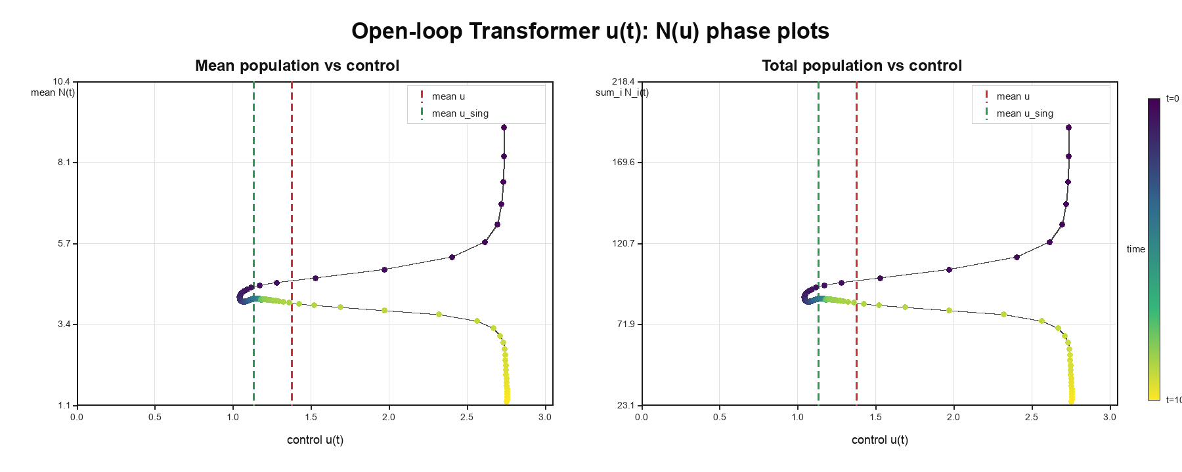
3. Training Loss Trajectories for PMP/KKT Conditions
The table reports the smallest recorded training loss. In this experiment, the training loss is the manuscript's PMP/KKT optimality gap, composed of the singular condition and the non-singular Hamiltonian minimization condition.
metric | value
total training loss / PMP-KKT optimality gap | 0.02637
singular-condition training loss | 0.00167
non-singular Hamiltonian-minimization training loss | 0.02471
objective J on the training grid | 384.76
range and mean of u_theta(t) | min 1.038, max 2.758, mean 1.372
terminal mean state | 1.207

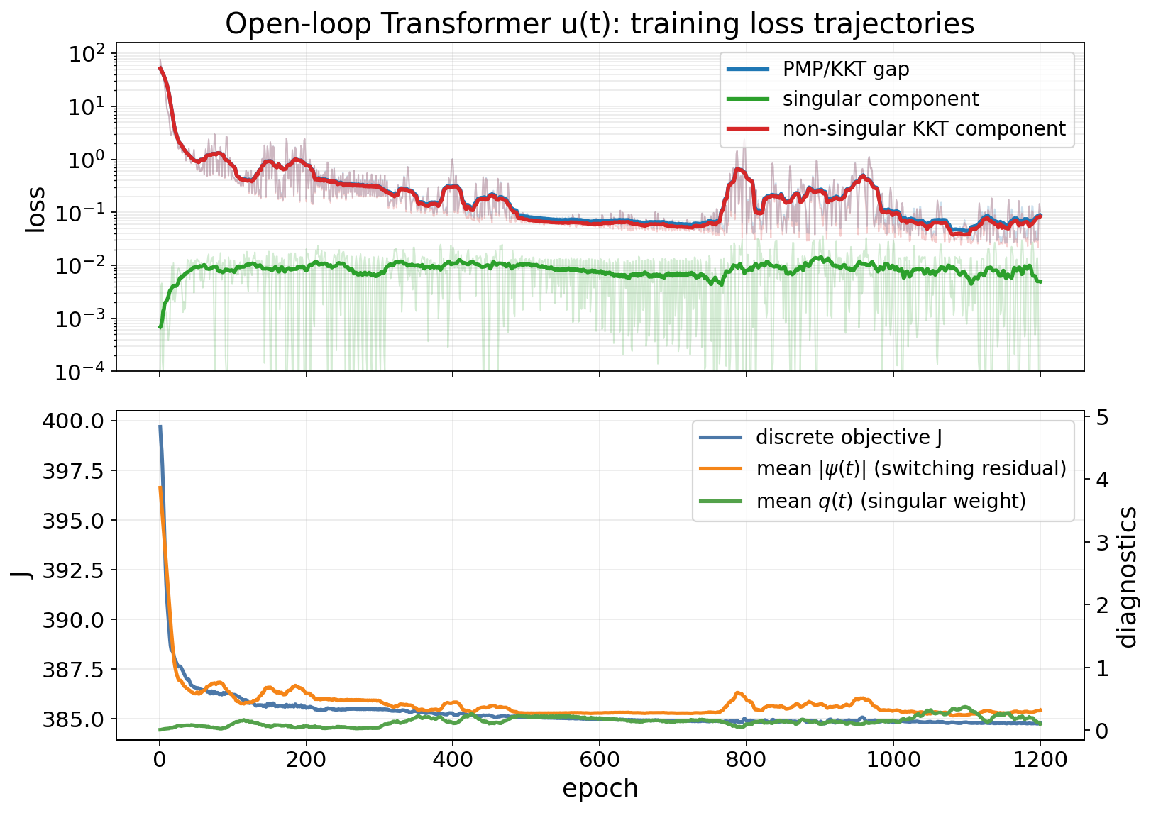
The final pointwise diagnostic below uses a smooth weight q(t) to separate the two regimes: near psi(t)=0 it emphasizes the singular-condition error; away from psi(t)=0 it emphasizes the boundary KKT error.
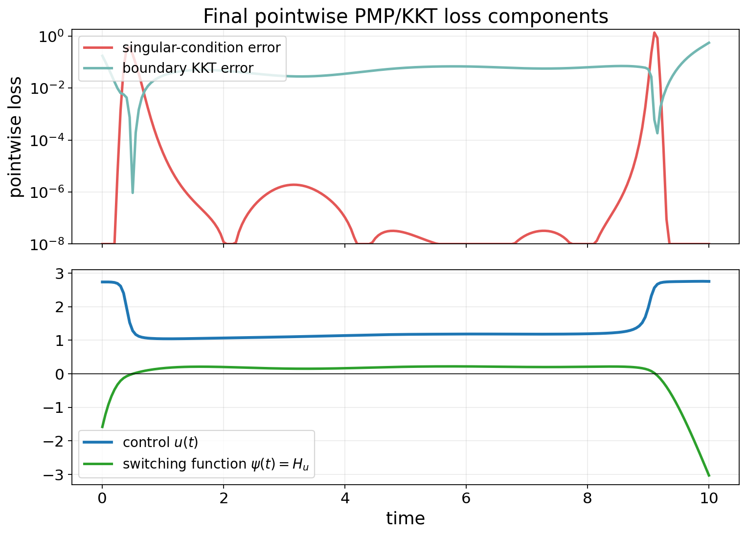
4. Comparison With Related Work [3]
Related work [3], Neural-PMP / PMP-gradient, also follows a Pontryagin-style procedure: forward state integration, backward costate recursion, and Hamiltonian-gradient updates of a discrete control sequence. For comparison on the same model and parameters, we implemented the corresponding control-update step from [3].
method | control update / training criterion | PMP/KKT gap | objective J* | note
Transformer u(t) | paper PMP/KKT optimality-gap loss | 0.0523 | 386.70 | main u(t) reproduction
Neural-PMP [3] | Hamiltonian-gradient update of control sequence | 7.47 | 387.02 | related-work comparison
direct grid cost | minimize discretized J | 0.805 | 386.47 | reference only
constant u=1.5 | no training | 76.89 | 400.40 | scale check

* The J values in this table are computed after fixing u(t), reintegrating N(t) with a finer-step fourth-order Runge-Kutta method, and then applying the manuscript objective definition. This is only to use the same numerical integration accuracy across methods.
Under the same PMP/KKT gap calculation, the Transformer u_theta(t) has a much smaller gap than the Neural-PMP implementation of [3]. When J is recomputed with the same numerical evaluator, the Transformer also has a slightly lower objective value in this run.
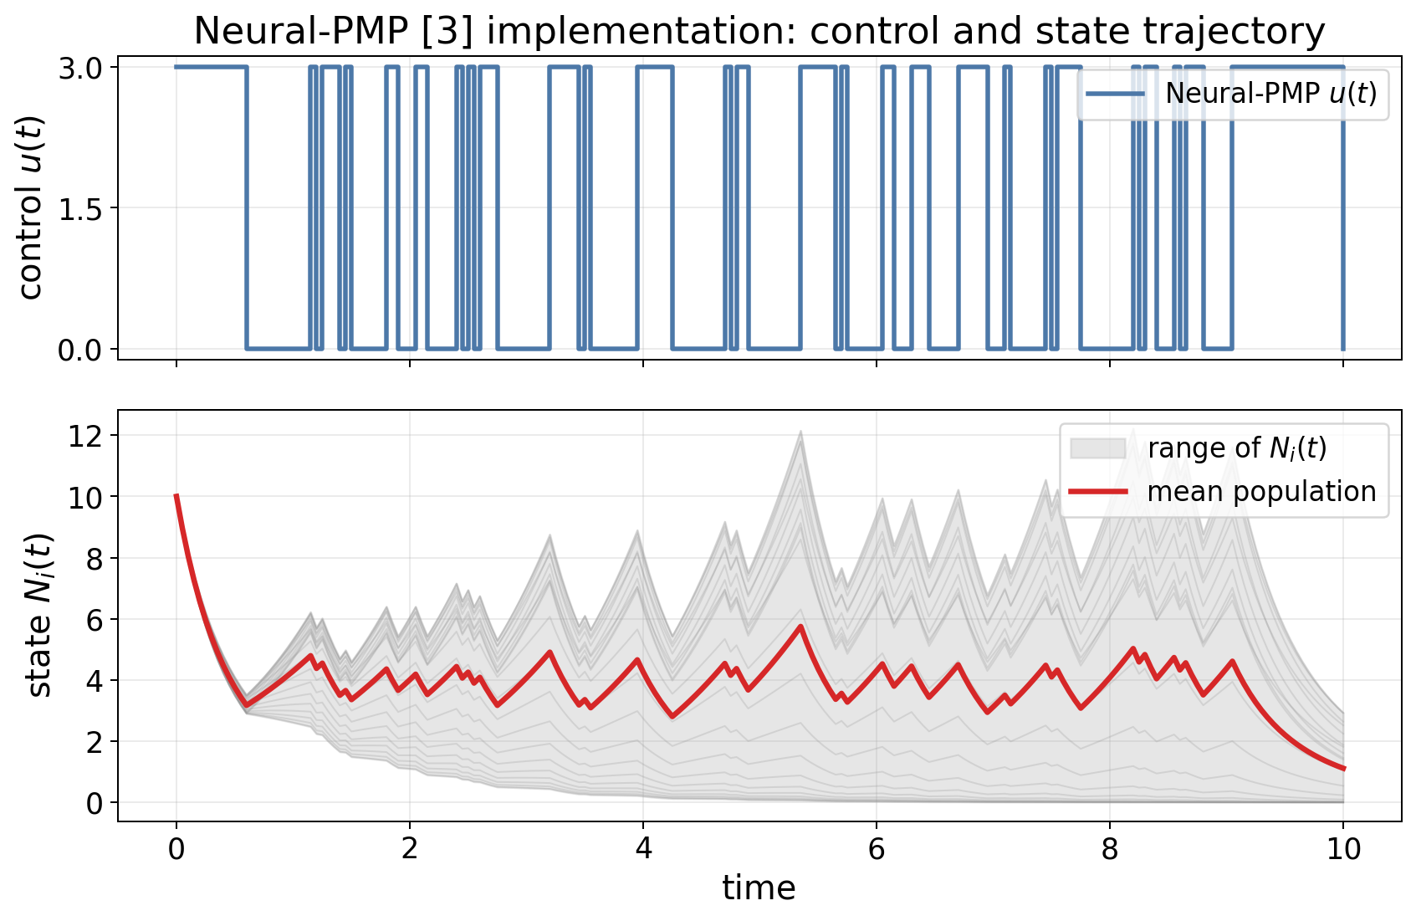
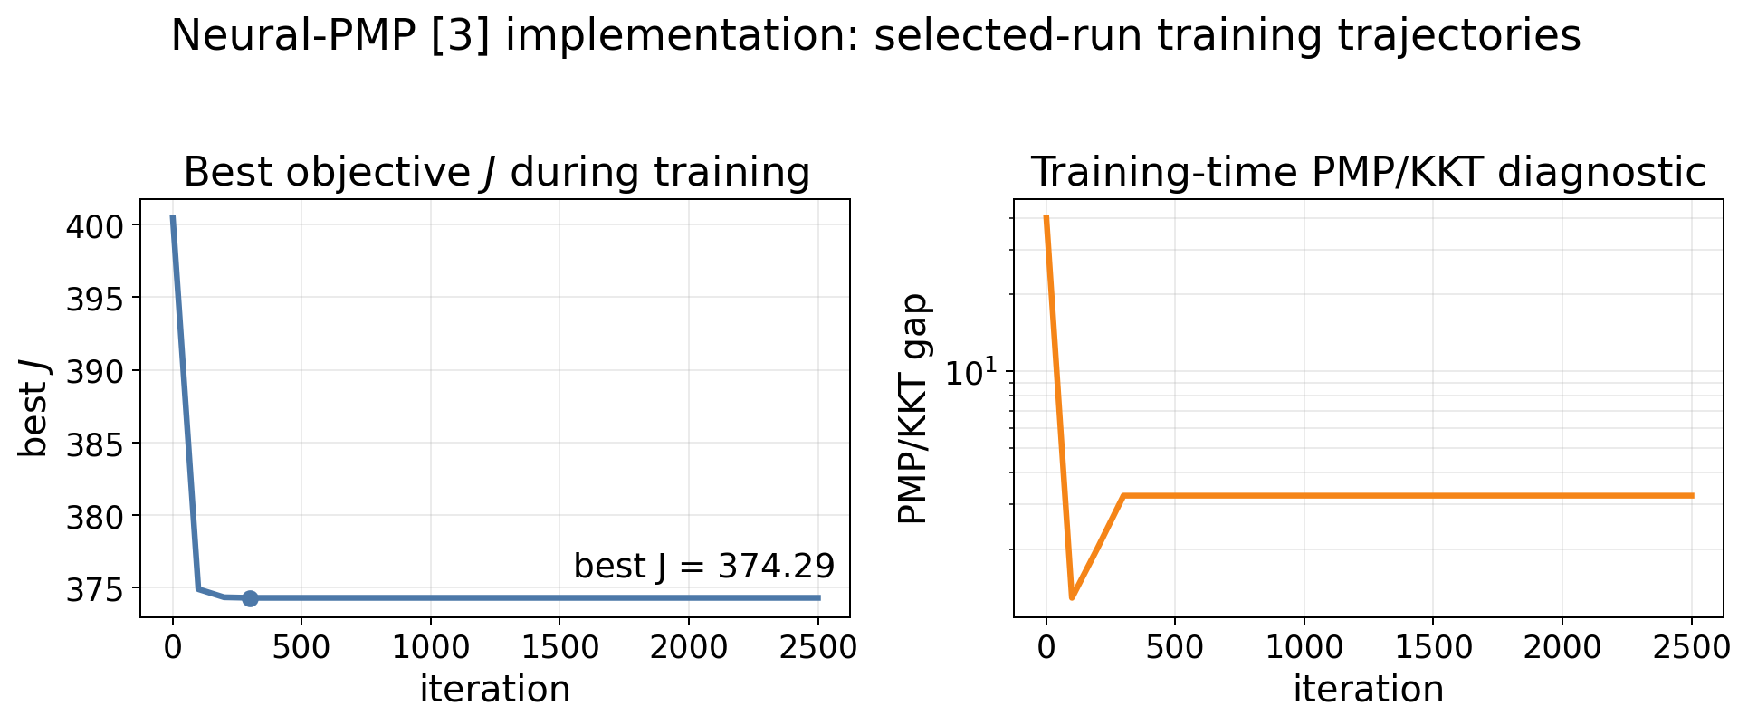
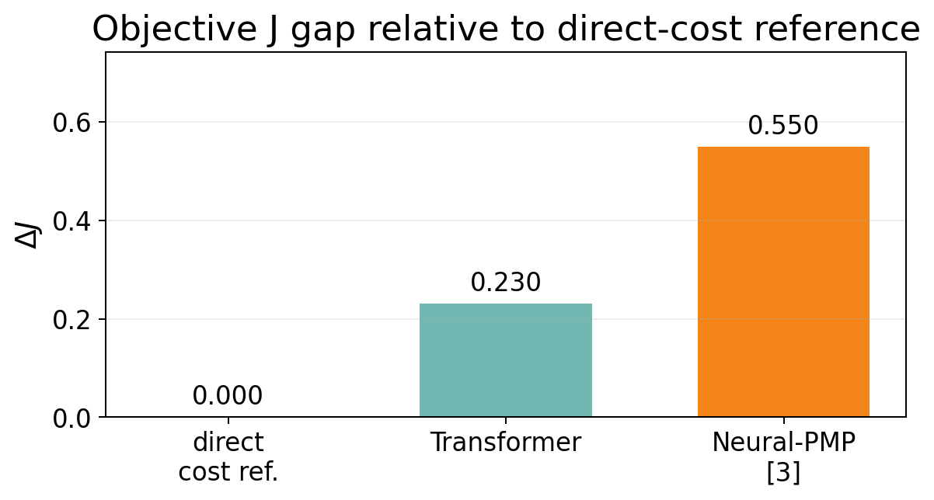
5. Conclusion
The requested u(t) reproduction is complete. The Transformer control trajectory trained with the manuscript's PMP/KKT optimality-gap loss is smooth and satisfies the control bounds, reduces the training optimality gap from 76.26 to 0.02637, and gives J approximately 386.70 under the common numerical evaluation. The feedback case u(t,N) is not included here.

