Supplementary material 2
Landscape-scaled technological structure in surface-collected Quina scrapers
Pei-Yuan Xiao^{a,b,c}, Qi-Jun Ruan^{d}, Davide Delpiano^{e}, Marco Peresani^{e,f}, Zhen-Xiu Jiaª, Li-Jing Yang^{g}, Ben Marwick^{c,✉}, and Hao Li^{a,✉}
2026-09-05
Table of contents

ª Alpine Paleoecology and Human Adaptation Group (ALPHA Group), State Key Laboratory of Tibetan Plateau Earth System, Environment and Resources, Institute of Tibetan Plateau Research, Chinese Academy of Sciences, Beijing, China
^{b} University of Chinese Academy of Sciences, Beijing, China
^{c} Department of Anthropology, University of Washington, Seattle, WA, USA
^{d} Yunnan Provincial Institute of Cultural Relics and Archaeology, Kunming, Yunnan, China
^{e} Department of Human Studies, Prehistoric and Anthropological Science Unit, University of Ferrara, Ferrara, Italy
^{f} Consiglio Nazionale delle Ricerche-Institute of Environmental Geology and Geoengineering, Laboratory of Palynology and Palaeoecology, Research Group on Vegetation, Climate and Human Stratigraphy, Milan, Italy
^{g} Binchuan Cultural Relics Management Institute, Dali Bai Autonomous Prefecture, Yunnan, China
✉ Correspondence: Ben Marwick <bmarwick@uw.edu>, Hao Li <lihao@itpcas.ac.cn>

1. Summary

1.1 What This Document Is
This is Supplementary Material 2, the statistical supplement to the main paper. It reports one Bayesian analysis in full: the data, the model, the priors, how the model was fitted and checked, the posterior estimates, the decisions drawn from them, and how far those decisions depend on choices that could have been made differently.
The analysis follows two published guidelines, which divide the labour between them. Kruschke (2021) specifies what a completed Bayesian analysis should report, item by item, and Section 15 shows where each requirement is answered. Gelman, Vehtari, McElreath, et al. (2026) instead describe how model development proceeds before there is a final analysis to report: fit a model, check how well it performs, find the problems, change the model, and go round again. They argue that a real analytical problem is better understood by comparing several plausible models than by relying on one.
This supplement therefore follows the order in which the analysis was conducted, from Section 3 to Section 7, and puts the reporting checklist at the end. A reader auditing coverage can work through the checklist without interrupting the narrative.
The appendices give the complete tables, the model code and the diagnostics. A reader less familiar with Bayesian terminology can begin with Section 2, which introduces the vocabulary used throughout.

1.2 What Was Analysed
165 surface-collected Quina scrapers from 26 localities in two basins, Binchuan and Huangping. Seven attributes were taken on each specimen: its thickness, its overall size, its GIUR, the retouched share of its perimeter, its total scar count, its edge angle, and the number of retouch generations recorded on it. Three further attributes describe the locality rather than the specimen: which basin it lies in, how high it sits above the channel, and how far it is from the channel. Each is the same for every specimen collected from that locality.
One multilevel model takes all seven attributes at once, so that a single locality structure is shared across them instead of seven separate analyses being run and compared afterwards. The model gives every locality its own baseline for every attribute, and it answers two questions. How much of the variation in each attribute occurs between localities rather than among specimens within a locality? And how much of that difference between localities do the three landscape attributes explain?

1.3 What Was Found

1.3.1 Q1: Do the Localities Differ from One Another?
Yes, for 3 of the seven measurements: Geometric mean size, Total scars, Thickness. Between 22% and 29% of the variation in those measures sits between localities rather than between specimens within a locality, and for 2 of them the finding survives every one of the prior settings the model was refitted under. The remaining 4 are undecided (Section 6.2).

1.3.2 Q2: Do Basin, Elevation or Distance to the Channel Explain the Differences?
Not clearly. Of the 21 landscape effects estimated, 0 show an effect large enough to matter, 1 is close enough to zero to be called practically negligible, and the remaining 20 are too uncertain to separate the two. Adding all three landscape attributes to a model that lacks them barely moves the share of variation sitting between localities, the median change across the seven measures being +13.0% (Section 6.2, Section 6.3).
An undecided result is a finding rather than a failure to obtain one, so for each landscape effect we report the smallest effect the data can rule out, in the units of the measurement itself. For the three best-resolved effects those bounds are Retouched perimeter with height above channel (z), +/- 15 % in the odds; GIUR with height above channel (z), +/- 37 % in the odds; Retouched perimeter with distance to channel (z), +/- 35 % in the odds. Table 18 gives the same bound for all 21 effects, in degrees, retouch generations, or percentages of the measurement.

1.4 What the Study Cannot Settle
Basin, height above the channel and distance to the channel are recorded once per locality, so the three landscape attributes are estimated from 26 localities however many specimens each of them contributes. That number, together with the very uneven sizes of the assemblages behind it, sets the resolution of both research questions. Section 3.2 gives the argument in full, and Section 6.6 adds three limitations that apply to particular measures.

2. Reading Guide
Eleven terms do most of the technical work in what follows. Each is glossed again, in one clause, where it first appears in the main narrative.
Term | What it means here
Posterior distribution | The distribution of a quantity (a slope, a share of variance) after the data have been combined with the prior. Every number in this document is a summary of one.
95% credible interval | The central range containing 95% of the posterior. It says where the quantity lies, given this model and these data. A confidence interval answers a different question, about the long-run behaviour of the procedure that produced it.
ROPE | Region of practical equivalence: the band of values around zero that the analysis is willing to treat as no effect. Calling an effect absent means showing that the posterior sits inside that band.
Intraclass correlation (ICC) | The share of a measure’s variation that sits between localities rather than between specimens within a locality.
Link scale, and dividing by the link-scale SD | Thickness is modelled on a logarithmic scale, GIUR on a log-odds scale, edge angle in degrees. A slope on one of those scales cannot be compared with a slope on another until each is divided by the spread of its own response on its own scale. Every standardised slope here has been divided in that way, which is what lets one ROPE serve all seven measures.
Partial pooling | A locality with one specimen is estimated partly from the other localities, so its level is pulled towards the overall level. It stops a single-specimen locality from being read as a well-measured one.
Prior predictive check | Simulating data from the prior alone, before the real data are used, to confirm that the prior puts no weight on physically impossible values.
Posterior predictive check | Simulating data from the fitted model and comparing them with the observed data, to see what the model reproduces and what it misses.
R-hat and effective sample size | Diagnostics of the simulation rather than of the archaeology. R-hat near 1 means the independently started chains agree; the effective sample size says how many independent draws the correlated ones are worth.
Rank plot | A picture of the same thing. Pool the draws from all four chains, rank them, and count how many of each chain’s draws fall in each rank bin. Four flat, overlapping lines mean the chains explored the same distribution.
Sensitivity analysis | Refitting under different priors to find out which conclusions depend on the prior and which do not.

3. The Estimand and the Design
Gelman, Vehtari, McElreath, et al. (2026, ch. 10) set out the chain any empirical claim depends on. A generative theory motivates an estimand; the theory and the estimand together justify a design; the design yields a sample; and a statistical model, the estimator, turns that sample into an estimate. The links exist whether or not the analyst names them, and a reader can walk the chain backwards from a conclusion to find the one that fails. This section names them for the present study, because three facts about the design fix the resolution of everything that follows, and because the specimen count overstates what the design delivers for the second research question.

3.1 Theory and Estimand
The theory is that the technological character of a Quina assemblage varies with where in a valley system its makers worked, so that assemblages from different parts of a basin should differ in systematic ways.
Two quantities to be estimated follow from it, and the rest of the document keeps them apart (Section 4.2). Q1 is the proportion of the variation in each of the seven measures that occurs between localities rather than among specimens within the same locality. Q2 is the difference in each measure associated with belonging to one basin rather than the other, together with the change associated with a one-standard-deviation increase in height above the channel or in distance from the channel, the other two attributes held fixed.
Q2 estimates an association. The study did not assign the localities their elevations, it states no causal diagram, and it derives no adjustment set from one. A slope near zero therefore means that the landscape attribute fails to predict the measure across these 26 localities. It does not establish that moving an assemblage’s position in the landscape would leave the measure unchanged. A causal reading would need a design that separates the landscape variables from whatever else distinguishes one locality from another.

3.2 Design and Sample
Three features of the sample constrain every result below. They follow from how the material was collected, so no choice of model, no choice of prior and no further specimens can overcome them.
For Q2 the unit of information is the locality, and there are 26 of them. Basin, height above the channel and distance to the channel are recorded once per locality and are identical for every specimen collected there. The 165 specimens sharpen the estimate of within-locality variation and of each locality’s overall level. They add no independent information about the three landscape slopes, so collecting more scrapers from the same localities would describe those localities better while leaving Q2 where it is. The same fact rules out landscape slopes that vary from locality to locality, which is why the question of whether the landscape effects differ between the two basins has to be put at basin level (Section 6.4).
The basin comparison rests on a single contrast, between 21 localities in Binchuan and 5 in Huangping. The width of the interval estimate is what reports the uncertainty that follows from it.
The assemblages are very uneven. One locality contributes 49 of the 165 specimens, and 10 localities contribute one specimen each. Partial pooling estimates a poorly sampled locality partly from the others instead of treating its level as precisely known (Section 13.2). This improves the estimate without creating information the sample does not contain.
Section 6.6 returns to these three limitations once the estimates are in, and adds three that arise from the model rather than from the sample.

4. The Analysis

4.1 Why the Analysis Is Bayesian
Cf. BARG Preamble A.
Four considerations led to a Bayesian treatment. The seven measures on a Quina scraper are not on one scale – thickness and overall size are positive and right-skewed, the geometric index of unifacial reduction (GIUR) and the retouched share of the perimeter are proportions with mass piled at one, the scar count is a count, and the edge angle and the number of retouch generations are treated as unbounded – and a single multivariate model that gives each measure the likelihood its scale calls for while still sharing one locality-level random structure across all seven is straightforward to write down and fit by MCMC, and awkward to fit any other way. Q1 asks for the share of link-scale variance attributable to locality, an intraclass correlation built from a variance component and a residual variance that are themselves functions of several parameters; under MCMC that ratio is computed draw by draw and inherits a genuine interval, with no approximation and no delta-method step. Q2 puts a claim of absence under test, which a frequentist test can only fail to reject, whereas a posterior distribution combined with a region of practical equivalence can accept it, reject it, or report that the data do not decide (Section 6.1). And the variance component Q1 asks about is estimated from 26 clusters (Section 3.2), a number at which asymptotic intervals deserve little trust while posterior intervals require no such argument.

4.2 Goals and the Two Research Questions
Cf. BARG Preamble B.
The study has two goals. The first is estimation: the size of each landscape effect and the amount of locality-level variation, with the uncertainty on each. The second is decision: whether each landscape effect is small enough to treat as practically absent. Predicting new specimens is outside both.
Formal model selection is outside the scope as well. One model answers the two research questions, and the analysis estimates its parameters instead of comparing competing scientific hypotheses. It computes no marginal likelihood and chooses no model on predictive performance. That matters for reading Section 5, which reports 11 fits. The fits measure how far the conclusions depend on reasonable alternative choices, and none is selected as best. Gelman, Vehtari, McElreath, et al. (2026, ch. 9) draw the same distinction, treating a series of fits as a way to understand one model rather than as a contest among models.
Q1 asks whether technological variation exists between localities at all. The locality-level variance component answers it through the intraclass correlation (ICC), the proportion of a measure’s total variation that occurs between localities rather than among specimens within the same locality (Section 13.1, Section 6.2). In plainer terms, Q1 asks how much specimens from one locality resemble each other, relative to how much the localities differ.
Q2 asks whether basin, elevation above the channel or distance to the channel explains that between-locality variation. The population-level slopes supply the answer (Section 13, Section 6.3).
The order of the questions matters. Q2 has something to explain only if Q1 shows that the localities differ in the first place. A “yes” for Q1 alongside an undecided result for Q2 is no contradiction: the two answer different questions, and this document reports them separately.

4.3 Data
Cf. BARG Step 1.A.
Table 1: The variables entering the model, and their observed range in the analysed sample.
Variable | Role | Type | Observed
Thickness | response | continuous, positive (mm) | 11.0 - 51.1
Geometric mean size | response | continuous, positive (mm); geometric mean of length, width and thickness | 22.2 - 71.4
GIUR | response | proportion in [0, 1] | 0.2 - 1.0
Retouched perimeter | response | proportion in [0, 1] | 0.2 - 1.0
Total scars | response | count | 6.0 - 87.0
Edge angle | response | continuous (degrees) | 45.3 - 96.3
Retouch generations | response | continuous (generations) | 1.0 - 4.0
Basin | predictor (locality level) | binary: Binchuan / Huangping | 46 / 119
Height above channel | predictor (locality level) | continuous (m) | 25 - 187
Distance to channel | predictor (locality level) | continuous (m) | 204 - 2690
Locality | grouping factor | factor, 26 levels | 165 specimens in 26 localities

GMsize is the geometric mean of the three linear dimensions,
$$GMsize=(Length×Width×Thickness)^{1/3},$$
computed for each specimen. The definition lives in the analysis code rather than in any measurement protocol, and it is stated here because it has a consequence.
Thickness is one of the three factors in GMsize, so the two responses share a component before any archaeology enters. The model is fitted with set_rescor(FALSE), which assumes the residuals of the seven responses are independent given the locality intercepts, and that assumption is not credible for this pair. The practical consequence is confined. With rescor = FALSE the multivariate model factorises into seven univariate models sharing only the correlated random intercepts, so the slopes and their intervals for each response remain valid marginally. The invalid readings are two: any statement about the joint uncertainty of the thickness slope and the size slope, and any treatment of those two responses as independent evidence. The observed correlation between their locality intercepts (Section 13.2) is therefore partly mechanical.
Two filters were applied before fitting. A specimen must have all seven measurements, and its locality must have a recorded basin, height and distance.
Table 2: Complete-case filtering. One specimen was dropped, for a missing GIUR.
step | specimens remaining | lost at this step
specimens in the surface Quina sheet | 166 | NA
matched to a locality in Site_information.xlsx | 166 | 0
complete on the seven measures | 165 | -1
complete on height, distance and basin | 165 | 0

Table 3: Localities and specimens by basin. Heqing, which appears under that name in the site table, is folded into Huangping: the two names refer to the same basin.
Basin | localities | specimens | specimens per locality
Binchuan | 21 | 46 | 1 - 10
Huangping | 5 | 119 | 6 - 49

The random intercept is the part of the model that enforces what Section 3.2 sets out, and it is why the intervals in Section 13 are as wide as they are.
The standardisation is specimen-weighted: zHeight and zDistance are centred and scaled over the 165 specimens rather than over the 26 localities, so a locality enters the centring and the scaling with the weight of its own assemblage. A locality-weighted standardisation would give slightly different numerical slopes on a rescaled axis. It would not change any decision, because every slope is reported divided by the link-scale SD of its own response and the ROPE moves with it.

4.4 Model and Likelihoods
Cf. BARG Step 1.B.
For specimen $i$ in locality $j$, each response $r$ has its own likelihood with a linear predictor on its own link scale:
$$g_{r}(μ_{ij}^{(r)}) = β_{0}^{(r)} + β_{\text{Basin}}^{(r)} {Basin}_{j} + β_{\text{H}}^{(r)} {zHeight}_{j} + β_{\text{D}}^{(r)} {zDistance}_{j} + u_{j}^{(r)},$$
$$(u_{j}^{(1)},…,u_{j}^{(7)})^{​⊤}∼MVNormal\left(0, D Ω D\right), D=diag(σ_{u}^{(1)},…,σ_{u}^{(7)}).$$
Table 4: Likelihoods. The last column is the SD of the observed response on its own link scale; it is the unit in which every slope and every ROPE below is expressed.
Response | Likelihood | Link for the mean | Auxiliary parameters | Link-scale SD
Thickness | lognormal | log | sigma | 0.297
Geometric mean size | lognormal | log | sigma | 0.228
GIUR | zero-one-inflated beta | logit | phi, zoi, coi | 1.974
Retouched perimeter | zero-one-inflated beta | logit | phi, zoi, coi | 1.530
Total scars | negative binomial | log | shape | 0.563
Edge angle | gaussian | identity | sigma | 8.072
Retouch generations | gaussian | identity | sigma | 0.657

4.4.1 Parameters of Theoretical Interest and Nuisance Parameters
Of the 256 estimated parameters, the research questions concern the 21 population-level slopes $β_{\text{Basin}}^{(r)},β_{\text{H}}^{(r)},β_{\text{D}}^{(r)}$ (Q2) and the seven locality SDs $σ_{u}^{(r)}$ together with the ICCs derived from them (Q1). The seven intercepts, the auxiliary parameters (sigma, phi, shape, zoi, coi) and the 21 elements of $Ω$ make the model coherent without answering any question posed here. Section 13.2 nevertheless reports the correlations in full, because the model estimated them and BARG asks for a description of every parameter.
With 10 localities of one specimen, the locality offsets shrink hard towards the grand mean. That shrinkage is partial pooling: a locality with little data of its own is estimated partly from the others, and the caterpillar plot in Section 13.2 shows how far each is pulled. The behaviour is intended, and it is why the ICC comes from the fitted variance components rather than from a between-group variance ratio of raw locality means.

4.4.2 A Trap in the Zero-One-Inflated Beta Parameterisation
For GIUR and the retouched perimeter, the three predictors enter only the beta component’s mean mu. The inflation parameters zoi (the probability that a value is exactly 0 or exactly 1) and coi (the probability that such a value is 1 rather than 0) are pure intercepts, constant across basins, elevations and distances. Two consequences follow for every GIUR and RLI number in this report.
- A reported slope is the effect on the logit of the beta-component mean, conditional on the value lying strictly inside (0, 1). The effect on the unconditional expected GIUR is a different quantity, because that one also moves with zoi and coi.
- The ICC for these two responses likewise comes from the beta component alone and ignores the inflation entirely.
In this sample there are 17 specimens with GIUR exactly 1 and 0 with GIUR exactly 0, and 9 and 0 for the retouched perimeter. There is therefore no zero inflation at all to model: the fitted coi is a posterior over “all inflated values are ones”, which the data determine almost completely, and the zero-inflation half of the family is supported by nothing. The family is effectively a one-inflated beta.

4.4.3 S6, the One-Inflated Refit
The paragraph above describes a defect rather than a design choice, and S6 acts on it. Setting coi to constant(1) in barg_priors.R gives the family the one-inflated beta shape the data actually show: mass at 1, none at 0, and the zero-inflation half deleted instead of estimated. brms implements the constant by moving coi_GIUR and coi_RLI out of the Stan parameters block into transformed parameters, so two parameters genuinely leave the sampled space instead of receiving a tight prior, and Table 16 shows S6 estimated over 254 parameters against 256 for the reference. The reference fit shows why that is worth doing: under beta(1, 1) and 17 ones out of 165 specimens, its posterior for GIUR’s coi centres on 0.962 rather than on 1, reserving 3.8% of the inflation mass for an outcome that cannot occur, which puts the probability of an exact zero at 0.0039 and predicts 0.65 zeros among the 165 specimens, where the data contain none.
No conclusion can change under the refit, and the reason is stronger than a sensitivity result. The zero-one-inflated beta likelihood factorises: an observation contributes $zoi⋅coi$ if it equals 1, $zoi⋅(1−coi)$ if it equals 0, and $(1−zoi)⋅Beta(y∣μ,ϕ)$ otherwise. The linear predictor enters only the third term; zoi and coi enter only the first two, take no predictors, and have their own priors. The posterior therefore separates, and the slopes, phi, the locality SDs and the locality correlation matrix come from the interior observations alone whatever value coi takes. S6 therefore checks that this reasoning, and the code that implements it, are both right, rather than whether the answers survive a different coi.
Table 5: The five landscape slopes on which the reference fit and S6 disagree most, on the link scale, ordered by the difference between the two posterior medians as a fraction of that slope’s own posterior SD. The other 16 agree more closely. The two runs are separate samplers over different Stan programs, S6 having two fewer parameters, so exact agreement is neither expected nor desirable; agreement within a small multiple of the Monte Carlo standard error is what the factorisation predicts.
Response | Predictor | reference median | S6 median | difference | difference in MCSE | difference / posterior SD
Geometric mean size | Height above channel (z) | -0.0264 | -0.0246 | 0.0018 | 3.7882 | 0.0563
Edge angle | Distance to channel (z) | 2.7123 | 2.7694 | 0.0571 | 2.5097 | 0.0390
Geometric mean size | Distance to channel (z) | 0.0370 | 0.0388 | 0.0018 | 1.8365 | 0.0336
Edge angle | Height above channel (z) | 0.7915 | 0.8206 | 0.0291 | 2.4224 | 0.0311
Total scars | Basin (Huangping vs Binchuan) | -0.0702 | -0.0746 | -0.0043 | 1.5596 | 0.0249

Across all 21 slopes the largest difference between the two posterior medians is 0.0571 on the link scale, which is 5.6% of that slope’s own posterior SD and 3.8 Monte Carlo standard errors; for the seven ICCs the largest difference is 0.0019, or 1.8 MCSEs. The MCSE figure is a maximum over 21 comparisons, so a value of three or four is ordinary behaviour rather than a discrepancy; by the percentage of the posterior SD, the plainer reading, the two fits agree to within a few percent of the width of the thing being estimated. The decisions agree exactly. All 21 slope verdicts and all 7 ICC verdicts are the same under the two specifications.
This document therefore reports S6 as the specification the data support and keeps the reference fit as the source of every other number. Exchanging them would change nothing, and Table 5 is the evidence for that claim.

4.5 Priors
Cf. BARG Step 1.C.

4.5.1 Why the Slope Prior Is Scaled to Each Response
The seven responses reach their linear predictor through three different links (log, logit, identity), and their link-scale SDs span two orders of magnitude, from 0.228 for Geometric mean size to 8.07 for Edge angle (Table 4). A single nominal slope prior, normal(0, 1) say, is therefore a very different statement about each of them. The clearest way to see it is the share of the prior that falls inside that response’s own ROPE, the interval of slopes the analysis is prepared to call practically zero.
Table 6: Percentage of the slope prior lying inside the response’s own ROPE, under a single unscaled normal(0, 1) and under the per-response scaling used here. One nominal specification ranges, across the seven responses, from an almost dogmatic rejection of a null effect to an almost dogmatic assertion of one; scaled to each response it is 7.97% for every one of them, by construction.
Response | Link-scale SD | ROPE half-width | normal(0, 1) | normal(0, SD_link)
Thickness | 0.297 | 0.030 | 2.37 | 7.97
Geometric mean size | 0.228 | 0.023 | 1.82 | 7.97
GIUR | 1.974 | 0.197 | 15.65 | 7.97
Retouched perimeter | 1.530 | 0.153 | 12.16 | 7.97
Total scars | 0.563 | 0.056 | 4.49 | 7.97
Edge angle | 8.072 | 0.807 | 58.04 | 7.97
Retouch generations | 0.657 | 0.066 | 5.24 | 7.97

The diagnostic that makes this more than an aesthetic point is the ratio of the posterior SD to the prior SD for each slope. A ratio near 1 means the posterior is the prior and the data contributed nothing.
Table 7: Posterior SD divided by prior SD, for every slope, under an unscaled normal(0, 1) slope prior (specification S1) and under the reference prior. Values near 1 mean the data did not move the prior. The prior SD is taken from the sample_prior = ‘only’ draws for the reference prior and analytically for normal(0, 1).
Response | Predictor | normal(0, 1) | normal(0, SD_link)
Thickness | Basin (Huangping vs Binchuan) | 0.098 | 0.309
Thickness | Height above channel (z) | 0.039 | 0.132
Thickness | Distance to channel (z) | 0.068 | 0.215
Geometric mean size | Basin (Huangping vs Binchuan) | 0.082 | 0.339
Geometric mean size | Height above channel (z) | 0.032 | 0.140
Geometric mean size | Distance to channel (z) | 0.059 | 0.237
GIUR | Basin (Huangping vs Binchuan) | 0.329 | 0.179
GIUR | Height above channel (z) | 0.142 | 0.074
GIUR | Distance to channel (z) | 0.242 | 0.126
Retouched perimeter | Basin (Huangping vs Binchuan) | 0.162 | 0.109
Retouched perimeter | Height above channel (z) | 0.071 | 0.046
Retouched perimeter | Distance to channel (z) | 0.099 | 0.064
Total scars | Basin (Huangping vs Binchuan) | 0.186 | 0.307
Total scars | Height above channel (z) | 0.074 | 0.129
Total scars | Distance to channel (z) | 0.133 | 0.221
Edge angle | Basin (Huangping vs Binchuan) | 0.913 | 0.271
Edge angle | Height above channel (z) | 0.669 | 0.118
Edge angle | Distance to channel (z) | 0.842 | 0.180
Retouch generations | Basin (Huangping vs Binchuan) | 0.176 | 0.261
Retouch generations | Height above channel (z) | 0.074 | 0.113
Retouch generations | Distance to channel (z) | 0.117 | 0.173

Under an unscaled normal(0, 1) the Edge angle slopes have posterior/prior SD ratios of 0.67, 0.84, 0.91: the posterior is very nearly the prior, so an edge-angle result read off that fit would be mostly a restatement of the prior scale. Under the reference prior the largest of the three is 0.27. The unscaled specification is kept in the sensitivity set as S1 (Section 14), so its effect on every quantity in the report can be read off directly.

4.5.2 The Reference Prior
Every class that get_prior() lists receives an explicit prior, and nothing stays at a brms default. Two reasons. BARG Step 1.C asks for the prior in full, and an inherited default goes unreported by construction; the default intercept prior, student_t(3, median(y), 2.5 mad(y)), is also read off the data. Beyond that, sample_prior = "only", which the prior predictive check of Section 10 needs, requires every prior to be proper.
Class | Prior | Reason
b (slopes) | normal(0, SD_link) per response | one prior SD equal to the whole observed spread of that response on its own link scale: an effect as large as the response’s total variation is a priori about one SD out. Puts 7.97% of the prior inside the ROPE for all seven.
Intercept | see below | fixed from the measurement scale rather than from the sample
sd (locality) | student_t(3, 0, 2) | heavy-tailed half-$t$; the one class not rescaled per response, and varied in S3 and S4
sigma | student_t(3, 0, SD_link) | half-$t$ scaled to the response, for the same reason as b
phi (zoib) | gamma(2, 0.1) | proper, mean 20, density zero at the origin. The brms default gamma(0.01, 0.01) piles mass arbitrarily close to zero, where the beta density is degenerate, and makes the prior predictive distribution unusable
shape (negbin) | gamma(2, 0.1) | same; the brms default inv_gamma(0.4, 0.3) has an extremely heavy right tail
zoi, coi | beta(1, 1) | uniform on (0, 1); this is also the brms default, stated here rather than inherited
cor (7x7) | lkj(1) | uniform over correlation matrices; varied in S5
The intercept priors are set from what a lithic analyst would have called possible for a retouched flake tool before seeing these 165 pieces, mapped through the link. Each is far wider than the observed spread.
Table 8: Intercept priors, fixed from the measurement scale rather than from the sample.
Response | Link | Prior | Implied 95% range on the response scale | Observed mean
Thickness | log | normal(3.2, 0.7) | 6 - 100 mm | 25.0 mm
Geometric mean size | log | normal(3.7, 0.6) | 12 - 134 mm | 40.7 mm
GIUR | logit | normal(0, 1.5) | GIUR 0.05 - 0.95 | 0.75
Retouched perimeter | logit | normal(0, 1.5) | 0.05 - 0.95 of the perimeter | 0.50
Total scars | log | normal(3, 1.0) | 3 - 143 scars | 23
Edge angle | identity | normal(65, 20) | 26 - 104 degrees | 70.0 deg
Retouch generations | identity | normal(3, 2) | -0.9 - 6.9 generations | 2.75

One qualification attaches to the reference prior. The scale of the slope prior and of the sigma prior is taken from the link-scale SD of the response, which is a function of the data. This is a unit-setting use of the data rather than a location-setting one: it fixes what “one unit of effect” means without expressing any belief about where the effect lies, and it is the standard construction behind weakly informative priors. It remains a mild empirical-Bayes element. S1 and S2 in Section 14 vary this scale by factors of roughly 1/8 to 2.5 and show what turns on it.
None of the priors used here is informed by previous work, because there is none to draw on. No published posterior or meta-analytic estimate exists for any of these seven measures in Quina assemblages; there is no prior literature on, for instance, how edge angle varies with elevation above a channel. That is why BARG item 5.B, sensitivity to a genuinely informed prior, has nothing to attach to in this analysis, and the gap is itself a statement about how little is established for these measures.
The complete prior is in Appendix A (Section 8): the generated Stan prior block, which is what was actually added to the log posterior, the rows prior_summary() still labels default and why the sampler never reaches them, and the brms defaults that the explicit specification replaced.

4.6 Fitting and Model Checks
brms (Bürkner 2017) fitted the model with the cmdstanr backend, running 4 chains of 10,000 iterations for 20,000 post-warmup draws in total. Ten further fits use identical settings; Section 5 says what each one is for. Table 15 gives versions, seeds and sampler settings, and Section 11 gives the convergence and resolution diagnostics for all eleven runs.
Three checks separate the fitted model from the results, and this section states their outcomes so that a reader can decide how much of the evidence to inspect. The prior predictive draws stay inside the physically possible range of every measure, which is what that check is asked to establish (Appendix C, Section 10). The sampler converged; Appendix D (Section 11.2) gives R-hat, divergences and treedepth saturation for all eleven runs. On the posterior predictive side (Appendix E, Section 12), the negative binomial reproduces the overdispersion of the scar count, while the gaussian likelihood for retouch generations smooths over their discreteness, a real limitation of that family visible in Figure 6. Figure 8 reports the test statistics fixed in advance, among them the pile-up of GIUR and retouched-perimeter values at exactly 1, against their predictive distributions.

5. The Model Series
Eleven fits underlie this report, and only one of them supplies the numbers in the results tables. The other ten exist because a single fit cannot show which of its answers depend on the analyst rather than on the scrapers. Gelman, Vehtari, McElreath, et al. (2026, ch. 9) treat this as the step that separates a Bayesian workflow from a Bayesian analysis: fit a series, keep the earlier members, and use them to understand the one you report. Each member of the series below differs from the reference in a single respect, so that any movement in a result can be attributed to a named choice.
Fit | How it differs from the reference | Why it was fitted | What it showed
ref | reference specification | supplies every number quoted outside the sensitivity appendix | Section 6.2, Section 6.3
prior_ref | sample_prior = "only" | to see what the prior alone predicts, before the data are used | the prior stays inside the physically possible range of all seven measures (Section 10)
noland | the three landscape terms removed, leaving the locality intercept alone | to test whether the landscape terms produce the between-locality variance, without depending on any single slope being well resolved | they absorb almost none of it (Table 10)
ref_basinx | Basin * zHeight + Basin * zDistance | to ask whether the answer to Q2 averages over two basins that behave differently | the contrasts are undecided, with a directional hint in Huangping (Section 6.4)
ref_rg_ln | lognormal likelihood for retouch generations | the gaussian family smooths over the discreteness of that response, so the conclusions should be visible under an alternative | the verdicts are unchanged (Table 17)
s1 | slope prior normal(0, 1), unscaled | the specification paper/_analysis.R uses, and the one the per-response scaling replaced | the edge-angle slopes are prior-dominated under it (Table 7)
s2 | slope prior widened by 2.5 | the broad prior BARG 5.A asks for | Section 14.1
s3 | locality SD prior exponential(1) | 26 clusters make this prior influential | Section 14.2
s4 | locality SD prior normal(0, 1) truncated at zero | a lighter tail than the reference half-$t$ | Section 14.2, Section 6.6
s5 | correlation prior lkj(2) | 21 correlations from 26 clusters are weakly identified | Section 13.2, Section 14.2
s6 | coi fixed at 1 | a defect in the zero-one-inflated beta, found while reading the fitted parameters | the slopes and ICCs agree with the reference to within a few percent of a posterior SD (Section 4.4.3)
Two of these entries record a defect the analysis found in itself: s1 the unscaled slope prior that says something different about each response (Section 4.5), and s6 a coi parameter estimating the frequency of an outcome that cannot occur (Section 4.4.3). Neither defect showed up in the research question, in the data or in the convergence diagnostics. Both surfaced from comparing the fitted parameters with what the sample contains, and that comparison is the part of the work a results table has no room for.
Fitting eleven models rather than one opens a familiar risk, and naming it is part of reporting it. A reader cannot tell from the finished document how many further specifications were tried and set aside, and a set of fits chosen after seeing the results can be made to bracket whatever range the analyst prefers. Two features of the design limit the room for that here. Each of s1 to s6 changes exactly one line of the reference prior, so the set is determined by the reference specification rather than by the results; and no fit was dropped, so Table 16 lists all eleven, including the 5 that produced a handful of divergent transitions. One thing the design cannot rule out is that a different analyst would have chosen a different reference, and Section 6.5 reports how much of the answer that choice governs.

6. Results
Cf. BARG Step 4.E, which requires every decision to appear beside the estimate and interval it rests on. Every decision table below gives all three.
Figure 1 answers both questions at a glance. The sections that follow give the rule those answers are drawn from, then each question in turn, then how much of the answer depends on the prior, and finally what the design cannot settle.
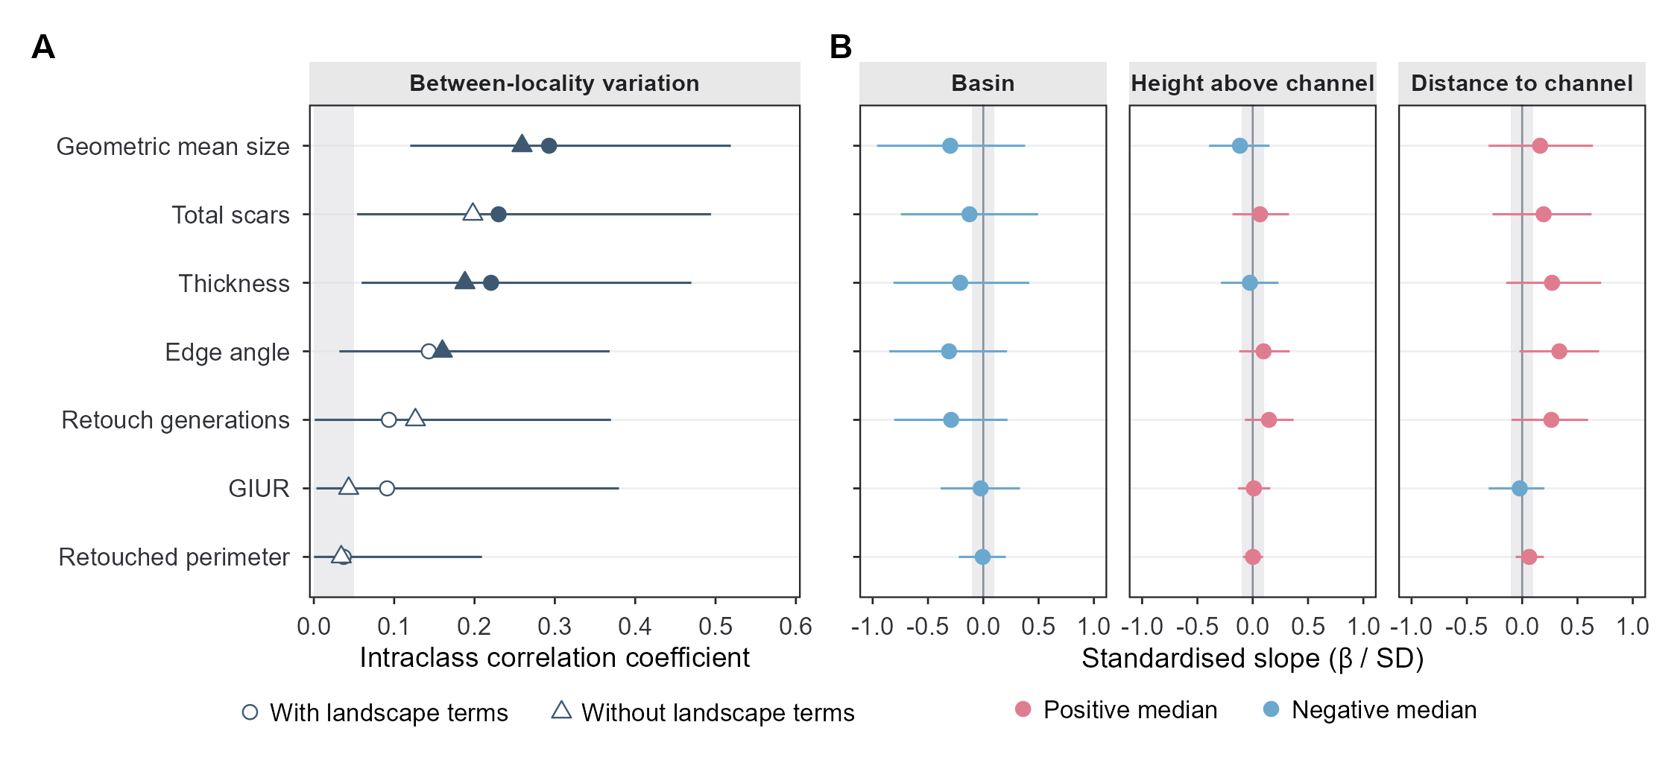
Figure 1: A (Q1): the locality share of link-scale variance for each response. Circles are the model with the landscape terms, triangles the intercept-only model, joined by a line. Filled circles mark responses whose 95% interval clears the 0.05 negligibility band (shaded). B (Q2): the 21 landscape slopes, each divided by the link-scale SD of its own response so that all seven share one axis and the ROPE is a single band at +/- 0.1. The basin slope is Huangping relative to Binchuan; height and distance are standardised, so their slopes are the change over one SD of the predictor. Rows are in the same order in both panels. Any slope whose posterior SD is still more than half its prior SD is drawn grey and hollow, because it has not been informed enough by the data to be read as an estimate.

6.1 The Decision Rule and the ROPE
Cf. BARG Step 4.A.
The substantive question asks how large an effect is and also whether it is small enough to treat as absent. An interval alone answers only the first, and so does a $p$-value, which can fail to reject and nothing more. The rule used here is Kruschke’s (2018) three-way decision against a region of practical equivalence, or ROPE, meaning the band of values around the null value that the analysis is willing to treat as no effect:
Decision | Condition (either suffices)
Reject the null value | the 95% credible interval lies entirely outside the ROPE, or less than 2.5% of the posterior mass is inside it
Accept the null value | the 95% credible interval lies entirely inside the ROPE, or more than 95% of the posterior mass is inside it
Undecided | neither of the above
An undecided verdict is a substantive outcome in its own right. It means the data are compatible both with an effect large enough to matter and with none, and Section 6.3.1 turns that into a quantitative statement of what the design was able to exclude.

6.1.1 The ROPE and Its Justification
Cf. BARG Step 4.C.
The ROPE half-width used in the text is 0.1 times the SD of the response on its own link scale, so a slope counts as practically zero if moving a predictor by one unit shifts the response by less than a tenth of that response’s total spread. Expressing the bound in link-scale SD units is what lets one number serve seven responses on three link scales (Table 6).
Two qualifications attach to it. The first is that 0.1 is a convention. No archaeological argument supports it, and none exists in the literature: nobody has established how large a difference in edge angle or scar count a lithic analyst would need before calling it a real difference in technological behaviour, and this report constructs no such argument either.
The second qualification is more serious. BARG asks for ROPE limits fixed by theoretical and practical considerations before the results are seen, and this analysis fails that precondition, because the model had already been fitted and inspected before the report was written. Choosing a half-width now, with the posteriors in view, would allow the bound to be tuned until it delivered a preferred verdict.
Reporting the whole curve answers the objection where defending a single number would not. The posterior mass inside the ROPE appears below as a continuous function of the half-width, so that a reader with a defensible bound of their own can read the answer off at it. The equivalence $p$-value curves of the companion analysis use the same device for the same reason.
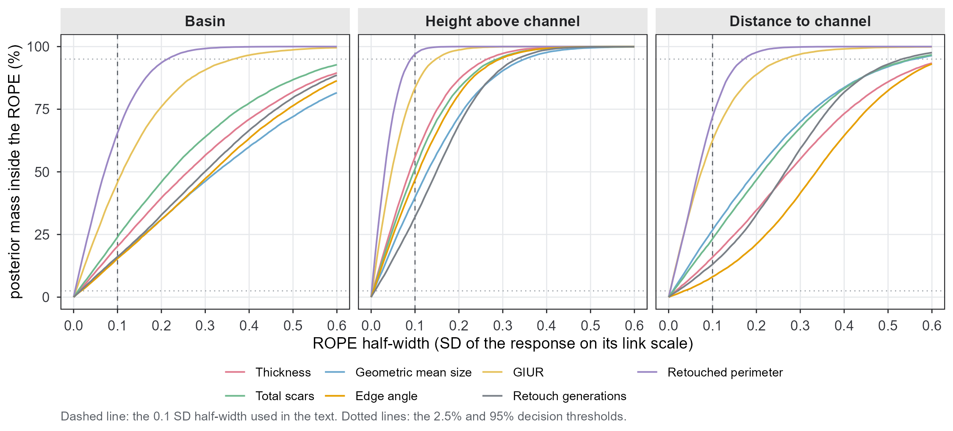
Figure 2: Posterior mass inside the ROPE as a function of the ROPE half-width, in link-scale SD units, for all 21 slopes. Dashed vertical line: the 0.1 half-width quoted in the text. Dotted horizontals: the 2.5% and 95% thresholds of the decision rule. A curve that has not reached 95% by a half-width the reader considers archaeologically negligible is a slope this design cannot declare absent.
A reader who wants the mass at a particular half-width can read it off the curve; rope_curve() in barg_quantities.R returns it numerically for any grid of half-widths.

6.2 Q1: Is There Technological Variation Between Localities?
Yes, for 3 of the seven measures under the reference prior, and for 2 of them under every prior tried.
For 3 responses (Geometric mean size, Total scars, Thickness) the 95% interval for the locality share of link-scale variance lies entirely above 0.05, so the rule of Section 6.1 rejects the null value of a negligible locality effect. Their posterior medians are 0.29, 0.23, 0.22, meaning that between 22% and 29% of the link-scale variance in those measures sits between localities rather than within them. The remaining 4 are undecided: their intervals run from near zero to values that would be substantial, and the design does not separate the two.
Table 9: Q1 decisions. The ROPE for the ICC is [0, 0.05]: a locality share of link-scale variance below 5% is treated as negligible. Unlike the slope ROPE this bound is one-sided and has a natural reading – 5% of variance is a share no archaeological argument would build on.
Response | ICC median [95% ETI] | P(ICC > 0.05) | Decision
Geometric mean size | 0.293 [0.120, 0.519] | 0.999 | locality variation present
Thickness | 0.221 [0.059, 0.470] | 0.983 | locality variation present
Total scars | 0.230 [0.054, 0.494] | 0.979 | locality variation present
Edge angle | 0.143 [0.032, 0.368] | 0.933 | undecided
GIUR | 0.091 [0.003, 0.380] | 0.702 | undecided
Retouch generations | 0.093 [0.001, 0.370] | 0.696 | undecided
Retouched perimeter | 0.037 [0.000, 0.209] | 0.398 | undecided

Q1 is the only part of the analysis that returns a decisive answer, so how far it survives the prior deserves setting out in detail (Table 22).
For Geometric mean size and Thickness the decision is ‘locality variation present’ under every one of the seven priors. For Total scars it is not: the 2.5% limit sits so close to the 0.05 bound that S3 pushes it just below, and the verdict becomes undecided (2.5% limit 0.048 under S3, against 0.054 under the reference). The median barely moves (0.218 against 0.230), so the decision turns on a boundary rather than on a change in the estimate.
The safe reading is therefore the narrower one: 2 of the seven measures show between-locality variation that no prior in the sensitivity set can explain away, and Total scars sits on the boundary.
The noland fit tests directly whether the landscape terms produce the between-locality variation (Section 5). It drops those three terms and keeps the locality intercept. If basin, elevation and distance supplied the between-locality signal, removing them would inflate the locality variance component; equivalently, adding them to the intercept-only model would deflate it. The comparison avoids the wide intervals on the individual slopes altogether.
Table 10: The ICC with and without the three landscape terms. A large negative change would mean the landscape terms had absorbed between-locality variance; a change near zero means they explain almost none of it.
Response | intercept only | with landscape terms | change in the median | as a share of the intercept-only median
Thickness | 0.188 [0.051, 0.416] | 0.221 [0.059, 0.470] | 0.033 | 0.173
Geometric mean size | 0.259 [0.095, 0.482] | 0.293 [0.120, 0.519] | 0.034 | 0.130
GIUR | 0.043 [0.000, 0.240] | 0.091 [0.003, 0.380] | 0.048 | 1.101
Retouched perimeter | 0.034 [0.000, 0.167] | 0.037 [0.000, 0.209] | 0.003 | 0.089
Total scars | 0.198 [0.044, 0.437] | 0.230 [0.054, 0.494] | 0.032 | 0.162
Edge angle | 0.160 [0.051, 0.357] | 0.143 [0.032, 0.368] | -0.017 | -0.105
Retouch generations | 0.126 [0.012, 0.375] | 0.093 [0.001, 0.370] | -0.033 | -0.261

The three landscape terms absorb none of the between-locality variance. If they explained it, the locality share would fall when they enter the model, and it does not fall: the median change across the seven responses is +13.0% of the intercept-only value, 5 of the seven go up and 2 go down, and the individual changes run from -26% (Retouch generations) to +110% (GIUR), the largest of which starts from an intercept-only median of only 0.043, so that ratio is unstable rather than meaningful. The pattern is noise scattered about zero. This is direct evidence on Q2, and it survives however poorly any single coefficient is resolved: whatever separates the localities, these three landscape variables do not supply it.

6.3 Q2: Do the Landscape Variables Explain It?
The analysis identifies no landscape variable that matters, and for most of them it also cannot establish that they do not.
Of the 21 slopes, at the 0.1 SD ROPE: 0 reject the null value, 1 accept it, and 20 are undecided. The intervals are too wide for the ROPE. That is what a design delivers when 26 localities supply every predictor and one binary contrast represents basin (Section 3.2). Table 18 gives each of the 21 decisions beside the estimate, the interval and the ROPE mass it rests on.
No slope in Panel B is prior-dominated: the largest posterior/prior SD ratio over all 21 is 0.34, so every point in the panel is an estimate the data have shaped.
What the analysis can state positively is confined to a single slope: Retouched perimeter with height above channel (z) (0.00 [-0.09, 0.09] on the standardised axis, 97.0% of the posterior inside the ROPE).
Direction certainty tells the same story from the other side. The largest value over all 21 slopes is 0.969 (Edge angle ~ Distance to channel (z)); a value of 0.5 would mean the posterior is split evenly about zero. Nothing here approaches the near-certainty of sign that would be needed to claim a directional landscape effect.

6.3.1 What This Design Could Have Decided: the Smallest Acceptable ROPE
For each slope there is a smallest ROPE half-width at which the 95% interval would have fitted entirely inside, namely $max(|\text{lower}|,|\text{upper}|)$. Anything wider than that, this design can declare practically zero; anything narrower, it cannot. Translating that bound into the response’s own units turns “we could not decide” into a quantitative statement of what the study was able to rule out. The last column of Table 18 gives that bound for every slope, in the response’s own units: an effect smaller than it is what the study can rule out, an effect larger than it is what the study cannot.
The slopes with a small minimum acceptable ROPE are where the “undecided” label most misleads. For the three best-resolved slopes the 95% interval sits within 0.20 SD, so the analysis declines to call them zero at a tenth of an SD while still ruling out anything larger than the following: Retouched perimeter with height above channel (z), +/- 15 % in the odds; GIUR with height above channel (z), +/- 37 % in the odds; Retouched perimeter with distance to channel (z), +/- 35 % in the odds. That is a real, if modest, constraint. At the other extreme, Geometric mean size ~ Basin (Huangping vs Binchuan); Edge angle ~ Basin (Huangping vs Binchuan); Thickness ~ Basin (Huangping vs Binchuan) are effectively uninformative: their intervals span 1.0 SD or more, and no bound a reader would accept as negligible lies inside them.

6.4 Are the Landscape Effects the Same in Both Basins?
Cf. BARG Step 5. A structural extension rather than a prior change.
Section 6.3 asks whether the landscape explains the differences between localities and answers no. The obvious follow-up is whether that “no” is uniform, or whether it averages over two basins that behave differently.
The localities cannot answer it. All three predictors are locality attributes, so a slope that varies by locality is unidentified: within a locality the predictor never moves, and $a_{j}+b_{j}x_{j}$ collapses to a single number however many specimens that locality contributes (Section 3.2). The basin is the finest level at which the question can be put, because height and distance do vary across the localities inside each basin.
Binchuan’s 21 localities span 25–187 m above the channel and Huangping’s 5 span 35–69 m, so there is a gradient inside each basin to fit a slope to.
ref_basinx therefore replaces the two shared gradient slopes with one of each per basin, writing Basin * zHeight + Basin * zDistance and leaving the reference model otherwise untouched. With two basins this is a fixed contrast rather than a random slope, since two groups supply no variance to estimate. Binchuan is the reference level of the factor, so the interaction coefficient gives the Huangping slope minus the Binchuan one, and the Huangping slope itself forms draw by draw as their sum.

6.4.1 The Difference Between the Two Basins
Table 11: The 14 basin contrasts: the Huangping gradient slope minus the Binchuan one, standardised by the link-scale SD of the response so that the ROPE is the same band used everywhere else in this report.
Response | Gradient | std median | 2.5% | 97.5% | % in ROPE | Verdict
Total scars | Height | 0.966 | 0.039 | 1.659 | 1.670 | reject the null value
Edge angle | Height | 0.572 | -0.345 | 1.293 | 7.145 | undecided
Retouch generations | Height | 0.508 | -0.288 | 1.193 | 7.310 | undecided
Geometric mean size | Height | 0.424 | -0.679 | 1.461 | 10.730 | undecided
Total scars | Distance | 0.413 | -0.416 | 1.205 | 11.555 | undecided
Retouch generations | Distance | 0.289 | -0.450 | 1.027 | 15.525 | undecided
GIUR | Distance | 0.270 | -0.319 | 0.795 | 16.855 | undecided
Thickness | Height | 0.265 | -0.801 | 1.219 | 13.855 | undecided
Thickness | Distance | -0.253 | -1.109 | 0.594 | 15.390 | undecided
Geometric mean size | Distance | -0.241 | -1.120 | 0.633 | 15.985 | undecided
GIUR | Height | 0.218 | -0.456 | 0.782 | 18.710 | undecided
Edge angle | Distance | 0.175 | -0.575 | 0.914 | 18.920 | undecided
Retouched perimeter | Height | 0.164 | -0.199 | 0.480 | 27.895 | undecided
Retouched perimeter | Distance | 0.007 | -0.381 | 0.378 | 40.030 | undecided

Of the 14 contrasts, 1 clears the ROPE and 13 are undecided. The one that clears it is Total scars with height with the gradient, and its interval reaches 0.04 at the near end. One result out of 14 comparisons, with a limit that close to zero, is what chance produces. Taken one at a time, then, the contrasts do not establish that the basins differ.

6.4.2 The Two Basins’ Slopes Side by Side
The contrasts give only part of the picture, because a difference can be undecided while the two slopes it separates look nothing alike. Binchuan’s slopes are estimated from its 21 localities and Huangping’s from its 5, on the same standardised axis as the contrasts above.
The pattern is one-sided. 8 of the 14 Binchuan slopes are positive and 6 negative, scattered about zero, and 0 have an interval excluding zero. All 14 Huangping slopes are positive, and 4 have an interval excluding zero. On its face that is the shape the question was asking about: a landscape signal in one basin and none in the other.
Three things argue for reading it as a hint rather than a finding. The Huangping intervals are 2.1 times as wide as Binchuan’s, so correspondingly less information sits behind the larger medians; a big point estimate with a wide interval is what a small sample looks like. The intervals that exclude zero do so by a margin of 0.02 at the near end. The consistency of sign is also weaker evidence than it appears: the posterior probability that all 7 Huangping height slopes are simultaneously positive is 33%, well short of the near certainty that 14 positive medians might suggest.
This design could ask the question and could not answer it. Huangping contributes 5 localities, and the number of localities sets the resolution of every landscape question in this report (Section 3.2). The Q2 answer therefore survives intact, with one addition: the answer was tested for basin-dependence, the test came back undecided, and a directional hint remains that a larger Huangping sample could settle.

6.5 How Far the Conclusions Depend on the Prior
Six fits differ from the reference in exactly one prior each, and Appendix G (Section 14) reports every ICC and every slope under all seven. The summary is short.
Of the 28 quantities, 1 receives a different decision under at least one of the seven priors: ICC: Total scars. Those rows are the ones a reader should treat as prior-dependent; the rest are not. The largest movement of a posterior median across the seven priors, relative to the average width of that quantity’s own 95% interval, is 39.5% of the interval width, for Edge angle ~ Distance to channel (z); for 24 of the 28 quantities the movement is under a tenth of the interval width.
The edge-angle ICC is the quantity most exposed to the prior, for a reason that deserves stating in its own right, and Section 6.6 gives it.

6.6 What This Study Can and Cannot Resolve
The three limits set by the design itself are stated in Section 3.2: 26 localities rather than 165 specimens as the effective sample for Q2, one basin contrast, and assemblages of very unequal size. Three further limits arise from the model rather than from the sample.
- The 21 correlations are weakly identified. Estimating a 7 x 7 correlation matrix from 26 clusters asks a great deal, so Figure 10 describes the fitted structure rather than reporting a set of findings. S5 shows how much the LKJ concentration moves them.
- The sd prior is unscaled across responses, and the results show where that matters. The reference student_t(3, 0, 2) on the locality SD keeps one scale for all seven responses, unlike the slope prior (Section 4.5). For edge angle, measured in degrees with a link-scale SD of 8.1, a prior of scale 2 is restrictive; for log thickness, whose link-scale SD is 0.30, the same prior is extremely loose. The sensitivity analysis shows the consequence in the numbers. The edge-angle ICC is 0.143 [0.032, 0.368] under the reference prior and 0.063 [0.007, 0.163] under S4, the largest prior-driven movement of any ICC in the set, and it happens to the response whose measurement scale is furthest from the prior’s. S4 replaces the heavy-tailed half-$t$ with a prior whose tail dies quickly, which on a scale measured in degrees is a strong statement. The refinement this calls for is the one already applied to the slopes: scale the locality SD prior to each response’s own link-scale SD. That specification fell outside the one-at-a-time set fitted here, and it is the clearest open refinement of this model. Until someone makes it, the edge-angle ICC should be read as prior-sensitive. The measures behind the Q1 answer are far less exposed, because their link-scale SDs are small enough that student_t(3, 0, 2) is uninformative for them: Geometric mean size and Thickness keep the same decision under all seven priors while Total scars changes only because its 2.5% limit is already touching the bound.
- Retouch generations are discrete and modelled as continuous (Section 12), and GMsize contains Thickness (Section 4.3) while the model assumes independent residuals across responses.

7. Reproducibility
Cf. BARG Step 6.

7.1 Install the Software
R 4.5.2 or later
CmdStan 2.39.0 (install with cmdstanr::install_cmdstan())
R packages brms, cmdstanr, posterior, bayesplot, here, readxl,
dplyr, tidyr, ggplot2, patchwork, knitr, quarto (CLI)
The backend must be cmdstanr, and the CmdStan version above is part of the specification; the caption of Table 15 gives the reason.

7.2 Retrieve the Files
File | What it is
data/Quina_scraper_surface.xlsx | specimen measurements, sheet “Quina scraper”
data/Site_information.xlsx | locality attributes: basin, height above channel, distance to channel
paper/barg/barg_data.R | builds the analysis frame; defines link_sd, the ROPE unit
paper/barg/barg_priors.R | all seven prior specifications, in full
paper/barg/barg_models.R | the eleven model specifications, the sampler call, the diagnostics
paper/barg/barg_quantities.R | every derived quantity: ICC, ROPE curves, HDI, MCSE, decisions
paper/barg/barg_context.R | assembles the environments the pipeline runs the above in
paper/barg/barg_theme.R | the figure style, copied from the manuscript pipeline
paper/barg/barg_figures.R | every figure
paper/barg/barg_dummy_data.R | the synthetic dataset described below
paper/barg/barg_report.qmd | this document
_targets.R | the pipeline: what depends on what, and what is rebuilt when
_targets/ | the store, with the eleven fits and the pipeline metadata
paper/barg/figures/*.png | the figures written by barg_figures.R, at 300 dpi
The scripts in that list produce every result in this document: barg_quantities.R the derived quantities, barg_figures.R the figures, and the code chunks of barg_report.qmd itself the tables, reading the stored fits. No result is transcribed by hand. Figure 4 is the one figure drawn inside the document rather than by barg_figures.R, for the reason given in Section 11.2. The tables that list rather than compute, such as the prior specification of Section 4.5 and the model series of Section 5, are written by hand and marked as such by having no code chunk. The rendered document omits the code; a reader who wants it goes to the archive.
paper/_analysis.R fits the same model for the two summary tables of the supplementary information, leaving the slope prior at normal(0, 1), which is specification S1 of Section 14. None of the files above uses it, and none of them modifies it.
Archive DOI: <10.17605/OSF.IO/XXXXXX>, to be minted on OSF or Zenodo at submission. The deposit will contain the four source files above, the paper/barg/ scripts, the _targets/ store with the fits, and the rendered HTML.
If the specimen data cannot be released, paper/barg/barg_dummy_data.R generates a synthetic dataset with the same columns, types, ranges, locality structure and missingness pattern as the real one, so that a reader can verify that the scripts run end to end without access to the measurements. It is simulated from the fitted model and reproduces no individual specimen.

7.3 Run the Analysis
Rscript -e "targets::tar_make()"
That is the whole command. The pipeline fits the eleven models, derives the quantities, draws the figures and renders this document and the two manuscript documents, in dependency order.
Only the fitting is expensive, and it runs once. Every later tar_make() compares the stored hash of each target against its inputs and rebuilds only what has changed: edit a prior in barg_priors.R and the eleven fits are refitted; edit a figure in barg_figures.R and no fit is touched. targets::tar_visnetwork() shows the graph and what in it is out of date, and targets::tar_make(names = "fit_ref") builds one target and its dependencies without touching the rest.
Table 12: Time taken by each run on the machine that produced this document, and the R version that run was produced under. NA means the fit was read from cache on this run rather than resampled.
Fit | Wall-clock minutes | R
ref | 3.0 | 4.6.1 (2026-06-24 ucrt)
prior_ref | 1.5 | 4.6.1 (2026-06-24 ucrt)
noland | 3.3 | 4.6.1 (2026-06-24 ucrt)
s1 | 4.4 | 4.6.1 (2026-06-24 ucrt)
s2 | 4.9 | 4.6.1 (2026-06-24 ucrt)
s3 | 4.5 | 4.6.1 (2026-06-24 ucrt)
s4 | 4.0 | 4.6.1 (2026-06-24 ucrt)
s5 | 4.5 | 4.6.1 (2026-06-24 ucrt)
s6 | 4.6 | 4.6.1 (2026-06-24 ucrt)
ref_rg_ln | 4.8 | 4.6.1 (2026-06-24 ucrt)
ref_basinx | 4.7 | 4.6.1 (2026-06-24 ucrt)

7.4 Session Information
CmdStan version: 2.39.0
Fits produced at: 2026-09-01 20:20:34 PDT
R version 4.6.1 (2026-06-24 ucrt)
Platform: x86_64-w64-mingw32/x64
Running under: Windows 11 x64 (build 26200)
Matrix products: default
LAPACK version 3.12.1
locale:
[1] LC_COLLATE=Chinese (Simplified)_China.utf8
[2] LC_CTYPE=Chinese (Simplified)_China.utf8
[3] LC_MONETARY=Chinese (Simplified)_China.utf8
[4] LC_NUMERIC=C
[5] LC_TIME=Chinese (Simplified)_China.utf8
time zone: America/Los_Angeles
tzcode source: internal
attached base packages:
[1] stats graphics grDevices datasets utils methods base
other attached packages:
[1] ggplot2_4.0.3 targets_1.12.0 knitr_1.51 tidyr_1.3.2
[5] dplyr_1.2.1 posterior_1.7.0 brms_2.23.0 Rcpp_1.1.2
[9] here_1.0.2
loaded via a namespace (and not attached):
[1] tidyselect_1.2.1 farver_2.1.2 loo_2.10.1
[4] S7_0.2.2 fastmap_1.2.0 TH.data_1.1-5
[7] tensorA_0.36.2.1 digest_0.6.39 base64url_1.4
[10] estimability_2.0.0 lifecycle_1.0.5 secretbase_1.3.0
[13] StanHeaders_2.32.10 survival_3.8-11 processx_3.9.0
[16] magrittr_2.0.5 compiler_4.6.1 rlang_1.3.0
[19] tools_4.6.1 igraph_2.3.3 yaml_2.3.12
[22] data.table_1.18.6.1 prettyunits_1.2.0 bridgesampling_1.2-1
[25] curl_8.0.0 pkgbuild_1.4.8 plyr_1.8.9
[28] RColorBrewer_1.1-3 cmdstanr_0.9.0.9002 multcomp_1.4-32
[31] abind_1.4-8 withr_3.0.3 purrr_1.2.2
[34] grid_4.6.1 stats4_4.6.1 xtable_1.8-8
[37] inline_0.3.21 emmeans_2.0.4 scales_1.4.0
[40] MASS_7.3-65 dichromat_2.0-1 cli_3.6.6
[43] mvtnorm_1.4-2 rmarkdown_2.31 generics_0.1.4
[46] otel_0.2.0 RcppParallel_6.2.1 reshape2_1.4.5
[49] rstan_2.32.7 stringr_1.6.0 splines_4.6.1
[52] bayesplot_1.16.0 parallel_4.6.1 BiocManager_1.30.27
[55] matrixStats_1.5.0 vctrs_0.7.3 V8_8.2.0
[58] Matrix_1.7-6 sandwich_3.1-3 jsonlite_2.0.0
[61] callr_3.8.0 glue_1.8.1 codetools_0.2-20
[64] ps_1.9.3 distributional_0.8.1 stringi_1.8.9
[67] gtable_0.3.6 QuickJSR_1.11.0 tibble_3.3.1
[70] pillar_1.11.1 htmltools_0.5.9 Brobdingnag_1.2-9
[73] R6_2.6.1 rprojroot_2.1.1 evaluate_1.0.5
[76] lattice_0.23-1 backports_1.5.1 renv_1.2.4
[79] rstantools_2.7.1 gridExtra_2.3.1 coda_0.19-4.1
[82] nlme_3.1-170 checkmate_2.3.4 xfun_0.56
[85] zoo_1.9-0 pkgconfig_2.0.3

8. Appendix A. Priors in Full
Section 4.5 states the prior and the argument for scaling the slope prior to each response. This appendix gives the authoritative record of what was added to the log posterior, and the brms defaults that the explicit specification replaced.
prior_summary(fit_ref) returns 41 rows with a non-empty prior field, 33 of them marked user, and 28 further rows whose prior field is empty. Every one of those empty rows names a specific coef and inherits the prior of its class. Rows that specify no coef and are still empty, meaning genuinely flat priors, number 0. That is the condition sample_prior = "only" imposes, and it is why the prior predictive draws of Section 10 exist at all: with a flat prior anywhere, brms cannot sample from the prior. The prior predictive fit ran, so the condition is met.
The authoritative record is the generated Stan program (Section 9) rather than prior_summary(). Its prior block, extracted verbatim, is the complete list of what was added to the log posterior:
lprior += normal_lpdf(b_Thickness | 0, 0.296954);
lprior += normal_lpdf(Intercept_Thickness | 3.2, 0.7);
lprior += student_t_lpdf(sigma_Thickness | 3, 0, 0.296954)
- 1 * student_t_lccdf(0 | 3, 0, 0.296954);
lprior += normal_lpdf(b_GMsize | 0, 0.227985);
lprior += normal_lpdf(Intercept_GMsize | 3.7, 0.6);
lprior += student_t_lpdf(sigma_GMsize | 3, 0, 0.227985)
- 1 * student_t_lccdf(0 | 3, 0, 0.227985);
lprior += normal_lpdf(b_GIUR | 0, 1.973705);
lprior += normal_lpdf(Intercept_GIUR | 0, 1.5);
lprior += gamma_lpdf(phi_GIUR | 2, 0.1);
lprior += beta_lpdf(zoi_GIUR | 1, 1);
lprior += beta_lpdf(coi_GIUR | 1, 1);
lprior += normal_lpdf(b_RLI | 0, 1.529982);
lprior += normal_lpdf(Intercept_RLI | 0, 1.5);
lprior += gamma_lpdf(phi_RLI | 2, 0.1);
lprior += beta_lpdf(zoi_RLI | 1, 1);
lprior += beta_lpdf(coi_RLI | 1, 1);
lprior += normal_lpdf(b_NScar | 0, 0.563059);
lprior += normal_lpdf(Intercept_NScar | 3, 1.0);
lprior += gamma_lpdf(shape_NScar | 2, 0.1);
lprior += normal_lpdf(b_EdgeAngle | 0, 8.072005);
lprior += normal_lpdf(Intercept_EdgeAngle | 65, 20);
lprior += student_t_lpdf(sigma_EdgeAngle | 3, 0, 8.072005)
- 1 * student_t_lccdf(0 | 3, 0, 8.072005);
lprior += normal_lpdf(b_RG | 0, 0.656843);
lprior += normal_lpdf(Intercept_RG | 3, 2);
lprior += student_t_lpdf(sigma_RG | 3, 0, 0.656843)
- 1 * student_t_lccdf(0 | 3, 0, 0.656843);
lprior += student_t_lpdf(sd_1 | 3, 0, 2)
- 7 * student_t_lccdf(0 | 3, 0, 2);
lprior += lkj_corr_cholesky_lpdf(L_1 | 1);
The 8 rows prior_summary() still labels default are not priors the sampler uses, which is why nothing in the block above corresponds to them: the sd rows name no group, so they sit one level above the sd + Locality rows that were set explicitly, and brms takes the most specific match. The L row is brms’s own restatement of the user-supplied lkj(1) in the Cholesky parameterisation it actually samples in.

8.1 What the brms Defaults Would Have Been
Leaving a class at its default means inheriting a prior without reporting it, and two of the defaults here are read off the data rather than set independently of it. They are listed so that the cost of the explicit specification in Section 4.5 is visible.
Table 13: The brms defaults for every class other than b and sd. None of them is used by the reference fit; each was replaced by an explicit prior. The Intercept and sigma rows are read off the data, which would make them empirical priors rather than the vague priors a reader would assume.
Class | Response | Group | brms default | Comment
cor | – | – | lkj(1) | the 7 x 7 LKJ prior
Intercept | Edge angle | – | student_t(3, 70, 6.4) | data-dependent: centred and scaled on the observed response
sigma | Edge angle | – | student_t(3, 0, 6.4) | half-t scaled on the observed response
coi | GIUR | – | beta(1, 1) | uniform on (0, 1); proper, but unstated
Intercept | GIUR | – | student_t(3, 0, 2.5) | data-dependent: centred and scaled on the observed response
phi | GIUR | – | gamma(0.01, 0.01) | near-improper; mass arbitrarily close to zero
zoi | GIUR | – | beta(1, 1) | uniform on (0, 1); proper, but unstated
Intercept | Geometric mean size | – | student_t(3, 3.7, 2.5) | data-dependent: centred and scaled on the observed response
sigma | Geometric mean size | – | student_t(3, 0, 2.5) | half-t scaled on the observed response
Intercept | Total scars | – | student_t(3, 3, 2.5) | data-dependent: centred and scaled on the observed response
shape | Total scars | – | inv_gamma(0.4, 0.3) | very heavy right tail
Intercept | Retouch generations | – | student_t(3, 3, 2.5) | data-dependent: centred and scaled on the observed response
sigma | Retouch generations | – | student_t(3, 0, 2.5) | half-t scaled on the observed response
coi | Retouched perimeter | – | beta(1, 1) | uniform on (0, 1); proper, but unstated
Intercept | Retouched perimeter | – | student_t(3, 0, 2.5) | data-dependent: centred and scaled on the observed response
phi | Retouched perimeter | – | gamma(0.01, 0.01) | near-improper; mass arbitrarily close to zero
zoi | Retouched perimeter | – | beta(1, 1) | uniform on (0, 1); proper, but unstated
Intercept | Thickness | – | student_t(3, 3.2, 2.5) | data-dependent: centred and scaled on the observed response
sigma | Thickness | – | student_t(3, 0, 2.5) | half-t scaled on the observed response

9. Appendix B. Formal Specification and Stan Code
Cf. BARG Step 1.D.
Thickness ~ Basin + zHeight + zDistance + (1 | p | Locality)
GMsize ~ Basin + zHeight + zDistance + (1 | p | Locality)
GIUR ~ Basin + zHeight + zDistance + (1 | p | Locality)
RLI ~ Basin + zHeight + zDistance + (1 | p | Locality)
NScar ~ Basin + zHeight + zDistance + (1 | p | Locality)
EdgeAngle ~ Basin + zHeight + zDistance + (1 | p | Locality)
RG ~ Basin + zHeight + zDistance + (1 | p | Locality)
The Stan program brms generated from it, in full:
// generated with brms 2.23.0
functions {
/* zero-one-inflated beta log-PDF of a single response
* Args:
* y: response value
* mu: mean parameter of the beta part
* phi: precision parameter of the beta part
* zoi: zero-one-inflation probability
* coi: conditional one-inflation probability
* Returns:
* a scalar to be added to the log posterior
*/
real zero_one_inflated_beta_lpdf(real y, real mu, real phi,
real zoi, real coi) {
row_vector[2] shape = [mu * phi, (1 - mu) * phi];
if (y == 0) {
return bernoulli_lpmf(1 | zoi) + bernoulli_lpmf(0 | coi);
} else if (y == 1) {
return bernoulli_lpmf(1 | zoi) + bernoulli_lpmf(1 | coi);
} else {
return bernoulli_lpmf(0 | zoi) + beta_lpdf(y | shape[1], shape[2]);
}
}
/* compute correlated group-level effects
* Args:
* z: matrix of unscaled group-level effects
* SD: vector of standard deviation parameters
* L: cholesky factor correlation matrix
* Returns:
* matrix of scaled group-level effects
*/
matrix scale_r_cor(matrix z, vector SD, matrix L) {
// r is stored in another dimension order than z
return transpose(diag_pre_multiply(SD, L) * z);
}
}
data {
int<lower=1> N; // total number of observations
int<lower=1> N_Thickness; // number of observations
vector[N_Thickness] Y_Thickness; // response variable
int<lower=1> K_Thickness; // number of population-level effects
matrix[N_Thickness, K_Thickness] X_Thickness; // population-level design matrix
int<lower=1> Kc_Thickness; // number of population-level effects after centering
int<lower=1> N_GMsize; // number of observations
vector[N_GMsize] Y_GMsize; // response variable
int<lower=1> K_GMsize; // number of population-level effects
matrix[N_GMsize, K_GMsize] X_GMsize; // population-level design matrix
int<lower=1> Kc_GMsize; // number of population-level effects after centering
int<lower=1> N_GIUR; // number of observations
vector[N_GIUR] Y_GIUR; // response variable
int<lower=1> K_GIUR; // number of population-level effects
matrix[N_GIUR, K_GIUR] X_GIUR; // population-level design matrix
int<lower=1> Kc_GIUR; // number of population-level effects after centering
int<lower=1> N_RLI; // number of observations
vector[N_RLI] Y_RLI; // response variable
int<lower=1> K_RLI; // number of population-level effects
matrix[N_RLI, K_RLI] X_RLI; // population-level design matrix
int<lower=1> Kc_RLI; // number of population-level effects after centering
int<lower=1> N_NScar; // number of observations
array[N_NScar] int Y_NScar; // response variable
int<lower=1> K_NScar; // number of population-level effects
matrix[N_NScar, K_NScar] X_NScar; // population-level design matrix
int<lower=1> Kc_NScar; // number of population-level effects after centering
int<lower=1> N_EdgeAngle; // number of observations
vector[N_EdgeAngle] Y_EdgeAngle; // response variable
int<lower=1> K_EdgeAngle; // number of population-level effects
matrix[N_EdgeAngle, K_EdgeAngle] X_EdgeAngle; // population-level design matrix
int<lower=1> Kc_EdgeAngle; // number of population-level effects after centering
int<lower=1> N_RG; // number of observations
vector[N_RG] Y_RG; // response variable
int<lower=1> K_RG; // number of population-level effects
matrix[N_RG, K_RG] X_RG; // population-level design matrix
int<lower=1> Kc_RG; // number of population-level effects after centering
// data for group-level effects of ID 1
int<lower=1> N_1; // number of grouping levels
int<lower=1> M_1; // number of coefficients per level
array[N_Thickness] int<lower=1> J_1_Thickness; // grouping indicator per observation
array[N_GMsize] int<lower=1> J_1_GMsize; // grouping indicator per observation
array[N_GIUR] int<lower=1> J_1_GIUR; // grouping indicator per observation
array[N_RLI] int<lower=1> J_1_RLI; // grouping indicator per observation
array[N_NScar] int<lower=1> J_1_NScar; // grouping indicator per observation
array[N_EdgeAngle] int<lower=1> J_1_EdgeAngle; // grouping indicator per observation
array[N_RG] int<lower=1> J_1_RG; // grouping indicator per observation
// group-level predictor values
vector[N_Thickness] Z_1_Thickness_1;
vector[N_GMsize] Z_1_GMsize_2;
vector[N_GIUR] Z_1_GIUR_3;
vector[N_RLI] Z_1_RLI_4;
vector[N_NScar] Z_1_NScar_5;
vector[N_EdgeAngle] Z_1_EdgeAngle_6;
vector[N_RG] Z_1_RG_7;
int<lower=1> NC_1; // number of group-level correlations
int prior_only; // should the likelihood be ignored?
}
transformed data {
matrix[N_Thickness, Kc_Thickness] Xc_Thickness; // centered version of X_Thickness without an intercept
vector[Kc_Thickness] means_X_Thickness; // column means of X_Thickness before centering
matrix[N_GMsize, Kc_GMsize] Xc_GMsize; // centered version of X_GMsize without an intercept
vector[Kc_GMsize] means_X_GMsize; // column means of X_GMsize before centering
matrix[N_GIUR, Kc_GIUR] Xc_GIUR; // centered version of X_GIUR without an intercept
vector[Kc_GIUR] means_X_GIUR; // column means of X_GIUR before centering
matrix[N_RLI, Kc_RLI] Xc_RLI; // centered version of X_RLI without an intercept
vector[Kc_RLI] means_X_RLI; // column means of X_RLI before centering
matrix[N_NScar, Kc_NScar] Xc_NScar; // centered version of X_NScar without an intercept
vector[Kc_NScar] means_X_NScar; // column means of X_NScar before centering
matrix[N_EdgeAngle, Kc_EdgeAngle] Xc_EdgeAngle; // centered version of X_EdgeAngle without an intercept
vector[Kc_EdgeAngle] means_X_EdgeAngle; // column means of X_EdgeAngle before centering
matrix[N_RG, Kc_RG] Xc_RG; // centered version of X_RG without an intercept
vector[Kc_RG] means_X_RG; // column means of X_RG before centering
for (i in 2:K_Thickness) {
means_X_Thickness[i - 1] = mean(X_Thickness[, i]);
Xc_Thickness[, i - 1] = X_Thickness[, i] - means_X_Thickness[i - 1];
}
for (i in 2:K_GMsize) {
means_X_GMsize[i - 1] = mean(X_GMsize[, i]);
Xc_GMsize[, i - 1] = X_GMsize[, i] - means_X_GMsize[i - 1];
}
for (i in 2:K_GIUR) {
means_X_GIUR[i - 1] = mean(X_GIUR[, i]);
Xc_GIUR[, i - 1] = X_GIUR[, i] - means_X_GIUR[i - 1];
}
for (i in 2:K_RLI) {
means_X_RLI[i - 1] = mean(X_RLI[, i]);
Xc_RLI[, i - 1] = X_RLI[, i] - means_X_RLI[i - 1];
}
for (i in 2:K_NScar) {
means_X_NScar[i - 1] = mean(X_NScar[, i]);
Xc_NScar[, i - 1] = X_NScar[, i] - means_X_NScar[i - 1];
}
for (i in 2:K_EdgeAngle) {
means_X_EdgeAngle[i - 1] = mean(X_EdgeAngle[, i]);
Xc_EdgeAngle[, i - 1] = X_EdgeAngle[, i] - means_X_EdgeAngle[i - 1];
}
for (i in 2:K_RG) {
means_X_RG[i - 1] = mean(X_RG[, i]);
Xc_RG[, i - 1] = X_RG[, i] - means_X_RG[i - 1];
}
}
parameters {
vector[Kc_Thickness] b_Thickness; // regression coefficients
real Intercept_Thickness; // temporary intercept for centered predictors
real<lower=0> sigma_Thickness; // dispersion parameter
vector[Kc_GMsize] b_GMsize; // regression coefficients
real Intercept_GMsize; // temporary intercept for centered predictors
real<lower=0> sigma_GMsize; // dispersion parameter
vector[Kc_GIUR] b_GIUR; // regression coefficients
real Intercept_GIUR; // temporary intercept for centered predictors
real<lower=0> phi_GIUR; // precision parameter
real<lower=0,upper=1> zoi_GIUR; // zero-one-inflation probability
real<lower=0,upper=1> coi_GIUR; // conditional one-inflation probability
vector[Kc_RLI] b_RLI; // regression coefficients
real Intercept_RLI; // temporary intercept for centered predictors
real<lower=0> phi_RLI; // precision parameter
real<lower=0,upper=1> zoi_RLI; // zero-one-inflation probability
real<lower=0,upper=1> coi_RLI; // conditional one-inflation probability
vector[Kc_NScar] b_NScar; // regression coefficients
real Intercept_NScar; // temporary intercept for centered predictors
real<lower=0> shape_NScar; // shape parameter
vector[Kc_EdgeAngle] b_EdgeAngle; // regression coefficients
real Intercept_EdgeAngle; // temporary intercept for centered predictors
real<lower=0> sigma_EdgeAngle; // dispersion parameter
vector[Kc_RG] b_RG; // regression coefficients
real Intercept_RG; // temporary intercept for centered predictors
real<lower=0> sigma_RG; // dispersion parameter
vector<lower=0>[M_1] sd_1; // group-level standard deviations
matrix[M_1, N_1] z_1; // standardized group-level effects
cholesky_factor_corr[M_1] L_1; // cholesky factor of correlation matrix
}
transformed parameters {
matrix[N_1, M_1] r_1; // actual group-level effects
// using vectors speeds up indexing in loops
vector[N_1] r_1_Thickness_1;
vector[N_1] r_1_GMsize_2;
vector[N_1] r_1_GIUR_3;
vector[N_1] r_1_RLI_4;
vector[N_1] r_1_NScar_5;
vector[N_1] r_1_EdgeAngle_6;
vector[N_1] r_1_RG_7;
// prior contributions to the log posterior
real lprior = 0;
// compute actual group-level effects
r_1 = scale_r_cor(z_1, sd_1, L_1);
r_1_Thickness_1 = r_1[, 1];
r_1_GMsize_2 = r_1[, 2];
r_1_GIUR_3 = r_1[, 3];
r_1_RLI_4 = r_1[, 4];
r_1_NScar_5 = r_1[, 5];
r_1_EdgeAngle_6 = r_1[, 6];
r_1_RG_7 = r_1[, 7];
lprior += normal_lpdf(b_Thickness | 0, 0.296954);
lprior += normal_lpdf(Intercept_Thickness | 3.2, 0.7);
lprior += student_t_lpdf(sigma_Thickness | 3, 0, 0.296954)
- 1 * student_t_lccdf(0 | 3, 0, 0.296954);
lprior += normal_lpdf(b_GMsize | 0, 0.227985);
lprior += normal_lpdf(Intercept_GMsize | 3.7, 0.6);
lprior += student_t_lpdf(sigma_GMsize | 3, 0, 0.227985)
- 1 * student_t_lccdf(0 | 3, 0, 0.227985);
lprior += normal_lpdf(b_GIUR | 0, 1.973705);
lprior += normal_lpdf(Intercept_GIUR | 0, 1.5);
lprior += gamma_lpdf(phi_GIUR | 2, 0.1);
lprior += beta_lpdf(zoi_GIUR | 1, 1);
lprior += beta_lpdf(coi_GIUR | 1, 1);
lprior += normal_lpdf(b_RLI | 0, 1.529982);
lprior += normal_lpdf(Intercept_RLI | 0, 1.5);
lprior += gamma_lpdf(phi_RLI | 2, 0.1);
lprior += beta_lpdf(zoi_RLI | 1, 1);
lprior += beta_lpdf(coi_RLI | 1, 1);
lprior += normal_lpdf(b_NScar | 0, 0.563059);
lprior += normal_lpdf(Intercept_NScar | 3, 1.0);
lprior += gamma_lpdf(shape_NScar | 2, 0.1);
lprior += normal_lpdf(b_EdgeAngle | 0, 8.072005);
lprior += normal_lpdf(Intercept_EdgeAngle | 65, 20);
lprior += student_t_lpdf(sigma_EdgeAngle | 3, 0, 8.072005)
- 1 * student_t_lccdf(0 | 3, 0, 8.072005);
lprior += normal_lpdf(b_RG | 0, 0.656843);
lprior += normal_lpdf(Intercept_RG | 3, 2);
lprior += student_t_lpdf(sigma_RG | 3, 0, 0.656843)
- 1 * student_t_lccdf(0 | 3, 0, 0.656843);
lprior += student_t_lpdf(sd_1 | 3, 0, 2)
- 7 * student_t_lccdf(0 | 3, 0, 2);
lprior += lkj_corr_cholesky_lpdf(L_1 | 1);
}
model {
// likelihood including constants
if (!prior_only) {
// initialize linear predictor term
vector[N_Thickness] mu_Thickness = rep_vector(0.0, N_Thickness);
// initialize linear predictor term
vector[N_GMsize] mu_GMsize = rep_vector(0.0, N_GMsize);
// initialize linear predictor term
vector[N_GIUR] mu_GIUR = rep_vector(0.0, N_GIUR);
// initialize linear predictor term
vector[N_RLI] mu_RLI = rep_vector(0.0, N_RLI);
// initialize linear predictor term
vector[N_NScar] mu_NScar = rep_vector(0.0, N_NScar);
// initialize linear predictor term
vector[N_EdgeAngle] mu_EdgeAngle = rep_vector(0.0, N_EdgeAngle);
// initialize linear predictor term
vector[N_RG] mu_RG = rep_vector(0.0, N_RG);
mu_Thickness += Intercept_Thickness + Xc_Thickness * b_Thickness;
mu_GMsize += Intercept_GMsize + Xc_GMsize * b_GMsize;
mu_GIUR += Intercept_GIUR + Xc_GIUR * b_GIUR;
mu_RLI += Intercept_RLI + Xc_RLI * b_RLI;
mu_NScar += Intercept_NScar;
mu_EdgeAngle += Intercept_EdgeAngle;
mu_RG += Intercept_RG;
for (n in 1:N_Thickness) {
// add more terms to the linear predictor
mu_Thickness[n] += r_1_Thickness_1[J_1_Thickness[n]] * Z_1_Thickness_1[n];
}
for (n in 1:N_GMsize) {
// add more terms to the linear predictor
mu_GMsize[n] += r_1_GMsize_2[J_1_GMsize[n]] * Z_1_GMsize_2[n];
}
for (n in 1:N_GIUR) {
// add more terms to the linear predictor
mu_GIUR[n] += r_1_GIUR_3[J_1_GIUR[n]] * Z_1_GIUR_3[n];
}
for (n in 1:N_RLI) {
// add more terms to the linear predictor
mu_RLI[n] += r_1_RLI_4[J_1_RLI[n]] * Z_1_RLI_4[n];
}
for (n in 1:N_NScar) {
// add more terms to the linear predictor
mu_NScar[n] += r_1_NScar_5[J_1_NScar[n]] * Z_1_NScar_5[n];
}
for (n in 1:N_EdgeAngle) {
// add more terms to the linear predictor
mu_EdgeAngle[n] += r_1_EdgeAngle_6[J_1_EdgeAngle[n]] * Z_1_EdgeAngle_6[n];
}
for (n in 1:N_RG) {
// add more terms to the linear predictor
mu_RG[n] += r_1_RG_7[J_1_RG[n]] * Z_1_RG_7[n];
}
mu_GIUR = inv_logit(mu_GIUR);
mu_RLI = inv_logit(mu_RLI);
target += lognormal_lpdf(Y_Thickness | mu_Thickness, sigma_Thickness);
target += lognormal_lpdf(Y_GMsize | mu_GMsize, sigma_GMsize);
for (n in 1:N_GIUR) {
target += zero_one_inflated_beta_lpdf(Y_GIUR[n] | mu_GIUR[n], phi_GIUR, zoi_GIUR, coi_GIUR);
}
for (n in 1:N_RLI) {
target += zero_one_inflated_beta_lpdf(Y_RLI[n] | mu_RLI[n], phi_RLI, zoi_RLI, coi_RLI);
}
target += neg_binomial_2_log_glm_lpmf(Y_NScar | Xc_NScar, mu_NScar, b_NScar, shape_NScar);
target += normal_id_glm_lpdf(Y_EdgeAngle | Xc_EdgeAngle, mu_EdgeAngle, b_EdgeAngle, sigma_EdgeAngle);
target += normal_id_glm_lpdf(Y_RG | Xc_RG, mu_RG, b_RG, sigma_RG);
}
// priors including constants
target += lprior;
target += std_normal_lpdf(to_vector(z_1));
}
generated quantities {
// actual population-level intercept
real b_Thickness_Intercept = Intercept_Thickness - dot_product(means_X_Thickness, b_Thickness);
// actual population-level intercept
real b_GMsize_Intercept = Intercept_GMsize - dot_product(means_X_GMsize, b_GMsize);
// actual population-level intercept
real b_GIUR_Intercept = Intercept_GIUR - dot_product(means_X_GIUR, b_GIUR);
// actual population-level intercept
real b_RLI_Intercept = Intercept_RLI - dot_product(means_X_RLI, b_RLI);
// actual population-level intercept
real b_NScar_Intercept = Intercept_NScar - dot_product(means_X_NScar, b_NScar);
// actual population-level intercept
real b_EdgeAngle_Intercept = Intercept_EdgeAngle - dot_product(means_X_EdgeAngle, b_EdgeAngle);
// actual population-level intercept
real b_RG_Intercept = Intercept_RG - dot_product(means_X_RG, b_RG);
// compute group-level correlations
corr_matrix[M_1] Cor_1 = multiply_lower_tri_self_transpose(L_1);
vector<lower=-1,upper=1>[NC_1] cor_1;
// extract upper diagonal of correlation matrix
for (k in 1:M_1) {
for (j in 1:(k - 1)) {
cor_1[choose(k - 1, 2) + j] = Cor_1[j, k];
}
}
}

10. Appendix C. Prior Predictive Check
Cf. BARG Step 1.E.
The reference prior was refitted with sample_prior = "only", so the draws below come from the prior alone with the data unseen. The question is not whether the simulated data look like the observed data. They should not; if they did, the prior would be doing the data’s work. The question is whether they are physically possible: no negative thicknesses, edge angles inside the range a goniometer can return, GIUR inside its definitional bounds, scar counts within reach of a single flake.
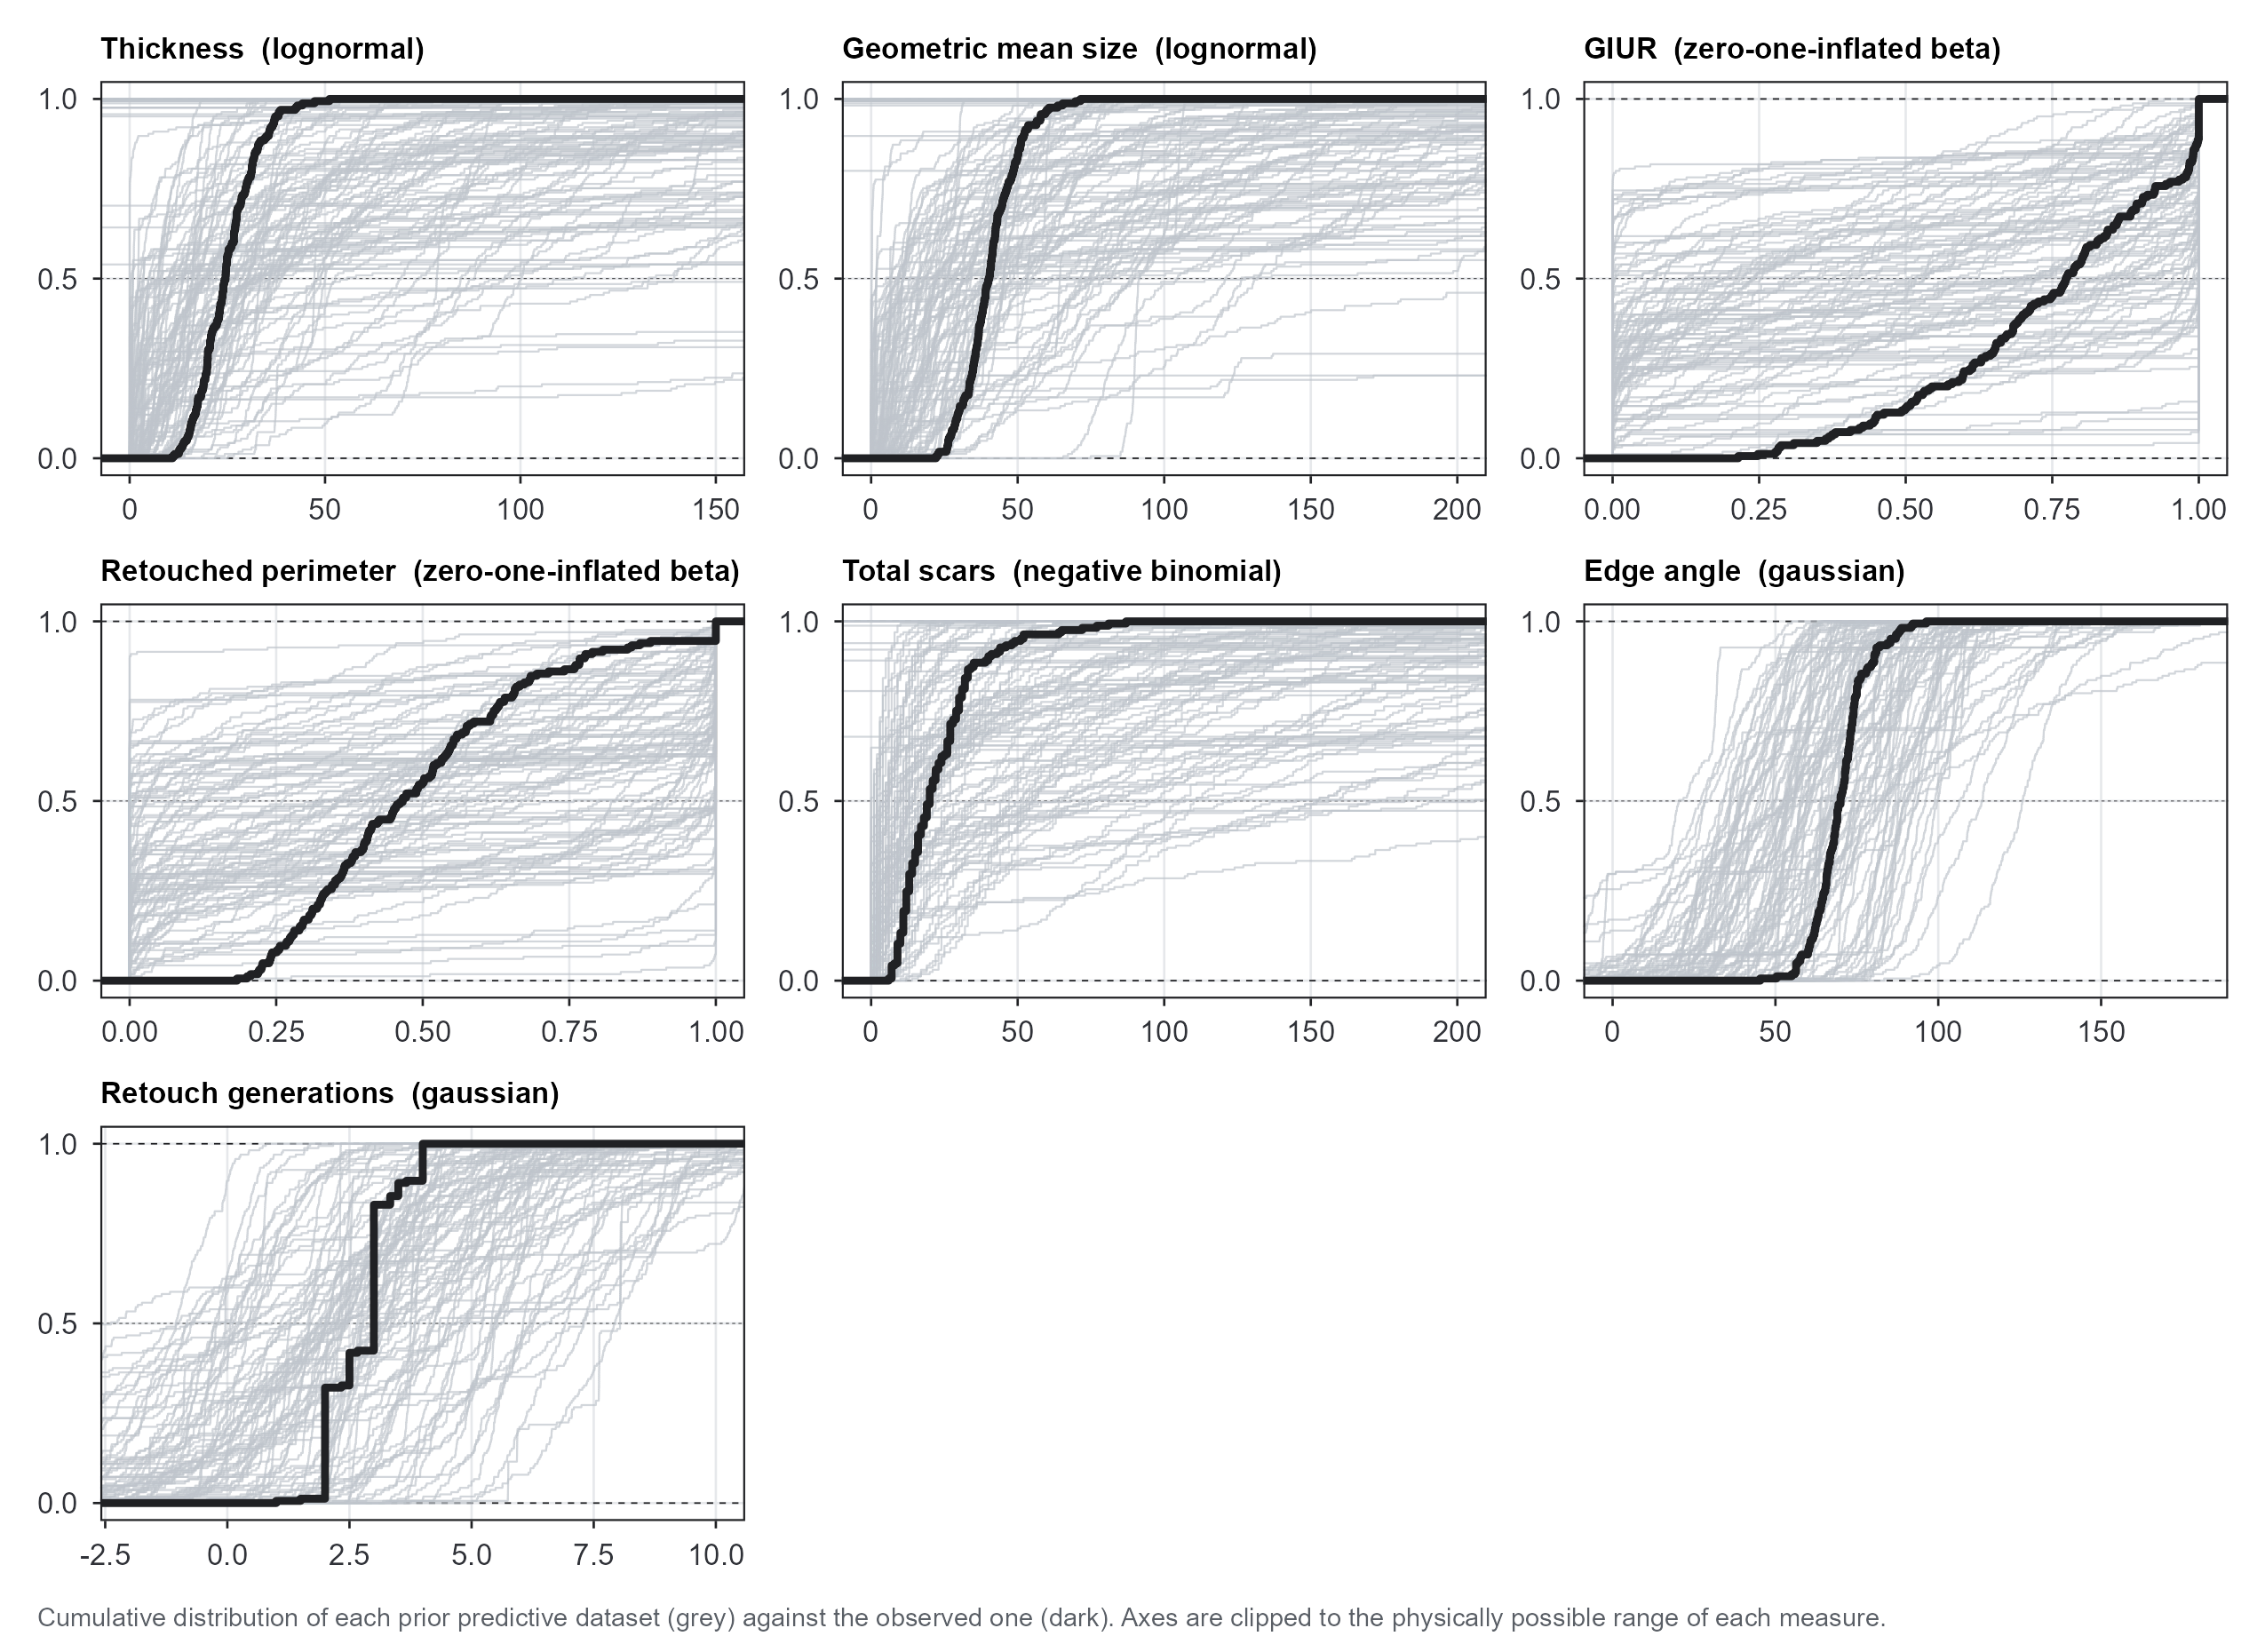
Figure 3: Prior predictive distributions (grey) against the observed distribution (dark), one panel per response. Axes are clipped to the physically possible range of each measure; the table below reports what falls outside.
Table 14: Prior predictive draws against the physically possible range of each measure. GIUR and the retouched perimeter cannot leave [0, 1] under the zero-one-inflated beta, so their zero is structural.
Response | physically possible range | prior-predictive median | prior-predictive 2.5% | prior-predictive 97.5% | % outside the possible range
Thickness | 0 - 150 | 24.67 | 0.06 | 19311.64 | 17.95
Geometric mean size | 0 - 250 | 42.77 | 0.06 | 24699.14 | 15.87
GIUR | 0 - 1 | 0.51 | 0.00 | 1.00 | 0.00
Retouched perimeter | 0 - 1 | 0.47 | 0.00 | 1.00 | 0.00
Total scars | 0 - 400 | 21.00 | 0.00 | 33562.70 | 11.59
Edge angle | 0 - 180 | 64.88 | 9.70 | 119.54 | 1.55
Retouch generations | 0 - 12 | 2.86 | -6.30 | 11.05 | 20.04

The prior predictive distributions are wide, deliberately so, since they encode ignorance about the effects; but they stay inside the possible range of every measure, and the prior passes.

11. Appendix D. Computation, Convergence and Resolution

11.1 Software and Settings
Cf. BARG Step 2.A.
Table 15: Computational settings. Chains, iterations, warmup, seed, sampler settings, brms and CmdStan are identical for all eleven runs. The R row lists every distinct R version in the cache; where it shows more than one, the cache was assembled over more than one session, and Table 12 gives the version each run was produced under. The backend is locked to cmdstanr: an rstan fit of the same model is not bit-for-bit reproducible against a cmdstanr fit, and the CmdStan version pins the C++ that sessionInfo() does not capture.
Item | Value
R | R version 4.6.1 (2026-06-24 ucrt)
brms | 2.23.0
Stan backend | cmdstanr
CmdStan | 2.39.0
posterior | 1.7.0
chains | 4
iterations per chain | 10000
warmup per chain | 5000
post-warmup draws | 20,000
seed | 2226
adapt_delta | 0.8 (default)
max_treedepth | 10 (default)

All results in this report come from the full run recorded above: 4 chains of 10,000 iterations and 20,000 post-warmup draws, rather than from a reduced pipeline test.

11.2 Chain Convergence
Cf. BARG Step 2.B.
For the reference fit: divergent transitions 0, iterations at maximum treedepth 0, largest $\hat{R}$ over all 256 estimated parameters 1.0013.
The conclusions rest on more than the reference fit: the intercept-only model supplies the Q1 comparison and the prior variants supply the sensitivity analysis. The same diagnostics therefore appear for all eleven runs.
Table 16: Diagnostics for all eleven runs, each of 20,000 post-warmup draws.
Fit | parameters | max Rhat | min bulk ESS | min tail ESS | divergent transitions | at max treedepth
ref | 256 | 1.0013 | 4255 | 4478 | 0 | 0
prior_ref | 256 | 1.0010 | 9280 | 9833 | 0 | 0
noland | 235 | 1.0007 | 6531 | 8380 | 4 | 0
s1 | 256 | 1.0009 | 4462 | 2935 | 2 | 0
s2 | 256 | 1.0013 | 4362 | 4242 | 0 | 0
s3 | 256 | 1.0010 | 4457 | 4793 | 1 | 0
s4 | 256 | 1.0011 | 4805 | 4135 | 1 | 0
s5 | 256 | 1.0009 | 4807 | 4733 | 0 | 0
s6 | 254 | 1.0011 | 4700 | 5480 | 0 | 0
ref_rg_ln | 256 | 1.0012 | 5173 | 5449 | 1 | 0
ref_basinx | 270 | 1.0010 | 5401 | 7066 | 0 | 0

5 of the eleven runs produced a small number of divergent transitions (noland: 4, s1: 2, s3: 1, s4: 1, ref_rg_ln: 1) against 20,000 draws each, which is at most 0.020% of the transitions in any run. Two observations bear on how much weight to put on them: the affected runs’ Rhat and ESS are indistinguishable from the clean ones, and their posteriors coincide with the reference in Figure 12. The usual explanation for divergences at this rate in a hierarchical model with 26 clusters and a 7 x 7 correlation matrix is mild curvature in the posterior near zero variance, but this report has not located them in parameter space and so offers that as an inference rather than as a demonstration. All eleven runs are reported here in full.
Table 16 reduces each run to its worst value on each diagnostic, which is the right summary for deciding whether a run is usable and the wrong one for seeing how the chains behaved. Figure 4 shows the chains themselves for the reference fit. It uses rank plots rather than trace plots, on the argument of Vehtari, Gelman, Simpson, et al. (2021), who introduced the $\hat{R}$ this report quotes and proposed the rank plot alongside it: with 20,000 draws a trace plot is an unreadable band of ink, whereas ranking the draws across chains and counting each chain’s share of each rank bin stays legible at any chain length and exposes chains that differ in location or in scale.
The 9 quantities in the figure are chosen by a rule fixed in the code rather than by inspection. The seven ICCs are there because Q1 rests on them and because the smallest effective sample size anywhere in the analysis is one of them (Section 11.3). The rest are the sampled parameter with the lowest bulk ESS, the sampled parameter with the lowest tail ESS, and the log posterior density, which come to 2 panels because one parameter is worst on both counts. A reader expecting the figure to reveal a problem will be disappointed, which is its purpose: with $\hat{R}$ at 1.0013 and 0 divergent transitions the chains should look interchangeable, and the figure lets a reader confirm that instead of taking the summary on trust.
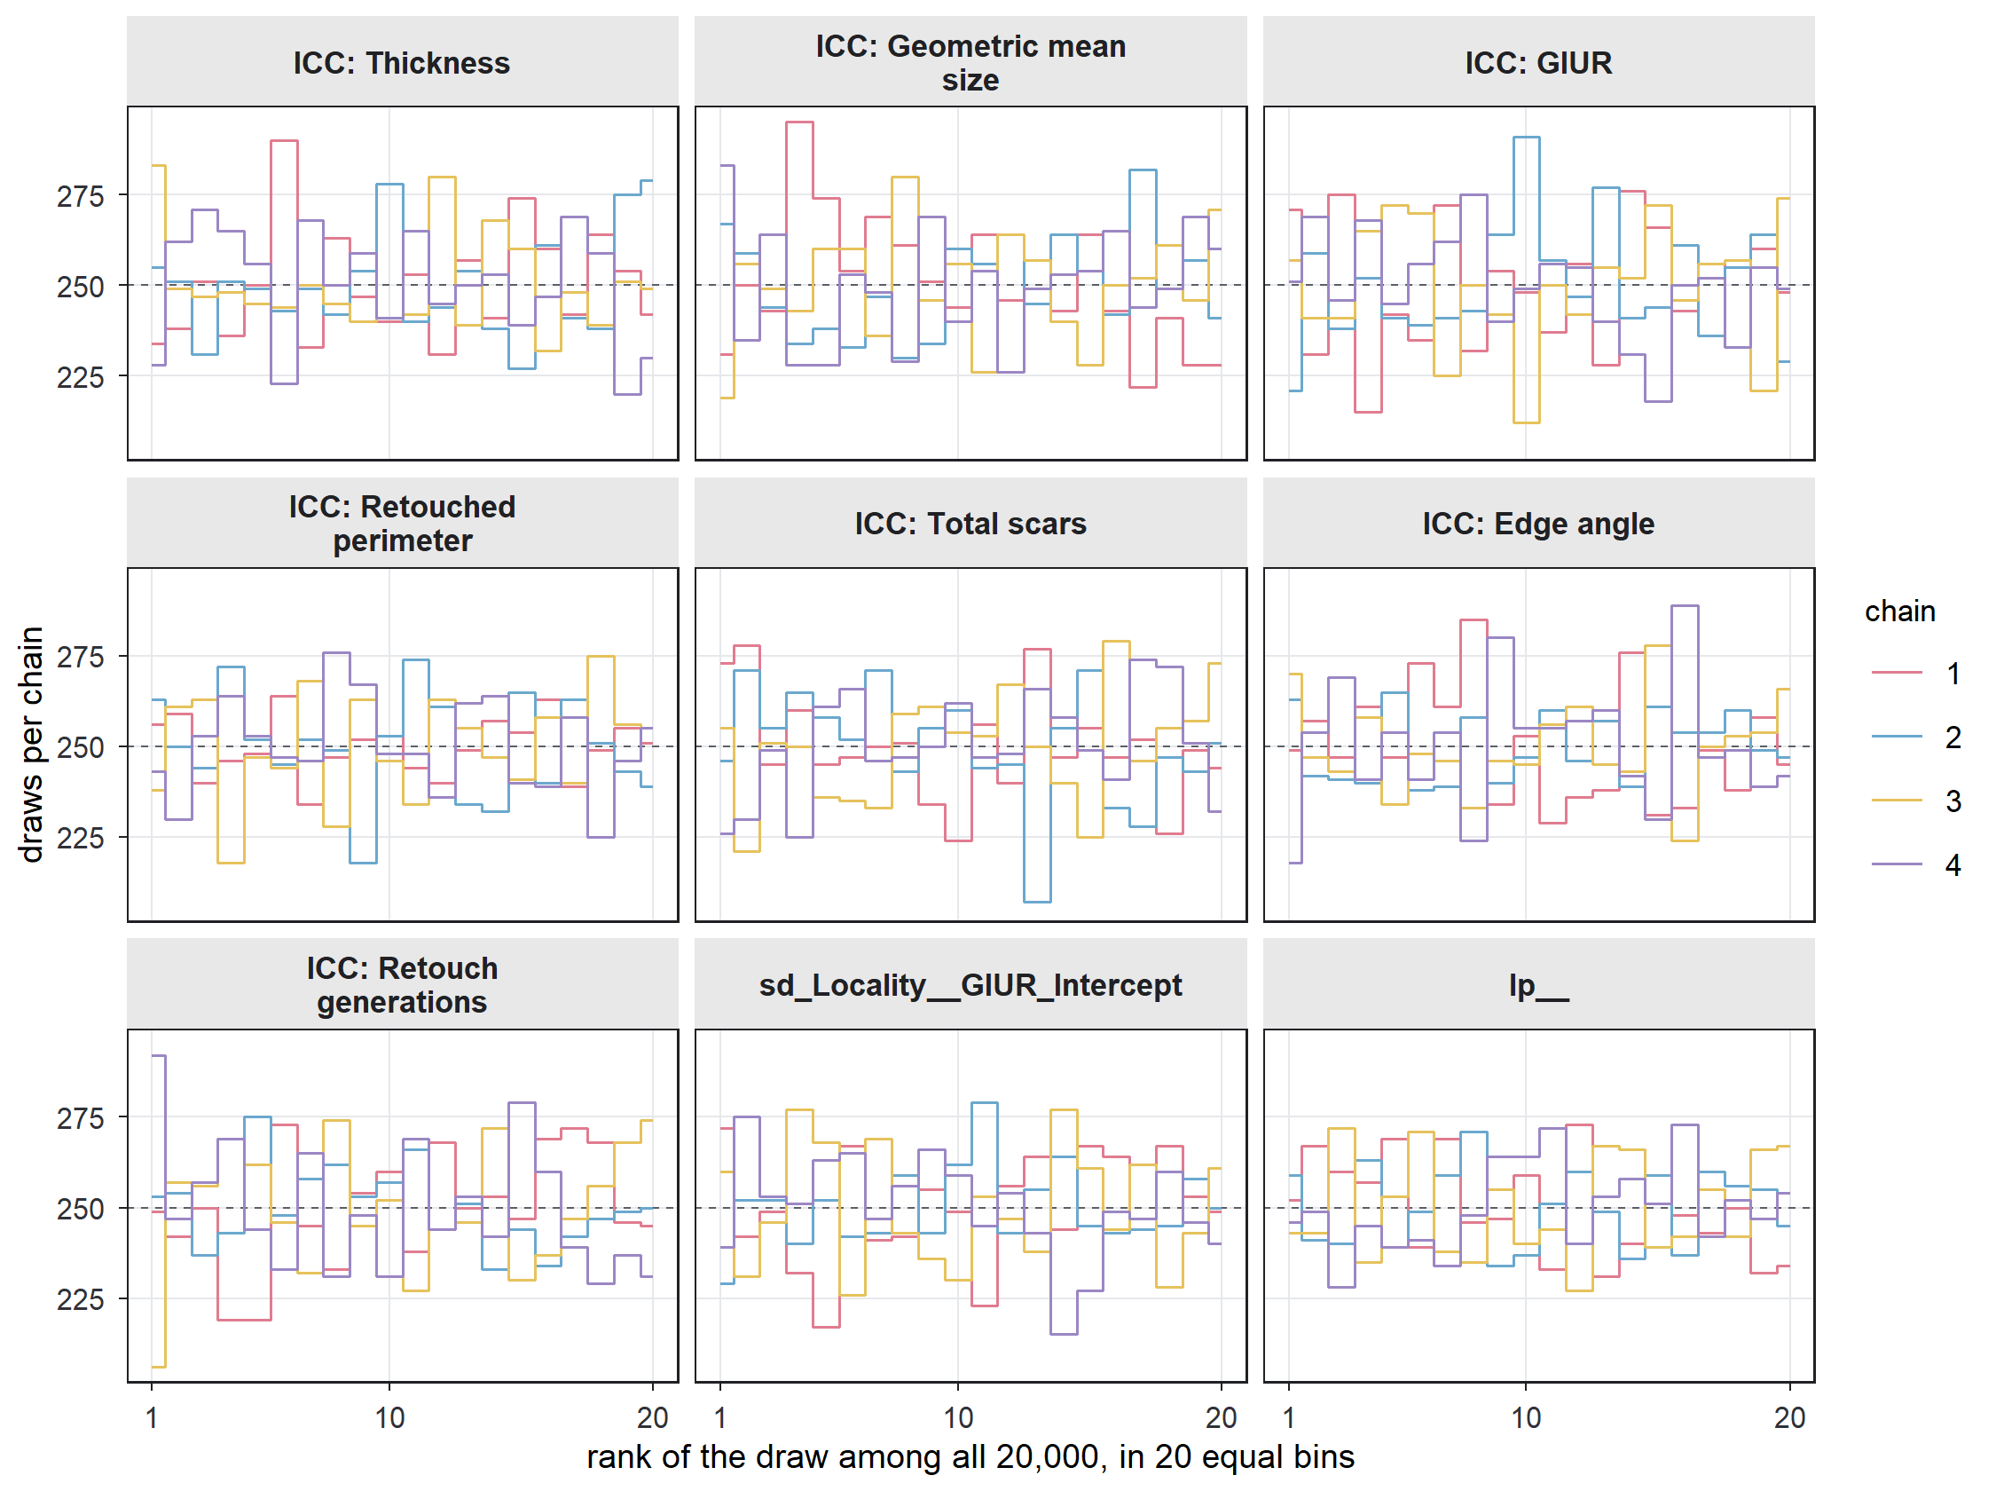
Figure 4: Rank plots for the reference fit. The draws of each quantity are pooled across the four chains and ranked; each line counts how many of one chain’s draws fall in each of 20 equal rank bins. Under convergence every chain contributes an equal share of every bin, so the four lines should be flat and overlapping around the dashed expected count. A chain running high at one end of the axis and low at the other has explored a different part of the distribution from the others. The seven ICCs are derived draw by draw and diagnosed exactly like sampled parameters; the remaining panels are the log posterior density and the sampled parameters with the lowest bulk and tail effective sample sizes.
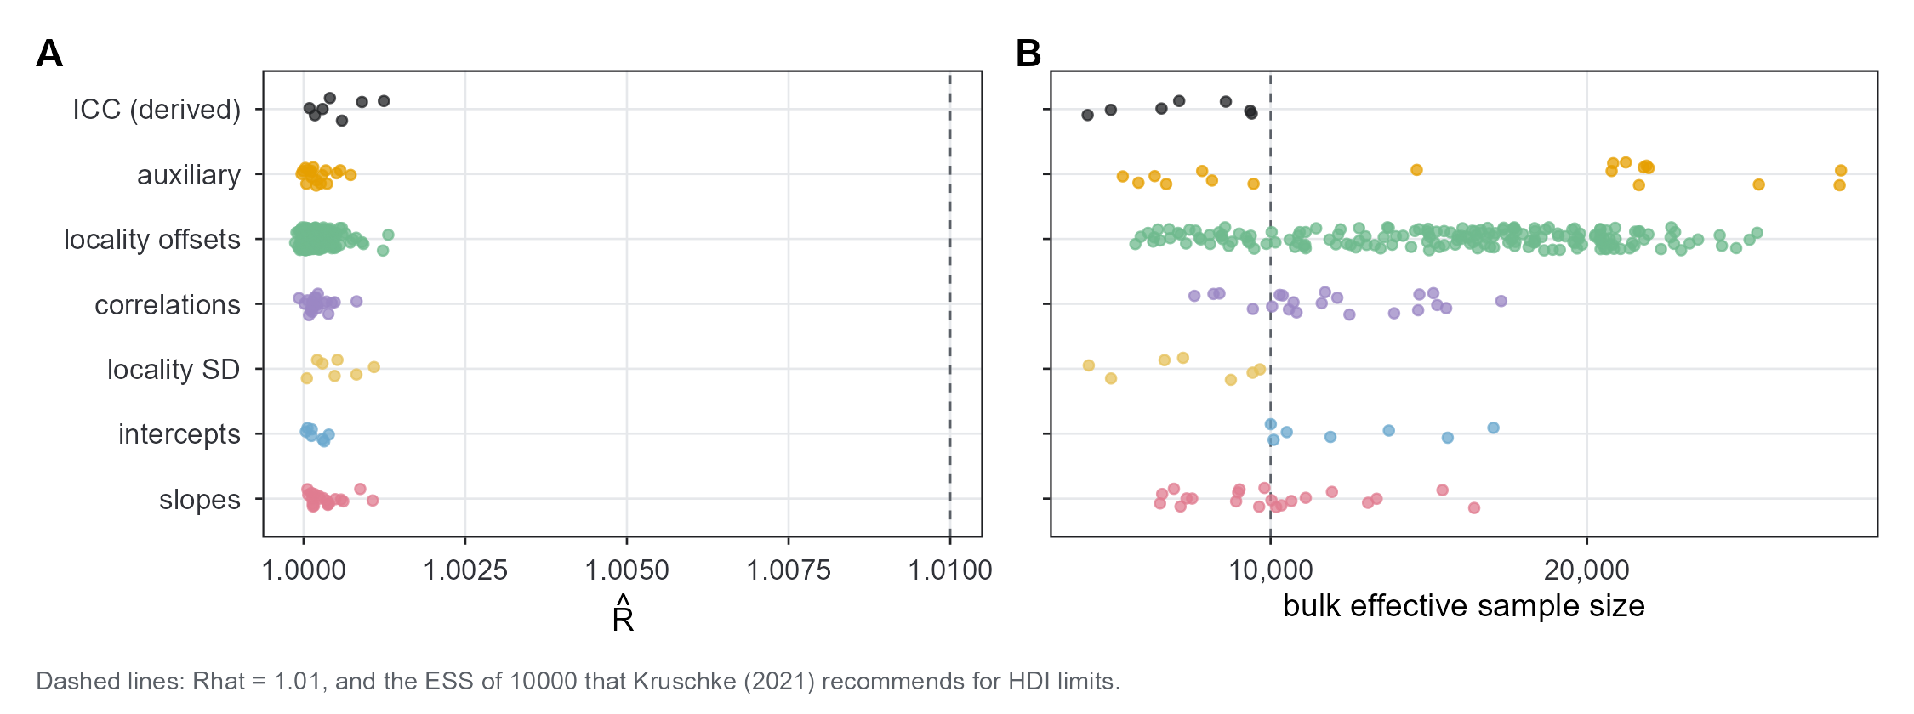
Figure 5: Rhat (A) and bulk effective sample size (B) for every estimated parameter, and for the seven ICCs, which are derived quantities computed draw by draw and diagnosed like any other.

11.3 Chain Resolution
Cf. BARG Step 2.C.
Kruschke (2021) suggests an ESS of about 10,000, with the explicit qualification that the figure aims at the stability of HDI limits and that quantile-based limits are less demanding. This report is quantile-based throughout (Section 13), so it gives both: the ESS, and the Monte Carlo standard error of each quantile it reports.
The diagnostics below are computed over all 263 quantities of the fitted model, the 21 slopes, the intercepts, the auxiliary parameters, the locality SDs, the locality offsets and the locality-intercept correlations, together with the seven derived ICCs. Figure 5 plots R-hat and effective sample size for every one of them; the per-parameter table, with the Monte Carlo standard error of each quantile, is deposited with the archive (Section 7).
Smallest bulk ESS: 4,221 (ICC_GIUR); smallest tail ESS: 4,478. 68 of the 263 quantities have a bulk ESS below Kruschke’s 10,000, so the recommendation is not met everywhere even at 20,000 draws. What matters for a quantile-based report is the Monte Carlo error of the quantiles themselves. The largest MCSE of a reported median, as a fraction of that parameter’s own posterior SD, is 0.0158 (ICC_RG), so the simulation noise in the numbers this report quotes is about 63 times smaller than the posterior uncertainty it describes. The archive (Section 7) carries the per-parameter MCSEs for anyone who wants to check a particular one.

11.4 How Many Digits the Simulation Supports
Gelman, Vehtari, McElreath, et al. (2026, sec. 11.6) argue that the number of digits to report should follow from the Monte Carlo error and the posterior uncertainty rather than from a printing default, taking two significant digits as the usual answer; Section 11.3 has already computed the Monte Carlo standard error of every quantile this report quotes, so the rule can be applied to this document rather than merely cited.
Each of the 263 quantities has two ceilings: the decimal places the Monte Carlo error leaves alone, which run from 1 to 3 with a median of 2 and bind first for 46 quantities, and two significant digits of the posterior’s own SD, which binds first for the other 217. The tables print three decimal places by default while 253 of the 263 quantities support fewer, and no single digits setting would fix that, because the ceiling varies across rows measured on three different link scales. Where one figure has to be chosen, two decimal places is what the rule endorses for a typical quantity here, and it is what the summaries in Section 1 and Table 21 use.

11.5 What This Report Does Not Check: Calibration
Convergence diagnostics establish that the sampler explored the posterior of the model that was coded, not that the coded model is the one intended or that the posterior it returns is calibrated. Simulation-based calibration checking (Modrák, Moon, Kim, et al. 2025) is the tool for that, and this report does not perform it. Cost is the weaker of the two reasons: one fit of this model takes about 5 minutes on the machine that produced this document, taking the median over the eleven runs of Table 12, so the few hundred refits a calibration check needs come to roughly 0.9 days of continuous computation and less than that in parallel, which is affordable. The real objection is that calibration checking draws its parameters from the prior, so it checks the model where the prior puts its mass; the intercept priors here are deliberately wide, spanning 6 to 100 mm of thickness and 26 to 104 degrees of edge angle before the data are seen (Table 8), datasets simulated from them would include assemblages no lithic analyst would recognise, and calibration verified over that range says little about the much narrower region the posterior actually occupies. Gelman, Vehtari, McElreath, et al. (2026, sec. 14.3) identify exactly this tension and point to posterior SBC (Säilynoja, Schmitt, Bürkner and Vehtari 2026), which conditions the simulation on the observed data and so checks calibration where the answers live, recommending it in particular when convergence diagnostics show only faint signs of trouble – the position of the 5 runs in Table 16 with a handful of divergent transitions. Posterior SBC on the reference fit is therefore the computational check this analysis most clearly still owes, and a reader should treat the evidence in this appendix as evidence about the sampler rather than about the calibration of the model.

12. Appendix E. Posterior Predictive Checks
Cf. BARG Step 3.A. Kruschke (2021) treats this check as a precondition for reporting parameter estimates at all.
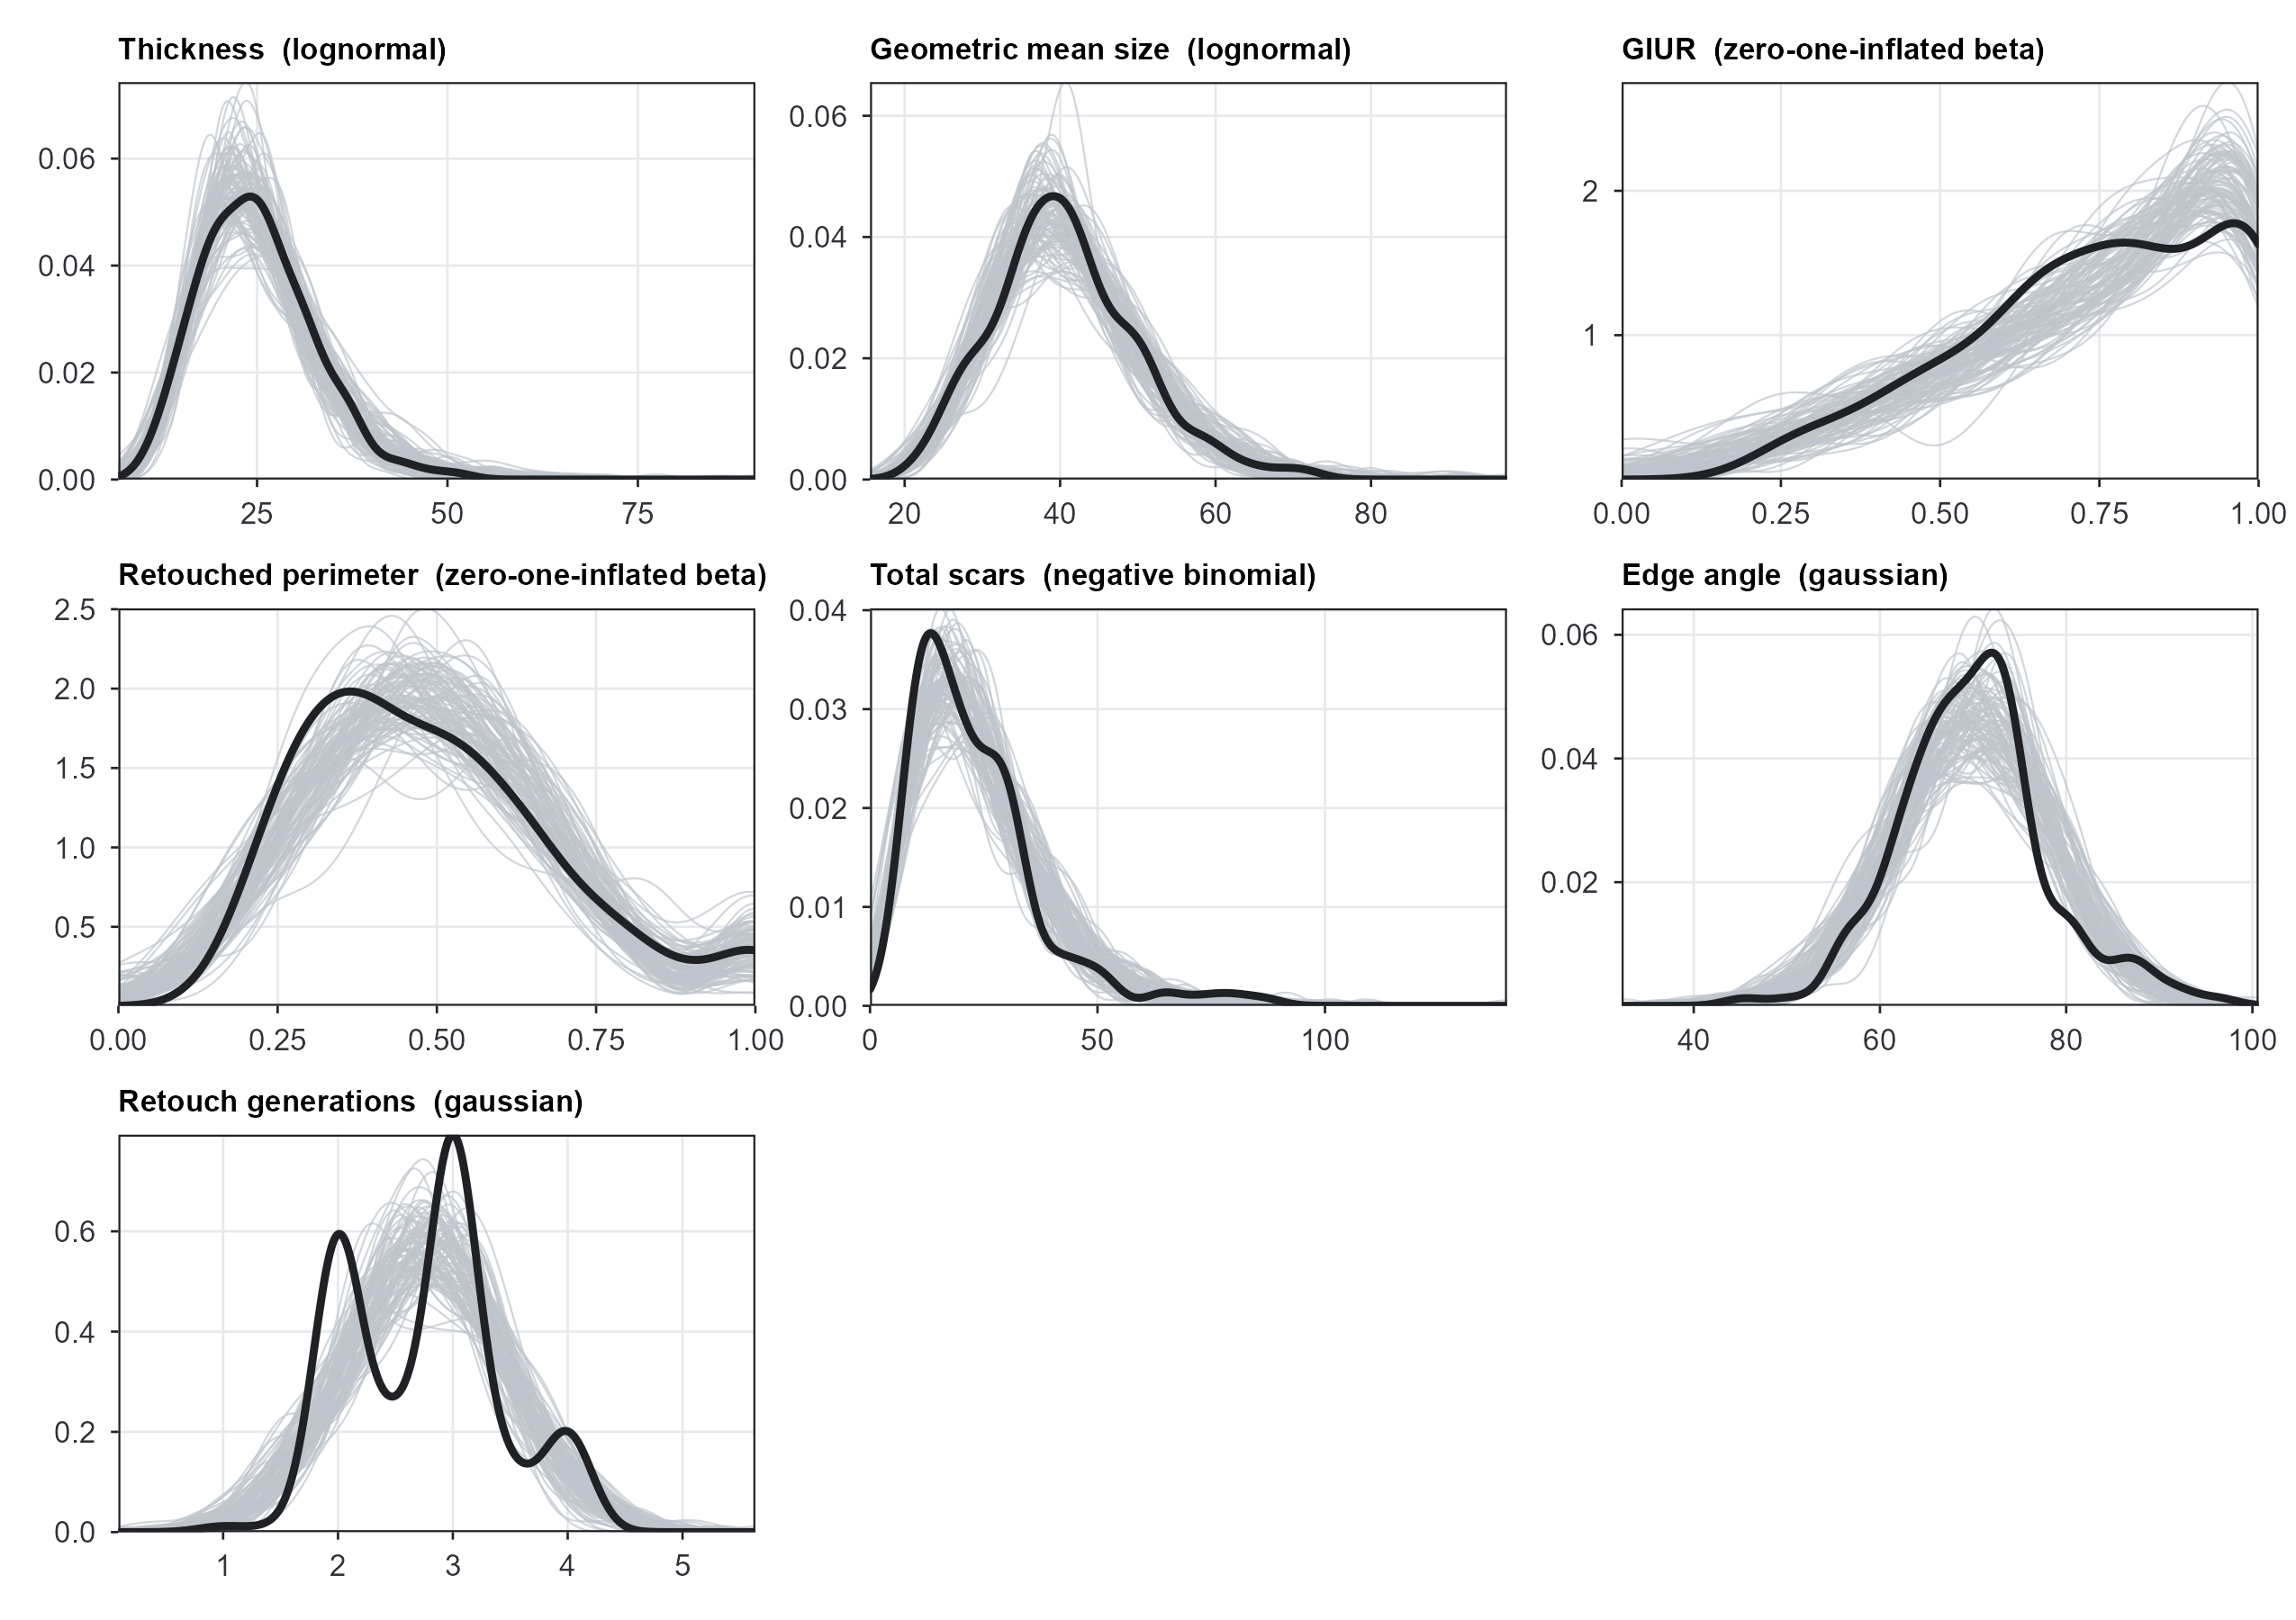
Figure 6: Posterior predictive distributions (grey, 100 draws) against the observed distribution (dark), one panel per response.
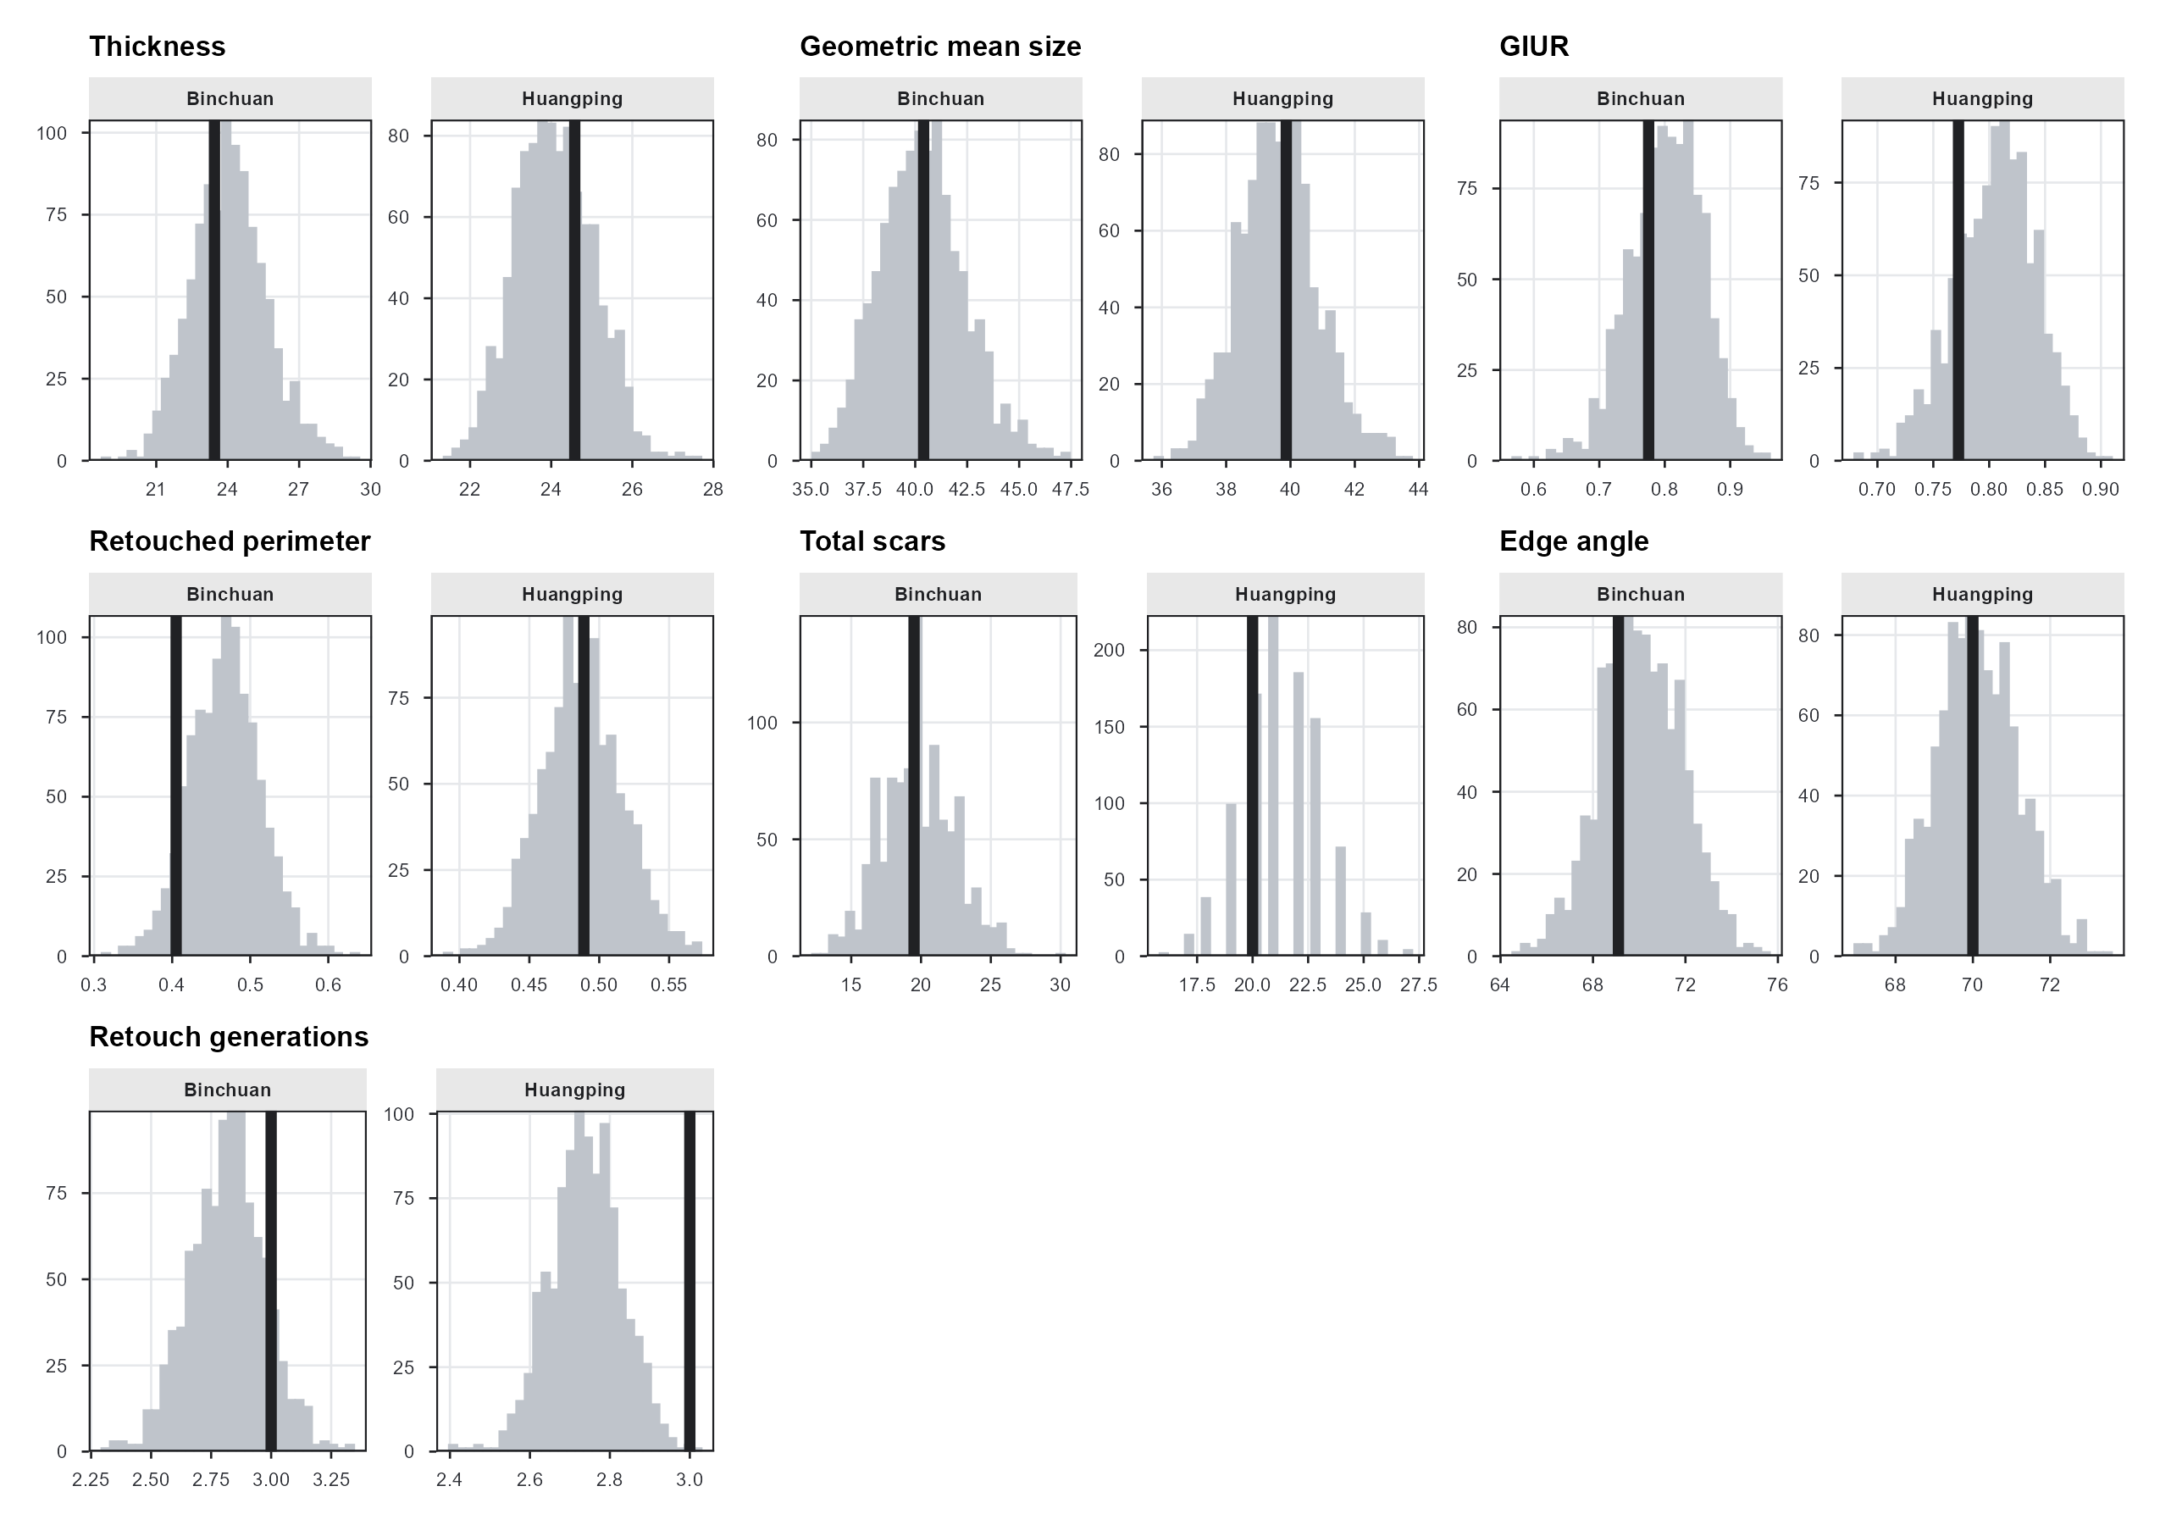
Figure 7: Posterior predictive check by basin: the observed median of each response within each basin, against the distribution of that same statistic in the replicated datasets.

12.1 The Checks That Were Specified in Advance
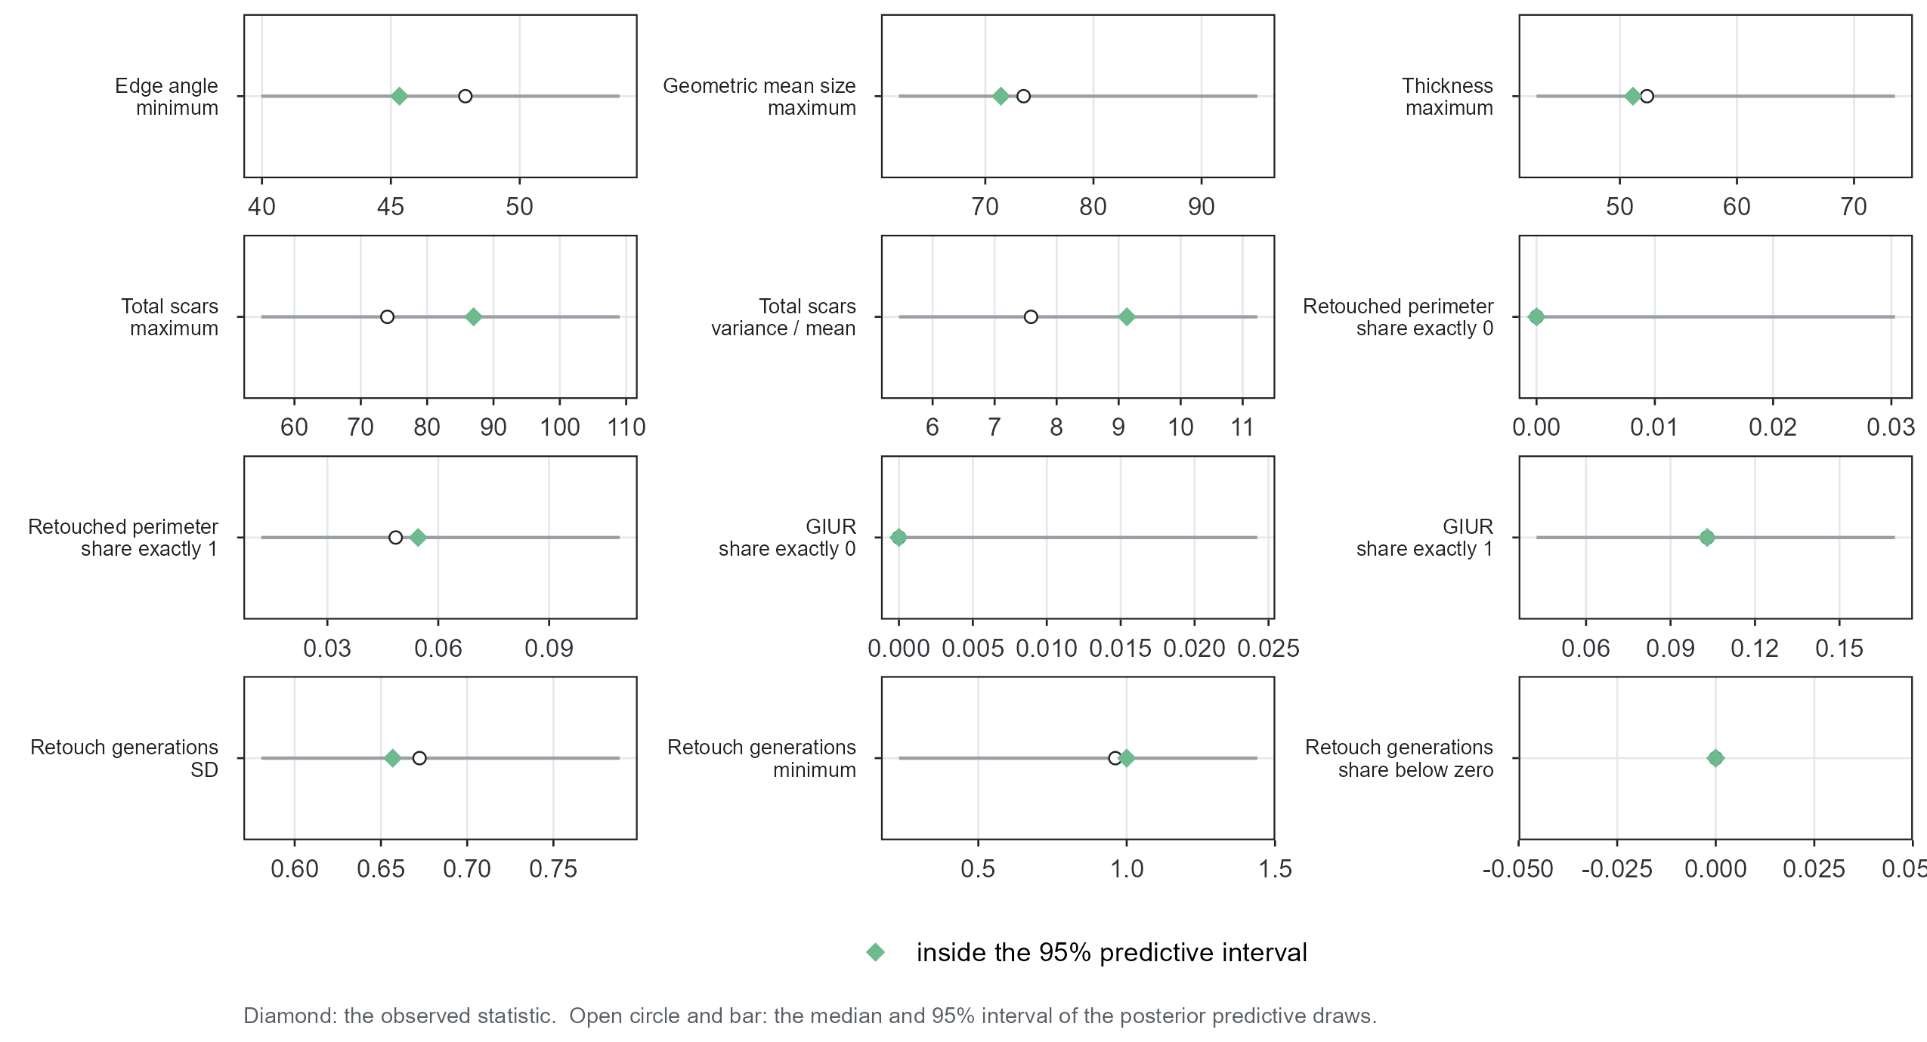
Figure 8: Targeted posterior predictive statistics. Diamond: the observed value. Open circle and bar: the median and 95% interval of the same statistic over the replicated datasets. Green means the observation falls inside the interval.

12.1.1 Does the Gaussian Likelihood for Retouch Generations Predict Negative Values?
The observed share of retouch-generation values below zero is 0.000; over the replicated datasets the share has median 0.000 and 95% interval [0.000, 0.000]. The observed minimum is 1.00 against a replicated interval of [0.23, 1.44]. The gaussian’s support extends below zero, while the fitted mean sits far enough above it relative to the residual SD that the model rarely generates impossible values in practice. The gaussian misses the discreteness instead: retouch generations are recorded as a small number of counted generations averaged over at most three edges, so the observed distribution is a spike train and the replicated one is smooth. Figure 6 shows it, and it is a real limitation of the family, though it leaves a location parameter unbiased.
The check is a judgement call rather than a pass or a failure, so the ref_rg_ln fit refits the same response as a lognormal for comparison (Section 5), letting a reader see directly whether the choice of family moves the conclusions:
Table 17: Retouch generations: the reference gaussian fit against a lognormal refit of the same response. Both are shown on their own standardised axis, so the ROPE is +/- 0.1 in each case.
Family | Predictor | standardised median | 2.5% | 97.5% | % in ROPE | Verdict
gaussian (reference) | Basin (Huangping vs Binchuan) | -0.291 | -0.806 | 0.219 | 16.155 | undecided
lognormal (comparison) | Basin (Huangping vs Binchuan) | -0.275 | -0.888 | 0.362 | 16.265 | undecided
gaussian (reference) | Distance to channel (z) | 0.264 | -0.096 | 0.596 | 13.070 | undecided
lognormal (comparison) | Distance to channel (z) | 0.266 | -0.195 | 0.692 | 15.580 | undecided
gaussian (reference) | Height above channel (z) | 0.147 | -0.071 | 0.370 | 31.970 | undecided
lognormal (comparison) | Height above channel (z) | 0.168 | -0.084 | 0.431 | 26.925 | undecided

12.1.2 Do the Zero-One-Inflated Beta Fits Reproduce the Pile-Up at 1?
For GIUR the observed share of exact ones is 0.103 against a replicated interval of [0.042, 0.170]; for the retouched perimeter, 0.055 against [0.012, 0.109]. The share of exact zeros is 0 in the data and 0 in the replications. That agreement shows only that the zero-inflation half of the family is estimating a probability the data have pinned at essentially zero, and says nothing about whether the model captures zero inflation. See the note in Section 4.4.

12.1.3 Is the Overdispersion of the Scar Count Captured?
The observed variance-to-mean ratio is 9.13, well above the value of 1 a Poisson would imply; the replicated interval is [5.46, 11.24]. The negative binomial captures it.

13. Appendix F. Full Posterior Summaries
Cf. BARG Step 3.B.
Every interval in this report is a 95% equal-tailed (percentile) credible interval, running from the 2.5th to the 97.5th posterior percentile, and every point summary in the text is the posterior median. That is the quantile-based convention, and this document keeps to it throughout: the density-based pair, the posterior mode and the 95% highest-density interval, is not tabulated alongside. A reader who prefers that pair can compute it from the draws, which are deposited with the archive (Section 7). Section 11.4 says how many of the printed decimal places the simulation supports.
Table 18: The 21 landscape slopes in full, each with the decision it supports beside the estimate, the interval and the ROPE mass that decision rests on. The first interval is on the response’s own link scale; the std interval divides by the link-scale SD of the response, which is the axis the 0.1 ROPE is defined on. ‘Direction certainty’ is max(P(beta > 0), P(beta < 0)): 0.5 means the posterior is split evenly about zero, 1.0 that the sign is certain. ‘Min ROPE’ is the smallest ROPE half-width at which the 95% interval would have fitted entirely inside, translated into the response’s own units (Section 6.3.1).
Response | Predictor | Link | median [95% ETI], link scale | std median [95% ETI] | % in ROPE | direction certainty | min ROPE, response scale | Verdict
Thickness | Basin (Huangping vs Binchuan) | log | -0.062 [-0.241, 0.123] | -0.21 [-0.81, 0.42] | 20.3 | 0.756 | +/- 27.3 % | undecided
Thickness | Height above channel (z) | log | -0.007 [-0.085, 0.069] | -0.03 [-0.29, 0.23] | 55.9 | 0.581 | +/- 8.9 % | undecided
Thickness | Distance to channel (z) | log | 0.080 [-0.043, 0.212] | 0.27 [-0.14, 0.71] | 15.9 | 0.907 | +/- 23.6 % | undecided
Geometric mean size | Basin (Huangping vs Binchuan) | log | -0.068 [-0.219, 0.086] | -0.30 [-0.96, 0.38] | 16.0 | 0.821 | +/- 24.5 % | undecided
Geometric mean size | Height above channel (z) | log | -0.026 [-0.090, 0.035] | -0.12 [-0.40, 0.15] | 39.8 | 0.803 | +/- 9.4 % | undecided
Geometric mean size | Distance to channel (z) | log | 0.037 [-0.069, 0.146] | 0.16 [-0.30, 0.64] | 26.7 | 0.763 | +/- 15.7 % | undecided
GIUR | Basin (Huangping vs Binchuan) | logit | -0.047 [-0.760, 0.656] | -0.02 [-0.39, 0.33] | 45.8 | 0.558 | +/- 113.9 % in the odds | undecided
GIUR | Height above channel (z) | logit | 0.021 [-0.261, 0.313] | 0.01 [-0.13, 0.16] | 83.5 | 0.561 | +/- 36.7 % in the odds | undecided
GIUR | Distance to channel (z) | logit | -0.043 [-0.597, 0.398] | -0.02 [-0.30, 0.20] | 62.5 | 0.581 | +/- 81.7 % in the odds | undecided
Retouched perimeter | Basin (Huangping vs Binchuan) | logit | -0.008 [-0.340, 0.311] | -0.00 [-0.22, 0.20] | 65.5 | 0.520 | +/- 40.5 % in the odds | undecided
Retouched perimeter | Height above channel (z) | logit | 0.003 [-0.134, 0.142] | 0.00 [-0.09, 0.09] | 97.0 | 0.521 | +/- 15.3 % in the odds | accept the null value
Retouched perimeter | Distance to channel (z) | logit | 0.098 [-0.090, 0.300] | 0.06 [-0.06, 0.20] | 71.9 | 0.865 | +/- 35.0 % in the odds | undecided
Total scars | Basin (Huangping vs Binchuan) | log | -0.070 [-0.420, 0.279] | -0.12 [-0.75, 0.50] | 24.0 | 0.665 | +/- 52.2 % | undecided
Total scars | Height above channel (z) | log | 0.037 [-0.103, 0.185] | 0.07 [-0.18, 0.33] | 51.1 | 0.701 | +/- 20.3 % | undecided
Total scars | Distance to channel (z) | log | 0.109 [-0.151, 0.353] | 0.19 [-0.27, 0.63] | 23.3 | 0.818 | +/- 42.4 % | undecided
Edge angle | Basin (Huangping vs Binchuan) | identity | -2.501 [-6.859, 1.735] | -0.31 [-0.85, 0.21] | 15.4 | 0.882 | +/- 6.9 degrees | undecided
Edge angle | Height above channel (z) | identity | 0.792 [-0.988, 2.704] | 0.10 [-0.12, 0.33] | 46.8 | 0.808 | +/- 2.7 degrees | undecided
Edge angle | Distance to channel (z) | identity | 2.712 [-0.199, 5.620] | 0.34 [-0.02, 0.70] | 8.1 | 0.969 | +/- 5.6 degrees | undecided
Retouch generations | Basin (Huangping vs Binchuan) | identity | -0.191 [-0.530, 0.144] | -0.29 [-0.81, 0.22] | 16.2 | 0.874 | +/- 0.5 generations | undecided
Retouch generations | Height above channel (z) | identity | 0.096 [-0.047, 0.243] | 0.15 [-0.07, 0.37] | 32.0 | 0.909 | +/- 0.2 generations | undecided
Retouch generations | Distance to channel (z) | identity | 0.173 [-0.063, 0.391] | 0.26 [-0.10, 0.60] | 13.1 | 0.938 | +/- 0.4 generations | undecided

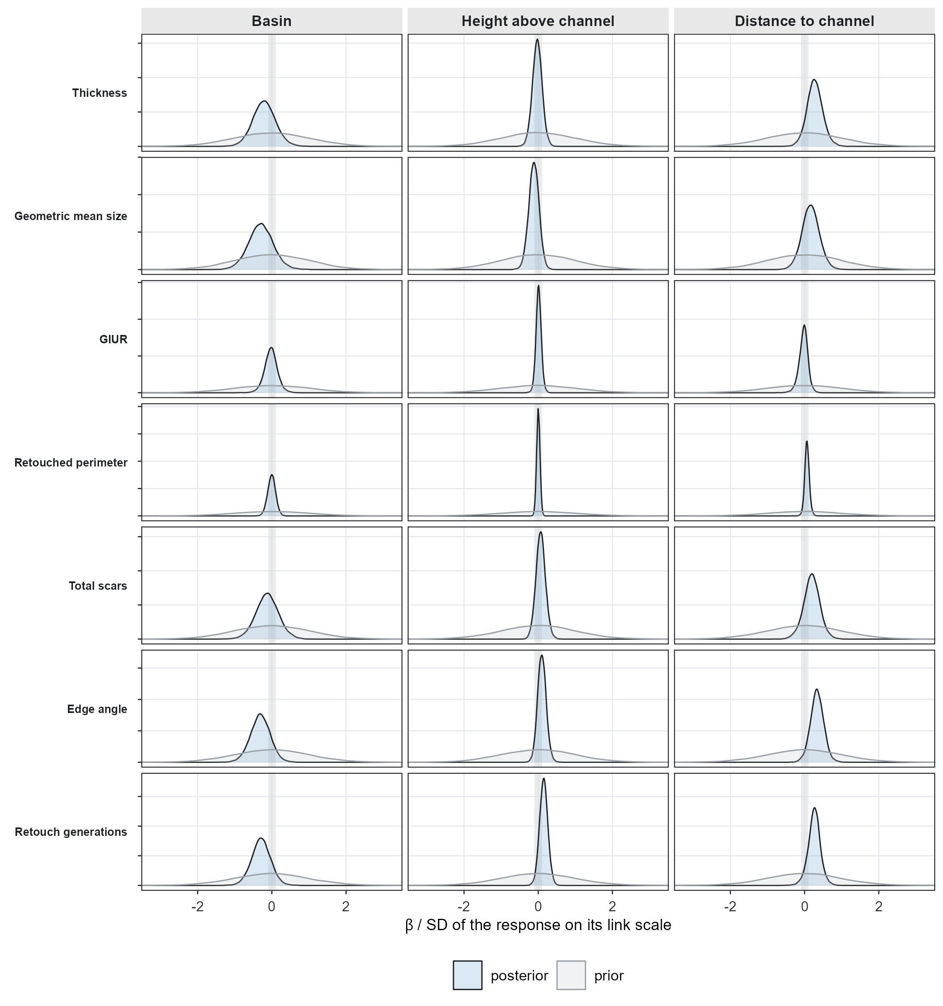
Figure 9: Prior (grey) against posterior (blue) for every slope, on the standardised axis. The shaded band is the ROPE. Where the two curves nearly coincide, the data have said little.

13.1 Locality-Level Variance and Correlation Structure
Cf. BARG Step 3.B, for the parameters that answer Q1.
The intraclass correlation is ${ICC}^{(r)}=σ_{u}^{(r)2}/(σ_{u}^{(r)2}+σ_{\text{resid}}^{(r)2})$, computed draw by draw so that it acquires a full posterior. The residual variance is taken on the link scale, and its form depends on the family: $σ^{2}$ for the gaussian and lognormal responses; $log(1+1/μ+1/\text{shape})$ evaluated at the intercept for the negative binomial; and, for the two zero-one-inflated beta responses, $ψ^{′}(μϕ)+ψ^{′}((1−μ)ϕ)$, the logit-scale variance of the beta component. For those two the ICC therefore describes the beta component alone and ignores the inflation (Section 4.4).
Table 19: Locality SD and intraclass correlation, with diagnostics for the derived quantity.
Response | Family | locality SD | SD 2.5% | SD 97.5% | ICC median | 2.5% | 97.5% | P(ICC > 0.05) | Rhat | ESS bulk | Verdict
Geometric mean size | lognormal | 0.132 | 0.077 | 0.211 | 0.293 | 0.120 | 0.519 | 0.999 | 1.001 | 9403 | locality variation present
Total scars | negative binomial | 0.269 | 0.121 | 0.484 | 0.230 | 0.054 | 0.494 | 0.979 | 1.001 | 8587 | locality variation present
Thickness | lognormal | 0.147 | 0.071 | 0.256 | 0.221 | 0.059 | 0.470 | 0.983 | 1.000 | 7112 | locality variation present
Edge angle | gaussian | 3.014 | 1.387 | 5.538 | 0.143 | 0.032 | 0.368 | 0.933 | 1.000 | 9356 | undecided
Retouch generations | gaussian | 0.203 | 0.021 | 0.478 | 0.093 | 0.001 | 0.370 | 0.696 | 1.000 | 4953 | undecided
GIUR | zero-one-inflated beta | 0.470 | 0.089 | 1.039 | 0.091 | 0.003 | 0.380 | 0.702 | 1.001 | 4221 | undecided
Retouched perimeter | zero-one-inflated beta | 0.146 | 0.011 | 0.377 | 0.037 | 0.000 | 0.209 | 0.398 | 1.000 | 6554 | undecided

13.2 The 21 Locality-Intercept Correlations
Cf. BARG Step 1.B and 3.B. These 21 parameters are part of the model and no research question is about them, so they are reported here rather than in the main narrative.
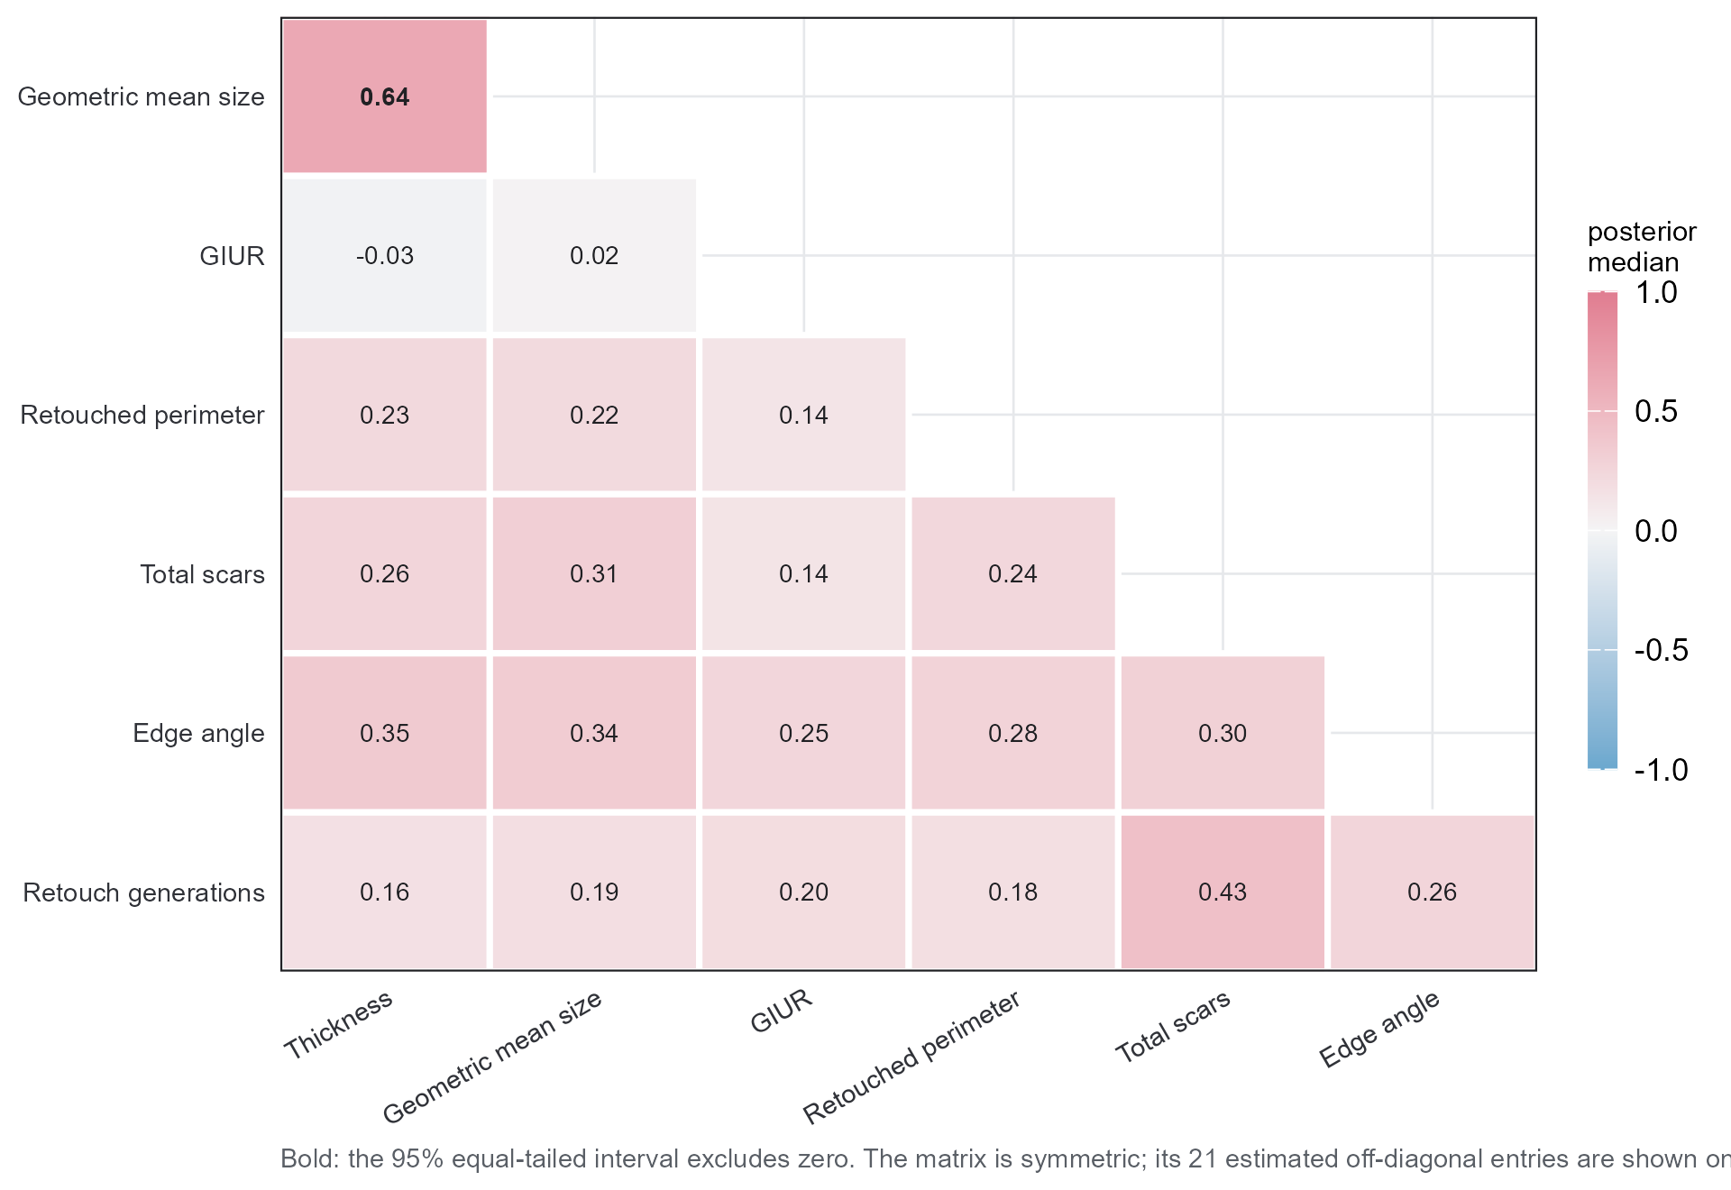
Figure 10: Posterior median of each of the 21 locality-intercept correlations. Bold entries are those whose 95% equal-tailed interval excludes zero.
With 26 clusters these 21 parameters are weakly identified; the lkj(1) prior is uniform over correlation matrices and S5 varies it (Section 14.2). Their posterior draws, from which medians, intervals and per-parameter diagnostics follow, are deposited with the archive (Section 7).
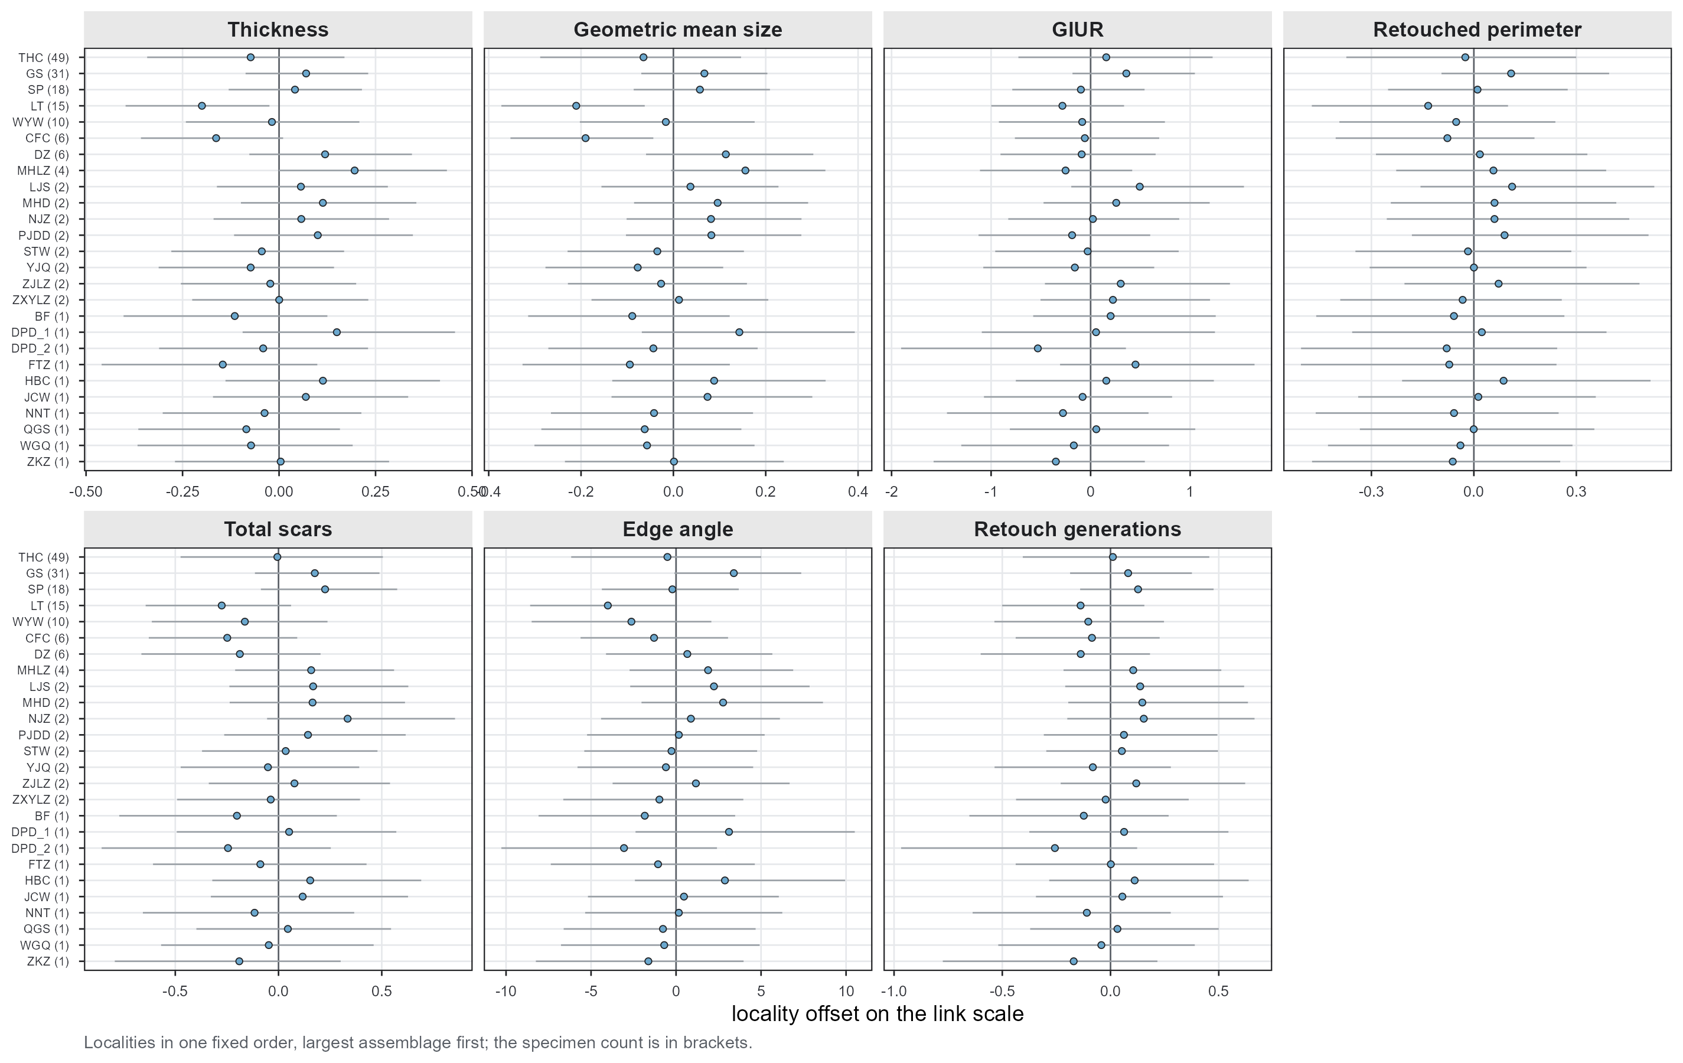
Figure 11: Locality offsets on the link scale, one panel per response, with 95% equal-tailed intervals. Localities are in one fixed order in every panel, largest assemblage first, with the specimen count in brackets. Reading down each panel shows partial pooling at work: the smaller the assemblage, the harder the offset is pulled towards zero and the wider its interval.

14. Appendix G. Sensitivity Analysis in Full
Cf. BARG Step 5.
Seven fits, identical in every respect except the prior, each changing one element of the reference specification. A full factorial would have made any movement impossible to attribute, so the design here changes one thing at a time (Section 5). S1 is the unscaled normal(0, 1) slope prior discussed in Section 4.5, which is also the specification paper/_analysis.R uses for the main paper’s summary tables (Section 7).
S6 differs in kind from the rest. S1 to S5 vary how much the data are allowed to say about a quantity the report decides on; S6 removes a parameter the data cannot inform, so its curves in Figure 12 and Figure 13 coincide with the reference by construction (Section 4.4.3).
Table 20: The seven prior specifications. REF is the reference; each of S1 to S6 changes exactly one line of it.
Fit | Prior change | Rationale
REF | b: normal(0, SD_link); sd: student_t(3, 0, 2); cor: lkj(1) | reference
S1 | b: normal(0, 1) | the original specification, kept for comparison
S2 | b: normal(0, 2.5 x SD_link) | slopes two and a half times wider
S3 | sd: exponential(1) | locality SD; 26 clusters make this prior influential
S4 | sd: normal(0, 1) truncated at zero | locality SD, a lighter tail than the half-t
S5 | cor: lkj(2) | 26 clusters and 21 correlations; lkj(2) shrinks towards zero
S6 | coi: constant(1) | one-inflated beta; there are no zeros for coi to describe

14.1 Broad Prior
Cf. BARG Step 5.A.
S2 widens every slope prior by a factor of 2.5, to normal(0, 2.5 x SD_link). This is the broad prior the guideline asks for: if the posterior barely moves when the prior becomes two and a half times more permissive, the result rests on the data instead of on the prior. S3 and S4 play the same role for the locality SD, and S5 for the correlation matrix.

14.2 Variations of the Default Priors
Cf. BARG Step 5.C.
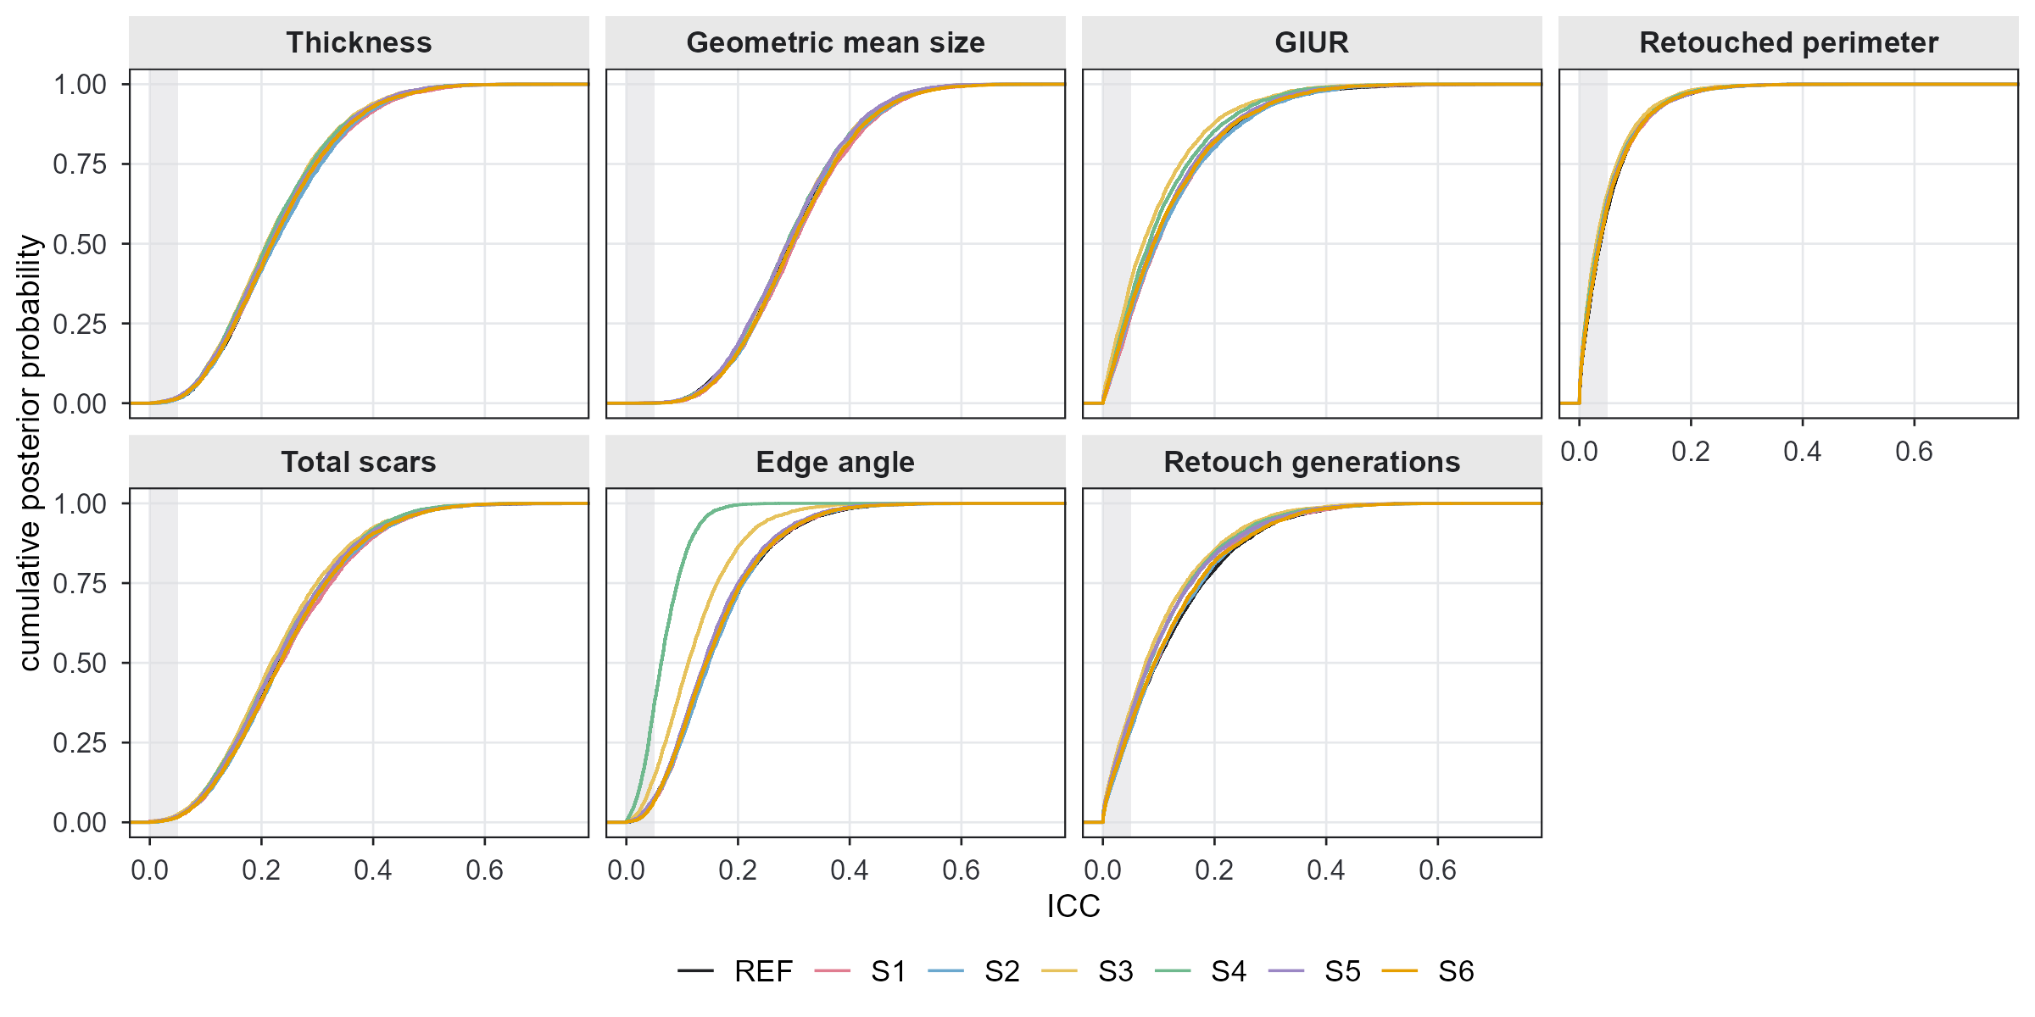
Figure 12: Q1 under all seven priors: the cumulative posterior distribution of each ICC. The shaded band is the ICC ROPE [0, 0.05]. A curve’s height where it crosses the right edge of the band is P(ICC <= 0.05).
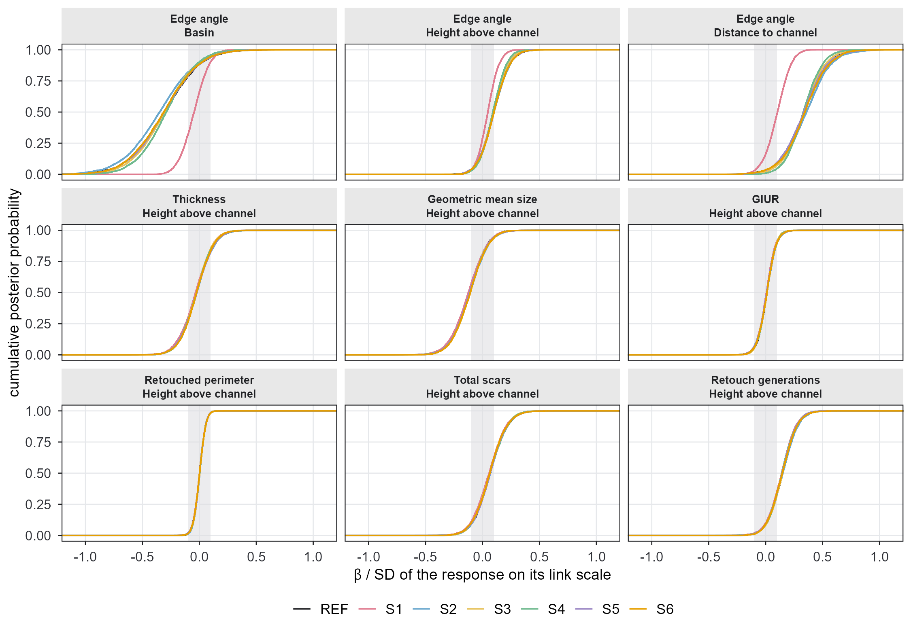
Figure 13: Q2 under all seven priors, for the slopes most exposed to the prior: the three edge-angle slopes (the response that was prior-dominated under the original specification) and the height slope of every response. Cumulative distributions on the standardised axis, with the ROPE shaded.
The curves are cumulative distributions rather than densities, because this report’s summaries are quantiles: a horizontal slice at 0.025 and 0.975 reads off the interval limits directly, and the vertical distance between two curves at the ROPE edge is the change in the quantity the decision rule uses.
BARG asks for the numbers as well as the pictures, and for every parameter rather than only the plotted ones:
Table 21: Posterior median and 95% equal-tailed interval for every ICC and every slope, under each of the seven priors. Slopes are standardised by the link-scale SD of their response.
Quantity | REF | S1 | S2 | S3 | S4 | S5 | S6
ICC: Thickness | 0.22 [0.06, 0.47] | 0.22 [0.06, 0.48] | 0.23 [0.06, 0.48] | 0.21 [0.06, 0.45] | 0.21 [0.06, 0.46] | 0.21 [0.06, 0.46] | 0.22 [0.06, 0.47]
ICC: Geometric mean size | 0.29 [0.12, 0.52] | 0.30 [0.13, 0.53] | 0.30 [0.12, 0.53] | 0.29 [0.12, 0.51] | 0.29 [0.12, 0.51] | 0.29 [0.12, 0.51] | 0.29 [0.12, 0.53]
ICC: GIUR | 0.09 [0.00, 0.38] | 0.10 [0.00, 0.37] | 0.10 [0.00, 0.38] | 0.07 [0.00, 0.33] | 0.08 [0.00, 0.34] | 0.09 [0.00, 0.37] | 0.09 [0.00, 0.37]
ICC: Retouched perimeter | 0.04 [0.00, 0.21] | 0.04 [0.00, 0.21] | 0.04 [0.00, 0.21] | 0.03 [0.00, 0.19] | 0.03 [0.00, 0.20] | 0.03 [0.00, 0.20] | 0.04 [0.00, 0.21]
ICC: Total scars | 0.23 [0.05, 0.49] | 0.24 [0.06, 0.50] | 0.24 [0.06, 0.50] | 0.22 [0.05, 0.48] | 0.22 [0.06, 0.48] | 0.23 [0.05, 0.49] | 0.23 [0.06, 0.49]
ICC: Edge angle | 0.14 [0.03, 0.37] | 0.14 [0.03, 0.36] | 0.14 [0.03, 0.36] | 0.11 [0.02, 0.30] | 0.06 [0.01, 0.16] | 0.14 [0.03, 0.36] | 0.14 [0.03, 0.36]
ICC: Retouch generations | 0.09 [0.00, 0.37] | 0.10 [0.00, 0.37] | 0.10 [0.00, 0.37] | 0.08 [0.00, 0.34] | 0.08 [0.00, 0.35] | 0.08 [0.00, 0.36] | 0.09 [0.00, 0.37]
Thickness ~ Basin (Huangping vs Binchuan) | -0.21 [-0.81, 0.42] | -0.19 [-0.85, 0.48] | -0.25 [-0.91, 0.44] | -0.21 [-0.81, 0.41] | -0.21 [-0.80, 0.42] | -0.21 [-0.81, 0.41] | -0.21 [-0.81, 0.42]
Thickness ~ Height above channel (z) | -0.03 [-0.29, 0.23] | -0.03 [-0.30, 0.22] | -0.02 [-0.29, 0.24] | -0.02 [-0.28, 0.22] | -0.03 [-0.28, 0.23] | -0.02 [-0.28, 0.24] | -0.02 [-0.28, 0.23]
Thickness ~ Distance to channel (z) | 0.27 [-0.14, 0.71] | 0.23 [-0.20, 0.72] | 0.30 [-0.13, 0.78] | 0.27 [-0.14, 0.71] | 0.27 [-0.15, 0.70] | 0.27 [-0.16, 0.72] | 0.28 [-0.14, 0.72]
Geometric mean size ~ Basin (Huangping vs Binchuan) | -0.30 [-0.96, 0.38] | -0.28 [-1.00, 0.43] | -0.34 [-1.08, 0.37] | -0.30 [-0.95, 0.36] | -0.30 [-0.96, 0.36] | -0.30 [-0.96, 0.37] | -0.29 [-0.95, 0.39]
Geometric mean size ~ Height above channel (z) | -0.12 [-0.40, 0.15] | -0.12 [-0.41, 0.14] | -0.11 [-0.39, 0.16] | -0.11 [-0.39, 0.15] | -0.12 [-0.39, 0.15] | -0.12 [-0.39, 0.16] | -0.11 [-0.39, 0.16]
Geometric mean size ~ Distance to channel (z) | 0.16 [-0.30, 0.64] | 0.12 [-0.36, 0.66] | 0.19 [-0.29, 0.71] | 0.16 [-0.30, 0.64] | 0.16 [-0.29, 0.65] | 0.16 [-0.30, 0.66] | 0.17 [-0.30, 0.67]
GIUR ~ Basin (Huangping vs Binchuan) | -0.02 [-0.39, 0.33] | -0.01 [-0.34, 0.33] | -0.03 [-0.41, 0.33] | -0.03 [-0.36, 0.30] | -0.03 [-0.37, 0.30] | -0.03 [-0.38, 0.32] | -0.03 [-0.39, 0.32]
GIUR ~ Height above channel (z) | 0.01 [-0.13, 0.16] | 0.01 [-0.14, 0.15] | 0.01 [-0.14, 0.15] | 0.01 [-0.13, 0.15] | 0.01 [-0.13, 0.15] | 0.01 [-0.14, 0.16] | 0.01 [-0.13, 0.15]
GIUR ~ Distance to channel (z) | -0.02 [-0.30, 0.20] | -0.04 [-0.32, 0.17] | -0.02 [-0.31, 0.21] | -0.02 [-0.27, 0.19] | -0.02 [-0.29, 0.20] | -0.02 [-0.29, 0.20] | -0.02 [-0.30, 0.20]
Retouched perimeter ~ Basin (Huangping vs Binchuan) | -0.00 [-0.22, 0.20] | 0.00 [-0.21, 0.21] | -0.01 [-0.23, 0.20] | -0.01 [-0.22, 0.20] | -0.01 [-0.22, 0.20] | -0.00 [-0.22, 0.20] | -0.01 [-0.22, 0.21]
Retouched perimeter ~ Height above channel (z) | 0.00 [-0.09, 0.09] | 0.00 [-0.09, 0.09] | 0.00 [-0.09, 0.09] | 0.00 [-0.09, 0.09] | 0.00 [-0.09, 0.09] | 0.00 [-0.09, 0.09] | 0.00 [-0.09, 0.09]
Retouched perimeter ~ Distance to channel (z) | 0.06 [-0.06, 0.20] | 0.06 [-0.08, 0.19] | 0.07 [-0.06, 0.20] | 0.06 [-0.06, 0.19] | 0.07 [-0.06, 0.19] | 0.06 [-0.06, 0.20] | 0.06 [-0.06, 0.20]
Total scars ~ Basin (Huangping vs Binchuan) | -0.12 [-0.75, 0.50] | -0.10 [-0.77, 0.54] | -0.16 [-0.85, 0.49] | -0.14 [-0.75, 0.45] | -0.13 [-0.76, 0.47] | -0.14 [-0.76, 0.47] | -0.13 [-0.75, 0.48]
Total scars ~ Height above channel (z) | 0.07 [-0.18, 0.33] | 0.06 [-0.19, 0.33] | 0.07 [-0.18, 0.33] | 0.06 [-0.18, 0.32] | 0.06 [-0.18, 0.32] | 0.07 [-0.19, 0.33] | 0.07 [-0.19, 0.33]
Total scars ~ Distance to channel (z) | 0.19 [-0.27, 0.63] | 0.16 [-0.32, 0.62] | 0.21 [-0.26, 0.68] | 0.20 [-0.26, 0.62] | 0.19 [-0.26, 0.64] | 0.20 [-0.25, 0.63] | 0.20 [-0.26, 0.64]
Edge angle ~ Basin (Huangping vs Binchuan) | -0.31 [-0.85, 0.21] | -0.05 [-0.27, 0.17] | -0.35 [-0.92, 0.20] | -0.31 [-0.81, 0.18] | -0.29 [-0.74, 0.14] | -0.32 [-0.84, 0.22] | -0.32 [-0.85, 0.22]
Edge angle ~ Height above channel (z) | 0.10 [-0.12, 0.33] | 0.05 [-0.12, 0.21] | 0.10 [-0.12, 0.34] | 0.10 [-0.12, 0.31] | 0.09 [-0.10, 0.29] | 0.10 [-0.12, 0.33] | 0.10 [-0.12, 0.34]
Edge angle ~ Distance to channel (z) | 0.34 [-0.02, 0.70] | 0.10 [-0.11, 0.30] | 0.36 [-0.02, 0.74] | 0.34 [0.01, 0.67] | 0.33 [0.06, 0.61] | 0.34 [-0.03, 0.70] | 0.34 [-0.02, 0.71]
Retouch generations ~ Basin (Huangping vs Binchuan) | -0.29 [-0.81, 0.22] | -0.28 [-0.82, 0.25] | -0.32 [-0.88, 0.22] | -0.30 [-0.81, 0.20] | -0.29 [-0.81, 0.21] | -0.29 [-0.81, 0.21] | -0.29 [-0.82, 0.21]
Retouch generations ~ Height above channel (z) | 0.15 [-0.07, 0.37] | 0.14 [-0.08, 0.36] | 0.15 [-0.07, 0.38] | 0.14 [-0.07, 0.36] | 0.14 [-0.08, 0.37] | 0.15 [-0.08, 0.37] | 0.15 [-0.07, 0.37]
Retouch generations ~ Distance to channel (z) | 0.26 [-0.10, 0.60] | 0.24 [-0.14, 0.58] | 0.28 [-0.09, 0.63] | 0.27 [-0.07, 0.59] | 0.26 [-0.09, 0.59] | 0.26 [-0.08, 0.60] | 0.27 [-0.10, 0.61]

14.3 Do the Conclusions Change?
Cf. BARG Step 5.E. Some movement is inevitable, so the criterion is whether the numbers moved enough, relative to the width of the posterior interval and relative to the ROPE, to change a conclusion.
Section 6.5 gives the summary and quotes the largest movement of a posterior median across the seven priors. The table here gives the detail behind the decisions: what each quantity is judged to be under each prior. Table 21 above supplies the estimates those judgements come from.
Table 22: The 1 of 28 quantities whose decision is not the same under all seven priors, with the decision each receives under each. The remaining 27 take the same decision throughout and are omitted; Table 21 gives the estimates behind every one of them.
Quantity | REF | S1 | S2 | S3 | S4 | S5 | S6
ICC: Total scars | locality variation present | locality variation present | locality variation present | undecided | locality variation present | locality variation present | locality variation present

15. Appendix H. BARG Conformance
Kruschke (2021) sets out a checklist for reporting a Bayesian analysis. The table below places every item on it against the section that answers it. The same checklist can be walked from the other direction: each section of this document opens with a shaded box naming the item it addresses.
This table sits at the end rather than at the front because the narrative of this document follows the order of the work rather than the order of the checklist (Section 1). A reader auditing coverage should start here; a reader following the argument will have passed every row already.
BARG item | How it is addressed | Where
Preamble A. Why a Bayesian approach is used | Seven responses on three link scales share one locality-level structure in a single model; derived quantities acquire genuine intervals; a null value can be accepted rather than merely not rejected; no large-sample approximation is needed in a design with few clusters | Section 4.1
Preamble B. The goals of the analysis | Estimation of each landscape effect and of the locality variance, and decisions about null values. Prediction and model comparison are not goals | Section 4.2
1.A. Data variables, their roles and types | Seven responses, three locality-level predictors, one grouping factor, with the observed range of each; the complete-case filter is audited step by step; the estimand and the design that produced the sample are stated separately | Section 3, Section 4.3, Table 1, Table 2
1.B. The likelihood and its parameters, separating those of theoretical interest from nuisance parameters | One multivariate model over four distributional families, with the linear predictor written out; the slopes and the locality SDs answer the questions, the intercepts, dispersion parameters and 21 correlations do not | Section 4.4, Table 4
1.C. The prior distribution and its justification | Every class given an explicit prior, the slope prior scaled to each response’s own link-scale SD, with the share of prior mass inside each response’s ROPE as the argument for scaling it | Section 4.5, Section 8
1.D. Formal specification of the model | The brms formula and the complete generated Stan program | Section 9
1.E. Prior predictive check | The reference prior refitted with sample_prior = "only", and the simulated data checked against the physically possible range of each measure | Section 10, Table 14
2.A. Software, versions and settings | R, brms, backend and CmdStan versions, chains, iterations, warmup, seed, adapt_delta and max_treedepth, for all eleven runs | Section 11.1, Table 15
2.B. MCMC chain convergence | R-hat, divergent transitions and treedepth saturation, for the reference fit and for all eleven runs, with rank plots of the chains behind the reference fit | Section 11.2, Table 16, Figure 4
2.C. MCMC chain resolution | Bulk and tail effective sample size for every parameter and every derived ICC, plotted in Figure 5; the smallest of each and the largest Monte Carlo standard error of a reported median, as a fraction of that parameter’s own posterior SD, quoted over all of them, with the per-parameter table deposited in the archive; an audit of how many decimal places that error supports | Section 11.3, Section 11.4, Figure 5
2.D. Accuracy of any approximation used in place of exact sampling | Not applicable: every posterior in this document is a full MCMC sample, with no variational, Laplace or INLA approximation anywhere | Not applicable
3.A. Posterior predictive check | Full predictive distributions, a check of the within-basin medians, and test statistics fixed in advance | Section 12, Section 12.1, Figure 8
3.B. Summary of the posterior of every parameter | Posterior median and 95% equal-tailed interval – the quantile-based convention this document keeps to throughout – for the 21 slopes, the seven locality SDs and ICCs, and the 21 correlations; the draws are deposited with the archive for a reader who prefers density-based summaries | Section 13, Table 18, Section 13.1, Section 13.2, Figure 10
3.C. Bayes factors and posterior model probabilities | Not applicable: no model comparison is performed, so no marginal likelihood, no bridge sampling and no Bayes factor appears anywhere in this document | Not applicable (Section 4.2)
4.A. The decision procedure and its rule | Kruschke’s (2018) three-way decision (reject, accept, undecided) against a region of practical equivalence | Section 6.1
4.B. The loss or utility function, where decisions are made by formal decision theory | Not applicable: no cost attaches to being wrong about a landscape slope, so no loss function is specified; the ROPE curve reports the whole family of decisions instead of committing to one | Not applicable (Section 6.1.1)
4.C. ROPE limits and their justification | Half-width 0.1 of each response’s link-scale SD, with the convention acknowledged and the posterior mass reported as a continuous function of the half-width | Section 6.1.1, Figure 2
4.D. Bayes-factor decision thresholds | Not applicable: no Bayes factor is used, so no threshold on one is needed | Not applicable (Section 4.2)
4.E. Each decision reported with the estimate and interval it rests on | Every decision table gives the median, the 95% interval, the posterior mass inside the ROPE and the verdict in the same row | Section 6.2, Table 9, Section 6.3, Table 18
5.A. Sensitivity to a broad prior | S2 widens every slope prior by a factor of 2.5; S3, S4 and S5 do the same job for the locality SD and for the correlation matrix | Section 14.1, Table 20
5.B. Sensitivity to a genuinely informed prior drawn from previous research | Not applicable: no published posterior or meta-analytic estimate exists for any of these seven measures in Quina assemblages, so no informed prior can be built; the gap is discussed where the priors are set out | Not applicable (Section 4.5)
5.C. Variations of the default priors | Six fits, each differing from the reference in exactly one prior, with every ICC and every slope reported under all seven specifications; the eleven fits and the purpose of each are set out together | Section 5, Section 14.2, Table 21
5.D. Sensitivity of the Bayes factor to the prior | Not applicable: no Bayes factor is computed. The item is singled out in the guideline because Bayes factors are prior-dependent in a way posterior estimates are not, which is part of why this analysis is framed as estimation | Not applicable (Section 4.2)
5.E. Whether the conclusions change | The decision each quantity receives under each of the seven priors, and the largest movement of a posterior median relative to that quantity’s own interval width; and, for the one structural question the design can pose, whether the landscape slopes differ between the two basins | Section 6.5, Section 6.4, Section 14.3
6. Reproducibility of data, code and computational environment | Software versions, the file list, the archive DOI, a synthetic dataset for the case where the specimens cannot be released, run instructions and sessionInfo() | Section 7

15.1 What the Checklist Does Not Ask For
Three parts of this document answer to the second standard rather than to this one, and a reader auditing BARG coverage will not find rows for them. Section 3 states the estimand and the design before any model appears, so that the resolution of both research questions is fixed in the open rather than inferred from wide intervals later. Section 5 sets out all eleven fits together with the reason each exists, including the two that record a defect the analysis found in itself. Section 11.5 says which computational check this report has not performed, why, and what a follow-up should do instead. None of the three is required by Kruschke (2021), and each is standard in Gelman, Vehtari, McElreath, et al. (2026).

16. References
Bürkner, P.-C. (2017). brms: An R package for Bayesian multilevel models using Stan. Journal of Statistical Software, 80(1), 1–28.
Gelman, A., Vehtari, A., & McElreath, R., with Simpson, D., Margossian, C. C., Yao, Y., Kennedy, L., Gabry, J., Bürkner, P.-C., Modrák, M., & Leos Barajas, V. (2026). Bayesian Workflow. CRC Press.
Kruschke, J. K. (2018). Rejecting or accepting parameter values in Bayesian estimation. Advances in Methods and Practices in Psychological Science, 1(2), 270–280.
Kruschke, J. K. (2021). Bayesian analysis reporting guidelines. Nature Human Behaviour, 5, 1282–1291.
Modrák, M., Moon, A. H., Kim, S., Bürkner, P.-C., Huurre, N., Faltejsková, K., Gelman, A., & Vehtari, A. (2025). Simulation-based calibration checking for Bayesian computation: the choice of test quantities shapes sensitivity. Bayesian Analysis, 20, 461–488.
Säilynoja, T., Schmitt, M., Bürkner, P.-C., & Vehtari, A. (2026). Posterior SBC: simulation-based calibration checking conditional on data. Statistics and Computing, 36, 78.
Vehtari, A., Gelman, A., Simpson, D., Carpenter, B., & Bürkner, P.-C. (2021). Rank-normalization, folding, and localization: an improved $\hat{R}$ for assessing convergence of MCMC. Bayesian Analysis, 16(2), 667–718.

