Supplementary material
The Quina Valley: a regional Middle Palaeolithic technological system on the southeastern margin of the Tibetan Plateau
Peiyuan Xiao^{a,b,c}, Qijun Ruan^{d}, Zhenxiu Jiaª, Marco Peresani^{e,f}, Davide Delpiano^{e}, and Ben Marwick^{c,✉}
August 14, 2026
ª Alpine Paleoecology and Human Adaptation Group (ALPHA Group), State Key Laboratory of Tibetan Plateau Earth System, Environment and Resources, Institute of Tibetan Plateau Research, Chinese Academy of Sciences, Beijing, China
^{b} University of Chinese Academy of Sciences, Beijing, China
^{c} Department of Anthropology, University of Washington, Seattle, WA, USA
^{d} Yunnan Provincial Institute of Cultural Relics and Archaeology, Kunming, China
^{e} Department of Human Studies, Prehistoric and Anthropological Science Unit, University of Ferrara, Ferrara, Italy
^{f} Consiglio Nazionale delle Ricerche-Institute of Environmental Geology and Geoengineering, Laboratory of Palynology and Palaeoecology, Research Group on Vegetation, Climate and Human Stratigraphy, Milan, Italy
✉ Correspondence: Ben Marwick <bmarwick@uw.edu>
This document reports the full statistical output behind the results summarised in the main text, together with the diagnostic and robustness analyses that support them. Every number here is computed from the same data, in the same run and on the same fixed seed (2226) as the corresponding number in the paper: both documents source a single analysis file, so a value can never differ between them. The data and the code needed to regenerate this document are deposited with the research compendium.
All analyses were carried out in R version 4.5.2 (2025-10-31 ucrt), with the following packages: tidyverse 2.0.0, dplyr 1.2.1, tidyr 1.3.2, ggplot2 4.0.3, readxl 1.4.5, here 1.0.2, vegan 2.7.2, rstatix 0.7.3, ggpubr 0.6.2, patchwork 1.3.2, ggrepel 0.9.6, cvequality 0.2.0, mgcv 1.9.3, knitr 1.51. The seed 2226 is set once at the head of the analysis file and again immediately before each permutation, Monte Carlo or bootstrap procedure, so that no result depends on the order in which the others were evaluated.
Three resampling settings govern the results reported below. Permutation tests use 9,999 permutations throughout, PERMANOVA and PERMDISP alike. Percentile confidence intervals are taken from 5,000 bootstrap replicates. Three quantities carry such an interval, all of them reported in the main text: the between-group ratios of the coefficient of variation and of the Fano factor, Spearman’s ρ between each technological measure and distance to the nearest channel, and Cohen’s d for the difference between scraper edge angle and the exterior platform angle of the resharpening flakes. The Krishnamoorthy–Lee modified signed likelihood ratio test for equality of coefficients of variation is evaluated by Monte Carlo simulation with 100,000 iterations; its use of the random number stream is insulated, the state being saved and restored around each call, so that the bootstrap intervals do not depend on how many such tests preceded them. Every family of multiple comparisons carries a Bonferroni adjustment.
The tables and figures follow the order of the Results and are grouped into four sections: the techno-typological characterisation of the retouch products first, then the technological consistency of the surface collections with the excavated material at Longtan, then the raw material economy, and last the landscape structure of the technological variation. Each section opens with a short guide to what it contains. Each caption is written to stand on its own, so that no table or figure depends on the text of the paper to be read.

Techno-typological characterisation of the retouch products
This section describes the retouch products themselves. Fig. S1 illustrates further specimens beyond those figured in the main text. Table S1 gives the metric and reduction attributes of the surface Quina scrapers and of the resharpening flakes that accompany them, and Fig. S2 gives the categorical attributes of the scrapers — the cover and position of cortex, the type of platform and the direction from which retouch was struck — as the percentage of specimens in each class. The typological attribution of the same specimens is reported in the main text.

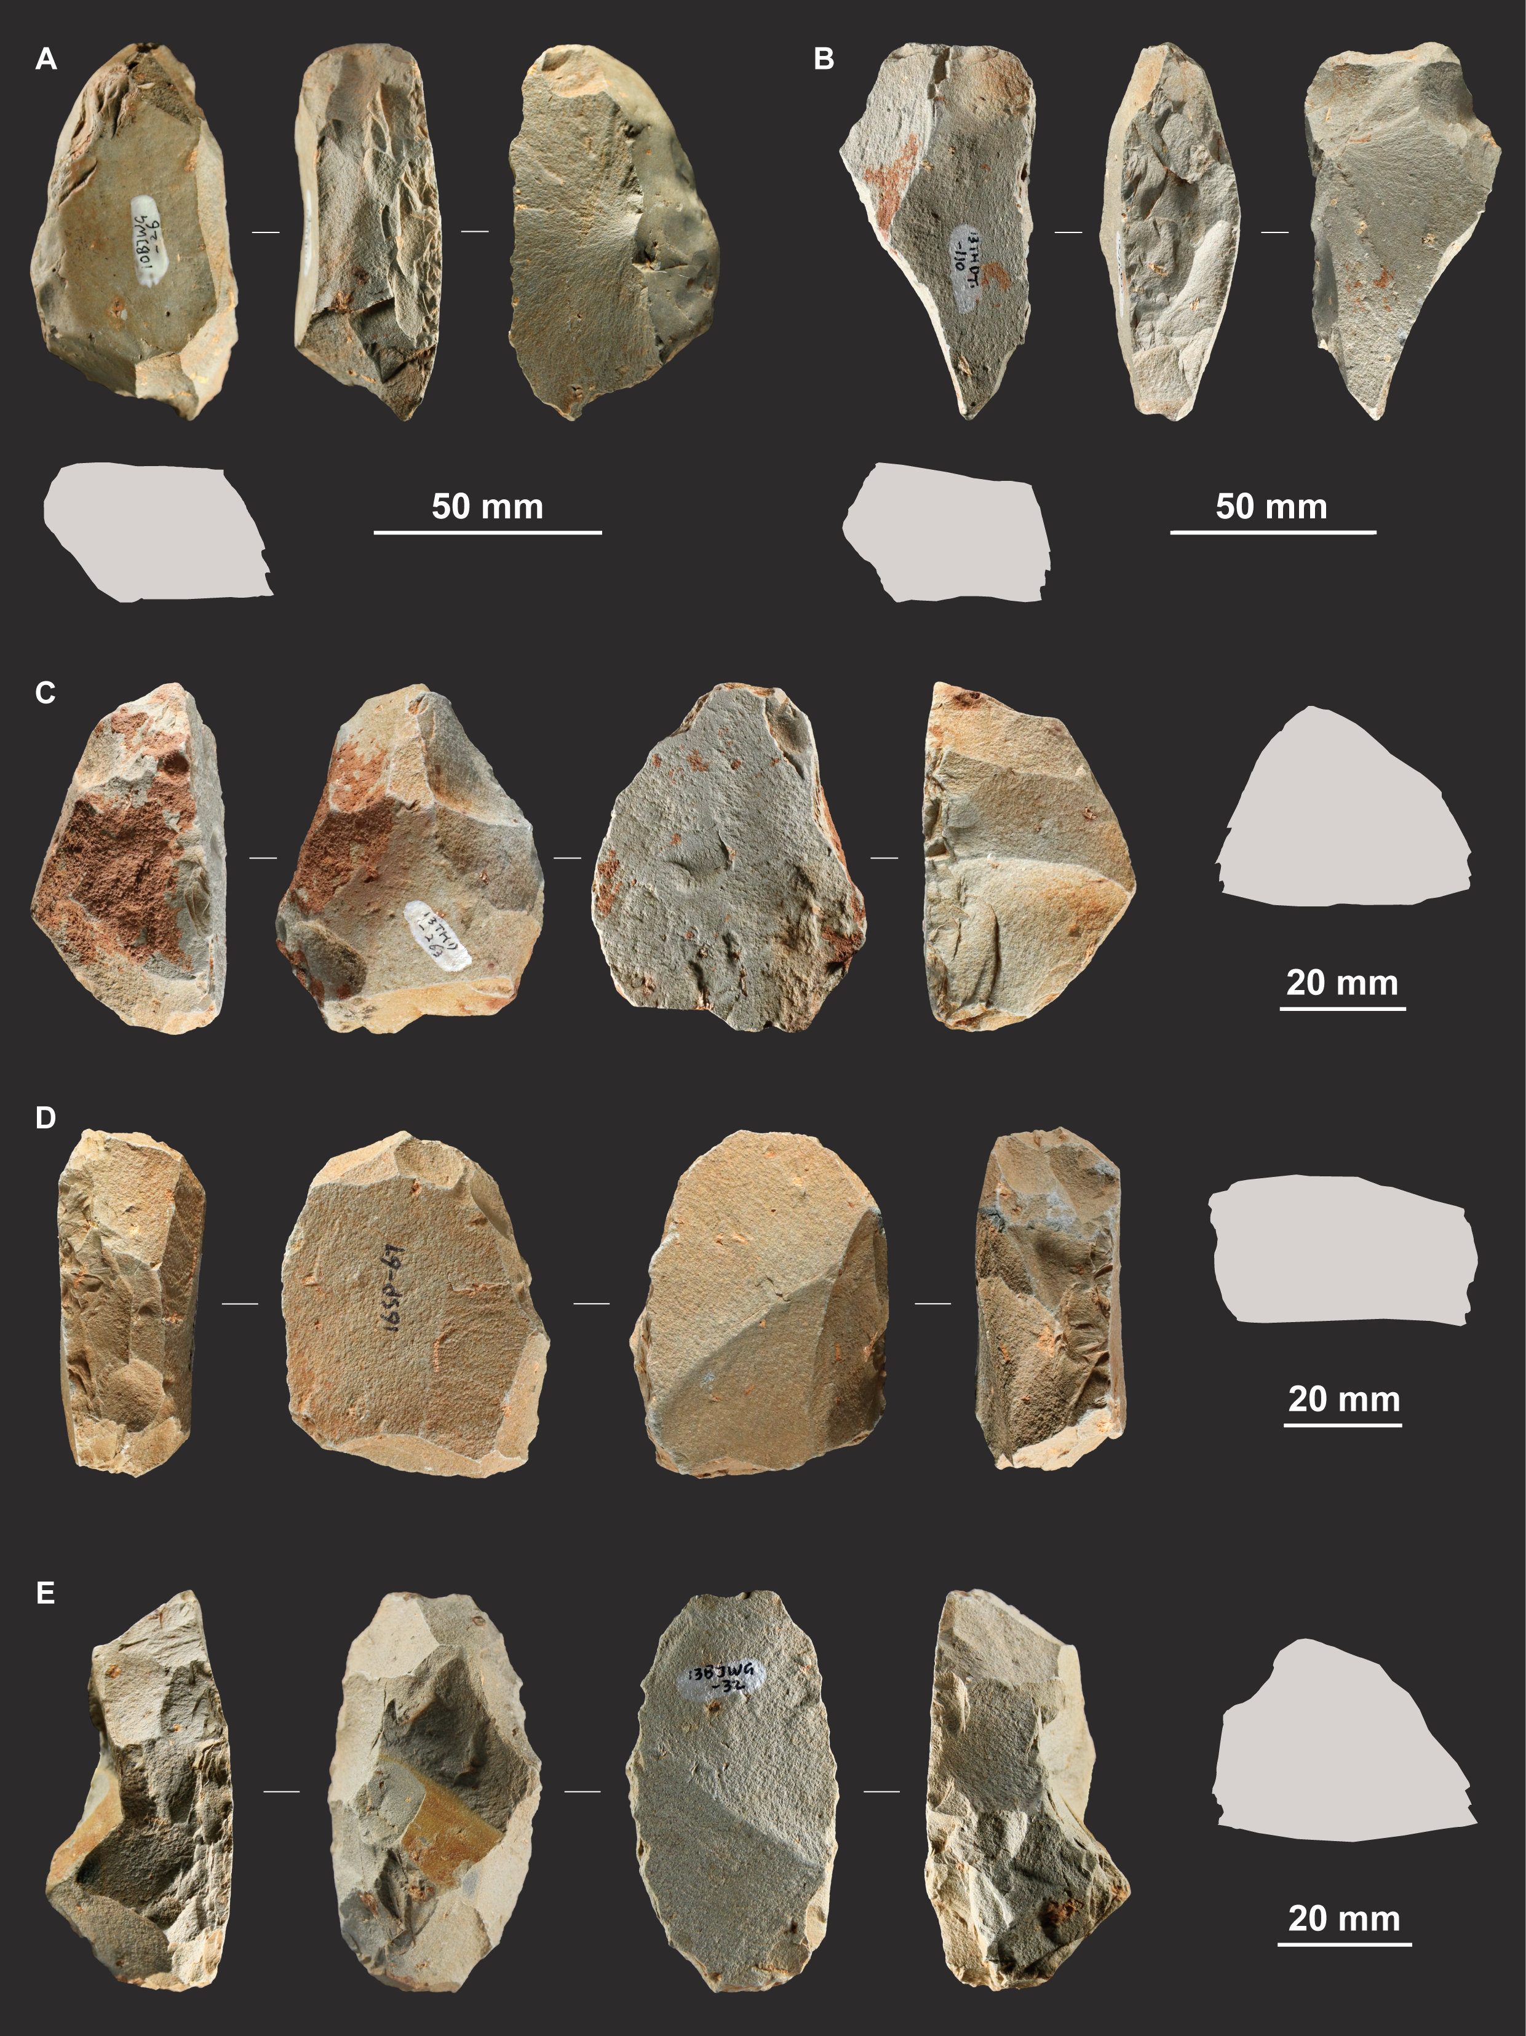
Fig. S1: Quina scrapers from the surface collections. (A) and (B) simple scrapers. (C) convergent scraper. (D) alternate scraper. (E) limace

Table S1: Metric and reduction attributes of the Quina scrapers and the resharpening flakes from the surface collections. Not every attribute could be measured on every specimen: the platform attributes are recorded only on those that retain the platform of the blank, and GIUR on all but one scraper. The retouch attributes apply to the scrapers alone and the exterior platform angle to the resharpening flakes alone.
Attribute | Mean | SD | Median | Q1–Q3
Quina scrapers (n = 166)
Length (mm) | 59.2 | 13.3 | 58.0 | 49.8–67.5
Width (mm) | 46.9 | 12.1 | 45.6 | 38.5–54.8
Thickness (mm) | 25.0 | 7.4 | 24.4 | 19.8–29.6
Mass (g) | 81.3 | 62.9 | 65.5 | 43.6–100.2
Platform depth (mm) | 14.8 | 5.4 | 13.9 | 11.3–18.1
Platform width (mm) | 32.5 | 13.5 | 30.9 | 23.2–40.4
IPA (°) | 122.4 | 14.1 | 124.9 | 117.0–131.0
Retouch generations | 2.76 | 0.66 | 3.00 | 2.00–3.00
Total scars | 23.1 | 14.5 | 20 | 13–29
GIUR | 0.75 | 0.21 | 0.77 | 0.61–0.93
Edge angle (°) | 70.0 | 8.1 | 70.0 | 65.1–74.0
Retouched perimeter | 0.50 | 0.21 | 0.46 | 0.34–0.62
Resharpening flakes (n = 58)
Length (mm) | 37.2 | 9.9 | 35.6 | 29.8–42.5
Width (mm) | 27.7 | 7.4 | 26.5 | 22.4–32.8
Thickness (mm) | 9.5 | 3.2 | 9.3 | 6.9–10.7
Mass (g) | 11.6 | 12.9 | 9.1 | 5.0–12.8
Platform depth (mm) | 5.3 | 3.6 | 4.3 | 3.0–6.4
Platform width (mm) | 16.2 | 10.9 | 14.0 | 7.6–19.5
IPA (°) | 117.9 | 6.3 | 118.0 | 113.8–122.0
EPA (°) | 72.8 | 9.5 | 73.0 | 65.0–79.2

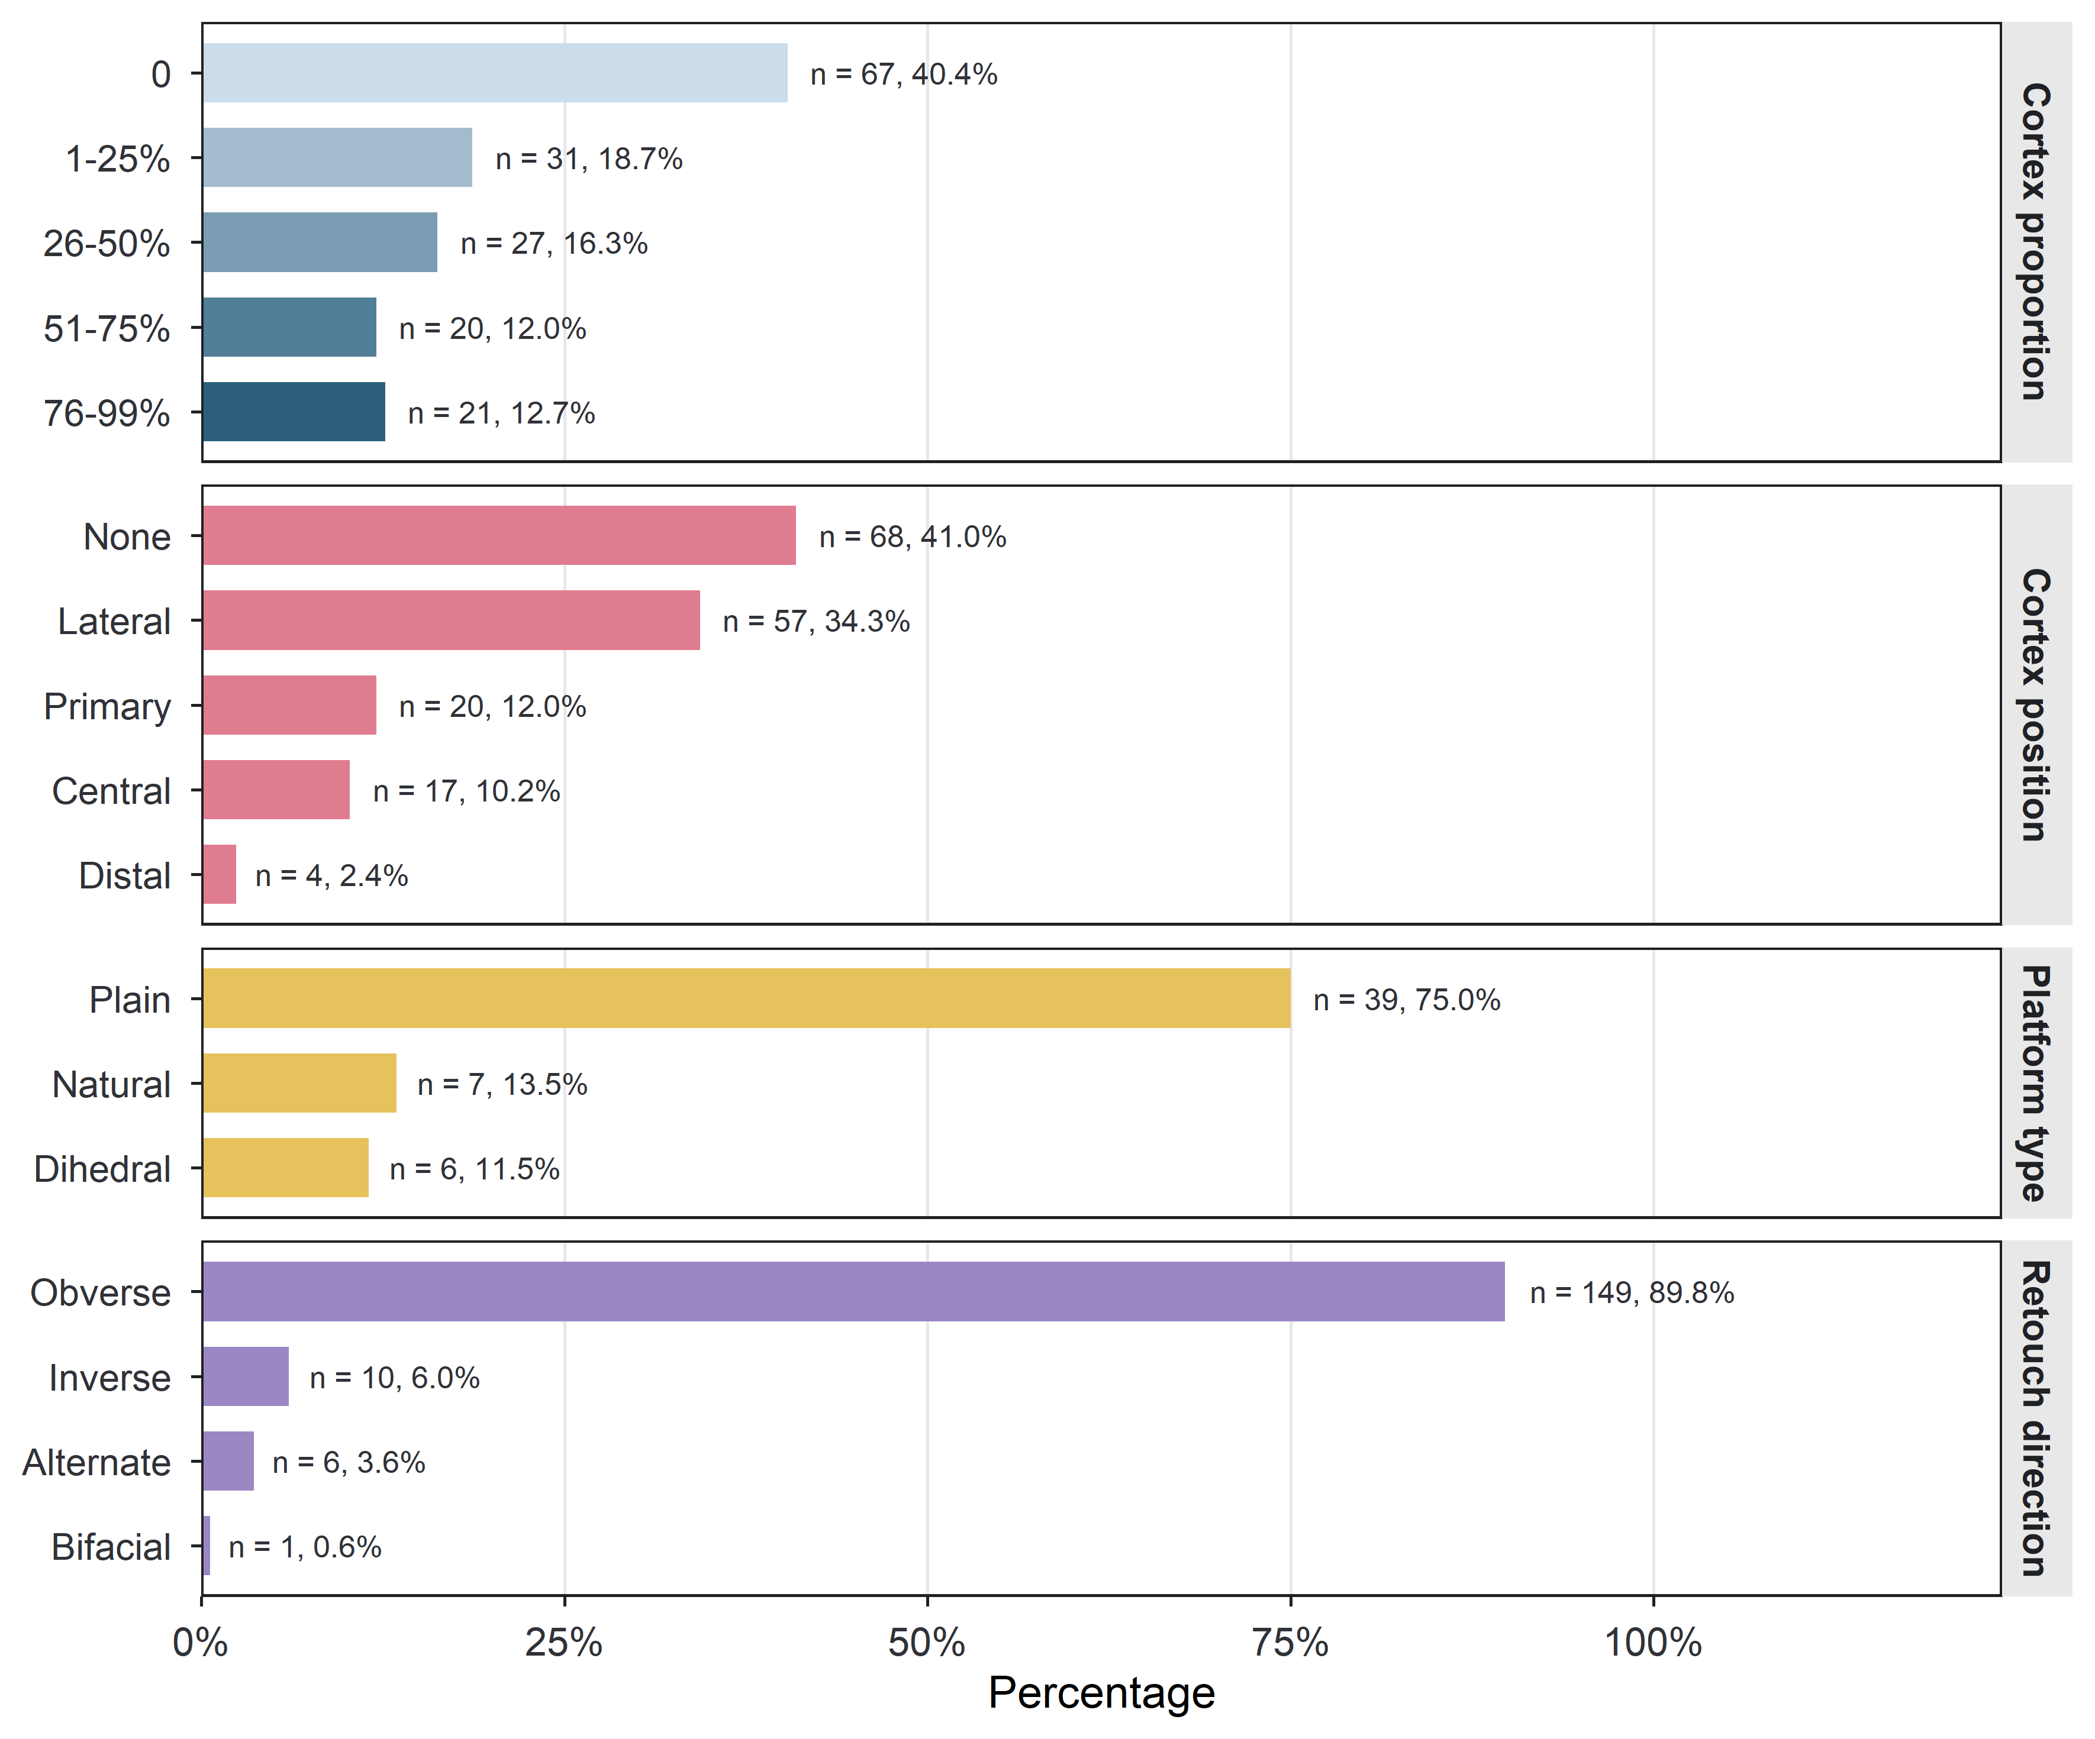
Fig. S2: Categorical attributes of the surface Quina scrapers: proportion of the dorsal face covered by cortex, position of that cortex, platform type, and the direction from which retouch was struck. Bars run to the percentage of the specimens recorded for that attribute, and the count and percentage are given at the end of each bar.

Technological consistency
This section compares the surface Quina scrapers with the excavated Quina scrapers from Longtan, against the Longtan non-Quina scrapers as a control. Fig. S3 shows the distribution of each of the six technological variables within each group, the check that stands behind the choice of test. Table S2 to Table S5 give the full output of the comparison: the pairwise tests of group position and of group spread, the variable-by-variable tests, and the loadings of the ordination. Table S6 and Fig. S4 then repeat the analysis with the surface specimens collected from within the area of the Longtan site removed.

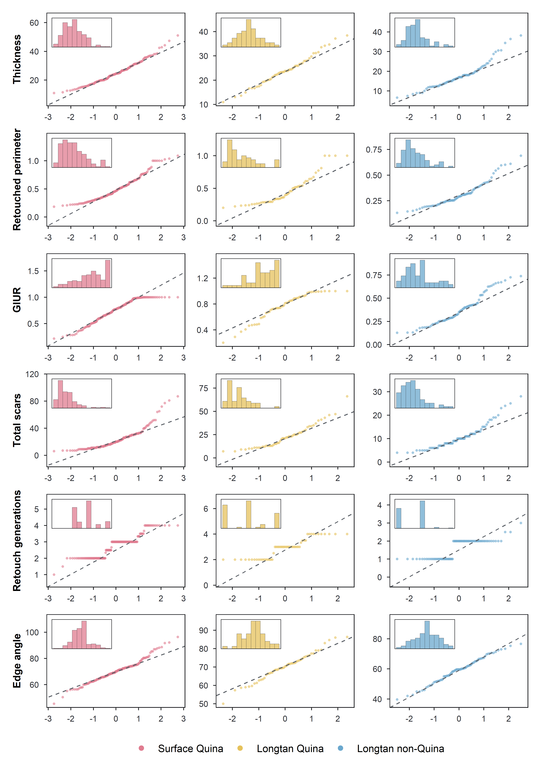
Fig. S3: Normal quantile–quantile plots of the six technological variables. In every panel the horizontal axis is the theoretical normal quantile and the vertical axis the sample quantile, and the dashed line passes through the first and third sample quartiles. Inset at the upper left of each panel is a histogram of the same values, plotted in its own right but with its axes suppressed, to give the shape of the distribution alongside its departure from normality.

Table S2: Pairwise PERMANOVA on the z-scored six-variable technological space, Euclidean distances, 9,999 permutations. Degrees of freedom are given as model, residual. Adjusted p is the Bonferroni adjustment across the three comparisons.
Comparison | n | df | SS | R² | pseudo-F | p | Adjusted p
Surface Quina vs Longtan Quina | 165, 53 | 1, 216 | 4.07 | 0.004 | 0.81 | 0.493 | 1.000
Surface Quina vs Longtan non-Quina | 165, 79 | 1, 242 | 428.21 | 0.287 | 97.51 | < 0.001 | < 0.001
Longtan Quina vs Longtan non-Quina | 53, 79 | 1, 130 | 259.57 | 0.362 | 73.67 | < 0.001 | < 0.001

Table S3: PERMDISP on the same technological space. The upper panel gives the mean distance of each group to its own centroid, the quantity the test compares; distance is measured in the z-scored space, so its units are standard deviations. The lower panel gives the pairwise tests, each fitted to its pair in turn, with the p-value from the permutation of the full three-group model alongside for comparison.
 | n | Mean / df | SD / F | SE / p | p (3-group)
Distance to centroid, by group
Surface Quina | 165 | 2.100 | 0.877 | 0.068
Longtan Quina | 53 | 2.020 | 0.727 | 0.100
Longtan non-Quina | 79 | 1.545 | 0.594 | 0.067
Overall test |  | 2, 294 | 13.71 | < 0.001
Pairwise tests
Surface Quina vs Longtan Quina | 165, 53 | 1, 216 | 0.35 | 0.558 | 0.552
Surface Quina vs Longtan non-Quina | 165, 79 | 1, 242 | 25.92 | < 0.001 | < 0.001
Longtan Quina vs Longtan non-Quina | 53, 79 | 1, 130 | 16.99 | < 0.001 | < 0.001

Table S4: Per-variable comparison of the three groups: the omnibus test for each variable, followed by its three post-hoc comparisons. GIUR, total scars and retouch generations were tested with Kruskal–Wallis and Dunn’s post-hoc comparisons, the effect size being epsilon-squared; thickness, retouched perimeter and edge angle with Welch’s ANOVA and Welch’s t post-hoc comparisons. All post-hoc p-values carry a Bonferroni adjustment within each variable. ns, not significant.
Variable / comparison | Statistic | df or n | p | Effect size
Thickness (mm)
Welch’s ANOVA | F = 34.39 | 2, 137.2 | < 0.001
Surface Quina vs Longtan Quina | t = 1.09 | 106.4 | 0.831 |  | ns
Surface Quina vs Longtan non-Quina | t = 8.09 | 176.1 | < 0.001 |  | ****
Longtan Quina vs Longtan non-Quina | t = 5.78 | 115.7 | < 0.001 |  | ****
Retouched perimeter
Welch’s ANOVA | F = 43.18 | 2, 128.8 | < 0.001
Surface Quina vs Longtan Quina | t = 1.14 | 83.9 | 0.774 |  | ns
Surface Quina vs Longtan non-Quina | t = 9.03 | 234.7 | < 0.001 |  | ****
Longtan Quina vs Longtan non-Quina | t = 4.55 | 72.4 | < 0.001 |  | ****
GIUR
Kruskal–Wallis | H = 119.03 | 2 | < 0.001 | ε² = 0.398
Surface Quina vs Longtan Quina | Z = 0.46 | 165, 53 | 1.000 |  | ns
Surface Quina vs Longtan non-Quina | Z = -10.33 | 165, 79 | < 0.001 |  | ****
Longtan Quina vs Longtan non-Quina | Z = -8.37 | 53, 79 | < 0.001 |  | ****
Total scars
Kruskal–Wallis | H = 79.80 | 2 | < 0.001 | ε² = 0.265
Surface Quina vs Longtan Quina | Z = 0.16 | 165, 53 | 1.000 |  | ns
Surface Quina vs Longtan non-Quina | Z = -8.53 | 165, 79 | < 0.001 |  | ****
Longtan Quina vs Longtan non-Quina | Z = -6.71 | 53, 79 | < 0.001 |  | ****
Retouch generations
Kruskal–Wallis | H = 116.16 | 2 | < 0.001 | ε² = 0.388
Surface Quina vs Longtan Quina | Z = 1.04 | 165, 53 | 0.897 |  | ns
Surface Quina vs Longtan non-Quina | Z = -10.01 | 165, 79 | < 0.001 |  | ****
Longtan Quina vs Longtan non-Quina | Z = -8.63 | 53, 79 | < 0.001 |  | ****
Edge angle (°)
Welch’s ANOVA | F = 50.78 | 2, 128.8 | < 0.001
Surface Quina vs Longtan Quina | t = -0.11 | 93.5 | 1.000 |  | ns
Surface Quina vs Longtan non-Quina | t = 9.64 | 149.6 | < 0.001 |  | ****
Longtan Quina vs Longtan non-Quina | t = 7.89 | 119.0 | < 0.001 |  | ****

Table S5: Loadings of all six principal components of the z-scored technological space, with the eigenvalue, the percentage of variance and the cumulative percentage for each.
Variable | PC1 | PC2 | PC3 | PC4 | PC5 | PC6
Thickness (mm) | -0.332 | 0.255 | -0.762 | -0.376 | -0.311 | -0.076
Retouched perimeter | -0.383 | -0.669 | -0.022 | 0.105 | -0.343 | 0.526
GIUR | -0.391 | 0.245 | 0.603 | -0.195 | -0.558 | -0.273
Total scars | -0.449 | -0.460 | -0.046 | -0.013 | 0.390 | -0.657
Retouch generations | -0.458 | 0.265 | 0.202 | -0.387 | 0.566 | 0.458
Edge angle (°) | -0.423 | 0.382 | -0.110 | 0.812 | 0.042 | 0.039
Eigenvalue | 3.41 | 0.93 | 0.83 | 0.37 | 0.31 | 0.15
Variance (%) | 56.9 | 15.5 | 13.8 | 6.1 | 5.2 | 2.5
Cumulative (%) | 56.9 | 72.4 | 86.2 | 92.3 | 97.5 | 100.0

Table S6: Sensitivity of the technological consistency result to the surface specimens collected from within the area of the Longtan site. The full set is the analysis reported in the main text, with 165 surface specimens; the reduced set excludes those collected within the site area, leaving 150, and is z-scored on its own. PERMANOVA p-values carry the Bonferroni adjustment across the three comparisons.
Comparison | Tests | R² | F | p | R² | F | p
Surface Quina vs Longtan Quina
PERMANOVA | centroid position | 0.004 | 0.81 | 1.000 | 0.005 | 1.11 | 0.976
PERMDISP | dispersion |  | 0.35 | 0.558 |  | 0.23 | 0.624
Surface Quina vs Longtan non-Quina
PERMANOVA | centroid position | 0.287 | 97.51 | < 0.001 | 0.319 | 106.15 | < 0.001
PERMDISP | dispersion |  | 25.92 | < 0.001 |  | 24.60 | < 0.001
Longtan Quina vs Longtan non-Quina
PERMANOVA | centroid position | 0.362 | 73.67 | < 0.001 | 0.360 | 73.28 | < 0.001
PERMDISP | dispersion |  | 16.99 | < 0.001 |  | 16.88 | < 0.001

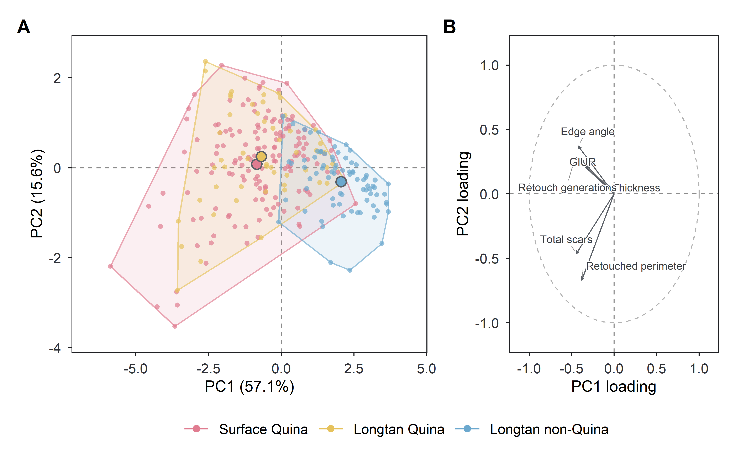
Fig. S4: Ordination of the technological space with the surface specimens from within the area of the Longtan site removed, to be compared with panel A of the corresponding figure in the main text. (A) Specimen scores, with convex hulls enclosing each group and filled points marking group centroids. (B) Loadings of the six variables on the same two components, drawn on their own axes so that the specimen scores are not overplotted.

Raw material economy
This section reports what was available on the river bars and what was chosen from it. Fig. S5 shows the sampling points at which the cobbles were recorded. Table S7 gives the raw material composition of the surveyed cobbles and of the surface Quina scrapers, valley by valley, and Table S8 sets the two against one another as an index of selection. Table S9 tests whether composition differs between sampling points, valleys and basins, and Table S10 reports the size of the surveyed cobbles by lithology.

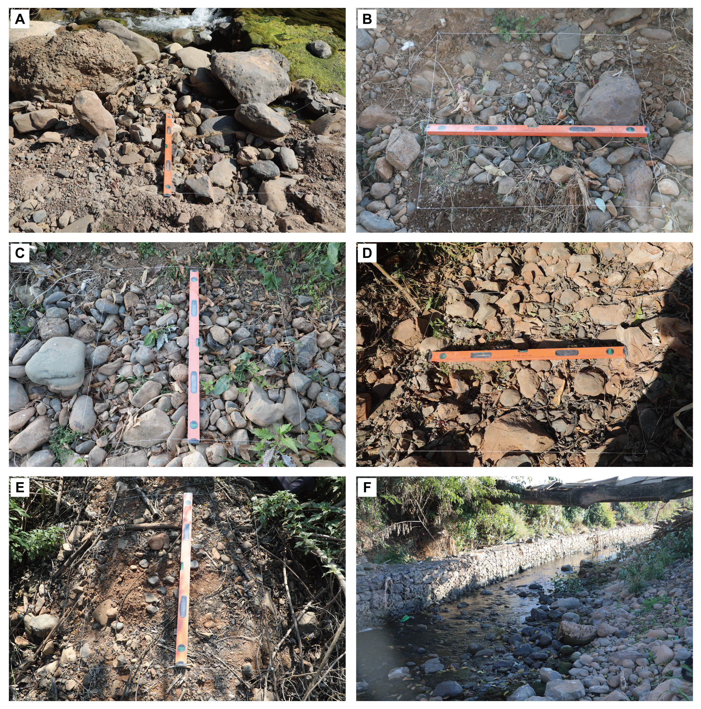
Fig. S5: The gravel-bar sampling points. (A) to (E) The five points at which the surveyed cobbles were recorded, each with the cleared quadrat marked out by string and a spirit level laid across it for scale. (F) A general view of one of the sampled channels. Every cobble longer than 30 mm exposed at the surface within the quadrat was recorded.

Table S7: Raw material composition of the river-bar cobbles and of the surface-collected Quina scrapers, by valley. Cells give the count with the percentage of the row in parentheses.
Valley | Trachyte | Sandstone | Quartz | Mudstone | Andesite | n
River cobbles
Sangyuan | 9 (8.9%) | 84 (83.2%) | 1 (1.0%) | 7 (6.9%) | 0 | 101
Liandong | 87 (46.3%) | 98 (52.1%) | 1 (0.5%) | 2 (1.1%) | 0 | 188
Caifeng | 33 (18.3%) | 145 (80.6%) | 1 (0.6%) | 1 (0.6%) | 0 | 180
Surface Quina scrapers
Sangyuan | 6 (100.0%) | 0 | 0 | 0 | 0 | 6
Liandong | 39 (97.5%) | 1 (2.5%) | 0 | 0 | 0 | 40
Caifeng | 114 (95.0%) | 2 (1.7%) | 0 | 0 | 4 (3.3%) | 120

Table S8: Jacobs’ electivity index for every raw material. D runs from −1, complete avoidance, through 0, use in proportion to availability, to +1, complete selection.
Raw material | Cobbles n | Cobbles % | Scrapers n | Scrapers % | D
Trachyte | 129 | 27.5 | 159 | 95.8 | 0.97
Sandstone | 327 | 69.7 | 3 | 1.8 | -0.98
Quartz | 3 | 0.6 | 0 | 0.0 | -1.00
Mudstone | 10 | 2.1 | 0 | 0.0 | -1.00
Andesite† | 0 | 0.0 | 4 | 2.4 | 1.00
Total | 469 | 100.0 | 166 | 100.0

Table S9: PERMANOVA and PERMDISP on raw material composition, on Bray–Curtis dissimilarities with 9,999 permutations. Sums of squares, degrees of freedom and residual degrees of freedom are those of the PERMANOVA; the last two columns give the pseudo-F and p of the test of homogeneity of dispersion on the same dissimilarity matrix. The unit is the individual cobble in the first panel and the individual artefact in the second.
Model | df | SS | R² | pseudo-F | p | PERMDISP F | PERMDISP p
Available river cobbles (n = 469)
~ sampling point | 4, 464 | 11.07 | 0.108 | 14.02 | < 0.001 | 18.19 | < 0.001
~ valley | 2, 466 | 10.84 | 0.106 | 27.53 | < 0.001 | 25.48 | < 0.001
Surface Quina scrapers (n = 166)
~ basin | 1, 164 | 0.03 | 0.005 | 0.78 | 0.462 | 0.65 | 0.504
~ valley | 2, 163 | 0.04 | 0.005 | 0.43 | 0.721 | 0.36 | 0.633

Table S10: Size of the surveyed river cobbles by lithology. Size is the geometric mean of length, breadth and thickness in millimetres, and GM is the geometric mean of that quantity within each lithology.
Raw material | n | GM (mm) | Median (mm) | Q1–Q3 (mm) | Range (mm)
Trachyte | 129 | 62.0 | 55.9 | 44.4–77.2 | 28.3–388.2
Sandstone | 327 | 52.2 | 50.6 | 38.9–66.9 | 20.5–152.4
Quartz | 3 | 56.7 | 42.0 | 40.2–77.4 | 38.5–112.7
Mudstone | 10 | 52.6 | 48.2 | 44.3–54.1 | 37.8–91.0

Landscape structure
This section asks whether the technological variation follows position in the landscape, with the locality rather than the specimen as the unit. Table S11 lists the localities that enter the analysis with their median value on each of the six measures, and Table S12 tests each landscape variable against that space. The three figures show the same data in turn: Fig. S6 as an ordination of the localities coloured by each landscape variable, Fig. S7 as each measure against each of the continuous variables, and Fig. S8 as a comparison between the two basins.

Table S11: Locality-level analysis frame. Each row is one Quina locality, with the number of Quina scrapers complete on all six variables and the median of those specimens on each. Distance and height are measured to and above the nearest channel.
Locality | Basin | n | Distance (m) | Height (m) | Thickness (mm) | Retouched perimeter | GIUR | Total scars | Retouch generations | Edge angle (°)
Wayaowan | Binchuan | 10 | 663 | 150 | 21.5 | 0.40 | 0.75 | 15 | 3.00 | 69.2
Caifengcun | Binchuan | 6 | 721 | 51 | 18.7 | 0.39 | 0.91 | 13 | 2.50 | 67.4
Mianhualiangzi | Binchuan | 4 | 468 | 55 | 36.2 | 0.45 | 0.60 | 26 | 3.00 | 73.8
Laojianshan | Binchuan | 2 | 721 | 60 | 27.5 | 0.60 | 0.94 | 30 | 3.17 | 75.3
Mianhuadi | Binchuan | 2 | 593 | 46 | 30.9 | 0.46 | 0.83 | 26 | 3.25 | 77.3
Nanjingzhuang | Binchuan | 2 | 944 | 30 | 25.9 | 0.79 | 0.73 | 48 | 3.17 | 69.4
Pengjiadadi | Binchuan | 2 | 1110 | 46 | 32.0 | 0.66 | 0.57 | 30 | 3.00 | 68.1
Shitouwan | Binchuan | 2 | 523 | 37 | 24.2 | 0.41 | 0.85 | 24 | 3.00 | 68.7
Yanjianqiao | Binchuan | 2 | 204 | 48 | 19.8 | 0.51 | 0.64 | 20 | 2.25 | 69.1
Zhongjialiangzi | Binchuan | 2 | 908 | 30 | 23.3 | 0.62 | 0.98 | 24 | 3.25 | 73.5
Zhouxiyingliangzi | Binchuan | 2 | 210 | 40 | 24.2 | 0.37 | 0.88 | 18 | 2.50 | 62.6
Baifen | Binchuan | 1 | 716 | 40 | 17.5 | 0.36 | 0.97 | 9 | 2.00 | 62.0
Dapingdi 1 | Binchuan | 1 | 1390 | 25 | 38.6 | 0.33 | 1.00 | 16 | 3.00 | 87.7
Dapingdi 2 | Binchuan | 1 | 268 | 38 | 22.9 | 0.36 | 0.21 | 9 | 1.00 | 55.0
Futianzhuang | Binchuan | 1 | 459 | 73 | 13.7 | 0.22 | 1.00 | 16 | 3.00 | 65.7
Haibacun | Binchuan | 1 | 550 | 158 | 31.8 | 0.62 | 0.88 | 32 | 3.50 | 87.0
Jiancaowan | Binchuan | 1 | 596 | 55 | 28.4 | 0.40 | 0.65 | 31 | 3.00 | 69.0
Niunitang | Binchuan | 1 | 480 | 58 | 20.9 | 0.27 | 0.37 | 15 | 2.00 | 78.3
Qingguangshan | Binchuan | 1 | 768 | 46 | 17.5 | 0.52 | 0.83 | 30 | 3.00 | 66.2
Wuguiqing | Binchuan | 1 | 305 | 187 | 16.9 | 0.35 | 0.52 | 24 | 3.00 | 73.7
Zhaokanzhuang | Binchuan | 1 | 2540 | 45 | 31.5 | 0.39 | 0.31 | 11 | 2.00 | 68.7
Tianhua Cave | Heqing | 49 | 2690 | 35 | 26.1 | 0.50 | 0.78 | 24 | 3.00 | 73.0
Guanshan | Heqing | 31 | 917 | 68 | 24.9 | 0.54 | 0.81 | 23 | 3.00 | 72.3
Songping | Heqing | 18 | 612 | 69 | 24.5 | 0.51 | 0.77 | 18 | 3.00 | 67.8
Longtan | Heqing | 15 | 617 | 40 | 18.4 | 0.37 | 0.69 | 11 | 2.00 | 63.0
Dazhuang | Heqing | 6 | 339 | 43 | 28.0 | 0.45 | 0.70 | 12 | 2.00 | 70.0

Table S12: Locality-level PERMANOVA for each landscape variable, on Euclidean distances in the z-scored six-variable space with 9,999 permutations, together with the test of dispersion for the one categorical variable.
Landscape variable | df | SS | R² | pseudo-F | p
Basin
PERMANOVA (Binchuan 21, Heqing 5) | 1, 24 | 1.64 | 0.011 | 0.265 | 0.909
PERMDISP |  |  |  | 4.880 | 0.035
Height above channel (m) | 1, 24 | 5.46 | 0.036 | 0.906 | 0.443
Distance to channel (m) | 1, 24 | 4.61 | 0.031 | 0.761 | 0.513
Assemblage size (n specimens) | 1, 24 | 0.87 | 0.006 | 0.140 | 0.970

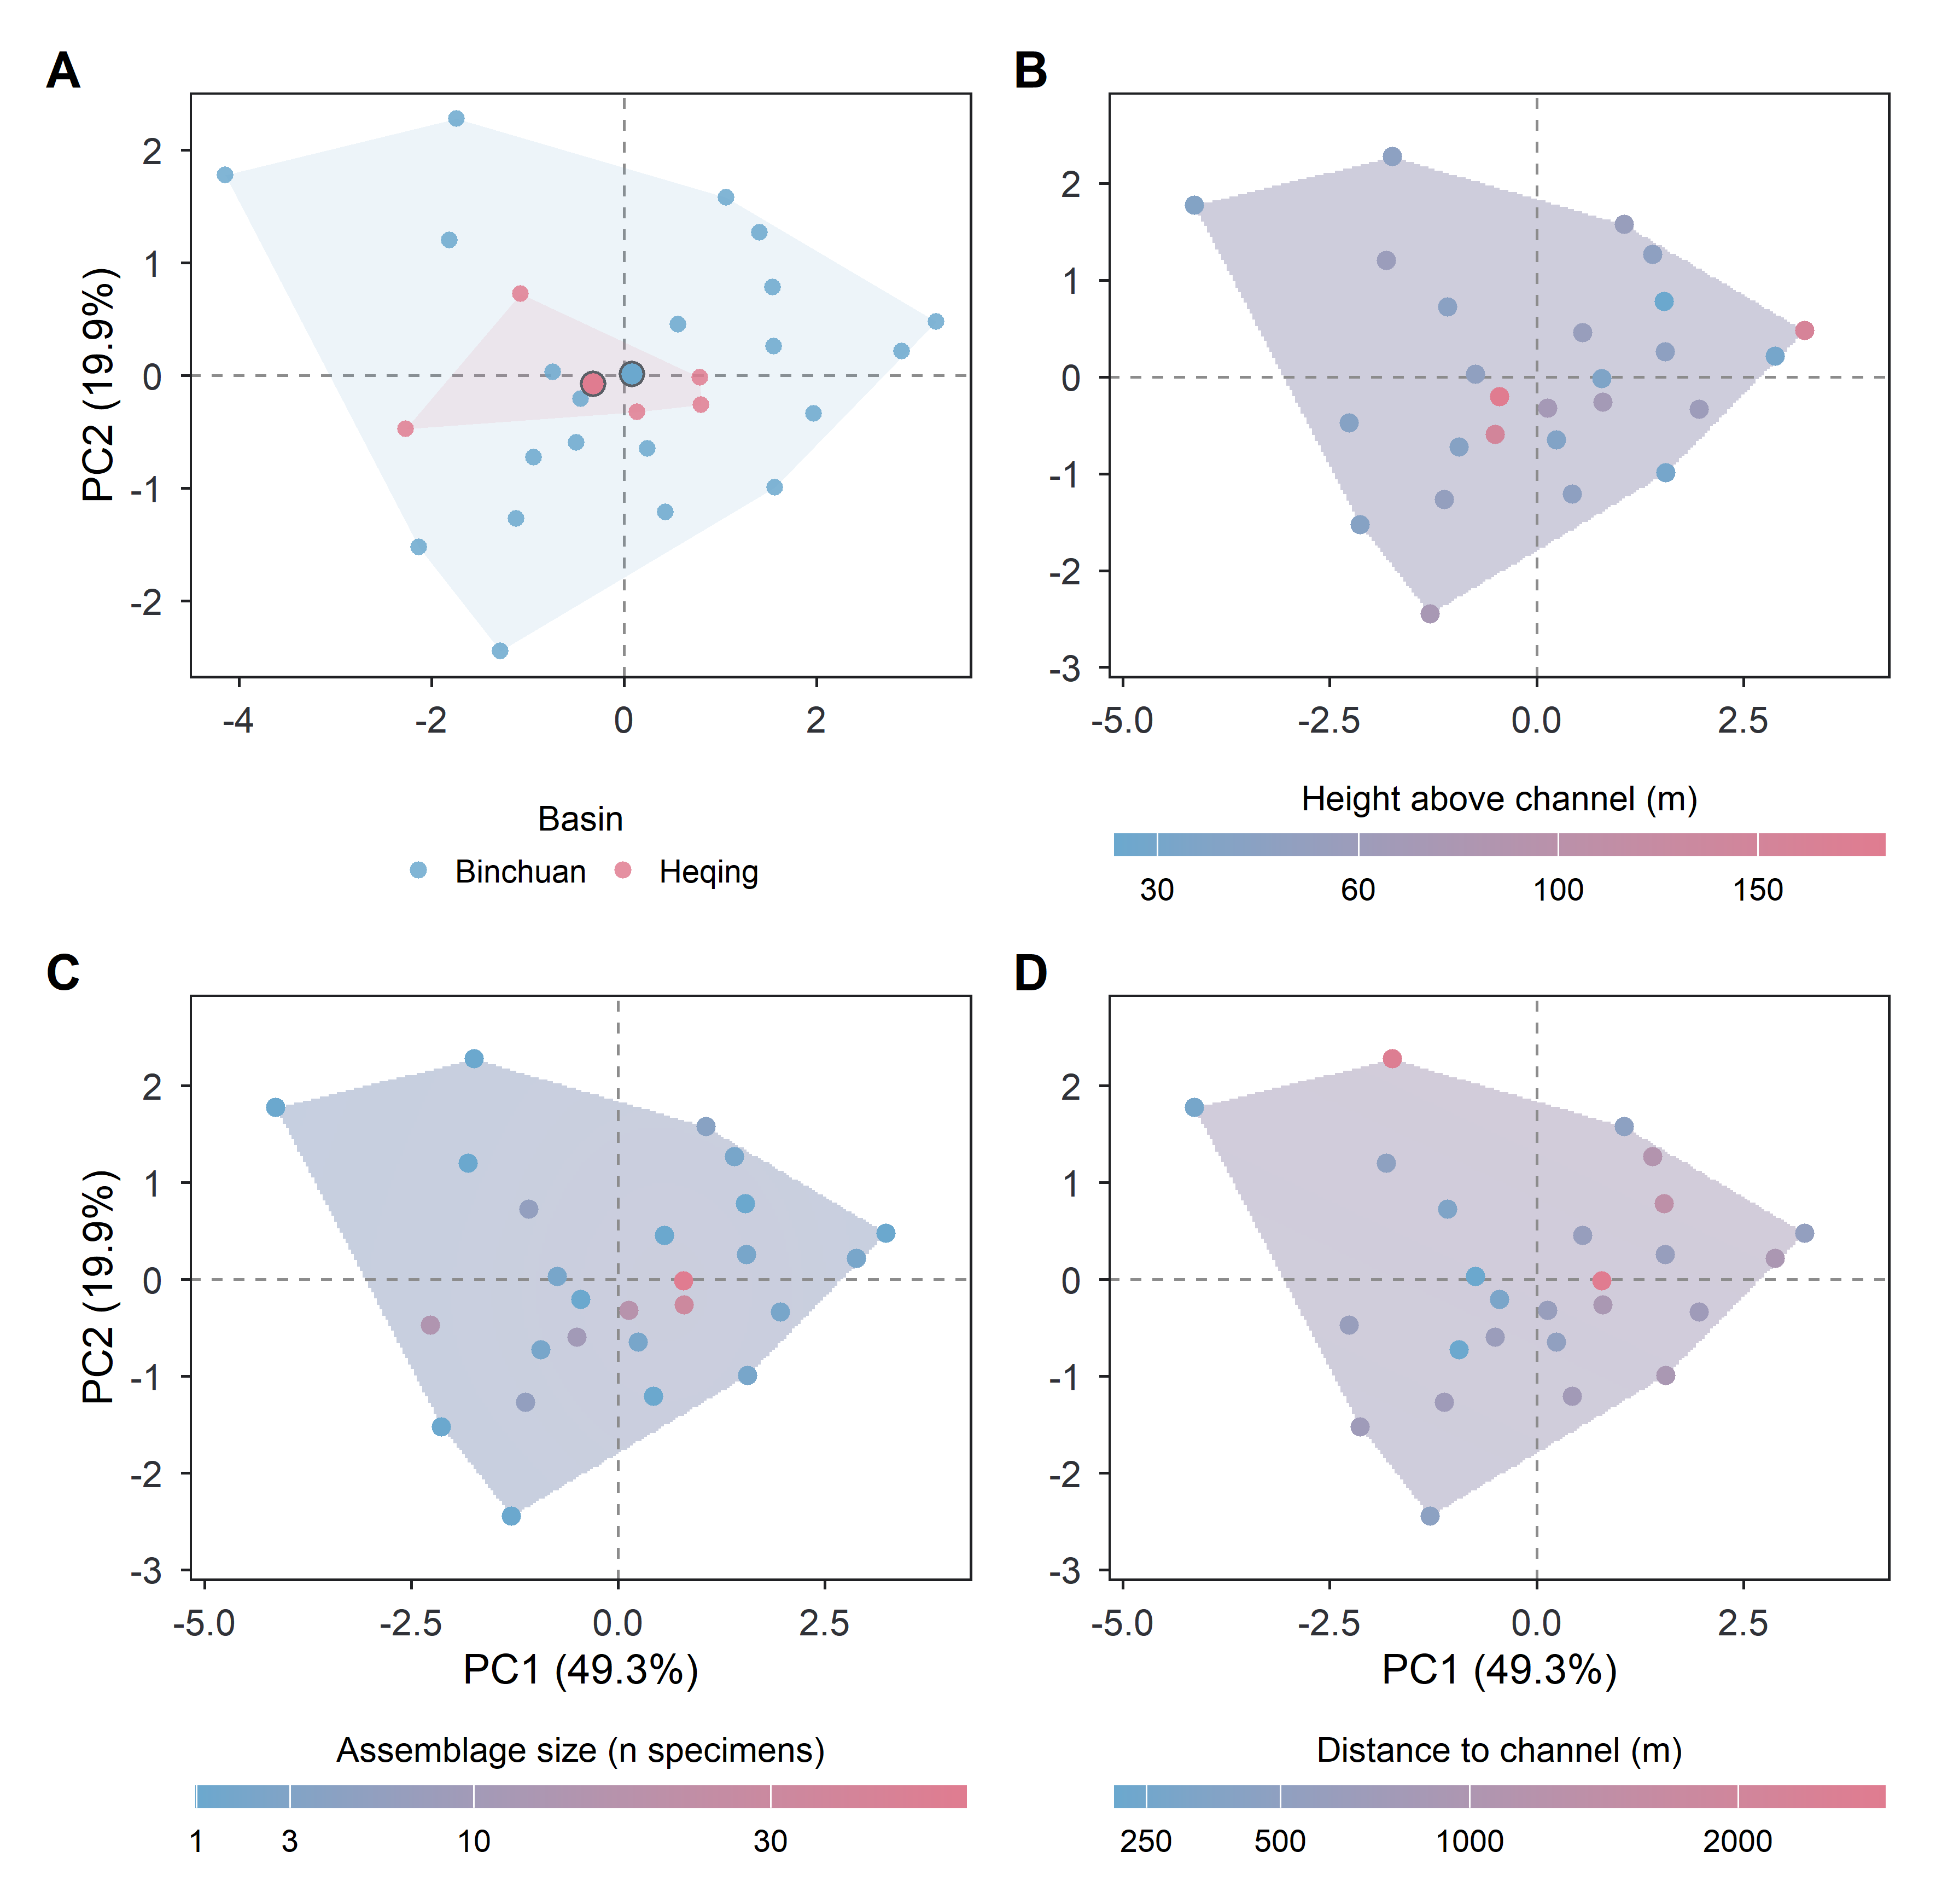
Fig. S6: Locality-level ordination of the six technological measures, each locality entered as the median of its Quina scrapers, coloured by (A) basin, (B) height above the channel, (C) assemblage size and (D) distance to the nearest channel. The four panels are the same ordination and differ only in the landscape variable shown, which is named in the legend beneath each. The three continuous variables are carried by the colour gradient at their measured values, the form in which they enter every test reported here; the gradient runs between the two colours that distinguish the basins in (A), the colour scale is square-root, all three being right-skewed, and the legend ticks are in the original units. Behind the localities of (B) to (D), on that same scale, is a thin-plate spline of the variable fitted over the ordination plane and clipped to the area the localities cover. A landscape gradient would show as colour running in a direction across a panel. Basin, the one categorical variable, has hulls enclosing each group and filled points marking group centroids.

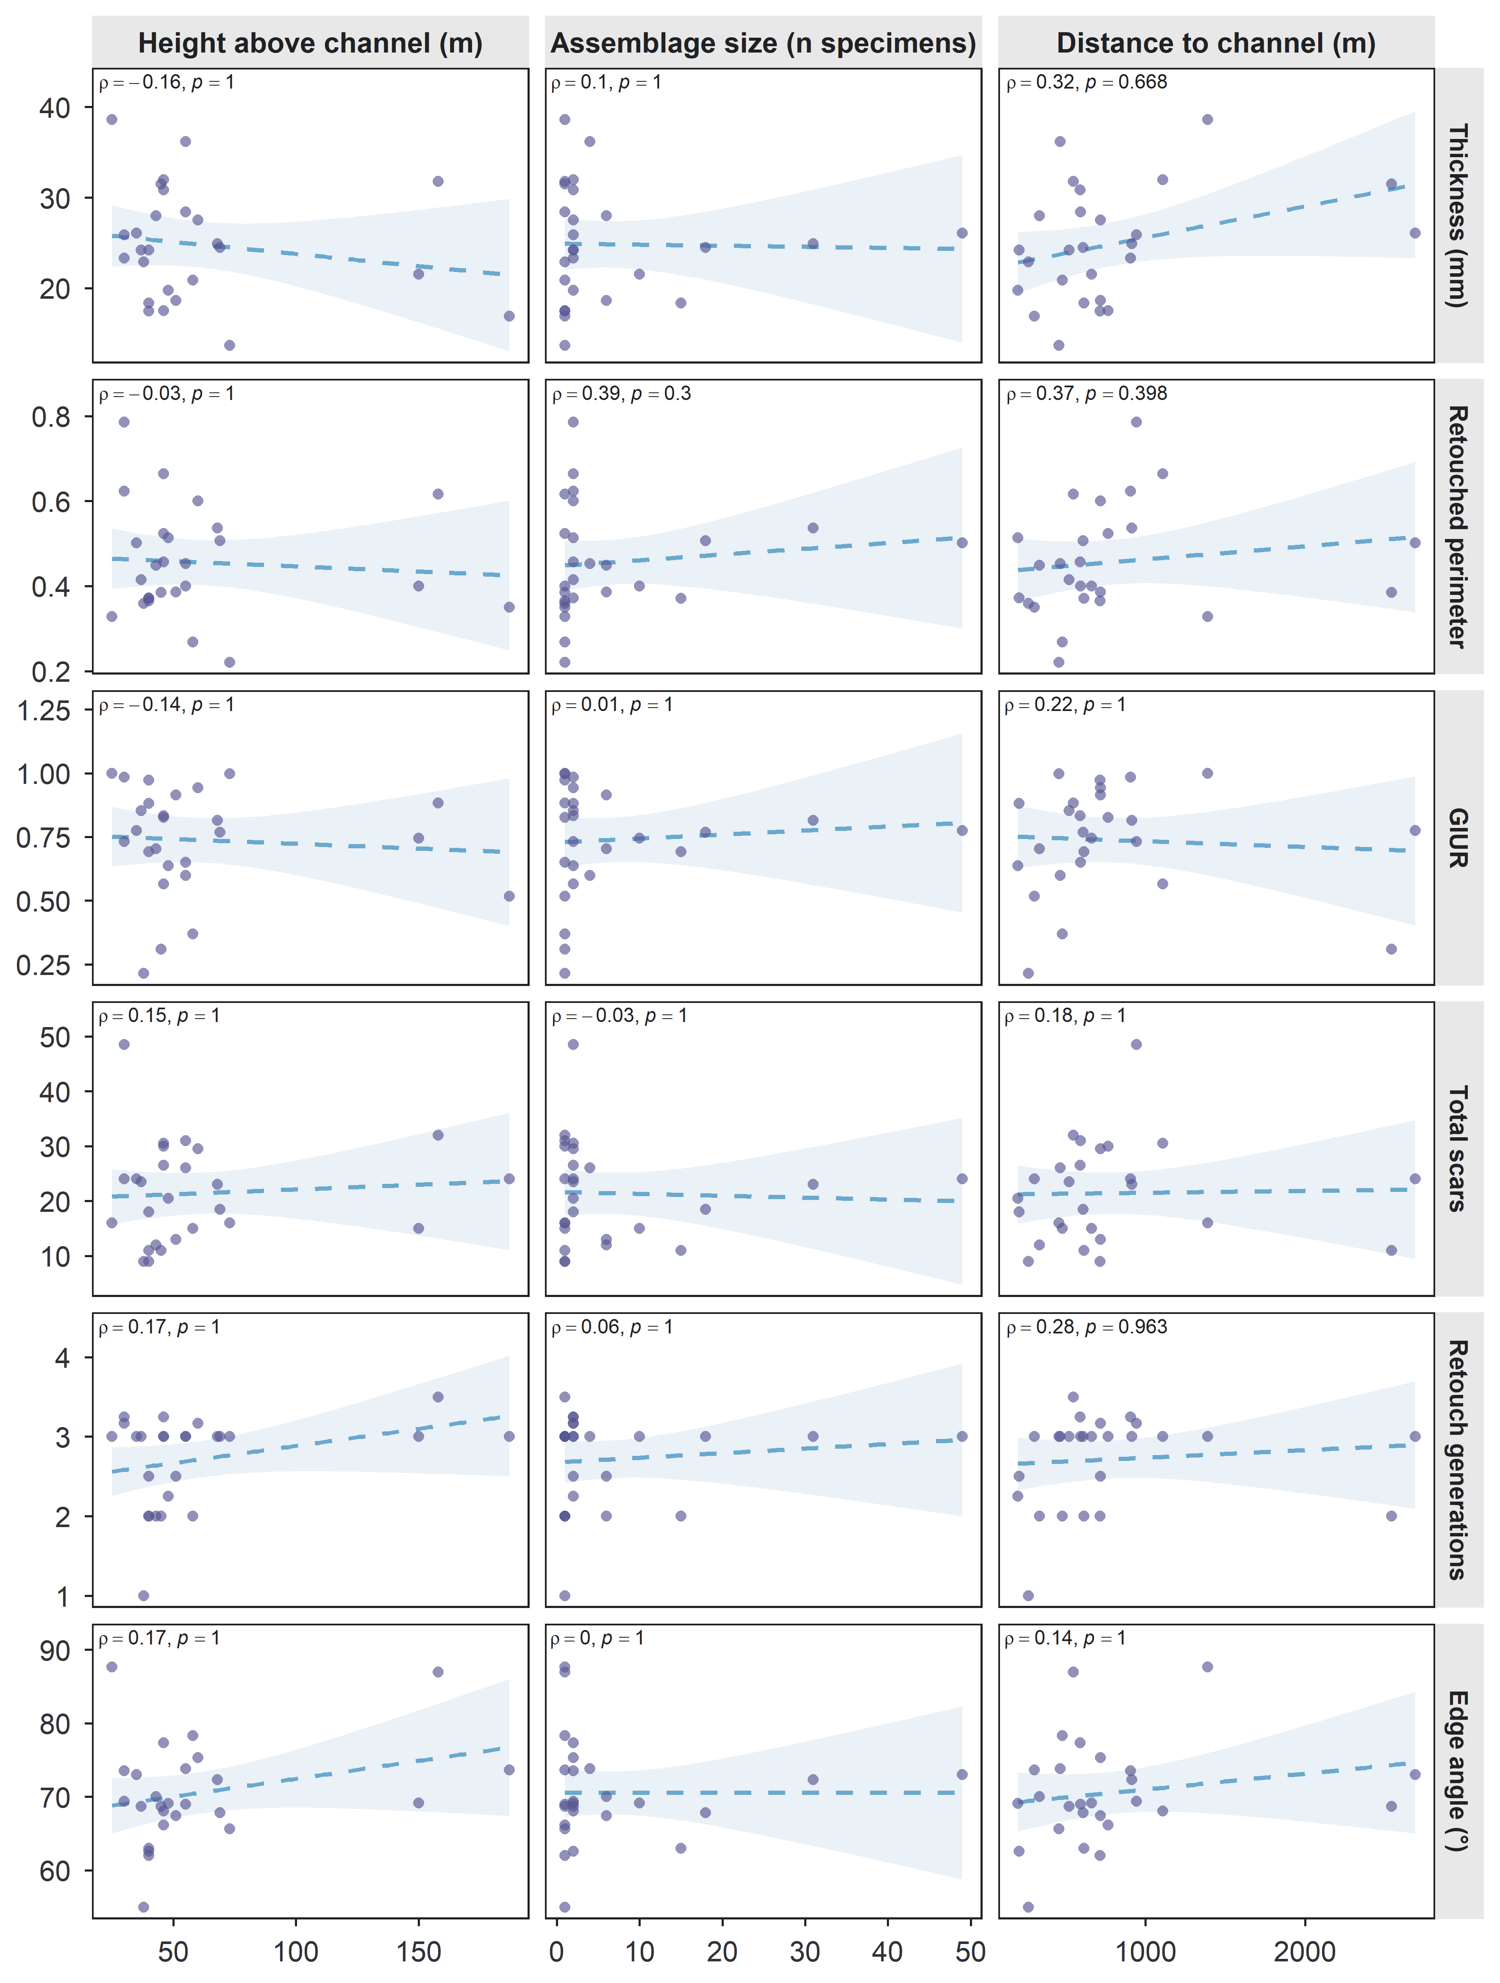
Fig. S7: Each of the six technological measures against each of the three continuous landscape variables, at the scale of the locality: one row per measure, one column per landscape variable, all at measured values. The dashed line is an ordinary least-squares fit, shown only as a guide to the direction of the relationship. Each panel gives Spearman’s ρ with its p-value, adjusted by the Bonferroni procedure within each column, every column being one family of six tests; the distance column is the family reported in the main text.

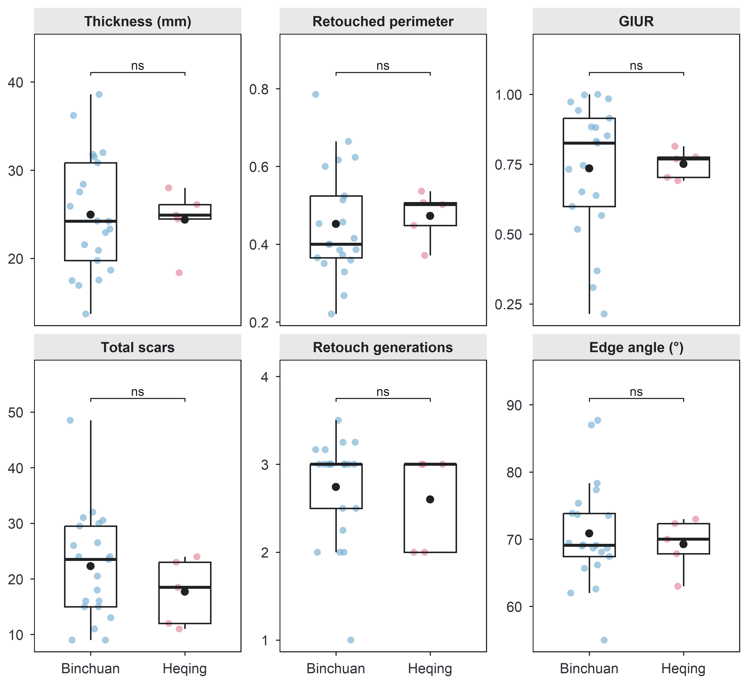
Fig. S8: Each of the six technological measures between the two basins, at the scale of the locality: one panel per measure, each point one locality entered as the median of its Quina scrapers, the box giving the median and the quartiles with whiskers reaching 1.5 times the interquartile range, and the filled point the mean.

