

**ATLAS**

**Web-Based Application**

**Creators:**  
**Alex Pela  
Tristan Knott**

**1/22/2024**

Table of Contents

Version History 4

Strategy 5

Features 6

User Personas 7

Sitemap Version 1.0 9

Sitemap 2.0 10

Sitemap Final 11

Wireframe Version 1.0 12

Wireframe/Prototype Final 13

Generated Assets 14

Fonts 14

General Body/Text/Tables/Forms 15

Colors: 16

Interactive Requirements 17

Home Page (Login) 18

Home Page (Create Org) 19

Home Page (Join Org) 20

Home Page (Not Verified) 21

Dashboard/General Landing Page 22

Org CRUD (View) 23

Org CRUD (Edit) 24

Org Controller 25

Department CRUD 26

User CRUD 27

Validation User 28

Account Settings (Personal/Update any user Settings) 29

Reset Password 30

Past Training 32

Individual Training CRUD 33

Module Viewer 34

Module CRUD 35

Training Validation Viewer 36

Training Validation CRUD 37

Design 38

Technologies 39

Technical Limitations 40

Feedback and Resulting Changes 41

Week 3 Presentation: 41

Week 6 Presentation: 41

Other Changes/Feedback: 41

# Version History

* Version 1.0 – Created document 1/22/2024 (Alex and Tristan)
* Version 2.0 – Heavily Modified to Include all requirements for 2nd submission (Alex and Tristan)
* Version 2.1 – Modified Wireframe to be more legible with lines and gave permission to access to Jay (Alex)
* Version 2.2 – Modified User Personas to reflect workflow of each user more accurately. (Tristan)
* Version 2.3 - Modified Design, Technologies, and Technical Limitations (Alex)
* Version 2.5 - Added Assets Section (Tristan Alex)
* Version 2.6 – Started to Update Interactive Requirements (Want to get feedback from Jay) (Alex)
* Version 2.7 – Added Feedback/Changes Section (Alex)
* Version 2.8 – Reorganized Sections of Design Document to be in a better order. (Tristan)
* Version 2.9 – Updated all sections of Interactive Requirements. (WIP) (Tristan Alex)
* Version 3.0 – Document Completed and Ready for Submission :) (Tristan Alex)

# Strategy

**What is it?**

ATLAS (Alex Tristan Learning Management System) is a streamlined web-based Learning Management Software meticulously crafted to meet the training program needs of small- to medium-sized organizations. Unlike most existing LMS applications that tend to be costly, excessively technical, and complex, LMS) offers a user-friendly and efficient alternative. It is designed to be implemented swiftly, addressing the limitations associated with long developmental timelines.

**Who is it for?**

(LMS) is tailored for organizations with up to 1,000 employees, focusing on the specific requirements of small- to medium-sized entities. The platform is attuned to the day-to-day operations of such organizations, providing a comprehensive solution for managing training programs seamlessly.

**Why are we making it?**

The development of ATLAS is driven by the need to alleviate the challenges posed by existing LMS applications. Recognizing the struggles faced by organizations with complex and time-consuming implementations, ATLAS aims to offer a practical solution that saves both time and resources. The platform's modular tracking features for individuals, departments, and the entire organization, coupled with its ability to export records conveniently, make it an indispensable tool. Moreover, the implementation of a robust user authority hierarchy ensures the safeguarding of critical information, preventing unauthorized access and ensuring data security. Ultimately, ATLAS was created to empower organizations with an efficient, user-friendly, and cost-effective training management solution.

**What are our Goals?**

The goal of ATLAS is to provide an organization with some structure in managing its many employees, departments, and training for its employees.

# Features

* A user should be able to Create their own Company/Organization and Invite others to join.
* Another user option should be to join a company/organization.
* A user should be able to modify their own personal settings or view their own login attempts.
* User Accounts are divided into four categories or levels that provide different ranges of functionality.
  + Org Admins can:
    - Assign Departments or Other rights to allow for different functionality/management of the organization. Manage other users as well in their own organization.
  + Training Managers can:
    - Create training for other users. This allows people to be assigned training and to validate that general users are completing any necessary training.
  + General Users can do the following:
    - Post their completed training.
    - View past training.
    - View new training.
  + Website Admins manage the website which includes:
    - Trouble shooting issues for other people or managing/deleting other organizations.
    - Can view every functionality that all other users can see.

# User Personas

**Website Administrator**

Name: Emily Johnson

Role: Works for ATLAS from desktop computer with hours from 9am-5pm

1. Emily logs into her administrative account where she checks the ticket list for ongoing tasks.
2. Emily resolves tickets generated by various organization’s admins:
   1. Utilizes Site Admin access to view sitewide login info, orgs, and user accounts.
   2. Utilizes Org Control Panels to modify any organizations specifications.
   3. Troubleshoots suspected nefarious login actions via login viewer.
   4. Respond to ticket generators for clarification/status of ticket.
   5. Mark when ticket is resolved.
3. Emily manages personal account settings to update password & personal information.
4. Emily onboards new Site Admins by creating their accounts & granting admin access.

**Organizational Administrator**

Name: Michael Jenkins

Role: Works from 9am-5pm as an org admin for Chipotle’s implemented ATLAS training program

1. Michael logs into his org administrative account where he checks ticket list for ongoing tasks.
2. Michael resolves tickets generated by training managers & general users within org:
   1. Forwards tickets outside of scope to site admins for assistance
3. Michael creates a record for a new department being stood-up in the organization.
   1. Assigns department email & name for newly created department.
   2. Michael assigns general users & training manager to the new department.
4. Michael checks validation list & upon outside confirmation approves new user account.
5. Michael manages personal account settings to update password & personal information.
6. Michael onboards new Org Admins/Training Managers by granting appropriate access.
7. Michael receives outside instruction to modify organization’s address & phone number:
   1. Utilizes org control panel to update relevant information that changed.

**Training Manager**

Name: Isabel Morrey

Role: Works from 9am-5pm as a Training Manager for ASUS’s Engineering Department

1. Isabel logs into the training manager account where she accesses the training control panel.
2. Isabel generates tickets to move users she no longer oversees to another department.
3. Isabel views training validation list to grant credit to user’s who submitted training:
   1. She notices a user was too vague in their course description & invalidates training.
   2. She checks other training entries and validates them as complete.
4. Isabel creates and preloads a new training module for users attending a conference.
5. Isabel receives a ticket that a user’s training was rejected, she investigates why in the viewer.

**General Users**

Name: Weston Parcel

Role: Works 9am-5pm as an electrical engineer for ASUS

1. Weston logs into the training program and views the status of training entries he submitted last.
2. Weston selects the training module to gain credit for ASUS’s seminar on conduit welding.
3. Weston sees that his training entry for advanced electrical fundamentals was rejected:
   1. View validator’s comments in training entry editor, rectifies issue and resubmits.
4. Weston needs to manually submit training for a conference he attended last year:
   1. Click create new training entry and manually enters training info in dropdown.
5. Weston manages personal account settings to update password & personal information.
6. Weston needs to change departments and submit a ticket to get the issue fixed.
7. Weston forgets the last time he logged in. He checks login list to view recorded attempts.

# Sitemap Version 1.0

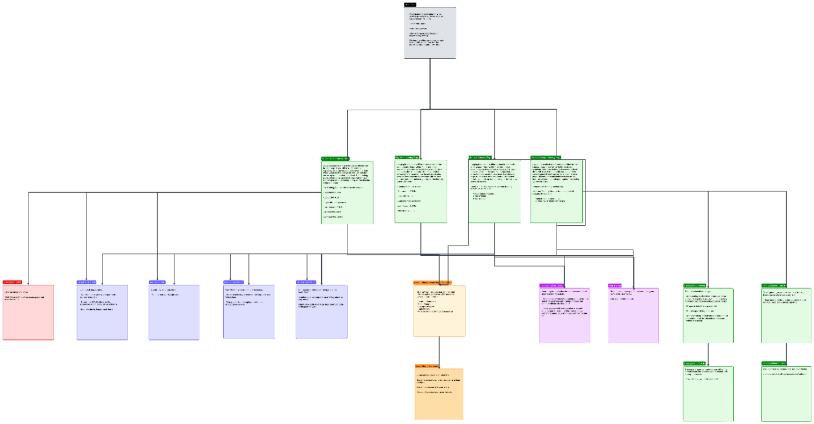

[https://lucid.app/lucidchart/180feeb8-8e59-4fb2-a293-35c1edc592ae/edit?docId=180feeb8-8e59-4fb2-a293-35c1edc592ae&shared=true&page=0_0&invitationId=inv_4075910d-7315-4c47-9dc8-447fcec6d73a#](https://lucid.app/lucidchart/180feeb8-8e59-4fb2-a293-35c1edc592ae/edit?docId=180feeb8-8e59-4fb2-a293-35c1edc592ae&shared=true&page=0_0&invitationId=inv_4075910d-7315-4c47-9dc8-447fcec6d73a)

# Sitemap 2.0

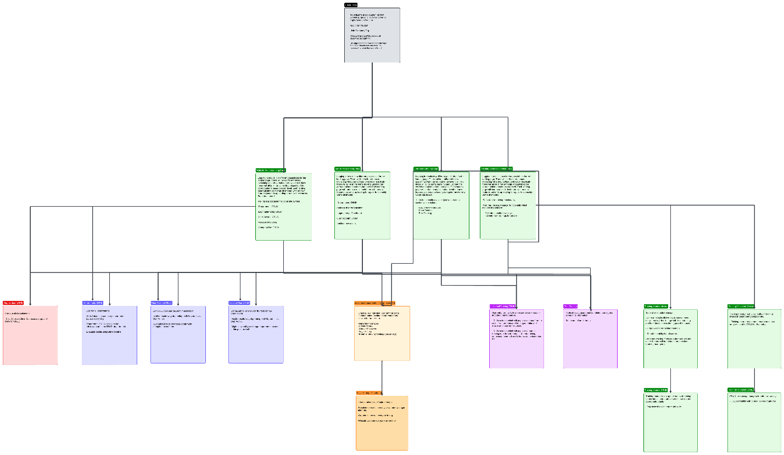

[https://lucid.app/lucidchart/180feeb8-8e59-4fb2-a293-35c1edc592ae/edit?docId=180feeb8-8e59-4fb2-a293-35c1edc592ae&shared=true&page=0_0&invitationId=inv_4075910d-7315-4c47-9dc8-447fcec6d73a#](https://lucid.app/lucidchart/180feeb8-8e59-4fb2-a293-35c1edc592ae/edit?docId=180feeb8-8e59-4fb2-a293-35c1edc592ae&shared=true&page=0_0&invitationId=inv_4075910d-7315-4c47-9dc8-447fcec6d73a)

Updated to reflect removed job codes and updated some functionality descriptions to match current product.

# Sitemap Final

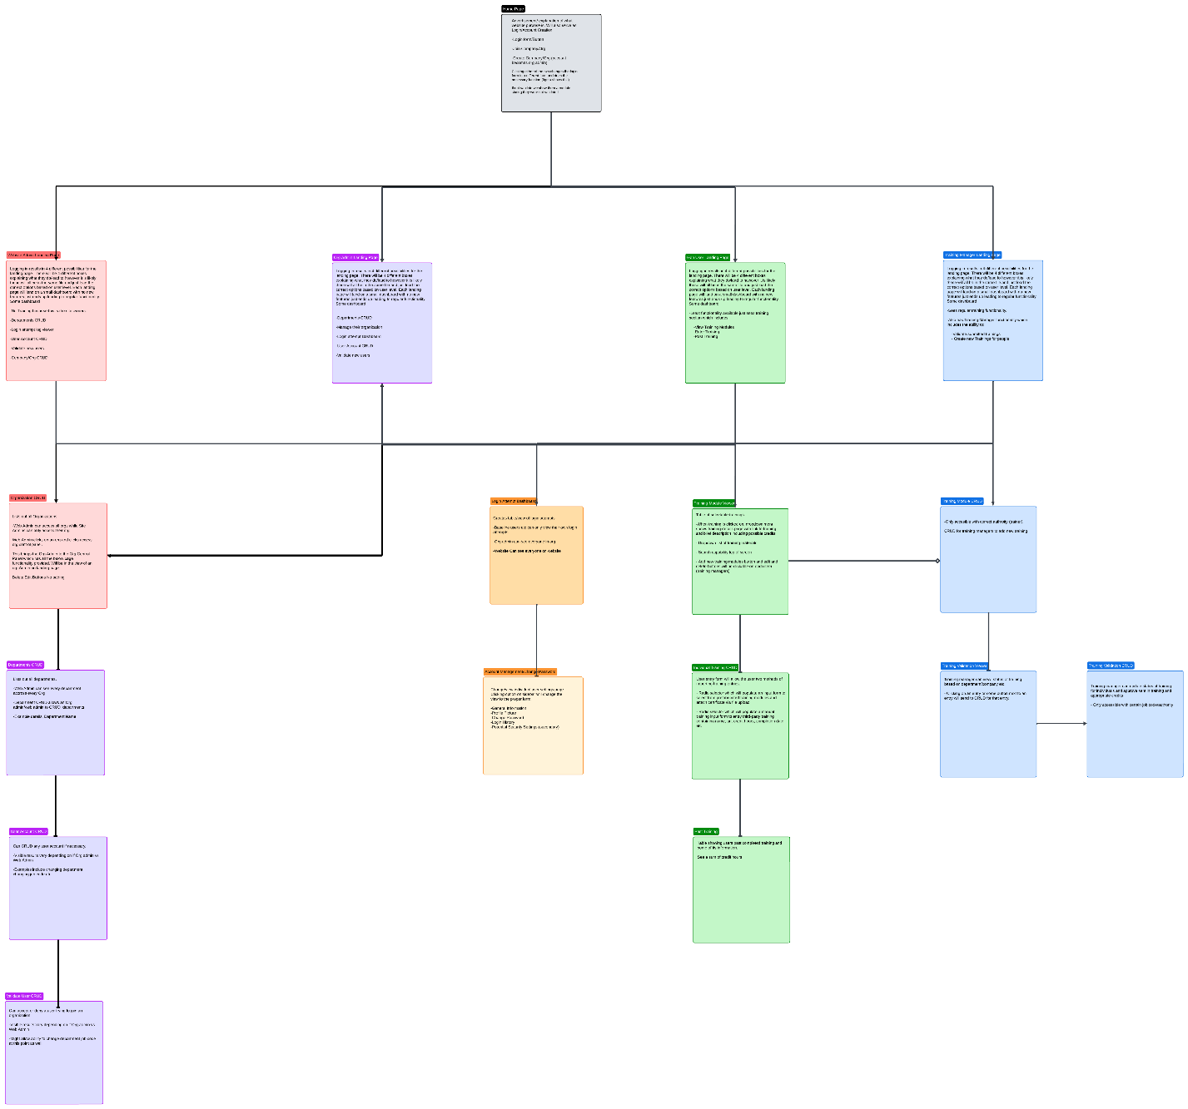

# Wireframe Version 1.0

<https://www.figma.com/file/TeRxzBkcKvKLFyIPVPA5mM/LMS-Wireframe?type=design&node-id=0-1&mode=design&t=BHAP2mrz3KNomMt2-0>

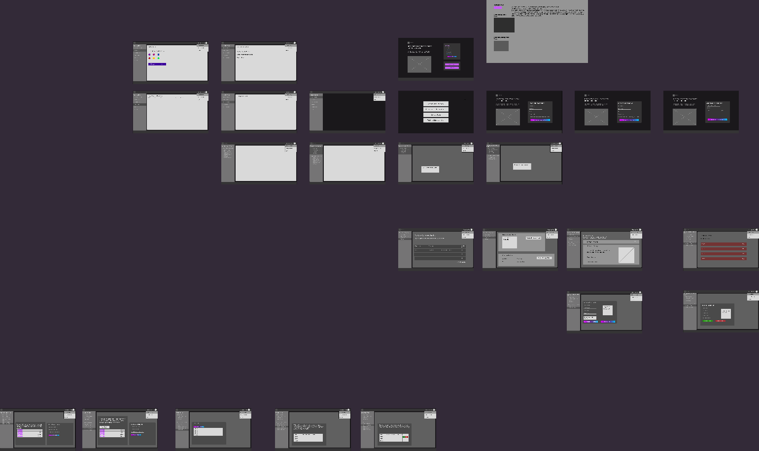

# Wireframe/Prototype Final

We need to update how error validation appears in the figma design. The plan is for any and all validation to occur with javascript and using onchange. Visuals will be using Bootstraps validation tools which add nice check marks and will have dynamic message. (Invalid Email Format, Enter an Email, Email is Already in Use etc. The rest of the design is finalized

<https://www.figma.com/file/TeRxzBkcKvKLFyIPVPA5mM/LMS-Wireframe?type=design&node-id=0-1&mode=design&t=BHAP2mrz3KNomMt2-0>

# Generated Assets

## Fonts

**Headers & Buttons**

* Buttons:
  + Base Color: #A525E0;
  + Border Color: #A525E0;
  + Text: White;
  + padding: 8px;
  + border-radius: 8px;
  + font-size: 20px;
  + On hover:
    - background-color: #5b0981;
    - border-color: #5b0981;

Advent Pro

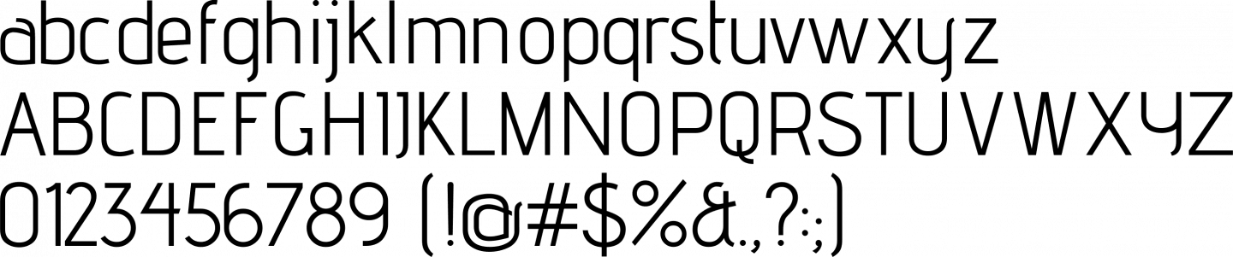

General Body/Text/Tables/Forms **Calibri**

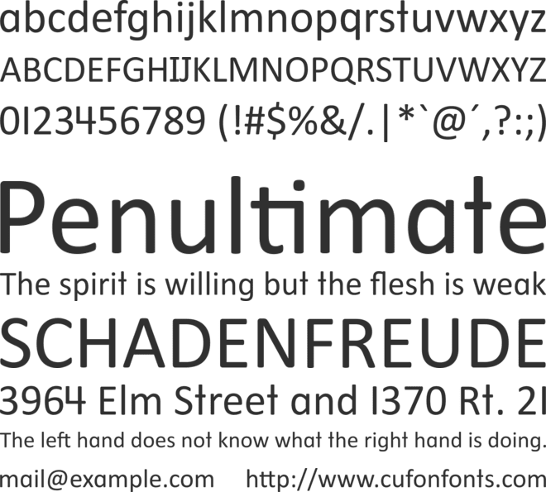

* Text Fields/Select Dropdown:
  + Text-Input field background: (#222222)
  + Border: #9966FF
  + Text-color: #9966FF
  + Placeholder text-color: #858585
* Radio Select
  + Border: #9966FF
  + Text-color: #9966FF
  + Selected: #9966FF
  + Unselected: Transparent
* Calendar
  + Default Styling
* Radio Buttons
  + Default Styling

## Colors:

 Background for Aside, Header, Footer

Border Color for aside/header/footer

**#555555**

H2/H3/H4 etc.

**#CC00FF**

Button Default.

**#9933FF**

Button Hover. Radio Select

**#9966FF**

Highlights/Borders for text inputs.

Text Color.

**#FFFFFF**

HTML Body Background Color: (Makes Transparent objects appear darker).

**#332A38**

# Interactive Requirements

**Universal**

* Every text field has field validation using Bootstrap styling and JavaScript code that contains RegEx expressions and or calls to Ajax to verify unique data to the server. It will not allow form submission (disable button or fade out haven’t fully figured out functionality on that yet)
* All fields use the most optimal or least user annoying field types. (Calendar for Date, Radio Buttons for Selecting between two options or a few options, select dropdown for selecting between a lot of choices etc.)
* Navbar links will have icons next to them and on hover will change font color and background to show that a user is selecting that option (blackish background, purple text)
* No plan for the aside to be minimizable now.
* Our database has On Cascade Delete on so deleting any information that connects to a foreign table will delete that data as well.
* No validation needed on searches.

## Home Page (Login)

All Home Pages have a carousel that visualizes the website for users. Buttons to slide back and forth and text explaining the images/short description. Sticky footer on bottom as well.

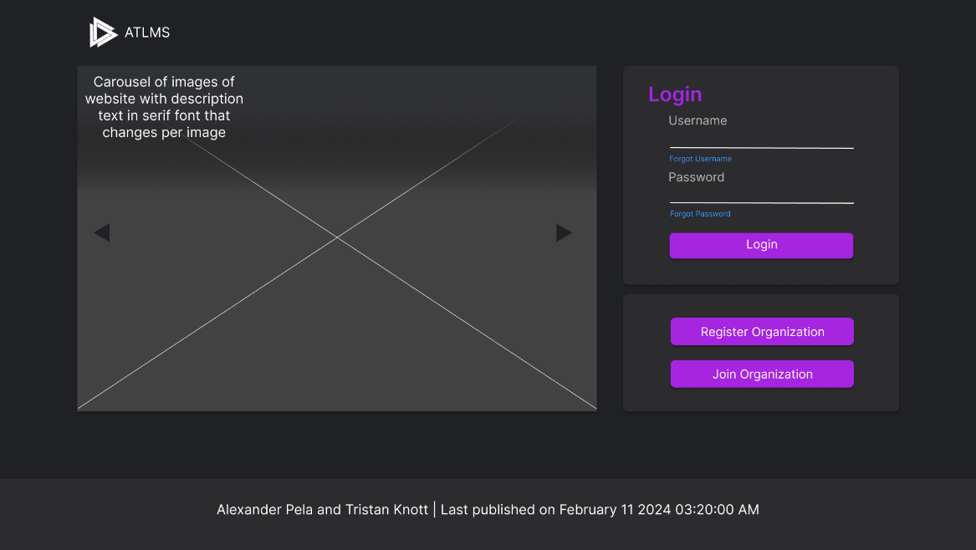

* *Login Form*
  + Username Text Box
  + Password Text Box
  + Login Button (On hover effect to lighter color)
  + Clicking login will either send user to landing page with their content, send them to a section on page telling them their account is not verified (pass action variable load content for not verified)

## Home Page (Create Org)

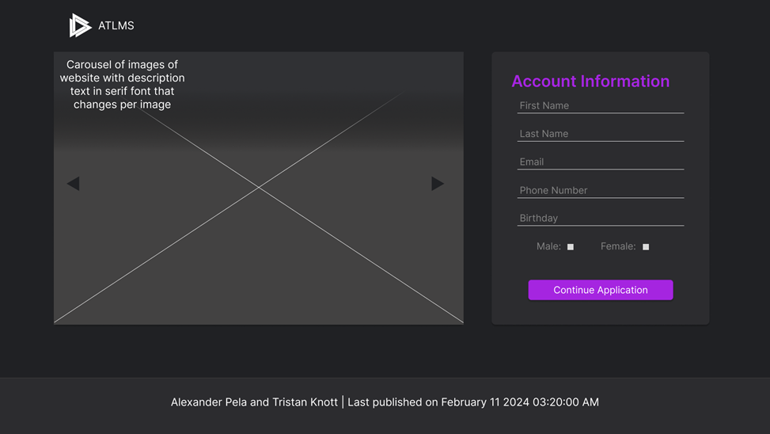

* *Create Company Form*
  + Text boxes for Company info
  + Text boxes for user information
  + Button to submit Form.
  + Submit the form validates. Will not post unless all valid. If valid send it to Org Admin Landing Page.

## Home Page (Join Org)

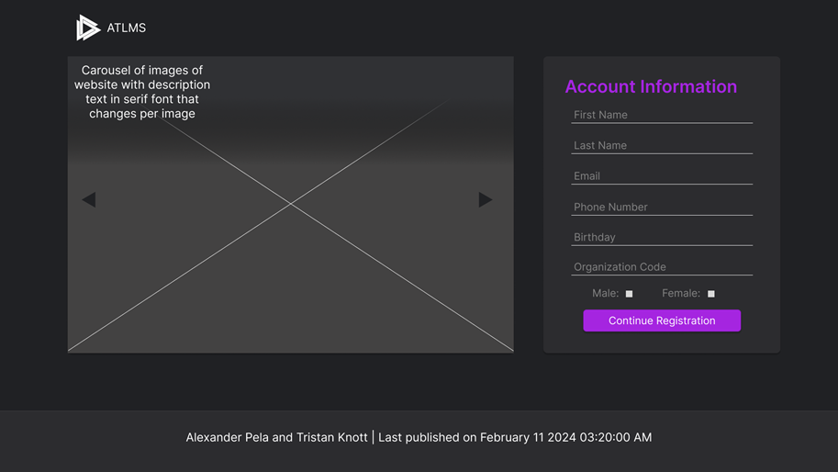

* *Join Company Form*
  + Text boxes for joining company info (organization code length must be 20.
  + Text boxes for user information
  + Button to submit Form.
  + On Submit the form validates. Will not post unless all valid. If valid send to not verified page.

## Home Page (Not Verified)

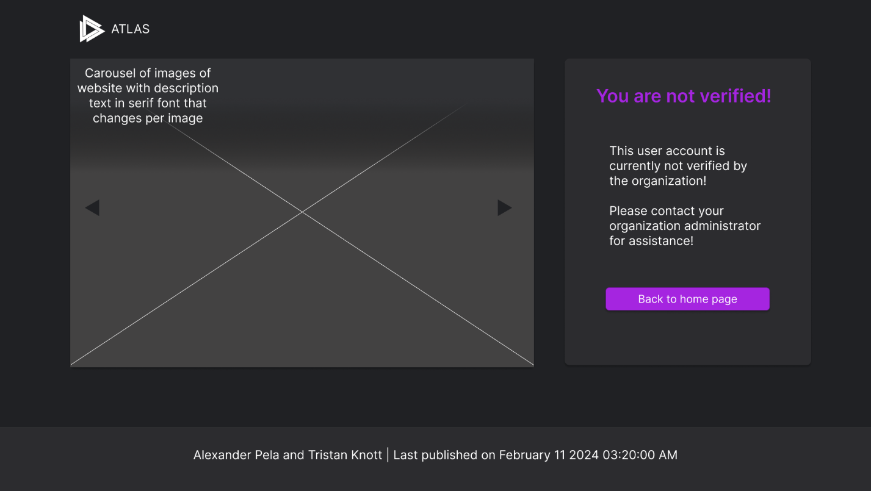

* *Not verified*
  + Short message stating that their account is not verified and to contact an organization administrator also back button to go back to login page (default) purple button with on hover to lighter color.

## Dashboard/General Landing Page

* Atlas Logo that brings to landing page.
* Top Nav bar that has a drop down with the users profile picture and their full name (first+last).
  + Account Settings, Change Password and Logging out.
* Side Navbar that fills with appropriate responsibilities that user has.
* Inside the main view there will be visual shortcuts to the users’ functionalities and show some minor stats if possible. (See Figma and how the options in the aside are present on the landing page as modules/shortcuts.

## Org CRUD (View)

* Table Listing out all Organizations.
* Search functionality with option on Org Name and State.
  + Two fields (one text box one selects drop down) (No validation)
  + Search button.
* Button option to Edit.

Org CRUD (Edit)

* Reloads page to form with organizations data.
* Delete Organization button. (only for a site admin).
* Edit Organization button. (Brings back to either landing page if org admin, Site admin to org viewer)
* Access Organization Control Panel button (Brings to view of individual organizations functions).
* Text fields with organization Data.
* Error messages on each individual field (use RegEx to test for no “invalid” data).

## Org Controller

* Options are given that an organization admin would have that you could go to edit information for an individual organization/user in an organization.

## Department CRUD

* List out all departments that are in an Org in the table.
* Add Option as a button outside on top of table.
* Edit Option inside the table.
* Form will either be blank or filled in depending on if add or edit was clicked. (dep email and name)
* Option to Delete if editing.

## User CRUD

* Table of Users
* Search functionality based on a lot of properties of user.
  + First Name, Last Name, Select Organization, Gender, Site Admin, Org Admin, Training Manager.
* Add option for creating a user for someone ahead of time.
* Delete option for a user in table.
* Edit option (brings to edit user information page (see below))
  + Fill form out with that user’s account settings, the ability to add rights.
  + Rights appear as square checkboxes with selected being purple and not selected being a more transparent color.
* Form will allow for Departments to be Changed etc.

## Validation User

* Table of company’s user applicants.
* Button to Approve or Deny
* (Go back button is only present for a site admin accessing an organizations control panel.

## Account Settings (Personal/Update any user Settings)

* Profile Pic, Password Changes, General User Info etc. (see Figma)
* Two buttons bringing either to change password page or editing account information page.
  + Profile pic preselected choices.
  + General user information
  + Seeing user rights where appropriate and the ability to change settings based on rights. Personal information changeable by anyone, Rights only accessible my Admins.

## Reset Password

* Two text inputs with new password and confirm password.
* Error validation if not the same
* Change password button.

**Login Dashboard**  
  
* Table to see Login Attempts last successful login etc. Higher levels can see other users (Org Admin/Web Admin.
* Search functionality for different fields to filter.
  + Org ID that when selecting an option updates User ID’s to fill with all users in that appropriate Org. (Site Admin Only)
  + User ID that can be selected
  + Attempt Date (Date field)
  + Radio Select Button for whether a login was successful or not

## Past Training

* Search on text field and category.
  + Search button.
  + Create a new training entry button.
* List of all past submitted training.

## Individual Training CRUD

* Radio Button options for preset training or custom.
* Drops down form dependent on which selected.
* Form field options for whatever information is needed (Training Name etc.)

## Module Viewer

* Search fields on text input and select category.
* Module list out of all training available to a user.
  + Clicking a module provides more info about training and link to training (outside link)
* Option to Edit/Add/Delete if Training Manager

## Module CRUD

* Edit/Add a new Training for people you are a training manager for
* Form fields for whatever needed to create a training.
  + Text inputs
  + Search field.
* Category dropdown with limited options that can’t be added to (50 or so options)

## Training Validation Viewer

* Search fields to narrow results. (two date fields two text fields one search button)
* See table list out of all users who submitted training depending on user level.
  + Select validate to go to CRUD.

## Training Validation CRUD

* Form fills out.
* Approve or Deny Credit Hours.
* Text area field for validation comments 3 date fields and some text fields and two select fields).  
    
    
    
  A screenshot of a computer

  Description automatically generated

# Design

**Desktop/Computer Layout:**

The Desktop/Computer Layout of our ATLAS system is designed to optimize user experience on desktop and computer platforms only. With an intuitive and user-friendly interface, this layout ensures seamless navigation, allowing users to access and manage training programs efficiently. Tailored for desktop environments, it enhances the overall usability of the ATLAS system, providing a comfortable and effective interface for users.

**Web-based Application:**

Our ATLAS is a cutting-edge web-based application, offering users the flexibility to access the system from any location with internet connectivity. This web-based architecture ensures universal accessibility, enabling users to manage training programs, view simple data metrics, and perform administrative tasks seamlessly through standard web browsers. The application is designed for compatibility across various devices, providing a consistent and optimal user experience.

# Technologies

* PHP (Handle Server Logic and Classes)
  + PHPMailer (Email Library for PHP if we manage to get around to this functionality (extra for us)
  + Gmail STMP (Simple Mail Transfer Protocol)
* HTML 5
* JavaScript (Validation and dynamic Ajax Calls to Server)
* CSS & Bootstrap (Styling)
* MySQL Workbench (Database)
* XAMPP (Server for testing and building)

Technical Limitations

ATLAS has some limitations due to the time constraints provided and our technologies used. Below is the list

**Time Constraints:**

We wanted to add the ability to export data into CSV format for use in PowerBI.

PowerBI dashboards/visualizations on landing page.  
  
Giving users Job codes for better organization of users in an organization.  
  
Making search fields more dynamic and updating the table as you enter input rather than requiring a button.

**Technology Constraints**  
  
PHP uses a synchronous response model which means it needs to wait for a response from the server before continuing to write code. This means that our site by default isn’t super dynamic and responsive. With the addition of some JavaScript and Ajax it starts to become more dynamic however PHP is very limited in that regard.

# Feedback and Resulting Changes

## Week 3 Presentation:

* Received feedback that our styling looked very dull.
  + The physical layout was correct we just had not decided on our assets/colors/fonts.
* Received feedback that some user input options were suboptimal.
  + Date Field to Date Time Input
  + Deleting buttons moved from some tables and added to others that did not have them.
* Feedback that some functionality was confusing for users to understand and that we needed to iron out specifics for certain sections of the prototype.
  + We were struggling to figure out how the project would work and what data we needed to track. We took this feedback to figure out what data we needed to track for our users and create a database.
* Feedback that tables needed search functionalities to reduce how much data is loaded for the user.
  + Search on certain fields to vastly reduce the number of results.

## Week 6 Presentation:

* Received feedback that we needed to have some navigation tools to go back pages/forms.
  + Created back buttons to allow a user to navigate backwards for necessary sections (Create an organization).
* Received feedback that some search fields could be organized better and to resize some content so make better use of space.
  + Edited all search forms to be organized better.
  + Rearranged some content to better fit the page.
* Received feedback that error validation messages should occur next to each input rather than as one unordered list at the top of any form.
  + Used Bootstrap Validation styling along with custom JavaScript, RegEx, and AJAX to validate acceptable user data.
* Received feedback on some generated assets.
  + Modified what colors were placed on some text/backgrounds.
    - For example, we modified some fields to not use a semitransparent purple background.

## Other Changes/Feedback:

* Footer/Aside/Header changed to not be sticky as it caused issues with content being cut off and it felt unnecessary for a website.
* Color changes made to aside to make it pop out more.